AI-Assisted Waste Collection & Resource Planning System
Business Analysis Deliverables

Riverside Municipal Council - Fictional scenario

Prepared by: Sahana Pathirana
June 2026

Table of Contents
Table of Contents 1
1. Introduction & Project Context 1
2. Stakeholder Analysis 1
3. Requirements Specification 1
3.1 Functional Requirements 1
3.2 Non-Functional Requirements 1
4. AS-IS Process 1
5. TO-BE Process 1
6. Gap Analysis 1

1. Introduction & Project Context
Managing waste collection efficiently is a challenge when collection schedules are based on fixed routines rather than actual demand. Riverside Municipal Council serves five areas with different waste generation patterns: Market Square, Lakeview Residences, Riverside Heights, Hillside Gardens, and Greenfield Industrial Park. As a result, some areas may receive unnecessary collections while others face overflowing bins and delayed pickups.
This project proposes an AI-Assisted Waste Collection and Resource Planning System to help the council make better use of its resources. By analyzing waste collection data and identifying trends, the system aims to improve planning, reduce overflow incidents, and support more informed decision-making. This document outlines the key stakeholders, business requirements, current processes, and proposed improvements for the solution.

2. Stakeholder Analysis
Stakeholders are categorized based on the power/interest matrix (also referred to as Mendelow’s Matrix). Those with high power and high interest levels receive close management, while those with high power but low day - to - day interest are made happy, while those with high interest levels but less power are informed.
Stakeholder | Type | Interest | Influence | Engagement Strategy
Municipal Council (Sponsor) | Primary | High - funds and owns the outcome | High | Manage Closely
Waste Collection Supervisors | Primary | High - responsible for daily operations | High | Manage Closely
Truck Drivers / Collection Crew | Primary | High - direct system users | Low | Keep Informed
Residents | Secondary | Medium - affected by service quality | Low | Keep Informed
Environmental Authorities | Secondary | Medium -compliance & sustainability oversight | High | Keep Satisfied

3. Requirements Specification

3.1 Functional Requirements
Functional requirements are prioritized using MoSCoW (Must / Should / Could) to reflect what is essential for a working version versus what can follow.
ID | Requirement | Priority
FR1 | Record daily waste collection data per area (date, weight, bins, truck, fuel, time) | Must
FR2 | Track vehicle assignments, maintenance schedule, and fuel consumption | Must
FR3 | Manage and display collection routes, including area and schedule assignments | Should
FR4 | Manage employee work schedules, including shift and route assignments | Should
FR5 | Generate predictive forecasts of waste volume per area for the upcoming period | Must
FR6 | Flag areas at high risk of bin overflow based on historical and predicted data | Must
FR7 | Recommend resource reallocation (trucks and workers) based on predicted demand | Should
FR8 | Generate daily, monthly, and resource-utilization reports | Could

3.2 Non-Functional Requirements
ID | Requirement | Priority
NFR1 | Security: role-based access control; sensitive data encrypted at rest and in transit | Must
NFR2 | Usability: dashboard usable by non-technical supervisors with minimal training | Must
NFR3 | Scalability: support additional areas, trucks, and staff without redesign | Should
NFR4 | Reliability: system available during all operating hours (target 99% uptime) | Should
NFR5 | Performance: standard dashboard views load within 3 seconds | Could
NFR6 | Compliance: data retention aligned with local environmental reporting requirements | Should

4. AS-IS Process
The current process is manual and fixed: trucks follow the same weekly route regardless of how much waste each area has actually generated, and almost nothing is recorded digitally after a collection run.
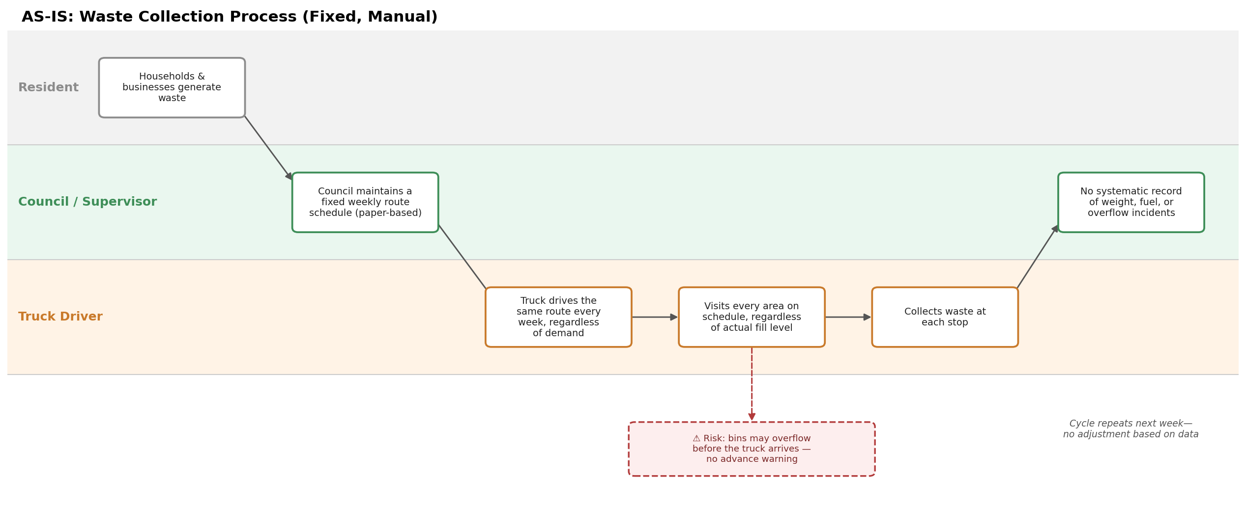
Figure 1. AS-IS: fixed, manual waste collection process.
Key points:
- No visibility into which areas are likely to overflow before it happens
- Trucks visit low-waste areas on the same schedule as high-waste areas, wasting fuel and labor
- Little to no historical data exists to inform planning decisions
- Workforce and vehicle assignments don't adjust for seasonal demand (e.g festival periods)

5. TO-BE Process
The future process introduces a continuous feedback loop, historical and real-time data feeds an AI forecasting step, which generates route and resource recommendations that a supervisor reviews before drivers execute them. Every run is then logged automatically, improving the next cycle's predictions.
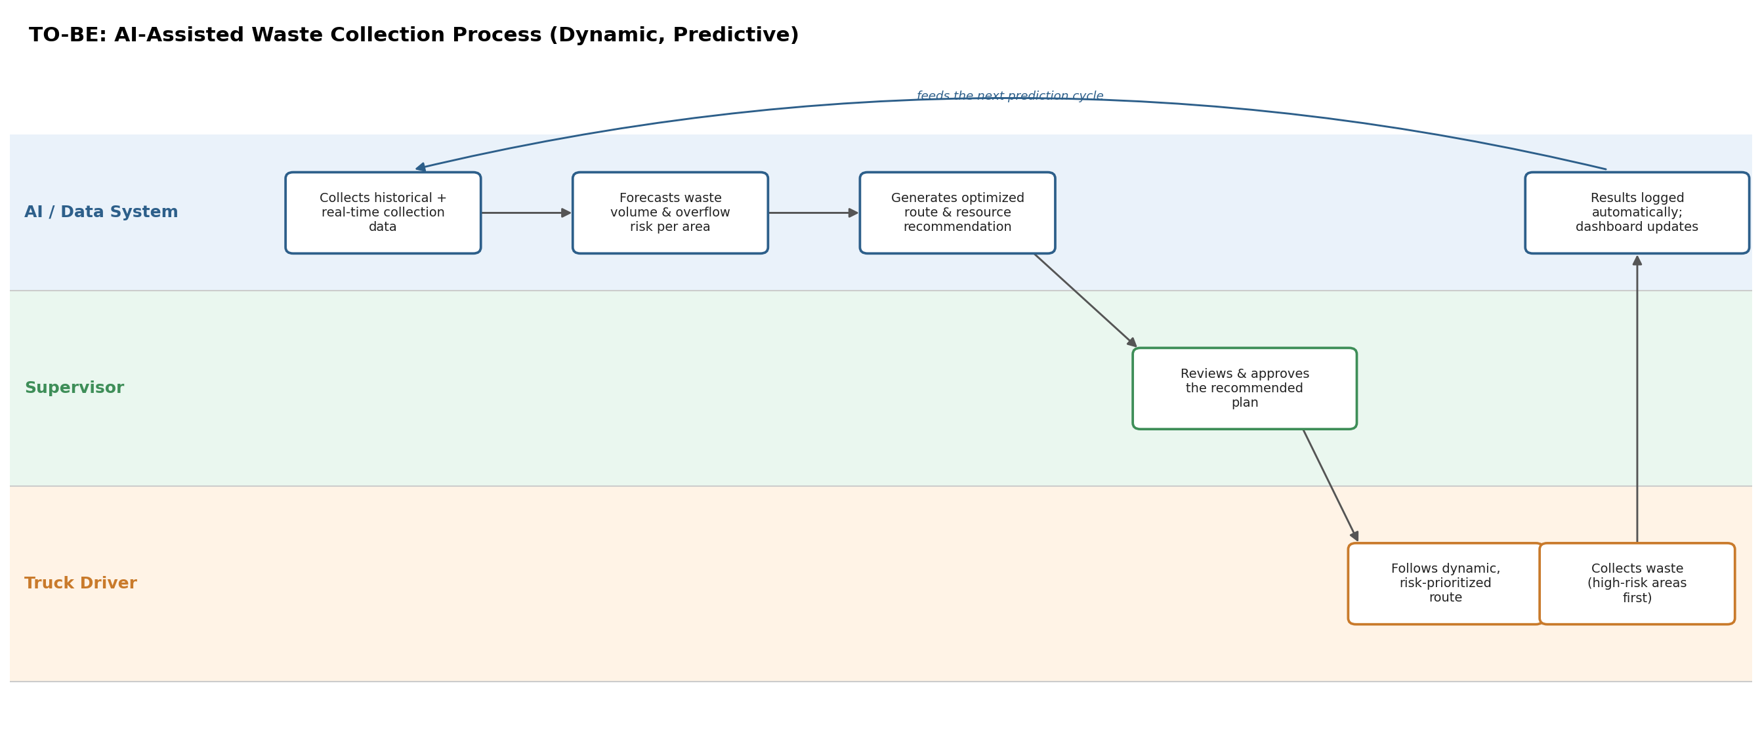Figure 2. TO-BE: AI-assisted, dynamic waste collection process.
Key improvements:
- Forecasts highlight which areas need attention before bins overflow
- Routes and resource allocation adjust to actual predicted demand, reducing wasted trips
- Every collection run is logged automatically, building a growing dataset for better predictions over time
- Supervisors retain final approval - a human stays in the loop while benefiting from data-driven recommendations

6. Gap Analysis
Summarized the core differences between current and future state across the dimensions that matter most to council operations.
Dimension | AS-IS | TO-BE
Route Planning | Fixed weekly routes, unchanged regardless of demand | Dynamic, AI - recommended routes prioritized by predicted waste & overflow risk
Data Collection | Minimal or no digital records of collection runs | Every collection run logged automatically, feeding a central dataset
Decision Making | Based on supervisor experience and habit | Based on historical data and predictive analytics
Overflow Handling | Reactive - discovered only when the truck arrives or a resident complains | Proactive - flagged in advance via overflow risk prediction
Resource Allocation | Static - same trucks / workers regardless of varying demand | Recommended dynamically based on forecast demand per area
Reporting | Ad hoc or none | Automated daily / monthly dashboards in Power BI

