BUSINESS ANALYST CASE STUDY
NeighbourNet
Designing a Trusted, Unified Digital Ecosystem for
Hyperlocal Resource Sharing & Trusted Local Services
Prepared By
Sahana Rajaram

June 2026
Independent Business Analysis Portfolio Project • Illustrative Business Case • Not Affiliated With Any Live Commercial Entity

Table of Contents
1. Executive Summary 3
2. Business Context & Problem Statement 3
3. Target Users & Personas 4
4. Research Methodology & Market Analysis 4
5. Root-Cause Analysis 5
6. Stakeholder Analysis 6
7. Proposed Solution 7
8. Process Reengineering: AS-IS vs. TO-BE 7
9. Requirements Snapshot 8
10. Business Impact, Revenue & KPIs 8
11. Implementation Roadmap 9
12. Risk Assessment & Mitigation Register 10
13. Recommendations & Future Scope 10
14. Lessons Learned — BA Skills Demonstrated 10
15. Conclusion 11
A. Appendix — Tools & Techniques Applied 11
B. Appendix — Glossary of Terms 11

1. Executive Summary
Across most residential neighbourhoods, two everyday problems persist side by side: households buy items they use only rarely, while neighbours who already own the same items have no safe way to lend them; and finding a verified electrician, tutor, or photographer still depends on WhatsApp groups and word-of-mouth. NeighbourNet is proposed as a single, verified digital ecosystem that solves both problems together, rather than the fragmented, single-purpose way today's marketplace and services apps solve them separately.
This case study is built the way a real consulting engagement is structured — from a validated business problem, through market research and root-cause analysis, into a recommended solution, requirement prioritisation, a phased roadmap, and measurable success criteria.

Key Findings at a Glance
Dimension | Finding
Core Problem | No existing platform combines verified neighbourhood trust, item-sharing, and local service booking in one place.
Market Gap | 5 benchmarked platforms each solve only one slice of the problem — trust, sharing, or services — never all three.
Root Cause | Absence of identity verification and a unified digital process, not lack of user willingness to share.
Recommended Fix | A single verified platform integrating marketplace, bookings, chat, payments, and community trust scoring.
Projected Impact | 8,000 projected monthly active users and 5,400 completed transactions by end of Year 1 post-pilot.

What This Case Study Demonstrates
- Structured problem framing and stakeholder analysis
- Competitive benchmarking and market gap research
- Root-cause analysis using Ishikawa (Fishbone) and 5 Whys
- AS-IS → TO-BE process redesign and MoSCoW requirement prioritisation
- Business impact quantification, KPI design, phased roadmap, and risk mitigation

2. Business Context & Problem Statement

About NeighbourNet
NeighbourNet is a proposed hyperlocal community platform connecting verified residents within the same neighbourhood or apartment community — to borrow, rent, sell, exchange, and donate household items, and to discover and book trusted local service providers such as tutors, electricians, plumbers, and photographers, all inside one verified, community-first application.
Three pillars: verified trust (identity checks, ratings, reviews) · resource efficiency (sharing under-used items) · local economic opportunity (helping nearby freelancers reach genuine demand).

Industry Context
India's sharing economy and hyperlocal services market has grown rapidly, led by services marketplaces (Urban Company) and classifieds platforms (OLX, Facebook Marketplace). Dense apartment communities in Tier 1/2 cities create natural, trust-adjacent neighbourhood units — residents already share a gate, a lift, and a WhatsApp group, but not a structured platform to transact safely. NeighbourNet sits at the intersection of three established trends — resale/rental, local services, and hyperlocal community coordination — combined for the first time into one verified product.

Problem Statement
PROBLEM STATEMENT
Neighbourhoods lack a single trusted platform to share under-used household resources and hire verified local service providers — forcing residents onto fragmented, low-trust channels that waste money, time, and community goodwill.

Who Is Affected
Affected Group | Impact of the Problem
Households / Residents | Spend on items used only occasionally; struggle to find verified help nearby.
Local Freelancers & Providers | Limited visibility to nearby customers; depend on inconsistent referrals.
Apartment Associations | No structured tool to manage shared resources, trust, or engagement.
Environment / Community | Under-utilised resources and unnecessary purchases increase waste.

Why now: Informal WhatsApp groups already show residents actively trying to lend, borrow, and refer services — demand isn't the gap. The gap is structural: no platform provides identity verification, a standard process, secure payment, and dispute protection together, so users default to riskier informal exchange or simply buy new / pay more.

3. Target Users & Personas
Two representative personas illustrate the range of people NeighbourNet serves — one primarily sharing/borrowing items, the other offering a local service. Designing for both on one platform is central to the product's value proposition.
Attribute | Persona 1 — Priya, The Practical Resident | Persona 2 — Arun, The Local Freelancer
Profile | 28, working professional, mid-sized apartment community | 24, freelance photographer building a local client base
Goal | Host a birthday party without buying decorations she'll use once | Consistent, nearby bookings without high commissions to large apps
Pain Point | Doesn't know which neighbours own decorations; hesitant to ask strangers on WhatsApp | Relies on inconsistent word-of-mouth; struggles to build a visible profile nearby
How NeighbourNet Helps | Searches verified listings, books & pays in-app, returns item with a review | Verified profile with booking calendar, discovered by nearby residents, builds public rating

Both personas share the same underlying need: a trusted, structured way to connect with people who already live nearby. Treating item-sharing and service-booking as one need rather than two separate products is the core product insight behind NeighbourNet.

4. Research Methodology & Market Analysis
Research combined secondary research on five widely-used platforms with a structured feature audit. Each platform was scored 1 (weak) to 5 (strong) across five capability dimensions: verified trust, item sharing, local service booking, community engagement, and unified experience.
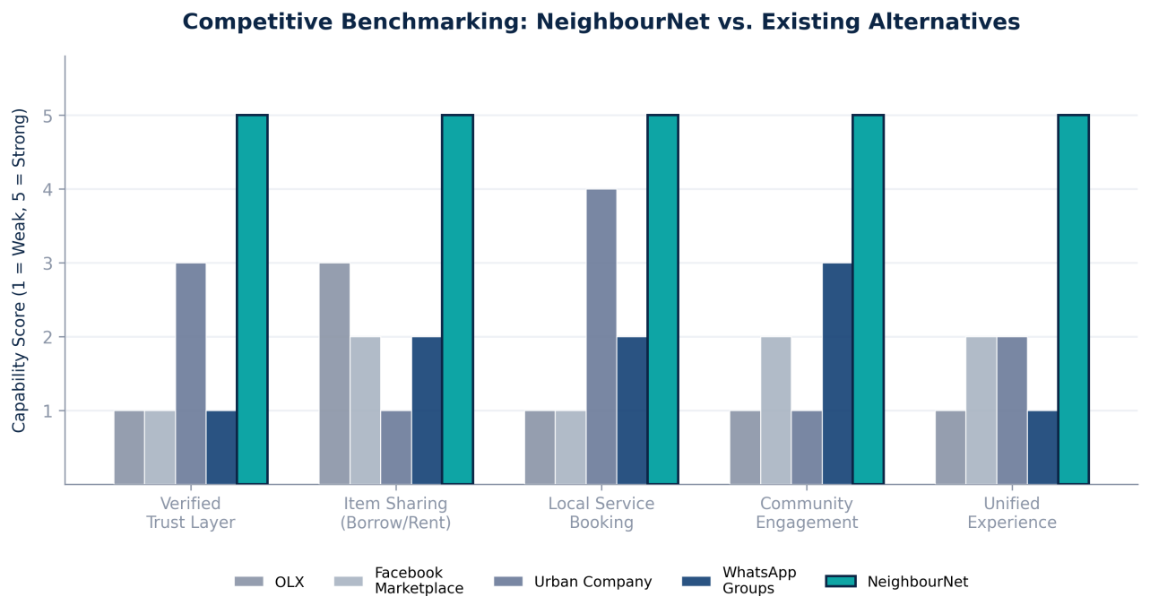
Figure 1 — Capability comparison across five existing alternatives and NeighbourNet.
The benchmarking makes the gap explicit: Urban Company scores well on service booking but not item-sharing; OLX and Facebook Marketplace support selling but lack verification and services; WhatsApp groups enable engagement but offer no structure, payments, or safety. No competitor combines all five capabilities.

Market Gap Analysis
Platform | Strength | Key Gap
OLX | Large resale marketplace reach | No verification; no rental/borrowing workflow; no services
Facebook Marketplace | Wide, free-to-use audience | Weak trust signals; no local service booking; not hyperlocal
Urban Company | Strong verified service booking | No item-sharing; not community-owned or neighbourhood-based
WhatsApp Groups | High engagement, zero cost | No structure, payments, verification, or dispute handling
Gain (community apps) | Some community focus | Limited depth; inconsistent verification and monetisation

KEY INSIGHT
The market does not lack sharing-economy demand — it lacks a platform that treats verified trust as a first-class feature rather than an afterthought.

5. Root-Cause Analysis
To avoid designing around symptoms, the causes of low neighbourhood resource-sharing were analysed with two complementary techniques: the Ishikawa (Fishbone) diagram to organise causes into categories, and the 5 Whys to drill into the deepest root cause.

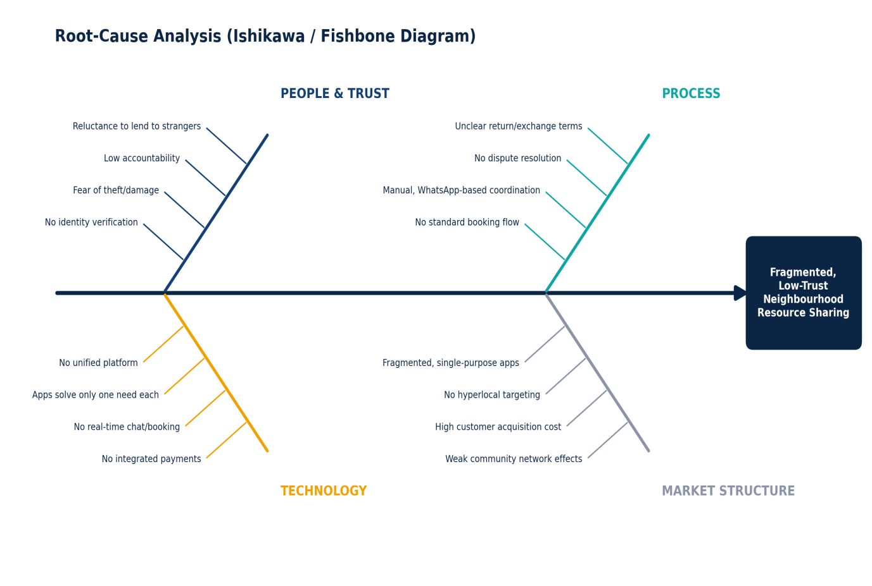
Figure 2 — Root causes grouped by People & Trust, Process, Technology, and Market Structure.

The 5 Whys
Step | Question & Answer
Why 1 | Why do neighbours rarely lend/rent to each other? → They do not know or trust the other person enough.
Why 2 | Why is there not enough trust? → There is no way to verify a neighbour's identity or reliability.
Why 3 | Why is there no verification mechanism? → Current channels (WhatsApp, word of mouth) were never built for transactions.
Why 4 | Why hasn't a dedicated platform been adopted? → Existing apps solve only selling, or only services — not both.
Why 5 — Root Cause | Why does no platform combine both? → No product has been designed specifically around verified, hyperlocal, multi-purpose community trust.

6. Stakeholder Analysis
Identifying stakeholders early ensures the solution addresses real needs across every group involved in adoption and success, not just end users.
Stakeholder | Interest | Influence | Engagement Strategy
Residents (Borrowers/Lenders) | High | High | User research, beta testing, feedback loops, in-app incentives
Freelancers / Service Providers | High | Medium | Free early listings, onboarding support, visibility guarantees
Apartment Associations | Medium | High | Pilot partnerships, bulk resident onboarding, admin dashboards
Platform Administrators | High | High | Moderation tools, fraud dashboards, escalation workflows
Payment Gateway Partners | Medium | Medium | API integration, compliance alignment, SLA agreements
Future Logistics Partners | Low (initially) | Low (initially) | Evaluated in later growth phases for delivery-assisted items

Residents and apartment associations carry the highest combined interest and influence — making early pilot partnerships with a small number of apartment communities the most effective adoption strategy.

7. Proposed Solution
NeighbourNet combines four capability layers into one product: a verified identity & trust layer; a marketplace layer (borrow, rent, sell, exchange, donate); a services layer (discover & book local professionals); and a community layer (chat, ratings, reviews, notifications). Every transaction flows through the same verified, secure process.

Feature-to-Problem Mapping
Business Problem | NeighbourNet Feature | Business Outcome
No identity verification | OTP + document-based verification at sign-up | Increases willingness to lend/borrow; reduces fraud
Fragmented discovery | Unified marketplace + services module with search & filters | One app instead of five; higher engagement & retention
No secure transaction process | In-app booking, chat, UPI payments with deposit protection | Reduces disputes; safe, repeatable transaction flow
No post-transaction accountability | Ratings, reviews, cumulative trust score per user | Long-term reputation incentives for good behaviour
Low visibility for freelancers | Searchable provider profiles with booking calendars | Expands local livelihood opportunities & repeat bookings
No community-level oversight | Apartment-association-linked admin dashboard | Enables moderation, dispute handling, bulk onboarding

8. Process Reengineering: AS-IS vs. TO-BE
Mapping the current (AS-IS) process against the proposed (TO-BE) process makes the redesign concrete: borrowing a projector moves from an unstructured, high-risk chain of manual steps to a short, verified, digitally-supported flow.
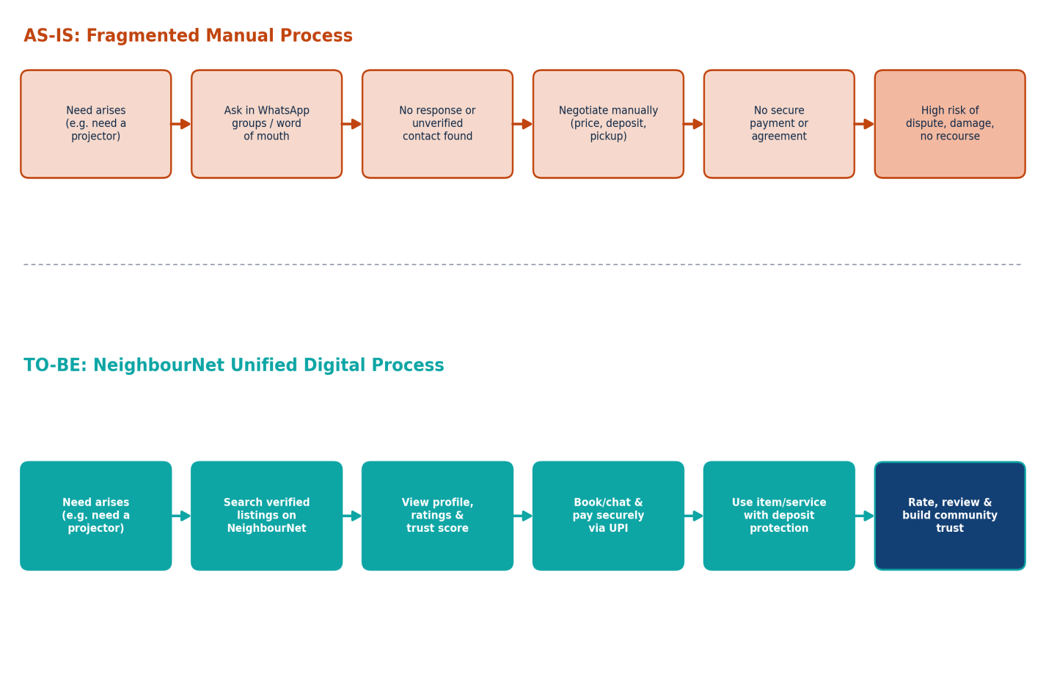
Figure 3 — AS-IS manual, WhatsApp-based process vs. the TO-BE unified NeighbourNet process.
The redesign removes three failure points: an unanswered/unverified WhatsApp message, the absence of secure payment, and the lack of recourse for damage or unsatisfactory service — replaced with verified listings, secure in-app payment, and deposit-backed protection with review-based accountability.

9. Requirements Snapshot
The full BRD captures detailed functional, non-functional, and business rule requirements. This snapshot uses MoSCoW prioritisation to show how scope was structured for a phased build.
Priority | Requirement
Must Have | OTP-based registration & login; identity verification; item/service listing creation; booking workflow; UPI payment integration; ratings & reviews
Should Have | In-app chat; wishlist; push notifications; admin moderation dashboard; security deposit handling
Could Have | AI-based recommendations; community trust score; gamified badges; sustainability impact dashboard
Won't Have (This Phase) | Third-party logistics/delivery integration; multi-city expansion tools; voice search

This ensures the MVP focuses entirely on establishing trust and completing a full transaction loop before layering on engagement and intelligence features.

10. Business Impact, Revenue & KPIs
Value is assessed across three lenses: direct household savings, local economic opportunity, and platform revenue. Figures below are illustrative estimates built to demonstrate business-value reasoning, not measured production data.
- Households avoid low-frequency purchases by borrowing/renting instead — estimated savings of ₹3,000–₹8,000/year for an actively participating family.
- Local freelancers gain a low-cost customer acquisition channel vs. relying on referrals or expensive third-party apps.
- Apartment associations gain a structured tool for engagement and dispute visibility, reducing informal WhatsApp friction.

Revenue Model
Revenue Stream | Description
Transaction Commission | Small % fee on completed bookings, rentals, and service payments
Premium Memberships | Optional paid tier: priority listing visibility, lower commission
Featured Listings | Paid promotion for items or providers within their local area
Business Subscriptions | Monthly plans for local businesses needing consistent visibility
Local Advertising | Hyperlocal ad placements for community-relevant businesses

KPIs & Success Metrics
KPI | Definition | Target (Year 1)
Monthly Active Users | Unique residents engaging per month | 8,000
Completed Transactions | Successfully closed bookings, rentals, or sales | 5,400 (cumulative)
Repeat User Rate | Share completing more than one transaction | ≥ 40%
Average Rating | Mean rating across completed transactions | ≥ 4.3 / 5
Booking Completion Rate | Bookings completed vs. initiated | ≥ 85%
Dispute Rate | Transactions resulting in a formal dispute | < 3%
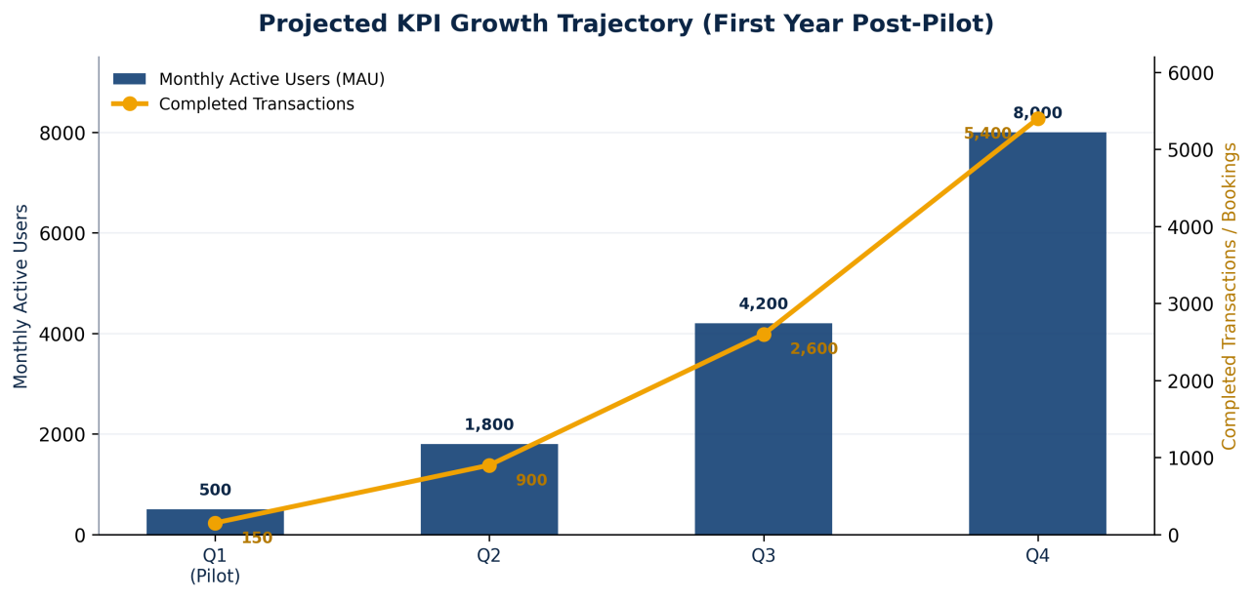
Figure 4 — Projected quarterly growth in MAU and completed transactions, Year 1 post-pilot.
BUSINESS VALUE STATEMENT
NeighbourNet converts an existing informal habit — neighbours already trying to share and refer informally — into a monetisable, trust-verified transaction layer, rather than creating new user behaviour from scratch.

11. Implementation Roadmap
A phased, 12-month roadmap sequences discovery, design, build, pilot, and scaled rollout — front-loading requirement and trust-mechanism validation before wider investment in growth.
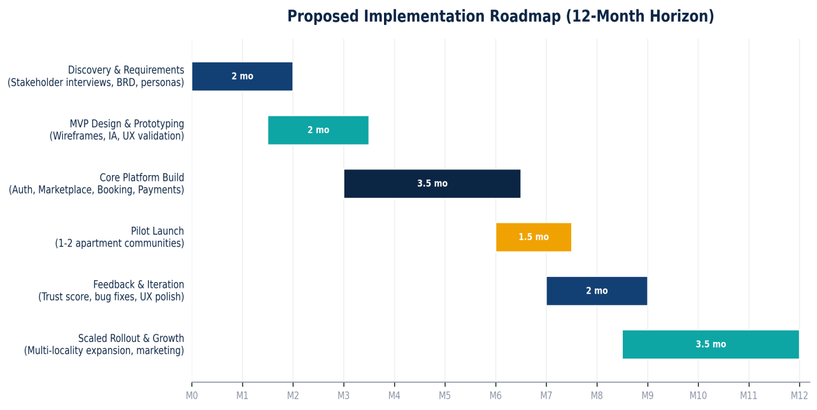
Figure 5 — Proposed 12-month implementation roadmap from discovery through scaled rollout.
Phase | Key Deliverables
1. Discovery & Requirements | Stakeholder interviews, BRD, personas, journey maps
2. MVP Design & Prototyping | Information architecture, low-fi wireframes, UX validation
3. Core Platform Build | Authentication, marketplace, booking engine, chat, UPI
4. Pilot Launch | Controlled rollout across 1–2 apartment communities with hands-on support
5. Feedback & Iteration | Trust-score refinement, bug fixes, UX polish based on pilot feedback
6. Scaled Rollout & Growth | Multi-locality expansion, marketing push, subscription onboarding

12. Risk Assessment & Mitigation Register
Risk | Likelihood | Impact | Mitigation Strategy
Fake or duplicate user profiles | Medium | High | Mandatory OTP + ID verification; anomaly-detection flags
Item damage / non-return disputes | Medium | High | Refundable security deposits; return-condition photos at handover
Payment disputes / failed transactions | Low | High | Escrow-style hold on UPI payments until confirmation
Privacy concerns over location/profile data | Medium | Medium | Minimal data collection; visible privacy controls; encryption
Low initial user adoption | High | Medium | Apartment-association pilot partnerships; referral incentives
Service-provider quality inconsistency | Medium | Medium | Mandatory ratings/reviews; minimum-rating thresholds

Low initial adoption is treated as the highest-priority risk in Year 1, since trust-based platforms depend on reaching critical mass within each pilot community before referral-led growth takes over.

13. Recommendations & Future Scope
Beyond the MVP, the following are recommended once the core trust and transaction loop is validated in the pilot phase:
- AI-based recommendations — suggest relevant nearby items/services based on activity and neighbourhood trends.
- Community trust score — a cumulative, transparent score combining verification, ratings, and history.
- Emergency assistance mode — fast-path request type for urgent local help (e.g., a plumber for a leak).
- Community events & volunteer network — extend beyond transactions into neighbourhood coordination.
- Skill exchange — trade skills (e.g., tutoring for photography) without a monetary transaction.
- Sustainability dashboard — show each user's cumulative contribution to reduced purchases and waste.
- Smart fraud detection — pattern-based detection of suspicious listing or messaging behaviour.

14. Lessons Learned — BA Skills Demonstrated
Building this case study end-to-end reinforced how each BA technique connects to the next — a benchmarking gap justifies a root-cause investigation, which justifies a specific feature, which is then prioritised, resourced, and measured.
BA Competency | Demonstrated Through
Business Problem Framing | Structured problem statement with affected-stakeholder impact analysis
Market & Competitive Research | Five-platform benchmarking across weighted capability dimensions
Root-Cause Analysis | Ishikawa (Fishbone) diagram and the 5 Whys technique
Stakeholder Management | Interest/influence matrix with tailored engagement strategies
Process Modelling | AS-IS vs. TO-BE workflow redesign
Requirements Prioritisation | MoSCoW-based scope definition for MVP planning
Business Case Development | Quantified value analysis and multi-stream revenue model
Performance Measurement | KPI framework with quarterly growth projections
Delivery Planning | Phased 12-month implementation roadmap
Risk Management | Likelihood/impact risk register with mitigation ownership

15. Conclusion
NeighbourNet demonstrates that the biggest opportunity in the neighbourhood-sharing and local-services space is not a missing feature, but a missing layer of structured trust. Every technique applied here — benchmarking, root-cause analysis, stakeholder mapping, process redesign, prioritisation, and KPI planning — was used to validate that a single, verified, community-first platform can convert an already-existing informal behaviour into a safe, scalable, and monetisable product.
As a portfolio project, this case study demonstrates applied Business Analyst thinking: moving from an ambiguous, real-world problem to a structured, evidence-backed, prioritised solution — the same process a Business Analyst applies on an actual product initiative.

Appendix A — Tools & Techniques Applied
Tool / Technique | Purpose in This Case Study
Competitive Benchmarking Matrix | Compared NeighbourNet against 5 alternatives across 5 dimensions
Ishikawa (Fishbone) Diagram | Organised root causes into People & Trust, Process, Technology, Market
5 Whys | Traced the surface problem to its structural root cause
Stakeholder Interest/Influence Matrix | Prioritised engagement strategy across six stakeholder groups
AS-IS / TO-BE Process Mapping | Visualised the current manual process vs. the proposed digital workflow
MoSCoW Prioritisation | Structured MVP scope into Must/Should/Could/Won't Have
KPI Framework | Defined leading and lagging indicators for post-launch success
Gantt-Style Roadmap | Sequenced a 12-month, six-phase implementation plan
Risk Register (Likelihood × Impact) | Assessed and mitigated top operational and adoption risks

Appendix B — Glossary of Terms
Term | Meaning
BRD | Business Requirements Document — formal document capturing business needs
MoSCoW | Prioritisation technique: Must / Should / Could / Won't have (this time)
MAU | Monthly Active Users — a core engagement metric
MVP | Minimum Viable Product — smallest usable version delivering core value
Ishikawa / Fishbone | Root-cause tool organising causes into categories around a central effect
5 Whys | Root-cause technique repeatedly asking 'why' to move from symptom to cause
AS-IS / TO-BE | Process terms describing the current state and the proposed future state
KPI | Key Performance Indicator — measurable progress toward an objective
UPI | Unified Payments Interface — real-time payment system used in India
Trust Score | Cumulative reputation metric combining verification, ratings, history

