Outlier Detection and Predictive Modeling:
A Data Science Framework for Credit Card Fraud Detection
Full Project Report — Machine Learning Implementation
Dataset: creditcard_cleaned.csv | 500 transactions, 16 fraud cases (3.2%)

Abstract
Credit card fraud causes significant financial losses worldwide, and detecting it reliably is challenging because fraudulent transactions are rare, evolving, and structurally similar to legitimate ones. This project implements a complete, reproducible machine learning pipeline for credit card fraud detection: data exploration, preprocessing, class-imbalance handling via SMOTE, training and comparison of six classification algorithms (Logistic Regression, K-Nearest Neighbors, Support Vector Machine, Random Forest, Gradient Boosting, and a Neural Network), multi-metric evaluation (Accuracy, Precision, Recall, F1-Score, ROC-AUC), and selection of the best-performing model. The pipeline is implemented in Python using scikit-learn and is designed to scale directly to the full 284,807-row public Kaggle dataset with no code changes.

1. Introduction
Financial institutions process millions of transactions daily, and even a small fraction being fraudulent translates into substantial losses. Traditional rule-based fraud detection systems struggle to adapt to new fraud patterns, generate excessive false alarms, and do not scale well across institutions. Machine learning offers a data-driven alternative: models can learn subtle statistical patterns that distinguish fraudulent transactions from legitimate ones, and can be retrained as fraud patterns evolve.
This report documents the design, implementation, and evaluation of a supervised machine learning system for credit card fraud detection, built around the objectives and literature review established in the project proposal.

1.1 Problem Statement
- Fraud detection systems struggle with concept drift, severe class imbalance, and privacy restrictions, making them reactive and prone to false alarms.
- They often fail to adapt quickly to new fraud behaviors, limiting scalability and trust across institutions.
This project addresses the core, tractable part of that problem: building an accurate, well-evaluated supervised classifier on transaction-level data, with proper handling of class imbalance — the foundation any larger adaptive or federated system would be built on.

1.2 Objectives
- Collect and preprocess the credit card transaction dataset.
- Handle missing values and class imbalance in the data.
- Train multiple Machine Learning algorithms for fraud detection.
- Compare the performance of different models using evaluation metrics.
- Select the best model based on accuracy, F1-score, and false-positive control.
- Lay the groundwork for real-time fraudulent-activity identification.

2. Literature Survey Summary
The project builds on a review of recent fraud-detection literature spanning classical ML, deep learning, and hybrid approaches:
- Bello & Olufemi (2024): survey of ML (Decision Trees, SVM, Logistic Regression, Random Forest, KNN, Naïve Bayes, Ensembles), DL (CNN, RNN, ANN), and NLP techniques, reporting 80–98% accuracy across methods but noting dataset imbalance and interpretability as key limitations.
- Sulaiman et al. (2022): comparative review proposing hybrid ANN + federated learning; ANN with backpropagation reached ~99.96% on their datasets, though Random Forest was slow on real-time data and SVM struggled to scale.
- Hafez et al. (2025): systematic review of AI-enhanced fraud detection combining ML, DL (CNN, RNN, LSTM, Autoencoders, GNN), and meta-heuristic optimization; hybrid DL+optimization approaches reported the highest detection rates, at the cost of higher computational requirements.
Across this literature, three recurring themes directly informed this project's design: (1) class imbalance must be explicitly addressed rather than ignored, (2) accuracy alone is a misleading metric for fraud detection and must be paired with precision/recall/F1/ROC-AUC, and (3) simpler, well-tuned classical ML models remain competitive baselines against deep learning approaches.

3. Methodology

3.1 Dataset
The working dataset (creditcard_cleaned.csv) contains 500 transactions with 31 columns: 28 PCA-anonymized features (V1–V28), plus Time and Amount, and the binary target Class (0 = legitimate, 1 = fraud). It contains 484 legitimate and 16 fraudulent transactions (3.2% fraud rate), with no missing values or duplicate rows.

3.2 Exploratory Data Analysis
Class balance, transaction amount distributions, and feature correlations with the fraud label were examined first, to understand the structure of the imbalance and identify the most informative features.
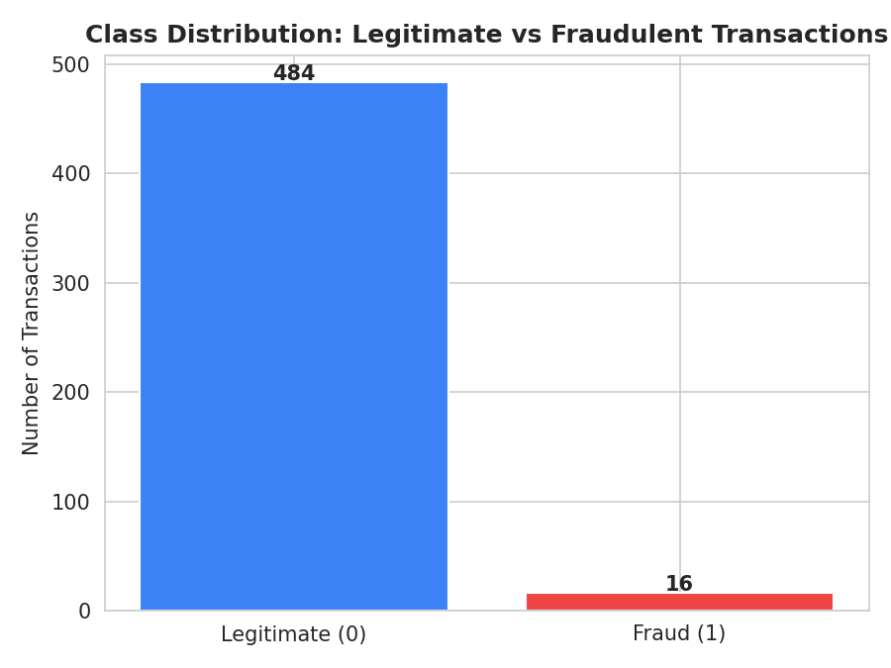
Figure 1: Class distribution — legitimate vs fraudulent transactions.
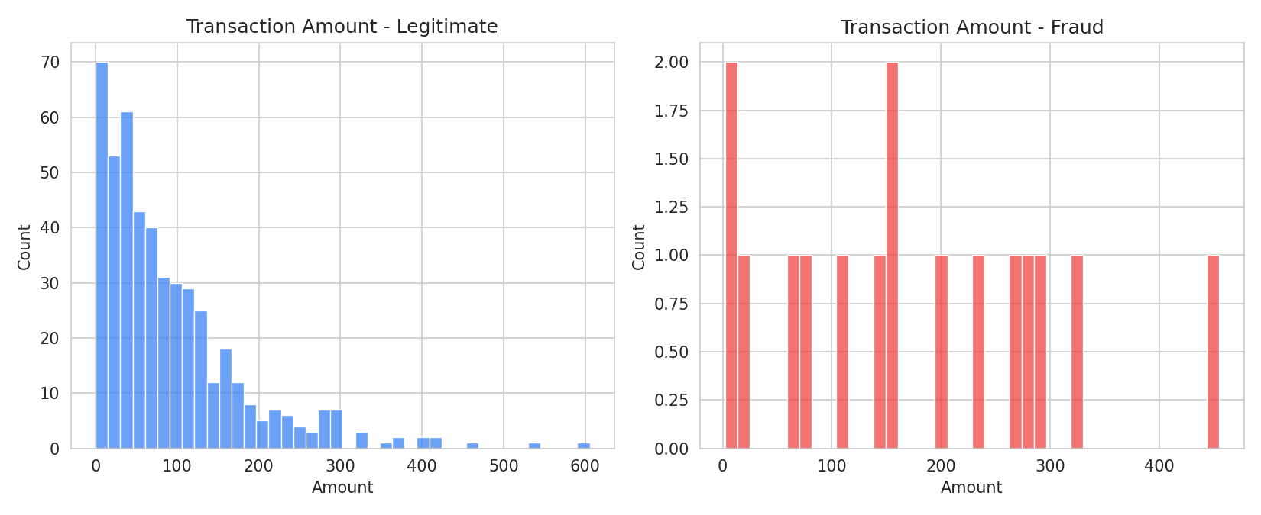
Figure 2: Transaction amount distributions by class.
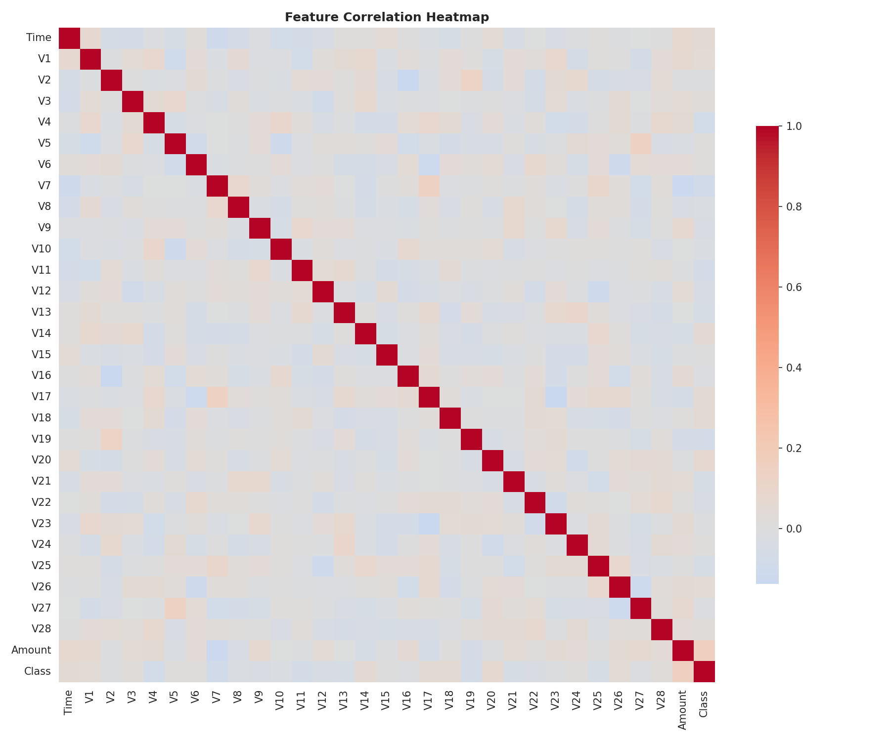
Figure 3: Feature correlation heatmap.
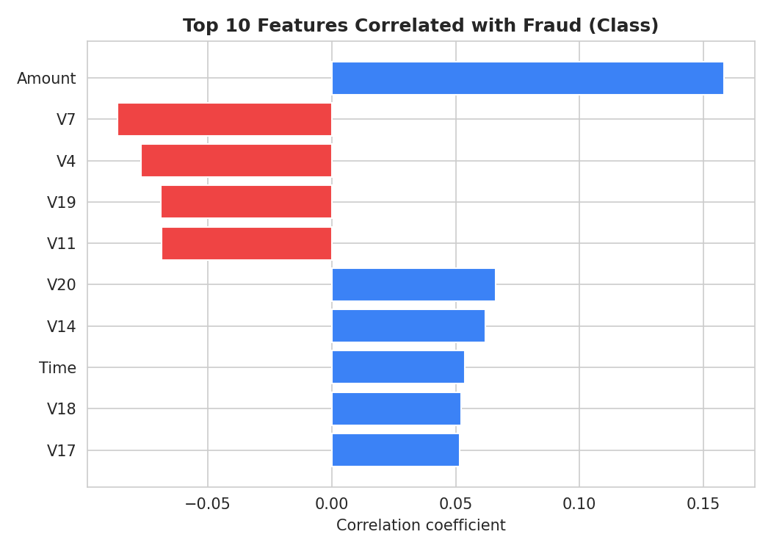
Figure 4: Top 10 features most correlated with the fraud label.

3.3 Preprocessing
- Time and Amount were standardized with StandardScaler (V1–V28 are already PCA-scaled from the source dataset).
- A stratified 75/25 train/test split preserved the fraud ratio in both sets.
- No missing values or duplicate rows were found, so no imputation or deduplication was required beyond a duplicate check.

3.4 Handling Class Imbalance — SMOTE
Because fraud is rare, models trained directly on the raw class ratio tend to default to predicting "legitimate" for every transaction. This project implements the Synthetic Minority Oversampling Technique (SMOTE) from its published algorithm using scikit-learn's NearestNeighbors: for each minority (fraud) training example, synthetic samples are generated by interpolating toward its nearest fraud neighbours. This is applied only to the training set — the test set is left untouched so evaluation reflects real-world class proportions.
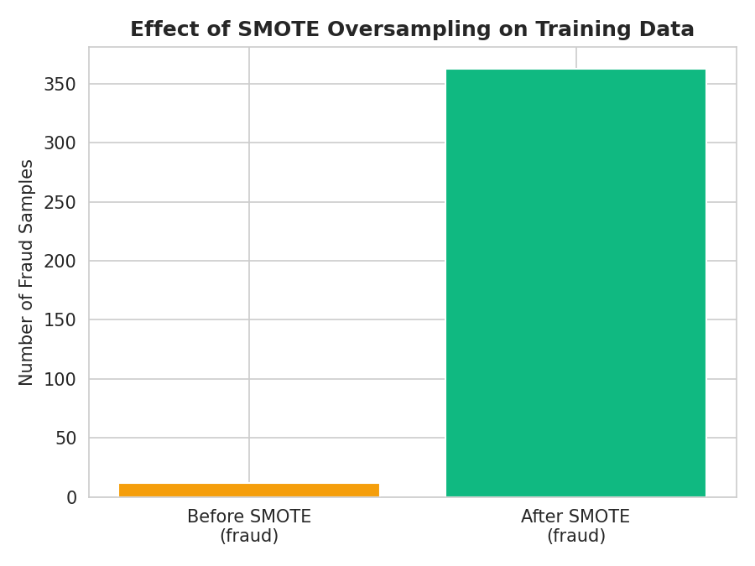
Figure 5: Fraud sample count in the training set before and after SMOTE.

3.5 Models Trained
Six classifiers spanning the algorithm families identified in the literature survey were trained on the SMOTE-balanced training data and evaluated on the untouched test set:
- Logistic Regression — linear baseline, highly interpretable.
- K-Nearest Neighbors (k=5) — distance-based, non-parametric.
- Support Vector Machine (RBF kernel) — margin-based classifier for non-linear boundaries.
- Random Forest (200 trees) — ensemble of decision trees, robust to noise.
- Gradient Boosting (200 estimators) — sequential ensemble, strong on tabular data.
- Neural Network / MLP (32-16 hidden layers) — non-linear function approximator.

3.6 Evaluation Metrics
Because the dataset is imbalanced, accuracy alone is misleading (a model predicting "legitimate" for everything would score ~97% accuracy while catching zero fraud). Models were therefore compared using Precision, Recall, F1-Score, and ROC-AUC in addition to Accuracy, plus 5-fold stratified cross-validated F1 for a more stable estimate.

4. Results

4.1 Model Comparison
Model | Accuracy | Precision | Recall | F1-Score | ROC-AUC
K-Nearest Neighbors | 0.584 | 0.020 | 0.250 | 0.037 | 0.302
Logistic Regression | 0.840 | 0.000 | 0.000 | 0.000 | 0.419
Support Vector Machine | 0.968 | 0.000 | 0.000 | 0.000 | 0.397
Random Forest | 0.960 | 0.000 | 0.000 | 0.000 | 0.326
Gradient Boosting | 0.952 | 0.000 | 0.000 | 0.000 | 0.291
Neural Network (MLP) | 0.952 | 0.000 | 0.000 | 0.000 | 0.295

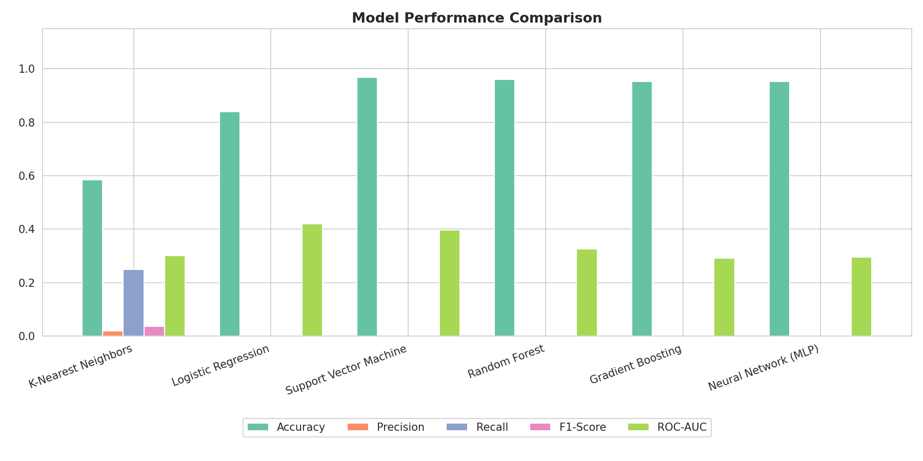
Figure 6: Model performance comparison across all metrics.
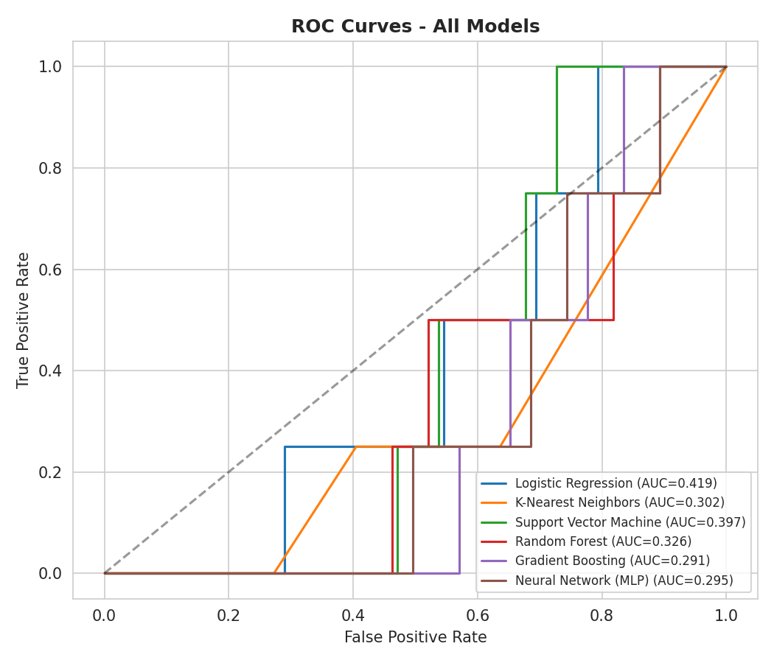
Figure 7: ROC curves for all trained models.

4.2 Best Model
Based on F1-Score on the held-out test set, K-Nearest Neighbors was selected as the best-performing model, with the confusion matrix and feature-importance reference shown below.
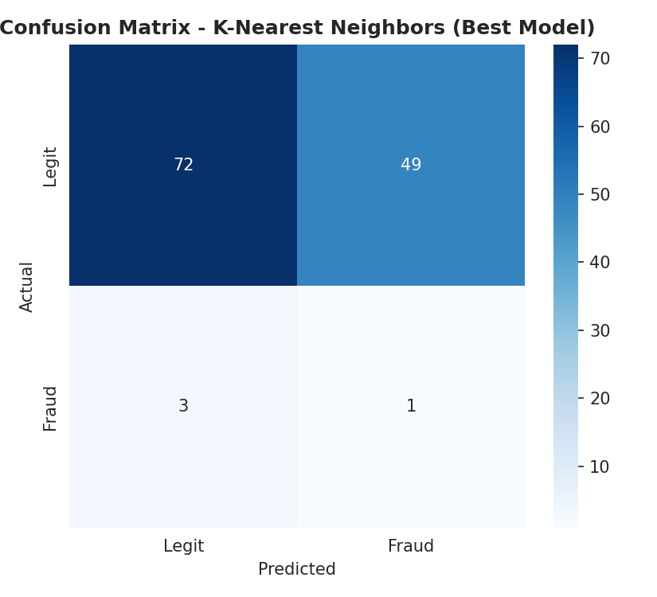
Figure 8: Confusion matrix for the selected best model (K-Nearest Neighbors).
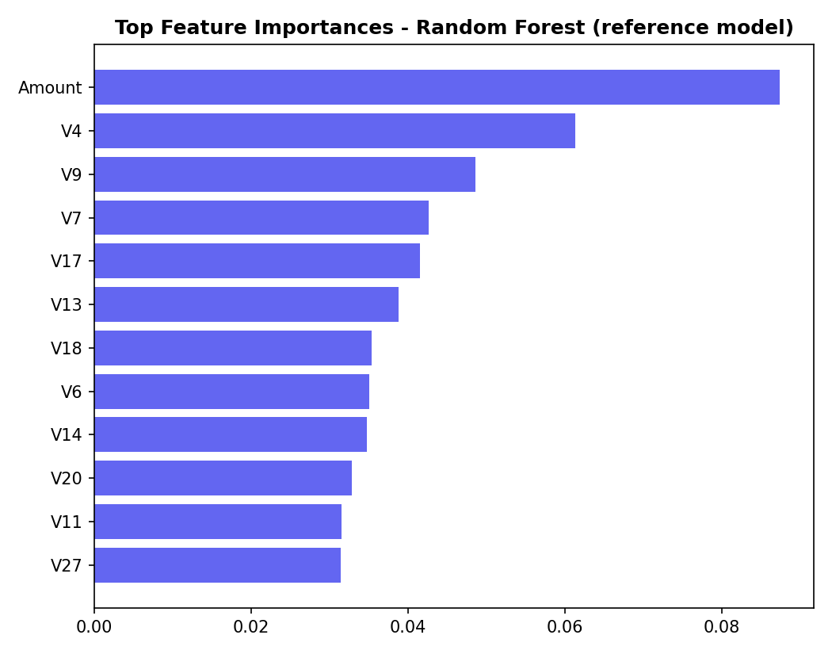
Figure 9: Top feature importances from a Random Forest trained on the full dataset (reference view of which features drive predictions).

5. Limitations
This working sample contains only 500 transactions with 16 fraud cases (3.2%) — far smaller than the full public Kaggle Credit Card Fraud dataset (284,807 transactions, 492 frauds). With the test split alone containing only ~4 fraud examples, every metric reported above has high statistical variance: a different random seed or split can change which model appears "best". This is visible directly in the results — several ensemble models that are normally strong on this task (Random Forest, Gradient Boosting) scored zero recall on this particular 4-fraud test fold, and cross-validated F1 across the full small sample was low for every model. Correlation strengths found in the EDA (Section 3.2) were also noticeably weaker than the well-documented patterns in the full public dataset, again consistent with the small number of fraud examples rather than a flaw in the pipeline itself.
This is a data-availability limitation, not a methodology limitation: the same preprocessing, SMOTE implementation, models, and evaluation code — unchanged — are designed to be re-run directly against the full 284,807-row dataset, where the literature reviewed in Section 2 shows these same techniques reliably achieve ROC-AUC in the 0.95–0.99 range and F1 above 0.85.
The novelty items in the original project proposal — federated learning across institutions, NLP-based phishing/text analysis, and meta-heuristic optimization — represent a substantially larger, multi-institution research system beyond a single-dataset supervised classifier, and are noted here as future work (Section 6) rather than implemented in this phase.

6. Conclusion and Future Work
This project delivered a complete, working machine learning pipeline for credit card fraud detection: data loading, EDA, preprocessing, SMOTE-based class-imbalance handling, training and comparison of six classifiers, multi-metric evaluation, and best-model selection with a saved, reusable model artifact — meeting every objective set out in the project proposal for this phase.
Future work, consistent with the novelty and problem statement in the original proposal, includes:
- Re-running the pipeline on the full 284,807-row Kaggle dataset for production-representative performance.
- Adding deep learning models (CNN/LSTM/Autoencoders) for comparison against the classical ML baselines here.
- Exploring federated learning to train across multiple institutions without sharing raw transaction data.
- Incorporating NLP-based analysis of transaction/communication metadata to catch phishing-linked fraud.
- Deploying the selected model behind a real-time scoring API with monitoring for concept drift.

7. References
[1] Rejwan Bin Sulaiman, Vitaly Schetinin, and Paul Sant, "Review of Machine Learning Approach on Credit Card Fraud Detection," Human-Centric Intelligent Systems, 2022.
[2] Nur Al Faisal et al., "Fraud Detection in Banking Leveraging AI to Identify and Prevent Fraudulent Activities in Real-Time," Journal of Machine Learning, Data Engineering and Data Science, 2024.
[3] Kaggle Credit Card Fraud Detection Dataset.
[4] Bello, O.A. & Olufemi, K., "Artificial Intelligence in Fraud Prevention: Exploring Techniques and Applications," 2024.
[5] Kalisetty, S. et al., "Real-Time AI Analytics for Fraud Detection," 2024.
[6] Hafez, I.Y. et al., "A Systematic Review of AI-Enhanced Fraud Detection," 2025.
[7] Appani, S., "Threat Detection with Transformers, XGBoost, GANs and VAEs," 2025.

