NAME: SAHANA V

USN; 1NT19IS135

C1 BATCH

Queries:

1. Insert 5 records using Insert command in HiveQL

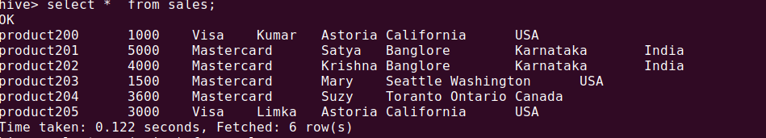

hive> select max(price) from sales;

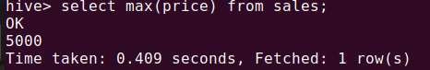

2. Import the dataset from the sales.csv

3. Count the number of sales done by each country

hive> select count(*) as count,country from sales group by country;

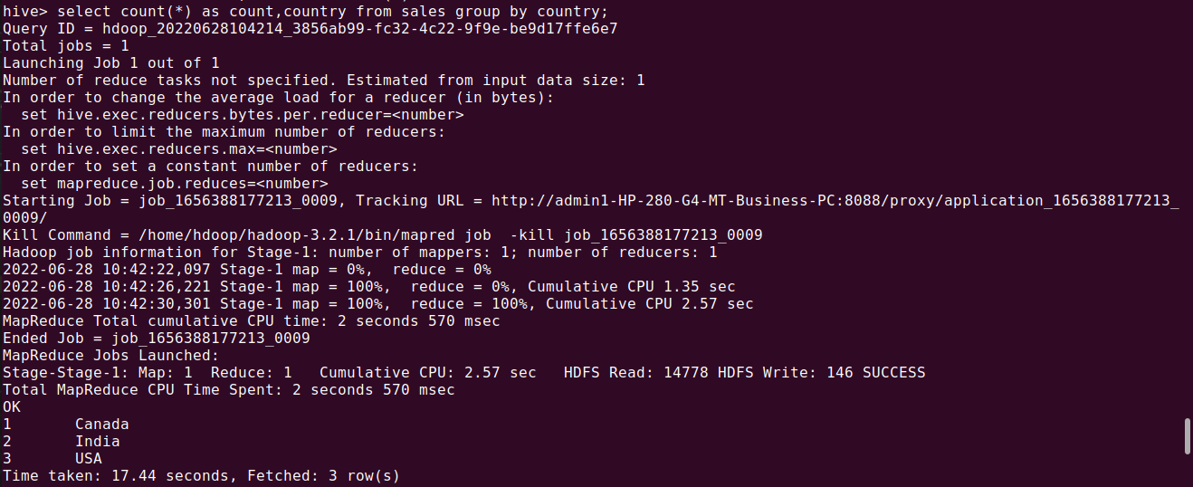

4. Count the number of sales done by each state

hive> select count(*) as count,state from sales group by state;

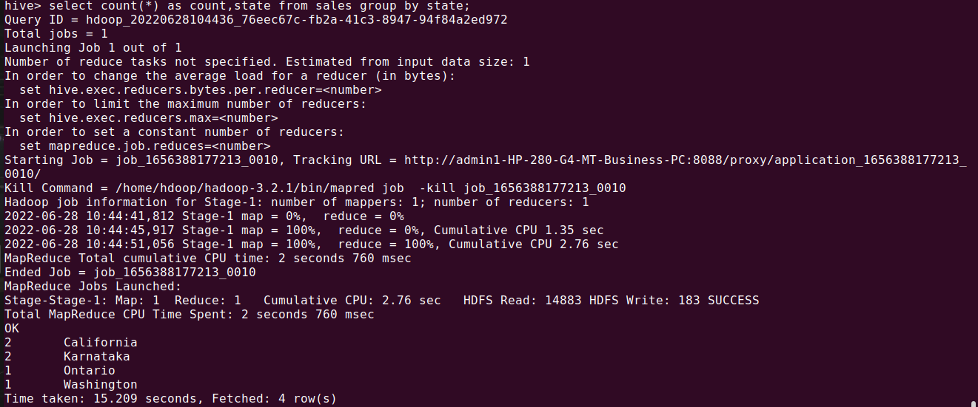

5. Display (Product, name) grouped by product

hive> select count(*) as count,state from sales group by state;

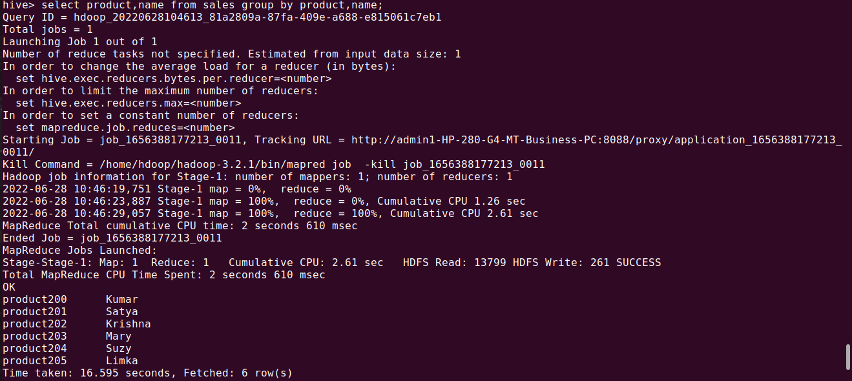

6. Create separate views for VISA and Mastercard

hive> create view visa as select *from sales where payment_type='Visa';



hive> select *from visa;

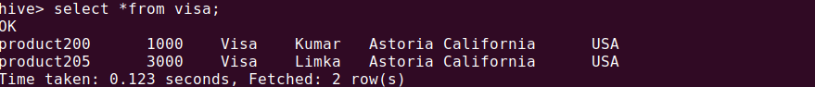

hive> create view master as select * from sales where payment_type='Mastercard';

hive> select *from master;

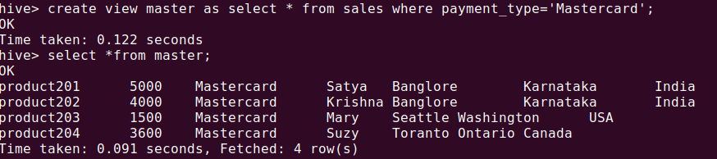

7. Show all the transactions done in Seattle

hive> select price from sales where city='Seattle';

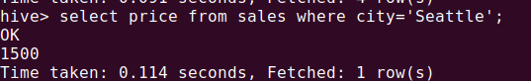

8. Find the max number of transactions done within the state of Ontario

hive> select max(price) from sales where state='Ontario' group by city;

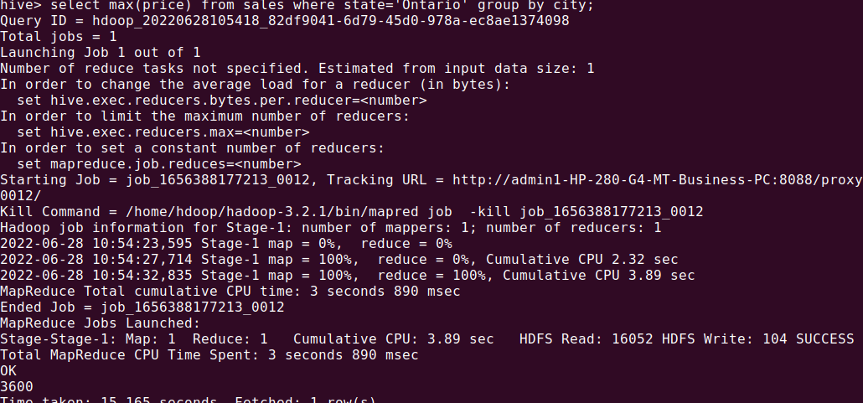

9. Find the number of transactions whose price is in between 1500-3600

hive> select count(*) from sales where price between 1500 and 3600;

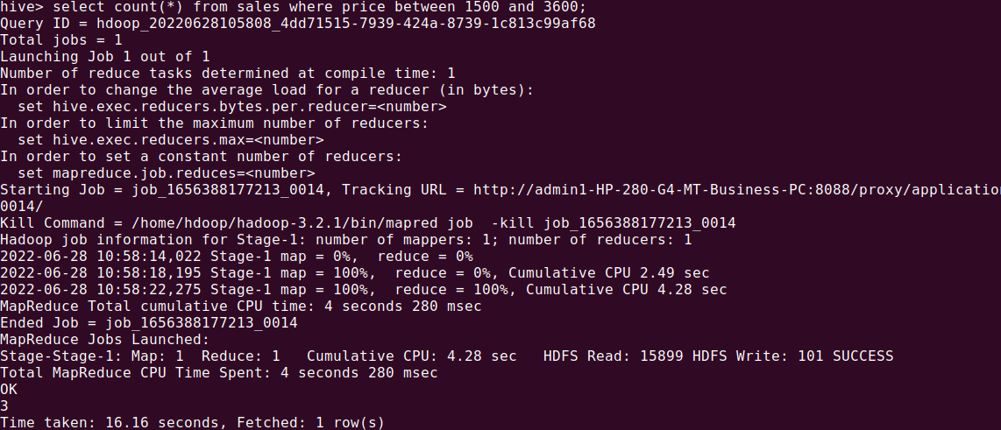

10. List all the transactions done in the United States using Mastercard

hive> select *from sales;

hive> select *from sales where country='USA' and payment_type='Mastercard';

