PART–A: GENERAL INFORMATION
(Please fill in all details in UPPERCASE LETTERS, except for the Email ID.)
 | Project Title: DIVYADRISHTI: AI-POWERED SMART HELMET FOR RIDER SAFETY, REAL-TIME HAZARD DETECTION, AND INTELLIGENT EMERGENCY RESPONSE
 | Keywords (5–8): ARTIFICIAL INTELLIGENCE, INTERNET OF THINGS (IOT), SMART HELMET, COMPUTER VISION, DRIVER DROWSINESS DETECTION, LANE DEPARTURE DETECTION, SENSOR FUSION, EMERGENCY RESPONSE
Broad Theme:
Select one of the 19 broad themes for Student Projects (SPP 50th Series).
Please select the one broad theme that most closely matches your proposed project. The 19 broad themes represent high-priority focus areas for Karnataka and are intended to encourage innovative, practical, and impactful student projects.
For detailed information about the 19 broad themes and their respective sub-themes, please visit the link provided below:
https://drive.google.com/drive/folders/1BmZ3ksrRA0GZ0SsBAnMR83tQL3VsMkkG?usp=drive_link
or www.kscst.org.in/spp.html
Note: Please select only one broad theme that is most relevant to your proposed project.
- Theme No.: 8
- Theme Name: SUSTAINABLE INFRASTRUCTURE, SMART CITIES AND SMART MOBILITY
- Sub-theme / Focus Area: SMART MOBILITY, INTELLIGENT TRANSPORT SYSTEMS (ITS) AND CONNECTED MOBILITY

Institution Details:
- Name of Institution:SMT. KAMALA AND SRI VENKAPPA M. AGADI COLLEGE OF ENGINEERING AND TECHNOLOGY, LAKSHMESHWAR - 582116.
- Course Name:BACHELOR OF ENGINEERING (B.E.)
- Department Name:COMPUTER SCIENCE AND ENGINEERING
- Affiliated University:VISVESVARAYA TECHNOLOGICAL UNIVERSITY (VTU), BELAGAVI
- District of Your Institution:GADAG
- Complete Postal Address of the Institution with Pin code: SMT. KAMALA AND SRI VENKAPPA M. AGADI COLLEGE OF ENGINEERING AND TECHNOLOGY, S. H. 6, SAVANUR ROAD, LAKSHMESHWAR, GADAG DISTRICT, KARNATAKA – 582116, INDIA.

5. | Project Guide Details:  - Project Guide Name: MR. NAGARAJ BARADELI  - Project Guide Designation: ASSISTANT PROFESSOR  - Project Guide Department:COMPUTER SCIENCE AND ENGINEERING  - Project Guide Email id:nagaraj.cse@agadiengcollege.com  - Project Guide Mobile Number:+91 7996972715
 | Student Team Details:

Sl. No. | Insert Passport-size Photograph | Name of the Student  (BLOCK LETTERS) | USN / Registration No. | Degree & Branch & Semester | Category as per College Records (SC/ST/  OBC/  General) | Mobile No. | Email Id
1. |  | Ms. SAHANA BASAVARAJ ULLAGADDI | 2KA23CS047 | Degree: B.E  Branch: CSE  Semester: VII | GENERAL | 8431712890 | Sahanabullagaddi6@gmail.com
2. |  | Ms. RAKSHITA PATIL | 2KA23CS040 | Degree: B.E  Branch: CSE  Semester: VII | GENERAL
3. |  | Ms. SNEHA DAVAGI | 2KA23CS050 | Degree: B.E  Branch: CSE  Semester: VII | GENERAL
4. |  | Mr. RAGHAVENDRASING BALAJISING HAJERI | 2KA23CS037 | Degree: B.E  Branch: CSE  Semester: VII | GENERAL | 9482672566 | raghavendrasingbhajeri@gmail.com

SPP Coordinator Details:

SPP Coordinator Name: Dr. SANTOSH S. BUJARI
- SPP Coordinator Designation: HOD, ECE DEPARTMENT
- SPP Coordinator Email:hod.ece@agadiengcollege.com
- SPP Coordinator Mobile Number:9449375371

PART - B: PROJECT DESCRIPTION
Background and Need of the Project:
1. Background: Motorized two-wheelers represent the primary mode of personal transport in India, accounting for over 70% of total vehicular volume. According to the official Ministry of Road Transport and Highways (MoRTH) report Road Accidents in India 2022 (published October 2023), motorized two-wheelers accounted for the highest share of road accident fatalities nationwide, representing 44.5% of all deaths (74,897 lives lost out of 168,491 total fatalities) [1]. The World Health Organization (WHO) identifies operator fatigue, delayed hazard response, alcohol impairment, and delayed medical assistance during the "Golden Hour" as primary factors exacerbating two-wheeler fatalities [2].
2. Existing Scenario: Conventional motorcycle helmets primarily provide passive mechanical protection against cranial impacts, but generally lack active sensing, driver alertness monitoring, and automated emergency notification capabilities. Commercial solutions incorporating smart features typically isolate single functions—such as basic cellular hands-free audio or standalone impact-activated beacons—without analyzing the rider's physiological alertness or the surrounding road scene. Furthermore, when accidents occur in isolated corridors, emergency medical services and family members often experience prolonged response delays.
3. Problem Statement: Motorcycle riders face heightened vulnerability to road accidents caused by driver fatigue, delayed reactions, unintended lane departure, alcohol presence, and high-energy collisions. The absence of an integrated, real-time safety system delays accident identification, precise location sharing, and emergency awareness.
4. Need for the Project: DivyaDrishti addresses this critical safety challenge by developing an integrated IoT and edge-computing safety architecture. By combining on-helmet embedded sensing (ESP32) with computer vision on an edge computing node, the system continuously monitors rider alertness and movement telemetry, issuing local warnings and dispatching automated notifications with GPS coordinates and short incident video footage to designated family contacts during potential emergencies.
5. Beneficiaries: The primary beneficiaries are motorcycle and scooter riders, daily commuters, student riders, delivery personnel, and long-distance travelers. Designated family contacts benefit from timely location-linked emergency notifications, while emergency responders and bystanders on-scene benefit from instantaneous access to the rider's medical profile and emergency contacts via the helmet-mounted QR code.
Review of Existing Work:
1. EXISTING TECHNOLOGIES
Research in intelligent motorcycle safety centers on embedded telematics and computer vision. Embedded systems incorporating accelerometers, gyroscopes, GPS, and communication modules have demonstrated threshold-based accident detection and location reporting [3]. Concurrently, computer vision systems utilizing facial landmark tracking (Eye Aspect Ratio—EAR) enable non-intrusive fatigue monitoring [5]. However, existing academic literature highlights significant challenges in power consumption, false alarms, and the lack of unified multi-sensor fusion combining physiological states with vehicle dynamics [3], [4].
2. COMMERCIAL PRODUCTS
Commercial products such as the Forcite smart helmet platform and Livall connected helmets demonstrate the feasibility of integrating electronics into protective headgear for communication and navigation. However, these proprietary systems remain cost-prohibitive for mass adoption in developing regions, rarely integrate front-facing road obstacle detection with driver eye monitoring, and lack open incident-video context for emergency contacts.
3. RESEARCH PAPERS
The following research works form the academic foundation for this project:
• Applications of Smart Helmet in Applied Sciences: A Systematic Review (2021) by Y. Choi and Y. Kim systematically reviewed smart helmet applications (2009–2020), showing that modular single-board microcontrollers dominate research prototypes, but real-world reliability is hindered by power constraints and false impact alerts [3].
• Trends in Smart Helmets With Multimodal Sensing for Health and Safety: Scoping Review (2022) by P. Lee et al. examined wearable helmet sensors, finding that isolated accelerometer thresholds produce significant false alarms during routine helmet handling unless validated against secondary motion or physiological indicators [4].
• Technologies for Detecting and Monitoring Drivers' States: A Systematic Review (2024) by M. S. Al-Quraishi et al. evaluated sensor- and vision-based approaches, identifying camera-based facial landmark tracking as a reliable non-intrusive method for detecting fatigue through eye-closure duration [5].
• Real-Time Eye Blink Detection using Facial Landmarks (2016) by T. Soukupová and J. Čech established real-time facial landmark geometry for calculating Eye Aspect Ratio (EAR) and detecting blink frequency [6].
• Random Forests (2001) by L. Breiman established the mathematical foundation for Random Forest ensemble classification, demonstrating high resilience to noisy multi-sensor telemetry [7].
4. PATENTS
The international patent Integrated Smart Helmet and Methods and Systems of Controlling Smart Helmet (WO2020217089A1, inventor: Anirudha Surabhi Venkata Jagannadha Rao) discloses crash detection using IMU sensors, location-based emergency notifications, and blind-spot indication [10]. Existing patents focus heavily on specific hardware packaging, leaving open opportunities for distributed architectures that fuse embedded sensor telemetry with edge computer vision.
5. EXISTING SOLUTIONS, SHORTCOMINGS AND RESEARCH GAPS
Existing solutions generally focus on individual functions, such as crash detection, GPS tracking, alcohol sensing, or emergency messaging. Important challenges include false crash alerts, high hardware costs, power constraints, and lack of visual contextual evidence.
Research gap: Existing prototypes present three main gaps: (a) absence of coordinated fusion between rider alertness (EAR) and vehicle motion dynamics (acceleration, pitch, roll); (b) high rates of unverified false-positive emergency alerts; and (c) absence of visual incident context and rapid medical profile access for first responders. DivyaDrishti addresses these challenges through a modular ESP32-to-laptop edge pipeline, an interactive 10-second cancelable SOS countdown, automated video black-box clip generation, and a power-independent printed QR emergency medical profile.
Problem Statement:
Motorcycle riders face severe risks from operator fatigue, lane deviation, alcohol presence, and high-energy collisions. Existing protective equipment remains purely passive, while available research prototypes address isolated sensing functions that suffer from frequent false alarms, high fabrication costs, and an inability to deliver immediate visual or medical context to family contacts and first responders.
DivyaDrishti addresses this problem by implementing a distributed AIoT safety architecture that integrates: (1) low-latency ESP32 embedded telemetry, (2) computer-vision-based drowsiness and lane monitoring, (3) Random Forest multi-sensor classification, and (4) an emergency notification mechanism featuring a 10-second cancelable window, automated incident-video clip generation, and a power-independent printed QR code that links to an online emergency information portal (access to the portal requires network connectivity and continued hosting).
The primary engineering challenge is to achieve reliable detection, low response latency, and false-positive alert mitigation under practical operating constraints.
Objectives:
● To maintain and refine the distributed AIoT prototype architecture, interfacing an ESP32 helmet unit (MPU6050 IMU, Quectel L86-M33 GPS, MQ-3 gas sensor, MFRC522 RFID, SH1106 OLED, buzzer) with a companion edge computing node running YOLOv8n object detection, polynomial lane tracking, and MediaPipe facial landmark analysis.
● To collect and label data from controlled sensor tests, stationary rider-facing video sessions, and prerecorded road-scene footage. The existing models will be evaluated on appropriate independent test sets, and retraining will be undertaken if sufficient labelled data is available.
● To implement and benchmark real-time road-object detection using YOLOv8n to identify relevant road users (cars, pedestrians, motorcycles, buses, trucks) and evaluate detection performance using precision, recall, and inference latency.
● To characterize false-alert rates and calibrate active thresholds, evaluating the firmware impact threshold (25.0 m/s² ≈ 2.55 g), the edge AI impact baseline (4.8 g), the raw MQ-3 baseline, and eye-closure duration thresholds (2.0 s for drowsiness, 10.0 s for unresponsiveness) under controlled non-hazardous disturbances.
● To validate the automated emergency notification workflow, evaluating the end-to-end reliability of the 10-second cancelable SOS interface, Twilio SMS delivery, NTFY.SH push notifications, 10-second H.264 video black-box export, and QR-based emergency portal access.
● To evaluate system performance across end-to-end response latency, notification delivery success, video encoding delay, power consumption, and overall implementation cost under controlled, non-hazardous test conditions.
Innovation / Novelty:
1. WHAT IS NEW?
DivyaDrishti implements an edge-to-cloud framework that pairs localized microcontroller sensing on the helmet with computer vision on an edge node to support proactive hazard warnings and post-incident response. Specific features include a rolling 250-frame circular video buffer that automatically exports a 10-second H.264 incident clip upon emergency detection, and a power-independent printed QR code attached to the helmet that links to an online emergency information portal. The printed decal requires no helmet battery power, though accessing the portal requires cellular connectivity and active hosting.
2. HOW IS IT DIFFERENT FROM EXISTING WORK?
While typical research prototypes isolate sensing to a single microcontroller or an in-cabin dashcam, DivyaDrishti synchronizes vehicle motion dynamics (MPU6050 acceleration, pitch, roll, gyro rates) with vision-derived metrics (bi-ocular EAR, blink rate, lateral lane deviation, obstacle distance proxies) into a 12-dimensional feature vector. To mitigate false dispatches caused by minor drops or rough handling, the system allows the rider to cancel suspected false alarms during a 10-second countdown on the dashboard accompanied by acoustic alerts, providing an opportunity to dismiss non-injury events before messages are dispatched.
3. WHY IS IT INNOVATIVE?
The approach emphasizes practical, cost-conscious engineering. Rather than placing heavy, power-intensive single-board computers inside the helmet shell, the system utilizes a lightweight, low-power ESP32 on the helmet tethered over local Wi-Fi to an edge device (laptop/PC). Offloading heavy vision computing to an external laptop reduces onboard hardware bulk and payload, though physical testing is required to assess the structural impact of external sensor enclosures.
Proposed Methodology:

1. OVERALL METHODOLOGY

The proposed DivyaDrishti system follows a modular, four-layer architecture integrating embedded hardware, artificial intelligence, backend services, and a real-time monitoring dashboard.

Initially, an ESP32 microcontroller collects sensor data from the MPU6050 inertial measurement unit (IMU), Quectel L86-M33 GPS module, MQ-3 gas sensor, and MFRC522 RFID reader. Rider authentication and safety status are displayed locally on an SH1106 OLED, with a buzzer generating acoustic warnings. The ESP32 transmits sensor telemetry to the backend through Wi-Fi.

Simultaneously, a camera connected to an edge node (laptop) supplies video frames to a Python-based AI pipeline. In the current physical prototype, the software pipeline (ai/main.py) captures a single video stream via cv2.VideoCapture (evaluated individually with a webcam facing the rider for EAR analysis or facing pre-recorded road footage for lane/object analysis; simultaneous dual-view was evaluated via the synthetic driving simulator harness). Ultralytics YOLOv8n detects road obstacles, polynomial lane detection analyses lane boundaries, and MediaPipe facial landmarking computes Eye Aspect Ratio (EAR) for drowsiness monitoring.

The extracted visual features are combined with hardware telemetry to form a 12-dimensional feature vector classified by Scikit-Learn Random Forest models for driving-event identification and risk estimation. The Node.js backend persists records in MongoDB Atlas and streams live updates to the React dashboard over Socket.IO. When an emergency condition confirms, the system executes a 10-second cancelable SOS countdown and dispatches GPS-linked SMS and push notifications to emergency contacts.

2. BLOCK DIAGRAM / FLOW CHART
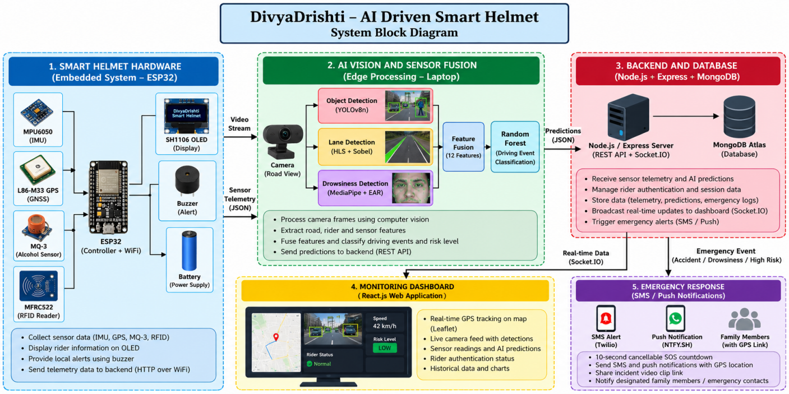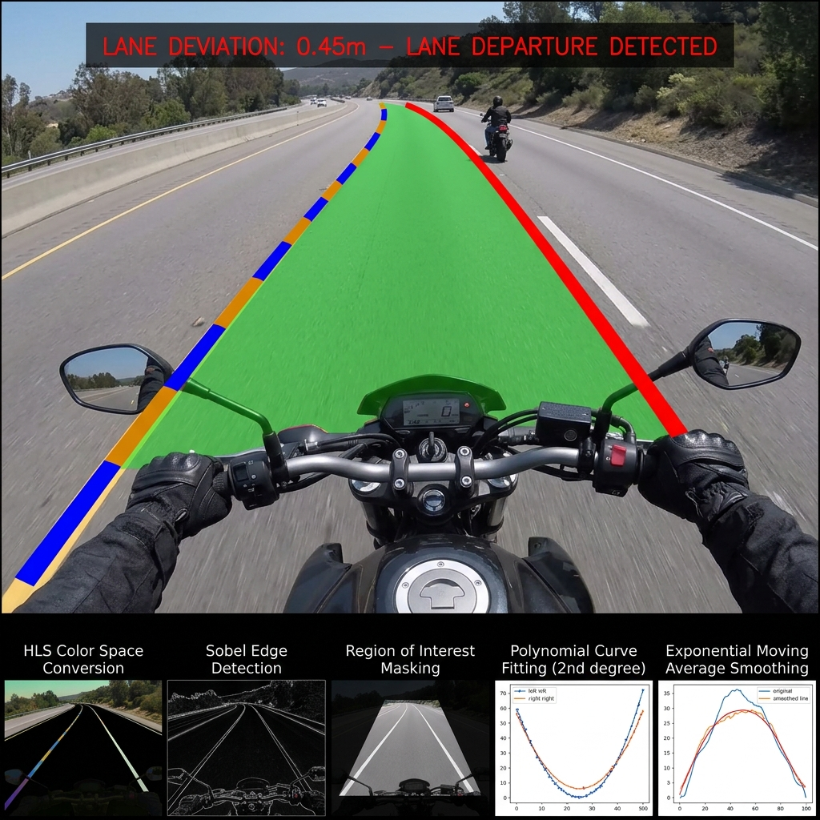

3. SYSTEM ARCHITECTURE
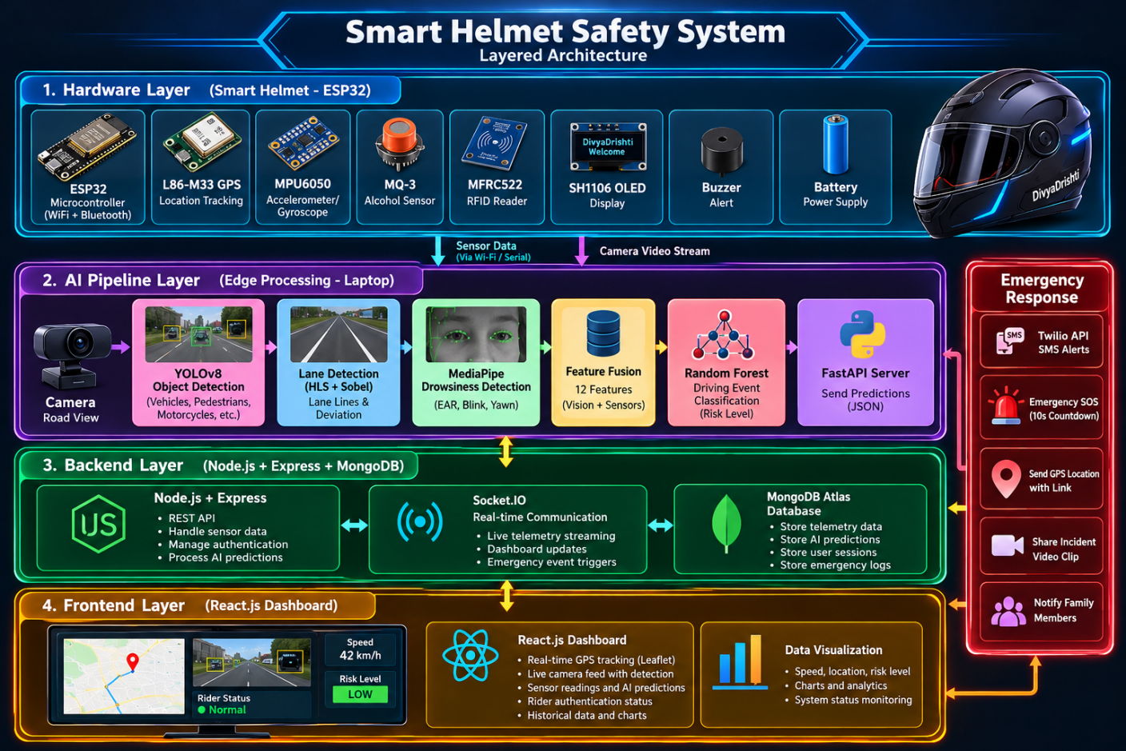
The system consists of four layers:
Layer 1 – Hardware and Embedded System: An ESP32-based helmet unit interfaces with the MPU6050, Quectel L86-M33 GPS, MQ-3 alcohol sensor, MFRC522 RFID reader, SH1106 OLED, and piezoelectric buzzer. Arduino C++ firmware executes non-blocking sensor sampling, evaluates the 25.0 m/s² (≈ 2.55 g) impact threshold, manages rider authentication sessions, renders local status screens, and transmits JSON telemetry via HTTP POST over Wi-Fi.
Layer 2 – AI and Computer Vision: A Python-based edge-computing pipeline runs on a laptop and processes video frames. YOLOv8n identifies safety-relevant road objects, HLS and Sobel-based polynomial lane detection analyses lateral deviation, and MediaPipe calculates eye-related features for drowsiness monitoring. Sensor and vision features are combined into a 12-dimensional vector and classified by Random Forest models. FastAPI provides the video-streaming and incident-clip export interfaces.
Layer 3 – Backend and Database: Node.js and Express manage incoming sensor telemetry, AI predictions, authentication sessions, and emergency events. Socket.IO broadcasts real-time updates, while MongoDB Atlas stores telemetry readings, predictions, session information, and emergency logs. A connection watchdog monitors helmet connectivity heartbeats.
Layer 4 – Dashboard and Emergency Response: A React-based dashboard displays GPS location using Leaflet, historical telemetry using Recharts, live camera footage, rider status, and AI predictions. The emergency module provides an acoustic 10-second cancelable SOS countdown and integrates Twilio SMS and NTFY.SH push notifications with GPS coordinates and incident-video links. A power-independent printed QR code on the helmet links to an online emergency portal (emergency-portal/index.html); accessing this profile requires cellular network access and active server hosting.
4. DESIGN APPROACH
The design follows a modular, incremental engineering approach:
Hardware development: Interface sensors with the ESP32, implement non-blocking firmware tasks, verify MPU6050 motion readings, GPS coordinate acquisition, RFID authentication, OLED rendering, and buzzer alarms.
AI module development: Benchmark YOLOv8n object detection, polynomial lane tracking under HLS/Sobel gradient filtering, and MediaPipe-based drowsiness tracking via bi-ocular EAR.
Machine-learning integration: Combine visual and telematic features into a 12-dimensional vector. Benchmark Random Forest models using the synthetic driving dataset described in the report, and prepare data pipelines for empirical retraining.
Backend and dashboard development: Integrate telemetry ingestion and AI prediction logging via REST APIs, persist data in MongoDB Atlas, and stream live telematic metrics to the React dashboard over Socket.IO.
Emergency-response integration: Configure crash and prolonged eye-closure triggers, the 10-second cancelable SOS countdown, incident-video clip export, and Twilio SMS / NTFY.SH notifications containing GPS location links.
System integration: Validate end-to-end communication across hardware, edge AI, backend, and dashboard before conducting safe, controlled experimental evaluations.
5. EXPERIMENTAL PLAN
The prototype will be evaluated through safe, controlled, consent-based testing protocols:
Safety & Ethics Protocol: Testing will strictly avoid hazardous public-road driving. Drowsiness detection will be evaluated on stationary seated volunteers. Road-scene analysis will use recorded dashcam video or low-speed closed tracks. Impact detection testing will be conducted on isolated sensor enclosures or test fixtures; no certified road helmets will have their protective EPS liners modified, drilled, or damaged.
Data Privacy Protocol: During testing and demonstrations, only synthetic dummy medical profiles, simulated phone numbers, and non-sensitive video clips will be used. Public temporary file hosts will not be used for real identifiable rider data.
Hardware testing: Verify MPU6050 communication, Quectel L86 GPS fix time under open-sky conditions, raw MQ-3 baseline voltage, RFID card verification, OLED display cycling, and buzzer operation.
Object-detection testing: Evaluate YOLOv8n using labelled images and video clips containing vehicles, motorcycles, and pedestrians. Measure precision, recall, and inference frame rate.
Lane-detection testing: Use recorded road videos under varied lighting (day, dusk, artificial streetlights) to evaluate lane identification, deviation tracking, and warning reliability.
Drowsiness testing: Test the MediaPipe-based module using voluntary blinking and eye-closure scenarios on seated participants. Measure EAR threshold response and classification accuracy.
Machine-learning evaluation: The current models were trained and benchmarked on a 10,000-sample synthetic dataset. Independent test evaluations and retraining will be conducted as empirical sensor and video data are collected.
Integration testing: Verify communication latency between the ESP32, AI edge node, Node.js backend, MongoDB Atlas, and React dashboard.
Emergency-response testing: Simulate crash events (accel > 25.0 m/s²) and prolonged eye closure (duration > 10 s) under controlled conditions. Measure cancelation response times, SMS delivery success, and video export delays.
Performance assessment: Measure video processing frame rate, end-to-end notification latency, power consumption, and overall prototype bill-of-materials cost.
6. SOFTWARE AND HARDWARE TO BE USED
Hardware
ESP32 WROOM-32 development board – embedded processing and Wi-Fi communication.
MPU6050 six-axis IMU – acceleration, angular motion, and impact-related measurements.
Quectel L86-M33 GPS module – geographical location tracking.
MQ-3 gas sensor – analog alcohol-related sensor readings.
MFRC522 RFID reader and compatible cards – rider authentication.
SH1106 1.3-inch OLED display – rider and system-status information.
Piezoelectric buzzer – audible safety warnings.
USB webcam or compatible camera – real-time video acquisition.
Laptop with a suitable processor, memory, and camera interface – AI edge processing and application hosting.
Regulated power supply, connecting wires, non-destructive helmet mounting arrangements, and supporting electronic components.
Software, Frameworks, and Libraries
Embedded firmware: Arduino IDE, ESP32 Arduino Core, Arduino C++, ArduinoJson, TinyGPSPlus, MFRC522, and Adafruit SH110X.
Computer vision and AI: Python, OpenCV, Ultralytics YOLOv8n, MediaPipe, NumPy, and scikit-learn.
AI server: FastAPI and Uvicorn for API services and video streaming.
Backend: Node.js, Express.js, and Socket.IO.
Database: MongoDB Atlas for telemetry, predictions, session records, and emergency logs.
Frontend: React.js, Leaflet, React-Leaflet, Recharts, and Tailwind CSS.
Emergency communication: Twilio SMS, NTFY.SH push notifications, GPS-based map links, and incident-video export.
Communication protocols: I²C for compatible sensors, UART for GPS, SPI for RFID, HTTP/REST for telemetry and predictions, and Socket.IO for real-time dashboard updates.
The system will be evaluated using a combination of embedded hardware tests, AI performance measurements, integration tests, and controlled simulations to assess feasibility, reliability, and suitability for further improvement.
Expected Deliverables:
● Working Smart Helmet Hardware Prototype: An ESP32-based helmet unit integrating MPU6050 6-axis IMU, Quectel L86-M33 GPS, MQ-3 gas sensor, MFRC522 RFID reader, SH1106 OLED display, and piezoelectric buzzer for local status monitoring and audible warnings.
● Edge AI Computer Vision Suite: A Python software pipeline incorporating YOLOv8n road-object detection, polynomial lane departure tracking, MediaPipe facial landmark drowsiness detection, and Random Forest event/risk classification.
● Web-Based Monitoring Dashboard: A React.js dashboard displaying live GPS location tracking (Leaflet), sensor telemetry gauges, rider authentication status, AI predictions, and historical telemetry charts.
● Backend and Database System: A Node.js and Express backend integrated with MongoDB Atlas and Socket.IO for real-time telemetry streaming, session verification, and incident logging.
● Automated Emergency Alert System: An emergency response module featuring a 10-second cancelable SOS countdown and automated dispatch of SMS (Twilio) and push notifications (NTFY.SH) containing Google Maps GPS coordinates.
● Incident Video Black Box Module: A rolling 250-frame (~10 s) circular video buffer that automatically encodes an H.264 incident clip following emergency detection for cloud/local sharing via notification links.
● QR-Based Emergency Medical Portal: A power-independent printed helmet QR code linking to an online emergency portal (emergency-portal/index.html) displaying essential medical details and click-to-call emergency contacts.
Expected Outcomes and Impact:
TECHNICAL
Delivery of an open, reproducible multi-sensor fusion architecture demonstrating that lightweight microcontrollers (ESP32) and edge vision models can be synchronized to monitor rider alertness and vehicle motion dynamics.
SOCIAL
Proactive warnings for fatigue and lane departure, paired with automated location sharing and instant first-responder QR medical profile access, supporting faster emergency awareness during accidents.
ENVIRONMENTAL
Emphasizes component reuse and non-destructive helmet mounting. The design avoids modifying helmet EPS foam, preserves protective gear, and utilizes low-power embedded electronics.
ECONOMIC
Replaces expensive proprietary smart helmets with an accessible system built from off-the-shelf components (ESP32, standard IMU, open-source AI frameworks), establishing a baseline for affordable two-wheeler safety.
INDUSTRIAL
Provides experimental insights for intelligent transportation systems (ITS), two-wheeler telematics providers, and delivery fleet operators seeking modular rider safety solutions.
ACADEMIC
Provides final-year engineering students with hands-on experience in embedded C++ development, edge computer vision, ensemble machine learning, distributed web architectures, and telematic communication protocols.
POTENTIAL USERS
Two-wheeler commuters, student riders, delivery personnel, family members seeking location tracking, and first responders accessing emergency medical profiles on-scene.
Relevance:
Tick wherever applicable
☑ SDGs (Sustainable Development Goals)
☑ Karnataka Priority Sector
□ Rural Development
□ MSME
□ Agriculture
□ Healthcare
□ Water
□ Environment
□ Climate
□ Manufacturing
☑ Smart Cities
☑ Digital India
□ Startup
□ Women Empowerment

☑ Others (Please Specify): ROAD SAFETY, INTELLIGENT TRANSPORTATION SYSTEMS (ITS), ARTIFICIAL INTELLIGENCE (AI), INTERNET OF THINGS (IoT), AND EMERGENCY RESPONSE TECHNOLOGY.

Work Plan (Please specify the month and tick ✓)
Activity | Dec 2026 | Jan 2027 | Feb 2027 | Mar 2027 | Apr 2027
Baseline hardware testing & calibration (MPU6050, raw MQ-3, GPS) | ✔️
Safe empirical data collection (stationary seated & recorded road video) | ✔️ | ✔️
Model retraining, feature evaluation & Random Forest tuning |  | ✔️ | ✔️
False-alert characterization & threshold testing (bench vibration, head turns) |  |  | ✔️ | ✔️
Emergency notification pipeline & QR portal evaluation (SMS, video export) |  |  |  | ✔️ | ✔️
Documentation, final report, synopsis compilation & poster presentation |  |  |  |  | ✔️

Facilities Available:
Please mention the details of the available facilities under each category. If any facility is not available in your institution, please enter “NONE”.

1. Laboratory | Available (Department of CSE Computer Laboratory with desktop PCs and campus network)
2. Equipment | Standard desktop workstations available; specialized dedicated GPU systems: NONE (Subject to departmental confirmation)
3. Software | Available (Python 3.10+, Arduino IDE 2.x, VS Code, Git, Node.js, modern web browsers)
4. Instruments | Standard digital multimeters and USB serial cables available; calibrated test rigs or impact analyzers: NONE
5. Workshop | Basic mechanical mounting aids; institutional fabrication/workshop services: NONE (Subject to college confirmation)
6. Institutional facilities | Campus network and departmental seminar halls available; 24/7 power backup: Subject to college confirmation

Major Requirements for the Project:
1. HARDWARE
Microcontroller: Espressif ESP32 WROOM-32 development board.
Inertial Measurement Unit: InvenSense MPU6050 6-axis accelerometer and gyroscope.
GPS Module: Quectel L86-M33 GNSS receiver module with integrated patch antenna.
Alcohol Gas Sensor: MQ-3 analog gas sensor module.
Rider Authentication: MFRC522 13.56 MHz RFID reader with compatible Mifare Classic cards.
Display and Alerts: SH1106 1.3-inch 128×64 monochrome I²C OLED display; active 5V piezoelectric buzzer.
Edge Computing Host (Existing/Available): Laptop/PC with Intel Core i5/i7 or AMD Ryzen processor, 8GB/16GB RAM, and USB interface.
Camera Module: USB HD webcam (720p/1080p, 30 FPS).
Power Supply: 3.7V rechargeable Li-ion battery pack with 5V step-up booster/charging module.
Supporting Hardware: Breadboard/perfboard, jumper wires, terminal connectors, and non-destructive external helmet mounting fixtures.
2. SOFTWARE
Firmware: Arduino IDE 2.x, ESP32 Arduino Core, TinyGPSPlus, Adafruit_SH110X, MFRC522, ArduinoJson.
Computer Vision & AI: Python 3.10+, OpenCV, Ultralytics YOLOv8n, MediaPipe, scikit-learn, NumPy, pandas.
AI Server: FastAPI, Uvicorn, imageio-ffmpeg.
Backend: Node.js, Express.js, Socket.IO, cookie-parser, dotenv.
Database: MongoDB Atlas (cloud M0 cluster).
Frontend Dashboard: React.js (Vite), Tailwind CSS, Leaflet, react-leaflet, Recharts, Lucide React.
Emergency Communication: Twilio REST API (SMS gateway), NTFY.SH (push notifications).
3. CONSUMABLES
Electronic components and spare sensor modules.
Jumper wires, terminal headers, solder wire, and heat-shrink tubing.
Weatherproof vinyl adhesive decals for helmet QR codes.
Non-destructive external mounting clips, foam vibration dampeners, and cable ties.
4. FIELD STUDIES
Safe, consent-based stationary testing for drowsiness tracking.
Pre-recorded road video and low-speed closed-track testing for lane and object detection.
Controlled bench-drop and vibration testing on isolated sensor enclosures (preserving helmet shell integrity).
Budget Estimate (Remove whichever is not relevant for the project):
Item | Estimated Cost (₹)
Equipment / Components | 0
Consumables | 1200
Fabrication | 1000
Software / Cloud Services | 1500
Field Survey / Data Collection | 1500
Testing / Analysis | 1000
Miscellaneous | 800
Total | 7000
The budget specified in the Google Form must align with the amounts indicated in the project proposal. If no cost is associated with a subhead, indicate Rs. 0/-.

Important Note
KSCST provides only a modest financial grant for projects recommended by the Expert Committee. The sanctioned financial assistance shall be in the range and maximum up to ₹10,000 per project (or such amount as may be decided by KSCST from time to time). Students and institutions are encouraged to utilize available laboratory facilities and institutional resources. Any expenditure beyond the sanctioned assistance shall be borne by the institution and/or the project team.
References:
[1] Ministry of Road Transport and Highways, Government of India, "Road Accidents in India 2022," New Delhi, India: Transport Research Wing, Oct. 2023. [Online]. Available: https://morth.nic.in/sites/default/files/RA_2022_30_Oct.pdf
[2] World Health Organization, "Global Status Report on Road Safety 2023," World Health Organization, Geneva, Switzerland, Tech. Rep. ISBN 978-92-4-008651-7, Dec. 2023. [Online]. Available: https://www.who.int/publications/i/item/9789240086517
[3] Y. Choi and Y. Kim, "Applications of Smart Helmet in Applied Sciences: A Systematic Review," Applied Sciences, vol. 11, no. 11, Art. no. 5039, May 2021. doi: 10.3390/app11115039.
[4] P. Lee, H. Kim, M. S. Zitouni, A. Khandoker, H. F. Jelinek, L. Hadjileontiadis, U. Lee, and Y. Jeong, "Trends in Smart Helmets With Multimodal Sensing for Health and Safety: Scoping Review," JMIR mHealth and uHealth, vol. 10, no. 11, Art. no. e40797, Nov. 2022. doi: 10.2196/40797.
[5] M. S. Al-Quraishi, S. S. A. Ali, M. Al-Qurishi, T. B. Tang, and S. Elferik, "Technologies for Detecting and Monitoring Drivers' States: A Systematic Review," Heliyon, vol. 10, no. 20, Art. no. e39592, Oct. 2024. doi: 10.1016/j.heliyon.2024.e39592.
[6] T. Soukupová and J. Čech, "Real-Time Eye Blink Detection using Facial Landmarks," in Proc. 21st Computer Vision Winter Workshop (CVWW), Rimske Toplice, Slovenia, Feb. 2016, pp. 1–8.
[7] L. Breiman, "Random Forests," Machine Learning, vol. 45, no. 1, pp. 5–32, Oct. 2001. doi: 10.1023/A:1010933404324.
[8] G. Jocher, A. Chaurasia, and J. Qiu, "Ultralytics YOLO," Version 8.0.0, Jan. 2023. [Online]. Available: https://github.com/ultralytics/ultralytics
[9] C. Lugaresi et al., "MediaPipe: A Framework for Building Perception Pipelines," arXiv preprint arXiv:1906.08172, Jun. 2019. doi: 10.48550/arXiv.1906.08172.
[10] Anirudha Surabhi Venkata Jagannadha Rao, "Integrated Smart Helmet and Methods and Systems of Controlling Smart Helmet," WIPO Patent WO2020217089A1, Oct. 29, 2020. [Online]. Available: https://patents.google.com/patent/WO2020217089A1/en
Processing Fee Payment Details:
Payment Details:
- Mode of Payment: ☐ UPI ☐ NEFT
- Transaction / UTR / Reference Number:
- Date of Payment: ____ / ____ / ____
- Amount Paid: ₹1,180/-
- Name of Account Holder:
- Name of Bank (for NEFT):
- UPI ID Used:
Attachment:
☐ Copy of UPI Payment Receipt / NEFT Transaction Receipt enclosed.
Student Details with Signature:
Sl. No. | Name of Student  (Block Letters) | USN / Registration No. | Signature | Date
1. | SAHANA BASAVARAJ ULLAGADDI | 2KA23CS047
2. | RAKSHITA PATIL | 2KA23CS040
3. | SNEHA DAVAGI | 2KA23CS050
4. | RAGHAVENDRASING BALAJISING HAJERI | 2KA23CS037

Dr. SANTOSH S. BUJARI  (Name & Signature of  SPP Coordinator with Seal) | Mr. NAGARAJ BARADELI  (Name & Signature of  Project Guide with Seal)
Email id:hod.ece@agadiengcollege.com | Email id:nagaraj.cse@agadiengcollege.com
Contact No.:9449375371 | Contact No.:7996972715

DECLARATION
(From the Project Team)
(To be signed by all student members, scanned, and uploaded along with the project proposal)

Project Details
Title of the Project: DIVYADRISHTI: AI-POWERED SMART HELMET FOR RIDER SAFETY, REAL-TIME HAZARD DETECTION, AND INTELLIGENT EMERGENCY RESPONSE
Broad Theme: SUSTAINABLE INFRASTRUCTURE, SMART CITIES AND SMART MOBILITY
Sub-theme / Focus Area: SMART MOBILITY, INTELLIGENT TRANSPORT SYSTEMS (ITS) AND CONNECTED MOBILITY
Department: COMPUTER SCIENCE AND ENGINEERING
Institution: SMT. KAMALA AND SRI VENKAPPA M. AGADI COLLEGE OF ENGINEERING AND TECHNOLOGY, LAKSHMESHWAR - 582116.
We, the undersigned members of the above project team, hereby declare that the information furnished in this project proposal is true, complete, and correct to the best of our knowledge and belief.
We further declare that:
- The proposed project is our original work and has not been copied, purchased, or submitted previously to any agency or institution for financial assistance or academic evaluation.
- We shall execute the project under the guidance of our Project Guide using the facilities available at our institution and maintain the highest standards of academic integrity and professional ethics. We shall abide by the financial and project policies of our institution throughout the execution and completion of the project.
- We shall not indulge in plagiarism, fabrication, falsification, manipulation, or misrepresentation of data or results or other project-related information, or inappropriate use of AI tools, including ChatGPT and similar AI-based tools. Any violation shall render the proposal / project liable for rejection or cancellation, and may attract such further action as deemed appropriate by KSCST. We shall promptly inform KSCST, through the Project Guide or the SPP Coordinator, of any changes in the project title, objectives, methodology, or team composition after obtaining the necessary approvals.
- We understand that the processing fee of ₹1,180/- (₹1,000/- + 18% GST) has to be paid before submission of the proposal through the Google Form. We certify that the payment details furnished in the proposal are true and verifiable. We also understand that the processing fee is non-transferable and non-refundable, and that proposals submitted without payment or with incorrect, incomplete, or unverifiable payment details are liable to be rejected.
- We agree to participate in all stages of the Student Project Programme, including the Mid-term Evaluation, submission of the Synopsis and Final Project Report, and the Annual State-Level Poster Presentation and Exhibition, if selected.
- We understand that if the project is sanctioned and the team fails to participate in the Mid-term Evaluation, submit the required reports, or participate in the Annual State-Level Poster Presentation and Exhibition (if selected), KSCST reserves the right to recover the financial assistance released for the project.
- We authorize KSCST to use, publish, reproduce, archive, and disseminate the project title, abstract, photographs, videos, and other non-confidential information relating to the project for academic, educational, promotional, reporting, and publication purposes, with due acknowledgement wherever applicable.
- We understand that submission of the proposal and payment of the processing fee does not guarantee sponsorship. The decision of KSCST and the Expert Committee regarding evaluation and selection of project proposals shall be final and binding.
- We agree that any dispute arising out of the submission of this proposal or participation in the Student Project Programme shall be subject to the exclusive jurisdiction of the competent courts at Bengaluru, Karnataka.
We hereby affirm that we have carefully read and understood all the guidelines, terms, and conditions of the 50th Series Student Project Programme (SPP): 2026–2027, and agree to abide by them.
Note: The use of AI tools, including ChatGPT and similar AI-based tools, shall not be used to generate or substitute the core project work, technical content, experimental results, data, analysis, or conclusions. Any use of AI tools for limited assistance, such as language improvement or formatting, shall be appropriately verified by the students and project guide and the students shall remain fully responsible for the accuracy, originality, and authenticity of the submitted work.
Student Details
Sl. No. | Name of Student | USN / Registration No. | Signature | Date
1. | SAHANA BASAVRAJ ULLAGADDI | 2KA23CS047
2. | RAKSHITA PATIL | 2KA23CS040
3. | SNEHA DAVAGI | 2KA23CS050
4. | RAGHAVENDRASING B HAJERI | 2KA23CS037

Dr. SANTOSH S. BUJARI  (Name & Signature of  SPP Coordinator with Seal) | Mr. NAGARAJ BARADELI  (Name & Signature of  Project Guide with Seal)
Email id:hod.ece@agadiengcollege.com | Email id:nagaraj.cse@agadiengcollege.com
Contact No.:9449375371 | Contact No.:7996972715


ENDORSEMENT

This is to certify that:
- Ms. SAHANA BASAVARAJ ULLAGADDI
- Ms. RAKSHITA PATIL
- Ms. SNEHA DAVAGI
- Mr. RAGHAVENDRASING BALAJISING HAJERI
are bonafide final-year students of the Department of COMPUTER SCIENCE AND ENGINEERING, pursuing BACHELOR OF ENGINEERING (B.E.) at SMT. KAMALA AND SRI VENKAPPA M. AGADI COLLEGE OF ENGINEERING AND TECHNOLOGY, LAKSHMESHWAR - 582116.
The institution has scrutinized and approved this project proposal for submission to the Karnataka State Council for Science and Technology (KSCST) under the 50th Series Student Project Programme (SPP): 2026 - 2027.
We hereby certify and undertake that:
- The project proposal has been reviewed by the Department and recommended for submission under the appropriate SPP broad theme.
- The institution shall provide the necessary laboratory facilities, equipment, software, workshop, computing facilities, infrastructure, and academic guidance required for successful completion of the project.
- The Project Guide shall monitor the progress of the project and ensure its timely completion in accordance with the approved objectives and work plan.
- The institution shall facilitate the participation of the student team in the Mid-term Evaluation, submission of the Synopsis and Final Project Report, and the Annual State-Level Poster Presentation and Exhibition, if selected.
- If the project receives financial assistance from KSCST, the institution shall ensure that the grant is utilized exclusively for the approved project and that all financial and technical requirements prescribed by KSCST are duly complied with and will submit the Utilisation Certificate and Statement of Expenditure after the completion of the project.
- If the student team fails to complete the project, submit the required reports, participate in the Mid-term Evaluation, or participate in the Annual State-Level Poster Presentation and Exhibition (if selected), the institution agrees to cooperate with KSCST in recovering the financial assistance released for the project, wherever applicable.
- The institution certifies that the information furnished in this proposal is true and correct to the best of its knowledge.
Mr. NAGARAJ BARADELI  (Name & Signature of  Project Guide with Seal) | Dr. SANTOSH S. BUJARI  (Name & Signature of  SPP Coordinator with Seal) | Dr. ARUN KUMBI  (Signature of HoD  with Seal)
Email id:nagaraj.cse@agadiengcollege.com | Email id:hod.ece@agadiengcollege.com | Email id:hod.cse@agadiengcollege.com
Contact No.:7996972715 | Contact No.:9449375371 | Contact No.:

Institutional Certification: The institution certifies that this proposal has been scrutinized by the Department and the Institutional SPP Coordinator, and is recommended as one of the officially approved project proposals of the institution for submission under the KSCST 50th Series Student Project Programme (SPP): 2026 - 2027.

(Signature of the Principal with Seal)
Email id:
Contact No.:
DETAILS OF PROCESSING FEES MADE THROUGH
NEFT / UPI PAYMENT
(Note: Include this page in the softcopy of the student project proposal. The student team shall furnish the details in the Google Form. It is informed to the students to 1) keep ready the softcopy of the project proposal and other documents and 2) Furnish the payment made details as processing fees and 3) update the details in the Google Form on the same day of payment made to KSCST by NEFT / UPI payment).
For finance related queries, please contact KSCST accounts section: 080 – 23341652, 23348849, email: finance@kscst.org.in
- TITLE OF THE PROJECT | : | DIVYADRISHTI: AI-POWERED SMART HELMET FOR RIDER SAFETY, REAL-TIME HAZARD DETECTION, AND INTELLIGENT EMERGENCY RESPONSE
- NAME OF THE TEAM LEADER | : | Ms. SAHANA BASAVARAJ ULLAGADDI
- EMAIL ID | : | sahanabullagaddi6@gmail.com
- CONTACT MOBILE NO. | : | 8431712890
PAYMENT MADE DETAILS
- BANK REF. NO. / UTR NO. / UPI No. (12 digits) | :
- TRANSACTION ID | :
- NAME OF THE SENDER / ACCOUNT HOLDER and CONTACT NUMBER | : | RAGHAVENDRASING BALAJISING HAJERI
- NAME OF THE BANK | : | STATE BANK OF INDIA
- PROCESSING FEES | : | Rs. 1,180/- (Inclusive of 18% GST)
- DATE OF PAYMENT MADE | :
- TIME | :
- MODE OF PAYMENT MADE  (NEFT / UPI, PLEASE SPECIFY) | : | UPI

Ms. SAHANA BASAVARAJ ULLAGADDI  (Name & Signature of  the team leader) | Mr. NAGARAJ BARADELI  (Name & Signature of  Project Guide with Seal)

