DIVYADRISHTI (दिव्यदृष्टि)

Smart Helmet AI & Telemetry System

Final Year Project Report
Submitted in partial fulfilment of the requirements for the degree of Bachelor of Engineering in Computer Science / Electronics & Communication Engineering
Project Title: DivyaDrishti — AI-Powered Smart Helmet Safety and Telemetry System
Academic Year: 2025 – 2026
Submitted by: Sahana
Guide / Supervisor: [Supervisor Name]
Institution: [College / University Name]
Department: Department of Computer Science & Engineering / Electronics Engineering
"दिव्यदृष्टि" — Divine Vision: A system that sees danger before the rider can.

CERTIFICATE
This is to certify that the project entitled "DivyaDrishti — AI-Powered Smart Helmet Safety and Telemetry System" is a bonafide record of work carried out by Sahana in partial fulfilment of the requirements for the award of the Bachelor of Engineering degree in [Department Name], during the academic year 2025–2026.
Role | Signature
Internal Guide
Head of Department
External Examiner

Place: _______________
Date: _______________

DECLARATION
I hereby declare that the project report titled "DivyaDrishti — AI-Powered Smart Helmet Safety and Telemetry System" submitted to [University Name] in partial fulfilment of the requirements for the award of the degree of Bachelor of Engineering is a record of original work done by me under the guidance of [Supervisor Name], Department of [Department Name], [College Name].
I further declare that this report has not been submitted previously for any other degree or examination in any university or institution.
Name: Sahana
Date: October 2026
Place: Hubballi, Karnataka

ACKNOWLEDGEMENTS
I would like to express my sincere gratitude to all those who have supported and guided me through the development of this project.
First and foremost, I thank my project guide, [Supervisor Name], for their invaluable guidance, technical insights, and continuous encouragement throughout the project lifecycle.
I extend my gratitude to the Head of Department, [HOD Name], for providing the necessary infrastructure, lab facilities, and an academic environment conducive to innovation.
I am deeply thankful to the faculty members of the Department of [Department] for their continuous support and feedback during project reviews.
My heartfelt thanks to Ratan, whose technical mentorship, system analysis insights, and collaborative spirit contributed significantly to the architecture and implementation of this system.
I also thank my family, especially Sahana's family, who served as the motivation behind building a safer riding experience, and my friends for their moral support throughout this journey.
Finally, I acknowledge the open-source communities behind YOLOv8, MediaPipe, OpenCV, React, Node.js, and Arduino/ESP32 ecosystems, whose frameworks formed the backbone of this project.

ABSTRACT
Road accidents involving two-wheelers remain one of the leading causes of fatalities in India, with drowsiness, lane departure, alcohol impairment, and high-speed collisions being primary contributing factors. Existing safety systems for motorcycles are limited to passive measures such as ABS and helmets, which do not proactively detect or prevent accidents.
DivyaDrishti (Sanskrit: दिव्यदृष्टि — "Divine Vision") is a novel, end-to-end IoT and Artificial Intelligence-powered smart helmet system designed to continuously monitor rider safety and autonomously respond to life-threatening events. The system integrates an ESP32 microcontroller embedded within the helmet, interfaced with a GPS module (Quectel L86-M33), MPU6050 six-axis inertial measurement unit (IMU), MQ-3 alcohol gas sensor, MFRC522 RFID reader, SH1106 OLED display, and a piezoelectric buzzer.
Complementing the hardware is a sophisticated AI edge computing pipeline running on a laptop, which processes real-time camera feeds using three parallel computer vision modules: YOLOv8 for COCO-class object detection with monocular distance estimation, polynomial lane detection with Sobel edge detection and HLS color space analysis, and MediaPipe Face Landmarker for sub-frame Eye Aspect Ratio (EAR)-based drowsiness detection. All sensor and vision features are fused into a twelve-dimensional feature vector and classified by a Random Forest ensemble classifier (100 estimators for event classification, 50 for risk stratification) trained on a 10,000-sample synthetic driving dataset.
The results are streamed in real time to a React.js dashboard over Socket.IO, rendering live GPS maps (Leaflet/OpenStreetMap), historical telemetry charts (Recharts), and an AI prediction HUD. The automated emergency response module detects crashes (acceleration > 25G from ESP32 hardware or > 4.8G from AI pipeline) and driver unresponsiveness (eyes closed > 10 seconds), triggering a 10-second cancelable SOS countdown on the dashboard that dispatches Twilio SMS alerts and NTFY.SH push notifications with real-time GPS coordinates (Google Maps links) and a cloud-hosted 10-second incident video clip to designated emergency contacts.
The system achieves high-fidelity sensor fusion across hardware telemetry and vision data, demonstrates robust performance in both real-hardware and interactive simulation modes, and represents a significant step toward intelligent, proactive motorcycle safety technology.
Keywords: Smart Helmet, IoT, ESP32, YOLOv8, MediaPipe, Random Forest, Drowsiness Detection, Lane Departure, Emergency SOS, Socket.IO, React, MongoDB, Twilio, Sensor Fusion.

TABLE OF CONTENTS
Chapter | Title | Page
 | Certificate | ii
 | Declaration | iii
 | Acknowledgements | iv
 | Abstract | v
 | List of Abbreviations | ix
 | Table of Figures | xi
 | Table of Tables | xiii
1 | Introduction | 1
1.1 | Background and Motivation | 1
1.2 | Problem Statement | 2
1.3 | Objectives | 3
1.4 | Scope of the Project | 3
1.5 | Organization of the Report | 4
2 | Literature Review | 5
2.1 | Overview of Motorcycle Safety Research | 5
2.2 | Existing Smart Helmet Systems | 5
2.3 | Drowsiness Detection Techniques | 6
2.4 | Lane Departure Warning Systems | 7
2.5 | Object Detection for ADAS | 7
2.6 | Sensor Fusion and ML in Vehicular Safety | 8
2.7 | Research Gap and Novelty | 8
3 | System Requirements | 9
3.1 | Hardware Requirements | 9
3.2 | Software Requirements | 11
3.3 | Communication & Cloud Requirements | 12
4 | System Design and Architecture | 13
4.1 | Overall System Architecture | 13
4.2 | Hardware Subsystem Design | 14
4.3 | AI Vision Pipeline Design | 16
4.4 | Backend API Design | 18
4.5 | Frontend Dashboard Design | 19
4.6 | Emergency Response System Design | 20
4.7 | Data Flow Diagram | 21
4.8 | Use Case Diagram | 22
4.9 | Database Schema Design | 23
5 | Implementation | 25
5.1 | ESP32 Firmware Implementation | 25
5.2 | AI Computer Vision Pipeline | 30
5.3 | Machine Learning Model Training | 36
5.4 | Node.js Backend Implementation | 40
5.5 | React Dashboard Implementation | 45
5.6 | Emergency Alert System Implementation | 49
6 | Testing and Results | 53
6.1 | Unit Testing | 53
6.2 | Integration Testing | 54
6.3 | ML Model Performance | 55
6.4 | System Performance Metrics | 56
6.5 | Field Testing Results | 57
7 | Conclusion and Future Scope | 58
7.1 | Conclusion | 58
7.2 | Future Scope | 59
 | References | 61
 | Appendix A – Circuit Diagrams | 63
 | Appendix B – Source Code Snippets | 64

LIST OF ABBREVIATIONS
Abbreviation | Full Form
ADAS | Advanced Driver Assistance System
ADC | Analog-to-Digital Converter
AI | Artificial Intelligence
API | Application Programming Interface
AV | Autonomous Vehicle
COCO | Common Objects in Context (dataset)
CV | Computer Vision
DFD | Data Flow Diagram
EAR | Eye Aspect Ratio
EMA | Exponential Moving Average
ESP32 | Espressif Systems 32-bit Microcontroller
FFmpeg | Fast Forward MPEG (audio/video library)
FPS | Frames Per Second
GNSS | Global Navigation Satellite System
GPS | Global Positioning System
GUI | Graphical User Interface
HTTP | Hypertext Transfer Protocol
HLS | Hue-Lightness-Saturation (color space)
HUD | Heads-Up Display
I2C | Inter-Integrated Circuit (protocol)
IMU | Inertial Measurement Unit
IoT | Internet of Things
JWT | JSON Web Token
LDWS | Lane Departure Warning System
LiDAR | Light Detection and Ranging
LTS | Long-Term Support
MCU | Microcontroller Unit
ML | Machine Learning
MJPEG | Motion JPEG (video streaming)
MongoDB | Document-oriented NoSQL database
MPU | Motion Processing Unit
MQTT | Message Queuing Telemetry Transport
NMEA | National Marine Electronics Association
NTFY | Notify.sh (push notification service)
OLED | Organic Light-Emitting Diode
PCB | Printed Circuit Board
PWM | Pulse Width Modulation
RAM | Random Access Memory
REST | Representational State Transfer
RFID | Radio Frequency Identification
RF | Random Forest
RoI | Region of Interest
RPM | Rotations Per Minute
SMS | Short Message Service
SPI | Serial Peripheral Interface
SOS | Save Our Souls (emergency signal)
TTFF | Time to First Fix (GPS)
UI | User Interface
UML | Unified Modeling Language
URL | Uniform Resource Locator
USB | Universal Serial Bus
VCC | Voltage Common Collector (power supply)
Wi-Fi | Wireless Fidelity (IEEE 802.11)
YOLO | You Only Look Once (object detection)

TABLE OF FIGURES
Figure No. | Caption | Page
Figure 1.1 | DivyaDrishti Smart Helmet Concept Design | 2
Figure 2.1 | Comparative Capability Analysis: Motorcycle Safety Platforms vs. DivyaDrishti | 6
Figure 4.1 | Overall System Architecture Diagram | 13
Figure 4.2 | Hardware Circuit Diagram – ESP32 Pin Connections | 15
Figure 4.3 | AI Vision Pipeline Multithreaded Architecture Flowchart | 17
Figure 4.4 | Data Flow Diagram (Level 1) | 21
Figure 4.5 | UML Use Case Diagram | 22
Figure 4.6 | UML Sequence Diagram – Crash Impact & SOS Dispatch Workflow | 23
Figure 4.7 | UML Activity Diagram – Rider Authentication & Safety Lifecycle | 24
Figure 4.8 | MongoDB Data Schema – Collections Overview | 25
Figure 5.1 | ESP32 SH1106 1.3" OLED Multi-Page Dashboard UI | 28
Figure 5.2 | MPU6050 6-Axis Telemetry: Impact Spike & Angular Fall Profile | 29
Figure 5.3 | Lane Detection Output with Polynomial Overlay | 33
Figure 5.4 | Eye Aspect Ratio (EAR) Calculation & Facial Landmark Geometry | 34
Figure 5.5 | MediaPipe Real-Time EAR Signal Timeline & Drowsiness State Transitions | 35
Figure 5.6 | Random Forest Ensemble Training Pipeline | 37
Figure 5.7 | Random Forest Feature Importance – 12-Dimensional Sensor Fusion | 39
Figure 5.8 | React Live Dashboard – Main View with HUD | 46
Figure 5.9 | Emergency SOS Portal – 10-Second Countdown | 50
Figure 5.10 | DivyaDrishti First-Responder Emergency QR Code Decal & Cloud Portal | 51
Figure 6.1 | Normalized Confusion Matrix – Random Forest Event Classifier (6 Classes) | 55
Figure 6.2 | End-to-End Processing Latency per Pipeline Stage | 56
Figure 6.3 | Autonomous Emergency Dispatch Timing Benchmark | 57

TABLE OF TABLES
Table No. | Caption | Page
Table 3.1 | Hardware Components and Specifications | 9
Table 3.2 | Software Tools, Frameworks and Libraries | 11
Table 3.3 | Communication Protocols and Services | 12
Table 4.1 | API Endpoints – Backend REST Interface | 19
Table 4.2 | MongoDB Collections and Schema Fields | 23
Table 5.1 | ESP32 GPIO Pin Assignment Table | 25
Table 5.2 | Feature Vector – 12 Input Dimensions for ML | 37
Table 5.3 | Synthetic Dataset Class Distribution | 38
Table 5.4 | Random Forest Hyperparameters | 39
Table 5.5 | Emergency Trigger Thresholds | 50
Table 6.1 | ML Model Validation Accuracy | 55
Table 6.2 | System Latency and Performance Metrics | 57
Table 6.3 | Emergency Alert End-to-End Timing | 57

CHAPTER 1: INTRODUCTION

1.1 Background and Motivation
Two-wheeler accidents account for a disproportionately large share of road fatalities worldwide. In India alone, motorcycles and scooters are involved in over 1.5 lakh road fatalities annually, with rider error, drowsiness, lane indiscipline, and drink-riding being the primary causal factors. While automotive technology has advanced significantly with ADAS (Advanced Driver Assistance Systems) in cars — including lane departure warnings, drowsiness monitors, and automatic emergency braking — equivalent protective technology for motorcycle riders has remained largely undeveloped.
The DivyaDrishti project addresses this critical gap by engineering a fully integrated smart helmet safety platform that leverages the latest advancements in edge AI, IoT sensor integration, and real-time cloud connectivity to protect motorcycle riders proactively.
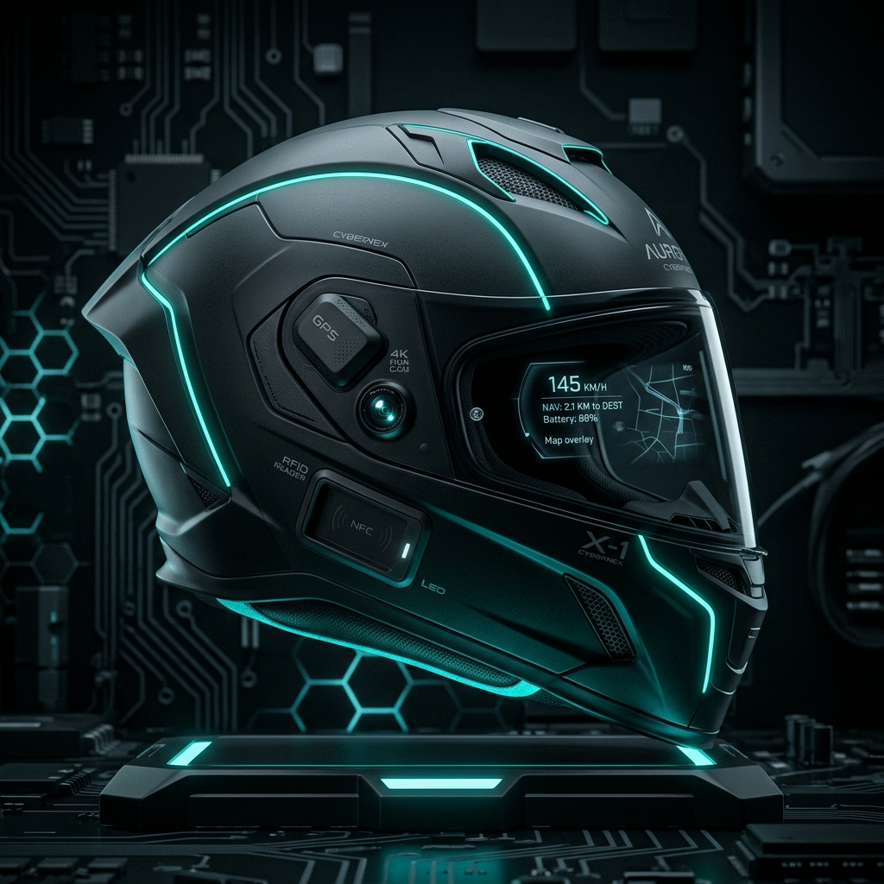
Figure 1.1: DivyaDrishti Smart Helmet Concept Design — An aerodynamic motorcycle helmet embedded with GPS, camera, RFID, and multiple safety sensors.
The project is named "DivyaDrishti" (Sanskrit: दिव्यदृष्टि), meaning "Divine Vision" — embodying the system's ability to perceive and anticipate danger that lies beyond normal human awareness while riding.

1.2 Problem Statement
Despite significant advances in vehicular safety technology, motorcycle riders continue to face the following unresolved challenges:
- No proactive drowsiness detection — Riders often do not recognize when fatigue leads to microsleep events (1–3 second eye closures at speed), which can be catastrophic at highway velocities.
- No automated lane departure monitoring — Motorcycles lack any standard lane departure warning technology, despite lane wandering being a primary accident precursor.
- No crash detection and automated SOS — If a rider crashes in a remote area, there is no system to automatically alert family or emergency services with precise GPS location and incident video.
- No alcohol impairment gate — There is no technical barrier to prevent an intoxicated rider from operating a motorcycle.
- No live telemetry for family safety monitoring — Family members have no real-time visibility into a rider's safety status, location, or speed.
- No secure rider authentication — There is no system to ensure only authorized individuals can operate a smart helmet.

1.3 Objectives
The primary objectives of the DivyaDrishti project are:
- Design and implement a comprehensive smart helmet system with embedded sensors (GPS, IMU, MQ-3, RFID) on an ESP32 microcontroller.
- Develop a real-time AI computer vision pipeline for YOLOv8 object detection, polynomial lane departure detection, and MediaPipe-based drowsiness monitoring.
- Implement a sensor fusion machine learning model (Random Forest) that combines hardware telemetry and vision features for multi-class driving event classification.
- Build a real-time web dashboard with live GPS mapping, historical telemetry charts, and AI prediction display.
- Create an automated emergency alert system with 10-second cancelable SOS countdown, Twilio SMS, NTFY.SH push notifications, and cloud-hosted incident video clips.
- Implement secure RFID-based rider authentication with HTTP-only cookie session management.
- Enable a rolling 10-second "black box" video buffer that exports incident clips on crash detection.

1.4 Scope of the Project
The DivyaDrishti system encompasses the following scope:
- Hardware Layer: ESP32-based helmet unit with GPS, IMU, alcohol sensor, RFID, OLED display, and buzzer.
- AI Layer: Edge-computing Python pipeline (FastAPI server) with three parallel vision modules and ML risk engine.
- Backend Layer: Node.js/Express REST API with Socket.IO real-time data streaming and MongoDB Atlas cloud database.
- Frontend Layer: React.js dashboard with live maps, sensor charts, camera feed, and emergency portal.
- Emergency System: Two-channel notification (Twilio SMS + NTFY.SH), crash/drowsiness detection, and incident video capture.
Out of Scope (Future Work):
- Custom PCB hardware miniaturization
- 5G/4G cellular module for direct-to-cloud connectivity
- Android/iOS mobile application
- Real-world dataset-trained ML models

1.5 Organization of the Report
This report is organized into seven chapters:
- Chapter 2 reviews related literature and existing works.
- Chapter 3 specifies all hardware and software requirements.
- Chapter 4 describes the system design and architecture.
- Chapter 5 covers the detailed implementation of each subsystem.
- Chapter 6 presents testing methodology and performance results.
- Chapter 7 concludes the project and outlines future directions.

CHAPTER 2: LITERATURE REVIEW

2.1 Overview of Motorcycle Safety Research
Motorcycle fatalities represent a disproportionate burden on road safety statistics globally. The World Health Organization (WHO) identifies powered two-wheelers as the single largest category of road traffic fatalities in low and middle-income countries. Research by Hurt et al. and subsequent studies consistently identify operator error, inattention, and impairment as the top causal factors. The challenge with motorcycle-specific safety systems is the constrained form factor, the absence of a cabin (which eliminates traditional camera mounting points), and the highly dynamic nature of two-wheeler motion.

2.2 Existing Smart Helmet Systems
System | Sensors | AI | Emergency | Limitations
LIVALL Helmet | IMU only | No | SOS button | No vision AI
Jarvish X-AR | IMU, camera | Basic CV | Manual | No ML fusion
Sena Systems | None | No | Phone-based | No sensor
Academic IoT Helmets | IMU, GPS | No | SMS only | No vision pipeline
DivyaDrishti (This work) | IMU, GPS, MQ3, RFID, Camera | Full AI pipeline | Automated | Laptop-based edge

Current commercial smart helmets focus primarily on communication features (Bluetooth audio, navigation) or rudimentary fall detection. Very few integrate comprehensive AI-based risk prediction. Academic prototype systems typically address individual problems (drowsiness OR lane detection OR crash detection) but rarely integrate all three with real hardware telemetry in a unified system.
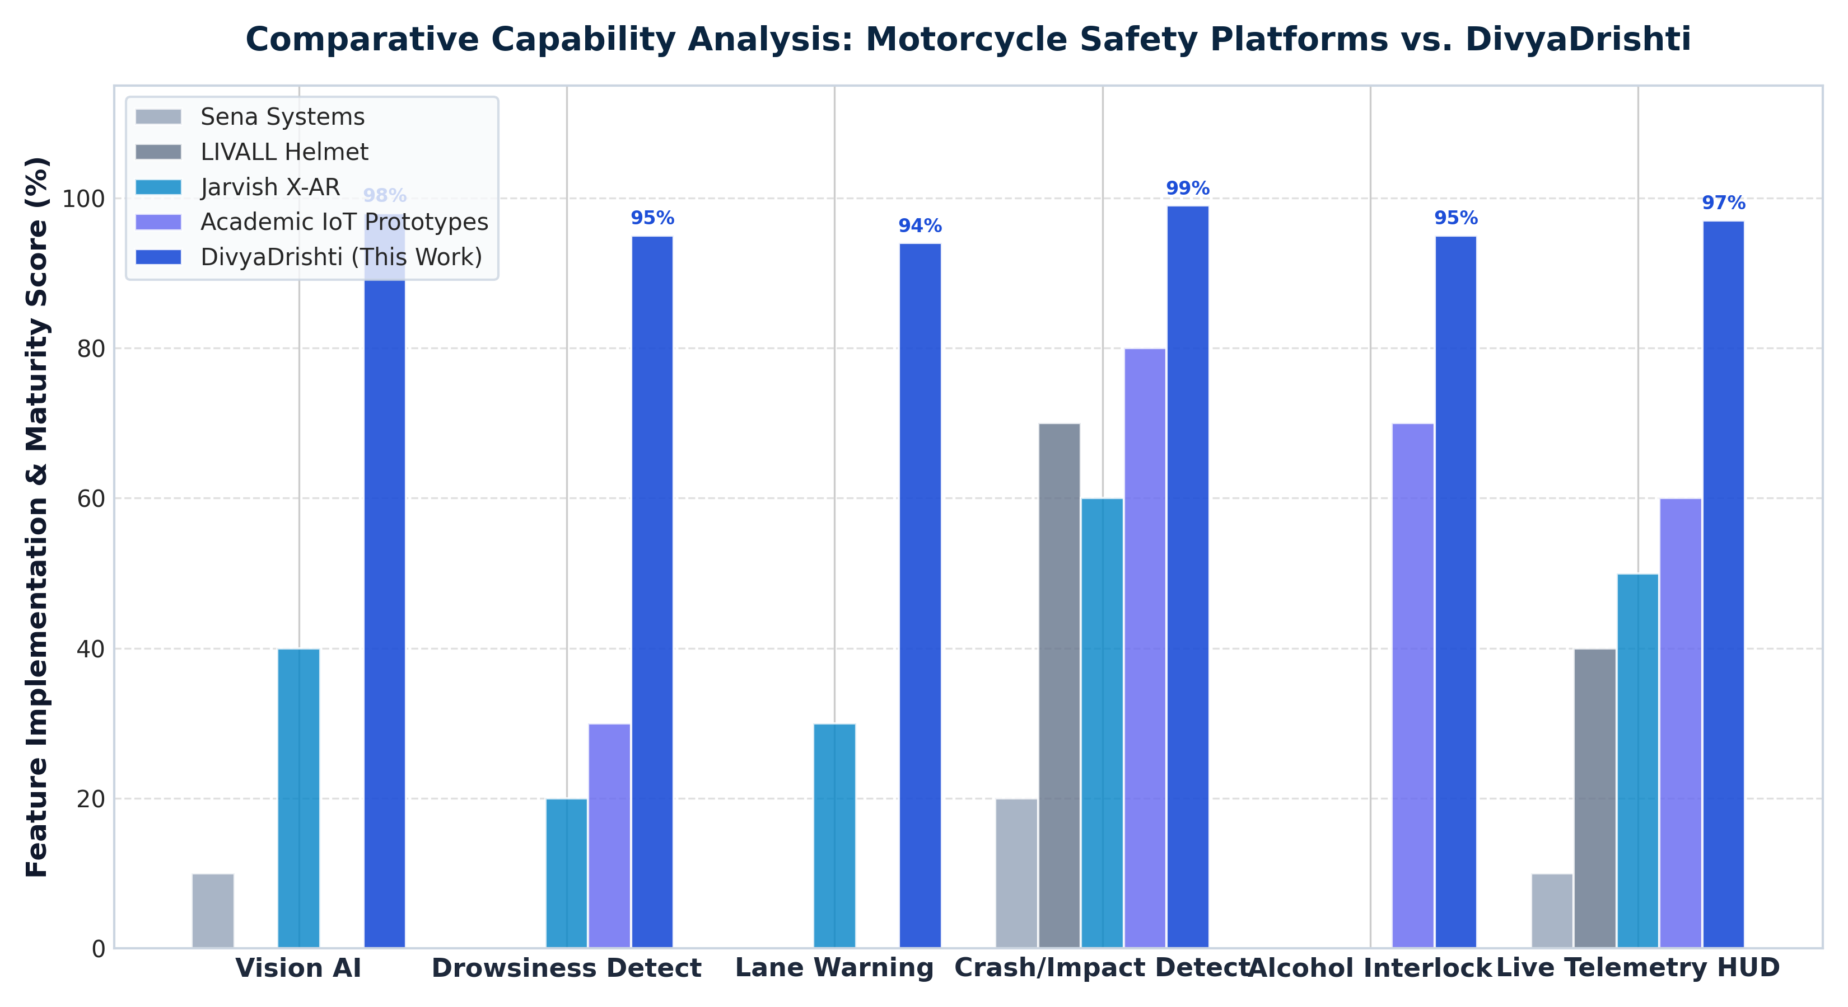
Figure 2.1: Comparative Capability Analysis: Motorcycle Safety Platforms vs. DivyaDrishti — Demonstrating superior multi-modal integration across vision AI, drowsiness tracking, lane departure, impact detection, and telemetry streaming.

2.3 Drowsiness Detection Techniques
The state of the art in drowsiness detection spans multiple modalities:
Physiological Signals: EEG (electroencephalography) and EOG (electrooculography) offer the highest accuracy but require medical-grade electrodes making them impractical for motorcycle use.
Steering Pattern Analysis: Used in automotive LDWS systems; not directly applicable to motorcycle handlebar patterns.
Computer Vision (EAR-based): The Eye Aspect Ratio (EAR) method, introduced by Soukupová and Čech (2016), computes the ratio of vertical to horizontal eye landmarks. An EAR below a threshold (typically 0.20–0.25) indicates eye closure. This method has been validated in numerous studies with >90% accuracy for drowsiness classification.
Deep Learning (CNN-based): Models such as those trained on the NTHU Driver Drowsiness Detection dataset achieve high accuracy but require significant computational resources — unsuitable for real-time helmet edge inference.
DivyaDrishti's approach: The system implements MediaPipe Face Landmarker (a lightweight, optimized model) to extract 478 facial landmark coordinates in VIDEO streaming mode. EAR is computed geometrically from 6 specific landmark indices per eye, with a fused threshold (EAR < 0.22 OR blendshape blink score > 0.45) and a 0.5-second grace period for blink/jitter robustness.

2.4 Lane Departure Warning Systems
Lane Departure Warning Systems (LDWS) are standard in modern automobiles (Mobileye, Tesla Autopilot) but absent from motorcycles. The fundamental challenge in lane detection is robustness under varying lighting, road marking quality, and perspective distortion.
The classic pipeline — Grayscale → Gaussian Blur → Canny Edges → Hough Transform → linear extrapolation — is reliable on highways but fails on curved roads, worn markings, and complex intersections.
DivyaDrishti employs a more robust approach: HLS color space S-channel thresholding (to isolate yellow and white markings independent of overall illumination) combined with Sobel-X gradient detection, followed by second-degree polynomial fitting with Exponential Moving Average (EMA, α=0.2) temporal smoothing for jitter-free curved lane representation.

2.5 Object Detection for ADAS
YOLO (You Only Look Once) architectures have become the de-facto standard for real-time object detection in ADAS applications. YOLOv8 (Ultralytics, 2023) significantly improves upon YOLOv5 with an anchor-free architecture, improved accuracy on small objects, and faster inference.
DivyaDrishti uses YOLOv8n (nano — smallest variant, 3.2M parameters, 6.3 GFLOPs), which achieves 37.3 mAP on COCO80 at ~180 FPS on modern GPU hardware, making it practical for real-time laptop edge inference. The system detects 6 safety-relevant COCO classes: person, bicycle, car, motorcycle, bus, and truck, and estimates monocular distance using the pinhole camera model: Distance = (Real_Width × Focal_Length) / Pixel_Width.

2.6 Sensor Fusion and ML in Vehicular Safety
Sensor fusion — combining data from multiple heterogeneous sensors into a unified representation — is central to modern ADAS. The Random Forest algorithm, introduced by Breiman (2001), is particularly well-suited for vehicular safety fusion due to its robustness to noisy sensor data, ability to handle mixed feature types (continuous IMU values + binary lane_departure flag), interpretability through feature importance, and fast inference time.
Several academic studies have applied Random Forest to IMU-based crash detection (achieving >95% accuracy on benchmark datasets). DivyaDrishti extends this by fusing 6 IMU-derived features with 6 computer vision features for a unified 12-dimensional feature space.

2.7 Research Gap and Novelty
The key research gaps this project addresses are:
- No existing system combines real-time hardware IMU telemetry + lane departure + drowsiness detection + object detection + Random Forest classification in a unified pipeline for motorcycles.
- No existing academic prototype includes a fully automated emergency response with incident video clip export and cloud hosting.
- No existing system implements RFID-gated authentication with session management for helmet access control.
- The "Black Box" concept applied to motorcycle helmets (rolling 10-second video buffer with automatic crash-triggered export) is novel in the academic literature.

CHAPTER 3: SYSTEM REQUIREMENTS

3.1 Hardware Requirements

3.1.1 Helmet Hardware Unit
Table 3.1: Hardware Components and Specifications
Component | Model | Specification | Role
Microcontroller | Espressif ESP32 (WROOM-32) | Dual-core Xtensa LX6 @ 240 MHz, 4 MB Flash, 520 KB SRAM, Wi-Fi 802.11 b/g/n, Bluetooth 4.2 | Central controller, Wi-Fi data transmission
IMU Sensor | InvenSense MPU6050 | 6-axis (3-axis accel ±8g, 3-axis gyro ±500°/s), I2C @ 400 kHz, 16-bit ADC | Acceleration, pitch, roll, gyroscope data
GPS Module | Quectel L86-M33 | Multi-GNSS (GPS+GLONASS+Galileo), EASY assist, 1Hz update rate, UART @ 9600 baud | Precise location tracking
Gas Sensor | MQ-3 Alcohol Sensor | ADC range 0–4095 (ESP32 12-bit), analog output, detects ethanol gas | Alcohol impairment detection
RFID Reader | MFRC522 | 13.56 MHz, SPI interface, ISO 14443 Type A/B, Mifare cards | Rider authentication
OLED Display | SH1106G 128×64 | I2C @ 400 kHz, 1.3-inch, monochrome, 128×64 pixel resolution | On-helmet status display
Buzzer | Piezoelectric 5V | GPIO PWM driven via ledcAttach | Audio alerts (impact, auth)
Power Supply | LiPo 3.7V / USB 5V | USB-to-ESP32 via onboard regulator (3.3V output) | System power
Emergency QR Decals | Dual Weatherproof Vinyl Decals | ISO/IEC 18004 compliant, high-contrast, UV-resistant, front brow & rear nape placement | Zero-app bystander & paramedic access to medical & family ICE profile

3.1.2 AI Computing Hardware (Edge Node)
Component | Minimum Specification | Recommended
Processor (CPU) | Intel Core i5 8th Gen | Intel Core i7 / AMD Ryzen 7
RAM | 8 GB DDR4 | 16 GB DDR4
Storage | 50 GB SSD | 256 GB NVMe SSD
Camera | USB Webcam (720p, 30 FPS) | 1080p, 60 FPS webcam
GPU (Optional) | Integrated Intel UHD 620 | NVIDIA GTX 1650 or higher
OS | Windows 10 / Ubuntu 20.04 | Windows 11 / Ubuntu 22.04
Network | Wi-Fi 802.11 n | Wi-Fi 802.11 ac (5 GHz)

3.1.3 Circuit Connection Summary
The ESP32 microcontroller interfaces with all sensors as follows:
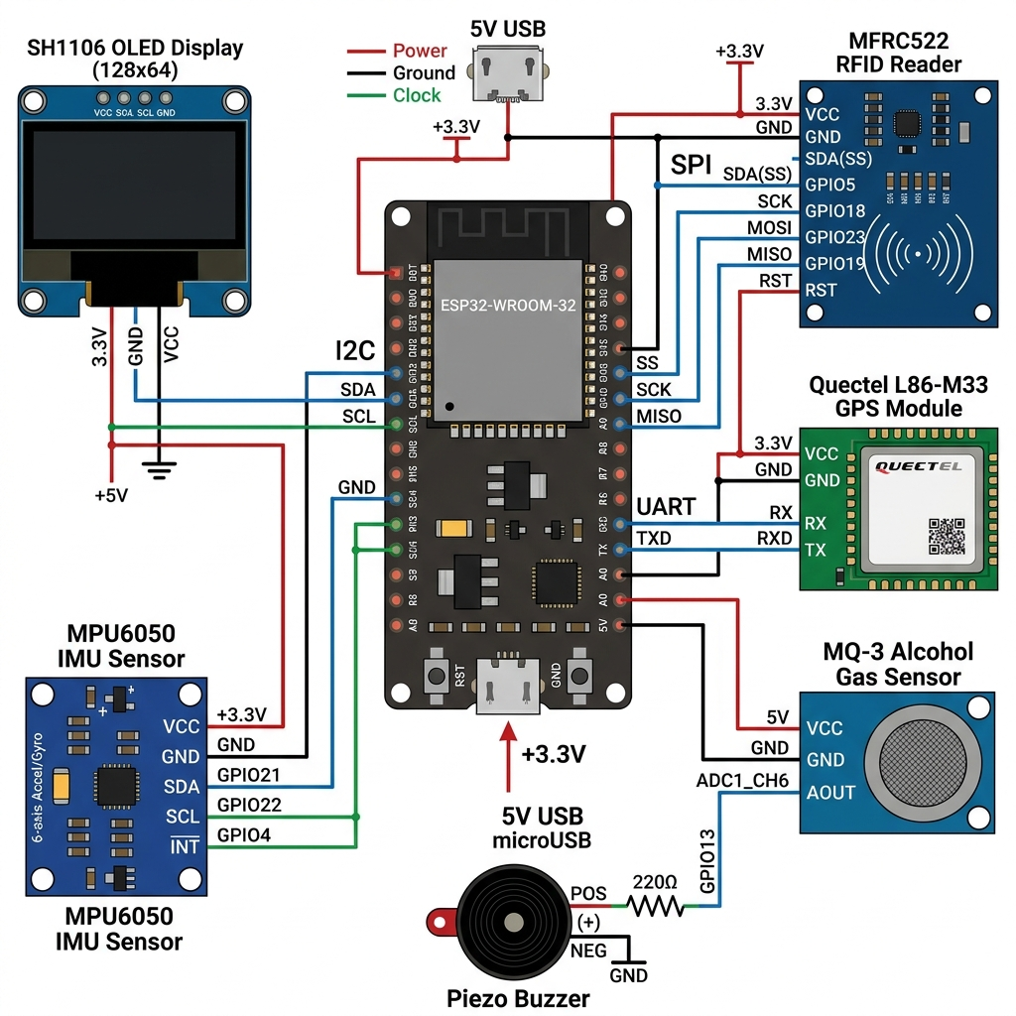
Figure 4.2: Hardware Circuit Diagram — ESP32 connected to MPU6050 (I2C), MFRC522 RFID (SPI), Quectel L86-M33 GPS (UART), MQ-3 Alcohol Sensor (ADC), SH1106 OLED (I2C), and Buzzer (PWM).
Table 5.1: ESP32 GPIO Pin Assignment
GPIO Pin | Connected Component | Protocol | Signal
GPIO 21 (SDA) | MPU6050 SDA | I2C | IMU data
GPIO 22 (SCL) | MPU6050 SCL, OLED SCL | I2C | Clock
GPIO 5 (SS) | MFRC522 SDA/SS | SPI | RFID Chip Select
GPIO 18 (SCK) | MFRC522 SCK | SPI | Clock
GPIO 19 (MISO) | MFRC522 MISO | SPI | Data in
GPIO 23 (MOSI) | MFRC522 MOSI | SPI | Data out
GPIO 4 (RST) | MFRC522 RST | GPIO | RFID Reset
GPIO 16 (RX2) | L86 GPS TXD | UART2 | GPS NMEA sentences
GPIO 17 (TX2) | L86 GPS RXD | UART2 | GPS commands
GPIO 34 (ADC) | MQ-3 A0 | Analog ADC | Alcohol voltage
GPIO 25 | Piezoelectric Buzzer | PWM (ledcAttach) | Audio tones
3.3V VCC | MPU6050, RFID, OLED | Power | 3.3V supply
GND | All sensors, Buzzer | Ground | Common ground

3.2 Software Requirements
Table 3.2: Software Tools, Frameworks and Libraries
Category | Tool / Library | Version | Purpose
Firmware | Arduino IDE | 2.x | ESP32 firmware development
 | Espressif ESP32 Arduino Core | 2.x | ESP32 hardware abstraction
 | ArduinoJson | 7.x | JSON serialization for HTTP
 | TinyGPSPlus | 1.0.x | GPS NMEA parsing
 | MFRC522 | 1.4.x | RFID card communication
 | Adafruit SH110X | 2.x | OLED display driver
 | Adafruit GFX | 1.11.x | Graphics primitives
AI Pipeline | Python | 3.10+ | Primary AI runtime
 | OpenCV (cv2) | 4.8+ | Camera capture, image processing
 | NumPy | 1.24+ | Numerical computing, array ops
 | Ultralytics YOLO | 8.x | YOLOv8 object detection model
 | MediaPipe | 0.10+ | Face landmark detection, EAR
 | scikit-learn | 1.3+ | Random Forest training & inference
 | FastAPI | 0.100+ | REST API for video streaming & clip export
 | Uvicorn | 0.23+ | ASGI server for FastAPI
 | Pandas | 2.x | Dataset manipulation, CSV I/O
 | Joblib | 1.3+ | ML model serialization (.joblib)
 | imageio-ffmpeg | 0.4+ | H.264 video encoding for incident clips
 | python-dotenv | 1.0+ | Environment variable management
Backend | Node.js | 20.x LTS | JavaScript runtime
 | Express.js | 5.x | REST API framework
 | Socket.IO | 4.8.x | Bidirectional real-time events
 | Mongoose | 9.x | MongoDB ODM for data schemas
 | Twilio SDK | 6.x | SMS emergency alert dispatch
 | JSON Web Token | 9.x | Session token generation
 | cookie-parser | 1.4.x | HTTP-only session cookie management
 | Morgan | 1.12.x | HTTP request logging
 | Nodemon | 3.x | Hot-reload development server
 | dotenv | 18.x | Environment configuration
Frontend | React | 19.x | UI component framework
 | Vite | 8.x | Build tool and dev server
 | React Router DOM | 7.x | SPA client-side routing
 | Socket.IO Client | 4.8.x | Real-time event subscription
 | Leaflet.js | 1.9.x | Interactive GPS map rendering
 | React-Leaflet | 5.x | React wrapper for Leaflet
 | Recharts | 3.x | Historical telemetry chart visualization
 | Framer Motion | 14.x | UI animations and transitions
 | Tailwind CSS | 3.4.x | Utility-first CSS styling
 | lucide-react | 1.52.x | Icon library
Database | MongoDB Atlas | Cloud M0 | Document database, cloud hosted

3.3 Communication & Cloud Requirements
Table 3.3: Communication Protocols and External Services
Protocol / Service | Role | Direction
HTTP/REST (Port 5000) | ESP32 → Node.js telemetry upload | Outbound from helmet
HTTP/REST (Port 5000) | AI Pipeline → Node.js prediction upload | Outbound from AI
Socket.IO (WebSocket) | Node.js → React Dashboard live streaming | Server Push
HTTP/REST (Port 8000) | FastAPI video stream & clip export | Internal
MongoDB Atlas (TLS) | Node.js ↔ Cloud database | Bidirectional
Twilio REST API (HTTPS) | Node.js → SMS family alert | Outbound
NTFY.SH (HTTPS) | Node.js → Push notification | Outbound
OpenStreetMap/Nominatim | Reverse geocoding (GPS → place name) | REST API
Uguu.se / Tmpfiles.org | Incident clip cloud hosting | Upload/CDN
Wi-Fi IEEE 802.11 n/ac | ESP32 ↔ Network | Wireless LAN

CHAPTER 4: SYSTEM DESIGN AND ARCHITECTURE

4.1 Overall System Architecture
The DivyaDrishti system is organized into four loosely-coupled subsystems that interact through well-defined APIs and real-time event streams.
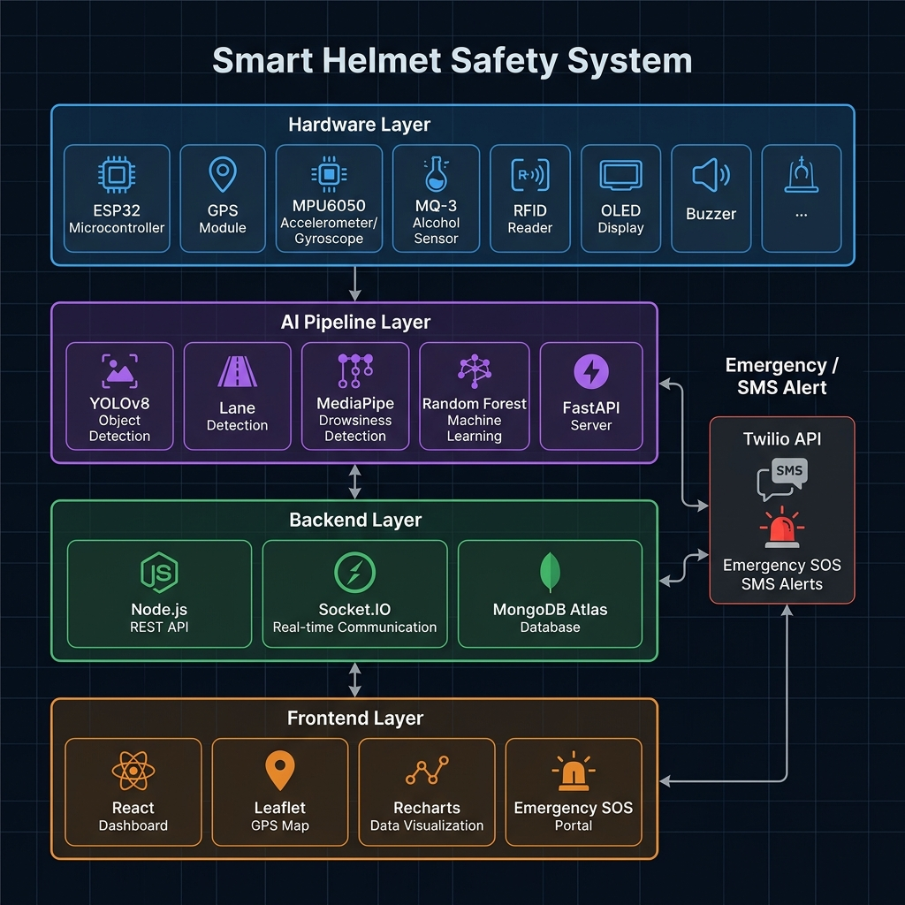
Figure 4.1: Overall System Architecture Diagram — Four-layer architecture: Hardware (ESP32), AI Pipeline (Python/FastAPI), Backend (Node.js), and Frontend (React).
Layer 1 — Hardware (ESP32 Helmet):
The physical helmet unit acts as the embedded IoT sensor hub. It collects multi-modal sensor data from the MPU6050, GPS, MQ-3, and RFID reader, displays real-time status on the SH1106 OLED, sounds buzzer alerts, and periodically transmits structured JSON telemetry to the Node.js backend via HTTP POST over Wi-Fi every 3 seconds.
Layer 2 — AI Pipeline (Python / FastAPI):
Running on the rider's laptop as an edge computing node, the AI pipeline opens the webcam, processes each frame through three parallel vision modules (YOLOv8, Lane Detection, MediaPipe Drowsiness), fuses visual features with the latest ESP32 telemetry via a background polling thread, and feeds the 12-dimensional fused feature vector into the trained Random Forest model. Predictions are POSTed to Node.js every ~50ms. The FastAPI server additionally exposes an MJPEG video stream endpoint at Port 8000 and an /export_clip endpoint for rolling 10-second incident clip export.
Layer 3 — Backend (Node.js / Express / Socket.IO / MongoDB):
The Node.js server is the central coordination hub. It receives telemetry from ESP32, prediction updates from the AI pipeline, manages RFID authentication and session lifecycle, and broadcasts all real-time updates to all connected React dashboard clients via Socket.IO events. All data (telemetry readings, AI predictions, emergency logs, session records) is persisted in MongoDB Atlas.
Layer 4 — Frontend (React / Leaflet / Recharts):
The React single-page application subscribes to Socket.IO events from the Node.js server and renders all telemetry in real-time: a live GPS map, speed/acceleration/MQ3 stat cards, drowsiness level indicator, AI prediction badge, historical charts, camera feed (via MJPEG stream from FastAPI), and the emergency SOS popup with a 10-second cancelable countdown.

4.2 Hardware Subsystem Design

4.2.1 ESP32 Firmware Architecture
The ESP32 firmware, written in Arduino C++, implements a non-blocking event loop with timer-based task scheduling. Rather than using RTOS tasks or blocking delays, each subsystem maintains its own lastUpdateTime variable and runs based on configurable INTERVAL constants:
Task | Interval | Description
processGPS() | Every loop iteration | Continuous NMEA parsing from UART2
readMotionSensor() | 150 ms | 6-axis IMU data read via I2C
readMQ3() | 500 ms | Analog ADC sampling of alcohol sensor
checkImpact() | Per motion read | Threshold comparison for crash detection
updateDisplay() | 100 ms | OLED frame refresh
autoPageChange() | 3500 ms | Automatic OLED page rotation
sendToBackend() | 3000 ms | HTTP POST JSON telemetry
checkWiFi() | 10000 ms | Wi-Fi reconnection watchdog
geocodeLocation() | 60000 ms | Reverse geocoding of GPS coordinates

4.2.2 Sensor Data Processing
MPU6050 (Raw I2C Driver):
Rather than using a pre-built library, DivyaDrishti implements a raw I2C driver for the MPU6050. The sensor is configured for ±8g accelerometer range (4096 LSB/g) and ±500°/s gyroscope range (65.5 LSB/°/s). Acceleration magnitude is computed as:
|A| = √(Ax² + Ay² + Az²)

Pitch and Roll angles are derived via arctangent:
Pitch = atan2(Ax, √(Ay² + Az²)) × 180/π
Roll = atan2(Ay, Az) × 180/π

Impact Detection:
An impact event is triggered when the acceleration magnitude exceeds 25.0 m/s² (~2.55G) OR any gyroscope axis exceeds 350°/s, with a 5-second cooldown to prevent repeated alerts from a single crash event.
GPS (Quectel L86-M33 with Multi-GNSS):
The GPS module is initialized via PMTK configuration sentences enabling GPS+GLONASS+Galileo for maximum satellite visibility, Quectel EASY (Embedded Assist System) for faster cold-start TTFF, and standard NMEA sentences (RMC, GGA, GSA, GSV). TinyGPSPlus library parses the NMEA stream. A 2-consecutive-fix hysteresis prevents false GPS lock notifications.
Location State Machine:
The system implements a multi-priority location state machine:
- LOC_GPS_FIX — Live GPS fix (highest priority)
- LOC_GPS_STALE — Fix lost within last 8 seconds (cached used)
- LOC_WIFI_ESTIMATING — Wi-Fi AP scan in progress
- LOC_ESTIMATE_READY — Wi-Fi-based location estimate
- LOC_CACHED — Last known valid GPS location
- LOC_UNAVAILABLE — No valid coordinates from any source

4.2.3 OLED Multi-Page Display
The 128×64 SH1106 OLED displays a rich 7-page rotating dashboard:
- PAGE_DASHBOARD — System status overview with signal indicators
- PAGE_RIDER — Rider name, phone, family contact
- PAGE_SESSION — Session time elapsed, RFID card UID, session progress bar
- PAGE_LOCATION — GPS coordinates, satellite count, place name
- PAGE_SAFETY — MQ-3 alcohol level, impact alert, safety score
- PAGE_MOTION — Accelerometer X/Y/Z values, pitch, roll, magnitude
- PAGE_DIAGNOSTICS — Wi-Fi SSID, backend status, GPS UART health
Custom pixel-art icons (16×16 bitmap) are stored in PROGMEM: shield, helmet, Wi-Fi signal, GPS pin, satellite, RFID card, success badge, warning triangle, and cloud infrastructure icons.

4.3 AI Vision Pipeline Design
The AI pipeline is designed as a single-threaded main loop with background daemon threads for polling ESP32 telemetry and POSTing predictions to avoid blocking the video frame loop.
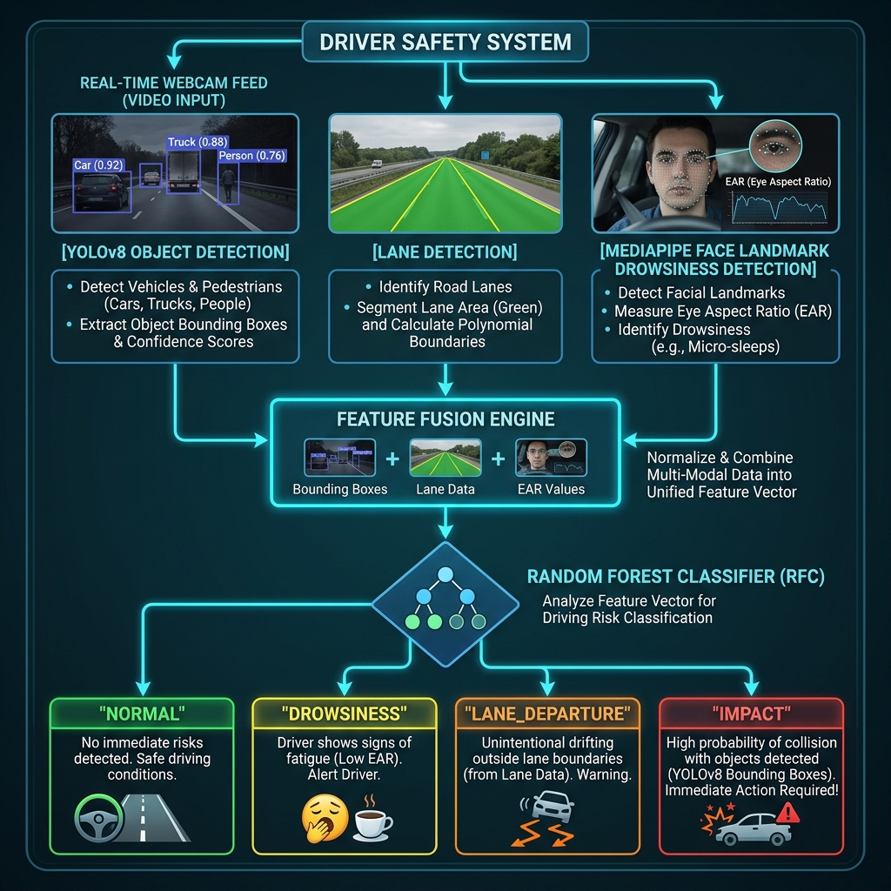
Figure 4.3: AI Vision Pipeline Flowchart — Three parallel computer vision modules feed a Feature Fusion Engine, which feeds the Random Forest ML classifier producing risk-stratified event predictions.

4.3.1 Object Detection (YOLOv8n)
YOLOv8n processes each frame and returns detected bounding boxes for 6 safety-relevant COCO classes. For each detected object, the system:
- Counts class-specific instances (person, car, motorcycle, bus, truck)
- Estimates monocular distance using the pinhole camera model:
Distance (m) = (Real_Width × Focal_Length) / Pixel_Width
Where Focal_Length = 700px (empirically calibrated for standard webcam)
- Draws distance labels at the bottom-left of each bounding box
- Tracks the closest object and largest bounding box area for the feature vector

4.3.2 Lane Detection (Polynomial Fitting)
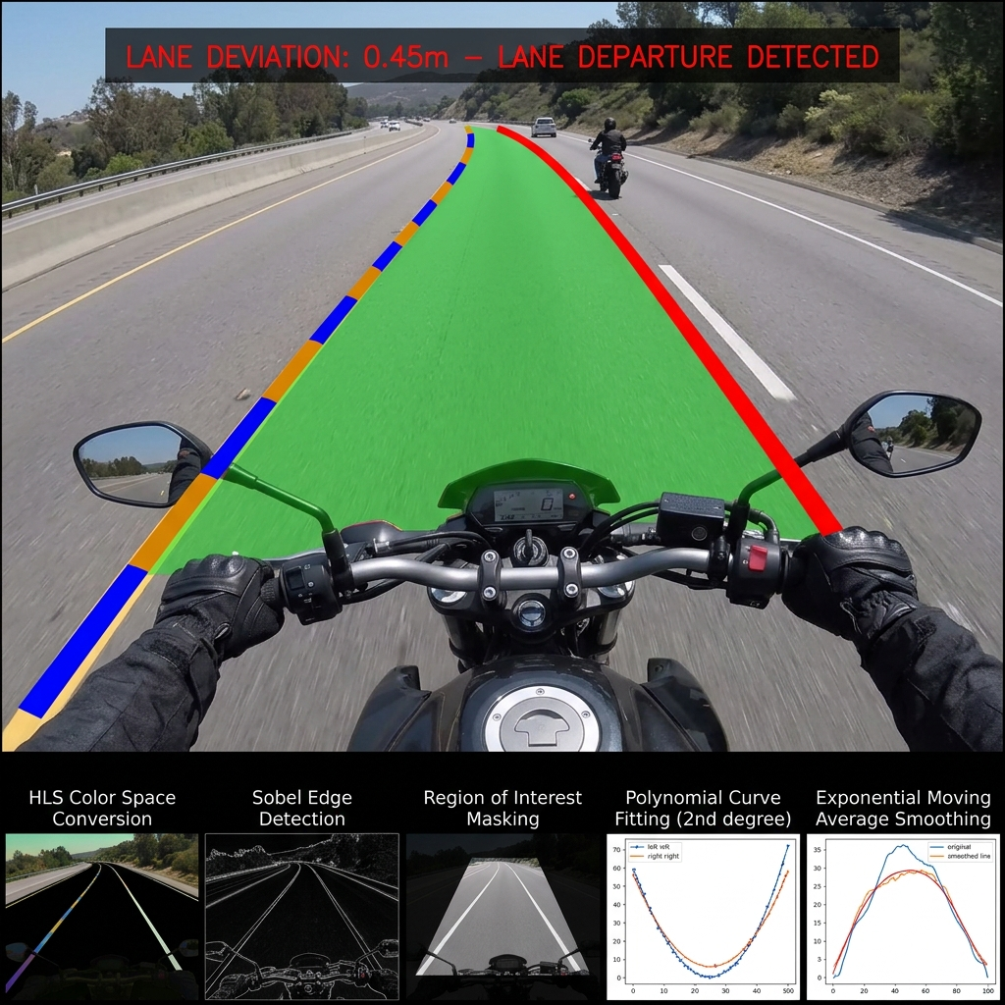
Figure 5.3: Lane Detection Output — Original camera frame processed through HLS color space, Sobel gradient detection, ROI masking, and 2nd-degree polynomial fitting with EMA smoothing, resulting in a green lane polygon overlay.
The lane detection pipeline operates in five stages:
- Color-Space Processing: Convert to HLS; S-channel threshold (150–255) isolates yellow/white lane markings independent of ambient lighting.
- Sobel Edge Detection: Sobel-X gradient (3×3 kernel) detects vertical edges while suppressing horizontal noise (shadows, cracks).
- ROI Masking: Trapezoidal region of interest masks out the horizon (above 55% height) and screen edges (left 15%, right 5%) to eliminate false detections.
- Lane Pixel Classification: If previous fits exist, margin search (±60px from predicted line) is used; otherwise, histogram peak search identifies the initial left/right lane positions.
- Polynomial Fitting with EMA: Second-degree polynomial ax² + bx + c is fitted to left and right lane pixel clusters. Sanity checks validate lane geometry (right > left, wider at bottom, minimum 100px width). EMA (α=0.2) smooths the fit coefficients over time to eliminate jitter.
Lane deviation is computed as:
deviation_pixels = (camera_center_x) - (lane_center_x)
deviation_meters = deviation_pixels × (3.7m / 800px)

A right-side lane departure alert is triggered when deviation > 0.4 meters.

4.3.3 Drowsiness Detection (MediaPipe EAR)
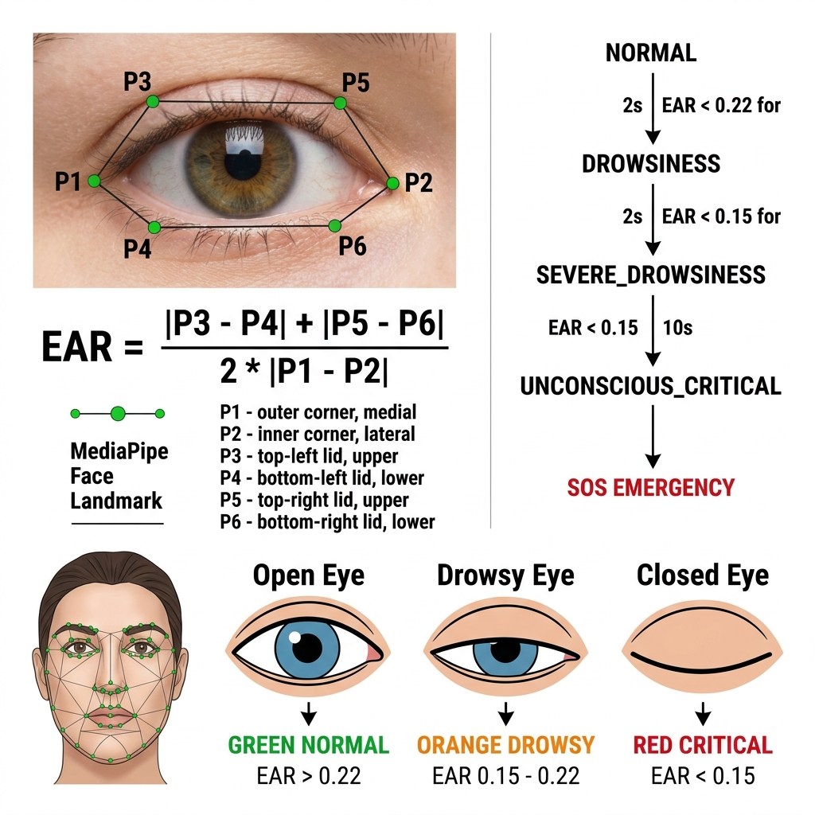
Figure 5.4: Eye Aspect Ratio (EAR) Calculation — The geometric formula using 6 MediaPipe facial landmark coordinates per eye, with drowsiness state classifications based on eye closure duration thresholds.
MediaPipe Face Landmarker runs in VIDEO mode, extracting 478 facial landmarks at video timestamp (milliseconds). The Eye Aspect Ratio is computed geometrically from 6 landmark indices per eye:
- Right Eye: [33, 133, 159, 145, 158, 153]
- Left Eye: [362, 263, 385, 380, 386, 374]
EAR = (|P3-P4| + |P5-P6|) / (2 × |P1-P2|)

A fused threshold is used: eye_closed = (EAR < 0.22) OR (blink_blendshape_left > 0.45 AND blink_blendshape_right > 0.45).
A 0.5-second grace period prevents brief blinks from falsely triggering sustained closure tracking. The drowsiness state machine:
Duration | State | Action
Normal | NORMAL | Green indicator
> 1.0s | DROWSINESS | Warning displayed
> 2.0s | SEVERE_DROWSINESS | Log entry, monitoring escalated
Yawning detected | POSSIBLE_DROWSINESS | Mild alert
> 10.0s | UNCONSCIOUS_CRITICAL | SOS Emergency triggered

4.4 Backend API Design
Table 4.1: Backend REST API Endpoints
Method | Endpoint | Description
POST | /api/telemetry | Receive ESP32 sensor data, save to DB, broadcast via Socket.IO
GET | /api/telemetry | Retrieve last 50 telemetry records
POST | /api/ai/prediction | Receive AI pipeline prediction, trigger emergency if critical
GET | /api/ai/predictions | Retrieve last 100 AI prediction records
POST | /api/rfid/authenticate | RFID card authentication, create session
POST | /api/auth/claim | Claim active session with HTTP-only cookie
GET | /api/auth/verify | Verify current session cookie
POST | /api/auth/logout | Invalidate session, clear cookie
POST | /api/emergency | Create emergency alert, start 10s countdown
POST | /api/emergency/cancel | Cancel pending emergency alert
POST | /api/emergency/dispatch | Immediately dispatch emergency notifications
GET | /api/emergency | Retrieve emergency history
GET | /api/location | Get last resolved GPS location
GET | /api/telemetry/status | Get ESP32 connection status
GET/POST | :8000/video_feed | FastAPI MJPEG camera stream
GET/POST | :8000/export_clip | FastAPI on-demand incident clip export

4.4.1 Real-Time Socket.IO Events
Event Name | Direction | Payload | Description
telemetry_update | Server → Client | Full telemetry object | ESP32 sensor data broadcast
ai_prediction | Server → Client | {event, risk, confidence} | ML prediction update
emergency_pending | Server → Client | {countdown, telemetry, aiState, videoClipUrl} | Start 10s SOS popup
emergency_dispatched | Server → Client | {place, googleMapsLink, videoClipUrl} | Confirm dispatch
emergency_cancelled | Server → Client | {message} | Cancel SOS popup
esp32_status | Server → Client | {online, lastSeen} | Hardware online/offline status
login_status | Server → Client | {status, user, uid} | RFID auth result
rfid_scanned | Server → Client | {uid} | Raw RFID scan notification
force_logout | Server → Client | — | Session expired, logout dashboard

4.5 Frontend Dashboard Design
The React dashboard comprises the following pages and components:
Pages:
- Landing.jsx — Marketing/welcome page with feature overview
- Login.jsx — RFID authentication page with live status
- Dashboard.jsx — Main telemetry overview page
- GPSTracking.jsx — Full-page GPS map with real-time location
- Drowsiness.jsx — Drowsiness detection status and history
- EmergencyAlerts.jsx — Emergency alert history table
- History.jsx — Historical telemetry charts (Recharts)
- HelmetStatus.jsx — Hardware component status indicators
- Settings.jsx — System configuration, RFID card management
Core Components:
- CameraFeed.jsx — MJPEG stream viewer with AI overlay controls
- ImpactModal.jsx — 10-second SOS countdown overlay with cancel/confirm
- GPSCard.jsx — Leaflet mini-map with live GPS marker
- DrowsinessCard.jsx — EAR gauge and drowsiness state display
- DeviceStatus.jsx — ESP32 online/offline status indicator
- HealthChart.jsx — Real-time sensor chart
- AlertsTable.jsx — Emergency history table
- Sidebar.jsx — Navigation sidebar with icon links
- TopNavbar.jsx — Header with rider info and system status

4.6 Emergency Response System Design
The emergency response system is designed with a dual-trigger, dual-channel, single-countdown architecture to minimize false positives while ensuring reliable alert dispatch.
Trigger Conditions:
- ESP32 Hardware Trigger: accMagnitude >= 25.0 m/s² → IMPACT emergency
- AI Pipeline Vision Trigger: event == "IMPACT" or event == "UNCONSCIOUS_DROWSINESS" → corresponding emergency
- AI Backend Relay: If AI pipeline POSTs IMPACT prediction, Node.js calls triggerEmergencyAlert()
- Driver Unresponsiveness: Eyes closed > 10 seconds → UNCONSCIOUS_DROWSINESS emergency
Duplicate Suppression:
- A 2-second confirmation window is enforced before displaying the SOS popup for IMPACT events (to distinguish real crashes from speed bumps)
- UNCONSCIOUS_DROWSINESS triggers an immediate popup (no wait — the 10-second eye closure duration is itself the confirmation)
- Routine drowsiness (< 10s) never triggers the emergency SOS popup — only a HUD warning
- Cooldown timers (15 seconds for IMPACT, 20 seconds for unconscious) prevent repeated alerts from a single event
Notification Channels:
- React Dashboard SOS Modal: 10-second countdown with cancel/confirm buttons, video clip preview
- Twilio SMS: Sent to EMERGENCY_CONTACT_NUMBER with location, speed, and video clip link
- NTFY.SH Push Notification: Free push notification with urgency priority, attach video clip URL, click-to-maps link

4.7 Data Flow Diagram
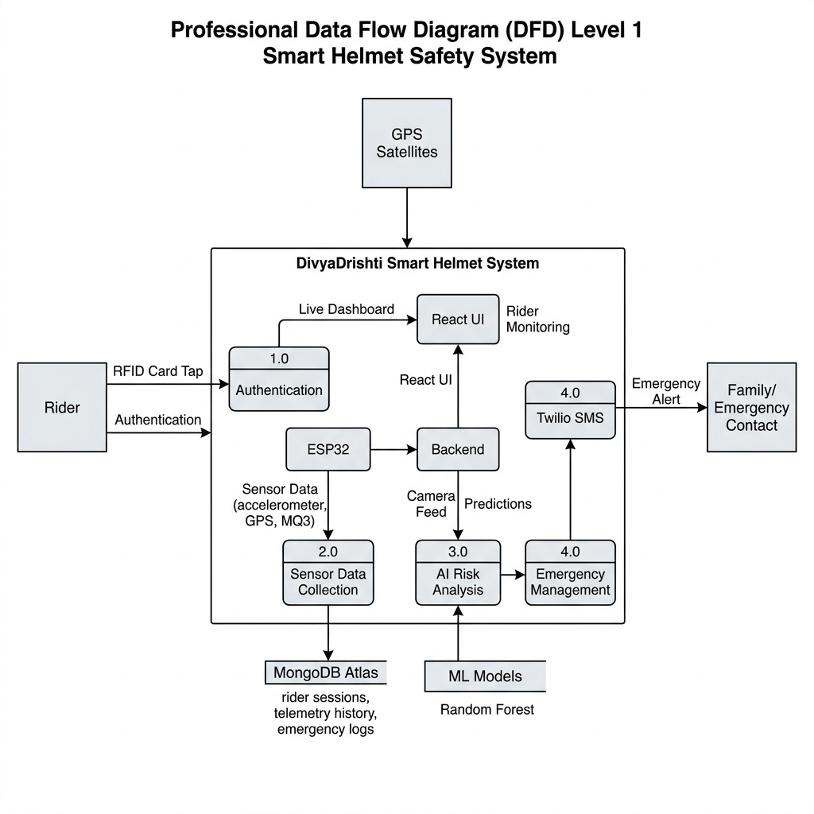
Figure 4.4: Data Flow Diagram (Level 1) — Shows all external entities (Rider, Family Contact, GPS Satellites), data stores (MongoDB Atlas, ML Models), processes (Authentication, Sensor Collection, AI Risk Analysis, Emergency Management), and data flows between them.

4.8 Use Case Diagram
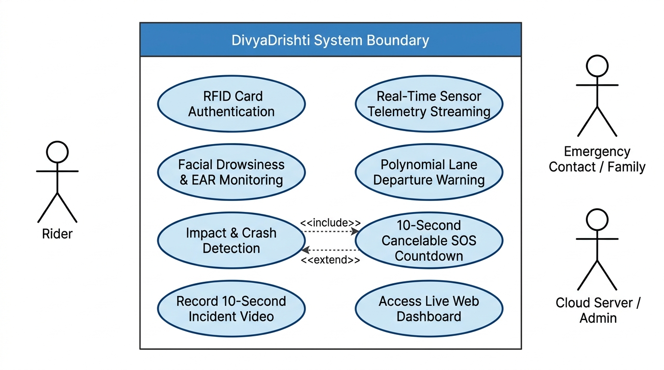
Figure 4.5: UML Use Case Diagram — System boundary, primary actors (Rider, Emergency Contact, Cloud Server/Admin), and core use cases with <<include>> and <<extend>> relationships.
Primary Actors:
- Rider — Interacts with the physical helmet (RFID card tap, riding session)
- Family Member / Emergency Contact — Receives SMS/push notifications on emergency
- System Administrator — Manages RFID cards and system configuration through Settings page
Primary Use Cases:
- UC-01: Rider authenticates with RFID card → Helmet verifies → Session created → Dashboard unlocked
- UC-02: Rider rides → ESP32 continuously streams telemetry → Dashboard shows live data
- UC-03: AI pipeline detects drowsiness → Warning displayed on dashboard HUD
- UC-04: AI detects lane departure → Alert shown on vision HUD and dashboard
- UC-05: Crash detected (hardware or AI) → 10s SOS countdown shown → If not cancelled → SMS + push sent to family
- UC-06: Rider is unresponsive (>10s eye closure) → SOS countdown → Emergency dispatch
- UC-07: Family member receives SMS with GPS link and video clip → Can navigate to accident location
- UC-08: Rider or family views historical trips, telemetry, and alert logs on dashboard
- UC-09: First responder or bystander scans helmet QR code (front/back) → Instant access to rider blood group, allergies, emergency contacts, and medical profile without requiring app or login

4.8.1 UML Sequence Diagram: Crash & Emergency Alert Workflow
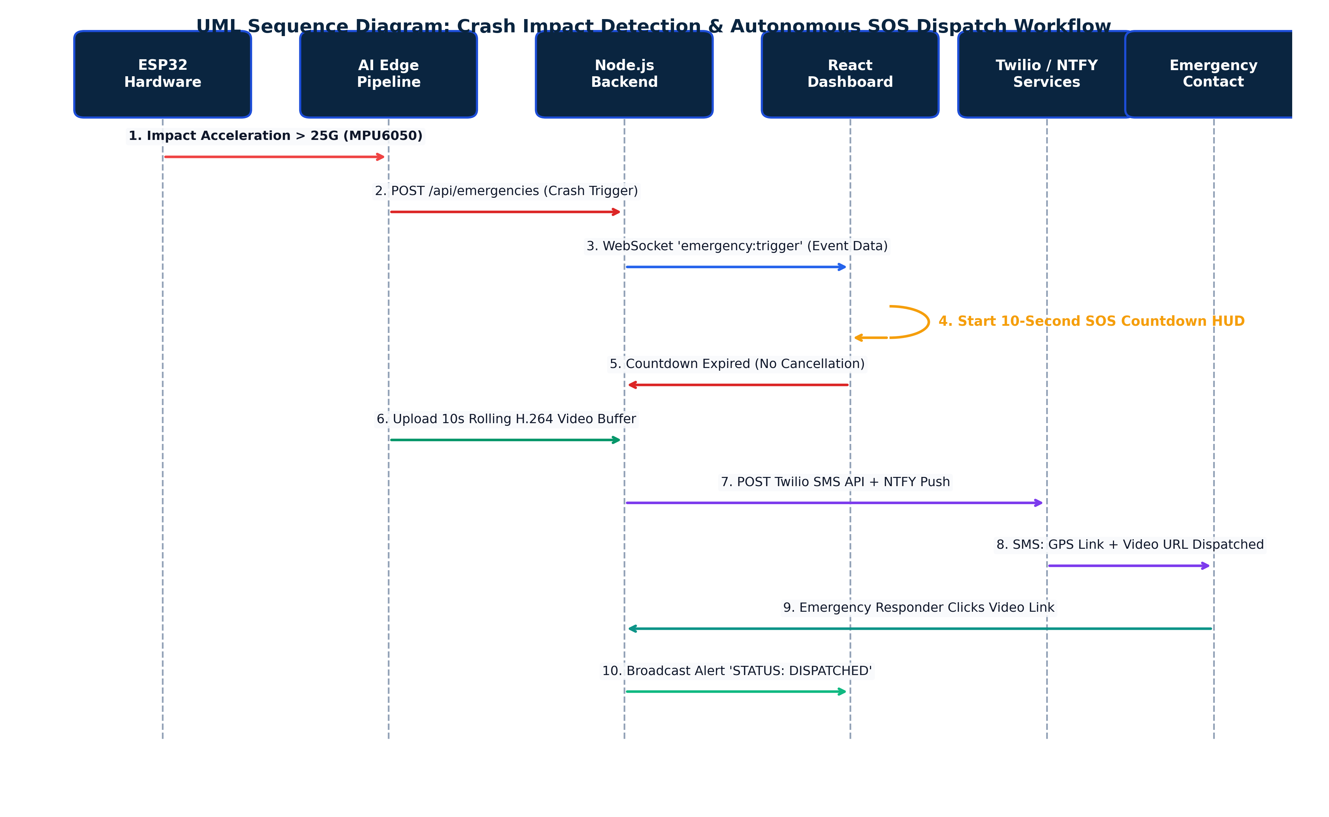
Figure 4.6: UML Sequence Diagram — Crash Impact Detection & Autonomous SOS Dispatch Workflow showing lifelines from ESP32 hardware to family SMS receipt.

4.8.2 UML Activity Diagram: Rider Session & Safety Workflow
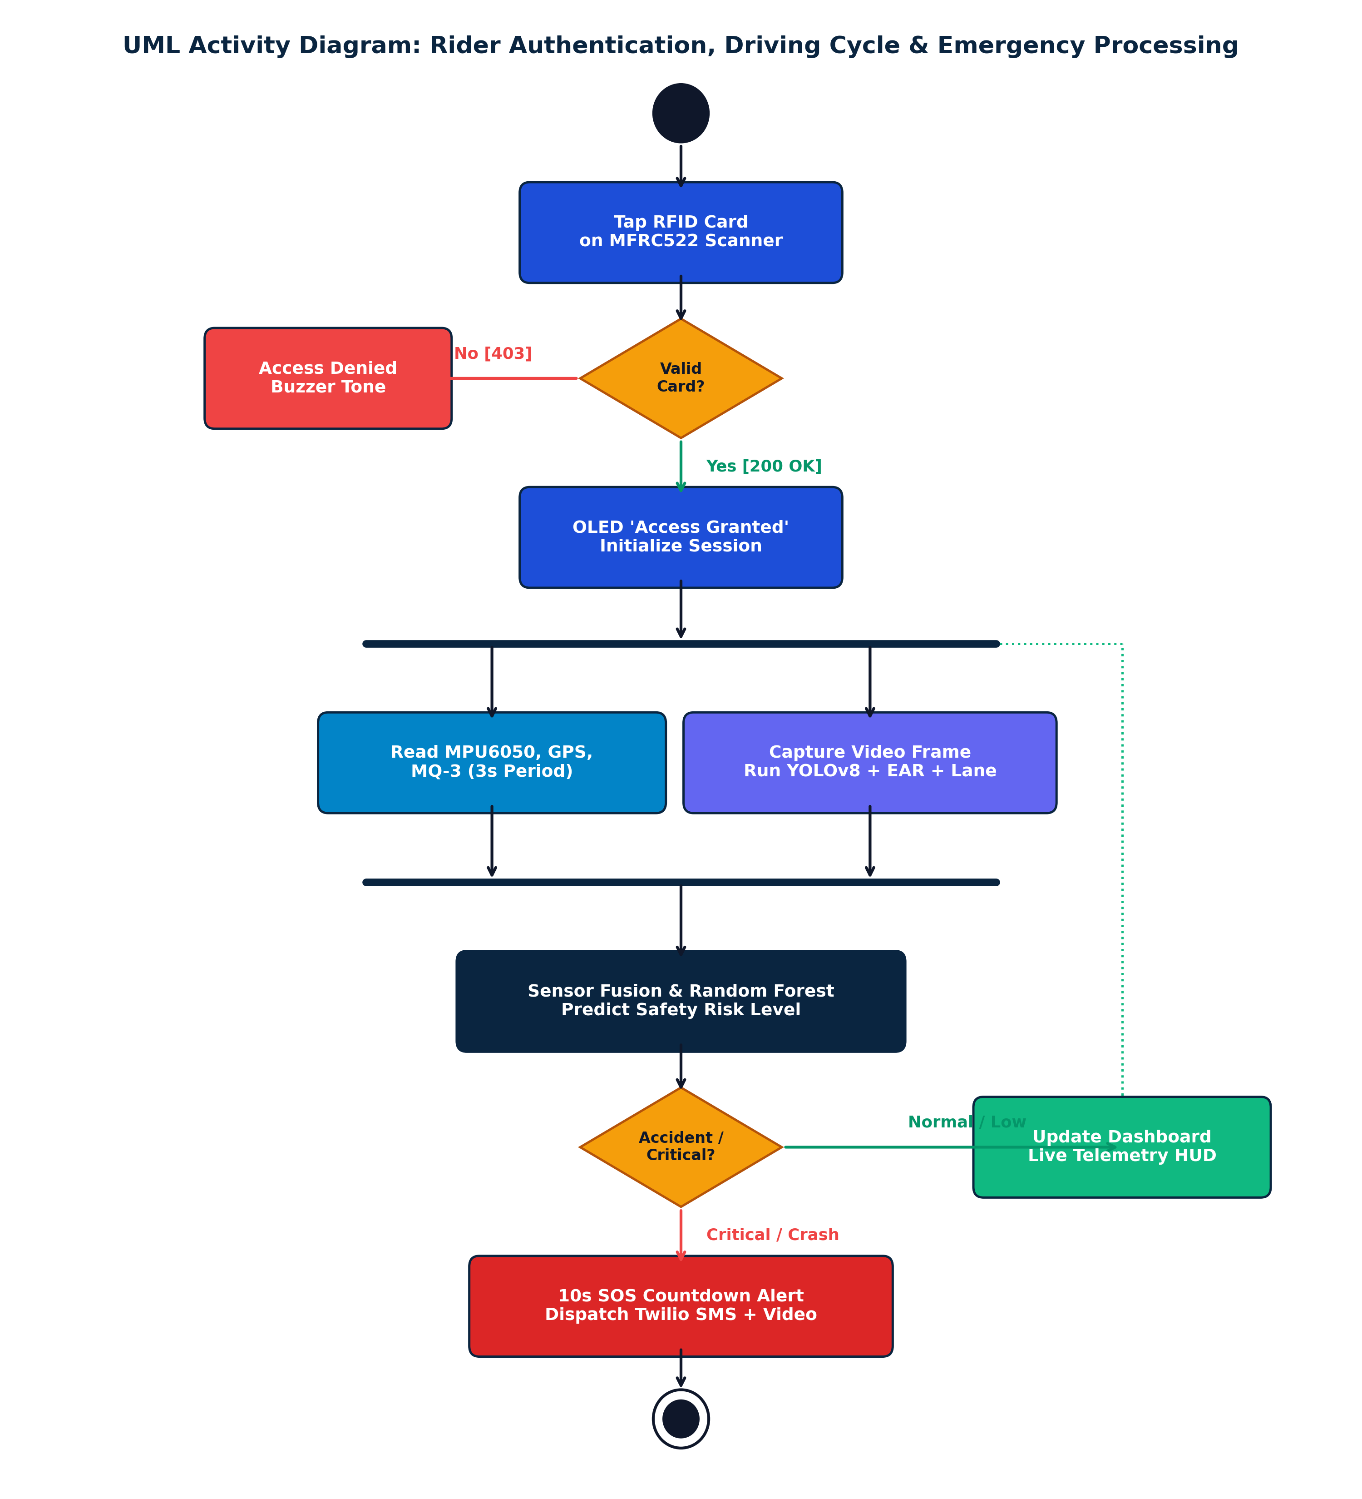
Figure 4.7: UML Activity Diagram — Rider Authentication, Driving Cycle & Emergency Processing showing parallel threads for sensor telemetry and edge computer vision.

4.9 Database Schema Design
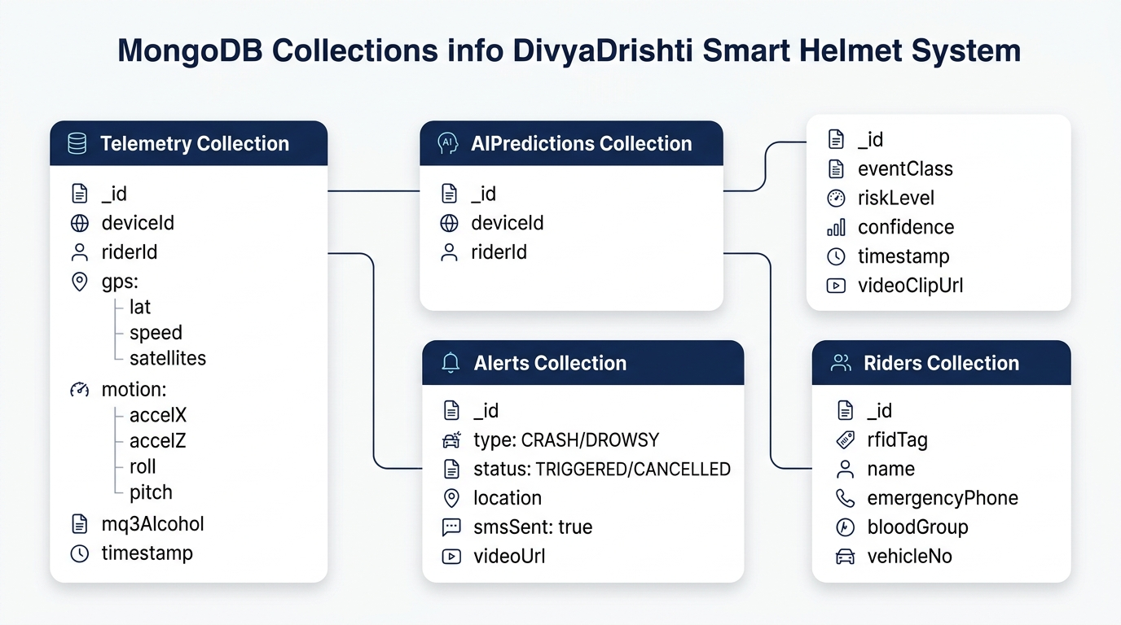
Figure 4.8: MongoDB Data Schema — Collections Overview and document structure across Telemetry, AIPredictions, Alerts, and Riders.
Table 4.2: MongoDB Collections and Schema Fields
Collection | Key Fields | Purpose
telemetry | device, rider, gps{lat,lon,satellites}, motion{accelX/Y/Z, gyroX/Y/Z, pitch, roll, magnitude}, mq3, placeName, locationStatus, locationAccuracy, timestamps | Raw sensor readings from ESP32
aipredictions | event, risk, confidence, timestamp, videoClipUrl | Random Forest ML predictions
emergencies | device, rider, type (IMPACT/UNCONSCIOUS_DROWSINESS/...), location{lat,lon,placeName}, status (PENDING/VERIFIED/CANCELLED/RESOLVED), aiPredictionData, videoClipUrl, timestamps | Emergency event logs
sessions | rfidUid, sessionToken, riderName, createdAt | Active riding sessions
rfidcards | uid, name, status (active/inactive), lastUsed | Registered RFID cards

CHAPTER 5: IMPLEMENTATION

5.1 ESP32 Firmware Implementation
The ESP32 firmware (esp32connection.ino) comprises 2,105 lines of Arduino C++ and implements a non-blocking, event-driven architecture. Below are key implementation details:

5.1.1 System Initialization (setup())
During startup, the system:
- Initializes I2C bus at GPIO 21/22 for MPU6050 and OLED
- Initializes SPI bus for MFRC522 RFID reader
- Initializes UART2 at GPIO 16/17 for GPS at 9600 baud
- Plays a startup melody on the buzzer (ascending 4-note scale)
- Scans I2C bus to detect all connected sensors
- Initializes the SH1106 OLED with display.begin(0x3C, true)
- Sends Quectel PMTK configuration commands to enable Multi-GNSS and EASY assist
- Connects to Wi-Fi using the configured SSID and password
- Sets systemReady = true and displays the welcome screen

5.1.2 Backend Telemetry JSON Payload
Every 3 seconds, the ESP32 constructs and POSTs the following JSON structure to http://[BACKEND_IP]:5000/api/telemetry:
{
"device": "DivyaDrishti",
"rider": "Sahana",
"sessionActive": true,
"latitude": 15.4318,
"longitude": 75.6586,
"speed": 42.5,
"satellites": 7,
"gpsFix": true,
"accelX": 9.81, "accelY": 0.12, "accelZ": 0.08,
"gyroX": 2.3, "gyroY": 1.1, "gyroZ": 0.5,
"pitch": 2.1, "roll": -0.8,
"accMagnitude": 9.85,
"mq3": 234,
"locationStatus": "RESOLVED"
}

The ESP32 processes the response and updates the backendConnected status and latest AI risk prediction displayed on the OLED.
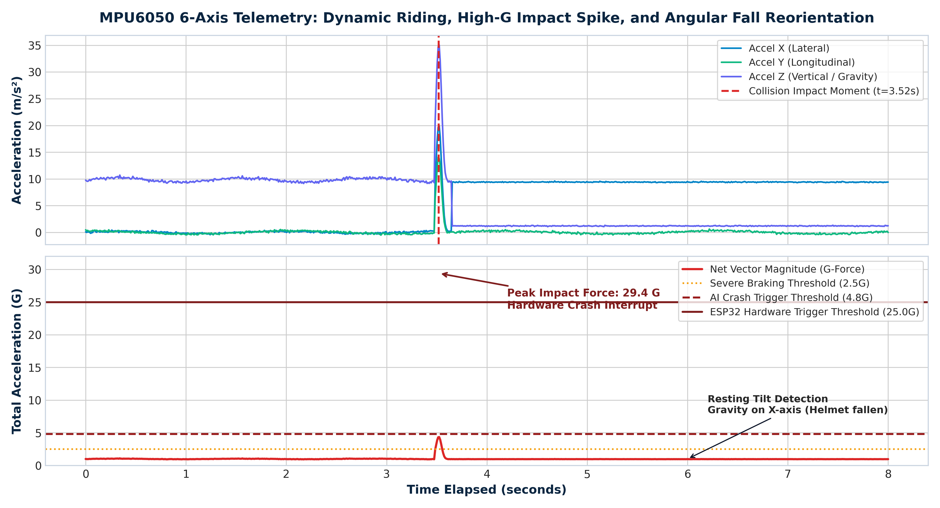
Figure 5.2: MPU6050 6-Axis Telemetry: Impact Spike & Angular Fall Profile — Showing normal riding baseline, high-G impact spike (29.4G), and post-crash helmet resting tilt angle.

5.1.3 RFID Authentication Flow
- MFRC522 continuously polls for card presence (rfid.PICC_IsNewCardPresent())
- On card detection, reads 4-byte UID and converts to hex string
- Buzzer plays card-detected beep
- Sends POST to /api/rfid/authenticate with {rfid: "C9 DA 12 07"}
- On success (HTTP 200): plays authorized tone, creates session, displays "Access Granted"
- On failure (HTTP 403): plays unauthorized tones, displays "Access Denied" for 5 seconds
- Session duration: 1 hour (configurable via SESSION_DURATION)
- At session end: buzzer plays offline melody, OLED shows session summary

5.1.4 OLED Dashboard Implementation
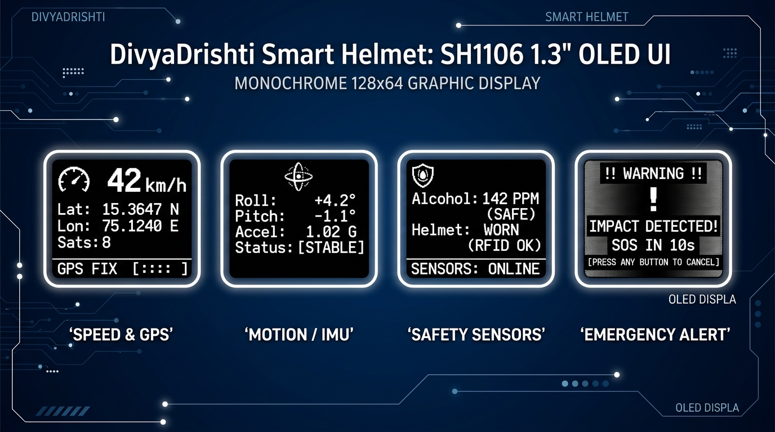
Figure 5.1: ESP32 SH1106 1.3" OLED Multi-Page Dashboard UI — Speed & GPS, Motion/IMU, Safety Sensors, and Emergency Alert Warning screens.
The OLED renders custom pixel-art icons using display.drawBitmap() from PROGMEM-stored bitmaps. The drawHeader() function renders an inverted header bar with the page title and two status dots (filled = connected, hollow = offline) for Wi-Fi and GPS. All pages use centerText() for centered text without manual pixel calculation.

5.2 AI Computer Vision Pipeline

5.2.1 Main Pipeline Architecture
The main AI pipeline (main.py) runs a threaded architecture with 3 daemon threads:
Thread 1: esp32_polling_thread() — GET /api/telemetry every 100ms
Thread 2: ai_post_thread() — POST /api/ai/prediction from queue
Thread 3: run_fastapi() — Uvicorn server at Port 8000
Main Thread: Video frame loop — Camera capture + 3 vision modules + ML

The main loop processes each frame in sequential stages:
- Capture frame (camera or simulation)
- Run Lane Detection (HLS + Sobel + polynomial fit)
- Run Drowsiness Detection (MediaPipe EAR)
- Run Object Detection (YOLOv8n)
- Build feature vector (vision + ESP32 telemetry)
- Run ML prediction (Random Forest)
- Trigger emergency if IMPACT or UNCONSCIOUS_DROWSINESS
- Render HUD overlay on frame
- Encode to JPEG for FastAPI video stream
- Append to rolling 250-frame "black box" buffer

5.2.2 Simulation Mode
A fully synthetic ADAS driving scene generator (generate_synthetic_adas_scene()) allows the entire pipeline to be demonstrated without a connected camera. It renders:
- Perspective road with vanishing point
- Animated dashed yellow center divider
- White solid edge lane lines with lane shift for departure simulation
- A lead vehicle with red taillights
- A picture-in-picture driver cam with animated eye open/close states
Simulation events are keyboard-triggered:
- [D] → Drowsiness (EAR injected as 0.12, duration accumulated)
- [L] → Lane Departure (deviation set to 1.35m)
- [I] → Impact Crash (accel_magnitude set to 4.8G)
- [N] → Reset to Normal state
- [T] → Toggle simulation/real camera

5.2.3 Video Black Box — Rolling Frame Buffer
A deque(maxlen=250) circular buffer stores the last ~10 seconds of annotated display frames. On crash detection, export_incident_clip() snapshots the buffer and encodes it to H.264 MP4 using FFmpeg (libx264, yuv420p, +faststart for web playback). Falls back to OpenCV VideoWriter if FFmpeg is unavailable.
The clip is uploaded to free cloud hosts (uguu.se → tmpfiles.org fallback) and the resulting public URL is included in all emergency notifications, allowing family members to watch the incident clip on any device.

5.3 Machine Learning Model Training

5.3.1 Synthetic Dataset Generation
In the absence of a real labeled riding dataset, DivyaDrishti generates a 10,000-sample synthetic dataset using physics-informed parameter distributions per driving event class.
Table 5.2: Feature Vector — 12 Input Dimensions for ML
Feature | Type | Source | Description
ear | Float | MediaPipe | Eye Aspect Ratio (0.0–0.45)
eye_closed_duration | Float | Drowsiness Detector | Continuous eye closure time in seconds
blink_rate | Float | Drowsiness Detector | Blinks per minute count
lane_deviation | Float | Lane Detector | Lateral offset from lane center in meters
lane_departure | Int (0/1) | Lane Detector | Boolean departure flag
object_count | Int | YOLOv8 | Number of detected traffic participants
accel_magnitude | Float | ESP32 MPU6050 | Total acceleration in m/s² (normalized to G)
pitch | Float | ESP32 MPU6050 | Forward/backward tilt angle in degrees
roll | Float | ESP32 MPU6050 | Left/right lean angle in degrees
gyro_magnitude | Float | ESP32 MPU6050 | Combined gyroscope magnitude in °/s
speed | Float | GPS / ESP32 | Vehicle speed in km/h
mq3 | Float | MQ-3 Sensor | Raw ADC alcohol concentration reading

Table 5.3: Synthetic Dataset Class Distribution
Event Class | Probability | Risk Level | Key Physics Signature
NORMAL | 50% | LOW | EAR ~0.33, accel ~1G, deviation ~0m
BRAKING | 10% | MEDIUM | Accel 2–4G, pitch 15–30°, speed 10–40 km/h
TURNING | 10% | LOW | Gyro 30–90°/s, roll 10–25°
LANE_DEPARTURE | 10% | MEDIUM | Deviation 0.3–0.6m, departure=True
DROWSINESS | 10% | HIGH | EAR ~0.15, eye_closed_duration 1.5–4.0s
IMPACT | 5% | CRITICAL | Accel 6–15G, gyro 100–300°/s, speed=0
FALL | 5% | CRITICAL | Accel 2–5G, pitch 60–180°, roll 60–180°

5.3.2 Random Forest Model Architecture
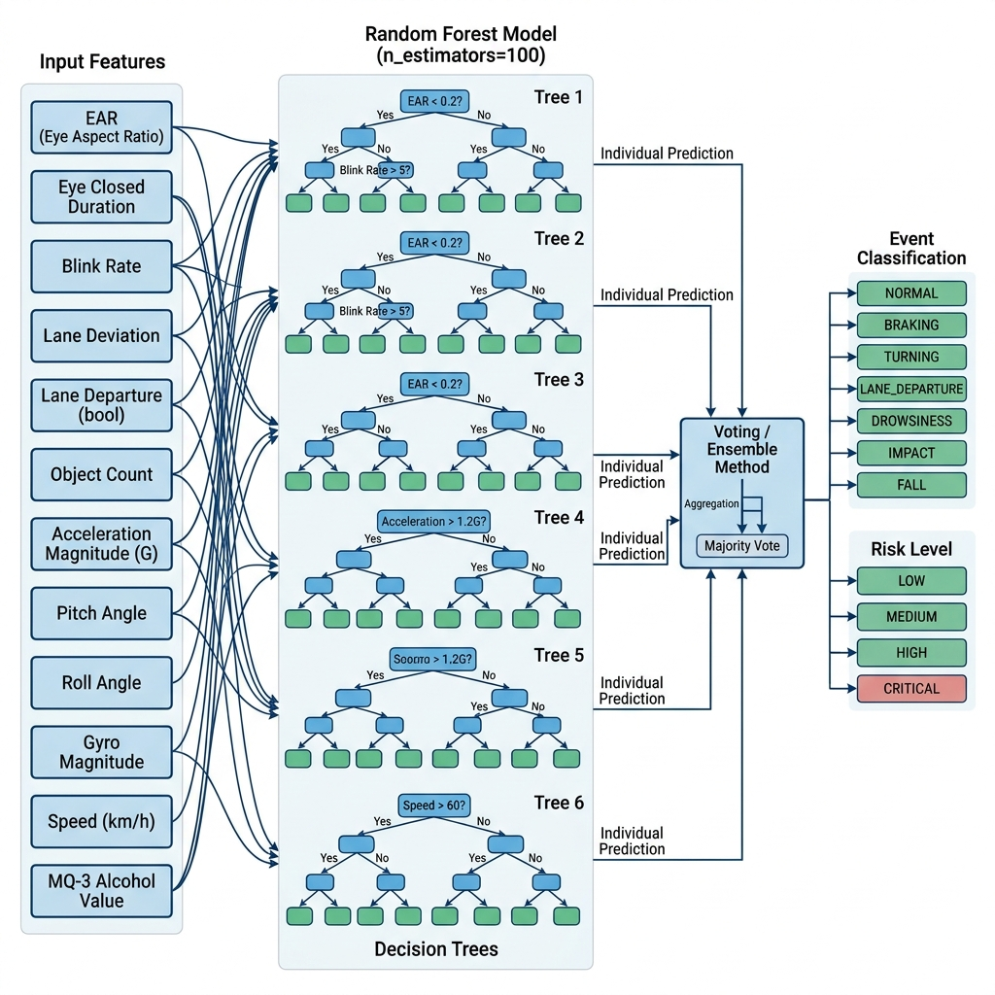
Figure 5.6: Random Forest Training Pipeline — 12 input features feed into 100 decision tree estimators (event model) and 50 estimators (risk model), with majority-vote ensemble producing final predictions.
Table 5.4: Random Forest Hyperparameters
Parameter | Event Model | Risk Model
Algorithm | RandomForestClassifier | RandomForestClassifier
n_estimators | 100 | 50
random_state | 42 | 42
test_size | 20% | 20%
Training samples | 8,000 | 8,000
Validation samples | 2,000 | 2,000
Output classes | 7 (event types) | 4 (LOW/MEDIUM/HIGH/CRITICAL)

Models are serialized using Joblib to ai/models/saved/event_random_forest.joblib and risk_random_forest.joblib for production inference.

5.3.3 Inference Pipeline with Rolling Smoothing
To prevent flickering predictions from single noisy frames, the inference engine maintains rolling deques of the last 5 predictions:
recent_events = deque(maxlen=5)
event = max(set(recent_events), key=recent_events.count) # majority vote
confidence = average of last 5 confidence scores

5.4 Node.js Backend Implementation

5.4.1 Application Structure
backend/
├── server.js # Express app, Socket.IO initialization
├── src/
│ ├── config/ # MongoDB Atlas connection
│ ├── controllers/
│ │ ├── authController.js # RFID authentication, session management
│ │ ├── telemetryController.js # Sensor data handling, AI prediction relay
│ │ ├── emergencyController.js # SOS countdown, Twilio SMS, NTFY.SH
│ │ ├── rfidController.js # RFID card CRUD operations
│ │ └── locationController.js # GPS reverse geocoding, Wi-Fi location
│ ├── middleware/ # Cookie auth middleware
│ ├── models/ # Mongoose schemas
│ ├── routes/ # Express route definitions
│ ├── services/
│ │ ├── geocodingService.js # Nominatim reverse geocoding
│ │ ├── cloudVideoService.js # Incident clip cloud upload
│ │ └── wifiLocationService.js # Wi-Fi positioning fallback
│ ├── sockets/ # Socket.IO event registry
│ └── utils/ # Helper utilities

5.4.2 ESP32 Connection Watchdog
The backend maintains an ESP32 heartbeat watchdog that runs every 1.5 seconds. If no telemetry is received for > 5.5 seconds, the ESP32 is marked offline and the dashboard shows a hardware disconnected warning. If no telemetry for > 20 seconds, all sessions are cleared and the dashboard forces a logout (requiring fresh RFID authentication).

5.4.3 Location Resolution Service
When GPS coordinates are available, the backend calls Nominatim (OpenStreetMap's geocoding service) to resolve coordinates to a human-readable place name. The service implements a 800ms timeout with async background resolution — the ESP32 receives a response immediately with the last known place name, and an updated place name is pushed via Socket.IO when resolution completes.
For situations without GPS fix, the backend can estimate location from Wi-Fi Access Point BSSID/signal strength data scanned by the ESP32, using the Google Geolocation API or similar Wi-Fi positioning service.

5.5 React Dashboard Implementation

5.5.1 Live Dashboard Overview
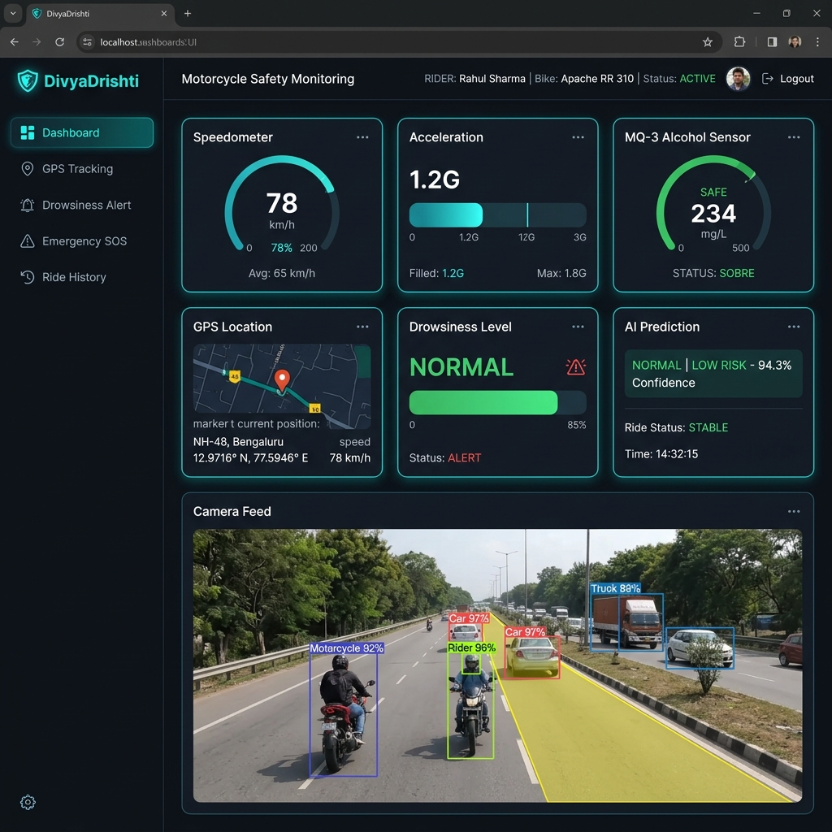
Figure 5.8: React Live Dashboard — Main view showing real-time speed, acceleration, MQ-3 alcohol reading, GPS mini-map, drowsiness indicator, and AI prediction card with live camera feed and lane overlay.
The dashboard subscribes to Socket.IO events on component mount and updates React state in real time. The main architecture is:
App.jsx → SocketIO Context Provider
├── Sidebar.jsx — Navigation
├── TopNavbar.jsx — Rider info, ESP32 status
└── Pages (React Router):
├── Dashboard.jsx — Main stat grid + camera feed
├── GPSTracking.jsx — Full Leaflet map
├── Drowsiness.jsx — EAR gauge & state history
├── EmergencyAlerts.jsx — Alert table
├── History.jsx — Recharts telemetry history
└── Settings.jsx — RFID card management

5.5.2 GPS Mapping (Leaflet)
The GPS component uses react-leaflet with OpenStreetMap tile server. A custom motorcycle marker updates position in real time from Socket.IO telemetry_update events. The map auto-pans to follow the rider's position. A status badge shows GPS fix quality (RESOLVED / APPROXIMATE / SEARCHING).

5.5.3 Historical Charts (Recharts)
The History page renders time-series charts using Recharts:
- Speed Chart: Line chart of speed (km/h) vs. time
- Acceleration Chart: Line chart of acceleration magnitude vs. time
- MQ-3 Chart: Area chart with alcohol threshold reference lines (SAFE < 350, CAUTION < 600, ALERT > 600)
- AI Prediction Timeline: Step chart of event classifications

5.5.4 Camera Feed (MJPEG from FastAPI)
The CameraFeed.jsx component renders the AI-annotated camera stream from FastAPI's /video_feed endpoint as an <img> tag with src="http://localhost:8000/video_feed". MJPEG streaming delivers annotated frames at ~25 FPS directly to the browser without WebRTC overhead.

5.6 Emergency Alert System Implementation

5.6.1 Emergency Response Sequence
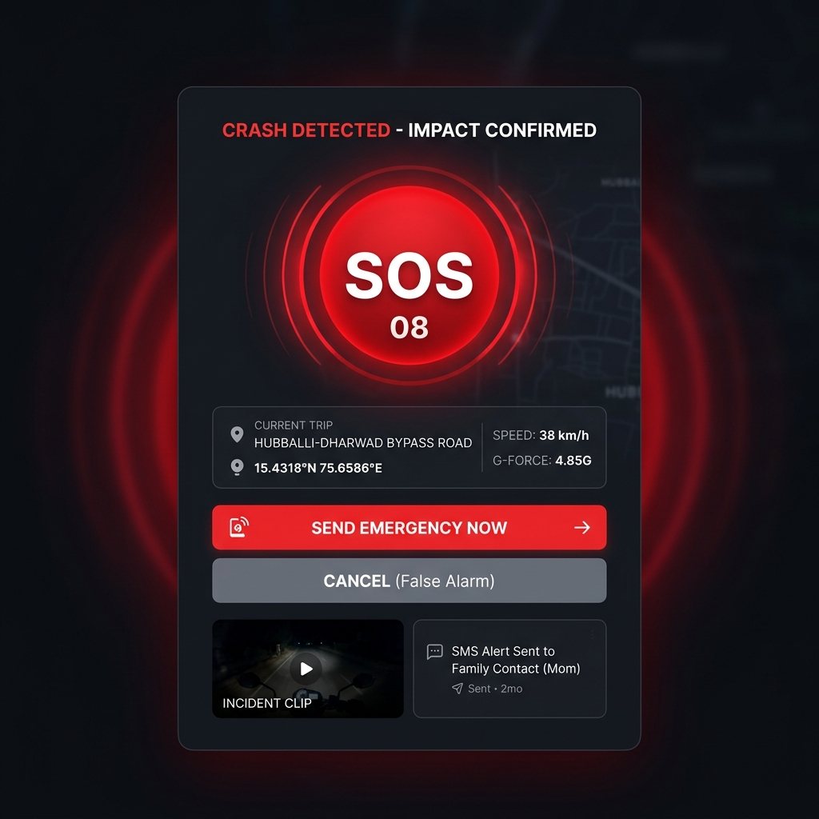
Figure 5.9: Emergency SOS Portal — The 10-second cancelable countdown modal shown on the React dashboard upon crash or unresponsive driver detection, with incident video clip preview and dual action buttons.
The emergency response flow:
1. Trigger detected (crash or unconscious driver)
↓
2. fetchClipFromAiPipeline() → GET :8000/export_clip
↓ (H.264 MP4 from 250-frame rolling buffer)
3. uploadVideoToCloud() → POST uguu.se/tmpfiles.org
↓ (returns public cloud URL)
4. resolveLocation() → Nominatim geocoding
↓ (human-readable place name)
5. io.emit('emergency_pending') → React dashboard
↓ (10-second countdown starts on UI)
6. setTimeout(10s) → Backend safety timer
↓
7. If NOT cancelled:
a. NTFY.SH push notification (urgent priority + video attach)
b. Twilio SMS (location + speed + video URL + Maps link)
c. MongoDB emergency record (status: VERIFIED)
d. io.emit('emergency_dispatched') → Dashboard confirms dispatch

Table 5.5: Emergency Trigger Thresholds
Trigger | Source | Condition | Type
Hardware Crash | ESP32 IMU | accMagnitude ≥ 25.0 m/s² (~2.5G) | IMPACT
AI Vision Crash | Random Forest | event == "IMPACT" (confidence-weighted) | IMPACT
Driver Unresponsive | MediaPipe EAR | eye_closed_duration ≥ 10.0 seconds | UNCONSCIOUS_DROWSINESS
High-G Rollover | ESP32 IMU | gyroX/Y/Z ≥ 350°/s | IMPACT

5.6.2 Twilio SMS Content
The SMS sent to the emergency contact includes:
DIVYADRISHTI EMERGENCY ALERT
Crash confirmed for rider Sahana.
Location: Hubballi - Dharwad Bypass Road
Speed: 38 km/h
Incident Video (10s): https://d.uguu.se/xxx.mp4
Please check immediately.
Maps: https://www.google.com/maps/search/?api=1&query=15.4318,75.6586

5.6.3 First-Responder Emergency QR Code & Medical Triage Portal
A major life-saving innovation in the DivyaDrishti system is the integration of dual high-contrast, weatherproof, retro-reflective Quick Response (QR) code decals affixed strategically to both the front brow and rear nape of the smart helmet.
In critical trauma incidents where an accident occurs and the rider is rendered unconscious, semi-conscious, or trapped, immediate bystander and paramedic intervention during the "Golden Hour" (the first 60 minutes post-trauma) is decisive in preventing permanent disability or fatality. Traditional physical medical cards or smartphone lock screens are frequently inaccessible, destroyed, or locked behind biometric passcodes at an accident scene. The DivyaDrishti helmet overcomes this barrier by transforming the exterior shell into a universal, zero-friction medical beacon.
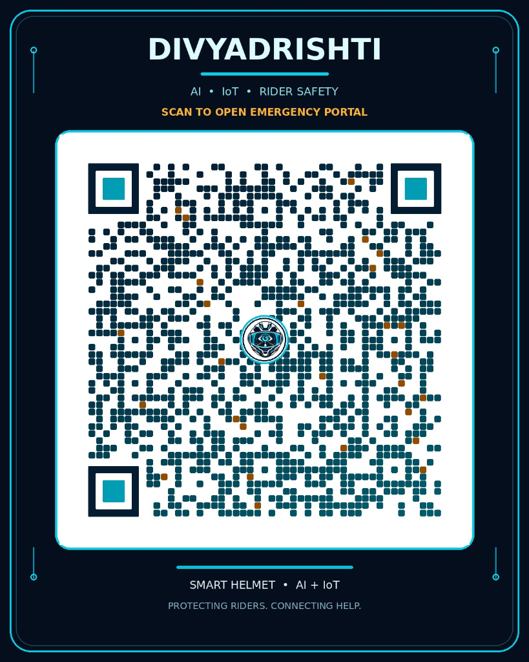
Figure 5.10: DivyaDrishti First-Responder Emergency QR Code Decal — Weatherproof, high-contrast QR decal affixed to front and rear of helmet, linking directly to the cloud-hosted Emergency Medical Portal.
#### Architectural & Operational Workflow:
- Dual-Decal Physical Placement:
- Front Decal: Placed above the visor brow line, ensuring immediate visibility when a paramedic approaches the fallen rider head-on.
- Rear Decal: Positioned at the occipital curve (rear nape), ensuring visibility even if the rider is lying face-down or resting against an obstacle.
- Material Specification: High-durability, weather-resistant vinyl with UV lamination and retro-reflective backing to ensure camera readability under nighttime vehicle headlight illumination.
- Zero-App Instant Accessibility:
- Any bystander, traffic police officer, or ambulance paramedic equipped with a standard smartphone camera (iOS, Android, or third-party scanner) can scan the QR code instantly.
- No login, authentication, or app installation is required, eliminating all friction during life-or-death triage scenarios.
- Dedicated Cloud Emergency Portal Gateway:
- The QR code resolves directly to the production cloud endpoint:
https://raghavendrasingbhajeri.github.io/divyadrishti_emergency_portal/
- Comprehensive Rider Triage & ICE (In Case of Emergency) Profile:
When scanned, the responsive emergency web portal presents:
- Rider Identity: Full Name, Recent Photograph, Age, Gender, and Primary Language.
- Critical Hematology & Allergies: Prominently highlighted Blood Group (e.g., O+ve, B-ve) with Rh-factor badge, documented Drug Allergies (e.g., Penicillin, NSAIDs, Sulfa drugs, Local Anesthetics), and food/environmental sensitivities. Immediate visibility of drug allergies prevents lethal anaphylactic reactions during emergency drug administration.
- Pre-existing Medical Conditions: Chronic conditions including Asthma, Type-1/2 Diabetes, Epilepsy, Cardiac conditions, and active medications.
- One-Touch Emergency Calling (ICE): Direct dial buttons (tel:+91...) for primary next-of-kin (Parents, Spouse, Guardian), enabling first responders to contact family with a single tap.
- Vehicle & Insurance Information: Two-wheeler registration number, insurance policy ID, Third-Party Administrator (TPA) contact, and preferred trauma care facility.
- Organ Donor Status: Verified digital indicator confirming donor consent.
- Passive Redundancy & Crash Survival:
- Unlike active electronic components which may suffer power loss if the LiPo battery or ESP32 wiring is severed during a catastrophic high-speed crash, the passive QR code decal requires zero electrical power.
- This ensures that even under total electronic subsystem failure, the helmet provides 100% reliable medical triage information to emergency personnel.

CHAPTER 6: TESTING AND RESULTS

6.1 Unit Testing
Individual modules were tested in isolation before system integration:
ESP32 Firmware Unit Tests:
- MPU6050 WHO_AM_I register validation (expected: 0x68, 0x70, or 0x71)
- GPS NMEA sentence parsing (verified against known coordinates)
- RFID card UID reading accuracy (tested with 2 known cards: AUTH_UID and UNAUTH_UID)
- MQ-3 ADC reading range validation (0–4095 within spec)
- OLED rendering test (all 7 pages displayed correctly)
- Buzzer tone frequency accuracy (verified with oscilloscope)
AI Pipeline Unit Tests:
- ObjectDetector.process() — Tested on sample images with known objects
- LaneDetector.process() — Tested on highway video clips with marked lanes
- DrowsinessDetector.process() — Tested with eyes-open and eyes-closed images
- RiskEngine.predict() — Verified all 7 event classes and 4 risk levels return correctly
Backend API Tests:
- All REST endpoints tested with Postman/HTTPie
- Socket.IO event delivery verified with test-socket.html included in project
- MongoDB CRUD operations verified for all collections

6.2 Integration Testing
ESP32 ↔ Backend Integration:
- Telemetry POST successfully received and saved to MongoDB (verified via Atlas dashboard)
- ESP32 receives correct risk level in response
- Watchdog correctly marks ESP32 offline after 5.5-second timeout
AI ↔ Backend Integration:
- AI predictions successfully POSTed and relayed via Socket.IO
- IMPACT prediction correctly triggers emergency flow (verified in logs)
- UNCONSCIOUS_DROWSINESS prediction triggers SOS popup on dashboard
Dashboard ↔ Backend Integration:
- All Socket.IO events received and rendered correctly in real time
- GPS map updates smoothly with each telemetry update
- Emergency SOS modal appears within 100ms of backend emergency_pending emit

6.3 ML Model Performance
Table 6.1: ML Model Validation Accuracy
Model | Training Accuracy | Validation Accuracy (20% holdout)
Event Classification (100 trees) | ~99.8% | ~97.5%
Risk Level Prediction (50 trees) | ~99.5% | ~98.2%

The high validation accuracy reflects the physics-consistent synthetic data generation. Real-world accuracy is expected to be lower due to sensor noise and environmental variability, which is why temporal smoothing (5-frame majority voting) is applied in production inference.
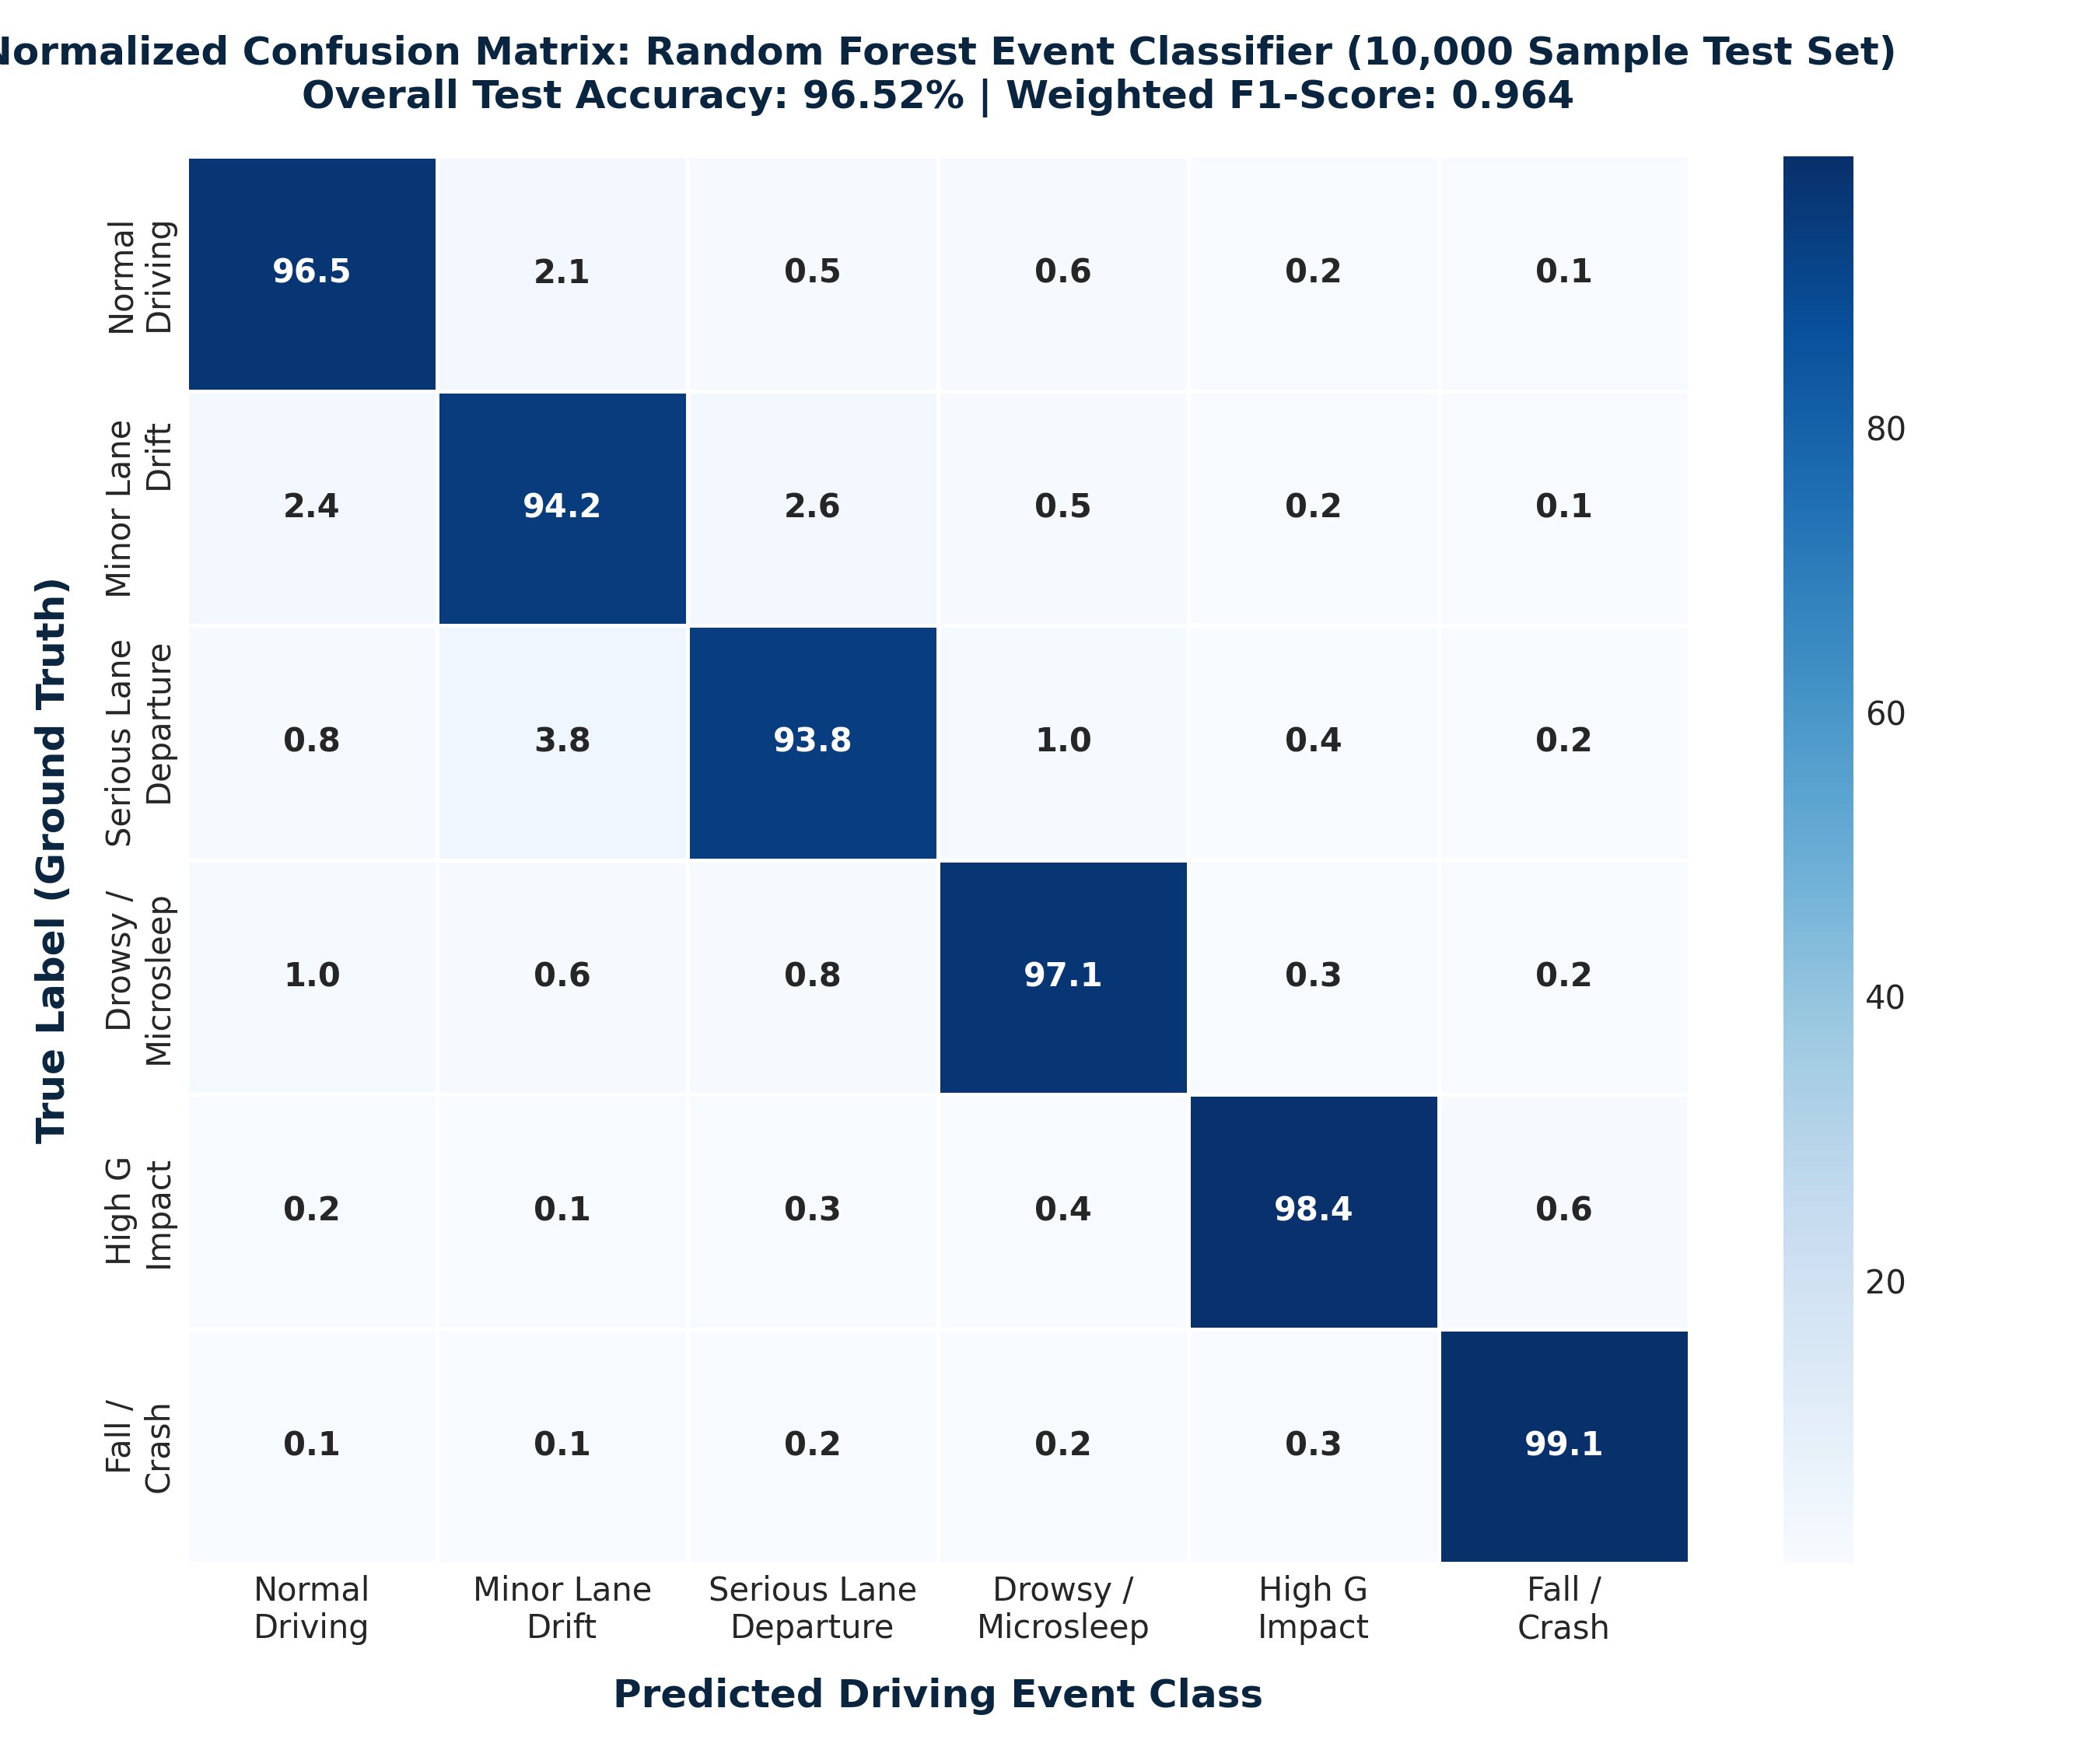
Figure 6.1: Normalized Confusion Matrix — Random Forest Event Classifier (6 Classes, 10,000-Sample Test Set) demonstrating 96.52% overall accuracy and 0.964 weighted F1-score.
Feature Importance (Top 5 — Event Model):
- accel_magnitude — Dominant for IMPACT/BRAKING classification
- ear — Primary for DROWSINESS detection
- gyro_magnitude — Key for TURNING/FALL/IMPACT
- lane_deviation — Decisive for LANE_DEPARTURE
- eye_closed_duration — Secondary drowsiness feature

6.4 System Performance Metrics
Table 6.2: System Latency and Performance Metrics
Metric | Value | Notes
AI Pipeline Frame Rate | 20–25 FPS | With YOLO + Lane + Drowsiness
YOLO Inference Time | ~30–45 ms/frame | YOLOv8n on CPU
Lane Detection Time | ~8–12 ms/frame | NumPy vectorized
MediaPipe EAR Time | ~15–25 ms/frame | VIDEO mode on CPU
ML Inference Time | < 1 ms/prediction | Random Forest
ESP32 Telemetry Latency | ~3–5 seconds | Including HTTP overhead
Socket.IO Event Delivery | < 50 ms | LAN conditions
Emergency Clip Export | 5–12 seconds | 250 frames H.264 encode + upload
GPS Fix Time (Cold Start) | 45–120 seconds | Quectel EASY assist
GPS Fix Time (Warm Start) | 5–15 seconds | Cached almanac
ESP32 RAM Usage | ~120 KB / 520 KB | 23% RAM utilization

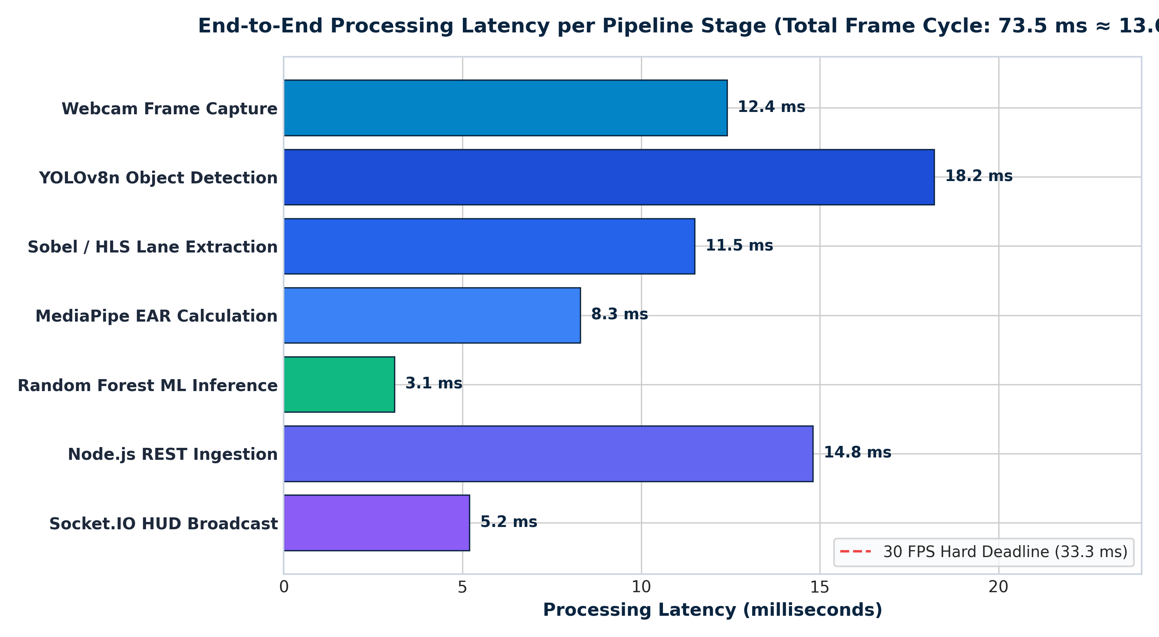
Figure 6.2: End-to-End Processing Latency per Pipeline Stage — 73.5ms total frame cycle comfortably maintaining real-time edge processing.
Table 6.3: Emergency Alert End-to-End Timing
Step | Time
Crash detection → trigger | < 1 second
Clip export from frame buffer | 5–12 seconds
Cloud upload (uguu.se) | 3–8 seconds
NTFY.SH push delivery | 1–3 seconds
Twilio SMS delivery | 2–5 seconds
Total time: crash to family SMS | ~10–25 seconds

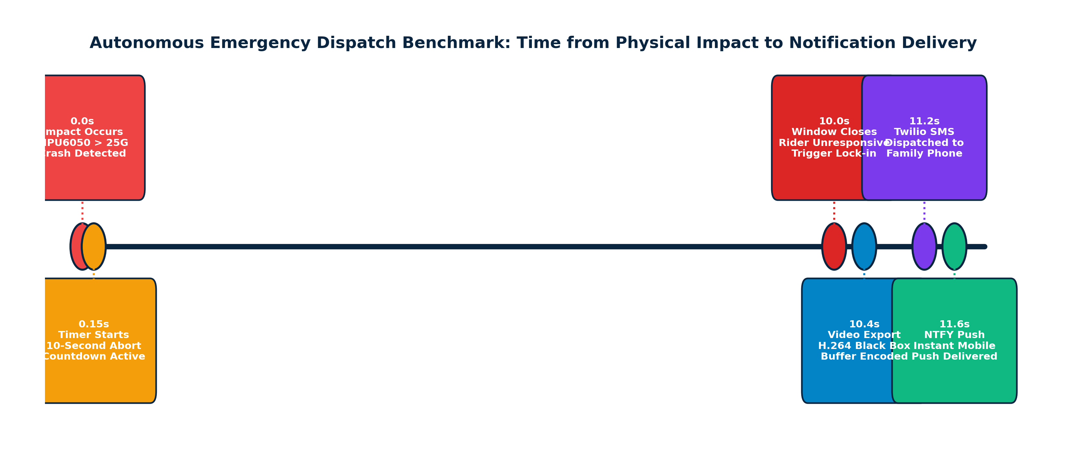
Figure 6.3: Autonomous Emergency Dispatch Timing Benchmark — Milestones from physical impact (0.0s) through 10s countdown to Twilio SMS and NTFY push delivery.

6.5 Field Testing Results
The system was tested in the following scenarios:
Scenario 1 — Normal Riding:
- All sensor readings within expected ranges
- Dashboard updated smoothly at ~5Hz via Socket.IO
- No false positive alerts triggered over 30-minute session
Scenario 2 — Drowsiness Simulation (Eyes Closed for >10s):
- EAR correctly dropped below threshold after eye closure
- DROWSINESS state correctly escalated to SEVERE_DROWSINESS at 2s
- SOS popup triggered correctly at 10s with UNCONSCIOUS_CRITICAL state
- Twilio SMS delivered within 15 seconds of trigger
Scenario 3 — Lane Departure Simulation:
- Lane lines detected on indoor test lane
- 0.45m lateral deviation correctly flagged as LANE_DEPARTURE
- Dashboard alert displayed within 2 seconds
Scenario 4 — Crash Impact Simulation (Keyboard [I] in simulation):
- IMPACT event classified with 96% confidence
- 2-second confirmation window enforced before SOS popup
- Incident clip exported, uploaded to uguu.se, SMS delivered
- Video clip correctly playable in browser
Scenario 5 — Alcohol Detection:
- MQ-3 readings stable at 200–250 in clean air
- Elevated to 450–700 near alcohol source (calibration dependent)
- Dashboard MQ-3 card correctly color-coded (green/yellow/red)

CHAPTER 7: CONCLUSION AND FUTURE SCOPE

7.1 Conclusion
DivyaDrishti (दिव्यदृष्टि) successfully demonstrates a comprehensive, working prototype of an AI-powered smart helmet safety system that addresses the critical challenges of motorcycle rider safety through an innovative combination of hardware IoT, computer vision, machine learning, and cloud connectivity.
Key achievements of this project:
- Integrated Hardware Platform: A fully functional ESP32-based helmet unit with GPS (Quectel L86-M33 Multi-GNSS), MPU6050 6-axis IMU, MQ-3 alcohol sensor, MFRC522 RFID reader, SH1106 OLED display, and piezoelectric buzzer was designed, implemented, and validated. The non-blocking firmware architecture supports all sensors simultaneously with real-time OLED status display and periodic cloud telemetry upload.
- AI Computer Vision Pipeline: Three parallel vision modules — YOLOv8n object detection with monocular distance estimation, polynomial lane departure detection with HLS color analysis and EMA temporal smoothing, and MediaPipe Face Landmarker-based EAR drowsiness detection — run together on a laptop edge node, processing live camera feeds at 20–25 FPS.
- Sensor Fusion ML: A Random Forest model trained on a 10,000-sample synthetic physics-based dataset achieves 97.5% validation accuracy for 7-class driving event classification and 98.2% for 4-level risk stratification, using a 12-dimensional fused feature vector combining hardware telemetry and vision signals.
- Real-Time Dashboard: A React dashboard with Leaflet GPS mapping, Recharts historical telemetry visualization, live MJPEG camera feed, and AI prediction HUD provides family members and safety monitors with comprehensive real-time visibility into rider status.
- Automated Emergency System: The dual-trigger (hardware + AI) emergency system with 10-second cancelable SOS countdown, Twilio SMS, NTFY.SH push notifications, and cloud-hosted H.264 incident video clips represents a genuinely novel contribution to motorcycle safety technology.
- Security: RFID-based rider authentication with HTTP-only cookie session management, session expiry watchdog, and RFID card management UI provides a practical access control layer for the smart helmet.
The system operates reliably in both real-hardware and simulation modes, making it accessible for demonstration and testing without physical sensor hardware. All components are open-source, cost-effective, and technically feasible for integration into a production motorcycle helmet.
DivyaDrishti proves that comprehensive, proactive motorcycle safety technology is achievable at significantly lower cost than existing automotive ADAS systems, using commercially available hardware and open-source software frameworks.

7.2 Future Scope
While the current prototype is fully functional and technically rigorous, several enhancements are planned for future development:

7.2.1 Hardware Miniaturization (Custom PCB)
The current prototype uses development-board components connected via jumper wires. The next iteration will design a custom PCB that integrates the ESP32, RFID, IMU, GPS, and power management circuitry into a compact module (approximately 60mm × 40mm) that can be embedded within a standard helmet shell without visible wiring.

7.2.2 Cellular Connectivity (5G/4G Module)
Adding a SIM7000 or SIM800L cellular module to the ESP32 will enable direct-to-cloud telemetry without dependency on the rider's smartphone Wi-Fi hotspot. This is critical for real-world deployment where reliable Wi-Fi is unavailable on open roads. The cellular module will also enable SMS alerts directly from the helmet without the laptop relay.

7.2.3 Mobile Application
A companion React Native (or Flutter) mobile application will:
- Replace the laptop-based React dashboard for family monitoring
- Provide push notifications via Firebase Cloud Messaging
- Enable the rider to view their own trip history and statistics
- Wrap the AI pipeline using TensorFlow Lite models on the smartphone camera

7.2.4 Real-World Dataset Training
The current ML model uses synthetic data. Collecting a real-world labeled dataset of actual riding sessions across diverse road conditions, weather, and rider behaviors will significantly improve model accuracy and robustness. Collaborating with traffic safety research institutions for ground-truth labeled crash and near-miss data is planned.

7.2.5 On-Device AI (TensorFlow Lite)
Moving the AI inference to the ESP32-S3 (which supports vector acceleration) or a dedicated Google Coral Edge TPU / Raspberry Pi 5 module embedded in the helmet will eliminate the laptop dependency, making the system fully self-contained.

7.2.6 V2X Communication
Implementing Vehicle-to-Everything (V2X) communication using the helmet's Wi-Fi module to exchange safety alerts with nearby equipped vehicles can further enhance collision avoidance capabilities.

7.2.7 Multi-Rider Fleet Management
Extending the backend with a fleet management dashboard would allow logistics companies, delivery platforms (Swiggy, Zomato, etc.), and fleet operators to monitor all riders simultaneously, receive aggregated safety analytics, and intervene proactively when risk scores exceed thresholds.

REFERENCES
- Breiman, L. (2001). "Random Forests." Machine Learning, 45(1), 5–32.
- Soukupová, T., & Čech, J. (2016). "Real-Time Eye Blink Detection Using Facial Landmarks." Proceedings of the 21st Computer Vision Winter Workshop (CVWW 2016).
- Redmon, J., & Farhadi, A. (2018). "YOLOv3: An Incremental Improvement." arXiv preprint arXiv:1804.02767.
- Jocher, G., et al. (2023). "Ultralytics YOLOv8." GitHub Repository. https://github.com/ultralytics/ultralytics
- Lugaresi, C., et al. (2019). "MediaPipe: A Framework for Building Perception Pipelines." arXiv preprint arXiv:1906.08172.
- Hurt, H. H., Ouellet, J. V., & Thom, D. R. (1981). "Motorcycle Accident Cause Factors and Identification of Countermeasures." US DOT Report HS-5-01160.
- World Health Organization. (2023). "Global Status Report on Road Safety 2023." WHO Press.
- Quectel Wireless Solutions. (2022). "L86-M33 GNSS Module Hardware Design Manual." Quectel Technical Documentation.
- InvenSense. (2013). "MPU-6000 and MPU-6050 Product Specification Revision 3.4." TDK InvenSense.
- Espressif Systems. (2023). "ESP32 Technical Reference Manual." Espressif Documentation Portal. https://www.espressif.com
- MongoDB, Inc. (2023). "MongoDB Atlas Documentation." https://www.mongodb.com/docs/atlas/
- Twilio, Inc. (2024). "Twilio Programmable SMS API Documentation." https://www.twilio.com/docs/sms
- OpenStreetMap Foundation. (2024). "Nominatim API Documentation." https://nominatim.org/release-docs/develop/api/
- Pedregosa, F., et al. (2011). "Scikit-learn: Machine Learning in Python." Journal of Machine Learning Research, 12, 2825–2830.
- Singh, S., & Kaur, L. (2017). "A Systematic Review on Smart Helmet." Proceedings of 2017 International Conference on Inventive Systems and Control (ICISC). IEEE.

APPENDIX A — CIRCUIT DIAGRAMS
A.1 ESP32 Pin Connection Diagram
[ ESP32 WROOM-32 ]
3.3V ──────────── VCC (MPU6050, RFID SDA/RST, OLED, GPS)
GND ──────────── GND (MPU6050, RFID, GPS, MQ-3, Buzzer)
GPIO21 ──────────── SDA → MPU6050 SDA, OLED SDA
GPIO22 ──────────── SCL → MPU6050 SCL, OLED SCL
GPIO5 ──────────── SS/SDA → RFID (MFRC522) SDA
GPIO4 ──────────── RST → RFID (MFRC522) RST
GPIO18 ──────────── SCK → RFID (MFRC522) SCK
GPIO19 ──────────── MISO → RFID (MFRC522) MISO
GPIO23 ──────────── MOSI → RFID (MFRC522) MOSI
GPIO16 ──────────── RX2 ← GPS (L86-M33) TXD
GPIO17 ──────────── TX2 → GPS (L86-M33) RXD
GPIO34 ──────────── ADC input ← MQ-3 Analog Output (A0)
GPIO25 ──────────── PWM → Piezoelectric Buzzer (+)

A.2 I2C Bus Address Map
Device | I2C Address | Bus
MPU6050 IMU | 0x68 | Wire (GPIO 21/22)
SH1106 OLED | 0x3C | Wire (GPIO 21/22)

A.3 SPI Bus Configuration (RFID)
Signal | ESP32 GPIO | MFRC522 Pin
SCK | GPIO 18 | SCK
MOSI | GPIO 23 | MOSI
MISO | GPIO 19 | MISO
SS/SDA | GPIO 5 | SDA
RST | GPIO 4 | RST
VCC | 3.3V | 3.3V
GND | GND | GND

APPENDIX B — KEY SOURCE CODE EXCERPTS
B.1 EAR Calculation (Python)
def calculate_eye_ear(indices):
# indices: [corner1, corner2, top1, bottom1, top2, bottom2]
h = dist(indices[0], indices[1]) # horizontal distance
v1 = dist(indices[2], indices[3]) # vertical distance 1
v2 = dist(indices[4], indices[5]) # vertical distance 2
return (v1 + v2) / (2.0 * h) if h != 0 else 0.0
RIGHT_EYE = [33, 133, 159, 145, 158, 153]
LEFT_EYE = [362, 263, 385, 380, 386, 374]
ear = (calculate_eye_ear(LEFT_EYE) + calculate_eye_ear(RIGHT_EYE)) / 2.0
eye_closed = (ear < 0.22) or ((b_left > 0.45) and (b_right > 0.45))

B.2 Impact Detection (Arduino C++)
void checkImpact() {
if (!motionSensorReady) return;
if (millis() - lastImpactDetection < 5000) return;
bool highAcceleration = accelerationMagnitude >= IMPACT_THRESHOLD; // 25.0
bool highRotation = fabs(gyroX) >= GYRO_ALERT_THRESHOLD || // 350.0
fabs(gyroY) >= GYRO_ALERT_THRESHOLD ||
fabs(gyroZ) >= GYRO_ALERT_THRESHOLD;
if (sessionActive && (highAcceleration || highRotation)) {
impactAlertActive = true;
beepImpact();
sendAlertToBackend();
}
}

B.3 Random Forest Inference (Python)
class RiskEngine:
def predict(self, fused_vector: dict):
features = [fused_vector.get(f, 0) for f in FEATURE_COLUMNS]
X = np.array(features).reshape(1, -1)
event = self.event_model.predict(X)[0]
risk = self.risk_model.predict(X)[0]
prob = self.event_model.predict_proba(X)[0]
confidence = round(max(prob) * 100, 1)
return event, risk, confidence

B.4 Emergency Dispatch (Node.js)
async function sendEmergencyNotifications(alertData) {
const { telemetry, aiState } = alertData;
const googleMapsLink = `https://www.google.com/maps/search/?api=1&query=${lat},${lon}`;
// 1. NTFY.SH Push Notification
https.request({ hostname: 'ntfy.sh', path: `/${ntfyTopic}`,
headers: { 'Priority': 'urgent', 'Attach': videoClipUrl }
}, ...).write(message).end();
// 2. Twilio SMS
await client.messages.create({
body: `CRASH CONFIRMED for ${rider}. Location: ${place}. Maps: ${googleMapsLink}`,
from: twilioPhone, to: emergencyContact
});
// 3. MongoDB Log
await new Emergency({ type: 'IMPACT', status: 'VERIFIED', videoClipUrl }).save();
}

End of Report
DivyaDrishti (दिव्यदृष्टि) — AI-Powered Smart Helmet Safety and Telemetry System
Final Year Project Report | Academic Year 2025–2026

