**SDM College of Engineering and Technology**

Dhavalagiri, Dharwad-580 002. Karnataka State. India.

Email: [principal@sdmcet.ac.in](mailto:principal@sdmcet.ac.in), [cse.sdmcet@gmail.com](mailto:cse.sdmcet@gmail.com)

Ph: 0836-2447465/ 2448327 Fax: 0836-2464638 Website: sdmcet.ac.in

**Department**

**of**

**COMPUTER SCIENCE AND ENGINEERING**

**ASSIGNMENT-1**

**[18UCSE508- ADVANCED OBJECT ORIENTED PROGRAMMING]**

Course Teacher: Prof. Indira R Umarji



**2022- 2023**

Submitted by

By

**Sahana Kulkarni**

**2SD20CS089**

**5th Semester B division**

**1.Problem definition:**

1. Write a Java program to generate and handle any three built-in exceptions and display appropriate error messages.

**Java Program:**

public class Assignment1{

public static void main(String[] args){

int a=10,b=5,c=5;

String s=null;

int d[]=new int[5];

try{

System.out.println(a/(b-c));

} catch(ArithmeticException ae){

System.out.println("division by zero error"+ae);

}

try{ System.out.println(s.length());

} catch(NullPointerException ne){

System.out.println("String is null"+ne);

}

try{

d[10]=50;

} catch(ArrayIndexOutOfBoundsException aoe){

System.out.println("array index exceeded"+aoe);

}

}

}

**OUTPUT**:

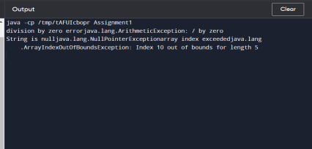

**2.Problem definition:**

Write a Java program to read an integer and check whether the number is prime or not. If negative number is entered, throw an exception NegativeNumberNotAllowedException and if entered number is not prime, then throw NumberNotPrimeException.

**Java Program:**

import java.util.Scanner;

import java.io.*;

class notPrime extends Exception{

public String toString(){

return "Not a Positive number";

}

}

class checkPrime{

public static void main(String[] args){

Scanner sc=new Scanner(System.in);

System.out.println("enter a number");

int n=sc.nextInt();

try{

if(n>0){

for(int i=2;i<=n/2;i++){

if(n%i==0){ System.out.println(n+" is not a prime number");

}

else{ System.out.println(n+" is a prime number");

}

}

}

else{

throw new notPrime();

}

}catch(notPrime np){

System.out.println(np.toString());

}

}

}

**OUTPUT:**

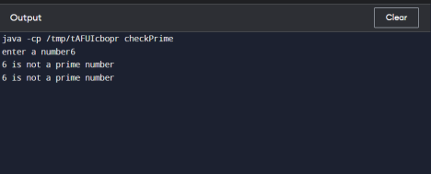

**3.Problem definition:**

 Write a Java program to perform the following operations:

a) Read a line of text

b) Search for a sub-string SDMCET (case insensitive search)

c) If found, then print success message

d) Otherwise throw an exception SubStringNotFoundException with appropriate message

**Java Program:**

import java.io.BufferedReader;

import java.io.FileReader;

import java.io.IOException;

public class SubString {

public static void main(String args[]) throws IOException {

//File f=new File("sdmcet.txt");

FileReader f=new FileReader("Sdmcet.txt");

BufferedReader br= new BufferedReader(f);

String s1="SDMCET";

String s2="";

while((s2=br.readLine())!=null) {

try {

if(s2.contains(s1)) {

System.out.println("SDMCET string found succesfully at position:"+s2.indexOf(s1) );

}

else {

throw new StringNotFoundException("String not found");

}catch(StringNotFoundException se) {

se.printStackTrace();

}

}

}

}

class StringNotFoundException extends Exception{

private String se;

StringNotFoundException(String s){

this.se=s;

}

**OUTPUT:**

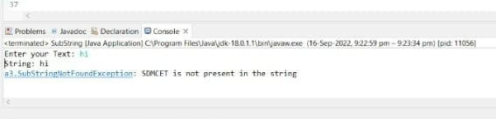

**4. Problem definition:**

4.Write a Java program to perform the following operations:

a) Create a file named Alphabets.txt and insert appropriate data into it

b) Read the file and copy all the consonants into another file named Consonants.txt.

 c) If vowel is encountered, throw an exception VowelNotAllowedException and continue until end of file

**Java Program:**

import java.util.*;

import java.io.*;

class Assignment4 {

public static void main(string[] args){

try{

FileInputStream fin=new

FileInputStream("C:\Users\pooja\Documents\5th sem\Alphabet.txt");

FileOutputStream fout=new FileOutputStream("C:\Users\pooja

\Documents\5th sem\consonant.txt");

int ch;

while(ch=fin.read()!=-1){

if(ch=='a'||ch=='e'||ch=='i'||ch=='o'||ch=='u'){

throw new vowelNotAllowedException();

}

else

fout.write(ch);

}

}catch(vowelNotAllowedException e){

System.out.println(e.toString());

}

}

}

class vowelNotAllowedException extends Exception{

public String toString(){

return "vowels are not allowed";

}

}

**OUTPUT:**

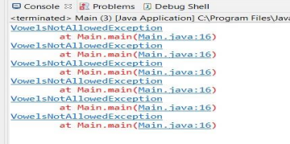

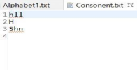

**5.Problem Definition:**

Write a Java program to implement the following scenario:

a) Create a file named Integers.txt and insert n-random integers into it.

b) Create three threads T1, T2 and T3 that read n/3 integers in sequence of occurrenceof  numbers from the file and sort the read n/3 integers.

c) Thread T4 waits for all the threads T1, T2 and T3 to complete sorting, then sorts and outputs the entire list of sorted numbers to another file named SortedIntegers.txt

**Java Program:**

import java.io.File;

import java.io.FileNotFoundException;

import java.io.FileWriter;

import java.io.IOException;

import java.util.Arrays;

import java.util.Scanner;

class five

{

private static int arr[];

public static void main(string []args) throws

FileNotFoundException,IOException,InterruptedException

{

 File ipFile = new File("Integers.txt");

 File opFile = new File("SortedIntegers.txt");

 FileWriter opWriter = new FileWriter(opFile);

 Scanner sc = new Scanner(ipFile);

 int size = sc.nextInt();

 arr = new int[size];

 int i = 0;

 while (sc.hasNext()) {

 arr[i++] = sc.nextInt();

 }

 Thread T1 = new Thread() {

 public void run() {

 ThreadSorting(arr, 0, (size / 3) - 1);  }

 };

 Thread T2 = new Thread() {

 public void run() {

 ThreadSorting(arr, (size / 3), ((size / 3) * 2) - 1);  }

 };

 Thread T3 = new Thread() {

 public void run() {

 ThreadSorting(arr, ((size / 3) * 2), (size - 1));  }

 };

 Thread T4 = new Thread() {

 public void run() {

 ThreadSorting(arr, 0, size - 1);

 }

 };

 T1.start();

 T1.join();

 T2.start();

 T2.join();

 T3.start();

 T3.join();

 T4.start();

 T4.join();

 for (int num : arr) {

 opWriter.append(String.valueOf(num) + " ");  }

 opWriter.close();

 }

 public static void ThreadSorting(int arr[], int start, int end) {  int tempArr[] = new int[end - start + 1];

 int tempIndex = 0;

 for (int i = start; i <= end; i++) {

 tempArr[tempIndex++] = arr[i];

 }

 Arrays.sort(tempArr);

 int index = start;

 for (int n : tempArr) {

 arr[index++] = n;

 }

 }

}

OUTPUT:

Output is stored in txt file.

Integer.txt : 20 46 12 7 94 35

SortedInteger.txt : 7 12 20 35 46 94