Personalised Skincare Recommendation in the Beauty & Wellness Industry
Week 1 Task: Data Science Orientation & Problem Definition
Data Science with Python Analytics Internship
Prepared by: SAHANA H S
November 2026
Code: github.com/Sahanahs-2005/beauty-wellness-data-science

Executive Summary
This report defines a data science problem in the beauty and wellness industry and sets out how it will be investigated. The chosen problem is personalised skincare product recommendation. Online shoppers choose from thousands of products and often buy items that do not suit their skin type, which lowers satisfaction and weakens brand loyalty.
The project will use publicly available skincare review data to test whether customer attributes (such as skin type) and product attributes (such as category, price, brand and ingredients) can predict whether a customer will recommend a product. It will also test whether a similarity-based recommender gives more relevant suggestions than a popularity-only baseline. This report presents the business context, industry research, problem statement, research questions and hypotheses, required data, analysis plan and the rationale for the chosen methods.

1. Introduction and Business Context
The beauty and wellness industry covers skincare, haircare, colour cosmetics, fragrance, personal care and wellness products and services. It is one of the largest consumer sectors in the world. IMARC Group estimated the global beauty and personal care products market at USD 552.0 billion in 2025, with a forecast of USD 804.3 billion by 2034, and reported skin care as the leading segment with over 27.7% market share [1][2].
Market size estimates differ between research firms because each defines the market differently. For example, Precedence Research values the 2025 market at USD 639.47 billion and Global Market Insights values the narrower cosmetics and personal care products market at USD 498.1 billion [3][4]. Whatever the exact figure, all sources agree that the market is large and growing.
Shopping is also moving online. IMARC Group puts the global online beauty and personal care market at USD 70.3 billion in 2025, forecast to reach USD 150.1 billion by 2034, growing at 8.53% a year from 2026 to 2034 [5]. Online shoppers cannot try products before buying, so they rely on ratings, reviews, influencers and social media. This creates a data-rich environment in which data science can help customers choose better and help brands understand what drives satisfaction.

2. Industry Trends and Research
The following trends are widely discussed in industry reports and trade press. Each is linked to the problem addressed in this project.
Trend | What is happening | Link to this project
Personalisation | Customers expect products matched to their skin type, concerns and goals, and brands are adopting skin analysis tools and quizzes. | Directly motivates a recommendation system that uses skin type and preferences.
Social media influence | Platforms drive product discovery, and viral trends can change demand quickly. IMARC lists the spread of social media as a growth driver [1]. | Reviews and ratings are a measurable record of customer opinion.
Ingredient transparency and clean beauty | Customers increasingly read ingredient lists and avoid ingredients they consider harmful. | Ingredients are a key product feature for prediction and similarity.
Growth of online retail | Online sales are growing faster than the overall market [5]. | Online platforms produce the review data needed for analysis.
Wellness convergence | Skincare is increasingly connected with sleep, nutrition, stress and overall health. | Suggests future extensions beyond skincare.
Sustainability | Eco-friendly packaging and ethical sourcing influence brand perception. | Possible additional features in later work.

2.1 Academic background
Recommender systems are a well-established area of research. Koren, Bell and Volinsky (2009) describe matrix factorisation, a widely used technique that learns hidden customer and product factors from past ratings [6]. Similarity-based (collaborative filtering) methods recommend items liked by customers who resemble the target customer. These ideas are used in streaming, e-commerce and retail, and apply naturally to skincare, where outcomes depend on the match between product and skin type.

3. Problem Statement
Online skincare shoppers choose from thousands of products and often buy ones that do not suit their skin type, which leads to low satisfaction. Using publicly available skincare review data, this project will investigate whether customer attributes (skin type, skin tone) and product attributes (category, price, brand, ingredients) can predict whether a customer will recommend a product. It will also test whether a similarity-based recommender gives more relevant suggestions than a popularity-only baseline, measured by precision@k.
In practical terms, the project asks two connected questions. First, which factors are associated with a customer recommending a product? Second, can that knowledge produce better recommendations than simply showing the most popular items?

4. Relevance to the Beauty & Wellness Sector
- Customers: less trial and error, less money spent on unsuitable products, and better outcomes for sensitive or problem skin.
- Brands: higher satisfaction, repeat purchase and loyalty, plus insight into which product features matter to which customer groups.
- Retailers and marketers: more relevant recommendations, better cross-selling and better targeting of campaigns.
- The industry: a data-driven way to combine marketing insight with analytical rigour, which is the aim of this task.

5. Objectives
- Define a clear and measurable business problem in the beauty and wellness domain.
- Identify the customer, product and review variables that may influence satisfaction.
- Explore patterns in ratings and recommendations across skin types, categories and price.
- Design a prediction and recommendation approach that can be tested in later weeks.
- Document the rationale for every methodological choice.

6. Research Questions and Hypotheses
# | Research question | Hypothesis
RQ1 | Does average rating differ by skin type within the same product category? | H1: Ratings differ across skin types for the same category.
RQ2 | Is price associated with customer satisfaction? | H2: Higher price is not by itself associated with higher ratings.
RQ3 | Which customer and product attributes best predict whether a product is recommended? | H3: Skin type and product category are stronger predictors than price.
RQ4 | Do review texts reveal reasons for dissatisfaction that ratings alone miss? | H4: Negative reviews cluster around themes such as irritation, texture and lack of effect.
RQ5 | Can a similarity-based recommender outperform a popularity baseline? | H5: A similarity-based recommender achieves higher precision@k than a popularity-only baseline.

7. Variables and Data
Variable | Type | Role | Possible source
rating (1 to 5) | Numeric | Outcome | Public review dataset
is_recommended | Binary | Target for classification | Public review dataset
skin_type | Categorical | Customer feature | Reviewer profile
skin tone, hair and eye colour | Categorical | Customer features | Reviewer profile
product category | Categorical | Product feature | Product catalogue
brand | Categorical | Product feature | Product catalogue
price | Numeric | Product feature | Product catalogue
ingredients | Text | Product feature | Product catalogue
review text | Text | Sentiment and themes | Public review dataset
helpfulness votes, loves count | Numeric | Engagement signal | Public review dataset

7.1 Candidate data sources
- Public skincare product and review datasets on Kaggle, for example a Sephora products and skincare reviews dataset [7].
- Open Beauty Facts, an open database of cosmetic products and ingredients [8].
- Public social media and search trend data for additional context.
The exact columns and licence of each dataset will be verified in Week 2 before use, and variables will be mapped to the table above.

8. Step-by-Step Approach
- Business understanding: confirm the problem, stakeholders and success measures.
- Data collection: download the public review and product datasets.
- Data cleaning: handle missing values, duplicates, inconsistent categories and outliers.
- Exploratory data analysis: distributions, correlations and group comparisons.
- Feature engineering: encode categories, scale numeric values and extract text features.
- Modelling: a popularity baseline, a similarity-based recommender and a classifier that predicts recommendation.
- Evaluation: accuracy, precision, recall, F1 and ROC-AUC for the classifier, and precision@k for the recommenders.
- Interpretation: identify drivers of satisfaction and turn them into business actions.
- Communication: charts and a short report for non-technical stakeholders.

9. Analysis Plan and Tools

9.1 Initial exploratory ideas
- Average rating by skin type and product category.
- Rating distribution and the share of recommended products.
- Price compared with rating, including correlation.
- Most frequent words in positive versus negative reviews.
- Top brands and categories by review volume and average rating.

9.2 Potential tools
Purpose | Tool
Data handling | Python, pandas, NumPy
Visualisation | Matplotlib, Seaborn
Machine learning | scikit-learn
Text analysis | NLTK, TextBlob or VADER for sentiment
Recommenders | Cosine similarity, matrix factorisation
Environment | VS Code, Jupyter notebooks, Git and GitHub

9.3 Illustrative example
The chart below was produced with a short Python script (eda_demo.py) on synthetic data. It demonstrates the style of analysis planned for RQ1 and is not a finding. Real results will follow once a public dataset is used.
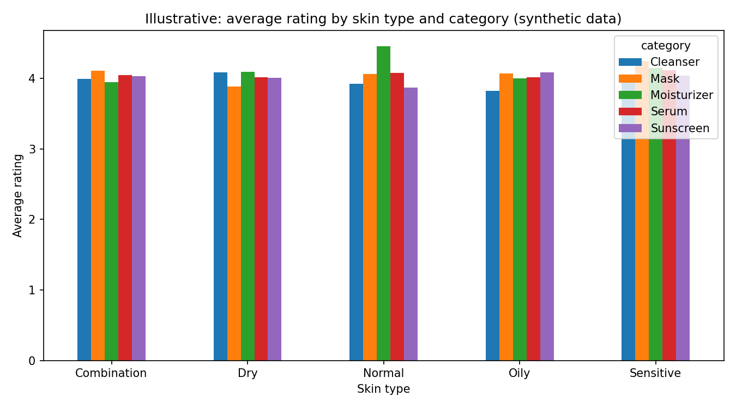
Figure 1: Illustrative average rating by skin type and category (synthetic data).

10. Rationale for the Approach
- Starting with exploratory analysis exposes data quality problems and gives a first test of the hypotheses before any modelling.
- A popularity baseline provides a fair benchmark, because a more advanced recommender is only useful if it beats it.
- Similarity-based methods are easy to explain and work when each customer has limited history.
- Combining ratings with review text captures both what customers think and why.
- Logistic regression and tree-based models give a balance of performance and interpretability.

11. Risks, Limitations and Ethics
- Reviews can be biased towards extreme opinions, and some may be influenced by free samples.
- Missing profile data may limit how far recommendations can be personalised.
- Skin reactions vary between people, so the output is a recommendation aid and not medical advice.
- Customer data must be anonymised and used within the licence and privacy terms of each dataset.
- Models may serve some groups less well if they are under-represented in the data, so results will be checked across skin types and skin tones.

12. Expected Outcomes and Next Steps
By the end of the project, the expected outcomes are a cleaned dataset, a set of findings on which attributes relate to recommendation, a working baseline and similarity-based recommender with measured performance, and a short set of business recommendations.
In Week 2, the focus moves to data identification and sourcing. The planned actions are to select and download a suitable public dataset, check its columns and licence against the variables table in Section 7, document data quality, and refine the analysis plan.

13. References
Web sources accessed on 1 November 2026. Market figures are estimates from commercial research firms and differ by definition.
- IMARC Group. Global Beauty and Personal Care Products Market (press release, 13 November 2025). https://www.imarcgroup.com/global-beauty-personal-care-products-market
- IMARC Group. Beauty and Personal Care Products Market Size and Share. https://www.imarcgroup.com/beauty-personal-care-products-market
- Precedence Research. Beauty and Personal Care Products Market Size, Share and Trends 2025 to 2034. https://www.precedenceresearch.com/beauty-and-personal-care-products-market
- Global Market Insights. Cosmetics and Personal Care Products Market. https://www.gminsights.com/industry-analysis/cosmetics-personal-care-products-market
- IMARC Group. Online Beauty and Personal Care Products Market. https://www.imarcgroup.com/online-beauty-personal-care-products-market
- Koren, Y., Bell, R., and Volinsky, C. (2009). Matrix factorization techniques for recommender systems. IEEE Computer, 42(8), 30-37.
- Kaggle. Public skincare product and review datasets (for example, Sephora Products and Skincare Reviews). https://www.kaggle.com
- Open Beauty Facts. Open database of cosmetic products. https://world.openbeautyfacts.org

