**Assignment-4**

**Develop and demonstrate a HTML5 file that includes JavaScript script that uses functions for the following problems:**

**a. Parameter: A string**

**b. Output: The position in the string of the left-most vowel**

**c. Parameter: A number**

**d. Output: The number with its digits in the reverse order**

<!DOCTYPE HTML>

<html>

<head><title>Program-4</title></head>

<body>

<script type="text/javascript">

var str = prompt("Enter the Input", "");

if (!(isNaN(str))) //isNaN means is Not a Number

{

var num, rev = 0,remainder;

num = parseInt(str);

while (num != 0)

{

remainder = num % 10;

num = parseInt(num / 10);

rev = rev * 10 + remainder;

}

alert("Reverse of " + str + " is " + rev);

}

else

{

str = str.toUpperCase();

for (var i = 0; i < str.length; i++) //0,1,2,3

}

var chr = str.charAt(i);

if (chr == 'A' || chr == 'E' || chr == 'I' || chr == 'O' || chr == 'U')

break;

}

if (i < str.length)

alert("The position of the left most vowel is " + (i + 1));

else

alert("No vowel found in the entered string");

}

</script>

</body>

</html>

**OUTPUT :**

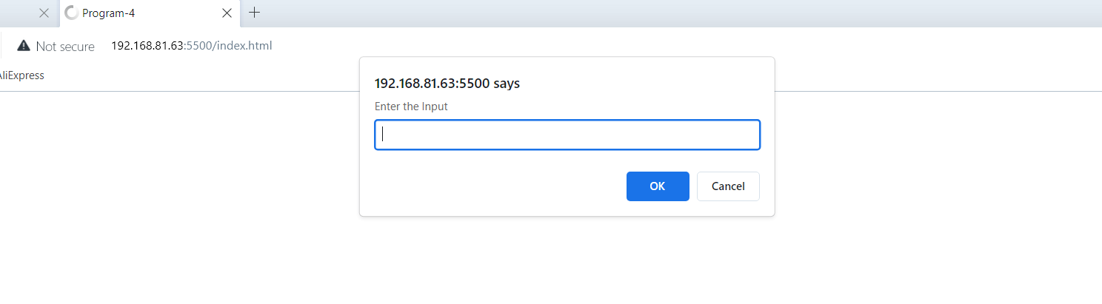

**Output-1 :Integer Value test**

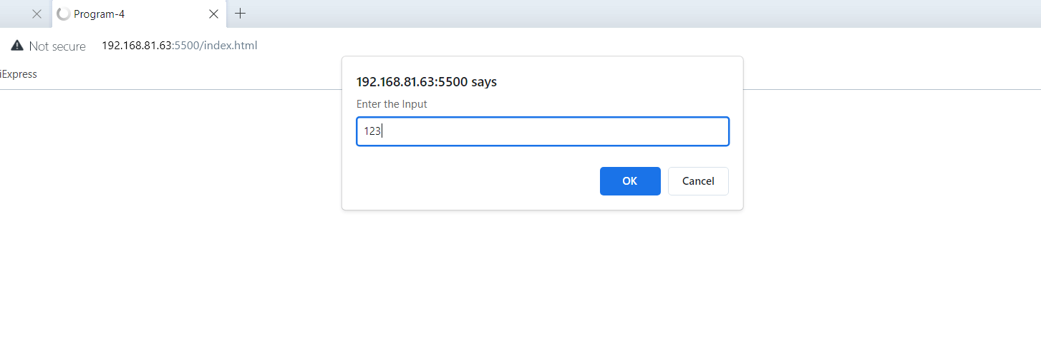

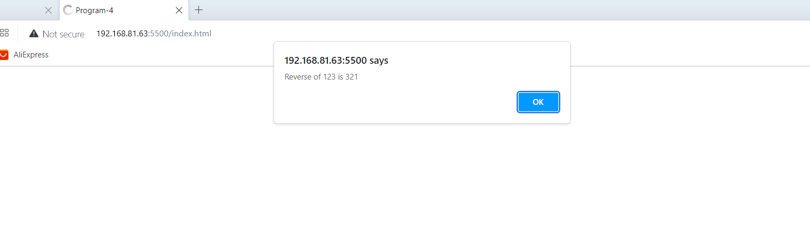

**Output-2 :String Value test**

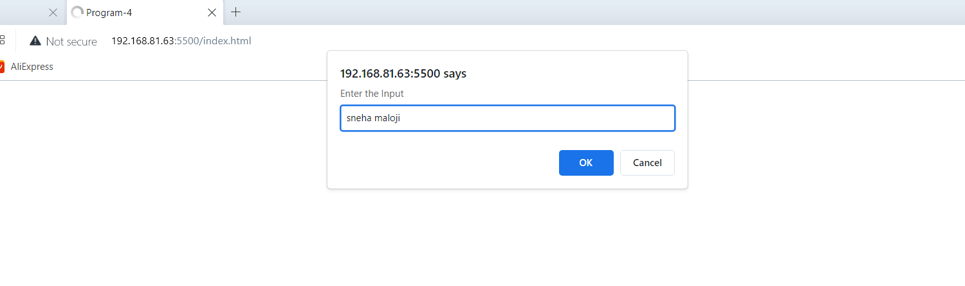

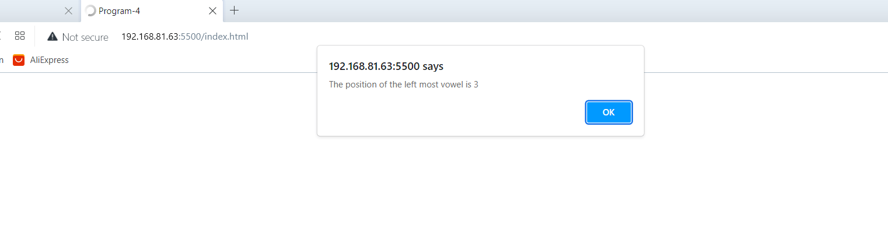

**Output-3 :Negative Integer value**

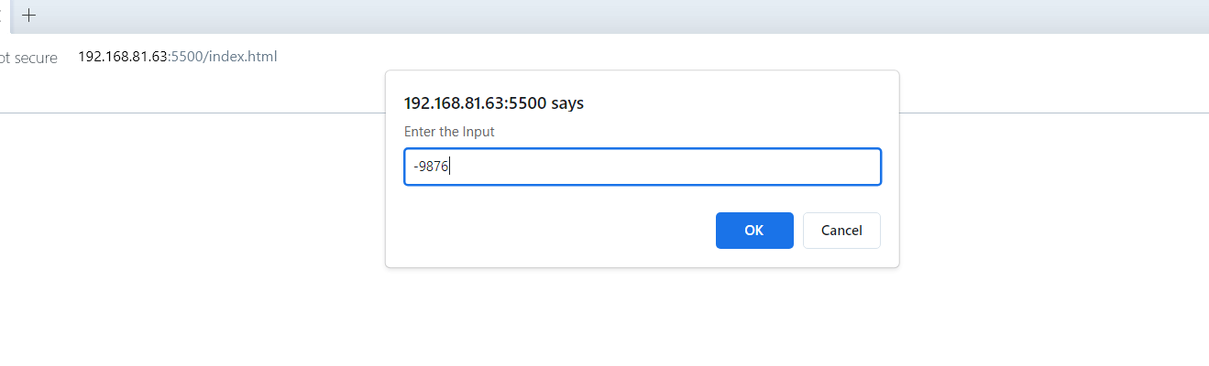

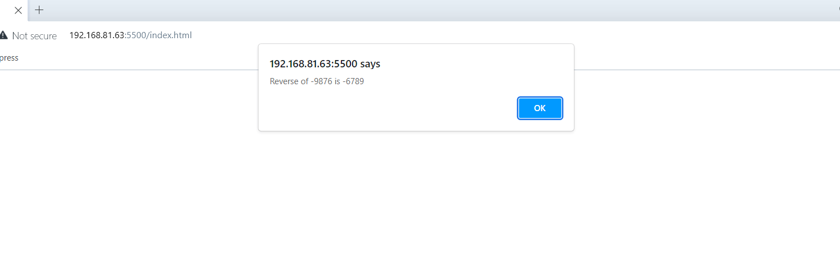

**Output-4 :Alpha numerical value:**

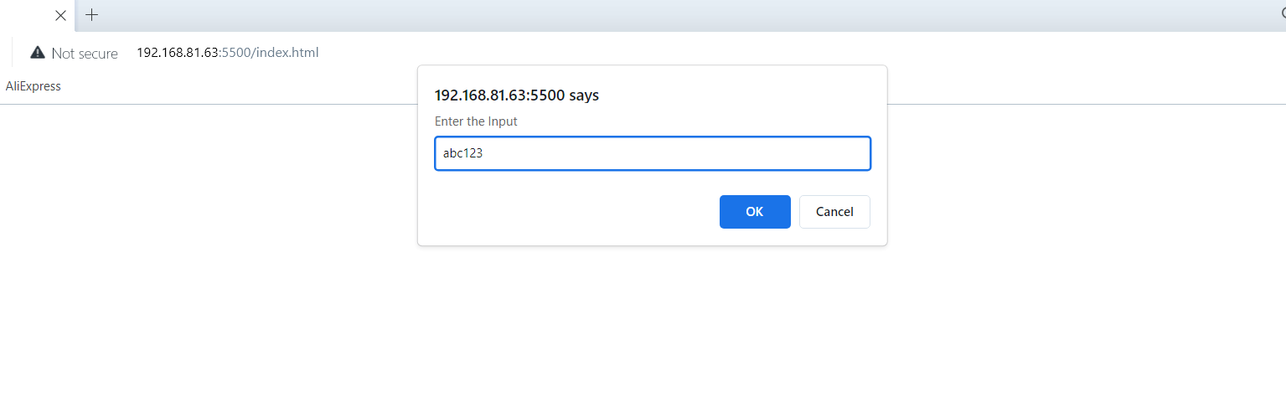

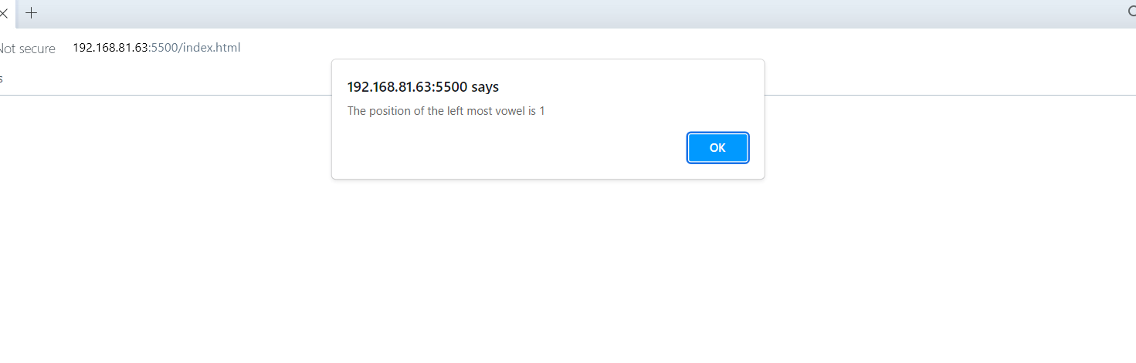**Output -5 :Non vowel string**

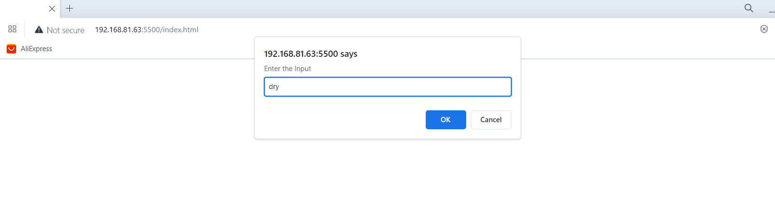

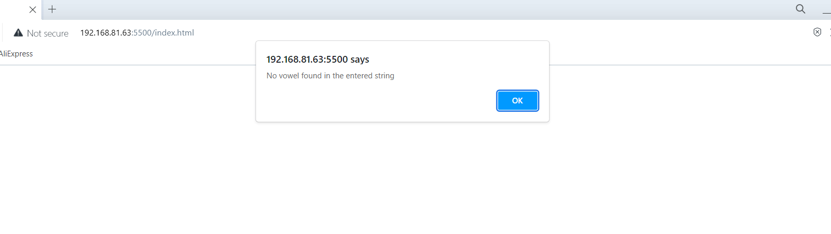

**CHALLENGE4.html**

<!DOCTYPE HTML>

<html>

<head>

<title>challenge-4</title>

</head>

<body>

<script type="text/javascript">

var str = prompt("Enter the Input", "");

if (!(isNaN(str))) //isNaN means is Not a Number

{

var num, rev = 0, remainder, product;

num = parseInt(str);

while (num != 0) {

remainder = num % 10;

num = parseInt(num / 10);

rev = rev * 10 + remainder;

}

product = parseInt(str) * rev;

alert("Reverse of " + str + " is " + rev + "and their product is : " + product);

}

else {

str = str.toUpperCase();

count =0;

for (var i = 0; i < str.length; i++) //0,1,2,3

{

var chr = str.charAt(i);

if (chr == 'A' || chr == 'E' || chr == 'I' || chr == 'O' || chr == 'U')

{

count++;

}

}

if (count>0)

alert("The given string :" + str + " has " + count + " number of vowels.");

else

alert("No vowel found in the entered string");

}

</script>

</body>

</html>

**OUTPUT :**

