**3 Apr 18**

**Macroeconomic Data and Currency - Regression & Random Forest Results Summary**

**Objective**

Observe and improve the results of running multiple linear regression and random forest algorithms on macroeconomic data to predict currency prices.

**Data**

UK, EU and US monthly macroeconomic data for last 18 years was used as the independent variable (X) and average monthly currency price for GBPUSD and EURUSD was the dependent variable (Y).

Total no of X variables = 23. Total no of Y values = 219.

Note that each countries macroeconomic data has to be considered separately and US data will impact both currency pairs.

Core macroeconomic data (interest rate, inflation, GDP, unemployment, etc) that is published monthly was used ignoring the quarterly and annual data.

The average currency price for each month, Y, was calculated using the End of Day price for each business day in the month (that had published prices) divided by the no of such days.

Historic macroeconomic data was taken from sites like tradingeconomics.com and dailyfx.com.

The historic currency prices were taken from sites like openexchangerates.org and fixer.io.

**Algorithms**

Standard sklearn libraries were used for running the different algorithms in python.

The data was split into test and training sets, with a test_size = 0.25, as that gave better results compared to 0.2 or 0.33.

Multiple linear regression was used as the regression algorithm as it gave better results.

For regression, Backward elimination was used to remove variables with p-value > 0.05, (95% confidence level).

You can further vary the data using the R-squared value.

However, difference in results wasn’t significant by varying the p-value or using R-squared value.

Polynomial regression did not show any useful correlations, with the predicted values having high variance from the test set.

Random forest gave much better results with variance between predicted and test sets being much lower compared to regression.

n_estimators = 20 (number of trees in the forest) gave the best results, any higher or lesser did not improve the results.

**Data and Algorithm Logic Variation**

Try changing the number of independent variables (X) considered for regression and random forest using backward elimination to remove X variables with low significance. It gives much better results in some cases, despite not being necessary for random forest.

Try varying the combination of macroeconomic data for each currency pair. For example, UK, US data impacts GBPUSD, so you can both together or separately to see impact.

Try varying the time series considered between the macroeconomic data (independent variable X) and the average currency price (dependent variable Y). This can be done by creating a time lag between the two variables.

I considered Xi vs yi+6m, Xi vs yi+12m and so on.

Where, *i* = month in given year and *6m* = 6 months lag added to *ith* month.

So effectively, we try and use current macroeconomic data to study their impact on future average currency prices, with time lags of 6 months, 12 months, etc.

This hypothesis is based on the premise that markets are forward looking and start adjusting their view based on future expectations using current data and trend.

The data and algorithms were used to find out if there is any relation between the macroeconomic data and currency prices. The fact that data with time lag of 12 months gave better results for random forest or multiple regression vs without any time lag, indicates that there is some validity for this hypothesis.

***Note -*** However, this is a very simple premise and by itself not sufficient for all possible variations to the relationship between the macroeconomic data, currency prices and timeframe. There are many other variations that can be tried with the data, time lag, different algorithms used and their parameters. Users can test that on their own and use as they see fit.

***Note*** – The predicted and test results are not an exact match, which is quite difficult for such scenarios and data sets. But the variance is small and reduces further with a larger data size, different time lags and other variables not considered here (central bank monetary policy statements, political statements, etc).

**Example Scenario**

As macroeconomic data improves, central banks raise interest rates and tighten monetary policy to counter inflation and tightening labour market. This is done at a steady or rapid pace depending on the pace of recovery and growth. This results in strengthening or weakening currency, depending on its role in global trade and as a risk-taking currency. This cycle eventually reverses as time progresses and the impact of tighter monetary policy feeds into the economy.

In the last 20 years we have had 2 big growth and bust cycles (2001 dot-com and 2008 credit crisis) that can be used to validate this. Both have similar characteristics before, during and after the crisis and the macroeconomic and currency data corroborates to that.

In fact, major stock market indices had shown very similar up/down cycles and price points.

The charts given at the end of this document show the different macroeconomic data and currency prices for the last 18 years. It shows a clear lag between improving macroeconomic data and impact on currency prices. EURUSD and GBPUSD, initially result in a weak USD as the market sees a strengthening economy so willing to take more risk. But at and after the peak of the macroeconomic and interest rate cycle, the pattern reverses with USD strength with a move away from risk to safe assets. See the period around 1998-2001 and 2005-2008 for macroeconomic data and currency prices in the periods after that.

However, we can see that indices and other prices post 2010 look highly inflated. What is different this time is that the market has been on the rise for a long time without any reversal. The main reason for this is the amount of monetary easing used by central banks globally to help the economies recover from the throes of a depression on the back of the credit crisis in 2008. It was a necessary and good measure then, but now most global economies or showing very good growth, employment and rising inflation. This has prompted some central banks, especially US, to start unwinding the loose monetary policy by raising interest rates and cutting the Quantitative Easing measures.

This is a classic cycle of easy monetary policy during crisis/low inflation to return to tighter policy during high inflation/over-heating economy. What is important to consider this time is the amount of asset inflation that has occurred as a result of the cheap money supply.

This is worrying and indicates that there is a good chance of a big correction in the market. Historic data already indicates that this is a possibility. Combine that with the recent reactions of the market to tighter monetary policy, trade war between major economies like US and China and private debt to GDP back to its high’s in major large economies, indicate the market is increasingly sensitive to negative news. Major indices have failed to breach the high’s in January ’18 after the volatile sell-off in February.

It might be possible that we have reached the top, though there is still time before interest rates normalize to their long run average and the economic growth momentum is still good. We are not sure how far the trade war will go and its net impact on the economy, which generally impacts inflation due to adjustments in the supply chain.

Overall, it looks increasingly likely that we are set for a big correction in the market and it would make sense to start considering safer assets, though as usual it is tough to call the top or the bottom. It is also important to note that a correction in the market this time doesn’t necessarily imply global economic growth turning negative, only a return to realistic valuations for some highly inflated assets supported by an era of cheap money supply.

**Sample code and Data**

Data used for this analysis along with sample code is given in the below Github location

<https://github.com/mobicloudtrees/Macroeconomic-Data-and-Currency-Regression.git>

**Data** – macroccyeurusdalldata_3Apr18.csv, macroccygbpusdalldata_3Apr18.csv

**Sample code** – MacrodataCurrencyRegressionRandomForest_3Apr18.py

**Results comparison** – MacrodataCcyPriceRegressionRandomForestResults_3Apr18.xlsx

Make sure you point the file loader to the correct location of the data file on your local drive.

Please use them keeping in mind the disclaimer below.

Please get in touch if you see any errors or want to discuss this further at [nitin@currentiax.com,](mailto:nitin@currentiax.com,) nitin@mobicloudtrees.com.

**Charts for Example Scenario**

Please find below 3 sets of charts showing some core macroeconomic data from US, UK and EU economies for last 20 years. That is compared with EURUSD, GBPUSD, S&P500 and Nasdaq100 for the same period. This and more data can be viewed on our website [www.currentiax.com](http://www.currentiax.com).

**Inflation and Interest rate Vs Currency prices and Stock Indices**

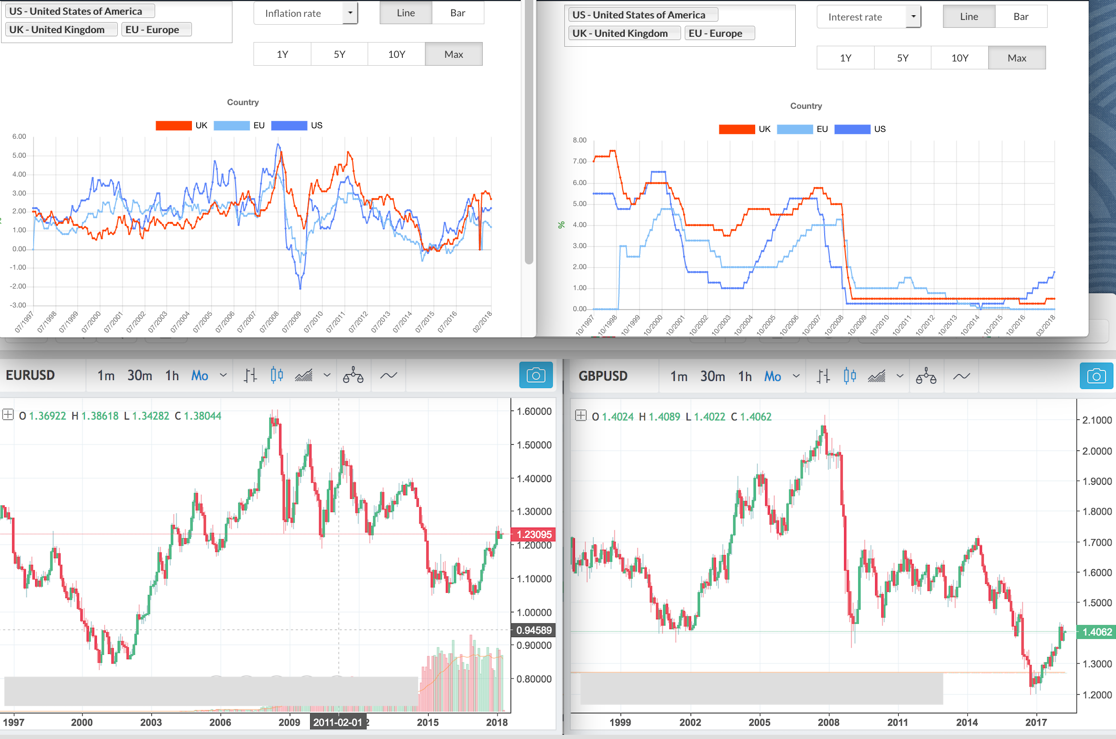

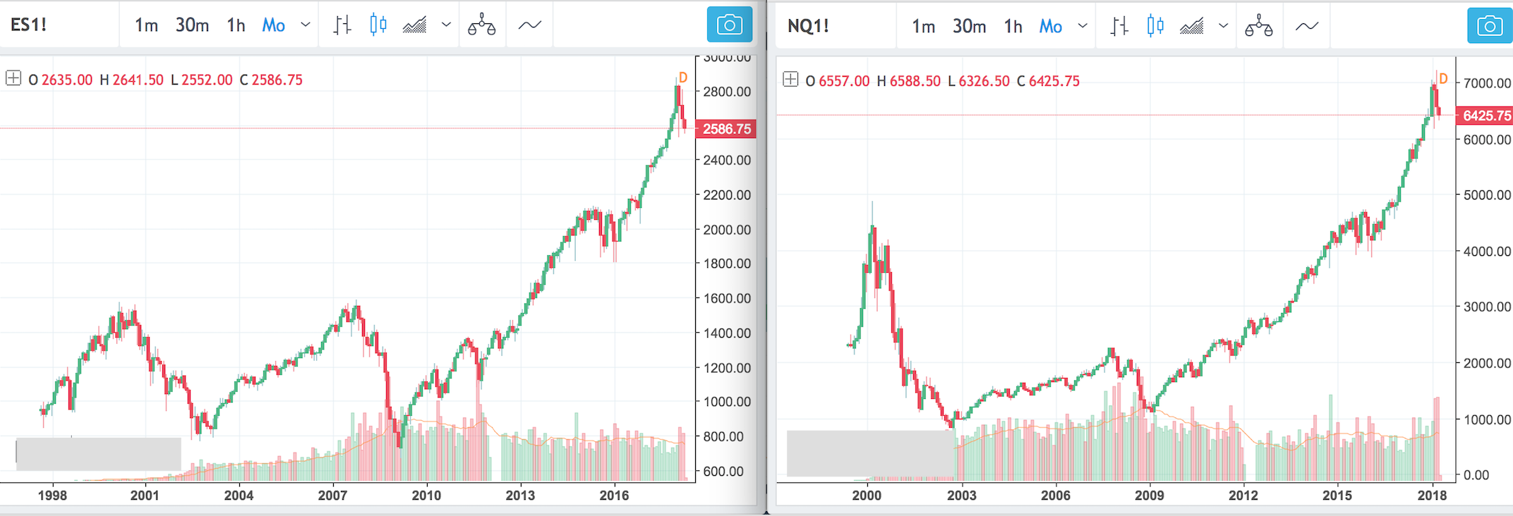

**GDP Annual Growth rate and Unemployment rate Vs Currency prices and Stock Indices**

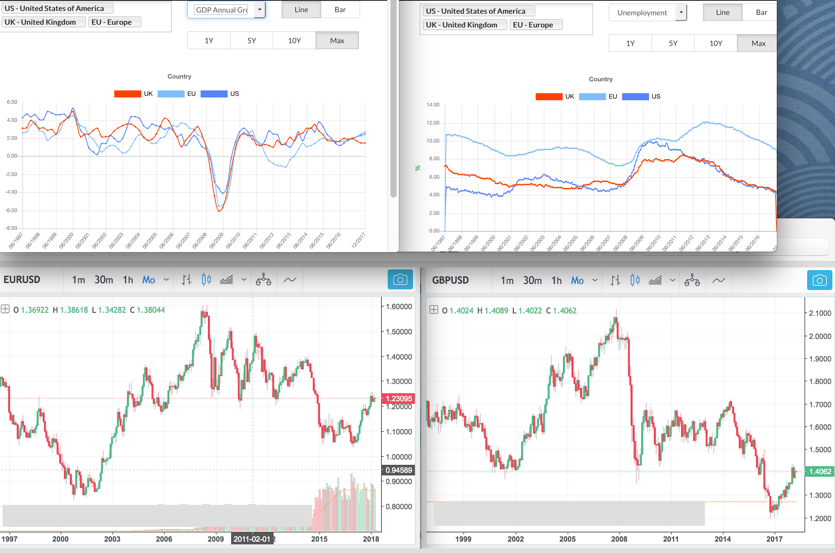



**Industrial and Manufacturing Production Growth rate Vs Currency prices and Stock Indices**

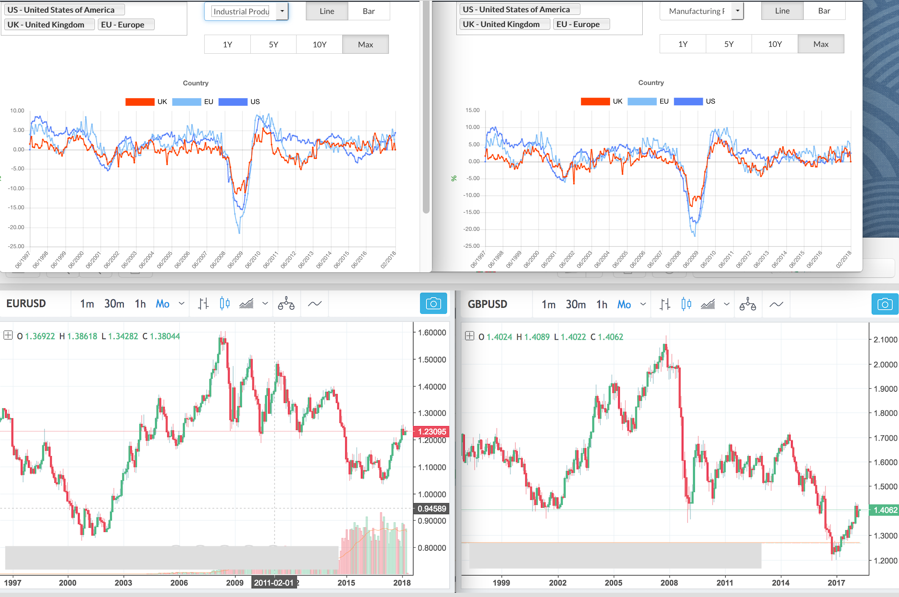



***DISCLAIMER – VERY IMPORTANT***

The sample data and code are provided only for reference purposes and their accuracy or validity cannot be guaranteed. No guarantees can be made about the accuracy of the data and all data and analysis should be used for reference purposes only.

Users should carry out their own data collection, validation and cleaning exercise.

Similarly, they should carry out their own analysis by using different algorithms and varying their parameters as they see fit.

Please see our website for more data and analysis – [www.currentiax.com](http://www.currentiax.com)

Please see the disclosure page on our website before reading this analysis - <http://www.currentiax.com/#/aboutus/disclosure_about>.