**Setting and theoretical value in BS formula**

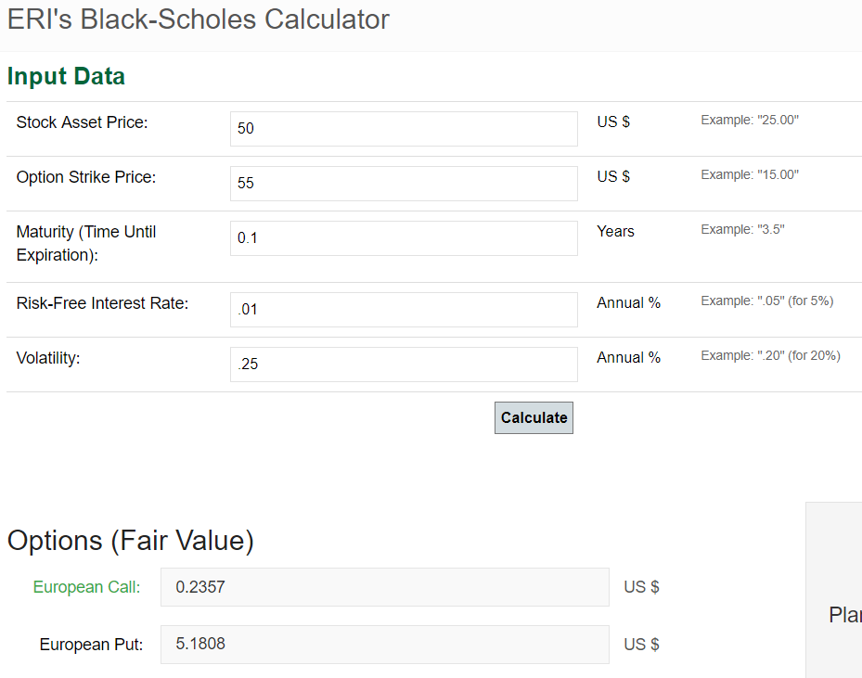

**Pricing using COS method and IV expansion**

**Below is the result.**

**Really really convergent!!**

**We can see the implied volatility expansion is precisely equal to the COS method rapidly. The truncationOrder is now only ~ O(numGrid) and has an asymptotic property.**

