Q1.

Code:

package Q_01;  
  
import javax.swing.*;  
  
public class Q01 {  
 public static void main(String[] args) {  
 JFrame frame = new JFrame();  
 frame.setSize(800,600);  
 frame.setTitle("Welcome to java");  
 frame.setVisible(true);  
 }  
}

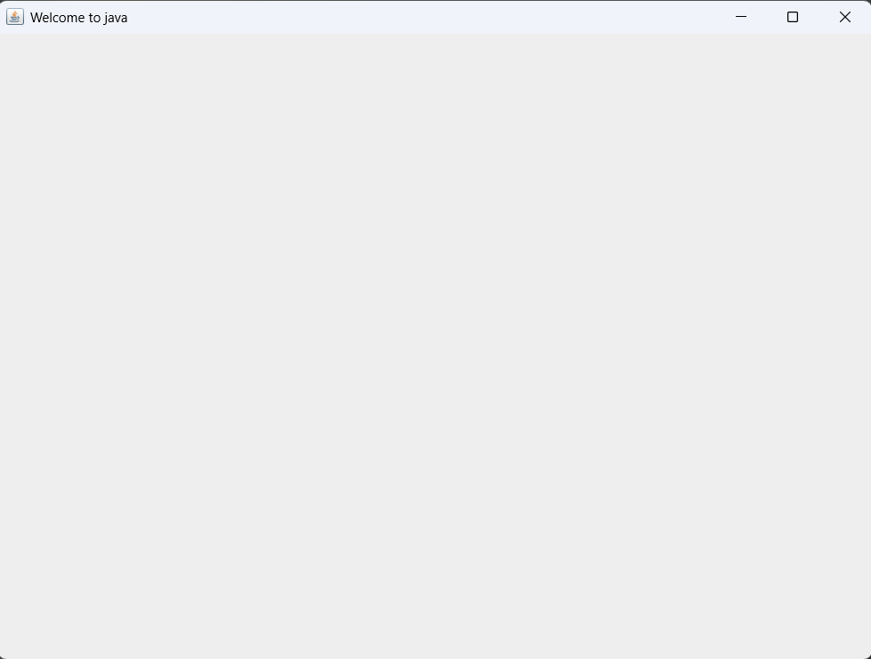Output:

Q2.

package Q_02;  
  
import javax.swing.*;  
import java.util.Scanner;  
  
public class Q02 {  
 public static void main(String[] args) {  
 Scanner scanner = new Scanner (System.*in*);  
 System.*out*.println("Enter the first name");  
 String firstname = scanner.next();  
 System.*out*.println("Enter the last name");  
 String lastname = scanner.next();  
  
 JFrame frame = new JFrame();  
 frame.setSize(300,400);  
 frame.setTitle(firstname+""+lastname);  
 frame.setVisible(true);  
 }  
}

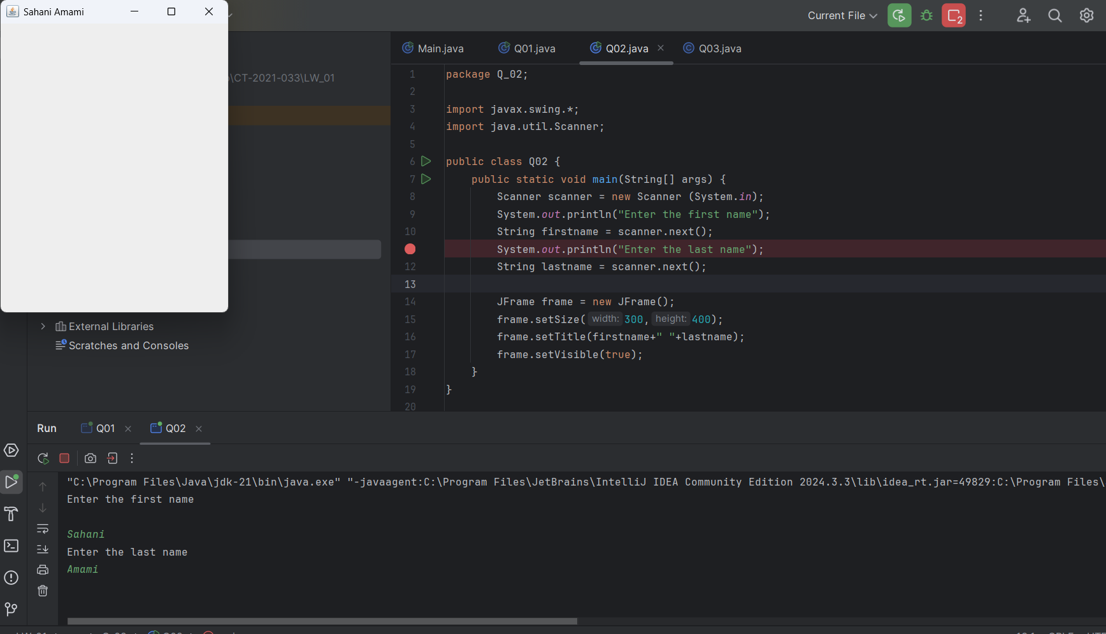Output:

Q3.

Code:

package Q_03;  
  
import java.util.*;  
  
public class Q03 {  
 public static void main(String[] args) {  
 Scanner scanner = new Scanner (System.*in*);  
 System.*out*.println("Enter your first name");  
 String firstName = scanner.next();  
 System.*out*.println("Enter your middle name");  
 String middleName = scanner.next();  
 System.*out*.println("Enter your last name");  
 String lastName = scanner.next();  
 String initial = middleName.substring(0,1);  
 System.*out*.println(firstName+" "+initial+"."+lastName);  
 }  
}

Output:

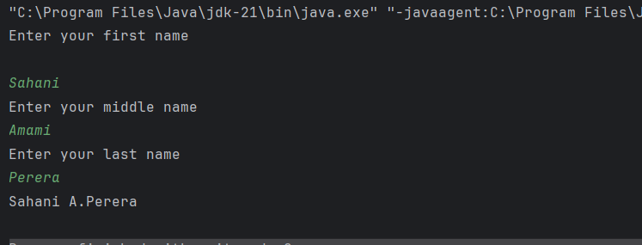

Q4.

Code:

package Q_04;  
  
import java.text.SimpleDateFormat;  
import java.util.*;  
  
public class Q04 {  
 public static void main(String[] args) {  
 Date today = new Date();  
 System.*out*.println(today);  
 SimpleDateFormat sdf = new SimpleDateFormat("dd MMMM yyyy");  
 System.*out*.println(sdf.format(today));  
 }  
}

Output:

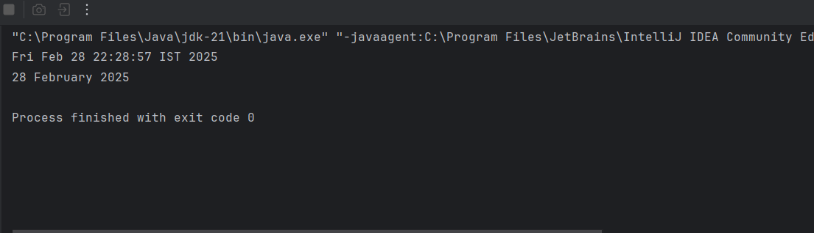

Q5.

Code:

package Q_05;  
  
import java.text.SimpleDateFormat;  
import java.util.*;  
  
public class Q05 {  
 public static void main(String[] args) {  
 Date today = new Date();  
 System.*out*.println(today);  
 SimpleDateFormat sdf = new SimpleDateFormat("EEEE,MMMM MM,yyyy");  
 System.*out*.println(sdf.format(today));  
 }  
}

Output:

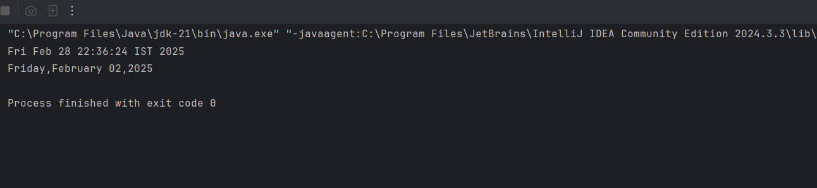

Q6.

Code:

package Q_06;  
  
import javax.swing.*;  
import java.util.*;  
  
public class Q06 {  
 public static void main(String[] args) {  
 JFrame frame = new JFrame();  
 Scanner scanner = new Scanner(System.*in*);  
  
 System.*out*.println("Enter the frame width");  
 int width = scanner.nextInt();  
 System.*out*.println("Enter the frame height");  
 int height = scanner.nextInt();  
  
 frame.setSize(width,height);  
 frame.setVisible(true);  
  
 }  
}

Output:

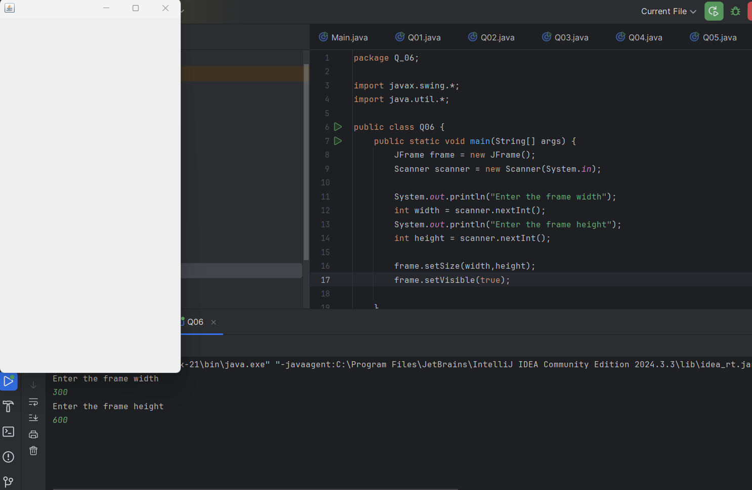

Q7.

Code:

package Q_07;  
  
import javax.swing.*;  
import java.text.SimpleDateFormat;  
import java.util.*;  
  
  
public class Q07 {  
 public static void main(String[] args) {  
 Date today = new Date();  
 SimpleDateFormat sdf = new SimpleDateFormat("hh:mm:ss a");  
 JFrame frame = new JFrame();  
 frame.setSize(500,600);  
 frame.setTitle(sdf.format(today));  
 frame.setVisible(true);  
 }  
}

Output:

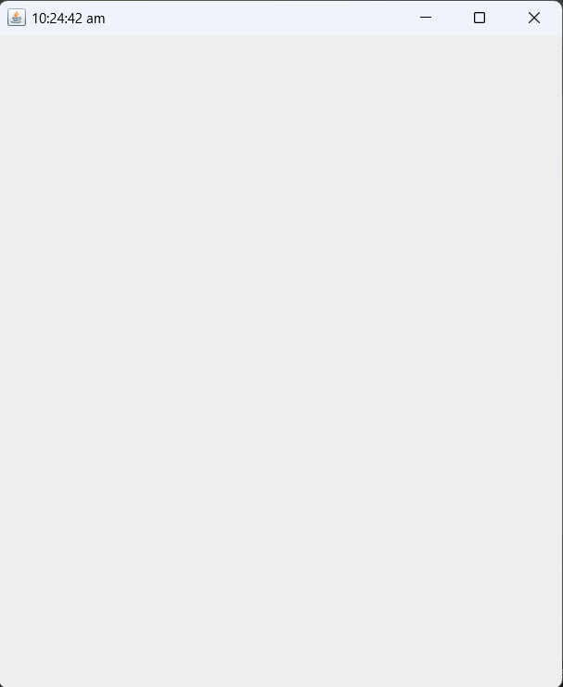

Q8.

Code:

package Q_08;  
  
import java.util.Scanner;  
  
public class Q08 {  
 public static void main(String[] args) {  
 Scanner scanner = new Scanner(System.*in*);  
 System.*out*.println("Enter the sentence:");  
 String sen = scanner.nextLine();  
 scanner.close();  
 String[] parts = sen.split("!");  
 for (String part:parts){  
 System.*out*.println(part.trim());  
 System.*out*.println();  
 }  
 }  
}

Output:

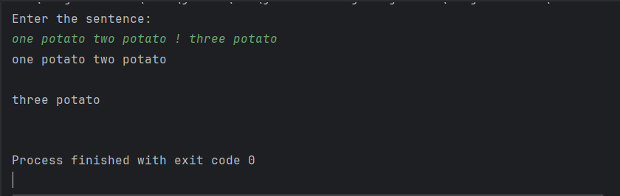

Q9.

Code:

package Q_09;  
  
import java.util.*;  
  
  
public class Q09 {  
 public static void main(String[] args) {  
 Scanner scanner = new Scanner(System.*in*);  
 String sentence;  
 System.*out*.println("Enter your sentence :");  
 sentence = scanner.nextLine();  
 System.*out*.println(sentence.length());  
 System.*out*.println(sentence.charAt(0));  
 System.*out*.println(sentence.charAt(10));  
 }  
}

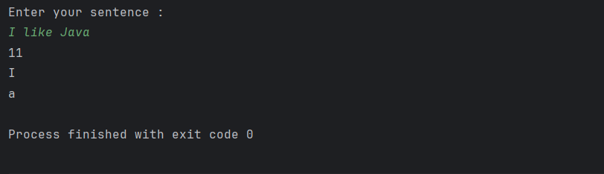Output:

Q10.

Code:

package Q_10;  
  
import java.util.Scanner;  
  
public class Q10 {  
  
  
 public static void main(String[] args) {  
 Scanner scanner = new Scanner(System.*in*);  
 System.*out*.print("Enter an odd-length word: ");  
 String word = scanner.nextLine();  
 scanner.close();  
  
 if (word.length() % 2 == 0) {  
 System.*out*.println("Please enter a word with an odd number of characters.");  
 } else {  
 int middleIndex = word.length() / 2;  
 System.*out*.println("Middle character: " + word.charAt(middleIndex));  
 }  
 }  
}

Output:

Q11

.Code:

package Q_11;  
  
import java.util.Scanner;  
  
public class Q11 {  
 public static void main(String[] args) {  
 Scanner scanner = new Scanner(System.*in*);  
 System.*out*.print("Enter your full name : ");  
 String fullName = scanner.nextLine();  
 scanner.close();  
  
 String[] nameParts = fullName.split(" ");  
 if (nameParts.length < 3) {  
 System.*out*.println("Please enter a valid full name with first, middle, and last name.");  
 return;  
 }  
  
 String firstName = nameParts[0];  
 String middleName = nameParts[1];  
 String lastName = nameParts[2];  
  
 System.*out*.println(lastName + ", " + firstName + " " + middleName.charAt(0) + ".");  
 }  
  
}

Output:

Q12.

Code:

package Q_12;  
  
import javax.swing.JFrame;  
public class Q12 {  
 public static void main(String[] args) {  
 JFrame frame = new JFrame("My First Frame");  
 frame.setSize(300, 200);  
 frame.setLocation(100, 50);  
 frame.setDefaultCloseOperation(JFrame.*EXIT_ON_CLOSE*);  
 frame.setVisible(true);  
 }  
}

Output:

Q13.

Code:

package Q_13;  
  
import javax.swing.*;  
  
public class Q13 {  
 public static void main(String[] args) {  
 JFrame myWindow;  
 myWindow = new JFrame();  
 myWindow.setSize(500, 250);  
 myWindow.setTitle("UOK");  
 myWindow.setVisible(true);  
 try {  
 Thread.*sleep*(500);  
 } catch (Exception e) {  
 }  
 myWindow.setVisible(false);  
 try {  
 Thread.*sleep*(500);  
 } catch (Exception e) {  
 }  
 myWindow.setVisible(true);  
 }

Output:

* This Java program demonstrates creating and manipulating a graphical window using the JFrame class from the Swing library, setting up the window, changing its visibility, and introducing timed delays using Thread.sleep().