Contents

Chapter 1 4

Introduction 4

1.1 Background and motivation. 4

1.2 Solution 5

1.3 Aim and Objectives 7

1.3.1 Aim 7

1.3.2 Objectives 7

1.4 Summary 7

Chapter 2 9

Review of Other’s Work 9

2.1 Introduction 9

2.2 Similar Approaches 9

2.2.1 Airclic Food Services and Food Distribution Products 9

2.2.2 Delivery Biz Pro 10

2.3 Summary 11

Chapter 3 12

Technology Adapted 12

3.1 Introduction 12

3.2 Technology 12

3.2.1 Applications work along with the Complex event processor 13

3.2.2 MySQL 14

3.2.3 WildFly application server 15

3.2.4 Apache Maven 15

3.2.5 Apache ActiveMQ 15

3.2.6 Apache Ant 15

3.2.7 Wso2 CEP 16

3.2.8 WebSocket 16

3.2.9 Object oriented programming- Java 17

3.2.10 Android SDK 17

3.2.11 Java EE 17

3.2.12 Google maps API 18

3.4 Summary 18

Chapter 4 19

4.1 Introduction 19

4.2 Modular approach 19

4.2.2 Web Interface 19

4.2.2.1 Web Interface for customers 20

4.2.2.2 Web Interface for Shop owners 20

4.2.3 Mobile Application 20

4.2.4 Inventory Management System 21

4.3 Summary 21

Chapter 5 22

5.1 Introduction 22

5.2 Analysis 22

5.2.1 Requirement Analysis. 22

5.2.2 Use Case Diagram and Use Case Specification 23

5.2.2.1 Use Case Specification 23

5.2.2.2 Use Case Diagram 24

5.2.3 Entity Relationship Diagram 25

5.2.4Sequence Diagram 26

5.2.5 Class Diagram 27

5.2.6 Activity Diagram 28

5.3 Design 31

5.3.1.1 Database Design 32

5.3.2 Android Application Interfaces and Web Interfaces 33

Chapter 6 34

Implementation 34

6.1 Introduction 34

6.2 Interfaces 34

6.2.1.Web Interface 34

6.2.2 Android Interface 36

6.3 Summary 36

Chapter 7 37

Evaluation 37

7.1 Design of questionnaire 37

7.2 Designed questionnaire 37

7.3 Control Experiments 42

7.4 Summary 42

# Chapter 1

# Introduction

## 1.1 Background and motivation.

Ever since the 21st century began, the revolutions of the Information Technology based solutions are slowly descending into the Industry. The reason why we are selecting this project is because of the current trend for delivering systems such as Kapruka, Pizza Hut, Dominos, Burger King, Lassana Flora, Spring and summer are coming forward into the scene with many facilities. Also now we are facing problems like traditional software paradigms have not been oriented towards event-driven functionality, but focused on more synchronous request driven interactions. A traditional software not an effective way to handle a business. Because they are not interact with normal employees. So each and every time it is waiting until to be told what to do, to an employee. So high management control is needed to get the fully output of the workers.

But here it can detect an event has happened and can decide whether and how to react. It automates without compromising managers’ control, Traditional software can’t identify and react to certain situations, either it is good or bad as they occur. Here there are sensors that detect, report and react to events. It can respond, where changes in state are monitored as they happen, in a much more timely fashion than a batch approach. If we need to add extra functions in some applications have to change the original one.

Sri Lankans are slowly getting rid of old fashioned systems and try to enhance the services provided by such companies. In modern day world people try to save their money and time by using new technologies. People always choose the most efficient and easiest way to do their work. So in modern day companies are always trying to use new things that satisfy their customers and attract more people.

The system that we are going to implement is going to very important to any company that has online services and delivery system. By implementing such system it will give more benefits to both customers and company. Such a system gives more efficiency to the companies’ procedure. And also customers can easily do their work without wasting time and money. In most of the current companies that has delivering system only considering about few sections. As an example some systems only considering about the delivery. They only think about how to do the delivery quickly. Some only think about deliver good products but not considering about the time. That’s motivates us to implement our system by considering about all the sections. In our system we are considering about the deliver goods to customers soon as possible, choose the best driver to deliver and best branch to take the goods that customer need.

Implementing a system that would provide certain abilities to maximize their services and performance has a high commercial value. This system can be implemented in several businesses regardless of what the service provide because the logic behind all these services is same, called “Complex Event Processing”.

## 1.2 Solution

Our project involves with a Fast Flower Delivery system using the WSO2 Complex Event Processor (CEP) as explained in below.

A consortium of flower stores in a large city wants to create a new flower delivery system for their business. They have to establish a new agreement with delivery drivers in the town such as local drivers and delivery boys to deliver flowers from the stores to their destination. When a customer creates a flower delivery order, the store should manually send a delivery request to the WSO2 Complex Event Processor to carry out the process. The system maintains a ranking of each individual driver based on his or her performance in delivering flowers on time. When the system receive delivery requests it starts to gather information about the registered drivers around the area and the particular branch that provides the best service. Also they should have a GPS capable Mobile device, so the system can track the currently available drivers with the least pick up time.

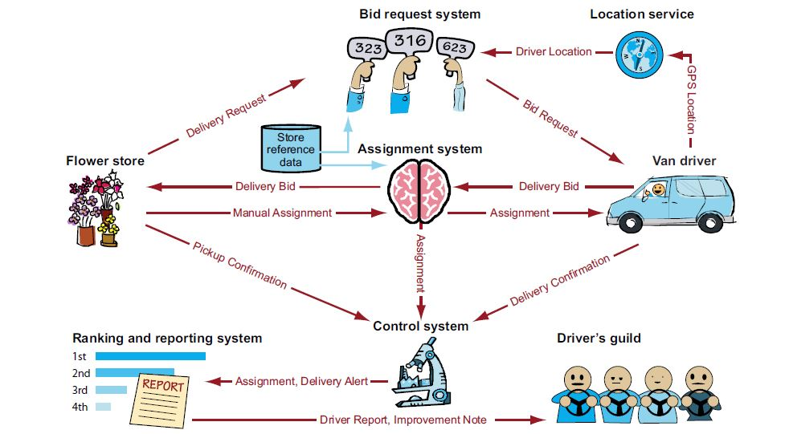

Figure 1.2

After the completion of this process the system will send biding requests to all the marked drivers. Then the drivers can start biding through their mobile device. According to the responses given by the drivers the system selects the best five drivers and choose the best driver using the ranking profiles. Then a driver is assigned and the customer is notified that a delivery has been scheduled. The driver makes the pickup and delivery and the customer confirms the delivery by signing on the driver’s mobile device and it will send back to the system.

Implementing a Fast Flower Delivery system will provide certain abilities that maximizes their services which will eventually results in effective performance. This system can be implemented in several businesses regardless of the service they provided, because the system logic is developed based on “Complex Event Processing”.

## 1.3 Aim and Objectives

### 1.3.1 Aim

The aim of this project is to develop a Complex Event Processor (CEP) based delivery service which can involve to handle the request of orders from clients via web page and manage to choose the best drivers by considering their current location and bid amount to handle orders for shops.

### 1.3.2 Objectives

* Study about main research area, Steam Processing Systems.
* Study about Complex Event Processing concepts and how they have been implemented.
* Design User Interface by using HTML5, CSS, and Java Script.
* Use responsive web for mobile compatibility.
* Design back end by using Esper/ Etalis.
* Learn about project management systems.
* Cloud service models and their terminology.
* Study about the open source applications and use them.
* Design the architecture and system.
* Implement the desired system.

## 1.4 Summary

In the first chapter, gave a brief introduction of our project “Fast flower Delivery System” with the problems in the traditional systems which our country encounter now a days. Chapter 2, contains the reviews of others work. Chapter 3, focus on the technology used to create the software part. Next, the approaches used in this projects. After, a detailed idea about the analysis and design is given. In next chapter, talk about implementation of the project. Finally, there will be an evaluation, conclusion and further work part which could not able to complete now.

# Chapter 2

# Review of Other’s Work

## 2.1 Introduction

Previous chapter presented an overall overview of the project. This chapter focus on others’ work and existing systems that have already implemented to accomplish the similar task. Also presents some of the similar works of others that related to this project idea, working in event driven processing or similar software which are created for online delivery in traditional way. And the drawbacks which the earlier works are not having and which emphasize this project work.

There are so many software was created based on delivery purposes. For convenient this chapter only focus two similar approaches.

## 2.2 Similar Approaches

1. AirClic Food Services and Food Distribution Software
2. Delivery Biz Pro

### 2.2.1 Airclic Food Services and Food Distribution Products

According to the Airclic website page, this product increase the efficiency and productivity of the operations of the particular food centre by providing real time visibility, tracking and management across every step of the distribution process. With Airclic, a particular person will know the product location, delivery status and driver productivity so can maintain superior operational efficiencies, on time deliveries and maximum product freshness.

Key Functionality for Food Distributors

|  |  |
| --- | --- |
| * Complete proof-of-delivery and chain-of-custody documentation * Dispatch control of scheduled routes * GPS tracking and geofences * Route reconciliation * Virtual cross-dock capabilities * Piece counts and weight | * Piece-level tracking and reconciliation * Route and location-based reports * Productivity and performance reports * Operational reports and alerts * Delivery notifications |

Key Functionality for Inventory Automation

|  |  |  |  |
| --- | --- | --- | --- |
| * Tracking of bar coded and non-bar coded product * Item-level tracking and reconciliation * Compliance with the GS1 US barcode standards * Operational reporting alerts, including real-time recall alerts * Store to store inventory transfer * Comprehensive management dashboard |  |  |  |

# 

### 2.2.2 Delivery Biz Pro

By referring the trademarkia.com, it is a downloadable cloud computer software for use by home and commercial delivery companies in managing daily operations such as customer management, product management, comprehensive billing, driver routing and inventory, marketing and reporting.

It provides an interactive website featuring technology that allows customers of home and commercial delivery companies to search products offered by the delivery companies, purchase these products, set delivery schedule and frequency for these products and update product selections and delivery schedules.

Here it organized by using their route organization tools, easily packed customers in the order they are making the stops- suggest the best route for the particular week’s load, visualize several routes at once and easily export stops to their GPS unit.

It also allows to not only assemble menu type products that change each week, but also package products together into combined offerings.

By comparing above software this system also has a real time tracking and GPS facilities. Also there is an interactive web application like they have to interact with the customers. But in this project it is allocating job for drivers and given orders to shops are happening with the help of CEP. CEP is the major advantage of this project. Because it helps to reduce the task of the management.

## 2.3 Summary

As described earlier there are many software in current trend which facilitate online shopping and delivery services. The above mentioned are some of the famous that identified which reduce the workload of vendors and drivers and make them to gain high profit by perform the task in an efficient and effective way not only that, but also make the customers for a delicious purchasing.

However both of the systems are not having Complex Event Processing (CEP) technique. Therefore there they wants to be a control person (manager) to control the delivery and hand over delivery for a particular person. By this way this system has a very major advantage among them.

# Chapter 3

# Technology Adapted

## 3.1 Introduction

The previous chapter described about the various approaches that others have taken and a brief comparison of our system with others implementations. This chapter is focused on the technologies we used with relevance of our project.

## 3.2 Technology

Complex Event Processing technology is a correlation technique that enables processing multiple events in real time with the goal of identifying meaningful events and is based on queries and rules.WSO2 Complex Event Processor has developed based on this technique and it identifies the most meaningful events within the event cloud, analyses their impacts and acts on real time and eventually provides significant time saving.

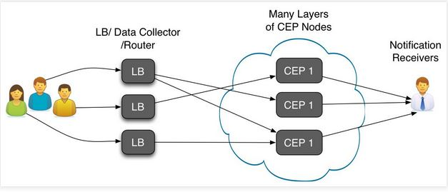

Figure 3.2.1

### 3.2.1 Applications work along with the Complex event processor

We implemented the project by targeting Customers, Drivers, Business owner and workers. We have provided interfaces to these three different types of users as the front end of the project. For customers we have designed a web interface and through that they can select the products, place the orders and enter the details as destination, specific time, special note, paying method (a payment gateway). Then the details will be send to CEP server in WSO2 which will processed the details and send the request to the nearest store.

The workers in the store can confirm or reject the order according to the availability of products in their shops. For that purpose we have designed a web based application which contains the details of the available resources (inventory management system) along with the driver’s profiles, workers profiles and customer’s profiles. Through this the shop owners can introduce new discount systems for regular customers, salary payments for workers, payments for the drivers and additionally by inserting the administrating cost and other expenses (like electricity bills, water bills, telephone bills) and able to find the total profit earning per month.

The drivers should have a Global Positioning System (GPS) capable mobile device with a touch screen. We have implemented a mobile software which will capable of sending the GPS location details to the CEP server and server will decide the nearest driver as well as the traffic condition of the route. The delivery details will be send to the CEP for confirmation. This application has the ability to place bids on each delivery.

These are the main components in the front end of the implementation. At the back end the CEP server and the database will run.



Figure 3.2.2

### 3.2.2 MySQL

Mysql is a fast reliable database management system with many features. It’s noncommercial and highly available product in any server if running with a JSP engine. This Relational Database Management System (RDBMS) plays a major part in our application. It handles millions of events while running the system and it’s capable enough to handle all those requests and give the necessary responses.

### 3.2.3 WildFly application server

WildFly formerly known as JBoss is an application server authored by JBoss and now developed by Red Hat. WildFly is written in Java and implement the Java Platform Enterprise Edition (Java EE) specification. It runs on multiple platforms and is free and open source software.

### 3.2.4 Apache Maven

Apache Maven is a software project management and comprehension tool. Based on the concept of a project object model (POM), Maven can manage a project's build, reporting and documentation from a central piece of information. Maven dynamically downloads Java libraries and Maven plug-ins from one or more repositories such as the Maven 2 Central Repository, and stores them in a local cache.

### 3.2.5 Apache ActiveMQ

Apache active MQ is a highly reliable message brocker, which is currently accepted as the most sophisticated message handling system in a server. This will be used to pass massages among the Complex event processor and other web pages while handling them without making unnecessary interruptions.

### 3.2.6 Apache Ant

Apache Ant is a Java library and command-line tool whose mission is to drive processes described in build files as targets and extension points dependent upon each other. The main known usage of Ant is the build of Java applications. Ant supplies a number of built-in tasks allowing to compile, assemble, test and run Java applications.

The complex event processor manager is used to define the events happening in the while its running and ant will be used as a build tool to define targets and solve the dependencies.

### 3.2.7 Wso2 CEP

This provides the core functionality to our system. Complex event processor define its data inflows and outflows and can be used to predict the correlation among many events. The overview of the CEP is can be as below.

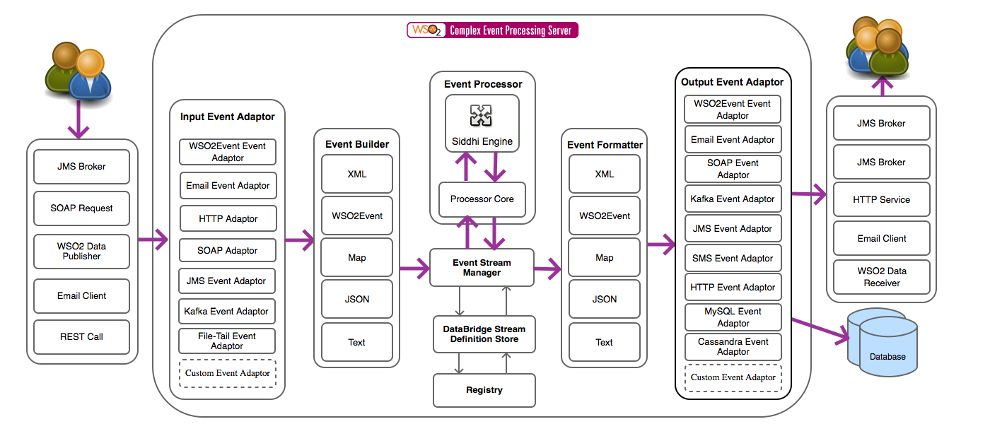

Figure 3.2.3

### 3.2.8 WebSocket

WebSocket is a protocol providing full duplex communication channels over a single TCP connection. WebSocket is designed to be implemented in web browsers and web servers but it can be used by any client or server application. The WebSocket Protocol is an independent TCP based protocol. The WebSocket protocol makes more interaction between a browser and a website possible, facilitating live content and the creation of real-time games.

### 3.2.9 Object oriented programming- Java

Java is the programming language used to develop applications in Android. Java is a free and open source language, so users do not have to struggle with heavy license fees each year. Java API's can easily be accessed by developers and it is a multi-platform support language and support for web-services. Multithreading is another advantage of Java which provides the capability for a program to perform several tasks simultaneously within a program. Java was designed to be easy to use and is therefore easy to write, compile, debug, and learn than other programming languages.

### 3.2.10 Android SDK

We chose the Android SDK to implement our project after doing a proper research. In fact it is an easy to use and most importantly, accompanied with lot of capabilities provided by Google Inc. Android is a software stack for mobile devices that includes an operating system, middleware, and key applications. The SDK provides the tools and libraries necessary to begin developing applications that run on Android-powered devices. Android includes a set of core libraries that provides most of the functionality available in the core libraries of the Java programming language.

### 3.2.11 Java EE

Our solution has a server side implementation and it is done with the use of a powerful java technology, Servlets. When a user uploads data to the system, those will be sent to the server and saved. Whenever those saved data are requested by a user, they are then sent to the client.

### 3.2.12 Google maps API

The Google Maps API provides web services as an interface for requesting Maps API data from external services and using them within Maps applications. These services are designed to be used in conjunction with a map, as per the Maps API Terms of Service License Restrictions. It has all the features we need including tracking driver’s path, showing customer’s location and etc.

## 

## 3.4 Summary

We have used OOP, Android SDK, Eclipse IDE, Databases and Web Services related technologies when implementing the system. Most of them are Open Source technologies. Integration of modules developed using different technologies will be done after each spring. There are many advantages of using these technologies for the system.

# Chapter 4

**Our Approaches**

## 4.1 Introduction

Previous chapter described about the technologies that we have adapted to solve the problem. It gave a description about technologies we used to give the most effective solution. This chapter mainly describes about the unique approach taken by the team to achieve the client requirements with reference to users, inputs, outputs, process, technology that implements the solution.

## 4.2 Modular approach

The development process was done using Agile software model with a master plan. In each module we did the requirements analysis, design, Implementation, Testing and Debugging and finally maintaining as per the RUP methods. So according to the plan we divided the whole project in to major sections.

* Study to find the mobile platforms, web development platforms
* Choose most appropriate platform to develop our application
* Developing the front end and back end of the application
* Integrating the implementations

### 4.2.2 Web Interface

Our project is based on a scenario of an online flower delivery system. We have customers, shop owners, Complex Even Processor and drivers as main actors. Customers, shop owners and drivers need to sign up by visiting the web application. Drivers need to download the mobile application from the web interface. Then he can work on with his mobile application.

But there are interactive and user-friendly web interfaces for customers and shop owners. After the completion of the sign up process they need to sign in. We have designed separate web applications for customers and shop owners. After the sign in process they are redirected to the particular web interface after the verification of the password and username.

### 4.2.2.1 Web Interface for customers

Unregistered customers can visit our site and can have an idea about our flower products. Registered customers can log in to our system and they can see, select and add product to the cart and then purchase. The website provides all the shipping details to the customers.

### 4.2.2.2 Web Interface for Shop owners

Shop owners can also log in through the shop owner’s web interfaces using their username and password. Each of them have separate profiles and they can add new products and change price level.

Our web application consists inventory management details about flower sales as well.

### 4.2.3 Mobile Application

The android application of our system was developed targeting the drivers. From that application drivers will receive bid request from CEP. Within three minutes they have to respond to the request. Then it will closed by CEP. If a driver has been selected for the delivery, then he will get delivery details through this application. After the completion of the delivery process the relevant delivery data will send to the CEP. These data will use to analyze the rankings and status of the drivers.

Through this application the driver’s profile can be viewed and the edited.

### 4.2.4 Inventory Management System

This part is having all the inventory details and accounts details of a particular shop. From this phase the shop owner views the shop’s accounting reports and stock levels. Also in his application he can update products, view driver profile.

## 4.3 Summary

We chose to work on Agile development process. Before stepping into development, initially we studied about the problem domain. According to our plan we have divided our project into five major sections. Each section will be integrated together at the end. Next chapter is about Analysis and Design of the system.

# Chapter 5

**Analysis and Design**

## 5.1 Introduction

In this chapter we want to describe the problem and determine what the system must do in order to perform as expected. By analyzing the system first, gives more convenient about the project. Also it will lead us to deliver a good product for end user. This chapter mainly describes about the analysis and design of the solution that has made, the analysis that has done when developing the system and design of the solution.

## 5.2 Analysis

We set up our boundaries and tried to understand the requirements of customers, drivers and the shop owner within the system scope. The requirements are gathered according to that analysis and remove the unnecessary details. After analyze the requirements the Use Case diagram has been drawn for convenient.

### 5.2.1 Requirement Analysis.

The following methodologies used for the process of gathering information.

* Discussion- By getting the information by discussing with WSO2 Company.
* Observation- By observing the problems of delivery, and the solutions which customers and shops like to have.
* Review of the current systems- By reviewing the current systems we could identify the about the current trends and also what are the functionalities and drawbacks they are having. The details of the review of current systems are discussed in chapter 2.

# 

### 5.2.2 Use Case Diagram and Use Case Specification

### 5.2.2.1 Use Case Specification

* Use case Name: Fast Flower Delivery System
* Use case purpose: This system provides the facilities for online flower delivery companies to log into this site and keep tracks and maintain the relationship with both customer and delivery persons. Selecting the most suitable driver according to the shop criteria and inform the driver about the duty will be handled by the system. Finally both shop and the delivery person will be assessed by the system by giving ranks according to the customer feedbacks about the quality of their jobs.
* Optimistic flow:

1. Actor (Customer) enter the website
2. If already registers Actor (Customer) log into the system.
3. If not registered, sign up
4. Actor (Customer) view the products and wish lists.

E. Actor (Customer) add to cart for a particular product.

F. System (CEP) view the order details.

G. System (CEP) filter the available drivers according to location, due time, and rank

H. System (CEP) send bid request for selected drivers

I. Actor (Drivers) bid for delivery

J. System (CEP) select the most suitable driver/s.

K. System (CEP) send order details to selected driver/s.

L. Actor (Driver) delivers the order and acknowledge about the finished time.

M. Actor (Customer) accept the order.

N. Actor (Shop) update products.

O. System (CEP) rank the shop and driver.

* Pragmatic flow

Condition 1:

If the customer, user name and password not validate,

B.1. Show error page

Condition 2:

If a driver’s bid request is not accepted

J.1. send notification.

### 5.2.2.2 Use Case Diagram

**Figure 5.2.1 Use Case Diagram**

### 5.2.3 Entity Relationship Diagram

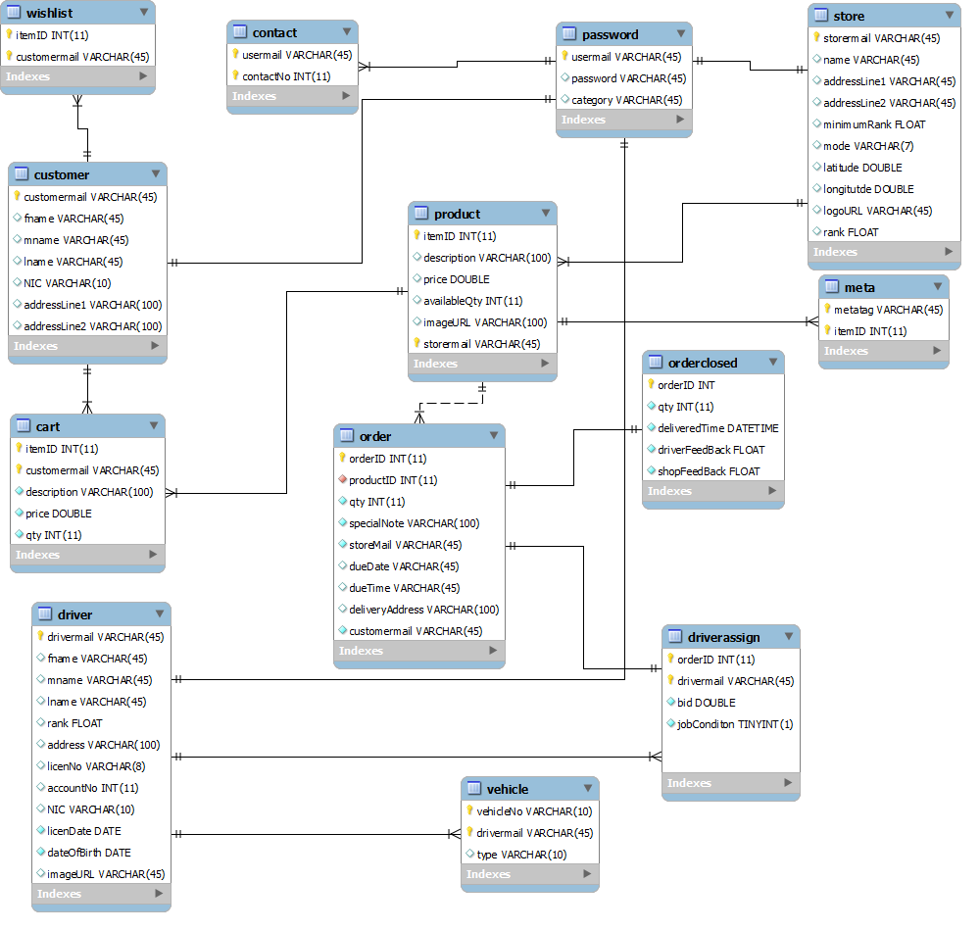

Figure 5.2.2 Entity Relationship Diagram

### 5.2.4Sequence Diagram

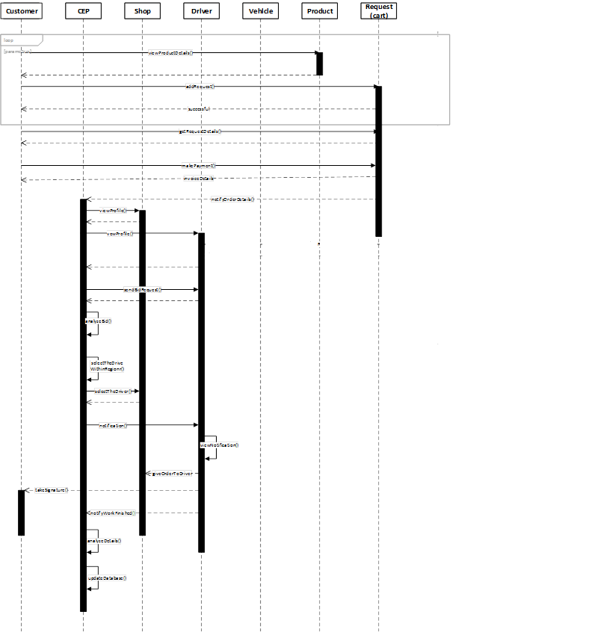

Figure 5.2.3 Sequence Diagram

### 5.2.5 Class Diagram

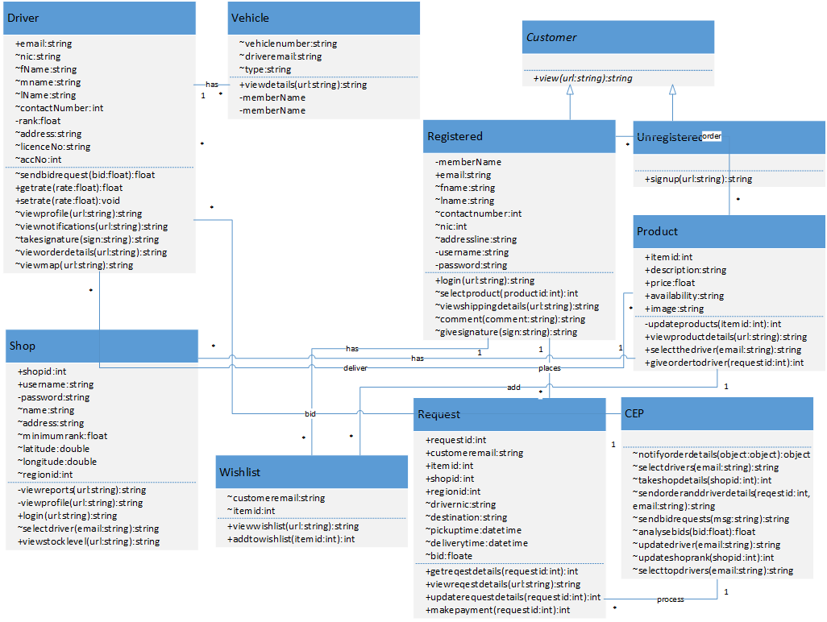

Figure 5.2.5 class diagram

### 5.2.6 Activity Diagram

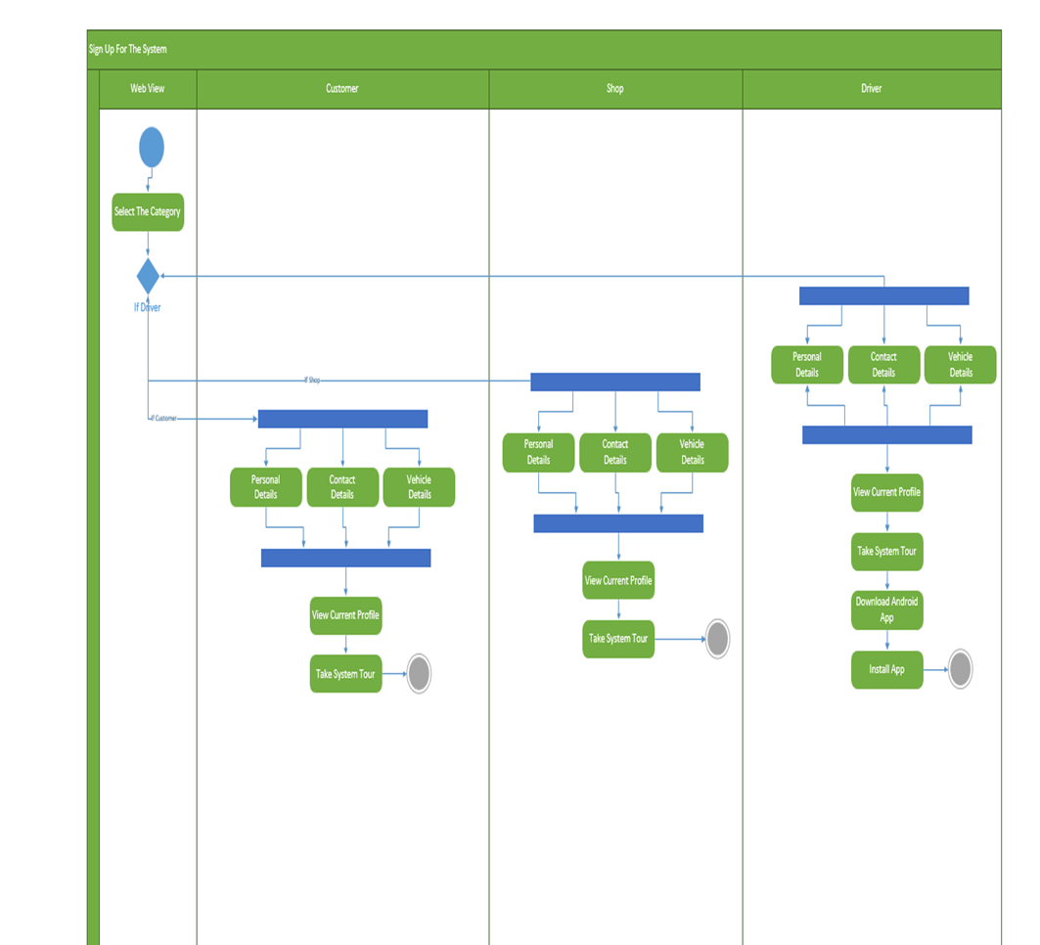

Figure 6.1 Login Activity Diagram



Figure 6.2 Purchasing Activity Diagram

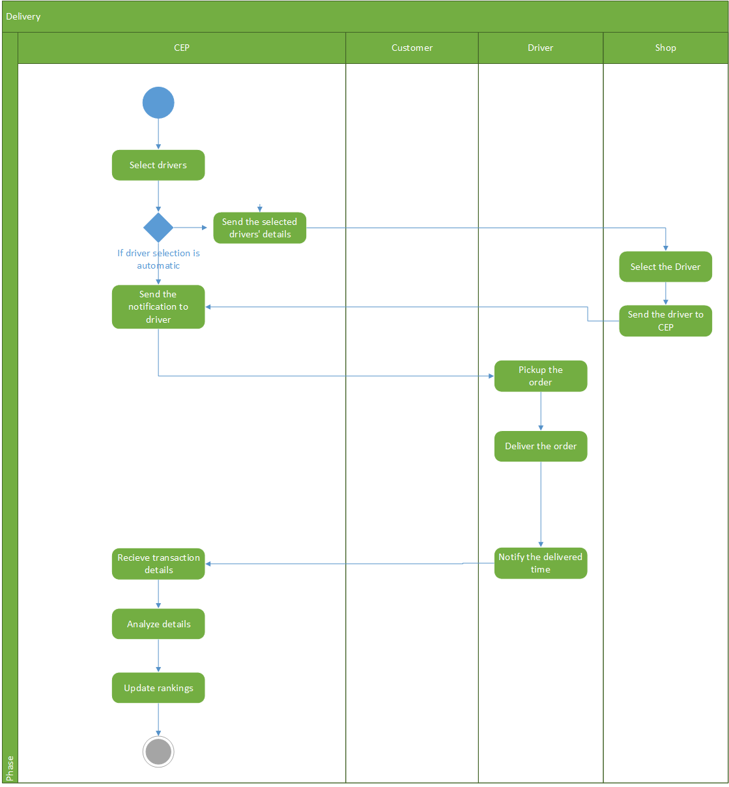

Figure 6.3 Buying Activity Diagram

## 5.3 Design

The main functionality provided by the system can be shown by the following context diagram. It shows the high level system architecture for the system.

Customers

Shops

Customer Order

Update shop and drivers details

Send order details

0

Delivery Management

System

Send bid request

Database

Send bid

Drivers

Figure5.3.1Context Diagram

### 5.3.1.1 Database Design

System database is mainly devoted for the work of Complex event processor because almost all the time it modifies the database according to the data inflows. Other than that it is used to maintain the details of the customers and their transactions during the particular time period. This will later be used to create more tables, which would tell the shop owners about the buying patterns in customers. They can even maintain their stock levels according to them and will give more competitive advantages.

Then the details about the shops has to be listed because CEP use them to communicate among shops. In here, we store details like available products, address, contact numbers and many other things to run the system as intended. Shop owners has to put them when they are signup into the system and can changed them as needed any time by viewing the profile.

The last part is about the drivers registered to the system. In here we take necessary details to contact the drivers and payment methods like direct cash, bank account and etc.

The database we used in here is MYSQL database management system because it’s free and support many features.

* Support multiple platforms
* Highly flexible
* Technically supported
* Reliable

### 5.3.2 Android Application Interfaces and Web Interfaces

All figures are included in Appendix

# Chapter 6

# Implementation

## 6.1 Introduction

In this chapter we intend to describe about the Implementation of the system using the given class and activity diagrams. The main web pages containing the login page, home page and product details page. This will give the basic entrance to almost every user. Drivers can view their profile details through their android application. The code segments for some of the login pages are shown in below.

## 6.2 Interfaces

### 6.2.1.Web Interface

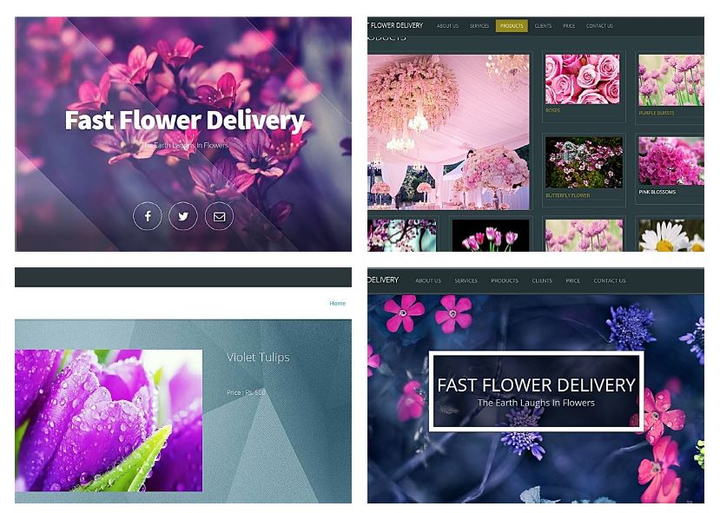

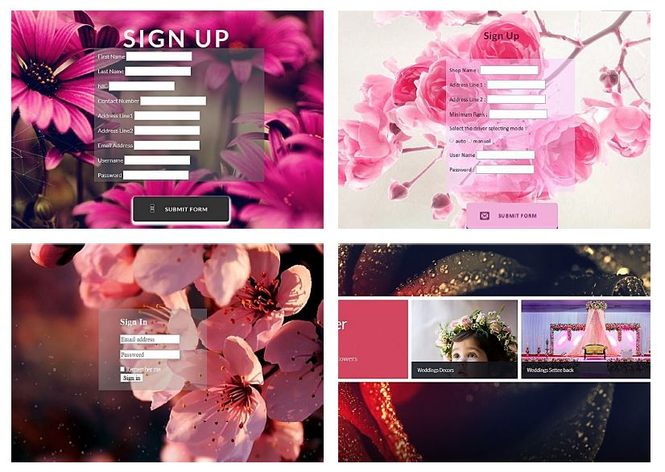

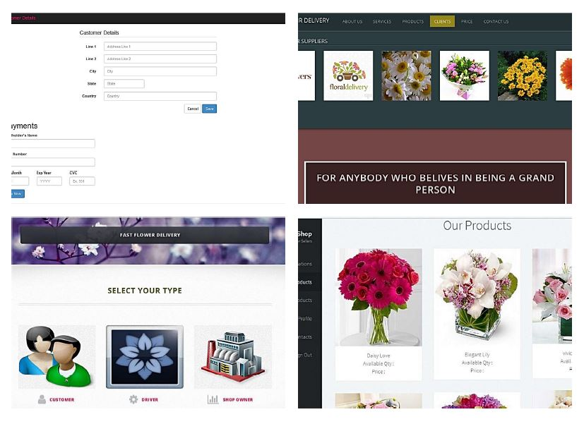

### 6.2.2 Android Interface

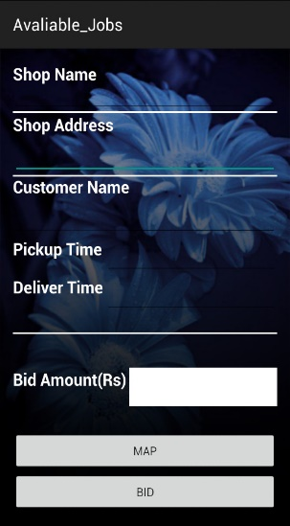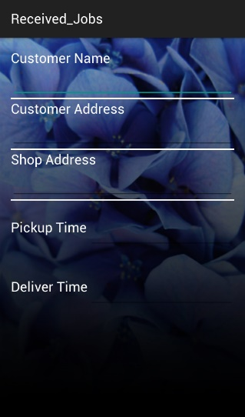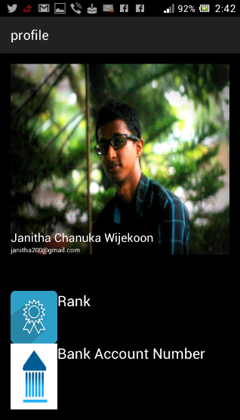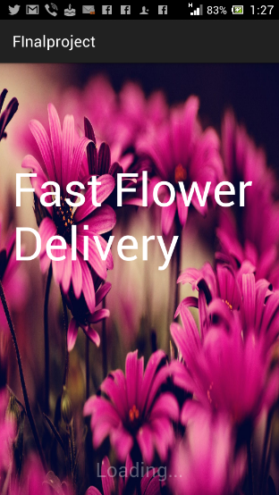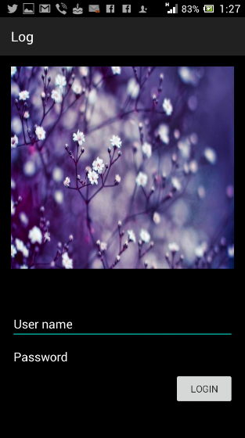

## 6.3 Summary

In this chapter we discuss about the way of implementing our Fast Flower Delivery system. We have includes source code for android and web applications. The interfaces and other relevant document are attached in the appendix.

# Chapter 7

# Evaluation

This section will basically cover the design of questionnaire and interviews for data gathering. Also this chapter will present the output of the questionnaire.

## 7.1 Design of questionnaire

The questionnaire was designed to evaluate the Fast Flower Delivery System based on given set of aspects. For the Questionnaire University students were asked to contribute. The questionnaire was based on multiple choice questions with yes, no, very good, good, average, poor, and very poor and with some detailed questions. The questionnaire will test the importance of this project as well as the quality of the Fast Flower Delivery System. It enables us to identify the drawbacks of the Fast Flower Delivery System in some the specified user requirements.

## 7.2 Designed questionnaire

#### How easy was it to use the overall system (Web page, Android application, ERP)?

Extremely easy

Very easy

Moderately easy

Slightly easy

Not at all easy

#### How user-friendly is our software's interface?

Extremely user-friendly

Very user-friendly

Moderately user-friendly

Slightly user-friendly

Not at all user-friendly

#### How often does our software freeze or crash?

Extremely often

Very often

Moderately often

Slightly often

Not at all often

#### How successful is our software in performing its intended task?

Extremely successful

Very successful

Moderately successful

Slightly successful

Not at all successful

1. How is the output of the system?

Extremely successful

Very successful

Moderately successful

Slightly successful

Not at all successful

#### How can we improve our software?



#### Overall, are you satisfied with our service, dissatisfied with it, or neither satisfied nor dissatisfied with it?

Extremely satisfied

Quite satisfied

Somewhat satisfied

Neither satisfied nor dissatisfied

Somewhat dissatisfied

Quite dissatisfied

Extremely dissatisfied

#### How likely is it that you would recommend our software to a friend or colleague?

Not at all likely

| 0 | 1 | 2 | 3 | 4 | 5 | 6 | 7 | 8 | 9 | 10 |
| --- | --- | --- | --- | --- | --- | --- | --- | --- | --- | --- |
| Not at all likely - 0 | 1 | 2 | 3 | 4 | 5 | 6 | 7 | 8 | 9 | Extremely likely 10 |

1. Which part do you think that more improvement is needed in this software system?

Web Application

Android Application

ERP System

By analyzing the questionnaire this system was got a positive comment which is shown in below.

|  |  |  |  |  |  |
| --- | --- | --- | --- | --- | --- |
| **Evaluation Questionnaire** | **Extremely**  **Good** | **Very**  **Good** | **Moderately Good** | **Slightly Good** | **Good** |
| How easy was it to use the overall system (Web page, Android application, ERP)? | 19 | 3 | 7 | 1 | 0 |
| How user-friendly is our software's interface? | 22 | 4 | 2 | 1 | 1 |
| How successful is our software in performing its intended task? | 2 | 1 | 23 | 3 | 1 |
| How is the output of the system? | 20 | 5 | 2 | 2 | 1 |
| Overall, are you satisfied with our service, dissatisfied with it, or neither satisfied nor dissatisfied with it? | 18 | 10 | 0 | 1 | 1 |
| How likely is it that you would recommend our software to a friend or colleague? | 25 | 3 | 1 | 1 | 0 |

There were total 30 participants taken into the consideration and 26 of them were responded with positive comments towards the Fast Flower Delivery System. The main reason of some people don’t like this system is they feel, if the internet go down or if the CEP not work what happen to the shops and the orders that client asked.

## 7.3 Control Experiments

Test Case 1

What happen if a client make an order then CEP finds that no drivers login to the system to bid. How the order is going to place.

Test case 2

What happen if the Internet go down for a while or the CEP crashes. How the shops and drivers contact.

## 7.4 Summary

Fast Flower Delivery System was delivered to the client one week before to the deadline with the basic features completed. The WSO2 satisfied with the user interface of the web application and the basic functionality. Done a survey to get user feedbacks. User feedbacks were recorded and analyzed carefully to figure out whether the application is up to the expectations. The next chapter will contain the details on conclusion and further work.