TryHackMe Networking Rooms

1. What is Networking?

Objective:

The objective of this room was to learn the basics of computer networking and how devices communicate with each other. I learned about networks, the Internet, IP addresses, MAC addresses and ICMP.

### What I Did – Step by Step

#### Step 1: Learning the Basics

I began the room by going through the introduction to networking. I learned that a network is essentially a group of connected devices that are able to communicate with each other.

I went through the provided information and answered the questions based on my knowledge.

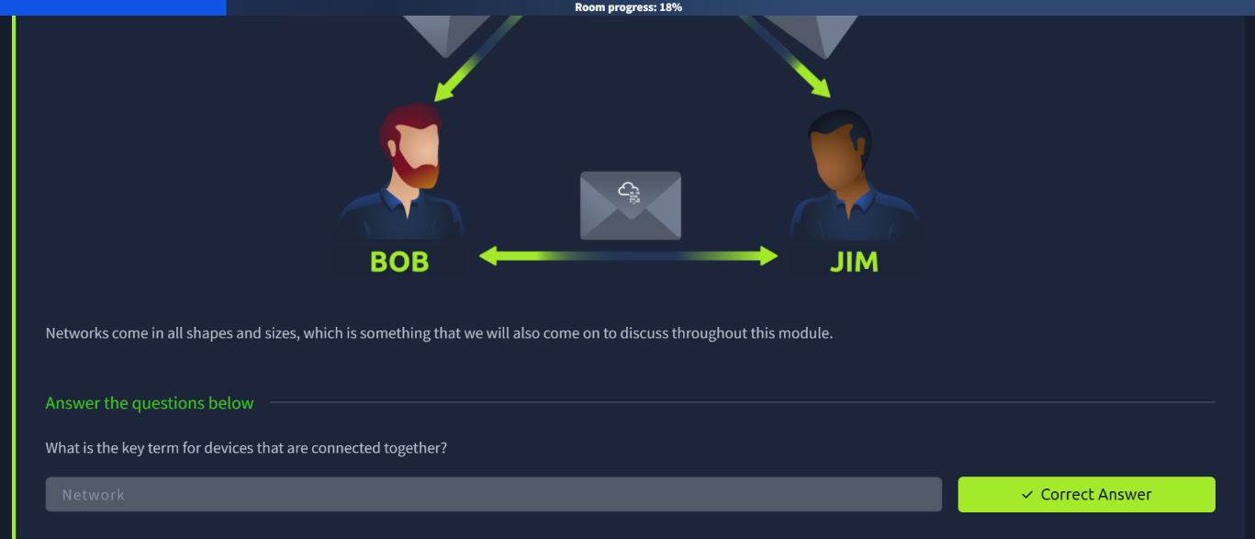

#### Step 2: Understanding the Internet

Next I learned about the Internet and how different networks are connected to each other. I understood that the Internet is not just one network, but a huge collection of connected networks.

I completed the questions of this section before moving ahead.

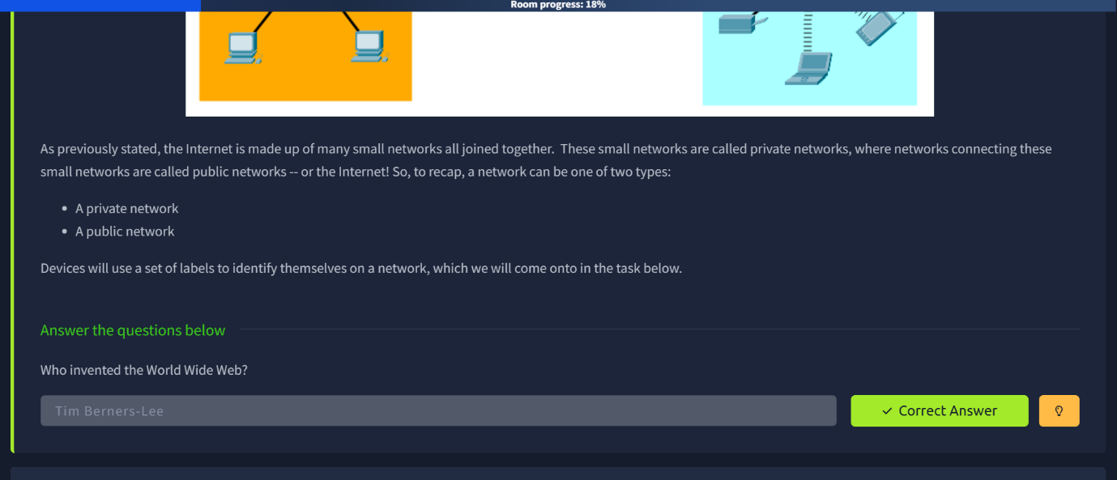
#### Step 3: IP and MAC Addresses

Afterwards, I learnt about IP and MAC addresses.

I learned that an IP address is used to identify a device on a network, while a MAC address is associated with the device’s network interface.

I went through the examples and completed the questions that were provided in this section.

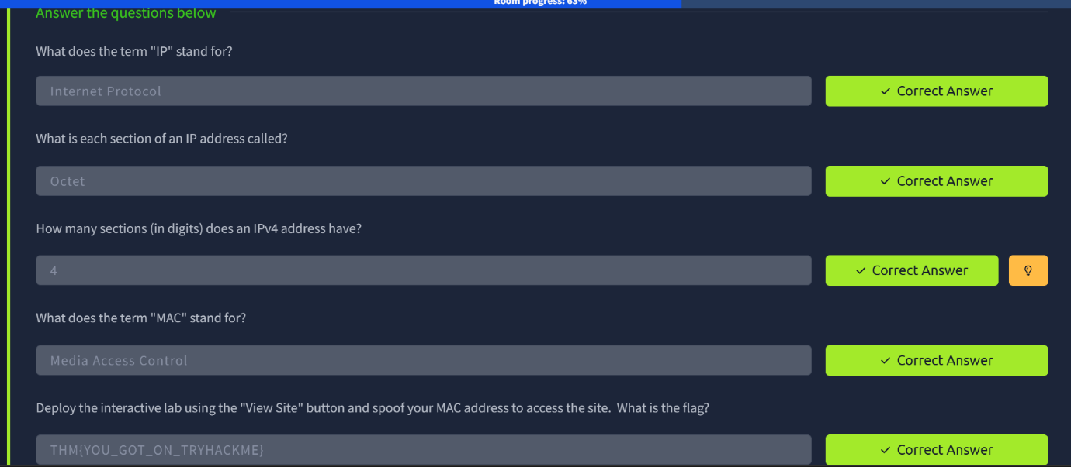
#### Step 4: Ping and ICMP

The next part introduced me to the `ping` command. I learned that ping can be used to test if the other devices or hosts are reachable.

I learned that ping works through ICMP. I followed the instructions from the room and completed the questions.


### What I Learned

From this room, I learned the basic concepts that are behind computer networking.

Some of the main things that I learned were:

A network allows devices to communicate with each other.

The Internet is made up of lots of connected networks.

IP addresses are used to identify devices on a network.

MAC addresses are associated with network interfaces.

IPv4 and IPv6 are different versions of IP addressing.

ICMP is used for network related communication and diagnostics.

The `ping` command can be used to test connectivity between devices.

This room gave me the basic understanding of networking that is necessary for learning about cybersecurity.

---

2. Intro to Networking

### Objective

The goal of this room was to understand networking a little more in-depth and gain some practical experience with the concepts and tools of networking.

### What I Did – Step by Step

#### Step 1: Getting Started

I began by going through the basic networking concepts described in the room. This helped me connect what I learned in the previous room to the topics in this room.

I read through the information and answered the questions as I went.

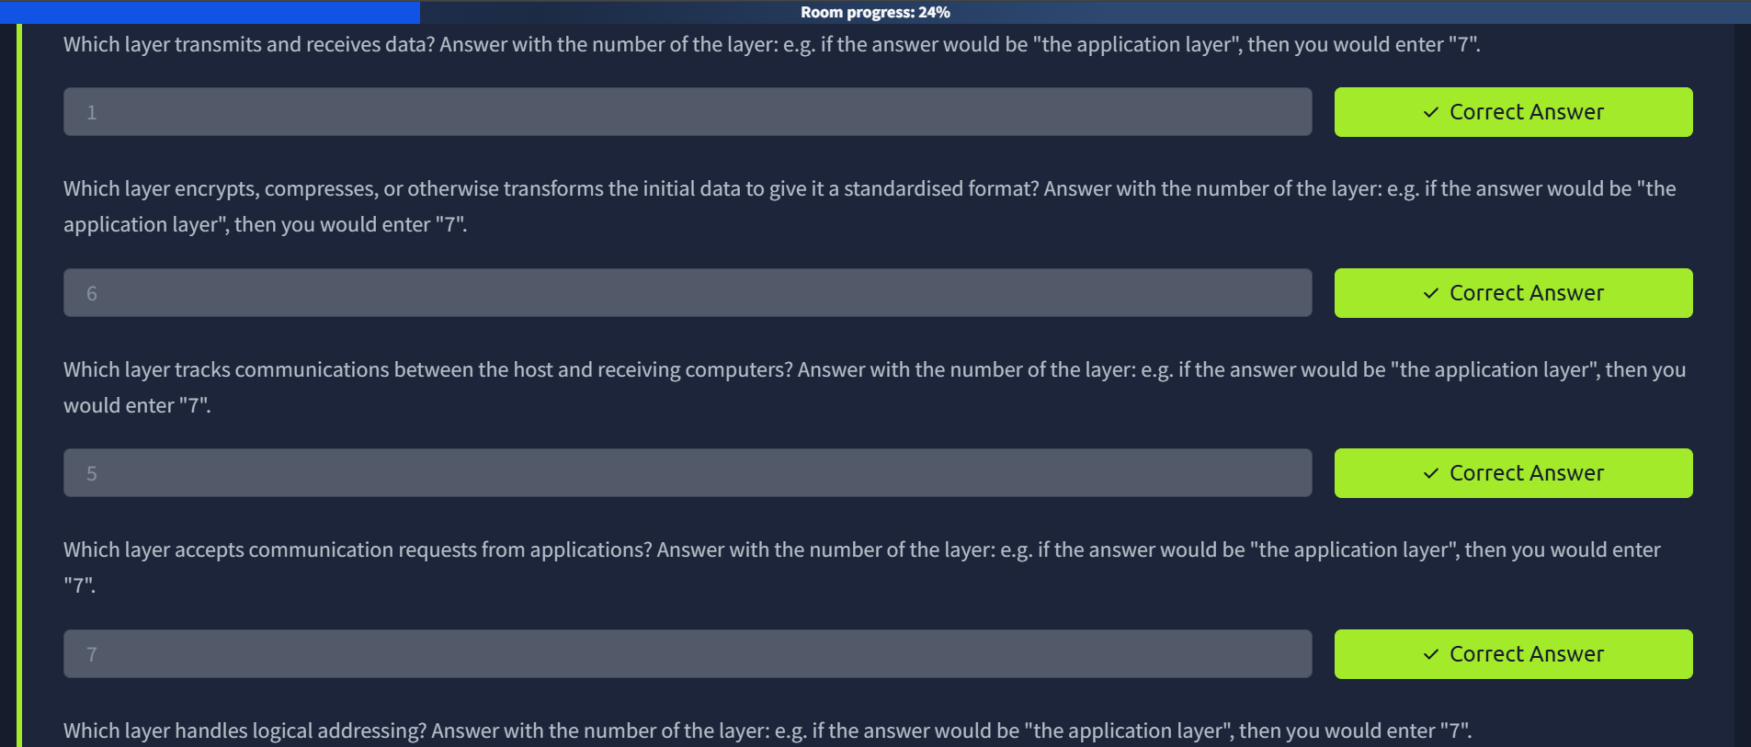
#### Step 2: Understanding Network Communication

I then learned more about how devices communicate with each other over a network.

I learned that different protocols are used in order to make communication between devices possible. I went through the examples that were provided in the room and answered the related questions.

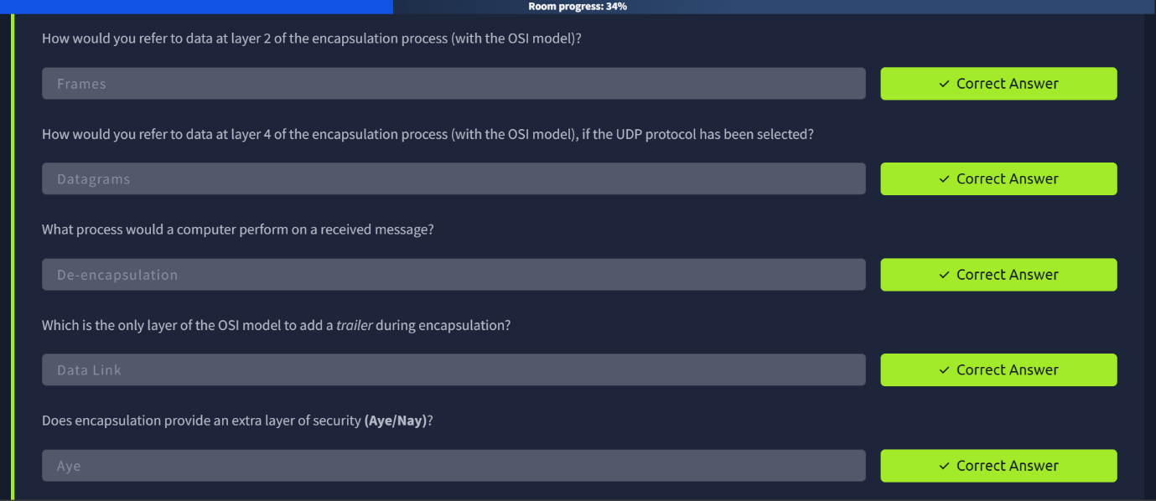

#### Step 3: Using Networking Tools

The room also introduced practical tools for networking and showed how they can be used in understanding and troubleshooting network communication.

I followed the instructions provided by TryHackMe and used the available environment to complete the practical tasks.

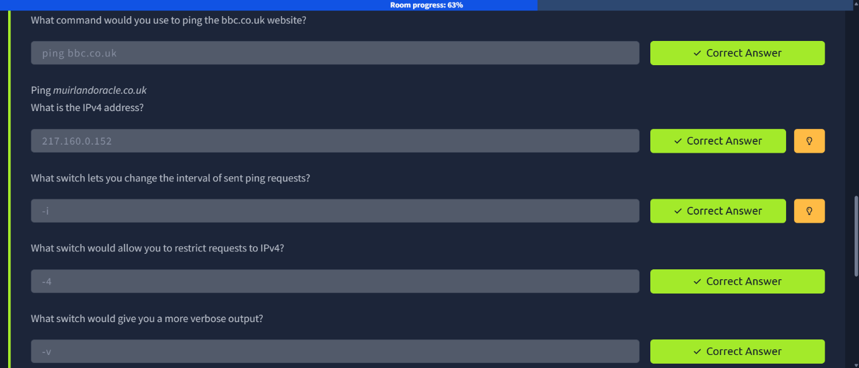
#### Step 4: Finishing the Room

I proceeded through the remaining sections and completed the questions one by one. After completing all the required tasks, I reached the completion screen.


### What I Learned

This room helped me learn about networking beyond the basic definitions.

I learned:

How devices communicate over a network.

Why protocols are needed for communication.

How networking tools can be used to check and understand the network activity.

How networking concepts can be applied practically.

Why networking is important when learning about cybersecurity.

The practical parts enabled me to understand the concepts better since I was able to actually use the tools rather than just reading about them.

---

3. Overall Learning

After completing both rooms, I now have a better understanding of how computer networks work.

The first room helped me learn the basic concepts like IP addresses, MAC addresses, the Internet and ICMP. The second room built upon those basics and gave me more practical experience with networking.

Overall I learned that networking is an important foundation in studying cybersecurity since computers, servers and other devices communicate with each other through networks.

4. TryHackMe Profile

My TryHackMe Profile:

https://tryhackme.com/p/rsahanna3

This profile can be used to verify that both rooms have been completed.

R.SAHANNA
CSE E

