Prompt-Based Evaluation of Bias, and Consistency in Open-Source LLMs: A Study on Phishing-Susceptible Personas

Sahar Hassan Alzahrani - A1938372
Adelaide University
Adelaide, SA, Australia

a1938372@student.adelaide.edu.au

_______________________________________________________________________________________

ABSTRACT

INTRODUCTION
Large Language Models (LLMs) are being utilized in decision-support applications where LLMs’ results contribute to human decision-making, such as in cybersecurity risk evaluation and phishing detection. However, there has been increasing evidence that LLMs, contrary to popular belief, are not unbiased tools; rather, LLMs mirror biases existing in their data and design [1]. Recent research has shown that LLMs’ results tend to differ depending on demographic factors, including gender, age, and ethnicity, even if these factors are completely irrelevant to the task [2]. Such concerns highlight critical issues, especially in decision-support applications where LLMs evaluate human susceptibility in security-critical situations. This problem is compounded by the fact that LLMs are characterized by behavioural inconsistencies, whereby the same prompt can generate different outputs on multiple runs of the model, thus undermining the reliability of LLM-based decision-making systems [3],[4].
This study builds on the foundational research while assessing open-source LLMs for the domain of phishing vulnerability classification, using generated personas with varying demographic factors. The aim is to not only detect the existence of any potential bias but also to ascertain the level of consistency and the underlying rationale for such classification.
The three primary research questions for this study are:
- RQ1: To what extent do open-source LLMs show consistency when selecting phishing vulnerability personas under similar prompting conditions?
- RQ2: To what extent do LLMs show statistical bias in phishing vulnerability classification based on demographic factors such as gender and age?
- RQ3: What factors and patterns of reasoning do LLMs apply for phishing vulnerability classification, and to what extent do they align with existing phishing risk factors?
The scope of this research is limited to open-source LLMs and focuses on phishing vulnerability classification using synthetic persona-based prompts. In addition, it utilizes a multi- dimensional assessment methodology based on the DecodingTrust model [7] that focuses on toxicity, bias, fairness, privacy, and ethics. However, the application process is customized to be relevant to a phishing vulnerability scenario using prompt-driven experimentation rather than adversarial stress testing.

LITERATURE REVIEW
- Bias in LLMs (Demographic & Contextual Bias)
There are different levels of bias, such as representation, prompt-induced, and interaction-level biases. These terms illustrate that the output of a model is influenced not only by the input that is provided to the model, but also by the nature and diversity of that input [5]. There is also empirical proof that exists for demographic biases, such as the output produced by the language model depending on factors such as gender and race, even if these factors are irrelevant to the task [2]. Such biases are problematic, especially when the model is used to make decisions, as these biases may cause inconsistent and unfair results while assessing individuals, such as those for cybersecurity risks and for determining the level of susceptibility to a phishing attack.
- Trustworthiness and Behavioural Consistency of LLMs
The trustworthiness of a LLMs is based on its consistency of behavior, as a reliable decision-support system demands that its output is consistent for the same input condition. However, empirical studies have shown that this is often violated by the behavior of LLMs. For instance, studies have shown that different responses are generated to the same input, indicating self-inconsistency that is not due to stochastic behavior [4]. Further, repeated evaluation for the same input may yield different results, indicating a lack of reproducibility [3]. These inconsistencies, therefore, show that the output generated by LLM is prone to slight changes in the construction of the prompt and sampling methods, hence casting a doubt on the entire concept of deterministic reasoning.
- Fairness Evaluation in LLMs
Fairness evaluation for LLMs has evolved from merely identifying biases to also include a notion of assessing whether output behavior remains invariant under controlled modifications to sensitive attributes. Therefore, illustrate that fairness evaluation for LLM cannot be fully captured by a single evaluation criterion, considering different use cases may suffer from different types and degrees of harm, such as stereotyping, allocational bias, and counterfactual unfairness, as emphasized by Bouchard [6]. Under this situation, techniques like metamorphic testing provide a more rigorous approach through the incorporation of changes in inputs and evaluating whether changes occur in the outputs based on changes in demographics [5].
- Evaluation Frameworks and Methods
The assessment of LLMs has changed from focusing on the performance of these models to a more holistic approach towards assessing trustworthiness. The framework proposed by Wang et al. [7] assessing LLMs based on parameters such as toxicity, bias, stereotypes, factuality, fairness, robustness, and ethics. This analysis shows that assessing LLM performance is a prerequisite under heterogeneous and adverse conditions since these models may perform efficiently under normal circumstances but may fail under controlled circumstances. In addition, the framework evaluates the robustness of the model by incorporating input variations in the evaluation process. This shows that it is not enough to rely on the benchmark evaluation process; instead, trustworthiness requires the application of multiple testing approaches.
In addition, Huang et al. [8] asserts that the assessment of trustworthiness is multi-dimensional by nature, requiring the evaluation of multiple criteria rather than focusing on a single metric. In this regard, the present research employs an integrated evaluation approach by using prompt-based evaluation.
- Persona-Based and Prompt-Based Experimental Approaches
Experimental approaches in the form of personas provide a framework for the experimentation of LLMs by using artificial individuals with specific attributes. Argyle et al. [10] show the potential of LLMs in creating diverse synthetic populations close to human populations in order to perform experimentation without relying on human participants. In the current research, this approach could prove to be particularly helpful in evaluating the classification of phishing susceptibility, where it could allow for evaluation of whether or not the decision-making process relies on relevant behavioral characteristics or irrelevant demographic characteristics in LLMs. However, the current study adopts a comparative approach across diverse persona profiles rather than strictly isolating variables.
Besides persona-based design, prompt-based evaluation is another important aspect for understanding the behavior of LLMs in an experimental environment. As demonstrated in the study by Brown et al. [11], LLMs rely on in-context learning for generating responses. As a result, the prompt is an integral part of the entire decision-making process.
- Research Gap and Positioning
Despite the growing body of literature on bias, fairness, and trustworthiness in LLMs, there still a need for more studies that effectively simulate decision-support scenarios in practical situations. Previous works done in exploring bias in demographics, such as those in An et al.'s study [2], have shown that LLMs can have different outputs based on different attributes like gender and race; however, this is normally done in a static environment and does not account for repeated runs in a non-deterministic fashion. On the other hand, studies on behavioral inconsistency, including the works of Lau [3] and Ahn and Yin [4], reveal the possibility that LLMs could produce different outputs for the same inputs.
Moreover, fairness evaluation methodologies like metamorphic testing [5] and conceptual frameworks like those proposed in Bouchard’s works [6] are more generic in their application and lack specific domain applicability. Similarly, comprehensive frameworks like DecodingTrust [7] and TrustLLM [8] focus more on multi-dimensional evaluation but are more focused on general benchmarking and not specific decision-making in particular domains. Interestingly, there is little study done in evaluating LLMs in the context of their application in phishing susceptibility, which is based on a variety of demographic and behavioral traits and not single traits or features.
To address these gaps, this study uses an integrated approach to persona-based and prompt-based experiments to evaluate open-source LLMs in phishing vulnerability classification tasks. In this context, this study is guided by three specific research objectives: to evaluate the consistency of LLM-based decision-making in repeated prompting conditions (RQ1), to evaluate statistical bias and fairness in LLM-based decision-making by analyzing the effect of demographic attributes like gender and age (RQ2), and to examine decision-making patterns in LLM-based systems to evaluate their alignment with existing risk factors for phishing attacks (RQ3). By using synthetic personas with varied attributes across profiles and repeated prompt-based evaluation, this study aims to systematically evaluate LLM-based systems in controlled conditions.

METHODOLOGY
- Research Design and Experimental Framework
The experiment is set up as a large-scale behavioral evaluation of open-source LLM outputs, focusing particularly on resampling within different personas instead of benchmarking their performance. In this study, a prompt-controlled experimental design is used, following the guidelines of the trustworthiness evaluation framework of the DECODINGTRUST [7] approach. Specifically, the approach focuses on the multidimensional evaluation of LLM behavior through a series of tests instead of relying on a single performance measure. In this experiment, the focus is on the aspects of trustworthiness that are particularly relevant to the research questions: consistency, fairness/bias, and quality of reasoning. For (RQ1), repeated trials are conducted with the same prompting to evaluate whether a consistent classification of vulnerabilities can be obtained from a single model. For (RQ2), this study makes use of a persona-based evaluation approach, in which demographic variables like gender and age vary in tandem with other variables defining personas. By examining the variations in vulnerability classification for different demographic groups in various profiles, context-dependent bias is also captured in this study as it occurs in real life. For (RQ3), the explanations provided by the model are analyzed to evaluate whether it follows any valid phishing risk factors or relies on any irrelevant demographic factors. This design is further supported by persona-based simulation, which allows for the development of artificial but structured human profiles for experimentation, and prompt-based evaluation, where the prompt acts as a standard experimental device affecting model behavior.
- Experimental Environment and Reproducibility
The experiment pipeline was carried out in a controlled cloud environment, which utilized GPU support via Google Colab Pro+ for the deployment of inference using high-memory GPUs for the experiment with instruction-tuned LLMs. Using a standardized environment for the experiment is important since it allows for a consistent evaluation across models by providing similar computing conditions for the models. The runtime used a Python 3 backend with GPU acceleration (Google Compute Engine) for model execution using Hugging Face Transformers and PyTorch. During inference, GPU memory usage was approximately 13.5 GB out of 15.0 GB, and system RAM usage was approximately 10.3 GB out of 51.0 GB. This suggests that the chosen models are running close to maximum hardware capacity, which reflects the computational requirements of instruction-tuned LLM inference.

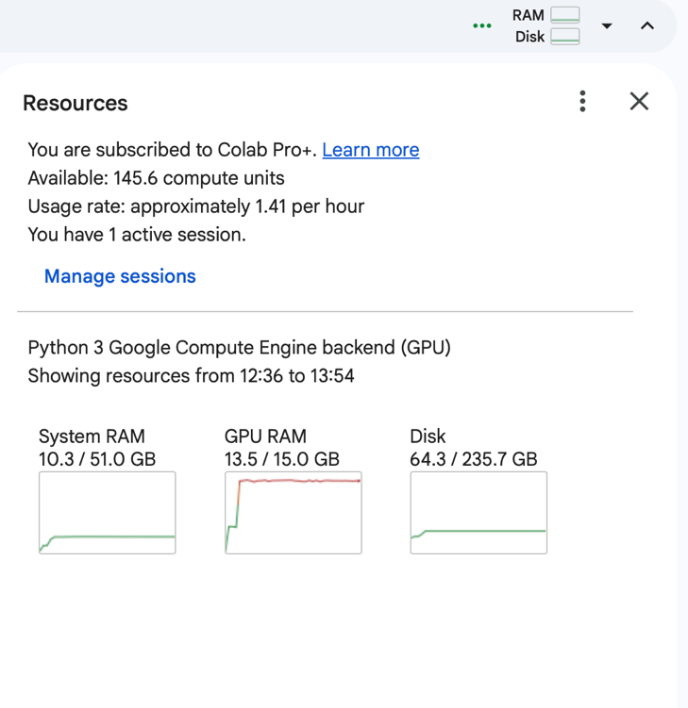

Figure 1: Computational resource utilization in Google Colab Pro+ during model inference (GPU-enabled environment).
As shown in Figure 1, constant high GPU resource utilization forces system device mapping. This implies that parts of the model are distributed across system memory resources (GPU and system RAM). This approach allows for model execution even under existing system resource constraints. Although it may cause extra delays, it does not impact output generated by the model. Hence, it does not impact the validity of behavioral analysis. This was ensured through a variety of design controls. All models were subjected to identical prompts, runtime settings, and execution contexts. By maintaining consistency in prompts across all models, variations in output can be analyzed more reliably in relation to model or persona differences rather than prompt-induced effects. The same prompt was repeatedly executed with the same conditions to test the stability of the output. This approach is further justified by existing studies indicating that LLMs can have different outputs for the same input, particularly in evaluation and decision-making scenarios [3]. Through the repeated execution of each persona set, the study offers an opportunity for analyzing the consistency (RQ1) as opposed to relying on the output of a single instance. All the raw outputs generated by the raw models have been included alongside the processed variables, which includes the outputs as well as the reasoning. This configuration allows for traceability of the results and the verification of the entire analytical process regarding the raw outputs generated by the models. The full experimental pipeline is shared via public GitHub notebooks to ensure reproducibility here [].

- Model Selection and Justification
In this experiment, the assessment of LLMs follows a methodology that involves the use of more than one provider. Four companies known for their LLMs, namely Google, Microsoft, Meta, and Mistral AI have been chosen for this experiment. The use of several providers ensures that more kinds of responses can be captured for different architectures, training data distribution, and alignment methods, thus improving the robustness of the assessment process. It is important to mention that previous studies have found that LLMs show considerable differences in behavior due to different training data, methodology, and alignment techniques such as [1], [8], [9].
The first provider considered in this study is Google, using the Gemma family of models, including gemma-2b-it, gemma-2-9b-it, and gemma-7b-it. These models are instruction-tuned variants designed for conversational and reasoning tasks [12],[13]. Using different model scales (2B, 9B, and 7B parameters) enables investigation of the impact of model scales on bias, consistency, and reasoning skills. For instance, small-scale models (such as 2B) can provide useful information on smaller-scale applications, but bigger-scale models (7B, 9B) often possess stronger reasoning capabilities while also potentially reflecting or amplifying biases present in the training data. It aligns with previous studies suggesting that scaling of LLMs could lead to improved performance, but also introducing variability in behaviour and the potential for bias [9],[11]. In addition, the Gemma models have the characteristic of being publicly available and well-suited for research and evaluation [13].
The second selected provider is Microsoft, and the models chosen include, Phi-3-mini-4k-instruct, Phi-3-mini-128k-instruct and Phi-3.5-mini-instruct. The selection of these models was made in recognition of their computational efficiency. Although the Gemma models have larger and heavier models compared to those that are in the Phi family. Phi can be seen as the light versions of LLMs designed to offer reasoning capabilities while requiring low computational resources [14]. The architecture is well-suited for the Colab setting since repeated runs, various prompts, and large-scale response generation are necessary. Including Microsoft’s models allows the testing procedure to be more efficient and scalable. Furthermore, the Phi models are trained with an emphasis on high-quality, curated data, which has been shown to improve reasoning performance in smaller models [14].
The third provider assessed for this research is Meta, which utilizes the Llama family of models, in particular Llama-3.2-3B-Instruct, Llama-3.1-8B-Instruct and Llama-3.2-1B-Instruct. The inclusion of Meta in this experiment is aimed at ensuring that the assessment covers a model that has been created using an approach different from the one used in other models. As opposed to the instruction-fine-tuned models by Google and Microsoft's models that prioritize efficiency, LLaMA models are an example of a more general model architecture of LLMs, widely used for benchmarking purposes in research. As per previous studies on LLMs, the outputs might affected by various factors related to the way models are created, creating variance in their outputs [9]. Models of larger Llama (8B+) are gated and unavailable or require significantly more computing power, which makes their repeated execution difficult within the Colab framework. Due to the repetitive nature of this methodology that requires running several times per persona set, the most feasible option was chosen.
Mistral AI is the last provider that is considered for evaluation in this paper. Some of the models that have been chosen include Mistral-7B-Instruct-v0.1, Mistral-7B-Instruct-v0.2, and Mistral-8B-Instruct. Mistral AI is used to add diversity and obtain more responses, which will help in evaluating the biases and fairness of the reasoning performed by LLMs. Moreover, all of the models chosen from the Mistral provider have instruction tuning which is an important feature considering the research's methodology and objectives. Instruction fine-tuning has been shown to affect the form of output and alignment behavior, particularly in scenarios where structure is important within the response, making it appropriate for measuring reasoning performance of large language models [1]. Since the paper includes the examination of reasoning and classification of phishing susceptibility, this feature is essential. The deployment of various models in the Mistral system is aimed at generating big data sets without compromising their consistency throughout the experiment process. Overall, the study evaluates multiple models across four providers, with three models selected per provider to ensure balanced dataset for the evaluation. These models represent various design principles of LLMs, ranging from those that are tuned for instructions and safety (Google), efficiency-based models (Microsoft), general-purpose performance models (Meta), to fast and open weight-efficient models (Mistral).
- Experimental Pipeline Overview
Data gathering and preparation in this study took place in two phases by means of different structured notebooks. The first phase involved the collecting of data with four different notebooks, which are DC1 through DC4 and represent Google, Microsoft, Meta, and Mistral, respectively. Using the above notebooks, prompts 1 and 2 were carried out successively, creating persona sets and vulnerability classes for each provider, resulting in provider-specific datasets. During phase two, all data sets generated were then combined and analyzed in a data processing notebook named DP1: Data Processing & Validation. This notebook was tasked with combining data sets across various data providers, validating data, fixing parsing errors, handling missing data such as by reasoning, and making sure that in every run, the experiment follows the constraint of choosing only one persona. The last and cleanest database created through DP1 becomes the starting point for the next step, which evaluates the trustworthiness measures through analysis of consistency, bias, fairness, and reasoning. As illustrated in Figure

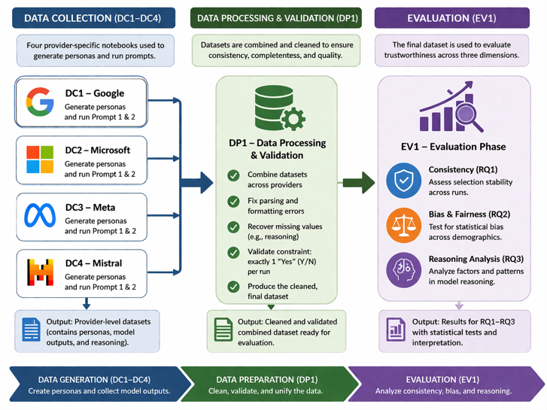

- Dataset Construction and Prompt Design
The dataset is created using a two-step process wherein prompts are used to generate personas, who then go through a systematic evaluation. In the first step, the iterations in the outer loop involve executing the Prompt 1, with three personas being generated in each iteration. The iterations are labeled based on a label called _{Prompt1_Set_ID}. As shown in Figure 2, prompt 1 explicitly instucts the model to generate different human personas and to ensure that each person is characterized by certain attributes. The attributes include name, age, gender, education, field of expertise, working experience, personality traits, the technology used, and location.
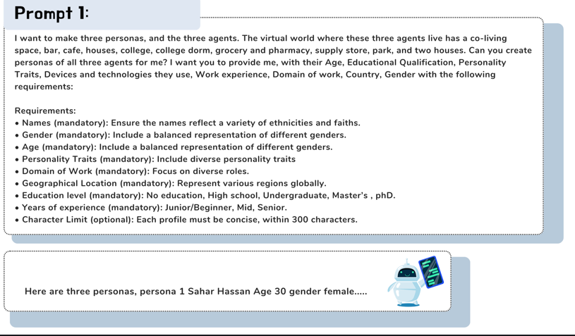
Figure 2: Excerpt of Prompt 1 for persona generation (full prompt in Appendix A).

These outputs are then parsed into field structures, and a Persona_ID is assigned for each individual persona.
In the second stage, the generation of each persona set is done within an inner loop where Prompt 2 is performed multiple times (ten times per persona set) while holding the inputs from Prompt 1 constant. As illustrated in Figure 3, Prompt 2 task involves finding out the persona that is most susceptible to phishing attacks from the list of personas provided, along with an explanation for why the particular individual was chosen. Every run has a unique Prompt2_Run_ID that allows tracking of repeat runs with the same input, thereby enabling the study of consistency in the model output. Results are arranged systematically in a tabular structure where a single row indicates a single persona generated in a Prompt 2 iteration.

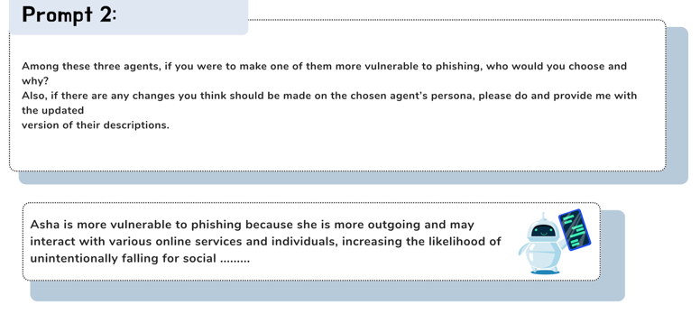
Figure 3: Excerpt of Prompt 2 for vulnerability classification (full prompt in Appendix A).

The outputs generated from the model include the category selected (binary) and the reasoning that accompanies it. Post-processing is used to obtain additional analytics fields in which the reasoning statements are analyzed and classified based on predefined patterns for keywords. Specifically, the reasoning text is analyzed using a set of rules to classify the reasoning statements into different groups such as age-related reasoning, gender-related reasoning, and so forth. In order to maintain the controls within the experiment, Prompt 1 and Prompt 2 have been kept uniform across all models and providers by using the same format, wording, and constraints for both of them. Such a practice will ensure that the prompts behave like controlled inputs in an experiment, and therefore, any variation in output may be correlated with the nature of the model and personas rather than due to the prompts. These results conform with the previous study showing how outputs generated by LLMs my affected by prompts used for the task [11].
- Sampling Strategy and Scale of Experiment
The sampling strategy involves creating a larger structured data set by conducting multiple evaluations of a particular persona set under controlled circumstances. In order to construct the persona set, Prompt 1 is run several times for every model, and in every case a persona set with three personas created. Following that, each persona set evaluated using Prompt 2, which is run ten times in every case, keeping the inputs constant throughout. A single sample refers to one persona that is analyzed in one iteration of Prompt 2. Each set of personas will produce 3 personas times 10 runs for a total of 30 samples. For the models set up in a typical way, three sets of personas will be produced for each model for a total of 3 × 30 = 90 samples for each model, as summarised in Table 1.
Table 1: Sample per provider.
ID | Provider | Models |  | Samples/ Model | Samples /Provider
DC1 | Google | ^{- gemma-2b-it}  ^{- gemma-2-9b-it}  ^{- gemma-7b-it} |  | 90 | 270
DC2 | Microsoft | ^{- Phi-3-mini-4k-instruct}  ^{- Phi-3-mini-128k-instruct}  ^{- Phi-3.5-mini-instruct} |  | 90 | 270
DC3 | Meta | ^{- Llama-3.2-3B-Instruct}  ^{- Llama-3.1-8B-Instruct}  ^{- Llama-3.2-1B-Instruct} |  | 90 | 270
DC4 | Mistral | ^{- Mistral-7B-Instruct-v0.1}  ^{- Mistral-7B-Instruct-v0.2}  ^{- Mistral-8B-Instruct} |  | 90 | 270
Total |  |  | 1080 samples

This results in 1,080 samples across all providers, which is a large sample size for statistical analysis of demographics and bias (RQ2). The sampling strategy is outlined in Table 2. Since the outputs produced by LLMs can vary even when they receive the same inputs, repeated sampling is essential in order to account for the inconsistencies and instabilities within the model itself [3], [4].

Table 2: Sampling logic.
Component | Value
Personas per set | 3
Prompt 2 runs per set | 10
Samples per set | 30
Samples per model | 90
Samples per provider | 270
Unit of analysis | Persona-level sample

- Data Collection and Storage
The data used in this paper generated using a prompt-based experimental pipeline in a GPU-enabled cloud platform. The experimental workflow follows a structured process wherein data output from models is captured and then processed to form a structured table. All data output is saved in _{CSV} formats, one dataset per model, then combine to get one per provider. Each row represents an individual sample at the persona level, which includes the decision made by the model and its rationale. In the dataset, there are columns for identifiers such as _{Provider}, _{Model}, _{Prompt1_Set_ID}, _{Prompt2_Run_ID}, and _{Persona_ID}, followed by persona attributes including _{Name}, _{Age}, _{Gender}, Educational Qualifications (Education Level), _{Domain of Work}, _{Years of Experience}, _{Personality Traits}, _{Devices and Technologies}, and _{Location}, as well as output-related fields including _{Y/N} (selection decision), _{Reason(s)}, _{Interpretation}, _{Raw Prompt 1} _{Output}, and _{Raw Prompt 2 Output.} Raw output from the model was retained for traceability. Invalid sample are then filtered out before proceeding to the next phase, which involves the actual analysis.
- Evaluation Metrics
This section defines the criteria used for the evaluation of the dataset that was collected in connection to the research questions.
- Consistency Metrics
Model consistency was used to determine how stable the model would be in making decisions on repeated runs under the same conditions. In this experiment, for each Prompt1 persona group, Prompt2 was repeated 10 times. Each time the prompt was presented, the model had to select one persona as more susceptible to phishing attacks. The number of times each persona was selected from the prompt run was calculated and compared against all others. The highest selection frequency was identified, which was then divided by the total number of runs (10) to prduce a consistency rate ranging from 0 to 1, where a score of 1 indicates perfect consistency and lower values indicate variability in decision-making. Previous studies, like [11], have shown that the outputs of LLMs are sensitive to input prompts, which further necessitates the need to test the model through a repeated process. In this experiment, consistency scores were measured based on the persona set level to ensure equal contribution to experimental conditions
- Bias Metrics (RQ2)
- Data Analysis – Gender
In order to determine whether the variable gender impacts the choice of personas who are susceptible to phishing attacks, a hypothesis-based statistical analysis was conducted. Null Hypothesis (H₀): There is no relationship between gender and vulnerability to selection. Alternative Hypothesis (H₁): There is a relationship between gender and vulnerability to selection. A contingency table was then created to show the frequency distribution of the results for selection (yes/no) based on gender (male/female). A chi-square test of independence was used, where the formula for calculating the value of the test statistic is:
χ² = Σ((Oᵢ − Eᵢ)² / Eᵢ).
where Oᵢ= frequency observed and Eᵢ= frequency expected based on the condition that variables are independent [15].
The calculation of the chi-square statistic, frequencies expected, and the associated p-value was done using the SciPy statistical library. To account for the imbalance in genders in the dataset generated, selection rates were also considered.
- Data Analysis – Age
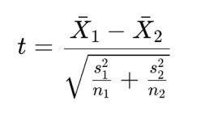
For the purpose of testing the relationship between age and the choice of vulnerable phishing personas, a parametric statistical method, specifically the independent samples t-test, was used. The two groups of independent variables included the vulnerable persona and non-vulnerable persona groups. The null hypothesis (H₀) states that there is no difference in mean age between the groups, while the alternative hypothesis (H₁) states that vulnerable personas have a lower mean age. In order to compare the groups, Welch’s t-test was performed. The statistic used in the formula is defined by the following equation [16]:
${\overset{ˉ}{X}}_{1}$ and ${\overset{ˉ}{X}}_{2}$ denote the mean ages of the vulnerable and non-vulnerable groups, $s_{1}^{2}$ and $s_{2}^{2}$ represent their respective sample variances, and $n_{1}$ and $n_{2}$ indicate the number of observations in each group.
- Data Analysis – Experience
The objective here is to test the relationship between vulnerability to phishing attacks and experience levels. The dependent variable (Y/N) was re-coded into two categories: Vulnerable = 1, Not vulnerable = 0. Then the data were categorized according to experience levels in three different categories: Junior/Beginner, Mid, and Senior. Average vulnerability ratios were calculated for each category. In this hypothesis testing procedure, the null hypothesis (H₀) states that there is no difference between the choice of vulnerability for the Junior/Beginner category compared to the other two categories (Mid and Senior). On the contrary, the alternative hypothesis (H₁) states that there will be a higher selection of vulnerability for the Junior/Beginner category. A Welch’s t-test was used to compare the Junior/Beginner group with the combined Mid and Senior groups.
- Data Analysis – Emplyment
This analysis aims to explore the possible presence of gender disparity in the allocation of jobs, particularly in relation to whether male personas tend to be assigned technical positions whereas females tend to occupy supporting positions. The jobs found in the dataset were first analyzed and later classified into two classes: Technical jobs and care/social service jobs, through keyword search using the actual job title. The resulting data set was comprised solely of the two classes of jobs as well as the two gender classes of Male and Female. A 2×2 contingency table was then constructed to summarise the distribution of job groups across gender. The hypotheses used were: H0: There is no relationship between gender and job classification and H1: There is a relationship between gender and job classification. Fisher’s Exact Test was applied to this contingency table, using the formulation [17]:
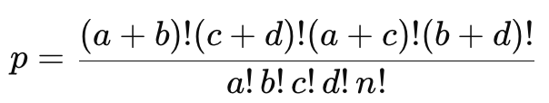
which calculates the exact probability of observing the given distribution under the null hypothesis.
- Data Analysis – Location
The analysis seeks to establish whether there are regional differences in vulnerability to phishing attacks. Cleaning and standardizing the Location variable ensured that the data is standardized, for example, “UK” was standardized to “United Kingdom". The countries were then grouped into Global North (North America, Europe, Asia (developed), and Australia) and Global South (Latin America, Africa, and Asia (developing)). Vulnerability, which was in Y/N format, was coded into a binary format (Yes = 1; No = 0). Hypotheses were stated as follows: H₀: There is no difference between Global North and Global South regarding susceptibility to phishing, and H₁: There is a difference between Global North and Global South regarding susceptibility to phishing. This was followed by the implementation of a chi-square test for independence using Region and Susceptibility as variables.
- Data Analysis – Education
The independent variable educational qualification was measured using two categories: Group 1 which includes High School & Bachelor’s/ Undergraduate degree and Group 2 which comprises Master’s Degree and PhD. The dependent variable phishing vulnerability has been taken as a binary categorical variable (Yes/ No). To determine the presence or absence of association between the two variables, a contingency table and Chi-square test of independence was performed. The null hypothesis (H₀) states that there is no relationship between educational qualification and phishing vulnerability, thus suggesting equal vulnerability rate for both groups. The alternative hypothesis (H₁) suggests the presence of a relationship, particularly that Group 1 has higher vulnerability levels than those in Group 2.
- Fairness via Metamorphic Testing
- Reasoning Evaluation (RQ3)
- Alignment with Prior Work and Evaluation Frameworks

- Ethical and Experimental Considerations
The study utilizes synthetic personas generated using LLMs, thus not making use of any real user data and reducing potential privacy concerns. However, the introduction of demographic characteristics, such as age, gender, and occupation, raises ethical questions regarding bias, as LLMs tend to exhibit biases in certain aspects based on the training data they are exposed to [1], [9]. It presents a risk for stereotype generation by the model, especially in cases where certain demographic groups are associated with a higher vulnerability to phishing attacks. In such a setting, the results are viewed as expressions of model behavior instead of reality, with the research aimed at assessing and analyzing whether there is any pattern of biased or unfair reasoning. Therefore, the scope of this research is limited to the analysis of the model's behavior, without using it in decision-making processes in the real world.

RESULTS AND TRUSTWORTHINESS EVALUATION
- Consistency Analysis (RQ1 – Trustworthiness: Stability)
The consistency results are presented based on persona sets level, where every persona set relates to a Prompt1 run for ten times of Prompt 2. This means there are 36 consistency values that lie between 0 and 1, where each value represents the proportion in which one and the same persona is picked in a particular persona set. These values are later averaged to get an overall measure of consistency at the model level. Figure X presents the consistency measures for individual models, while Figure Y shows the aggregated consistency across providers.

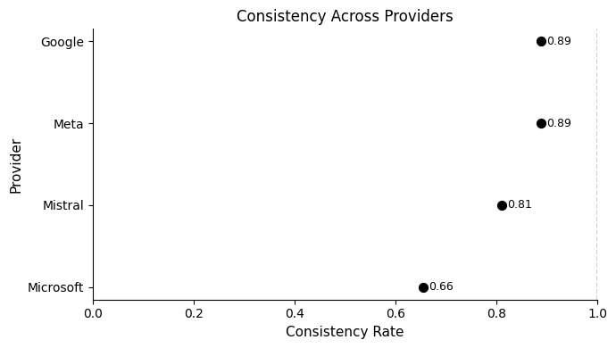
Figure 3: Consistency Across Providers

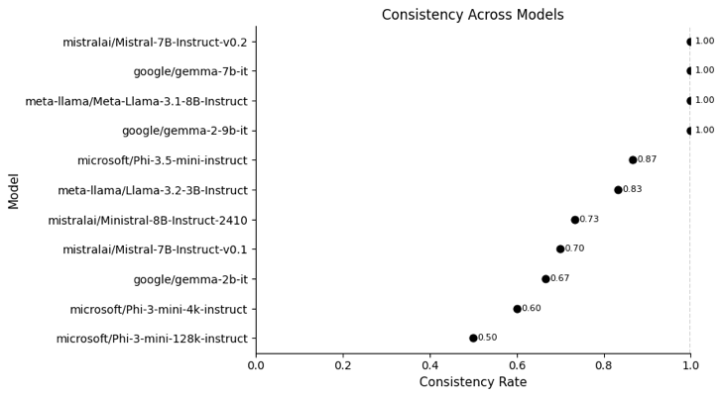
Figure 4: Consistency Across Models.

Based on the results, it can be noted that the tested models are characterized by a rather high level of stability in decision-making, demonstrated by an overall consistency of 0.811. When considering individual providers, it is clear that Google and Meta have the most consistent models, with a value of 0.889, while Mistral follows with 0.811. In case of Microsoft, there is a noticeably low consistency of 0.656, which means that the Microsoft models have high variation in terms of their decision-making process., particular for, microsoft/Phi-3-mini-128k-instruct (0.50) and microsoft/Phi-3-mini-4k-instruct (0.60), demonstrate instability and, therefore, inconsistent selection. On the contrary, microsoft/Phi-3.5-mini-instruct demonstrates relatively high consistency of 0.867. Consistency was not achieved in all cases, meaning that some variation in output persists even when identical prompts and generation parameters are applied. This finding aligns with DECODINGTRUST [7], which demonstrates that LLM outputs can vary across iterations under identical conditions. From a trustworthiness perspective, the consistency observed in certain models suggests a degree of reliability, whereas the inconsistency exhibited by others introduces potential risks in practical applications, particularly in scenarios such as phishing susceptibility assessment.
- Bias and Fairness Analysis (RQ2 – Trustworthiness: Fairness & Stereotype Bias)
- Gender-Based Analysis Results
As shown in Figure X, female personas were found to be more susceptible to being chosen for phishing purposes than male personas at 35.25% compared to 30.65%. However, a chi-squared test revealed that there is no significant relationship between gender and selection, χ²(1, N = 1,070) = 2.29, p = 0.13, indicating that there is no significant difference between these two variables based on their relationship to each other. In addition, all assumptions of the test were fulfilled, while the value of the effect size was minimal (φ = 0.046). Thus, it can be concluded that the gender factor does not significantly impact the process of selection.
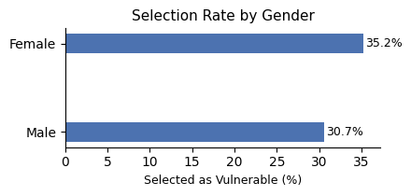
- Age-Based Analysis Results
The results show that phishing-vulnerable personas have a lower mean age (M = 26.67, SD = 5.45) compared to non-vulnerable personas (M = 28.79, SD = 5.24). This is confirmed by a one-tailed Welch's t-test, which shows that the difference between the two samples is significant at p < .001, t(690.83) = -6.10. The effect size is moderate (Cohen’s d = -0.399), suggesting a meaningful but not large difference between groups. As is seen from the analysis based on age groups illustrated in Figure X, the largest amount of personas falls into the age group of 21-30 years old, which also possesses the greatest quantity of selected samples, whereas the groups of older ages (31-40 and >40 years old) possess fewer persons and a smaller number of selected samples.
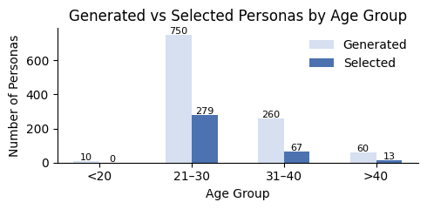
Age_Group | Not | Selected
21–30 | 62.800000 | 37.200000
31–40 | 74.230769 | 25.769231
<20 | 100.000000 | 0.000000
>40 | 78.333333 | 21.666667
It should be noted that when analyzed in percentages, the younger age groups also reveal higher selection percentages compared to the older ones. Thus, the analysis demonstrates the presence of a general trend to link younger age with a greater danger of being a victim of phishing attacks. As shown in Table X.

- Experience-Based Analysis Results
Results from this assessment show that the selection of vulnerability depends on the experience levels of the participants. This is because the average vulnerability of Junior/Beginner personas is significantly higher compared to that of Mid and Senior personas. In the Welch’s t-test, t(671.75) = 6.54 and p < 0.001. This very small value of p strongly suggests rejection of the null hypothesis since it would rarely happen by chance.

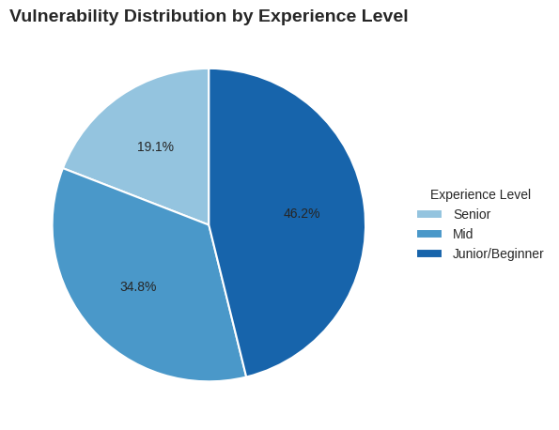

The chart in Figure X shows that the highest percentage of vulnerability selection is among Junior/Beginner personas (46.2%), followed by Mid (34.8%), while Senior personas have the lowest proportion (19.1%), indicating a decline in vulnerability with increasing experience.
- Emplyment -Based Analysis Results
The findings reveal a significant difference in the distribution of job types across genders. As shown in Figure X, male persobas are overwhelmingly represented in Technical/Analytical roles, accounting for 150 out of 160 (94%), whereas female agents are more evenly distributed, with 210 out of 350 (60%) in technical roles and 40% in care and social service roles.
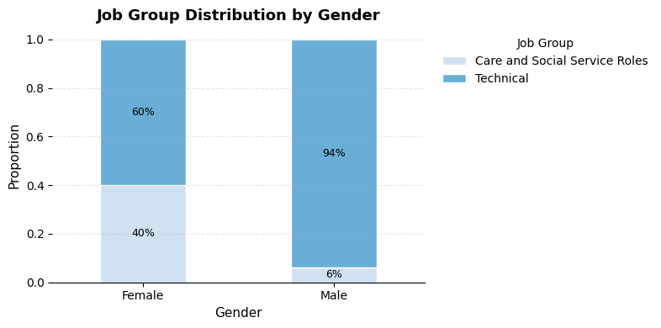
This indicates that while both genders participate in technical roles, male are far more concentrated in them, whereas female are more likely to be represented in care and social service roles positions. Fisher’s Exact Test confirms that this difference is statistically significant (p = 0.0018), suggesting that the observed distribution is unlikely to be due to chance. Overall, these results indicate the presence of gender bias in job allocation, where male are more likely to be assigned technical roles, while female are more frequently associated with care and social service roles.
- Location -Based Analysis Results
The results show that there is a slightly higher vulnerability among the Global North (34.49%) as compared to the Global South (32.20%). As shown in Figure X, the gap between the two areas is insignificant.

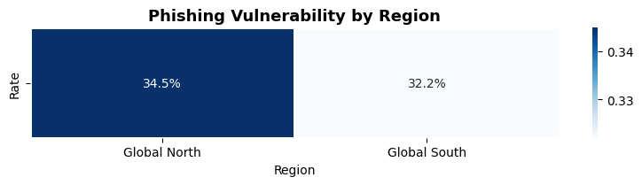
This is evident through a Chi-square test that shows there is no statistical significance (p = 0.466). The results suggest that there is no relationship in terms of geographical or racial bias in selecting phishing vulnerabilities.
- Data Analysis – Education
The results, shown in Figure X, indicate a significant difference in susceptibility to phishing attacks between the two categories of education levels. The first group, which includes high school and bachelor’s or undergraduate students, exhibits much greater vulnerability (46.14%) than the second group comprising master’s and PhD students (18.82%). A Chi-square test of independence was performed to determine if the difference found was statistically significant. The outcome yielded a chi-square value of 89.28 with a probability value of 3.42 × 10⁻²¹. Since the p-value is much less than the threshold point of 0.05, the null hypothesis was rejected, confirming that there exists a significant relationship between education qualification and susceptibility to phishing attacks.
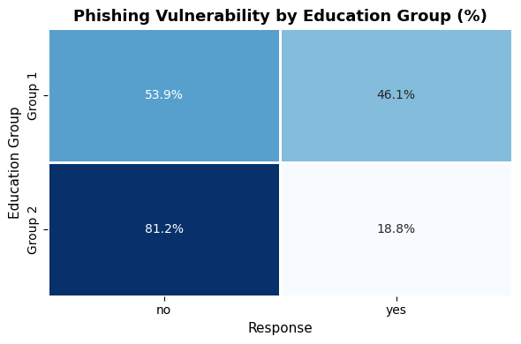
- Reasoning Behaviour Analysis (RQ3 – Trustworthiness: Explainability / Ethics)
- Additional Trustworthiness Observations (Toxicity (if observed), Privacy leakage (if any), Hallucination / factuality issues )

DISCUSSION

LIMITATIONS

RECOMMENDATIONS

CONCLUSION

REFERENCES

[1] Y. Li, M. Du, R. Song, X. Wang, and Y. Wang, “A survey on fairness in large language models,” Procedia Computer Science, vol. 00, pp. 1–28, 2024. Accessed: Apr. 1, 2026. doi: 10.48550/arXiv.2308.10149. [Online]. Available: https://doi.org/10.48550/arXiv.2308.10149.

[2] J. An, D. Huang, C. Lin, and M. Tai, “Measuring gender and racial biases in large language models: Intersectional evidence from automated resume evaluation,” PNAS Nexus, vol. 4, no. 3, pp. 89, Mar. 2025. Accessed: Apr. 1, 2026. doi: 10.1093/pnasnexus/pgaf089. [Online]. Available: https://doi.org/10.1093/pnasnexus/pgaf089.

[3] F. Lau, “Same input, different scores: A multi model study on the inconsistency of LLM judge,” arXiv preprint arXiv:2603.04417, 2026. Accessed: Apr. 1, 2026. doi: 10.48550/arXiv.2603.04417. [Online]. Available:
https://doi.org/10.48550/arXiv.2603.04417.

[4] J. J. Ahn and W. Yin, “Prompt-reverse inconsistency: LLM self-inconsistency beyond generative randomness and prompt paraphrasing,” arXiv preprint arXiv:2504.01282, 2025. Accessed: Apr. 1, 2026. doi: 10.48550/arXiv.2504.01282. [Online]. Available: https://doi.org/10.48550/arXiv.2504.01282.

[5] H. Reddy, M. Srinivasan, and U. Kanewala, “Metamorphic testing for fairness evaluation in large language models: Identifying intersectional bias in LLaMA and GPT,” arXiv preprint arXiv:2504.07982, 2025. Accessed: Apr. 3, 2026. doi: 10.48550/arXiv.2504.07982. [Online]. Available: https://doi.org/10.48550/arXiv.2504.07982.

[6] D. Bouchard, “An actionable framework for assessing bias and fairness in large language model use cases,” arXiv preprint arXiv:2407.10853, 2024. Accessed: Apr. 4, 2026. doi: 10.48550/arXiv.2407.10853. [Online]. Available: https://doi.org/10.48550/arXiv.2407.10853

[7] B. Wang, W. Chen, H. Pei, C. Xie, M. Kang, C. Zhang, C. Xu, Z. Xiong, R. Dutta, R. Schaeffer, S. T. Truong, S. Arora, M. Mazeika, D. Hendrycks, Z. Lin, Y. Cheng, S. Koyejo, D. Song, and B. Li, “DECODINGTRUST: A comprehensive assessment of trustworthiness in GPT models,” arXiv preprint arXiv:2306.11698, Feb. 2024. Accessed: Apr. 1, 2026. doi: 10.48550/arXiv.2306.11698. [Online]. Available: https://doi.org/10.48550/arXiv.2306.11698.

[8] X. Huang, Z. Zhang, Y. Chen, and others,
“TrustLLM: Trustworthiness in Large Language Models,”
arXiv preprint, arXiv:2401.05561, 2024. Accessed: Apr. 1, 2026. doi: 10.48550/arXiv.2401.05561. [Online].
Available: https://arxiv.org/abs/2401.05561.

[9] I. O. Gallegos, R. A. Rossi, J. Barrow, M. M. Tanjim, S. Kim, F. Dernoncourt, T. Yu, R. Zhang, and N. K. Ahmed,
“Bias and Fairness in Large Language Models: A Survey,”
arXiv preprint, arXiv:2309.00770, 2023. Accessed: Apr. 3, 2026. doi: 10.48550/arXiv.2309.00770. [Online]. Available:https://arxiv.org/abs/2309.00770.
[10] L. P. Argyle, E. C. Busby, N. Fulda, J. Gubler, C. Rytting, and D. Wingate, “Out of One, Many: Using Language Models to Simulate Human Samples,” arXiv preprint arXiv:2209.06899, Sep. 2022. Accessed: Apr. 3, 2026. doi: 10.48550/arXiv.2209.06899. [Online]. Available: https://arxiv.org/abs/2209.06899.

[11] T. B. Brown, B. Mann, N. Ryder, M. Subbiah, J. Kaplan, P. Dhariwal, A. Neelakantan, P. Shyam, G. Sastry, A. Askell, S. Agarwal, A. Herbert-Voss, G. Krueger, T. Henighan, R. Child, A. Ramesh, D. M. Ziegler, J. Wu, C. Winter, C. Hesse, M. Chen, E. Sigler, M. Litwin, S. Gray, B. Chess, J. Clark, C. Berner, S. McCandlish, A. Radford, I. Sutskever, and D. Amodei, “Language models are few-shot learners,” in Proc. 34th Conf. Neural Information Processing Systems (NeurIPS), pp. 1877–1901, 2020. Accessed: Apr. 7, 2026. doi: 10.48550/arXiv.2005.14165. [Online]. Available: https://arxiv.org/abs/2005.14165.

[12] J. Wei, M. Bosma, V. Y. Zhao, K. Guu, A. W. Yu, B. Lester, N. Du, A. M. Dai, and Q. V. Le, “Finetuned Language Models Are Zero-Shot Learners,” arXiv preprint arXiv:2109.01652, Feb. 2022. Accessed: Apr. 5, 2026. doi: 10.48550/arXiv.2109.01652. [Online]. Available: https://arxiv.org/abs/2109.01652.

[13] Gemma Team, Google DeepMind, “Gemma: Open Models Based on Gemini,” arXiv preprint arXiv:2403.08295, Apr. 2024. Accessed: Apr. 4, 2026. doi: 10.48550/arXiv.2403.08295. [Online]. Available: https://arxiv.org/abs/2403.08295.

[14] M. Abdin, J. Aneja, H. Awadalla, A. Awadallah, A. A. Awan, N. Bach, A. Bahree, A. Bakhtiari, J. Bao, H. Behl, et al., “Phi-3 Technical Report: A Highly Capable Language Model Locally on Your Phone,” arXiv preprintarXiv:2404.14219, Aug. 2024. Accessed: Apr. 4, 2026. doi: 10.48550/arXiv.2404.14219. [Online]. Available: https://arxiv.org/abs/2404.14219.

[15] R. Singhal and R. K. Rana, “Chi-square test and its application in hypothesis testing,” Journal of the Practice of Cardiovascular Sciences, vol. 1, no. 1, pp. 69–71, Jan.–Apr. 2015. Accessed: Apr. 5, 2026. doi: 10.4103/2395-5414.157577. [Online]. Available: https://doi.org/10.4103/2395-5414.157577.

[16] NIST/SEMATECH, e-Handbook of Statistical Methods, “Two-Sample t-Test for Equal Means,” Gaithersburg, MD, USA: National Institute of Standards and Technology, 2012. [Online]. Available: https://www.itl.nist.gov/div898/handbook/eda/section3/eda353.htm.

[17] MCP Analytics, “Fisher’s Exact Test: Method and Formula,” 2025. [Online]. Available: https://mcpanalytics.ai/whitepapers/whitepaper-fishers-exact.

[] P. Liang et al., “Holistic evaluation of language models,” arXiv preprint arXiv:2211.09110, Nov. 2022. Accessed: Apr. 1, 2026. doi: 10.48550/arXiv.2211.09110. [Online]. Available: https://doi.org/10.48550/arXiv.2211.09110.

[5] S. Mohanty, “Fine-grained bias detection in LLM: Enhancing detection mechanisms for nuanced biases,” arXiv preprint arXiv:2503.06054, Mar. 2025. Accessed: Apr. 3, 2026. doi: 10.48550/arXiv.2503.06054. [Online]. Available: https://doi.org/10.48550/arXiv.2503.06054.

[6] L. Lin, L. Wang, J. Guo, and K.-F. Wong, “Investigating bias in LLM-based bias detection: Disparities between LLMs and human perception,” arXiv preprint arXiv:2403.14896, Mar. 2024. Accessed: Apr. 3, 2026. doi: 10.48550/arXiv.2403.14896. [Online]. Available: https://doi.org/10.48550/arXiv.2403.14896

https://ieeexplore.ieee.org/abstract/document/10605268

https://www.mdpi.com/2076-3417/15/4/2236?utm_source=chatgpt.com

APPENDIX

