

**ENCS, Computer Systems Engineering**

**ENCS3130, LINUX LABORATORY**

**Project 1 Shell script**

Prepared by:

Sahar Hmidat ID: 1202038

Instructor’s Name: Dr. Mohammad Jubran

Assistant Name: Tareq

Section No: 1

Date: 27/4/2024

Table of Contents

**Introduction** IV

**Program Implementation** V

**Running the Program** XI

# List of figures

Figure 1 Main V

Figure 2 variables VI

Figure 3 loopStart VI

Figure 4 gridFunction VII

Figure 5 startGame VII

Figure 6 startGameFile VIII

Figure 7 winFunction VIII

Figure 8 winFunctionCont IX

Figure 9 score IX

Figure 10 moveOne X

Figure 11 moveTwo X

Figure 12 moveThree X

Figure 13 moveFour XI

Figure 14 Run1 XI

Figure 15 Run2 XII

Figure 16 Run3 XII

Figure 17 Run4 XII

Figure 18 Run5 XIII

Figure 19 Run6 XIII

Figure 20 Run7 XIII

Figure 21 Run8 XIV

Figure 22 Run9 XIV

Figure 23 Run10 XV

Figure 24 Run11 XV

# **Introduction**

This project is called X-O Game and consists of a board of NxN size and two opposing players and each one of them tries to win the game by placing his position in a certain state. The game contains five modes, the first is to add the special mark in a specific place, the second mode is to remove a specific mark from the place, the third mode is to change a row with another row, the fourth mode is to replace a column with a column, and the last mode is to change a place with another place.

# **Program Implementation**

We used shell script language to implement this game using Linux. We first start the main function for the user to enter player names and choose what they want from the directory. The grid has special character parameters. The board is a two-dimensional array, which includes only three ASCII characters: the 'X' and 'O' characters, plus the delimiter '|' With no spaces between them

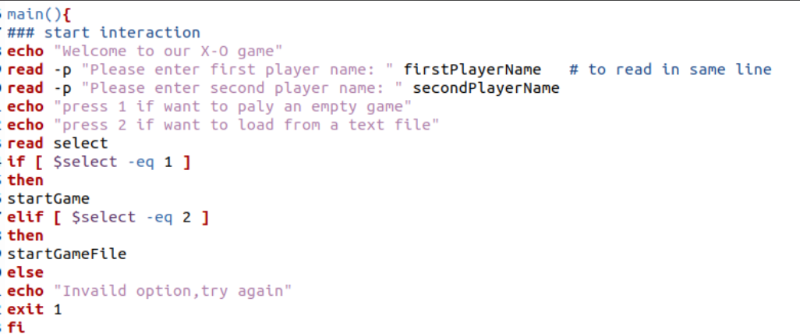

Figure 1 Main

Then we assigned these values to zero to update later when game start and each player do own action and earn points

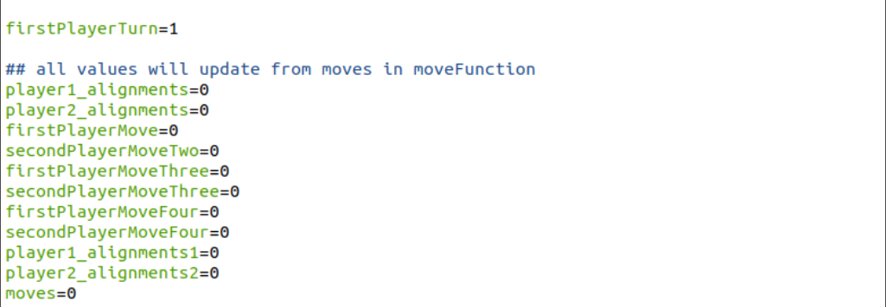

Figure 2 variables

After that, we passed the parameter (move) from the user to specify the number of rounds to finish the game, and then play the game based on this number. After reaching the last round, the score will be printed for each player and the winner will be determined.

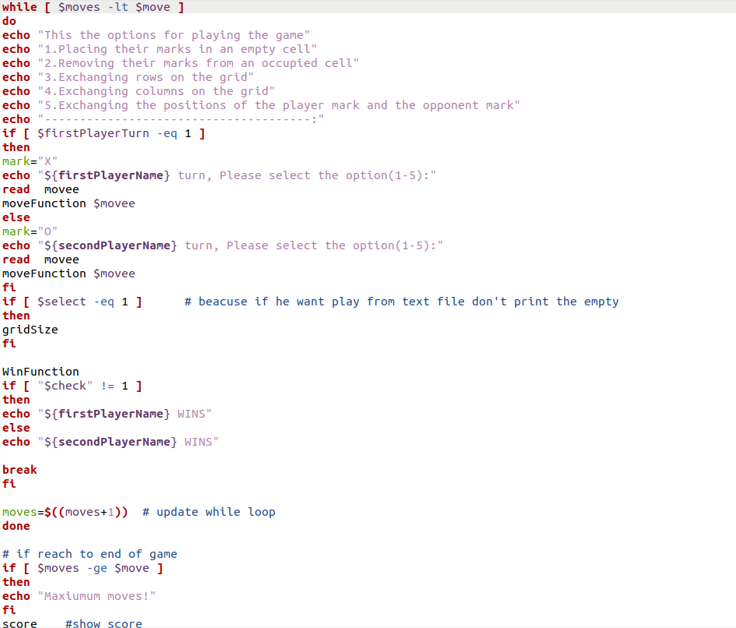

Figure 3 loopStart

The Gridsize function will print the panel shape that includes (|) The delimiter and the space between each (|) Based on user defined size.

-n >> we used to prevent print in new line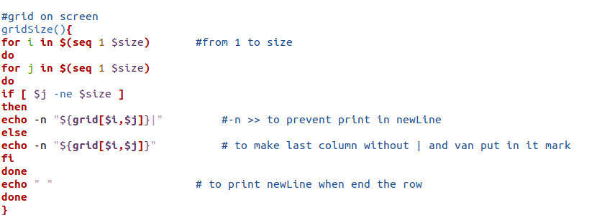

Figure 4 gridFunction

The user can choose the option to play in a empty board or load a board from a text file.

If he chooses the first option, we configured each index in the array to be printed with an empty character so we put a space and then the user will fill this panel with X-O marks.

Here the user is asked to choose the board size and maximum number of game finishes

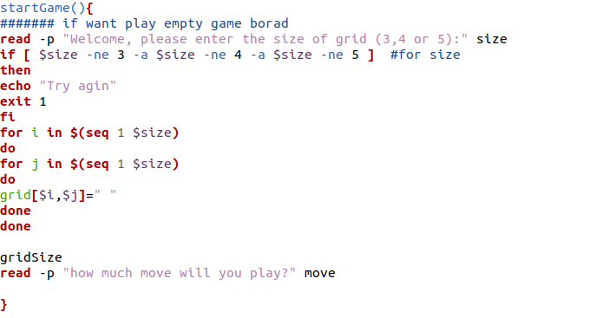

Figure 5 startGame

If he chooses the second option, will load a text file depends on size.

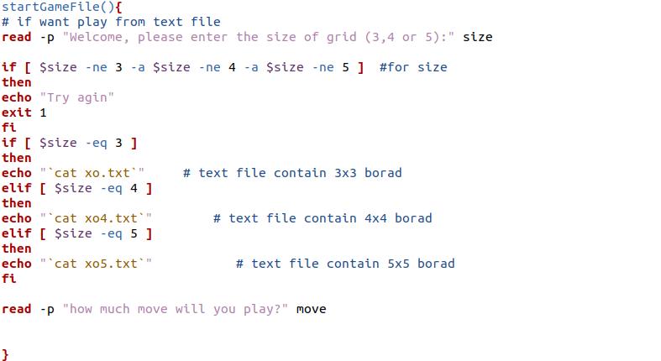

Figure 6 startGameFile

winFunction will check rows, columns and diagonals, it iterates for each row and column and diagonal and check if the place contains own mark or not

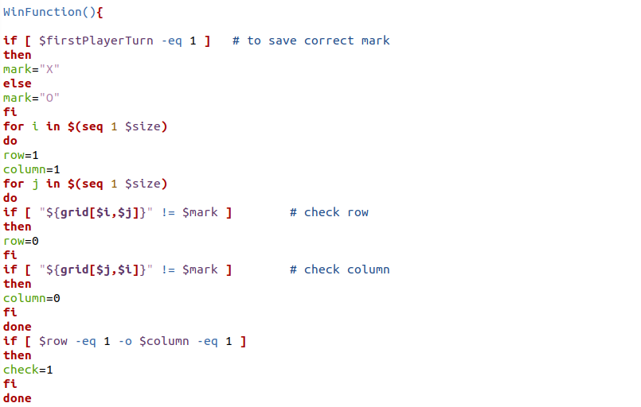

Figure 7 winFunction

Here will check left and right diagonal.

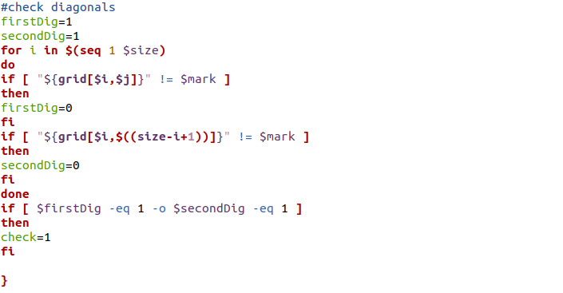

Figure 8 winFunctionCont

score function will calculate the score for each player, the value of variables will update from moveFunction and then print each score.

firstPlayerScore=$((2 * player1_alignments + player1_alignments1+ firstPlayerMove - firstPlayerMoveThree - - 2 * secondPlayerMoveFour))

secondPlayerScore=$((2 * player2_alignments + player2_alignments2 + secondPlayerMoveTwo - secondPlayerMoveThree - 2 * secondPlayerMoveFour))

if player choose move one here will either earn tow point for any alignment or lose three points for any alignment for opponent’s mark so we put (2 * player1_alignments) if earn two points because (player1_alignments) will increment one, but (player1_alignments1) will decrement three

if user chooses move two will earn one point (firstPlayerMove).

If user chooses move three or four will lose one point, so we declared the variable (-firstPlayerMoveThree) to assign any lose from these moves.

If user chooses move five will lose two points. (- 2 * secondPlayerMoveFour)



Figure 9 score

Here if player chooses move one, will ask player to determine the position of row and column to put the mark and check if this position in range and it null then will update the values for score function.

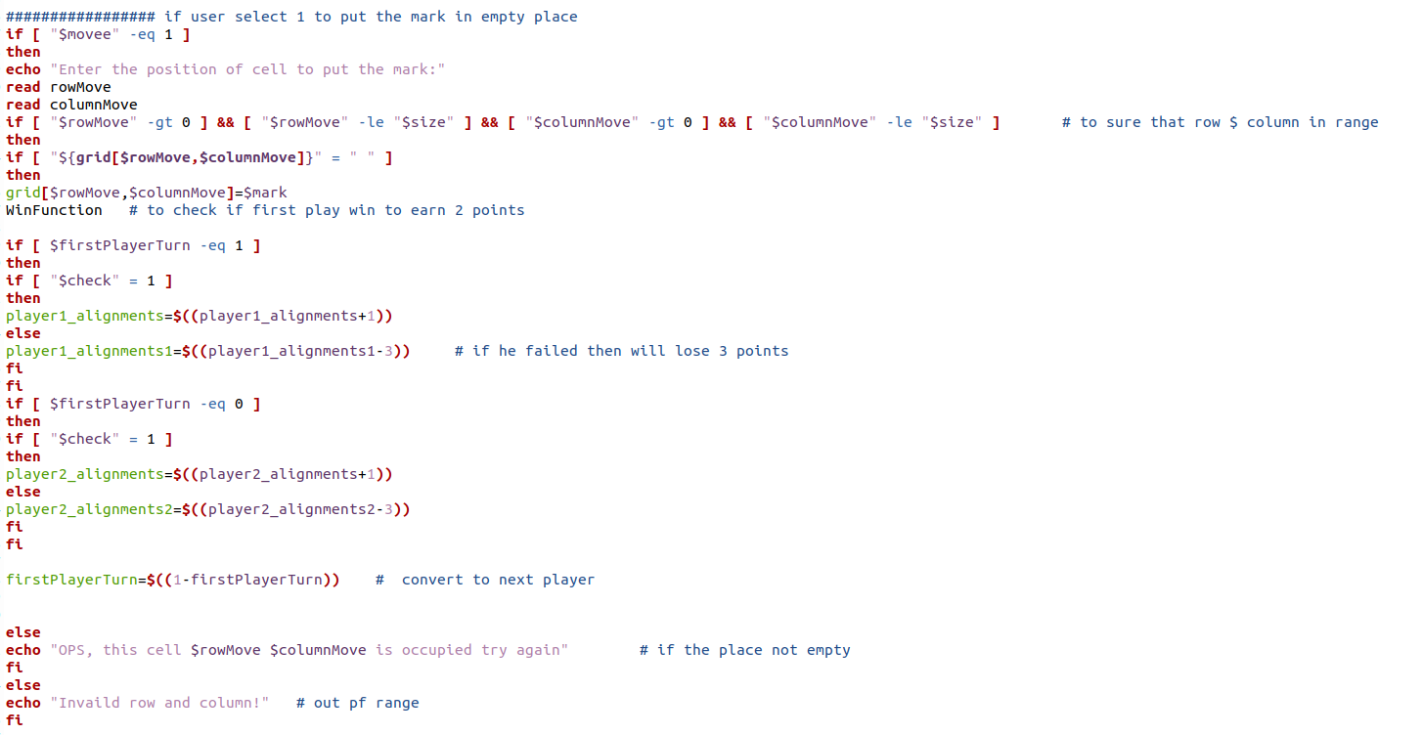

Figure 10 moveOne

if player chooses move 2 will asked the player to enter position to remove the mark and check if the position in range and contains the mark then update the values for score function.

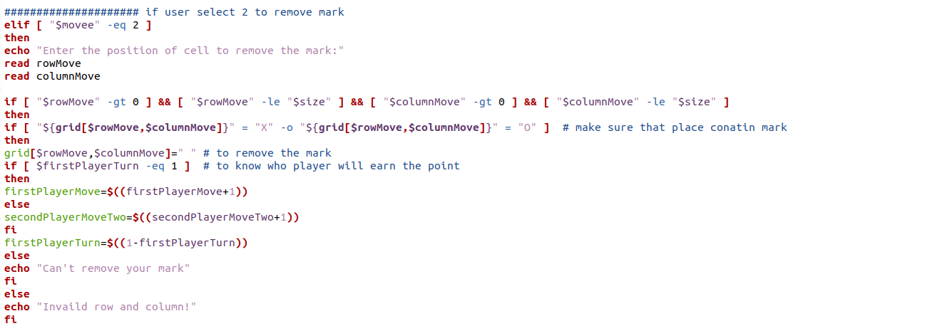

Figure 11 moveTwo

If player chooses move three, first we cut the (rxy) format to determine the row and column then check if they in range and made swap to exchange the rows after that will update the value of variables for score function.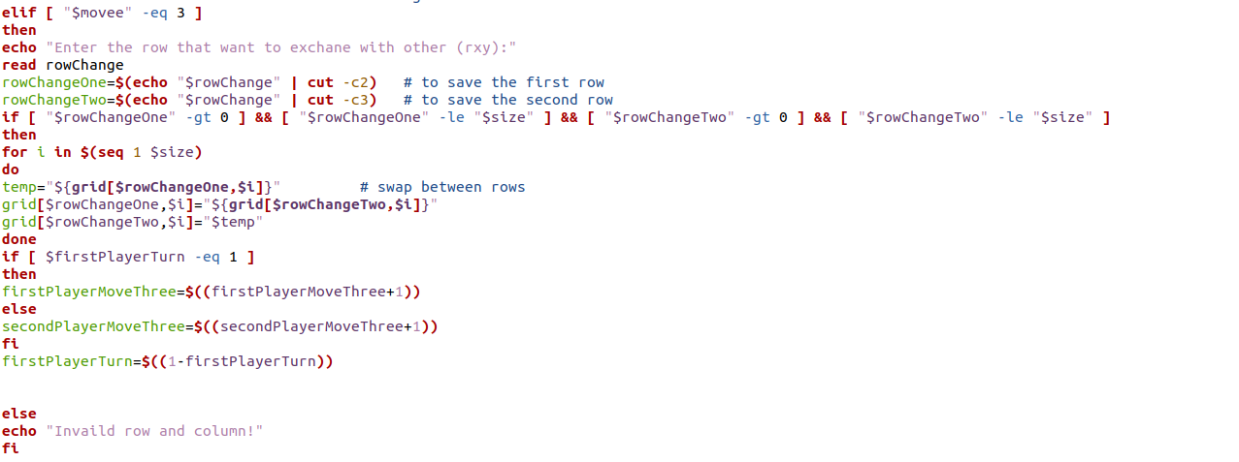

Figure 12 moveThree

If player chooses move four, we did the same thing like previous part put with change with index of array.

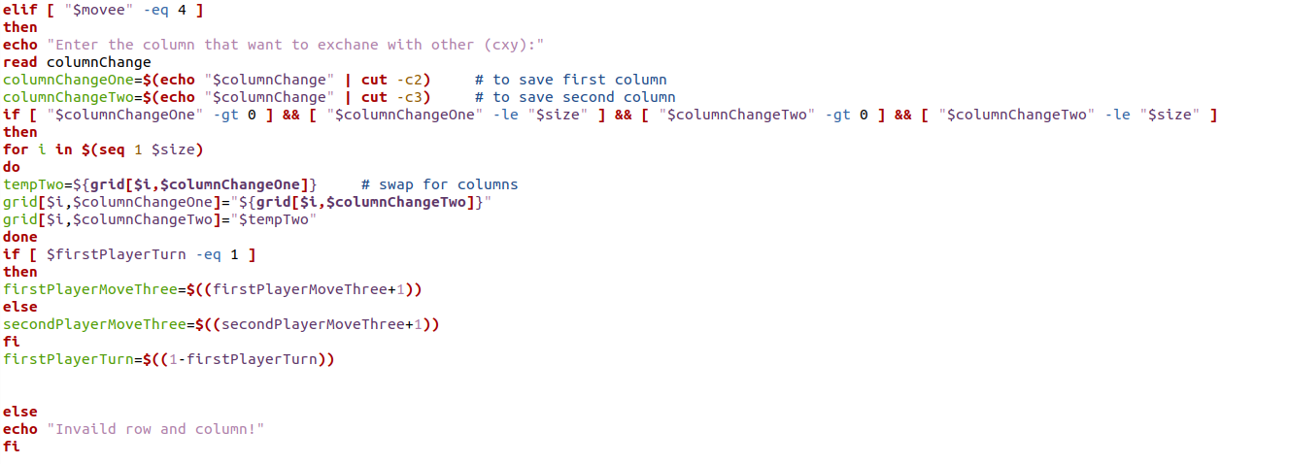

Figure 13 moveFour

If player chooses move five, will cut (exyuv) format to determine the first position that will replace with second position and check if the positions in range and update the value of variables foe score function

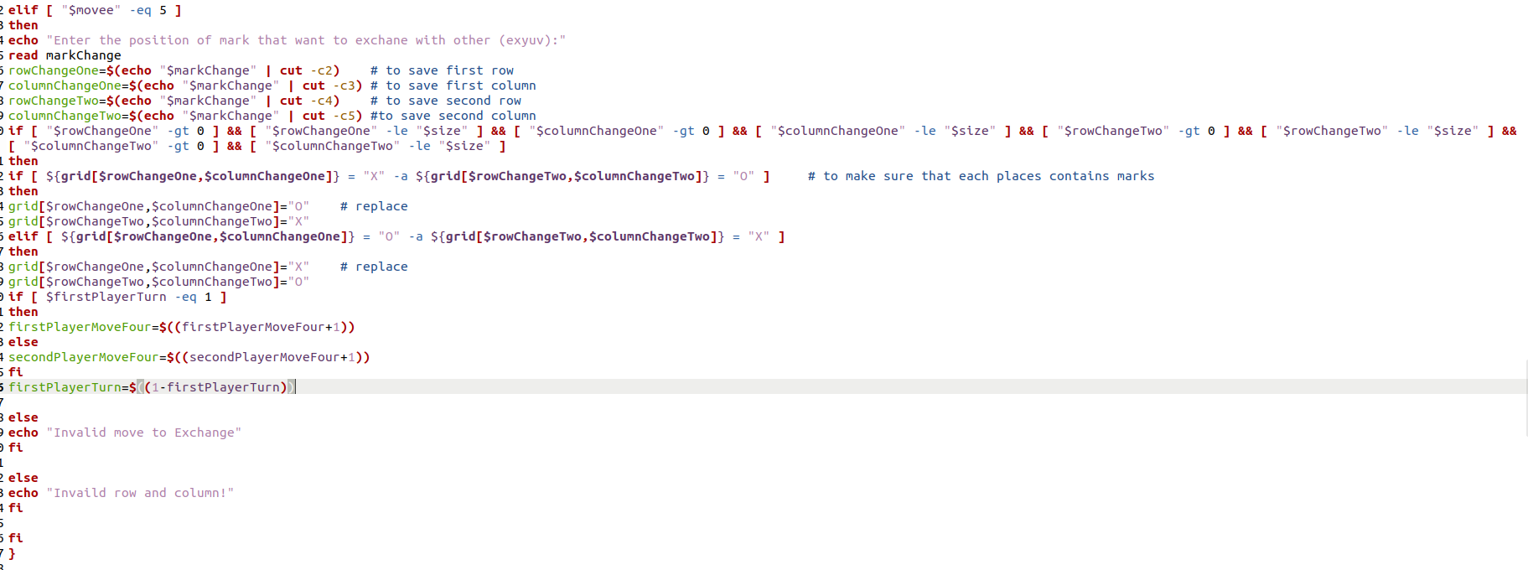

# **Running the Program**

Here the shape of board with 3,4 and 5 size

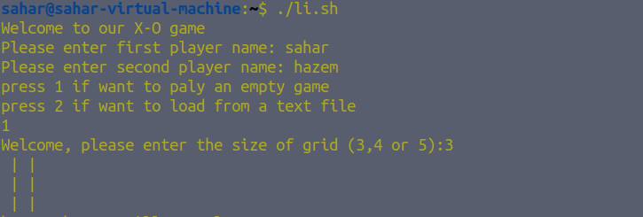

Figure 14 Run1

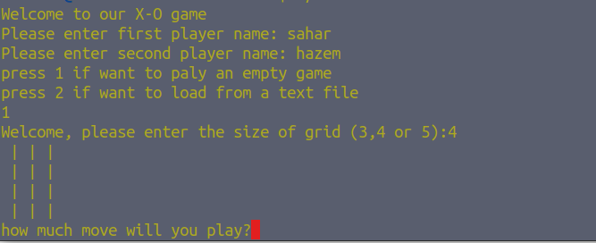

Figure 15 Run2

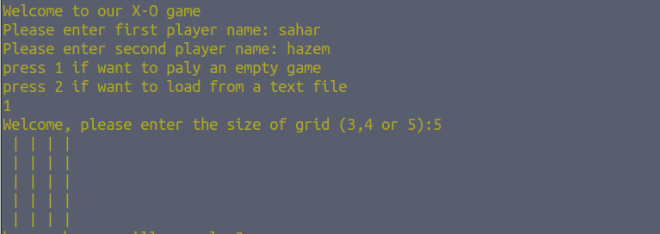

Figure 16 Run3

Here if chooses the option of load a text file

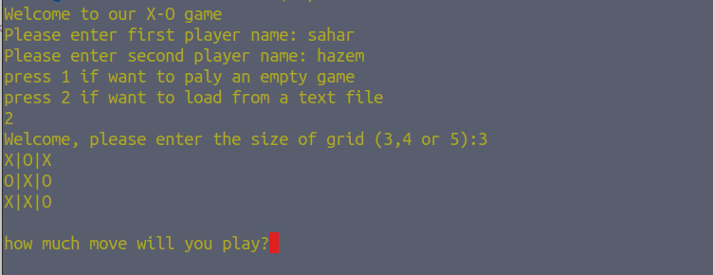

Figure 17 Run4

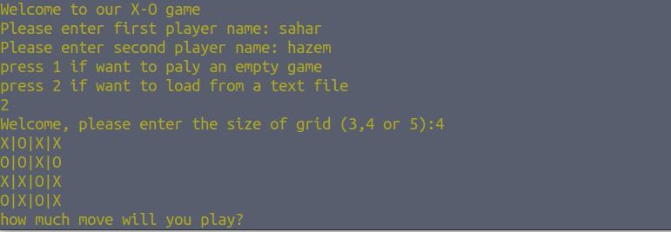

Figure 18 Run5

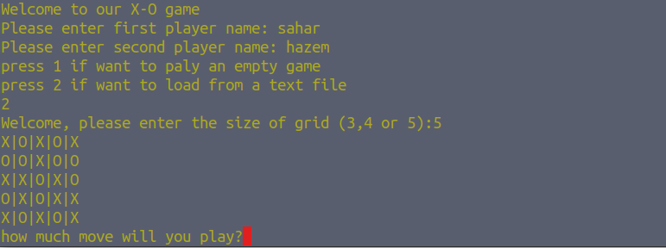

Figure 19 Run6

If chooses move one

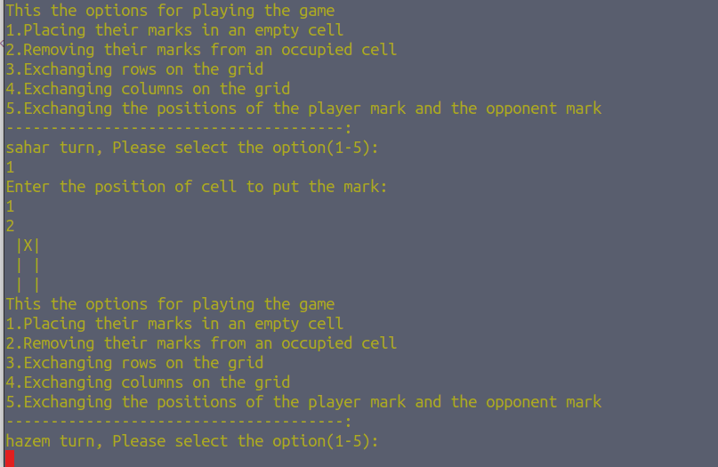

Figure 20 Run7

If chooses move two

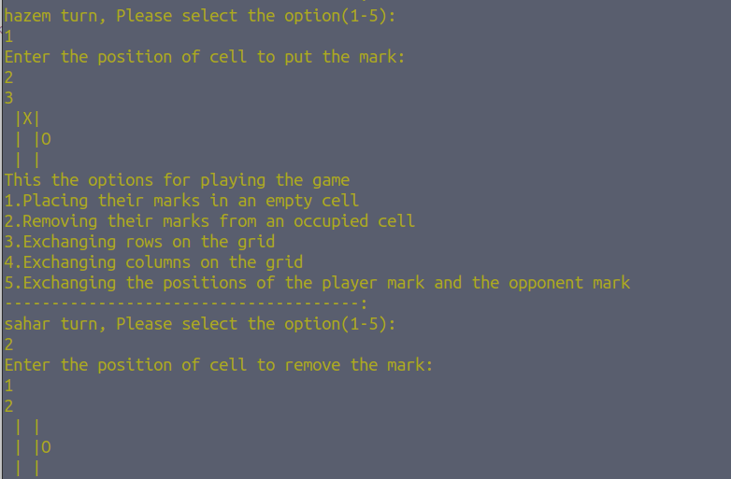

Figure 21 Run8

If chooses move three

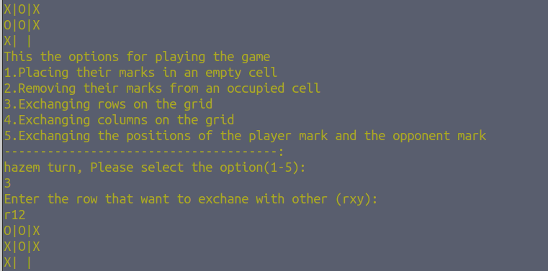

Figure 22 Run9

If chooses move four

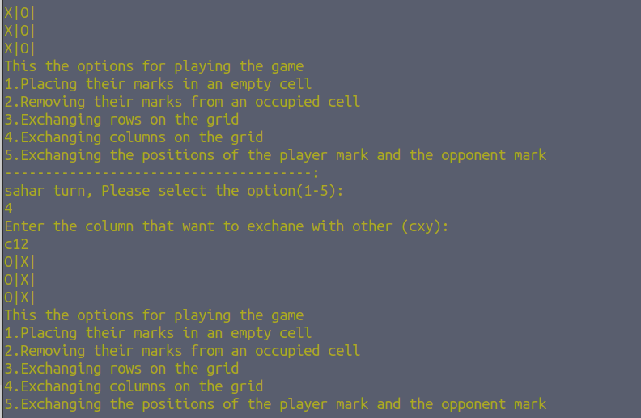

Figure 23 Run10

If chooses move five

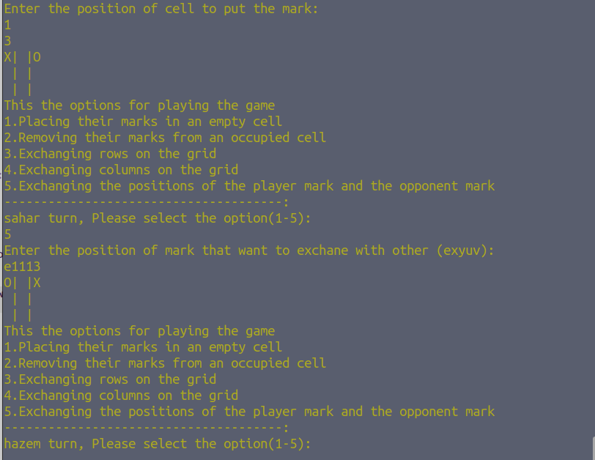

Figure 24 Run11

If choose play from text file

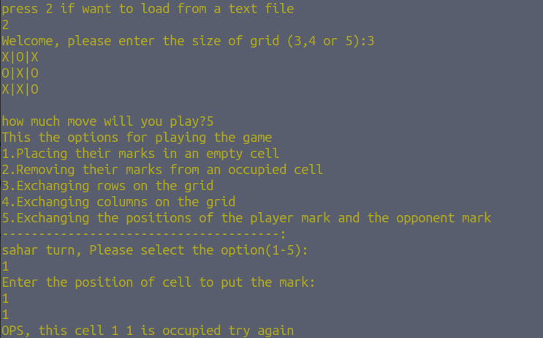

Figure 25 Run12