Pre-Assign VIN To OF



Engraving

Repair

Welding

Body Shop Storage

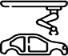

Office

SearchingRobotic

Engine

Mechanical

Finishing

Inspection

Sign Off

Storage Buffer

Storage Buffer