Paint Shop Storage



Enter To Paint Shop

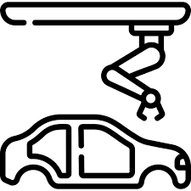

Base Coat

E-Coat

Primer

Office

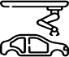SearchingRobotic

Engine

Mechanical

Finishing

Inspection

Sign Off

Storage Buffer

Storage Buffer