Log:

* 11/4/2021
  + Inspected dataset: looks like we will have high cardinality with many categorical data. Did research into what we can do to reduce the cardinality and reduce dimensionality since just doing OHE will face sparse dataset and have Curse of Dimensionality and may easily overfit our models.
  + Options:
    - Group and cluster our categorical features that have many classes
    - Continue with OHE and use strong L1/L2 regularization
    - Catboost
    - MCA/FAMD
    - Frequency thresholds
    - Grouping / clustering
  + Thinking about doing MCA/FAMD or clustering
* 11/10/21
  + Started pipeline for models with models.py and models_helper.py
  + Did feature selection with team on: <https://docs.google.com/spreadsheets/d/1qrFCjBWOn3emAx8xtMGC3bpg0CQsx3LMaK1O56ReDO0/edit?usp=sharing>
  + Will use Random Forest to check for Feature importance
    - Then do linear regression with most important features as baseline
    - Then do RandomForest & GradBoost & AdaBoost then tune/cross validate and use best model
* 11/12/21 & 11/13/21
  + Helped out on pre-processing, specifically, worked on encoding of categorical features and feature engineering/extraction.
  + Worked on function to fit and transform actors, director, and writer frequencies on occurrence from training dataset. This is a proxy for quantifying the popularity of cast, writer, or director. If more than one person, we take the average of the frequencies. We also weighted the frequencies by the order of importance that the person played in the movie from the ‘title_principals.csv’ dataset.
    - The weight can be calculated as linear model where order of 1 is most important with an assigned weighting of 10/10.
    - Order of 2 is assigned weighting of 9/10.
    - Order of 10 is assigned weighting of 1/10.
    - We can calculate the function based on input ‘order’ to output the desired weighting.
    - This is performed in the solve_linear_transformation() function in preprocessing_utils.py where:
      * order * m + b = weight multiplier, where m and b's are slope and intercept of our linear transformation
      * ie: 1m + b = 10/10, 2m + b = 9/10, 3m + b = 8/10, ...., 10m + b = 1/10
  + Next up is working on the encodings for
    - Genres: genre1, genre2, genre3 will be binary encoded
    - Production company: also frequency based but without order of importance weighting
    - Title: n words, ratio long words, ratio of vowels
    - Description: n words, ratio long words, ratio of vowels, ratio of punctuation, ratio of capital letters, ratio of capital letters after first word
* 11/14/21
  + Finished categorical encoding for:
    - Genres: genre1, genre2, genre3 are binary encoded
      * binary_encoder_fit()
      * binary_encoder_transform()
      * binary_encoder()
    - Production company: also frequency based but without order of importance weighting
      * fit_production_company_frequency()
      * transform_production_company_frequency()
    - Title & Description: n words, ratio long words, ratio of vowels, ratio of interesting characters, ratio of capital letters
      * n_words()
      * ratio_long_words()
      * ratio_vowels()
      * ratio_interesting_characters()
      * ratio_capital_letters
  + From preprocessing_utils.py, I wrote approximately 205 lines of actual code (excluding comments). About 36 lines of those I had to use Google to find solutions or code templates that I repurposed for my needs.
  + Next up is to work on actual modeling.
* 11/15/21
  + Started working on modeling part:
    - Created architecture and pipeline to handle modeling part and connect with rest of project modules
    - Created basic random forest regressor to check most important features
  + Changed `genre` encoding from having separate `genre1`, `genre2`, and `genre3` binary encoded labels to just using `genre` where each label is given for each unique tuple of `(genre1, genre2, genre3)` where contents inside tuple are sorted to take different ordering of same 3 genres in different observations into account.
* 11/17/21
  + Have base models trained and validation scores calculated
  + Used LinearRegression(), SGDRegressor(), RandomForestRegressor(), GradientBoostingRegressor(), AdaBoostingRegressor(), KNeighborsRegressor()
  + Here were their MSE and RMSE validation scores:

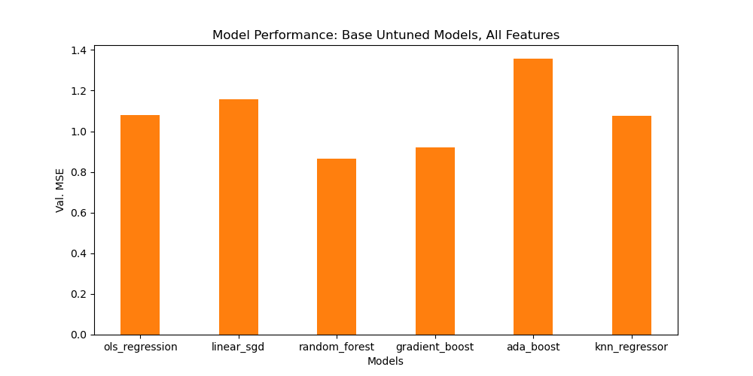

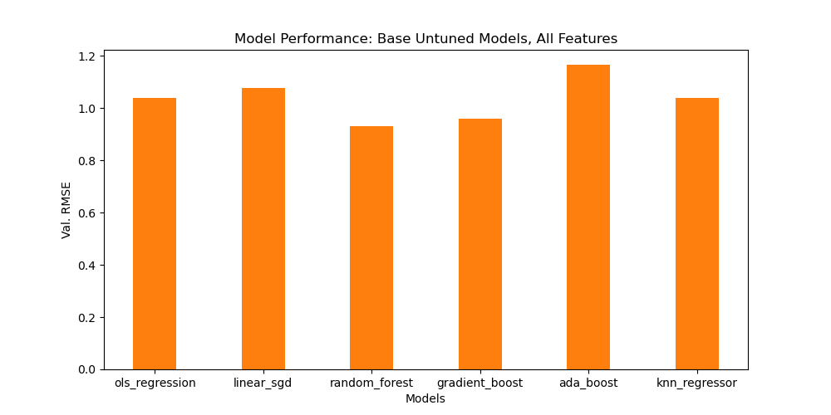

* + For GridSearch CV, looks like RandomForest and GradientBoosting have the most promise. KNN might be worth a try too to keep.

**Overall modeling process:**

1. Problem space:
   1. Problem type is regression where we are trying to predict a continuous value in ‘weighted_avg_vote’
   2. Will be using Mean Squared Error as score to evaluate model’s performance
2. Types of models available and what we are going to use in our modeling
   1. Will be using models from SKlearn to prevent recreating code and try to tune them
   2. Models to try out:
      1. SGDRegressor()
      2. RandomForestRegressor()
      3. GradientBoostingRegressor()
      4. AdaBoostingRegressor(),
      5. KNeighborsRegressor()
3. Base Models and their performance



Random Forest and Gradient Boosting seem to be the best performers out of the box with default SKlearn parameters. KNN is the next best performer. We will use these 3 in our hyperparameter tuning and cross validation phase.

1. Hyperparameter tuning and validation
   1. Strategy is to use grid search on a set number of parameters per model and test on validation set
   2. Parameters and their values to test are:
   3. Results are:
2. Selecting best model
   1. Selected best model by taking best model and parameters from hyperparameter tuning and validation
   2. Our best performing model is:
3. Best model evaluation and prediction
   1. The prediction score on testing data is:
   2. The score means … (provide context)