NUS-ISS MASTER OF TECHNOLOGY IN ARTIFICIAL INTELLIGENCE SYSTEMS
Pattern Recognition Systems (ISY5002)
Practice Examination Paper: Days 8 to 14 (self-made, not an official paper)
Instructions
Answer ALL THREE questions. Each question is worth 20 marks (total 60).
Open book. No calculators: leave answers as fractions, surds or expressions, and show the formula and the substitution.
Suggested time: 20 minutes per question (about one minute per mark), 60 to 70 minutes in total, plus checking.
Where a question asks you to "justify", tie your reasons to the numbers or data given.

Question 1 (Total: 20 Marks)
Wearable ECG patch. CardioPatch is a start-up that makes a skin patch recording a single-lead electrocardiogram (ECG) for patients at home. The patch sends the signal to a hospital system that must (1) clean the signal and find heartbeats, (2) compare each beat with a template, and (3) raise an alert when the heart rhythm looks abnormal. The analogue front end of the patch passes signal content up to 150 Hz. The current firmware samples at 200 Hz. A typical recording lasts 30 seconds. The hospital has collected 20,000 five-second windows from healthy volunteers and only 15 windows that cardiologists labelled as an arrhythmia.
a. (i) What is the minimum sampling rate for this patch? (ii) What goes wrong with the current 200 Hz firmware, and can it be repaired afterwards in software? (iii) How many samples does a 30-second recording contain at the correct rate, and at 200 Hz?
(3 marks)
b. Breathing makes the ECG baseline wander. A short excerpt of the signal, after the wander has been partly removed, is shown in Figure 1 (sample index 0 to 8): x = [1, 3, 8, 4, 2, 3, 5, 3, 1].
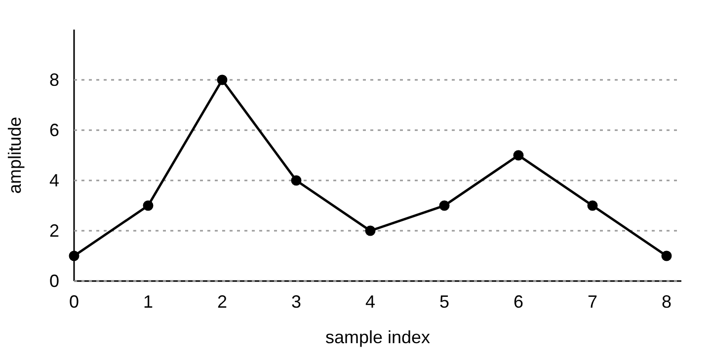
Figure 1. Excerpt of the ECG signal.
(i) Compute the forward differences and use them to locate the peaks. (ii) Compute the prominence of each peak. A colleague proposes keeping only peaks with prominence of at least 4; what is kept, and why would a plain height threshold of 4 behave differently? (iii) Explain why baseline correction is needed before peak detection, and how asymmetric least squares estimates the baseline. In particular, explain what the asymmetric weights do.
(5 marks)
c. Beats occur at different speeds from one patient to the next. A stored template beat is x = [0, 3, 3] and a new beat is y = [0, 0, 3]. Use the squared difference D(i, j) = (yi − xj)² as the local distance. (i) Build the distance matrix D and the accumulated cost matrix A for dynamic time warping (DTW). (ii) State the DTW distance and the warping path. (iii) Compare with the Euclidean distance between the two sequences and explain why DTW suits heartbeat comparison.
(4 marks)
d. Apply a two-level Haar wavelet decomposition to the sequence [5, 3, 8, 2], using the low-pass filter [1/√2, 1/√2] and the high-pass filter [−1/√2, 1/√2]. (i) Give the wavelet coefficients, leaving surds as surds. (ii) Check that the energy is preserved. (iii) Explain why wavelets are preferred to the Fourier transform for detecting arrhythmias, and how the decomposition can be turned into a fixed-length feature vector.
(4 marks)
e. A colleague proposes a convolutional neural network for two-class classification (normal versus arrhythmia) trained on all 20,015 windows, and reports 99.9% accuracy. (i) Do you agree with this proposal? Give one reason. (ii) Propose an autoencoder-based alternative. After training on normal windows only, the reconstruction errors on five normal validation windows are 0.02, 0.04, 0.03, 0.02 and 0.04. Set the alert threshold at the mean plus three standard deviations (use the population variance, dividing by 5, and take √0.00008 ≈ 0.009). A new window has an error of 0.09 and another has 0.05; what do you decide for each? (iii) How would you evaluate the detector, and why is accuracy a poor measure here?
(4 marks)

Question 2 (Total: 20 Marks)
Electricity demand forecasting. GridWise, a utility company, wants to forecast the hourly electricity demand of a city one hour ahead. For every hour it records four features: demand (MW), temperature, humidity and a public-holiday flag. It also wants to classify thermal camera images of substation equipment as healthy or faulty, and to combine several fault classifiers whose training labels are known to be partly wrong.
a. The first eight hourly demand values are 30, 32, 35, 40, 38, 36, 33, 31. Cut the series into windows of length 3 moving forward by a distance of 2, and pair each window with the demand of the next hour as its target. (i) List every window and its target. (ii) Give the shape of the input array if all four features are used for each hour. (iii) How should the data be split into training and test sets, and why?
(3 marks)
b. The forecasting model is: LSTM(16, return_sequences=True) → LSTM(8) → Dense(1). (i) Give the number of parameters in each layer and the total. Show the formula. (ii) Why does the first LSTM need return_sequences=True? (iii) How many parameters would the same model have with SimpleRNN layers in place of the LSTMs, and why is the LSTM count larger?
(4 marks)
c. Three networks are trained on the substation images.
Run | Network | Training accuracy | Validation accuracy
A | Plain 30-layer CNN, sigmoid activations | 52% | 51%
B | Plain 8-layer CNN, ReLU activations | 83% | 80%
C | 30-layer residual network, ReLU, He initialisation, batch normalisation | 100% | 71%

(i) Diagnose Run A. Is it overfitting? Give three changes and a reason for each. (ii) Explain how the skip connection H(x) = F(x) + x helps a very deep network. (iii) Diagnose Run C and give two remedies. (iv) A batch normalisation layer follows a convolution layer with 64 filters. How many parameters does it have, and how many are trainable?
(6 marks)
d. The fault labels are noisy because some technicians recorded the wrong cause. (i) Three independent classifiers each have 75% accuracy. What is the accuracy of their majority vote? (ii) Why would the real improvement be smaller? (iii) Should you use bagging (random forest) or boosting on the noisy labels? Justify. (iv) How can a random forest estimate its own error without a separate test set?
(4 marks)
e. GridWise wants to forecast using the previous 168 hours (one week). (i) Why might a transformer be preferred to an LSTM here? (ii) Write the attention formula and say what the query, key and value represent. (iii) Why is positional encoding needed?
(3 marks)

Question 3 (Total: 20 Marks)
Hospital disinfection robot. MedClean Robotics is building WardBot, an autonomous robot that moves through hospital wards at night and disinfects surfaces with an ultraviolet (UV) lamp. Wards are shared with patients, nurses and trolleys. WardBot has a LiDAR (10 Hz), an RGB-depth camera (30 frames per second), an inertial sensor (100 Hz) and a microphone (16 kHz) for hearing alarms. The UV lamp must never be on when a person is within range. The team decides to use deep reinforcement learning for navigation and cleaning.
a. (i) Identify three factors for the reward function and say whether each is a reward or a penalty. (ii) Draw or describe an architecture for the solution. It must include the robot hardware, the sensors, the environment (people and obstacles), the perception or identification part, the decision-making system and other relevant systems, with the flow of state, action and reward labelled. (iii) Real collisions during learning are dangerous. Suggest, with explanations, two ways to reduce this risk.
(6 marks)
b. Person detection can use the LiDAR, the camera and the microphone. At night the camera sometimes fails in dim wards. (i) Which fusion architecture (early, restricted or late) do you recommend, and why? Contrast it with one alternative. (ii) Name two alignment problems that arise because the sensors work at different rates and in different coordinate frames, and say how you would address them. (iii) How should the system behave when one modality is missing?
(4 marks)
c. The robot's maintenance log records two measurements and the cause of each stoppage. Current is High or Normal, temperature is Hot, Warm or Cool, and the cause is a Jammed wheel (Jam) or a Worn brush (Brush).
Record | Current | Temperature | Cause
1 | High | Hot | Jam
2 | High | Warm | Jam
3 | Normal | Hot | Brush
4 | High | Warm | Brush
5 | Normal | Cool | Brush
6 | Normal | Warm | Brush
7 | High | Hot | Jam
8 | Normal | Warm | Brush

(i) Use a naive Bayes classifier to decide the cause when Current = High and Temperature = Hot. Keep everything as fractions, show the priors, the likelihoods and both scores, give the posterior probability of your chosen cause, and state the independence assumption. (ii) Repeat for Current = Normal and Temperature = Cool. What goes wrong with one class, and how do you fix it? Show the corrected likelihoods and both corrected scores.
(5 marks)
d. WardBot has collected 200,000 unlabelled camera frames but only 40 labelled images of different floor types. Propose how to use the unlabelled frames, and explain the difference between linear adaptation and fine-tuning. Which would you try first, and why?
(2 marks)
e. The robot logs whether its wheels slip on each 10 m stretch. Two hidden floor types, A and B, are suspected. You start with P(A) = P(B) = 0.5, P(slip | A) = 0.8 and P(slip | B) = 0.2, and observe: slip, slip, no slip, slip. Use one round of Expectation-Maximisation (EM). (i) Give the E-step probabilities for a "slip" and for a "no slip" observation. (ii) Give the updated P(A). (iii) Give the updated P(slip | A).
(3 marks)
END OF PAPER

