ISY5002 OPEN-BOOK CHEAT SHEET Days 1 to 7, sorted by topic · no calculators: leave logs and fractions, compare, show the formula
Find it fast: A Answer routine · B Data and overfitting · C Metrics · D Regression, KNN, Naive Bayes · E Decision trees · F Neural networks · G CNN · H SVM · I Feature selection, PCA, LDA · J Clustering · K Choosing a model · L My traps

A. Answer routine and quick facts
- Which learning type? Labels given = supervised. No labels = unsupervised (clustering, PCA). Only reward feedback = reinforcement.
- Pipeline: Sense, Pre-process, Features, Model, Post-process. Deep learning learns the features itself from raw data.
- "What is wrong and how to improve?" (1) quote the numbers, (2) name the problem, (3) fix it with a reason, (4) say which metric proves it improved.
- No calculator: write the formula, substitute, then estimate. Compare sizes instead of computing. Keep fractions.
- Fraction to decimal: 1/8 = .125 · 1/5 = .2 · 1/4 = .25 · 1/3 = .33 · 3/8 = .375 · 2/5 = .4 · 1/2 = .5 · 5/8 = .625 · 2/3 = .67 · 3/4 = .75 · 4/5 = .8 · 1/20 = .05 · 17/20 = .85
- Recommending a model? Your reasons must match your recommendation (needs explaining to patients, regulators or marketing = decision tree; then state its cost).

B. Data preparation and overfitting
- Min-max (x−min)/(max−min) gives 0 to 1. Z-score (x−mean)/std gives mean 0, std 1.
- Scaling parameters come from the TRAINING set only. Reuse the same numbers on validation, test and new data. Using test data leaks information.
- Scale for: KNN, SVM, neural nets, PCA, K-means, DBSCAN, Lasso. Not for: decision trees (a split only moves its threshold).
- Split: training (about 70%) learns. Validation tunes. Test is used once at the end. Cross-validation (k folds, average the k scores) is done inside the training data.
- Order of steps: split, fit scaler on train, fit PCA or LDA on scaled train, apply the same scaler and PCA to test.
- Overfitting: train score high, validation or test score low. Fix: more data, simpler model, fewer features, regularise (L2, dropout), early stopping, prune the tree, lower C or gamma, cross-validate.
- Curse of dimensionality: data becomes sparse and near and far distances look alike, so KNN and clustering weaken. Cures: feature selection, PCA or LDA.
- Imbalance (always saying "no" scores 84.5% or 98%): accuracy hides it. Fix with class weights or a custom loss, SMOTE or oversampling the rare class, undersampling the common class, augmentation. Judge by recall, precision, F1, AUC.
- Hyperparameters are set before training and tuned on validation data (grid, random, Bayesian search): k, C, gamma, kernel, learning rate, dropout, batch size, max_depth.

C. Metrics
 | Predicted + | Predicted −
Actual + | TP | FN (Type II, missed)
Actual − | FP (Type I, false alarm) | TN

Recall = TP/(TP+FN): of the real positives, how many caught (top row). Precision = TP/(TP+FP): of those flagged, how many real (left column). Specificity = TN/(TN+FP). Accuracy = (TP+TN)/all. F1 = 2PR/(P+R).
- Always write TP, FN, FP, TN first. Example: TP 15, FN 5 gives recall 15/20 = 3/4 = 0.75.
- Which to favour: a miss is costly (disease, fraud, lost sale) = recall. A false alarm is costly (coupons, investigations) = precision.
- Compare two models without dividing: same actual positives, so fewer FN = higher recall. Write a rate as 1 − small fraction. Then state the business trade-off in words.
- A model that predicts all "negative" has high accuracy and recall 0.
- ROC/AUC: plots the true positive rate against the false positive rate across cut-offs. AUC 1 = perfect, 0.5 = guessing, independent of the cut-off.
- Check which class the table treats as positive. State your choice.

D. Regression, KNN, Naive Bayes
- Linear regression: least squares. R² = SSreg/SStotal = share of the variation in y explained (0 to 1). A coefficient is the change in y for +1 in that x, others held fixed.
- Logistic regression (classification): ln(P/(1−P)) = a + b1x1 + … (log-odds). Positive coefficient raises the chance of the positive class. Output is a probability, cut-off 0.5 is movable.
- KNN: lazy learner, majority vote of the k nearest points. Small k follows noise, large k blurs the boundary. Use odd k. Scale first. Slow at prediction time.
- Naive Bayes: score(C) = P(C) × P(x1|C) × P(x2|C) × … . P(value|C) = rows in class C with that value ÷ rows in class C. Pick the largest. Probability = own score ÷ sum of scores.
- Count is 0? One zero wipes out the product. Laplace: add 1 to each count and add the number of possible values to the denominator.
- By hand: cancel the shared prior, compare ratios (9/16 vs 1/16 = 9:1 = 90% / 10%).
- Independence assumption = features independent given the class. Often unrealistic (a worn bearing raises both heat and noise). Probabilities become overconfident but the ranking is often still right.

E. Decision trees
Node = test on one feature, branch = outcome, leaf = class. Readable rules, no scaling needed, boundaries are steps.
Entropy E = −Σ p·log₂p. Pure = 0, 50/50 = 1. Gini = 1 − Σp² (pure 0, 50/50 = 0.5).
Proportion = count in the class ÷ TOTAL in that node. "1 default, 5 repaid" is 1/6 and 5/6, not 1/5.
Gain = E(parent) − Σ (child size ÷ parent size) × E(child). The weights add to 1. Gain can never exceed E(parent). GainRatio = Gain / IntrinsicInfo (penalises many-valued features such as an ID code, which has top gain but memorises).
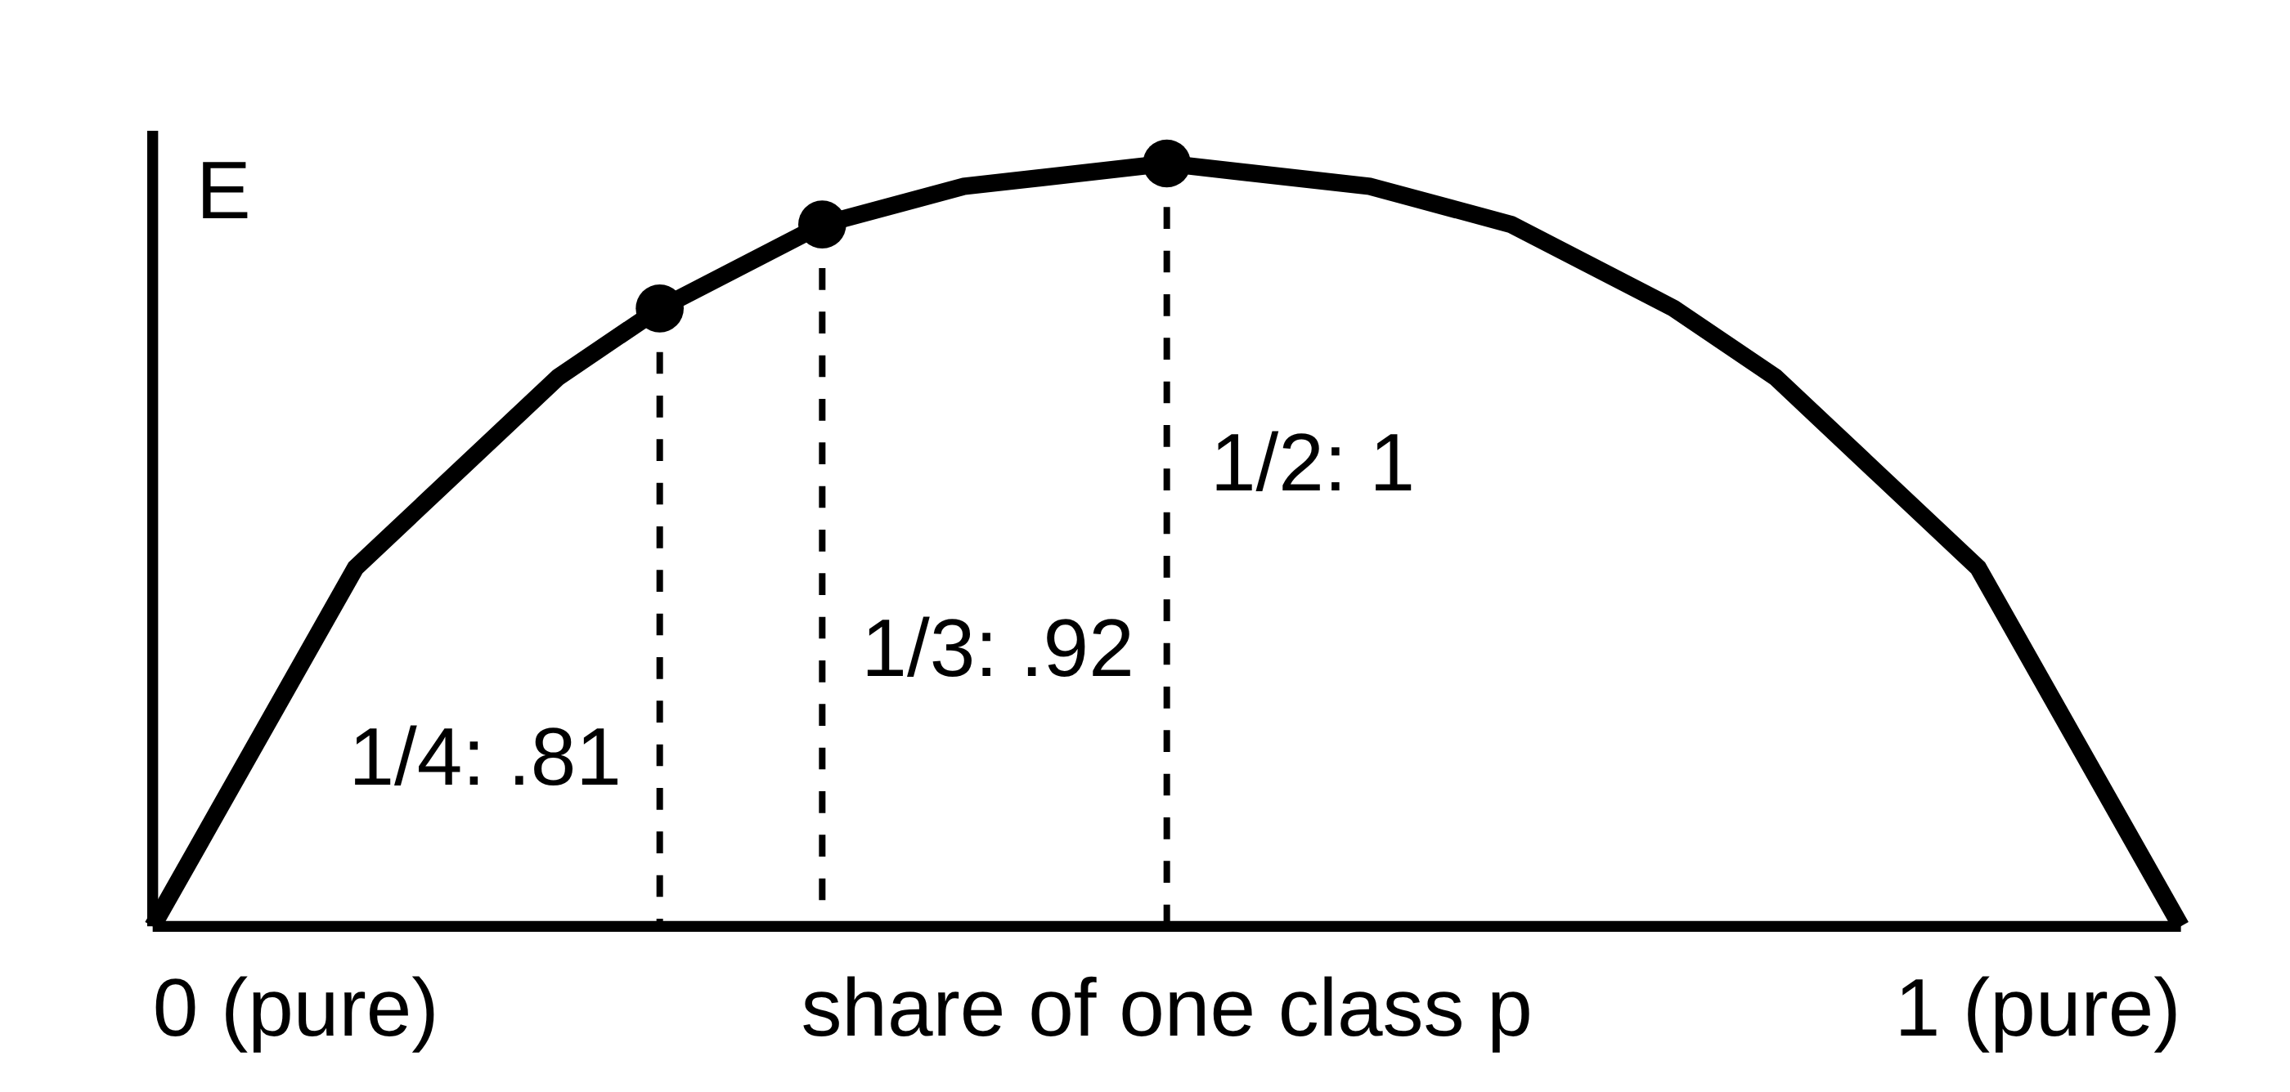
Entropy is symmetric: E(p) = E(1−p), so 3/4 = 1/4 and 2/3 = 1/3. Farther from 50/50 = purer = lower entropy.
p | 0 | 1/10 | 1/8 | 1/6 | 1/5 | 1/4 | 1/3 | 3/8 | 2/5 | 1/2
E | 0 | .47 | .54 | .65 | .72 | .81 | .92 | .95 | .97 | 1

- Best split = lowest weighted child entropy. Check how far each child is from 50/50. A perfectly pure child contributes 0, so it often wins even if small. Mirror-image splits tie. If each child has the same mix as the parent, gain = 0.
- Estimate: compute each child's E from the table, multiply by its weight, add, subtract from E(parent). Example: parent 5/5 (E 1), children (4/5, 1/5) twice gives 1 − .72 = .28. Children (pure 4 of 10) and (1/6 for 6 of 10) gives 1 − .6×.65 = .61, so the second wins.
- Logs left as expressions: E(1/6) = log₂6 − (5/6)log₂5. Useful: log₂3 ≈ 1.58, log₂5 ≈ 2.32, log₂7 ≈ 2.81, log₂(3/4) = log₂3 − 2. Bounds: 3² = 9 > 8 so log₂3 > 1.5; 5² = 25 < 32 so log₂5 < 2.5.
- Continuous feature: sort the values; candidate cuts are the midpoints of adjacent distinct values (20, 30, 45, 60 gives 25, 37.5, 52.5). Pick the cut with the highest gain. A cut that gives the same partition as another is redundant.
- Overfit tree (100% train, much lower test): pre-prune (max_depth, min_samples_leaf) or grow fully then post-prune on validation data.
- Reading a tree: follow the path, quote the leaf's share and purity, give the business meaning, name one flaw (imbalance, depth, overfitting) and the metric to judge the fix.

F. Neural networks
- Neuron: net = Σ w·x + b, out = f(net). The activation is applied to the net input, not to the raw inputs.
- Activations: hard-limit (0 if net ≤ 0, else 1) · sigmoid 0 to 1 (net 0 gives .5, negative net gives below .5) · tanh −1 to 1 (same sign as net) · ReLU max(0, net) (cheap, no vanishing gradient, sparse) · softmax (outputs sum to 1).
- Linear activations collapse: h = 4x then y = 0.5h means y = 2x, one neuron. Non-linearity lets extra layers draw curved boundaries.
- Output and loss: 2 classes = sigmoid + binary cross-entropy. Many classes, one label = softmax + categorical cross-entropy. Number = linear + MSE. Several labels at once = sigmoid + binary cross-entropy. Hidden layers: ReLU.
- Perceptron rule: Δwi = η(T−O)xi, with x0 = 1 for the bias. Correct output means no change. One perceptron draws one line, so XOR (opposite diagonals) fails. Two hidden nodes draw two lines and the output combines them.
- Backprop (sigmoid): δout = O(1−O)(T−O), Δw = η·δ·Oin, hidden δj = Oj(1−Oj)Σδk·wkj. Sign check: target above output gives δ > 0, weight up, output up.
- Loop: small random init, forward pass, loss, backward pass, update, repeat. Batch, stochastic or mini-batch (usual).
- Learning rate: too big overshoots, oscillates or diverges. Too small is slow or stuck. Bigger is not always faster. Momentum: adds a fraction of the previous update, smooths the path and carries over shallow dips.
- Never start with all-zero or identical weights: neurons stay identical (symmetry). Use small random values (Xavier or He).
- Overtraining: train loss falls, validation loss rises. Stop at the validation minimum and keep those weights. Also: dropout (training only, off at test), L2, fewer nodes or layers, more or augmented data.
- Scaling inputs: a feature in the thousands swamps one in the ones. Parameters from the training set only.
- Why deep learning took off (2012 AlexNet): ReLU, dropout, GPUs, ImageNet (1.2M images). Not backprop (1986). Earlier failures: tiny data, slow computers, bad init, sigmoid vanishing gradients.
- RBF net: Gaussian hidden nodes (centres by clustering), then a linear output. GRNN: one node per training pattern, distance-weighted average; small σ = spiky and overfits, large σ = smooth. SOM: lattice, winner-takes-all, unsupervised.

G. CNN
- Output = floor((W − F + 2P)/S) + 1. "Same" padding: P = (F−1)/2 keeps size at stride 1. Pool 2×2 stride 2 gives floor(W/2) (11 gives 5).
- Conv params (Fr·Fc·Cin + 1)·Cout · Dense in·out + out · Pool, Flatten, Dropout = 0.
- Examples: 128, 7×7, stride 2 gives 61. 64×64×3 with 5×5 and 10 filters gives 60×60×10 and (75+1)·10 = 760 params. Conv 7×7, 3 channels, 18 filters = 2,664.
- Convolution by hand: multiply the kernel with each window element by element, add up, slide. Kernel [1 0; 0 1] just adds the main diagonal. Early layers find edges, deeper layers shapes and objects.
- Max pool: halves height and width, keeps the strongest value, no parameters, tolerates small shifts. Filters are learned by training; you only choose size and number.
- Why CNN for images: local connections plus shared weights (far fewer parameters) and tolerance to position.
- Critique a CNN (Q2a): table of shapes and params. The first Dense after Flatten dominates (9,408 × 256 = 2.4M of 2.58M, 93%). With about 5,000 images and 918 classes (about 5 per class) this overfits.
- Fixes: Global Average Pooling (9,408 inputs down to 48), dropout, batch norm, augmentation, class weights, transfer learning.
- Several attributes (brand 18, type 17, value 3): shared backbone, one softmax head per attribute, summed cross-entropy. About 280, 290, 1,670 images per class instead of 5. New total 69,302 params (GAP + three heads), not 2,465,462 (heads only).

H. Support vector machines
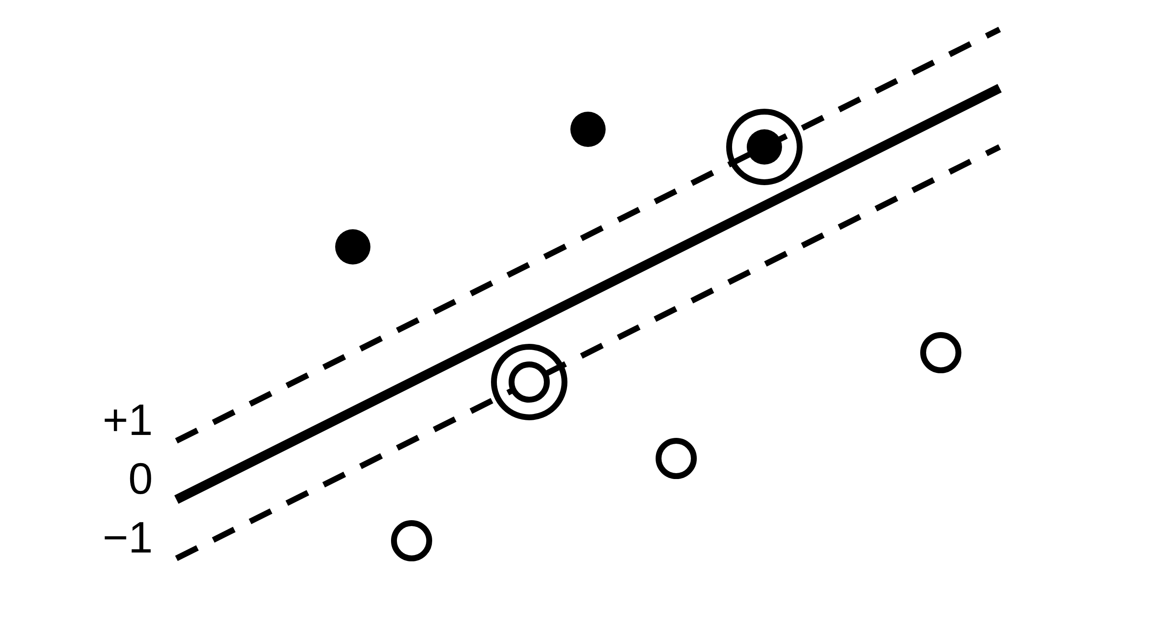
Score w·x + b. Dashed lines are the margin edges (±1). Ringed points are support vectors.
- Class = sign of the score. |score| ≥ 1: beyond the margin. = 1: on the edge, a support vector. Between −1 and 1: inside the margin, still takes the sign's class (soft margin only). = 0: on the boundary.
- Margin = 2/‖w‖. w = (3,4): ‖w‖ = 5, margin 0.4. w = (2,0): margin 1.
- Minimise ½wᵀw (= ½‖w‖²) to make the margin as wide as possible, subject to yᵢ(w·xᵢ+b) ≥ 1. Without the constraint, w = 0 wins: every point scores the same and nothing is classified.
- Support vectors alone define the boundary. Delete any other point and nothing changes. Hard margin: only the points exactly on the edges (at least 2, one per class). Adding far-away points changes nothing; points near or inside the margin can.
- C small: wide margin, tolerant, more support vectors, smoother, risk of underfitting. C large: narrow margin, fewer support vectors, bends to fit noise or an outlier, risk of overfitting.
- Kernel trick: a kernel gives dot products as if the data were in a higher dimension, without building the new coordinates. A ring becomes separable by a flat boundary. Linear, polynomial, RBF.
- Gamma (RBF): large = tight blobs around points, 100% train but poor test (overfit). Small = smooth. Overfit RBF-SVM: lower C and gamma.
- Multi-class: one-vs-rest = c SVMs, take the highest score. One-vs-one = c(c−1)/2 SVMs (5 classes = 10), majority vote.
- Scale inputs (distance-based). No direct probabilities. Hard to interpret. Slow on very large data. Imbalance: use class weights.

I. Feature selection, PCA, LDA

Selection vs extraction
Selection keeps original columns (still explainable). Extraction (PCA, LDA) builds new ones (harder to explain).
 | Filter | Wrapper | Embedded
Idea | Score features before any model | Train a model per subset, keep the best | Model selects while training
Examples | r > 0.9 drop one, variance threshold, mutual info, ANOVA, chi-square | Forward, backward, RFE | Lasso, trees, random forest importance
Speed | Fastest | Slowest, often best, can overfit | In between

- Rounds: keep m of p features. Forward needs m rounds, backward needs p − m. (Keep 10 of 12: 10 vs 2. Keep 2: 2 vs 10.) Choose the cheaper.
- Lasso (L1) sets some coefficients exactly to 0 (selection). Ridge (L2) shrinks but keeps all.

PCA
- Unsupervised. New components are weighted mixes of the features: uncorrelated, orthogonal, ordered by variance explained. Eigenvalue = variance of a component, eigenvector = its weights (loadings).
- Standardise first: PCA maximises variance and variance depends on units (grams would dominate cm). Standardised total variance = p, each feature 1.
- eigenvalue = %var × p / 100. Kaiser: keep eigenvalue > 1, i.e. %var > 100/p (8 features: 12.5%). Other rules: cumulative 80 or 90% (reaching it counts), scree elbow, communality > 0.5 for each variable.
- Rules can disagree (eigenvalues 2.4, 1.5, .9, .6, .3, .3: Kaiser keeps 2, 80% keeps 3, 90% keeps 4). Name the rule, quote the numbers, mention the other.
- Suitable? KMO ≥ 0.5 (below = too little correlation). Bartlett p < 0.05 (rejects "variables unrelated"). KMO .35 and p .40: unsuitable. Do not force PCA; keep original features or add related variables. PCA needs correlation, so do not remove correlated features first.
- Reading loadings: large |loading| (near ±1) defines the component. Same sign = move together, opposite sign = opposite. Near 0 = no role. Name it in business terms (Salary +, Bonus +, Rent − = "financial comfort").
- Limits: linear, outlier-sensitive, continuous variables, enough rows (150+, about 5 per variable), components harder to explain. PCA ignores the target, so a top-variance component is not guaranteed to predict well, and a small one can be the useful one.
- Using PCs in a model: uncorrelated and fewer inputs. Leave the target out of the PCA (leakage). Fit on training data only.

LDA
- Supervised. Finds directions that push class means apart relative to the spread inside each class. Axes ≤ min(p, c−1) (30 features, 5 classes: 4. 4 features, 7 classes: 4).
- PCA vs LDA: no labels, explore, compress = PCA. Labelled, prepare for classification = LDA. If classes overlap along the biggest-spread direction and differ along a small-spread one, PC1 puts them on top of each other (classifier near chance) while LDA finds the separating direction.
- LDA assumes roughly Gaussian classes, fails if the classes differ in variance not mean, unstable with small samples. Fit on training data only.

J. Clustering
- Unsupervised. Minimise intra-cluster distance, maximise inter-cluster distance. Scale first.
- Distances: Euclidean √Σ(diff)². To compare, compare the squared distances and skip the root. Manhattan Σ|diff|. Nominal: Hamming (match 0, mismatch 1, add up). Ordinal: map to ranks, then |difference|.

K-means
- Choose k. Seeds, then assign each point to exactly one nearest centre, set each centre to the mean of its points, repeat until nothing changes. SSE = Σ (distance to own centre)².
- Check each iteration: every point appears in exactly one cluster, and each centre is the average of its cluster (mean of 2, 4, 6 is 4).
- Reaches a local minimum, so results depend on the seeds: restarts (keep the lowest SSE) or K-means++. Weak: must choose k, outliers drag centres, prefers round equal-size clusters, numeric only. Variants: K-medoids (robust), K-medians, K-modes, K-prototypes.

Hierarchical
- Merge the two closest clusters repeatedly; the dendrogram records it. Merges cannot be undone. Cut with a horizontal line in the largest gap between merge heights; the number of branches crossed is the number of clusters.
- Linkage: single = closest pair (chaining), complete = farthest pair (compact), average = mean of all pairs, Ward = smallest SSE increase. Pair distances 2, 6, 5, 8: single 2, complete 8, average 21/4 = 5.25.

DBSCAN
- Settings ε and MinPts; no k. Core: at least MinPts points within ε. Border: inside a core's ε but not dense itself. Noise: neither, which makes the anomalies.
- ε: plot each point's distance to its k-th neighbour (k = MinPts), sort, take the elbow. MinPts ≥ dimensions (2D: 4; above 2D: 2 × dimensions).
- Choose: big data, round clusters = K-means. Any shape, outliers or fraud = DBSCAN. Small data or nested groups = hierarchical.

Is the clustering any good?
- Silhouette s = (b − a)/max(a, b). a = average distance from the point to the others in its own cluster. b = average distance from the point to the points of the nearest other cluster. Example: point 4 in {2, 4}, other cluster {10, 12, 14}: a = 2, b = (6+8+10)/3 = 8, s = 6/8 = 0.75. Above 0.3 acceptable, near 0 on a border, negative probably misplaced.
- Davies-Bouldin: lower is better. Calinski-Harabasz: higher is better. Elbow (WCSS): choose the k where the improvement flattens (500, 200, 120, 110, 105 gives k = 3). WCSS always falls and hits 0 at k = n, so never pick the minimum.
- Stability: split-half, same clusters and profiles. Tiny clusters may be outliers.
- Business lens: profile each cluster on its variables (means, box plots), give an intuitive name and an action. A good silhouette alone is not enough.
- Fraud with no labels: DBSCAN, scale numeric features, encode categories. Judge by analysts reviewing a sample of the flagged cases (precision), stability and the k-distance plot; later recall when labels exist.

K. Choosing a model
 | Tree | Neural net | SVM
Explainable | Yes | No | Little
Scale inputs | No | Yes | Yes
Data needed | Moderate | Lots | Moderate
Overfit guard | Prune, limit depth | Early stop, dropout, fewer nodes | Lower C, gamma
Settings | max_depth, min_samples | layers, nodes, lr | C, kernel, gamma

If explanations are required, pick the tree and state its cost (may be less accurate on ring-like or complex patterns; a deep tree overfits). Why a neural net: flexible, learns features; cost is data, tuning, scaling and being a black box.
L. My traps (mistakes made in the rounds)
- Proportion = count ÷ TOTAL in the node. "1 and 5" is 1/6, 5/6.
- Child weight = child size ÷ node size, and the weights add to 1.
- High gain = children are pure, not sizes split 50/50. Pure child contributes 0.
- Backprop δ uses (T − O). Target above output gives a positive δ.
- K-means centre is the mean. Every point in one cluster only.
- Silhouette b = average distance to the other cluster's points, not their positions.
- Elbow is where gains flatten, not the lowest WCSS.
- Recall ≠ accuracy. Recall = TP/(TP+FN).
- KMO under 0.5 or Bartlett p over 0.05 = PCA unsuitable. Do not remove correlation.
- Kaiser is eigenvalue strictly over 1. LDA axes = min(p, c−1).
- More support vectors means smaller C. Large C: fewer SVs, narrow margin.
- SVM class = sign of the score. A score of 0.5 is still class +1, inside the margin.
- Imbalance fixes are class weights, SMOTE, over or undersampling. One-vs-rest is for many classes.
- Scaler and PCA are fitted after the split, on training data only.
- Dropout is off at test time. Never zero-initialise. Higher learning rate is not always faster.
- A leaked target (in PCA or features) inflates accuracy. Exclude it.

