class04.R
saharkamali
2026-01-16
x <-1:50
plot(x)
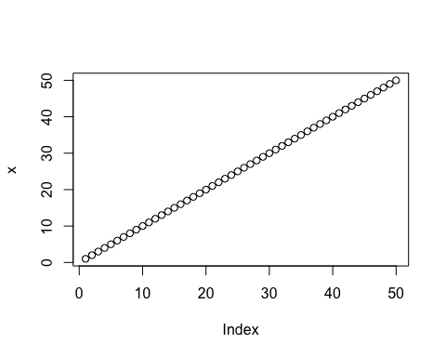
plot(x, sin(x), typ="l", col="pink", lwd=3,
xlab= "Is it lunch time yet?")
