A holistic continuous approximation framework for strategic last-mile distribution planning

A PROJECT REPORT

Submitted by
Share Saharsh Yadav

Under the guidance of
Dr. Anmol Pahwa

towards partial completion of
… in Civil Engineering



Department of Civil Engineering
Indian Institute of Technology Madras
Chennai, Tamil Nadu, India - 600036

Table of Contents
Abstract 6
List of Figures 3
List of Tables 4
List of Abbreviations 5
1. Background 6
1.1 Motivation and Problem Statement 6
1.2 Literature Review 7
1.3 Gaps in the Literature 7
1.4 Research Objectives and Contributions 8
2. Methodology 8
2.1 Distribution Environments 9
2.2 Adaptive Large Neighborhood Search Metaheuristic 12
2.2.1 Framework 13
2.2.2 Implementation 15
2.2.3 Validation 17
3. Work Plan 20
References 21

List of Figures
Fig. 1. Customer Spatial Dispersion - Illustrative Instances 12
Fig. 2. Customer Demand Pattern - Probability Density 13
Fig. 3. Illustrative Convergence Plots 18
Fig. 4. Box Plot - Deviation from the best 20

List of Tables
Table 1. Customer Spatial Distribution - Formulation 11
Table 2. Customer Demand Pattern - Formulation 11
Table 3. ALNS Parameters Calibrated to CVRP 17
Table 4. Summary of Benchmark Datasets Used for Validation 19
Table 5. ALNS Validation - Deviation from the best - Quartiles 20
Table 6. Proposed Timeline for the Remaining Work 21

List of Abbreviations
ALNS Adaptive Large Neighborhood Search
BHH Beardwood-Halton-Hammersley
BKS Best-Known Solution
CA Continuous Approximation
CVRP Capacitated Vehicle Routing Problem
CVRPLIB Capacitated Vehicle Routing Problem Library
GNN Graph Neural Network
TSP Traveling Salesman Problem
UoM Unit of Measure
VRP Vehicle Routing Problem

Abstract
Strategic last-mile distribution planning requires quick estimates of the total delivery tour length based on representative, rather than exact, information about customers. Running a Vehicle Routing Problem (VRP) solver for every candidate network configuration is computationally impractical, while classical Continuous Approximation (CA) formulas assume uniformly scattered customers with identical demands and lose accuracy in realistic distribution environments. This project aims to develop an interpretable, closed-form CA model for the tour length of the Capacitated Vehicle Routing Problem (CVRP) across diverse spatial and demand settings. During this semester, a library of synthetic environments was built by introducing two new families of customer distributions, multi-cluster and Beta (U-shaped), for both spatial dispersion and demand, alongside the uniform, triangular, normal, and exponential families. Combining six spatial and six demand patterns with sampled service-region sizes, depot locations, vehicle capacities, and customer counts (100–500) yielded 1,080 CVRP instances. Each instance was solved with an Adaptive Large Neighborhood Search (ALNS) metaheuristic to obtain near-optimal tour lengths. Validation on 68 CVRPLIB benchmark instances (680 runs across ten random seeds) showed median gaps to the best-known solutions of 1.05% (best of ten seeds), 1.57% (mean), and 2.07% (worst seed). The next phase will apply symbolic regression to this dataset, using moments of customers' nearest-neighbor distances and demands, together with depot distance, to discover closed-form tour-length equations, which will then be tested on independent benchmark instances against the classical Daganzo (1984) model.
Key words: Capacitated Vehicle Routing Problem, Continuous Approximation, Adaptive Large Neighborhood Search, Symbolic Regression, Last-Mile Distribution

- Background

1.1 Motivation and Problem Statement
Last-mile delivery is one of the most resource-intensive stages of modern supply chains, accounting for over 40% of overall supply-chain costs (Capgemini, 2019), as urban parcel volumes continue to grow (Anand et al., 2015; Universal Postal Union, 2021). When modelling these delivery networks, operations research traditionally relies on discrete mathematical formulations of the Vehicle Routing Problem (VRP) (Braekers et al., 2016). Because the VRP is NP-hard, finding strong solutions requires either exact branch-and-cut algorithms for small instances or computationally heavy metaheuristics - such as Tabu Search, Genetic Algorithms, or Adaptive Large Neighborhood Search (ALNS) - for realistic problem sizes (Elshaer and Awad, 2020; Konstantakopoulos et al., 2020; Zhang et al., 2021).
While running a full routing solver is necessary for operational planning, where dispatchers have exact daily order manifests and must generate the sequence of customer visits for each vehicle, it becomes a major bottleneck in strategic planning. During long-term planning - such as selecting warehouse locations, sizing delivery fleets, or designing service territories - planners work with representative demand scenarios rather than exact customer lists. At this stage, the planner only needs to know the expected total travel distance (tour length) to estimate operating costs, not the exact sequence of customer visits. Running an iterative optimization solver across thousands of candidate configurations is computationally impractical, creating a clear need for fast, accurate tour length estimation methods that generalize across realistic customer and demand distributions.

1.2 Literature Review
To bypass discrete optimization during strategic planning, the Continuous Approximation (CA) paradigm replaces discrete customer coordinates with continuous spatial density functions to estimate routing distances analytically (Ansari et al., 2018; Franceschetti et al., 2017; Langevin et al., 1996). Building on the foundational Beardwood-Halton-Hammersley (BHH) theorem for asymptotic Traveling Salesman Problem (TSP) tour lengths (Beardwood et al., 1959), Daganzo (1984) introduced a classic CA formulation for the VRP by splitting total route distance into two parts: a long-haul (stem) component connecting the depot to the service area, and a last-mile (detour) component covering customer-to-customer visits within each route. Assuming $n$ identical customers are distributed uniformly over an area $a$ (yielding density $δ=n/a$) and served by vehicles visiting $c$ stops per tour from a depot at average distance $ρ$, Daganzo (1984) approximated the tour length $l$ as:
$$l=2ρ+k\frac{c}{\sqrt{δ}}$$
Over the years, several studies have refined this foundational equation to relax its idealized assumptions. Figliozzi (2008, 2009, 2010) added empirical regression parameters to account for varying customer demand levels, delivery time windows, and traffic congestion. In the TSP domain, Çavdar and Sokol (2015) developed a distribution-free estimation formula using spatial dispersion metrics, Merchán and Winkenbach (2019) introduced road network circuity factors for urban zones, and Rifki et al. (2021) and Rifki and Garaix (2023) studied asymptotic approximations under varying spatial and temporal demand profiles. Because these analytical expressions are easy to evaluate, they have been widely embedded into strategic optimization models for terminal design, fleet sizing, and location-routing problems (Davis and Figliozzi, 2013; Ouyang and Daganzo, 2006; Pahwa and Jaller, 2022; Saberi and Verbas, 2012; Turkensteen and Klose, 2012).
However, when customer locations follow a non-uniform spatial probability density $f_{XY}\left(x,y\right)$, demands follow an arbitrary distribution $f_{D}$, and the depot is placed at a specific coordinate $\left(ρ_{x},ρ_{y}\right)$, the continuous approximation takes a general integral form (Beardwood et al., 1959; Pahwa and Jaller, 2022):
$$l=2\left[\int_{x}{\left|x-ρ_{x}\right|}f_{X}\left(x\right) dx+\int_{y}{\left|y-ρ_{y}\right|}f_{Y}\left(y\right) dy\right]+β\left[\iint_{xy}{\sqrt{f_{XY}\left(x,y\right)}} dx dy\right]\frac{c}{\sqrt{δ}}$$
For complex real-world spatial distributions, this integral does not have a closed-form analytical solution. To work around this, Nicola et al. (2019) used statistical regression to estimate VRP distances across varied customer layouts, though their predetermined functional forms limited flexibility and generalization. More recently, Kirubakaran et al. (2026) generated 1,080 synthetic VRP environments, solved them using an ALNS metaheuristic, and applied symbolic regression over statistical moments of nearest-neighbor distances and customer demands to automatically discover closed-form CA equations.
In parallel, learning-based methods have emerged as a data-driven alternative to closed-form approximations. Varol et al. (2024) trained neural network estimators on node-, instance- and solution-level features to predict optimal Traveling Salesman Problem (TSP) tour lengths for instances with arbitrary node distributions, reporting average deviations from optimality below 0.7% and strong performance on out-of-distribution instances. However, such estimators rely on hand-crafted instance descriptors and address the uncapacitated TSP, whereas CVRP tour length additionally depends on depot placement, vehicle capacity, and customer demand.

1.3 Gaps in the Literature
A review of the literature reveals three gaps that this project addresses.
Limited coverage of realistic distribution environments. Classical CA expressions assume customers scattered uniformly, identical demands and a depot located far from the service region (Daganzo, 1984; Franceschetti et al., 2017). Later extensions added correction terms for demand levels, time windows, congestion and road circuity (Figliozzi, 2008, 2009, 2010; Merchán and Winkenbach, 2019), but they still build on a simple spatial layout. When customer density, demand and depot position vary freely, the general integral form has no closed-form solution, and to our knowledge only Nicola et al. (2019) and Kirubakaran et al. (2026) have tried to estimate VRP tour lengths for such non-uniform settings. The environments in Kirubakaran et al. (2026), the most comprehensive of these, do not include polycentric cities with several customer hubs or tiered order profiles that mix small retail and large wholesale orders, even though both are common in practice.
Interpretability versus flexibility. The regression models of Nicola et al. (2019) rely on predetermined functional forms, which limits their flexibility and makes them prone to overfitting when they are not validated thoroughly on independent data. Learning-based estimators go to the other extreme: Varol et al. (2024) reached deviations below 0.7% for the uncapacitated TSP, but such black-box models depend on hand-crafted features and cannot be dropped into the analytical location-routing or fleet-sizing models that need closed-form expressions. Symbolic regression, which searches over the structure of an equation as well as its coefficients, offers a middle path, as shown by Kirubakaran et al. (2026), yet its use for CVRP tour length has so far been demonstrated on a limited range of environments.
Generalization of discovered equations. Equations discovered from synthetic data can fit their training environments closely and still fail on real instances, particularly as their complexity grows. Whether moment-based descriptors of nearest-neighbor distances and demand remain adequate when the environments include multi-modal spatial and demand patterns is not yet established, nor is how much model complexity is justified before generalization to independent benchmark instances deteriorates. A systematic, complexity-aware evaluation of symbolic-regression equations on a richer set of environments, with validated tour lengths as ground truth, is therefore still missing.

1.4 Research Objectives and Contributions
The overall objective of this project is to develop an interpretable, closed-form CA model that estimates the total CVRP tour length across varied customer, demand and depot configurations using only descriptors available at the strategic planning stage. This is pursued through four specific objectives: (a) to synthesize a diverse library of CVRP environments by extending the customer distribution families with multi-cluster and Beta (U-shaped) patterns; (b) to generate near-optimal tour lengths for every environment with an ALNS metaheuristic and verify the solver against benchmark instances; (c) to discover closed-form tour length equations from this dataset using symbolic regression; and (d) to test these equations on independent benchmark instances and quantify their improvement over the classical Daganzo (1984) model. Objectives (a) and (b) were completed this semester and are reported in Section 2, while objectives (c) and (d) form the work plan in Section 3.
The contributions of the work completed so far are twofold. First, a dataset of 1,080 CVRP instances was created, covering 36 combinations of six spatial and six demand patterns, each generated for 30 seeds. Because each seed fixes the service region, depot location, vehicle capacity and customer count across all 36 combinations, the effect of the distribution pattern alone can be isolated. Second, near-optimal tour lengths were obtained for all instances with an updated ALNS implementation, whose solution quality was verified on 68 CVRPLIB X-series instances (680 runs) with median gaps of 1.05%, 1.57% and 2.07% for the minimum, mean and maximum over ten seeds. Together, these provide the ground-truth data from which the closed-form models will be learned.
The anticipated contribution of the remaining work is a small set of interpretable equations that planners can use to estimate tour length when only aggregate information is available, as well as when detailed spatial and demand information exists, with their accuracy documented on independent benchmarks. By making the discovered relationships explicit, the equations will also show which features of a distribution environment drive routing distance.

- Methodology

2.1 Distribution Environments
To train a black-box tour length estimator that generalizes across diverse logistics networks, this study synthesizes a dataset of 1,080 Capacitated Vehicle Routing Problem (CVRP) instances. Each instance represents a rectangular service region of dimensions $l_{x}×l_{y}$, where $l_{x},l_{y}∈\left\{1,2,…,9\right\}$, centered at the origin $\left(0,0\right)$. Within this service area, a logistics operator serves $n∈\left[100,500\right]$ customers characterized by a spatial dispersion pattern $f_{s}∈\left\{U_{s},T_{s},NT_{s},ET_{s},MC_{s},B_{s}\right\}$ and a demand distribution pattern $f_{d}∈\left\{U_{d},T_{d},NT_{d},ET_{d},MC_{d},B_{d}\right\}$. Deliveries are carried out by a homogeneous fleet of vehicles, each with capacity $q_{v}∈\left\{10,20,…,100\right\}$, dispatched from a single distribution depot located at $\left(ρ_{x},ρ_{y}\right)$ relative to the center of the service region, where $ρ_{x}/l_{x},ρ_{y}/l_{y}∈\left\{-1.0,-0.9,…,0.9,1.0\right\}$. This formulation allows the depot to lie either inside the service boundaries ($|ρ_{x}|≤0.5l_{x}$ and $|ρ_{y}|≤0.5l_{y}$) or outside the service region. Across all instances, coordinates are expressed in a standard Unit of Measure (UoM) for distance (e.g., kilometers or miles), while customer demands and vehicle capacities are expressed in a standard UoM for load (e.g., parcel count, weight, or volume). Combining the six spatial distributions with the six demand patterns yields 36 distinct environment configurations, each evaluated across 30 fixed random seeds to produce the 1,080 instances. Checkpoint seeding is applied during generation so that for any given seed, the macro-level instance parameters ($l_{x},l_{y},ρ_{x},ρ_{y},q_{v},n$) remain identical across all 36 distribution pairs. Consequently, the dataset contains 30 distinct combinations of ($l_{x},l_{y},ρ_{x},ρ_{y},q_{v},n$), each paired with all 36 distribution combinations.

Customer locations $\left(x_{i},y_{i}\right)$ for $i∈\left[1,n\right]$ are generated within the service boundaries $\left[-0.5l_{x},0.5l_{x}\right]×\left[-0.5l_{y},0.5l_{y}\right]$ using six probability distributions that capture a wide spectrum of spatial topologies:

- Uniform Spatial Distribution ($U_{s}$): Customer horizontal and vertical coordinates are sampled independently and uniformly across the service region, matching the baseline assumption of classical Continuous Approximation models.
- Triangular Spatial Distribution ($T_{s}$): Customer coordinates along each axis $k∈\left\{x,y\right\}$ follow a triangular distribution bounded by $-0.5l_{k}$ and $0.5l_{k}$, with a mode $c_{k}$ drawn uniformly from $U\left(-0.5l_{k},0.5l_{k}\right)$ to create a single moderate zone of customer agglomeration.
- Normal (Truncated) Spatial Distribution ($NT_{s}$): Coordinates along each axis $k∈\left\{x,y\right\}$ are drawn from a normal distribution with mean $μ_{k}∼U\left(-0.5l_{k},0.5l_{k}\right)$ and standard deviation $σ_{k}∼U\left(0.1l_{k},0.4l_{k}\right)$, truncated at the service region boundaries $\left[-0.5l_{k},0.5l_{k}\right]$ to model monocentric urban density.
- Exponential (Truncated) Spatial Distribution ($ET_{s}$): Coordinates along each axis $k∈\left\{x,y\right\}$ follow a truncated exponential distribution shifted to the service region $\left[-0.5l_{k},0.5l_{k}\right]$, with scale parameter drawn from $U\left(0,l_{k}\right)$ and random directional orientation (skewed toward either $-0.5l_{k}$ or $+0.5l_{k}$), capturing asymmetric coastal or corridor-style urban layouts.
- Multi-Cluster Spatial Distribution ($MC_{s}$): To represent realistic polycentric cities with multiple commercial and residential hubs, $n_{k}∼DU\left(3,6\right)$ cluster centers are first generated in normalized coordinates ${\overset{˜}{c}}_{a}∼U{\left(-0.4,0.4\right)}^{2}$ ($a∈\left[1,n_{k}\right]$) subject to a minimum pairwise Euclidean separation of $0.25$ so that clusters remain distinct, and then scaled by $\left(l_{x},l_{y}\right)$. Each customer $i∈\left[1,n\right]$ is randomly assigned to a cluster $j∼DU\left(1,n_{k}\right)$ and its coordinates are sampled from a truncated normal distribution centered at $\left(c_{j,x},c_{j,y}\right)$ with cluster spread $σ_{k}∼U\left(0.07l_{k},0.10l_{k}\right)$ truncated to $\left[-0.5l_{k},0.5l_{k}\right]$.
- Beta (U-Shaped) Spatial Distribution ($B_{s}$): To model peripheral dispersion where customers concentrate near the edges of the service territory, normalized coordinates $z_{i,k}$ are sampled from a U-shaped Beta distribution $B\left(α_{k},β_{k}\right)$ with shape parameters $α_{k},β_{k}∼U\left(0.3,0.5\right)$ for $k∈\left\{x,y\right\}$, and mapped to the service region via $\left(z_{i,k}-0.5\right)l_{k}$.
Table 1 summarizes the mathematical formulations used to generate customer coordinates for each spatial distribution, while Fig. 1 presents illustrative customer layouts for the six distributions. Similarly, customer demands $d_{i}$ for $i∈\left[1,n\right]$ are generated over the interval $\left[0,2\right]$ (in standard load UoM) using six corresponding demand distributions:

- Uniform Demand Pattern ($U_{d}$): Customer demands are drawn uniformly between $0$ and $2$ UoM.
- Triangular Demand Pattern ($T_{d}$): Customer demands follow a triangular distribution on $\left[0,2\right]$ with mode $c∼U\left(0,2\right)$.
- Normal (Truncated) Demand Pattern ($NT_{d}$): Customer demands are sampled from a normal distribution with mean $μ∼U\left(0,2\right)$ and st andard deviation $σ∼U\left(0.2,0.8\right)$, truncated to the interval $\left[0,2\right]$.
- Exponential (Truncated) Demand Pattern ($ET_{d}$): Customer demands follow a truncated exponential distribution on $\left[0,2\right]$ with scale parameter drawn from $U\left(0,2\right)$, skewed toward either $0$ (many small orders, few large orders) or $2$ (mostly high-volume orders).
- Multi-Cluster Demand Pattern ($MC_{d}$): To reflect tiered order profiles (such as mixed retail and wholesale customers), $n_{k}∼DU\left(2,3\right)$ demand cluster centers $μ_{1}<…<μ_{n_{k}}$ are generated within $\left[0.3,1.7\right]$ with a minimum separation of $0.5$. Each customer $i∈\left[1,n\right]$ is assigned to a demand tier $j∼DU\left(1,n_{k}\right)$ and its demand is drawn from a truncated normal distribution $NT\left(μ_{j},σ_{d},0,2\right)$ with spread $σ_{d}∼U\left(0.10,0.20\right)$.
- Beta (U-Shaped) Demand Pattern ($B_{d}$): Customer demands are generated by scaling a symmetric U-shaped Beta distribution $2⋅B\left(α_{d},α_{d}\right)$ with $α_{d}∼U\left(0.3,0.8\right)$, concentrating demands near the lower ($0$) and upper ($2$) UoM limits.
Table 2 details the mathematical formulations for the six customer demand patterns, and Fig. 2 illustrates the corresponding probability density functions.

Table 1. Customer Spatial Distribution - Formulation
Spatial Distribution | Formulation
Uniform | $$\left\{U\left(-0.5l_{k},0.5l_{k}\right);i∈\left[1,n\right],k∈\left\{x,y\right\}\right\}$$
Triangular | $$\left\{T\left(-0.5l_{k},0.5l_{k},U\left(-0.5l_{k},0.5l_{k}\right)\right);i∈\left[1,n\right],k∈\left\{x,y\right\}\right\}$$
Normal (Truncated) | $$\left\{NT\left(U\left(-0.5l_{k},0.5l_{k}\right),U\left(0.1l_{k},0.4l_{k}\right),-0.5l_{k},0.5l_{k}\right);i∈\left[1,n\right],k∈\left\{x,y\right\}\right\}$$
Exponential (Truncated) | $$\left\{ET\left(U\left(0,l_{k}\right),0,l_{k}\right)-0.5l_{k}\text{OR}0.5l_{k}-ET\left(U\left(0,l_{k}\right),0,l_{k}\right);i∈\left[1,n\right],k∈\left\{x,y\right\}\right\}$$
Multi-cluster | $$\left\{NT\left(c_{j,k},U\left(0.07l_{k},0.10l_{k}\right),-0.5l_{k},0.5l_{k}\right);i∈\left[1,n\right],k∈\left\{x,y\right\}\right\};c_{j,k}∼U\left(-0.4l_{k},0.4l_{k}\right),j∈\left[1,DU\left\{3,…,6\right\}\right]\text{; centres at least 0.25 apart (normalised units)}$$
Beta (U-shaped) | $$\left\{\left(B\left(U\left(0.3,0.5\right),U\left(0.3,0.5\right)\right)-0.5\right)l_{k};i∈\left[1,n\right],k∈\left\{x,y\right\}\right\}$$
U: Uniform, T: Triangular, NT: Normal (Truncated), ET: Exponential (Truncated), B: Beta (U-shaped).

Table 2. Customer Demand Pattern - Formulation
Demand Pattern | Formulation
Uniform | $$\left\{U\left(0,2\right);i∈\left[1,n\right]\right\}$$
Triangular | $$\left\{T\left(0,2,U\left(0,2\right)\right);i∈\left[1,n\right]\right\}$$
Normal (Truncated) | $$\left\{NT\left(U\left(0,2\right),U\left(0.2,0.8\right),0,2\right);i∈\left[1,n\right]\right\}$$
Exponential (Truncated) | $$\left\{ET\left(U\left(0,2\right),0,2\right)\text{OR}2-ET\left(U\left(0,2\right),0,2\right);i∈\left[1,n\right]\right\}$$
Multi-cluster | $$\left\{NT\left(μ_{j},U\left(0.1,0.2\right),0,2\right);i∈\left[1,n\right]\right\};μ_{j}∼U\left(0.3,1.7\right),j∈\left[1,DU\left\{2,3\right\}\right]\text{; tier means at least 0.5 apart}$$
Beta (U-shaped) | $$\left\{2B\left(α,α\right);i∈\left[1,n\right]\right\};α∼U\left(0.3,0.8\right)$$
U: Uniform, T: Triangular, NT: Normal (Truncated), ET: Exponential (Truncated), B: Beta (U-shaped).

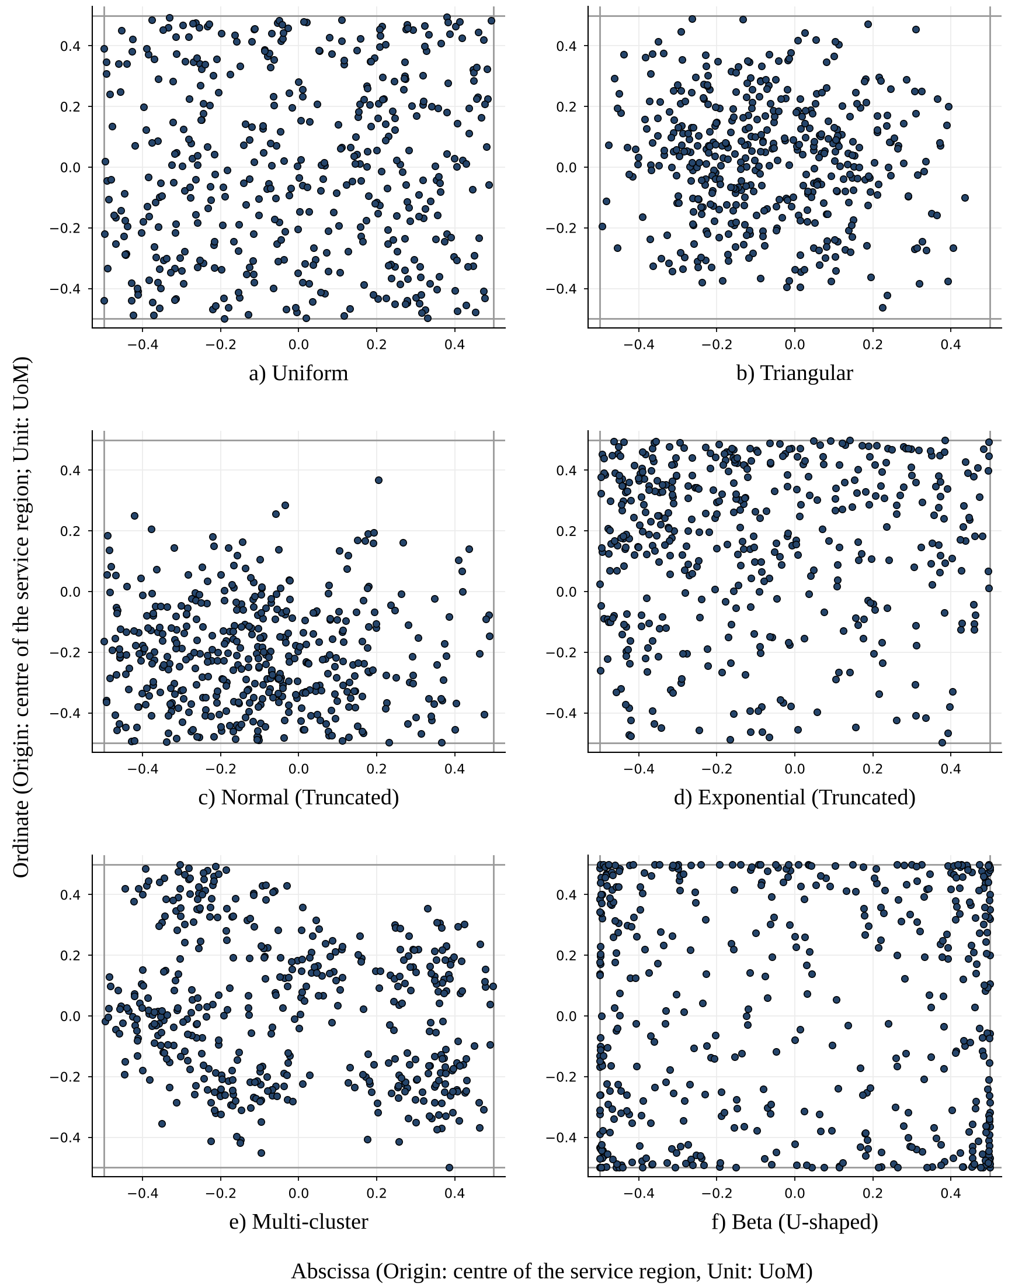
Fig. 1. Customer Spatial Dispersion - Illustrative Instances (on a unit square, l_{x} = l_{y} = 1; depot not shown).

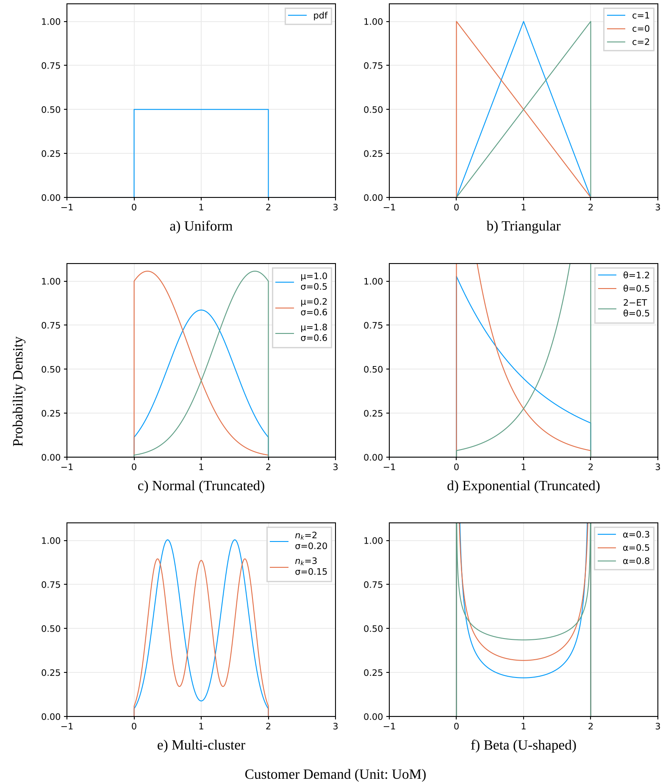
Fig. 2. Customer Demand Pattern - Probability Density.

2.2 Adaptive Large Neighborhood Search Metaheuristic
Originally introduced by Ropke and Pisinger (2006), the Adaptive Large Neighborhood Search (ALNS) metaheuristic explores the solution space by repeatedly tearing down a large part of an existing routing plan and rebuilding it in a different way. Instead of relying on a single fixed neighborhood move, the algorithm chooses among multiple ruin (removal) and recreate (insertion) operators in each iteration, adjusting their selection probabilities over time based on how well each operator has performed in earlier iterations. The subsections below outline the general ALNS framework, its specific implementation in our Julia solver (CVRP.jl), and the benchmark validation results used to verify solution quality before generating the synthetic training dataset.

2.2.1 Framework
The solver follows a standard ruin-and-recreate structure, keeping track of both the current working solution $s$ and the best overall solution $s^{*}$ found since the start of the run, both initialized from a starting route configuration $s_{0}$. The search is divided into $j$ sequential segments, with each segment running for $n$ iterations. Inside every iteration, the algorithm picks one removal operator $o_{r}∈Ψ_{r}$ and one insertion operator $o_{i}∈Ψ_{i}$ using a roulette-wheel mechanism, where the probability of picking an operator is proportional to its current adaptive weight ($w_{r}$ or $w_{i}$). The chosen removal operator strips a subset of $q$ elements out of the current solution $s$, where the destruction size $q$ is bounded by predetermined element limits $\left[\underline{e},\overline{e}\right]$ and fractional limits $\left[\underline{μ},\overline{μ}\right]$. The selected insertion operator is then applied to the partial route plan to reinsert the removed customers, producing a new candidate solution $s'$.
To learn which operators work best for a given problem instance, the algorithm tracks an accumulated score ($π_{r},π_{i}$) and a usage counter ($c_{r},c_{i}$) for every operator within the current segment, resetting both to zero at the beginning of each new segment. Whether the candidate solution $s'$ is accepted - and how much credit the active operators receive-depends on its objective value $f\left(s'\right)$ relative to $f\left(s\right)$ and $f\left(s^{*}\right)$, as well as whether $s'$ has been visited before, which is checked using a hash set $H$ storing solution encodings $h\left(s\right)$:
- New Global Best ($f\left(s'\right)<f\left(s^{*}\right)$): The candidate solution replaces both $s$ and $s^{*}$, and the removal and insertion operators used in that iteration each receive the highest reward score $σ_{1}$.
- Improving Current Solution ($f\left(s^{*}\right)≤f\left(s'\right)<f\left(s\right)$): The candidate solution replaces $s$, and if its hash $h\left(s'\right)$ is not already present in the tabu hash set $H$ (indicating a novel route configuration), both operators earn a moderate reward $σ_{2}$.
- Non-Improving Solution ($f\left(s'\right)≥f\left(s\right)$): To avoid getting trapped in local minima, a Simulated Annealing acceptance rule is used. The worse candidate solution $s'$ is accepted with Boltzmann probability $\exp\left(\left(f\left(s\right)-f\left(s'\right)\right)/T\right)$, where $T$ is the current search temperature. If accepted and novel ($h\left(s'\right)∉H$), the operators receive a small reward $σ_{3}$.
The temperature $T$ starts at an initial value $T_{0}=\overline{ω}f\left(s^{*}\right)/\ln\left(1/\overline{τ}\right)$, chosen so that a candidate solution whose cost is $\overline{ω}$ worse than $s^{*}$ has an initial acceptance probability of $\overline{τ}$. At the end of every iteration, $T$ is multiplied by a cooling rate $θ$, gradually lowering the chance of accepting poor moves down to a minimum floor temperature defined by deviation parameter $\underline{ω}$ and probability $\underline{τ}$. To keep the search from drifting too far into low-quality regions after several non-improving moves, every $k$ segments, if no new best solution has been found during those segments, the working solution $s$ is reset back to the best-known solution $s^{*}$.
At the end of each segment, the operator weights are updated using a reaction factor $ρ∈\left[0,1\right]$ that blends the operator's average score in the just-completed segment with its previous weight:
$$w_{r}←ρ\frac{π_{r}}{c_{r}}+\left(1-ρ\right)w_{r}, w_{i}←ρ\frac{π_{i}}{c_{i}}+\left(1-ρ\right)w_{i}$$
Before moving to the next segment, a set of local search operators $o_{l}∈Ψ_{l}$, each running for up to $m$ iterations, is applied to a copy of the current solution $s$; the result replaces $s$ (and $s^{*}$ if it is a new overall best) only if it improves on $s$. Once all $j$ segments are finished, the algorithm returns $s^{*}$.

Algorithm Adaptive Large Neighborhood Search (ALNS)
$1:$ | $$Procedure ALNS\left(s_{o},\left(j,k,n,m,Ψ_{r},Ψ_{i},Ψ_{l},σ_{1},σ_{2},σ_{3},\underline{e},\overline{e}, \underline{μ},\overline{μ} ,\underline{ω},\overline{ω},\underline{τ}, \overline{τ},θ,ρ\right)\right)$$
$2:$ | $$s←s_{o}$$ | // set current solution s to initial solution s₀
$3:$ | $$s^{*}←s$$ | // set best solution s* to current solution s
$4:$ | $H←\left\{h\left(s\right)\right\}$ | // initialize solution hash set
$5:$ | $$T←\overline{ω}f(s^{*})/\ln{(1/\overline{τ})}$$ | // set starting temperature from cooling schedule
$6:$ | $$for o_{r}∈Ψ_{r} do$$ | // set removal operator weights to 1
$7:$ | $$w_{r_{ }}←1$$
$8:$ | $$end for$$
$9:$ | $$for o_{i}∈Ψ_{i} do$$ | // set insertion operator weights to 1
$$10:$$ | $$w_{i}←1$$
$$11:$$ | $$end for$$
$$12:$$ | $$u ←1$$ | // set segment counter to 1
$13:$ | $$while u≤j do$$ | // iterate across j segments
$$14:$$ | $$for o_{r}∈Ψ_{r} do$$
$15:$ | $p_{r }←{w_{r}}/{\sum_{o∈Ψ_{r}}{w_{o}}}$ | // compute removal operator selection probability
$16:$ | $$end for$$
$17:$ | $$for o_{i}∈Ψ_{i} do$$
$18:$ | $p_{i}←{w_{i}}/{\sum_{o∈Ψ_{i}}{w_{o}}}$ | // compute insertion operator selection probability
$19:$ | $$end for$$
$$20:$$ | $$for o_{r}∈Ψ_{r} do$$
$21:$ | $$c_{r}←0$$ | // reset removal operator usage count to 0
$22:$ | $$π_{r}←0$$ | // reset removal operator score to 0
$23:$ | $$end for$$
$$24:$$ | $$for o_{i}∈Ψ_{i} do$$
$25:$ | $$c_{i}←0$$ | // reset insertion operator usage count to 0
$26:$ | $$π_{i}←0$$ | // reset insertion operator score to 0
$27:$ | $$end for$$
$28:$ | $$v←1$$ | // set iteration counter to 1
$29:$ | $$while v≤n do$$ | // iterate across n iterations
$30:$ | $$o_{r}\underset{←}{R_{p_{r}}}Ψ_{r}$$ | // sample a removal operator via roulette wheel
$31:$ | $$o_{i}\underset{←}{R_{p_{i}}}Ψ_{i}$$ | // sample an insertion operator via roulette wheel
$32:$ | $$c_{r}←c_{r}+1$$ | // increment removal operator usage count
$33:$ | $$c_{i}←c_{i }+1$$ | // increment insertion operator usage count
$$34:$$ | $$Λ \sim U\left(0,1\right)$$
$35:$ | $$λ \underset{←}{R}Λ$$
$36:$ | $$q←{\left[\begin{aligned}\left(1-λ\right)\min\left(\underline{e}, \underline{μ}\left\|s\right\|\right) \\ +λ\min\left(\overline{e}, \overline{μ}\left\|s\right\|\right) \end{aligned}\right]}^{-}$$ | // determine number of nodes to remove and reinsert
$37:$ | $$s^{'}←o_{i}\left(o_{r}\left(q,s\right)\right)$$ | // destroy and rebuild solution to obtain s'
$38:$ | $$if f\left(s^{'}\right)<f\left(s^{*}\right) then$$ | // if candidate improves on best solution
$39:$ | $$s^{*}←s'$$ | // update best solution to candidate solution
$40:$ | $$s ←s^{'}$$ | // update current solution to candidate solution
$41:$ | $$π_{r}←π_{r}+σ_{1}$$ | // add reward σ₁ to removal operator score
$42:$ | $$π_{i}←π_{i }+σ_{1}$$ | // add reward σ₁ to insertion operator score
$43:$ | $$else if f\left(s^{'}\right)<f\left(s\right) then$$ | // else if candidate improves on current solution
$44:$ | $$s ←s^{'}$$ | // update current solution to candidate solution
$45:$ | $$if h(s)∉H then$$ | // if solution is not in the hash set
$46:$ | $$π_{r}←π_{r}+σ_{2}$$ | // add reward σ₂ to removal operator score
$47:$ | $$π_{i}←π_{i }+σ_{2}$$ | // add reward σ₂ to insertion operator score
$48:$ | $$end if$$
$49:$ | $$else$$ | // else accept worse solution probabilistically
$50:$ | $$Λ \sim U\left(0,1\right)$$
$51:$ | $$λ \underset{←}{R}Λ$$
$52:$ | $if λ<\exp\left(\frac{f\left(s\right)-f\left(s^{'}\right)}{T}\right) then$
$53:$ | $$s ←s^{'}$$ | // update current solution to candidate solution
$$54:$$ | $$if h(s)∉H then$$ | // if solution is not in the hash set
$55:$ | $$π_{r}←π_{r}+σ_{3}$$ | // add reward σ₃ to removal operator score
$56:$ | $$π_{i}←π_{i }+σ_{3}$$ | // add reward σ₃ to insertion operator score
$57:$ | $$end if$$
$58:$ | $$end if$$
$59:$ | $$end if$$
$60:$ | $$H_{ }←H∪\left\{h\left(s\right)\right\}$$ | // record current solution in the hash set
$61:$ | $$T ←\max\left(θT,\underline{ω}f(s^{*})/\ln{(1/\underline{τ})}\right)$$ | // cool temperature according to schedule
$62:$ | $$v_{ }←v+1$$ | // increment iteration counter
$$63:$$ | $$end while$$
$64:$ | $$if u mod k$$ | // every k segments reset current solution to s*
$$65:$$ | $$s←s^{*}$$
$$66:$$ | $$end if$$
$67:$ | $$for o_{r}∈Ψ_{r} do$$ | // update removal operator weights
$68:$ | $$if c_{r}≠0 then$$
$69:$ | $$w_{r}←ρπ_{r}/c_{r} +\left(1-ρ\right)w_{r}$$
$70:$ | $$end if$$
$71:$ | $$end for$$
$72:$ | $$for o_{i}∈Ψ_{i} do$$ | // update insertion operator weights
$73:$ | $$if c_{i}≠0 then$$
$74:$ | $$w_{i}←ρπ_{i}/c_{i} +\left(1-ρ\right)w_{i}$$
$75:$ | $$end if$$
$76:$ | $$end for$$
$$77:$$ | $$for o_{l}∈Ψ_{l} do$$ | // apply local search operators to current solution
$78:$ | $$s←o_{l}\left(s,m\right)$$
$79:$ | $$end for$$
$80:$ | $$if f\left(s\right)<f\left(s^{*}\right) then$$ | // if current solution improves on best solution
$81:$ | $$s^{*}←s$$ | // update best solution to current solution
$$82:$$ | $$end if$$
$$83:$$ | $$H←H∪\left\{h\left(s\right)\right\}$$ | // record current solution in the hash set
$84:$ | $$u←u+1$$ | // increment segment counter
$85:$ | $$end while$$
$86:$ | $$return s^{*}$$ | // return best solution found

2.2.2 Implementation
The optimization pipeline is implemented in Julia using an updated version of the CVRP.jl ALNS library. Table 3 lists the calibrated parameter settings used across our runs.

Table 3. ALNS Parameters Calibrated to CVRP
ALNS Parameters |  | Data Generation | Validation
Number of segments | j | 100 | 200
Number of segments to reset the solution | k | 5 | 10
Number of iterations in a segment | n | x = max(100, |N|) | x = max(100, |N|)
Number of iterations in a local search | m | 100 x | 100 x
Removal operators | Ψ_{r} | random-node  random-arc  random-segment  related-node  related-arc  related-segment  worst-node  worst-arc  worst-segment | random-node  random-arc  random-segment  related-node  related-arc  related-segment  worst-node  worst-arc  worst-segment
Insertion operators | Ψ_{i} | best-precise  best-perturb  greedy-precise  greedy-perturb  regret2-precise  regret2-perturb  regret3-precise  regret3-perturb  regret5-precise  regret5-perturb | best-precise  best-perturb  greedy-precise  greedy-perturb  regret2-precise  regret2-perturb  regret3-precise  regret3-perturb  regret5-precise  regret5-perturb
Local search operators | Ψ_{l} | intra-move  intra-swap  intra-opt  inter-move  inter-swap  inter-opt | intra-move  inter-move  intra-swap  inter-swap  intra-opt  inter-opt
Reward for a new best solution | σ₁ | 15 | 15
Reward for a new better solution | σ₂ | 10 | 10
Reward for a new worse but accepted solution | σ₃ | 3 | 3
Minimum elements removed | e̲ | 5 | 5
Maximum elements removed | e̅ | 30 | 30
Minimum removal fraction | μ̲ | 0.05 | 0.05
Maximum removal fraction | μ̅ | 0.3 | 0.3
Initial temperature deviation parameter | ω̅ | 1/x | 1/x
Initial temperature probability parameter | τ̅ | 10 % | 10 %
Final temperature deviation parameter | ω̲ | 0.1/x | 0.1/x
Final temperature probability parameter | τ̲ | 1 % | 1 %
Cooling rate | θ | reaches the final temperature after 200 x iterations | reaches the final temperature after 200 x iterations
Reaction factor | ρ | 0.1 | 0.1

For an instance with customer count $n$ (and effective scaling parameter $x=\max\left(100,|N|\right)$, where $|N|$ is the number of graph nodes), the solver first constructs a starting solution $s_{0}$ via an iterated $k$-means clustering procedure that increments the cluster count until capacity constraints are satisfied. From this initial route plan, the solver executes $j=100$ segments, with each segment performing $x$ ruin-and-recreate iterations. In each iteration, roulette-wheel selection chooses from nine removal operators ($Ψ_{r}$) and ten insertion operators ($Ψ_{i}$):
- Removal Operators ($Ψ_{r}$): The nine ruin operators pair three selection criteria - random, related (spatial proximity), and worst (highest cost savings upon removal)-with three structural removal granularities: individual node (randomnode!, relatednode!, worstnode!), arc (randomarc!, relatedarc!, worstarc!), and contiguous route segment (randomsegment!, relatedsegment!, worstsegment!). In each ruin step, the number of removed elements is sampled between a lower bound of $\min\left(5,0.05x\right)$ and an upper bound of $\min\left(30,0.30x\right)$.
- Insertion Operators ($Ψ_{i}$): The ten recreate operators combine five insertion heuristics-best, greedy, regret-2, regret-3, and regret-5-with two evaluation modes: deterministic (precise, e.g., regret2precise!) and randomized (perturb, e.g., regret2perturb!).
Candidate solutions are scored by an objective function that sums total Euclidean travel distance and proportional penalty terms for any capacity violations, while route sequences are hashed to check solution novelty. The operator reward tiers are set to $σ_{1}=15$, $σ_{2}=10$, and $σ_{3}=3$. For the Simulated Annealing schedule, the initial temperature parameters are set to $\overline{ω}=1/x$ and $\overline{τ}=10\%$ ($0.1$), cooling exponentially toward $\underline{ω}=0.1/x$ and $\underline{τ}=1\%$ ($0.01$) at rate $θ=\exp\left(\ln\left(0.1\ln\left(1/0.1\right)/\ln\left(1/0.01\right)\right)/\left(200x\right)\right)$. Every $k=5$ segments, if no new best solution has been found during those segments, the current solution is reset to $s^{*}$. At the end of each segment, six local search operators ($Ψ_{l}$)-pairing intra-route and inter-route scopes with move, swap, and opt (2-opt) neighborhood moves-are applied for $m=100x$ iterations, and operator weights are updated using a reaction factor of $ρ=0.1$ (retaining $1-ρ=0.9$ of the prior weight).

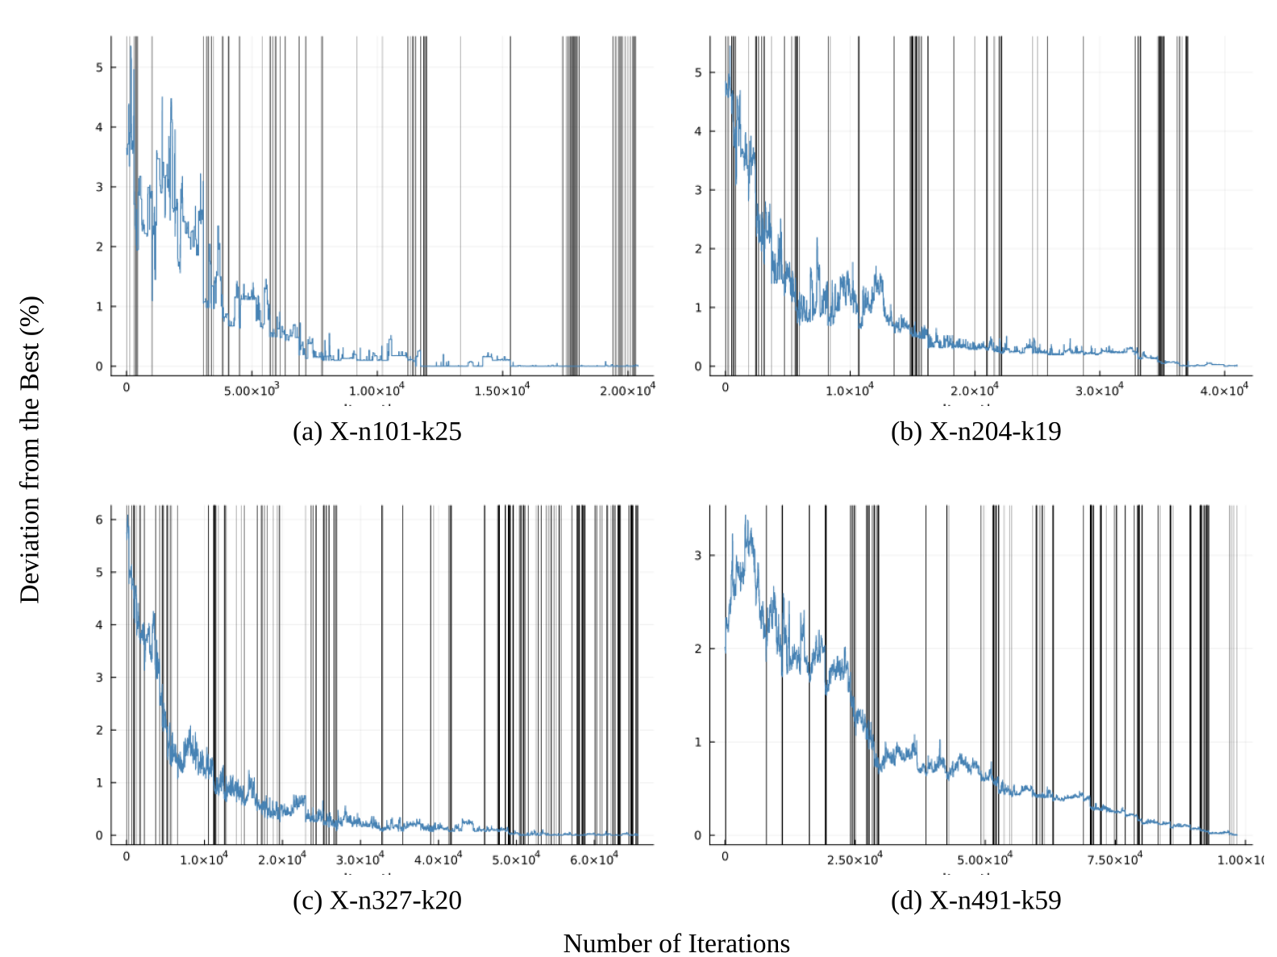
Fig. 3. Illustrative Convergence Plots.

2.2.3 Validation
Before using the ALNS solver to generate ground-truth tour lengths for our 1,080 synthetic environments, we validated its accuracy and consistency against the standard CVRP benchmark library (CVRPLIB). Specifically, we tested the algorithm on 68 benchmark instances from the widely used Uchoa et al. (2017) X-series dataset, spanning problem sizes from $100$ to $490$ customers (X-n101-k25 through X-n491-k59), which directly matches the customer count range ($n∈\left[100,500\right]$) of our synthetic training environments (Table 4). Illustrative convergence profiles of the algorithm across four representative benchmark instances (X-n101-k25, X-n204-k19, X-n327-k20, and X-n491-k59) are shown in Fig. 3.
To evaluate solver stability across different random initializations and stochastic operator choices, each of the 68 benchmark instances was solved $10$ independent times using $10$ fixed seeds of the Mersenne Twister random number generator (1010, 1106, 1509, 1604, 1905, 2104, 2412, 2703, 2710, and 2807), totaling $680$ validation runs. For every run, we computed the percentage gap to the published Best Known Solution (BKS) in CVRPLIB as:
$$\text{Gap (\%)}=\frac{z_{\text{ALNS}}-z_{\text{BKS}}}{z_{\text{BKS}}}×100$$
For each instance, we recorded the minimum, mean, and maximum percentage gap across the $10$ seeds. Table 5 reports the quartile distribution of these minimum, mean, and maximum gaps across all 68 benchmark instances, and Fig. 4 displays the corresponding boxplots. The updated solver achieves a median Min Gap of 1.05% (with first and third quartiles at 0.63% and 1.48%) and a median Mean Gap of 1.57% (interquartile range 1.25% to 2.04%), while even the worst - seed run per instance exhibits a median Max Gap of only 2.07%. These gaps are lower than those reported by Kirubakaran et al. (2026) (median Min, Mean, and Max gaps of $1.7\%$, $2.9\%$, and $4.0\%$), although the two studies use different benchmark sets and computational budgets, so the comparison is indicative only. Validation was performed with $j=200$ and $k=10$; the training data was generated with a lighter budget ($j=100$, $k=5$), so Table 5 represents an upper bound on label quality. Tour lengths are computed with unrounded Euclidean distances, whereas CVRPLIB BKS values use rounded integer distances; the resulting difference is negligible.

Table 4. Summary of Benchmark Datasets Used for Validation.
Dataset Source | Instances (68 Total) | Size (n)
Uchoa et al. (2017) (CVRPLIB) | X-n101-k25, X-n106-k14, X-n110-k13, X-n115-k10, X-n120-k6, X-n125-k30, X-n129-k18, X-n134-k13, X-n139-k10, X-n143-k7, X-n148-k46, X-n153-k22, X-n157-k13, X-n162-k11, X-n167-k10, X-n172-k51, X-n176-k26, X-n181-k23, X-n186-k15, X-n190-k8, X-n195-k51, X-n200-k36, X-n204-k19, X-n209-k16, X-n214-k11, X-n219-k73, X-n223-k34, X-n228-k23, X-n233-k16, X-n237-k14, X-n242-k48, X-n247-k50, X-n251-k28, X-n256-k16, X-n261-k13, X-n266-k58, X-n270-k35, X-n275-k28, X-n280-k17, X-n284-k15, X-n289-k60, X-n294-k50, X-n298-k31, X-n303-k21, X-n308-k13, X-n313-k71, X-n317-k53, X-n322-k28, X-n327-k20, X-n331-k15, X-n336-k84, X-n344-k43, X-n351-k40, X-n359-k29, X-n367-k17, X-n376-k94, X-n384-k52, X-n393-k38, X-n401-k29, X-n411-k19, X-n420-k130, X-n429-k61, X-n439-k37, X-n449-k29, X-n459-k26, X-n469-k138, X-n480-k70, X-n491-k59 | 100-490

Table 5. ALNS Validation - Deviation from the best - Quartiles
Quartile | Gap
 | Min | Mean | Max
Min | 0.03 % | 0.15 % | 0.20 %
1st Quartile | 0.63 % | 1.25 % | 1.60 %
Median | 1.05 % | 1.57 % | 2.07 %
3rd Quartile | 1.48 % | 2.04 % | 2.60 %
Max | 4.25 % | 6.08 % | 7.60 %

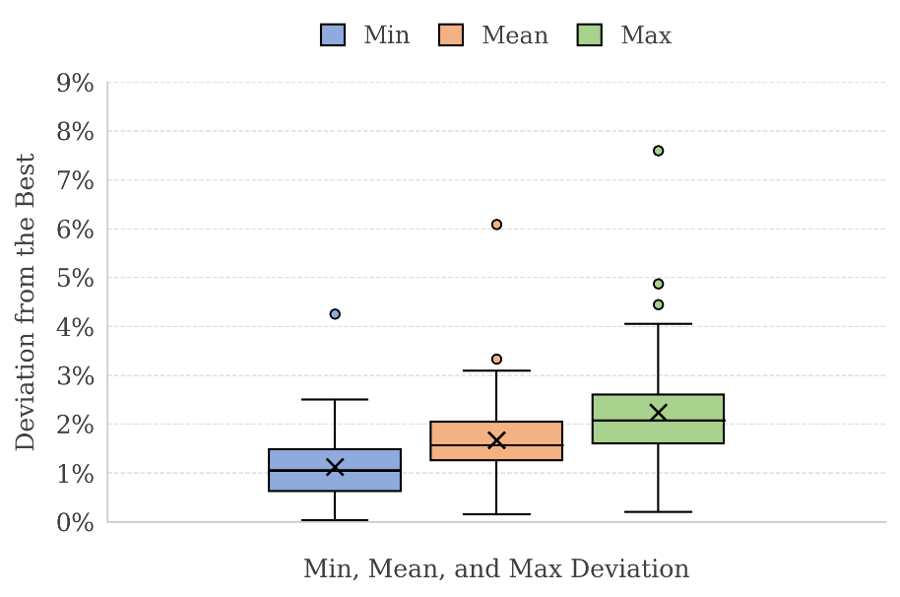
Fig. 4. Box Plot - Deviation from the best

- Work Plan

The work completed this semester, namely generating the 1,080 environments, solving them with ALNS and validating the solver, provides the ground truth needed to learn a tour length model. The next semester will use symbolic regression to convert this dataset into interpretable closed-form CA equations. The stages are described below, and the proposed schedule, with weeks counted from the start of the next semester, is summarized in Table 6.
Feature construction. For each instance, the exogenous descriptors that a planner could realistically obtain at the strategic stage will be computed: the customer count n, the effective service area a (the bounding-box area of the customer coordinates) and density δ = n/a, the nearest-neighbor distance s_{c} of every customer, the unweighted and demand-weighted mean distances from the depot to the customers (ρ_{u} and ρ_{w}), and the first four moments of both the nearest-neighbor distances and the customer demands. Distance-based quantities will be normalized by a characteristic length of the service region and demand-based quantities by the vehicle capacity q_{v}, so that the resulting equations remain dimensionally consistent. Additional dispersion descriptors will be considered if the multi-cluster and Beta patterns turn out to need them.
Model structure. Following the Daganzo (1984) decomposition into a long-haul and a last-mile component, the total tour length will be modeled as l = 2h(X) + k(X) n/√δ, where h(X) is the long-haul term, k(X) is the last-mile coefficient and X denotes the descriptors listed above. The long-haul term will be fixed in a small number of forms, combining either the unweighted or the demand-weighted mean depot distance with either a full-truckload or a partial-truckload estimate of the number of tours, while symbolic regression searches for the structure of k(X). For each form, models of increasing complexity will be explored, starting from a constant coefficient, which reproduces the Daganzo baseline, and gradually admitting the moments of nearest-neighbor distances and demands.
Training and model selection. Symbolic regression will be run on the 1,080 instances using a restricted set of operators (arithmetic, powers and roots) and a penalty on expression size to preserve interpretability, with the Absolute Percentage Error (APE) relative to the ALNS tour length as the main accuracy measure, reported through its mean, quartiles and maximum. Because the checkpoint seeding gives all 36 distribution pairs of a seed an identical region size, depot location, vehicle capacity and customer count, instances from the same seed are strongly related. Training and validation splits will therefore be grouped by seed, so that related instances never appear on both sides of a split.
Out-of-sample testing. The shortlisted equations will be tested on independent benchmark instances drawn from CVRPLIB and other public VRP collections, using the best-known solution of each instance as the reference tour length. Instances within the training range of 100 to 500 customers will be evaluated first, and larger instances will be treated as a separate extrapolation test. Every equation will be compared with the Daganzo baseline using statistical tests on the paired errors, and Pareto-optimal equations will be identified in terms of accuracy and complexity, so that models that merely overfit the synthetic data are discarded.
Interpretation and reporting. The terms retained by symbolic regression will be examined for physical plausibility, and errors will be broken down by spatial pattern, demand pattern and depot position (inside or outside the service region). The outcome will be recommended equations for two information settings: one using only aggregate system information and another using detailed spatial and demand descriptors.
Anticipated challenges. The ground-truth tour lengths come from a metaheuristic and carry a deviation of roughly 1–2% from the best-known solutions (Table 5), which sets a practical floor on achievable accuracy. Equations of higher complexity are likely to fit the training data well but generalize poorly, which the grouped validation and the benchmark tests are designed to detect. Finally, the benchmark libraries contain instances larger than any in the training set, so performance beyond 500 customers will be reported separately rather than assumed.
Table 6. Proposed Timeline for the Remaining Work
Stage / Week | 1 | 2 | 3 | 4 | 5 | 6 | 7 | 8 | 9 | 10 | 11 | 12 | 13 | 14 | 15 | 16
Data preparation and feature construction
Data preparation and feature construction | Activities: Compute descriptors for all 1,080 instances, normalize them, and create seed-grouped training and validation splits Timeline: Weeks 1–3. Deliverable: Feature table and data splits
Model-form specification
Model-form specification | Activities: Fix the long-haul forms and complexity levels, configure the symbolic regression search (operators, size penalty) and run pilot fits on a subset Timeline: Weeks 3–5. Deliverable: Candidate model forms and search configuration
Symbolic regression training
Symbolic regression training | Activities: Fit each model form at every complexity level with grouped cross-validation and record APE statistics Timeline: Weeks 5–9. Deliverable: Candidate closed-form equations
Training-set diagnostics
Training-set diagnostics | Activities: Analyze errors by spatial pattern, demand pattern and depot position; refine search settings and re-fit where required Timeline: Weeks 9–11. Deliverable: Diagnostic summary and shortlisted equations
Benchmark testing
Benchmark testing | Activities: Assemble the benchmark set, compute descriptors, evaluate the equations against best-known solutions, compare with the Daganzo baseline and identify Pareto-optimal models Timeline: Weeks 11–14. Deliverable: Test-set results and selected equations
Interpretation and reporting
Interpretation and reporting | Activities: Interpret the retained terms, finalize the recommended equations and write the final report Timeline: Weeks 14–16. Deliverable: Final report

References
Anand, N., Van Duin, R., Quak, H., Tavasszy, L., 2015. Relevance of city logistics modelling efforts: a review. Transp. Rev. 35, 701–719.
Ansari, S., Başdere, M., Li, X., Ouyang, Y., Smilowitz, K., 2018. Advancements in continuous approximation models for logistics and transportation systems: 1996–2016. Transportation Research Part B: Methodological 107, 229–252.
Beardwood, J., Halton, J.H., Hammersley, J.M., 1959. The shortest path through many points. Mathematical Proceedings of the Cambridge Philosophical Society 55, 299–327.
Braekers, K., Ramaekers, K., Van Nieuwenhuyse, I., 2016. The vehicle routing problem: State of the art classification and review. Comput. Ind. Eng. 99, 300–313.
Capgemini, 2019. Share of total supply costs worldwide in 2018, by type of cost. Capgemini.
Çavdar, B., Sokol, J., 2015. A distribution-free TSP tour length estimation model for random graphs. Eur. J. Oper. Res. 243, 588–598.
Daganzo, C.F., 1984. The distance traveled to visit N points with a maximum of C stops per vehicle: An analytic model and an application. Transportation Science 18, 331–350.
Davis, B.A., Figliozzi, M.A., 2013. A methodology to evaluate the competitiveness of electric delivery trucks. Transp. Res. E Logist. Transp. Rev. 49, 8–23.
Elshaer, R., Awad, H., 2020. A taxonomic review of metaheuristic algorithms for solving the vehicle routing problem and its variants. Comput. Ind. Eng. 140, 106242.
Figliozzi, M.A., 2008. Planning approximations to the average length of vehicle routing problems with varying customer demands and routing constraints. Transportation Research Record: Journal of the Transportation Research Board 2089, 1–8.
Figliozzi, M.A., 2009. Planning approximations to the average length of vehicle routing problems with time window constraints. Transportation Research Part B: Methodological 43, 438–447.
Figliozzi, M.A., 2010. The impacts of congestion on commercial vehicle tour characteristics and costs. Transp. Res. E Logist. Transp. Rev. 46, 496–506.
Franceschetti, A., Jabali, O., Laporte, G., 2017. Continuous approximation models in freight distribution management. TOP 25, 413–433.
Kirubakaran, B., Pahwa, A., Kancharla, S.R., Waller, S.T., 2026. A holistic continuous approximation framework for strategic last-mile distribution planning. Transp. Res. Interdiscip. Perspect. 35, 101720. https://doi.org/10.1016/j.trip.2025.101720
Konstantakopoulos, G.D., Gayialis, S.P., Kechagias, E.P., 2020. Vehicle routing problem and related algorithms for logistics distribution: a literature review and classification. Operational Research 1–30.
Langevin, A., Mbaraga, P., Campbell, J.F., 1996. Continuous approximation models in freight distribution: an overview. Transportation Research Part B: Methodological 30, 163–188.
Merchán, D., Winkenbach, M., 2019. An empirical validation and data-driven extension of continuum approximation approaches for urban route distances. Networks 73, 418–433.
Nicola, D., Vetschera, R., Dragomir, A., 2019. Total distance approximations for routing solutions. Comput. Oper. Res. 102, 67–74.
Ouyang, Y., Daganzo, C.F., 2006. Discretization and validation of the continuum approximation scheme for terminal system design. Transportation Science 40, 89–98.
Pahwa, A., Jaller, M., 2022. A cost-based comparative analysis of different last-mile strategies for e-commerce delivery. Transp. Res. E Logist. Transp. Rev. 164, 102783.
Rifki, O., Garaix, T., 2023. Traveling salesman problem with time slots: Asymptotic analysis and resolution algorithm. arXiv preprint arXiv:2303.13998.
Rifki, O., Garaix, T., Solnon, C., 2021. An asymptotic approximation of the traveling salesman problem with uniform non-overlapping time windows, in: 2021 IEEE 17th International Conference on Automation Science and Engineering (CASE). IEEE, pp. 983–988.
Ropke, S., Pisinger, D., 2006. An adaptive large neighborhood search heuristic for the pickup and delivery problem with time windows. Transportation Science 40, 455–472.
Saberi, M., Verbas, İ.Ö., 2012. Continuous approximation model for the vehicle routing problem for emissions minimization at the strategic level. J. Transp. Eng. 138, 1368–1376.
Turkensteen, M., Klose, A., 2012. Demand dispersion and logistics costs in one-to-many distribution systems. Eur. J. Oper. Res. 223, 499–507.
Uchoa, E., Pecin, D., Pessoa, A., Poggi, M., Vidal, T., Subramanian, A., 2017. New benchmark instances for the capacitated vehicle routing problem. Eur. J. Oper. Res. 257, 845–858.
Universal Postal Union, 2021. Number of parcels distributed worldwide from 2015 to 2020, by sector (in million units). Universal Postal Union.
Varol, T., Özener, O.Ö., Albey, E., 2024. Neural network estimators for optimal tour lengths of traveling salesperson problem instances with arbitrary node distributions. Transportation Science 58, 45–66. https://doi.org/10.1287/trsc.2022.0015
Zhang, H., Ge, H., Yang, J., Tong, Y., 2021. Review of vehicle routing problems: Models, classification and solving algorithms. Archives of Computational Methods in Engineering 1–27.

