Networking Assignment
1. DNS
DNS is like the internet’s phonebook. It converts a domain name, such as deloitte.com, into an IP address that computers use to connect.
The lookup generally follows this path:
Root DNS server → .com TLD server → authoritative DNS server → final IP address
Meaning of the servers
- Root server: Knows where .com DNS servers are located.
- TLD server: The .com server knows which DNS servers manage a particular domain.
- Authoritative server: Stores the actual DNS records for the domain.
- A record: Contains the IPv4 address of the domain.
Cmd to run
task a) dig @8.8.8.8 +trace A hashedin.com
dig DNS lookup tool
@8.8.8.8 Starts the lookup using Google Public DNS
+trace Follows the DNS hierarchy step by step
A Requests the IPv4 address record
hashedin.com Domain being resolved
similarly
dig @8.8.8.8 +trace A deloitte.com
dig @8.8.8.8 +trace A dna.hashedin.com

Root Servers
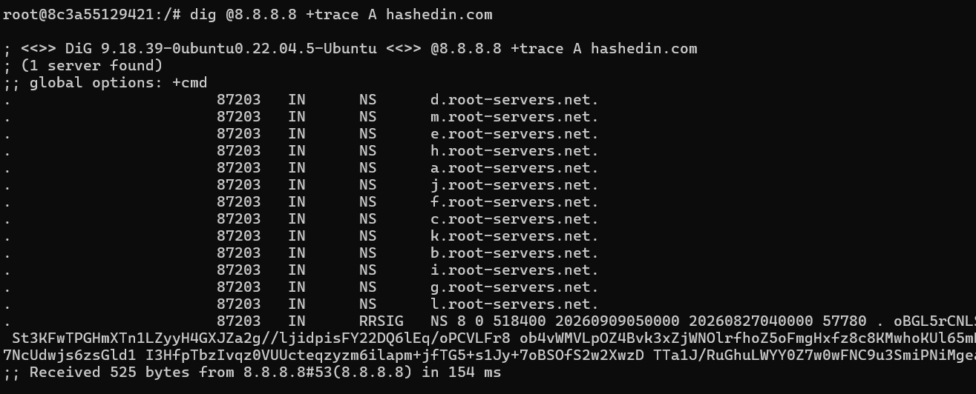
.com TDL Servers
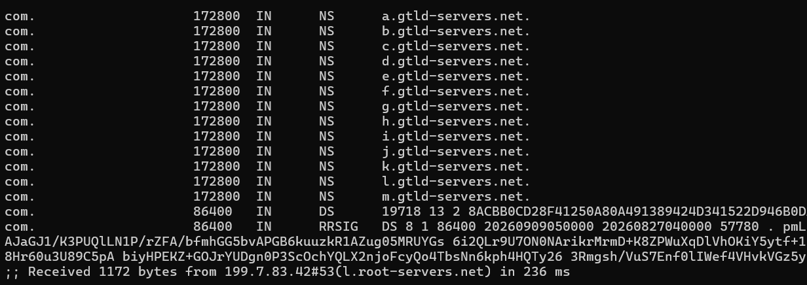

authoritative DNS Server
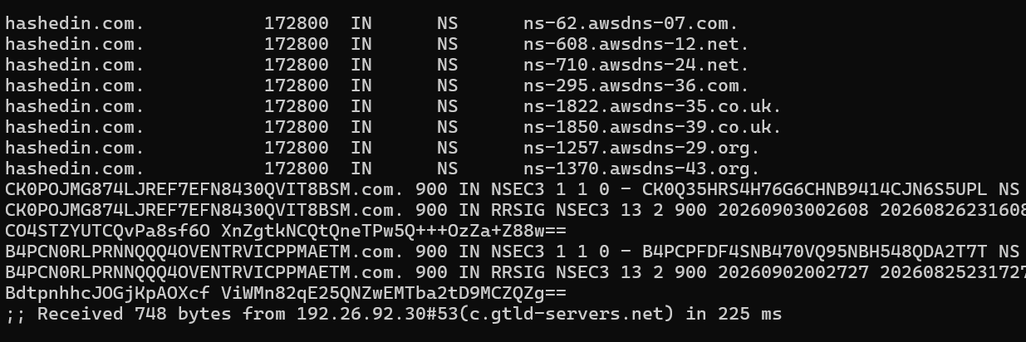
Final IP Address
