Task 1.
a) 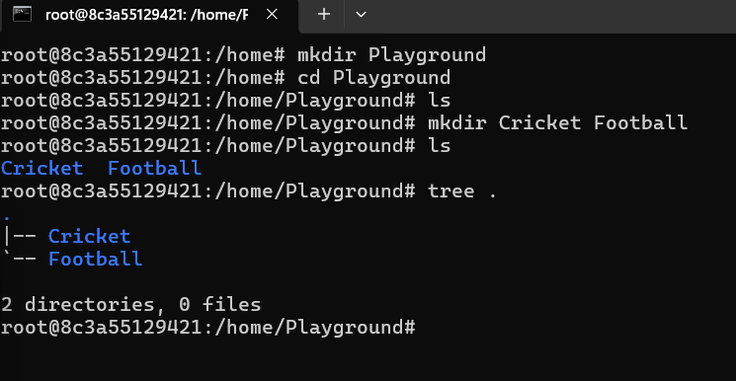
b) 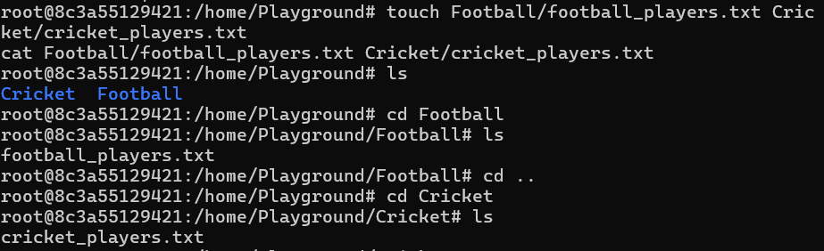
c) 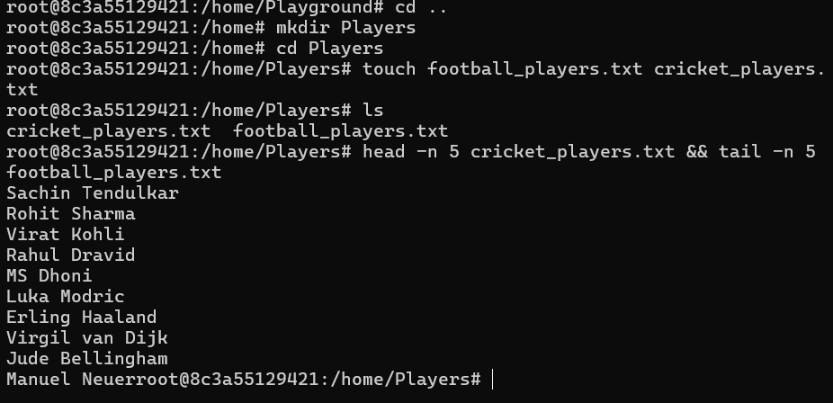
Explanation:
head -n 5 prints the first five lines.
&& means “run the next command only if the first succeeds.”
tail -n 5 prints the last five lines.
d) 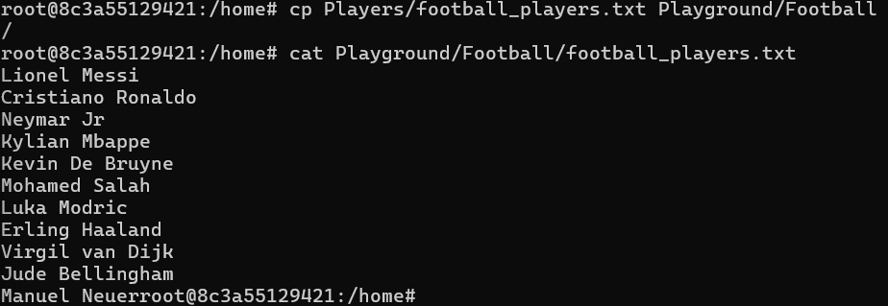
cp means copy
cp filepath destination path
cat-> display file content
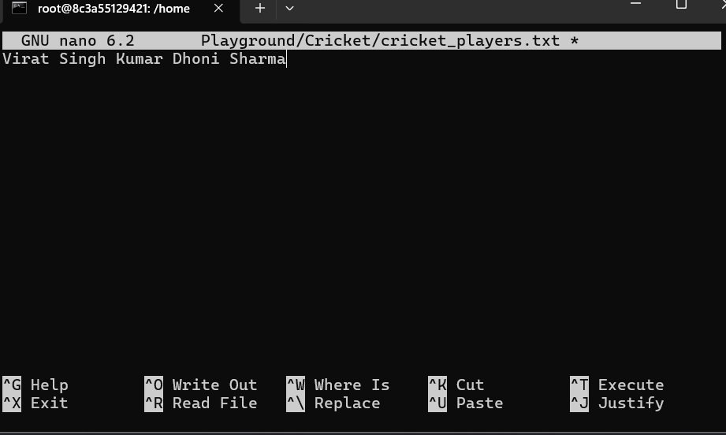
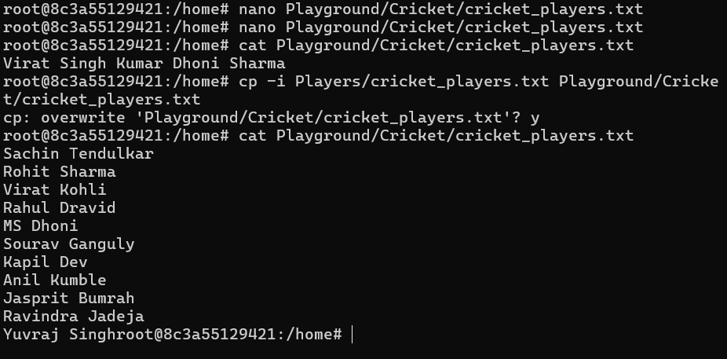
cp copies the file.
-i means interactive
D) 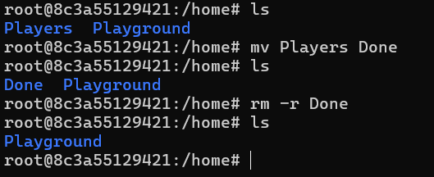
mv Players Done
Renames the directory Players to Done.
rm -r Done
Deletes the Done directory and everything inside it.
The -r means recursive, which is required to delete a directory containing files.
E)
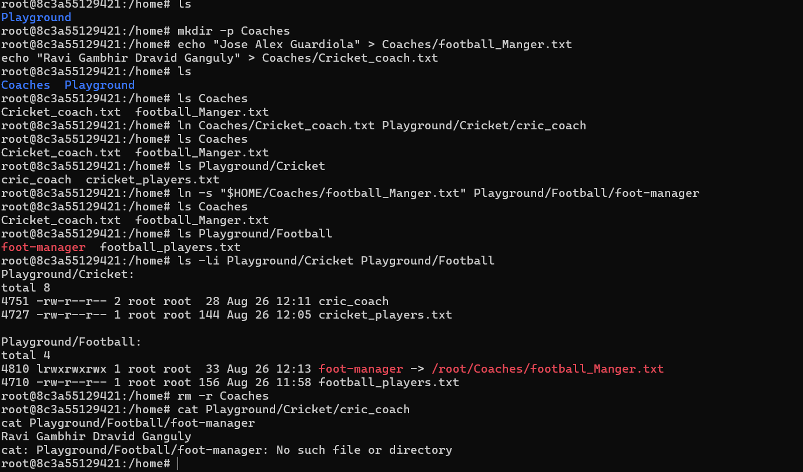
ls -li Playground/Cricket Playground/Football
- -l shows detailed file information.
- -i shows the inode number.
Check both links after deletion
- cat Playground/Cricket/cric_coach
- This will work because a hard link keeps the file data available.
- cat Playground/Football/foot-manager
- This will show an error such as No such file or directory.
- That is expected: the soft link points to a file inside Coaches, and that target was deleted.

Task 2)

