Assignment 1
Build an Amazon S3–to–Amazon SNS Email Alert Pipeline for New Object Uploads using Terraform.
Objective: Provision an Amazon Simple Storage Service (Amazon S3) bucket that triggers an Amazon Simple Notification Service (Amazon SNS) email notification when a file is uploaded to a specific “directory” (key prefix), using least-privilege AWS Identity and Access Management (AWS IAM) and bucket policies.
Tasks:
- Create an S3 bucket using Terraform with baseline security controls enabled (at minimum: block public access; encryption/versioning are encouraged if you document choices).
s3-secure-bucket
main.tf
variables.tf
terraform.tfvars
providers.tf
versions.tf
locals.tf
outputs.tf

terraform fmt -recursive
terraform init
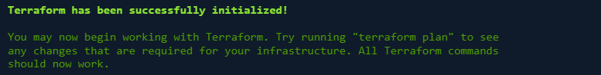 terraform validate
terraform plan -out=tfplan
terraform show tfplan

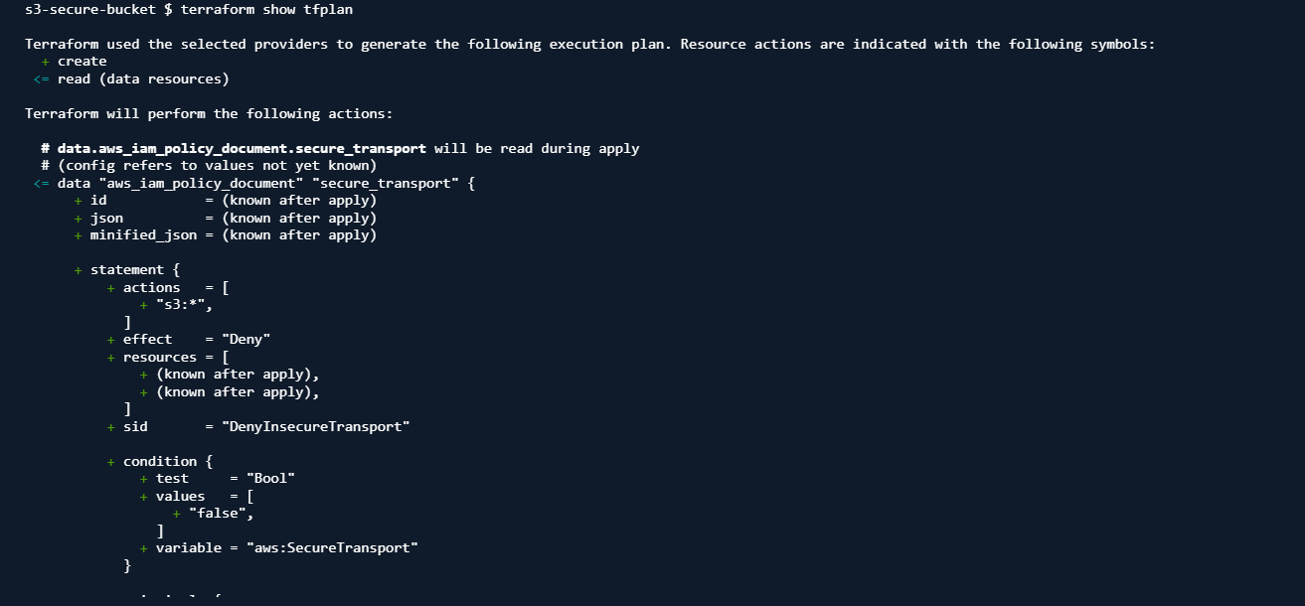
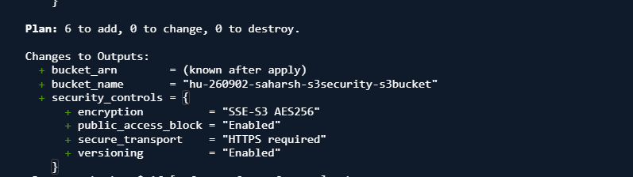
terraform apply tfplan
Apply complete! Resources: 6 added, 0 changed, 0 destroyed.
terraform output
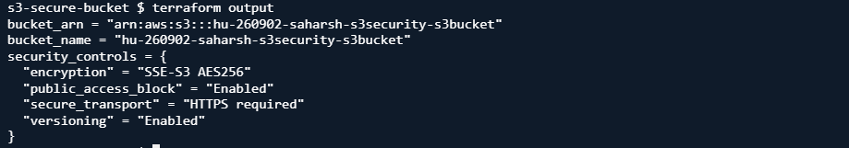
Verification from AWS Console
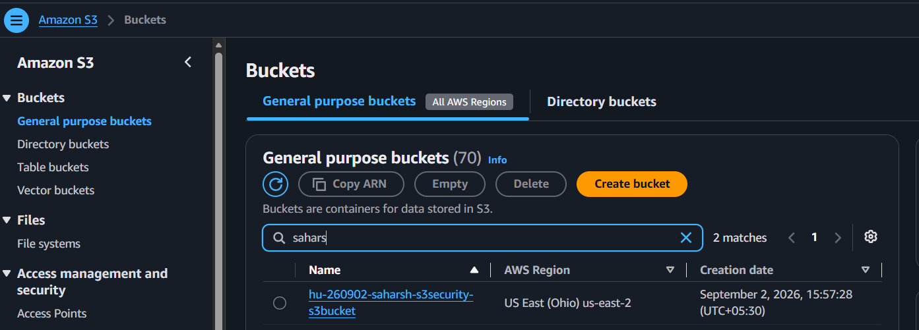
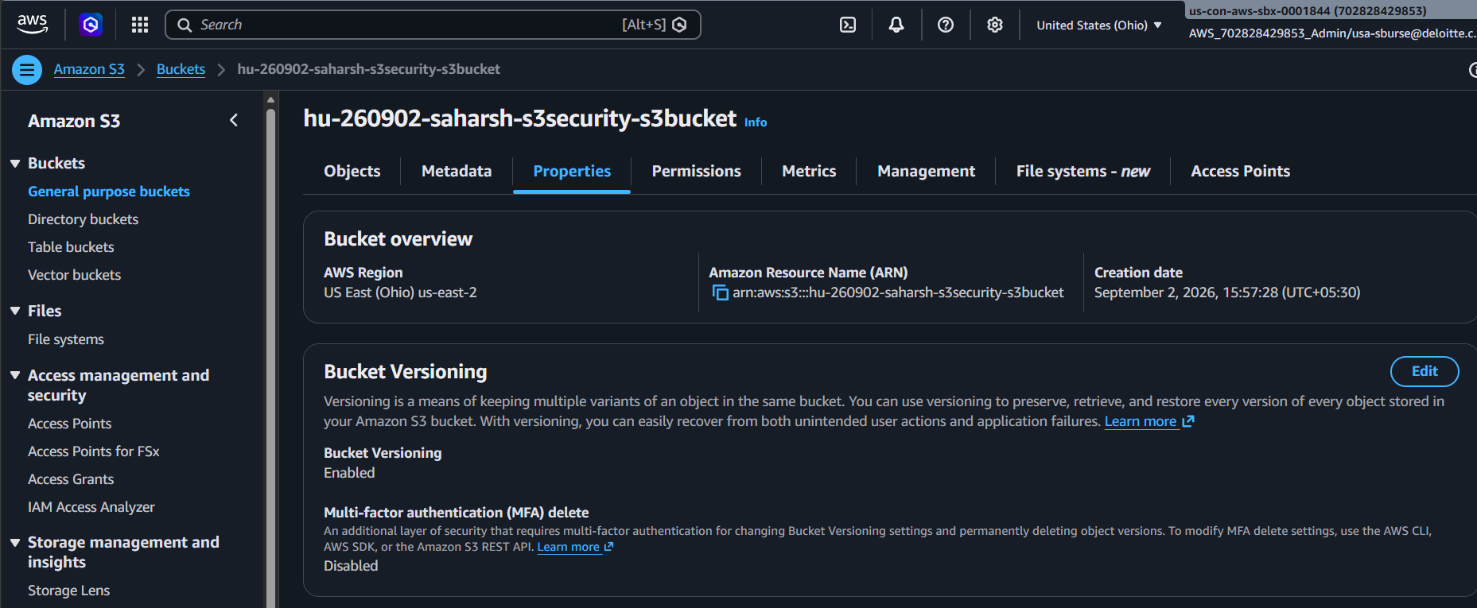
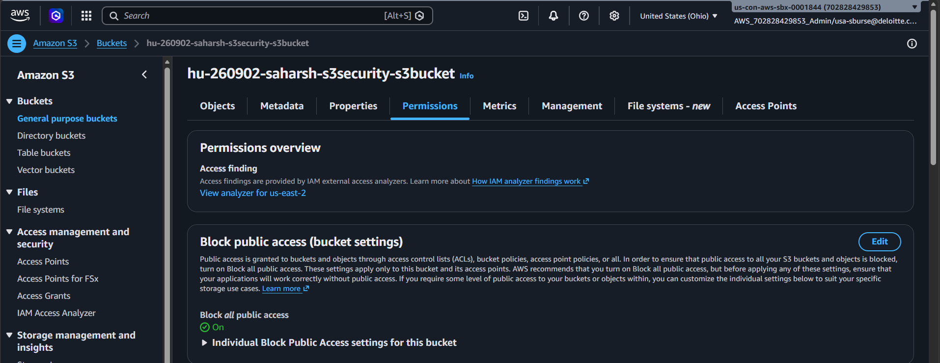
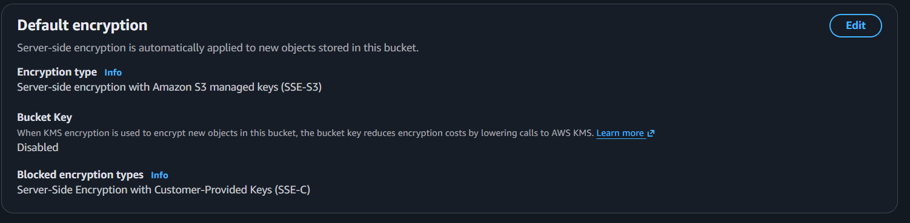

- Create an SNS topic and an email subscription (note: email subscriptions require confirmation by the recipient).

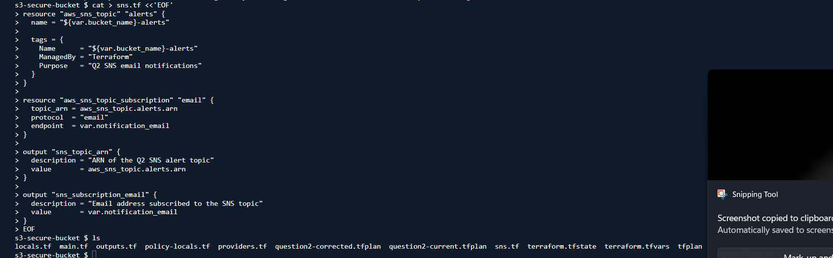
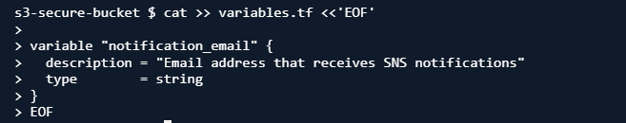
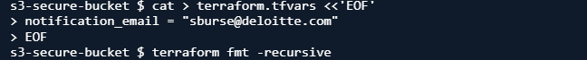

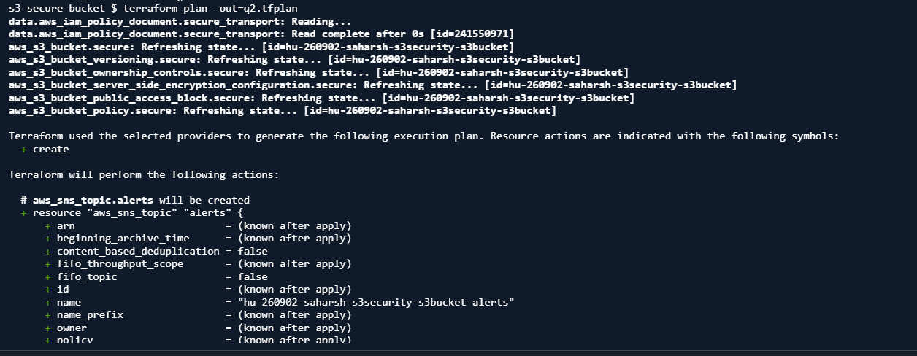
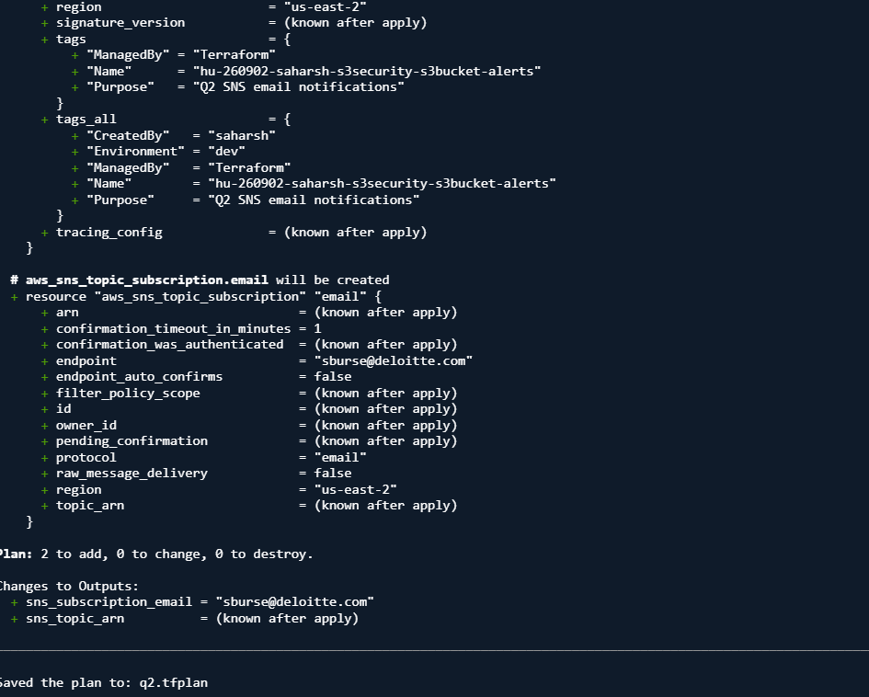

Two Resources
aws_sns_topic.alerts
aws_sns_topic_subscription.email
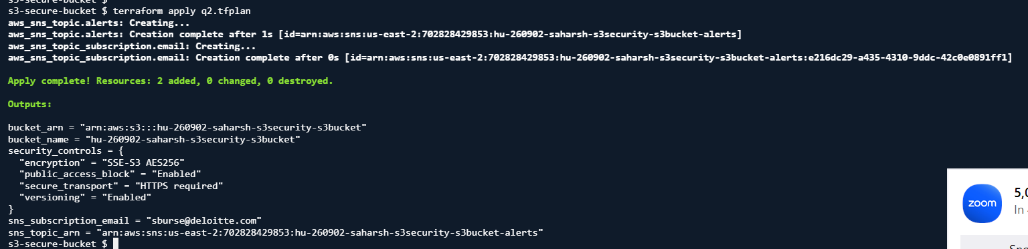
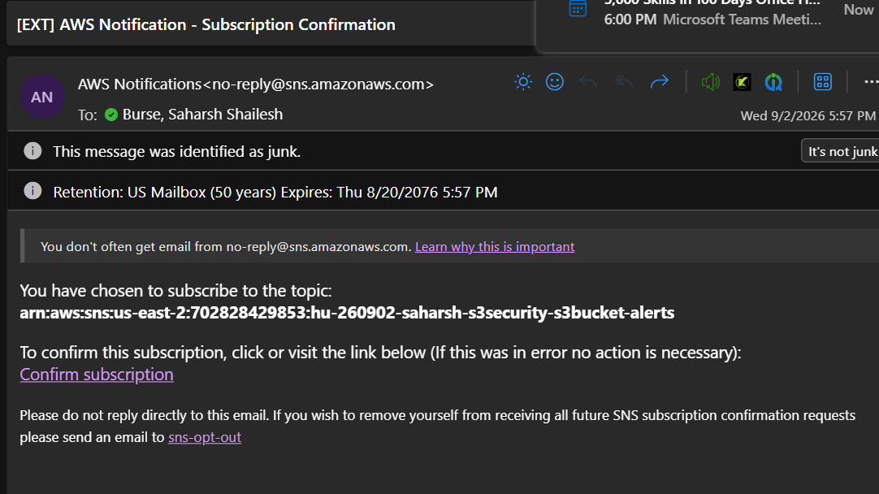

sudo dnf install -y yum-utils shadow-utils

sudo yum-config-manager --add-repo https://rpm.releases.hashicorp.com/AmazonLinux/hashicorp.repo
sudo dnf install -y terraform

