Activate

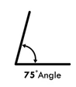

Forward

Reverse

Activate

Reverse

Forward

Activated

Forward

Reverse

Activate

Reverse

Forward