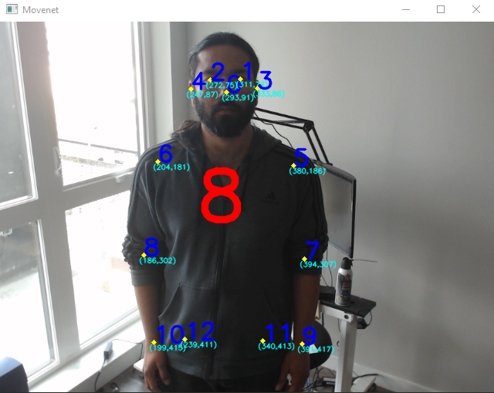

[{"Item1":295,"Item2":91},{"Item1":313,"Item2":74},{"Item1":275,"Item2":75},{"Item1":333,"Item2":86},{"Item1":248,"Item2":88},{"Item1":381,"Item2":185},{"Item1":203,"Item2":180},{"Item1":394,"Item2":305},{"Item1":184,"Item2":301},{"Item1":390,"Item2":416},{"Item1":199,"Item2":413},{"Item1":340,"Item2":412},{"Item1":239,"Item2":410},]

-----------------

[{"Item1":293,"Item2":92},{"Item1":311,"Item2":75},{"Item1":274,"Item2":75},{"Item1":332,"Item2":85},{"Item1":248,"Item2":87},{"Item1":381,"Item2":185},{"Item1":203,"Item2":180},{"Item1":394,"Item2":306},{"Item1":185,"Item2":302},{"Item1":391,"Item2":416},{"Item1":199,"Item2":415},{"Item1":340,"Item2":412},{"Item1":239,"Item2":410},]

-----------------

[{"Item1":293,"Item2":92},{"Item1":311,"Item2":75},{"Item1":274,"Item2":75},{"Item1":332,"Item2":85},{"Item1":248,"Item2":87},{"Item1":381,"Item2":185},{"Item1":203,"Item2":180},{"Item1":394,"Item2":306},{"Item1":185,"Item2":302},{"Item1":391,"Item2":416},{"Item1":199,"Item2":415},{"Item1":340,"Item2":412},{"Item1":239,"Item2":410},]

-----------------

[{"Item1":293,"Item2":91},{"Item1":311,"Item2":74},{"Item1":272,"Item2":75},{"Item1":333,"Item2":86},{"Item1":247,"Item2":87},{"Item1":380,"Item2":186},{"Item1":204,"Item2":181},{"Item1":394,"Item2":307},{"Item1":186,"Item2":302},{"Item1":391,"Item2":417},{"Item1":199,"Item2":415},{"Item1":340,"Item2":413},{"Item1":239,"Item2":411},]

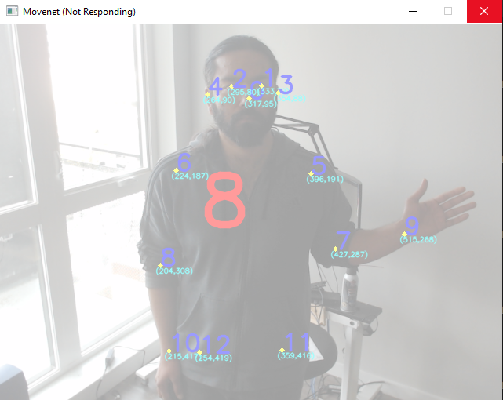

[{"Item1":316,"Item2":96},{"Item1":333,"Item2":79},{"Item1":294,"Item2":80},{"Item1":353,"Item2":87},{"Item1":264,"Item2":90},{"Item1":395,"Item2":190},{"Item1":224,"Item2":188},{"Item1":426,"Item2":287},{"Item1":204,"Item2":307},{"Item1":515,"Item2":268},{"Item1":215,"Item2":417},{"Item1":358,"Item2":415},{"Item1":254,"Item2":418},]

-----------------

[{"Item1":316,"Item2":96},{"Item1":333,"Item2":79},{"Item1":294,"Item2":80},{"Item1":353,"Item2":87},{"Item1":264,"Item2":90},{"Item1":395,"Item2":190},{"Item1":224,"Item2":188},{"Item1":426,"Item2":287},{"Item1":204,"Item2":307},{"Item1":515,"Item2":268},{"Item1":215,"Item2":417},{"Item1":358,"Item2":415},{"Item1":254,"Item2":418},]

-----------------

[{"Item1":316,"Item2":96},{"Item1":333,"Item2":79},{"Item1":294,"Item2":80},{"Item1":354,"Item2":87},{"Item1":264,"Item2":90},{"Item1":395,"Item2":191},{"Item1":225,"Item2":187},{"Item1":427,"Item2":287},{"Item1":204,"Item2":307},{"Item1":515,"Item2":268},{"Item1":215,"Item2":417},{"Item1":358,"Item2":414},{"Item1":254,"Item2":418},]

-----------------

[{"Item1":316,"Item2":96},{"Item1":333,"Item2":79},{"Item1":294,"Item2":80},{"Item1":353,"Item2":88},{"Item1":264,"Item2":90},{"Item1":395,"Item2":191},{"Item1":225,"Item2":187},{"Item1":427,"Item2":287},{"Item1":204,"Item2":308},{"Item1":515,"Item2":268},{"Item1":215,"Item2":417},{"Item1":358,"Item2":415},{"Item1":254,"Item2":418},]

-----------------

[{"Item1":317,"Item2":96},{"Item1":333,"Item2":78},{"Item1":294,"Item2":80},{"Item1":354,"Item2":87},{"Item1":264,"Item2":90},{"Item1":395,"Item2":190},{"Item1":224,"Item2":187},{"Item1":427,"Item2":287},{"Item1":204,"Item2":308},{"Item1":515,"Item2":268},{"Item1":215,"Item2":417},{"Item1":358,"Item2":415},{"Item1":254,"Item2":419},]

-----------------

[{"Item1":317,"Item2":96},{"Item1":333,"Item2":78},{"Item1":294,"Item2":79},{"Item1":354,"Item2":87},{"Item1":264,"Item2":90},{"Item1":395,"Item2":191},{"Item1":225,"Item2":187},{"Item1":427,"Item2":287},{"Item1":205,"Item2":308},{"Item1":515,"Item2":268},{"Item1":215,"Item2":417},{"Item1":359,"Item2":415},{"Item1":254,"Item2":419},]

-----------------

[{"Item1":317,"Item2":95},{"Item1":333,"Item2":79},{"Item1":295,"Item2":80},{"Item1":354,"Item2":88},{"Item1":264,"Item2":90},{"Item1":396,"Item2":191},{"Item1":224,"Item2":187},{"Item1":427,"Item2":287},{"Item1":204,"Item2":308},{"Item1":515,"Item2":268},{"Item1":215,"Item2":417},{"Item1":359,"Item2":416},{"Item1":254,"Item2":419},]

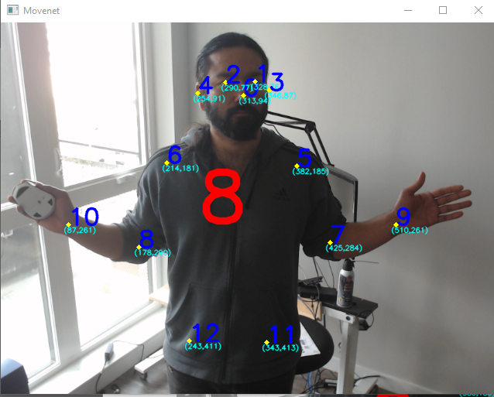

[{"Item1":315,"Item2":94},{"Item1":330,"Item2":77},{"Item1":292,"Item2":78},{"Item1":345,"Item2":87},{"Item1":255,"Item2":91},{"Item1":382,"Item2":184},{"Item1":214,"Item2":181},{"Item1":423,"Item2":285},{"Item1":178,"Item2":290},{"Item1":508,"Item2":253},{"Item1":87,"Item2":261},{"Item1":343,"Item2":413},{"Item1":244,"Item2":411},]

-----------------

[{"Item1":315,"Item2":94},{"Item1":329,"Item2":77},{"Item1":291,"Item2":78},{"Item1":346,"Item2":87},{"Item1":255,"Item2":91**},{"Item1":382,"Item2":184}**,{"Item1":214,"Item2":181},{**"Item1":424,"Item2":285},{"**Item1":178,"Item2":290**},{"Item1":508,"Item2":254},{**"Item1":88,"Item2":262},{"Item1":344,"Item2":413},{"Item1":244,"Item2":410},]

-----------------

[{"Item1":315,"Item2":94},{"Item1":329,"Item2":77},{"Item1":291,"Item2":78},{"Item1":346,"Item2":87},{"Item1":255,"Item2":91},{"Item1":382,"Item2":184},{"Item1":214,"Item2":181},{"Item1":424,"Item2":285},{"Item1":178,"Item2":290},{"Item1":508,"Item2":254},{"Item1":88,"Item2":262},{"Item1":344,"Item2":413},{"Item1":244,"Item2":410},]

-----------------

[{"Item1":314,"Item2":94},{"Item1":329,"Item2":76},{"Item1":291,"Item2":77},{"Item1":346,"Item2":87},{"Item1":254,"Item2":91},{"Item1":382,"Item2":185},{"Item1":214,"Item2":182},{"Item1":426,"Item2":285},{"Item1":178,"Item2":290},{"Item1":511,"Item2":258},{"Item1":87,"Item2":262},{"Item1":343,"Item2":413},{"Item1":243,"Item2":411},]

-----------------

[{"Item1":314,"Item2":94},{"Item1":329,"Item2":77},{"Item1":290,"Item2":77},{"Item1":346,"Item2":86},{"Item1":254,"Item2":91},{"Item1":382,"Item2":185},{"Item1":214,"Item2":181},{"Item1":425,"Item2":285},{"Item1":178,"Item2":291},{"Item1":510,"Item2":259},{"Item1":88,"Item2":262},{"Item1":343,"Item2":413},{"Item1":243,"Item2":411},]

-----------------

[{"Item1":313,"Item2":94},{"Item1":328,"Item2":76},{"Item1":290,"Item2":77},{"Item1":346,"Item2":87},{"Item1":254,"Item2":91},{"Item1":382,"Item2":185},{"Item1":214,"Item2":181},{"Item1":425,"Item2":284},{"Item1":178,"Item2":290},{"Item1":510,"Item2":261},{"Item1":87,"Item2":261},{"Item1":343,"Item2":413},{"Item1":243,"Item2":411},]

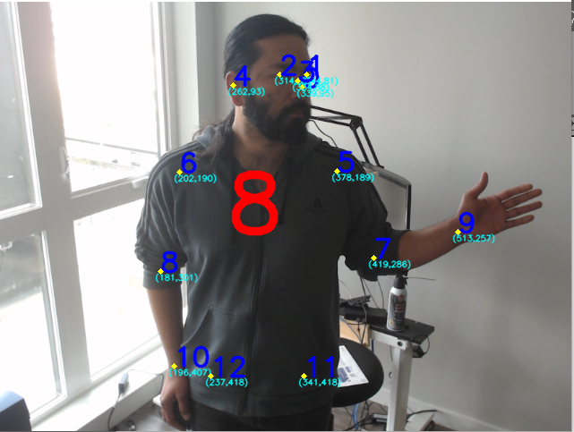

[{"Item1":337,"Item2":95},{"Item1":342,"Item2":81},{"Item1":312,"Item2":81},{"Item1":333,"Item2":88},{"Item1":261,"Item2":93},{"Item1":377,"Item2":188},{"Item1":202,"Item2":190},{"Item1":419,"Item2":286},{"Item1":181,"Item2":301},{"Item1":513,"Item2":257},{"Item1":195,"Item2":407},{"Item1":342,"Item2":418},{"Item1":237,"Item2":418},]

-----------------

[{"Item1":337,"Item2":95},{"Item1":342,"Item2":80},{"Item1":312,"Item2":81},{"Item1":332,"Item2":87},{"Item1":261,"Item2":93},{"Item1":378,"Item2":188},{"Item1":202,"Item2":190},{"Item1":418,"Item2":286},{"Item1":181,"Item2":301},{"Item1":512,"Item2":257},{"Item1":195,"Item2":407},{"Item1":342,"Item2":417},{"Item1":238,"Item2":416},]

-----------------

[{"Item1":338,"Item2":95},{"Item1":342,"Item2":81},{"Item1":312,"Item2":81},{"Item1":333,"Item2":88},{"Item1":261,"Item2":93},{"Item1":378,"Item2":188},{"Item1":202,"Item2":190},{"Item1":419,"Item2":286},{"Item1":181,"Item2":301},{"Item1":512,"Item2":257},{"Item1":195,"Item2":407},{"Item1":341,"Item2":418},{"Item1":238,"Item2":418},]

-----------------

[{"Item1":338,"Item2":95},{"Item1":342,"Item2":80},{"Item1":312,"Item2":81},{"Item1":332,"Item2":88},{"Item1":261,"Item2":93},{"Item1":377,"Item2":188},{"Item1":201,"Item2":190},{"Item1":419,"Item2":286},{"Item1":181,"Item2":301},{"Item1":513,"Item2":257},{"Item1":195,"Item2":407},{"Item1":341,"Item2":418},{"Item1":238,"Item2":416},]

-----------------

[{"Item1":339,"Item2":95},{"Item1":344,"Item2":81},{"Item1":313,"Item2":81},{"Item1":334,"Item2":88},{"Item1":263,"Item2":94},{"Item1":378,"Item2":188},{"Item1":202,"Item2":190},{"Item1":419,"Item2":286},{"Item1":181,"Item2":301},{"Item1":513,"Item2":257},{"Item1":195,"Item2":407},{"Item1":341,"Item2":417},{"Item1":238,"Item2":415},]

-----------------

[{"Item1":339,"Item2":95},{"Item1":344,"Item2":81},{"Item1":314,"Item2":81},{"Item1":334,"Item2":88},{"Item1":262,"Item2":93},{"Item1":378,"Item2":189},{"Item1":202,"Item2":190},{"Item1":419,"Item2":286},{"Item1":181,"Item2":301},{"Item1":513,"Item2":257},{"Item1":196,"Item2":407},{"Item1":341,"Item2":418},{"Item1":237,"Item2":418},]

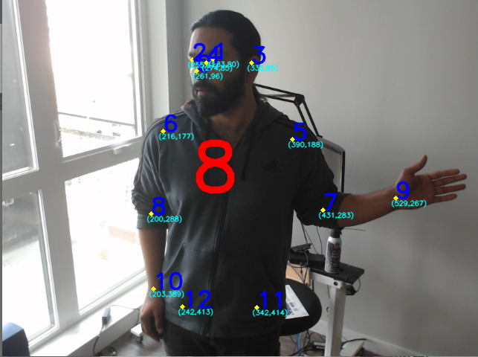

[{"Item1":265,"Item2":95},{"Item1":286,"Item2":80},{"Item1":258,"Item2":82},{"Item1":337,"Item2":85},{"Item1":274,"Item2":85},{"Item1":391,"Item2":188},{"Item1":218,"Item2":177},{"Item1":431,"Item2":282},{"Item1":199,"Item2":287},{"Item1":528,"Item2":269},{"Item1":204,"Item2":387},{"Item1":343,"Item2":413},{"Item1":244,"Item2":411},]

-----------------

[{"Item1":264,"Item2":95},{"Item1":285,"Item2":80},{"Item1":257,"Item2":82},{"Item1":336,"Item2":85},{"Item1":275,"Item2":85},{"Item1":391,"Item2":189},{"Item1":218,"Item2":177},{"Item1":431,"Item2":283},{"Item1":199,"Item2":286},{"Item1":529,"Item2":268},{"Item1":204,"Item2":387},{"Item1":344,"Item2":412},{"Item1":244,"Item2":408},]

-----------------

[{"Item1":263,"Item2":95},{"Item1":285,"Item2":80},{"Item1":257,"Item2":82},{"Item1":336,"Item2":85},{"Item1":274,"Item2":85},{"Item1":391,"Item2":188},{"Item1":218,"Item2":177},{"Item1":432,"Item2":283},{"Item1":199,"Item2":287},{"Item1":529,"Item2":268},{"Item1":204,"Item2":387},{"Item1":342,"Item2":413},{"Item1":243,"Item2":412},]

-----------------

[{"Item1":263,"Item2":96},{"Item1":284,"Item2":80},{"Item1":256,"Item2":81},{"Item1":336,"Item2":85},{"Item1":274,"Item2":85},{"Item1":390,"Item2":188},{"Item1":218,"Item2":177},{"Item1":431,"Item2":283},{"Item1":199,"Item2":287},{"Item1":529,"Item2":268},{"Item1":204,"Item2":388},{"Item1":342,"Item2":413},{"Item1":243,"Item2":412},]

-----------------

[{"Item1":261,"Item2":96},{"Item1":283,"Item2":80},{"Item1":255,"Item2":81},{"Item1":335,"Item2":85},{"Item1":274,"Item2":85},{"Item1":390,"Item2":188},{"Item1":217,"Item2":177},{"Item1":431,"Item2":283},{"Item1":200,"Item2":287},{"Item1":529,"Item2":268},{"Item1":204,"Item2":388},{"Item1":342,"Item2":414},{"Item1":242,"Item2":413},]

-----------------

[{"Item1":261,"Item2":96},{"Item1":283,"Item2":80},{"Item1":255,"Item2":81},{"Item1":335,"Item2":85},{"Item1":274,"Item2":85},{"Item1":390,"Item2":188},{"Item1":216,"Item2":177},{"Item1":431,"Item2":283},{"Item1":200,"Item2":288},{"Item1":529,"Item2":267},{"Item1":203,"Item2":389},{"Item1":342,"Item2":414},{"Item1":242,"Item2":413},]