Lab 6: Code and Branch Coverage Analysis
SRN: PES2UG24CS618
Module under test: course_registration.py
Tools: Python, pytest, coverage

1. Objective
Measure how much of course_registration.py is exercised by tests, and add test cases until both line (code) coverage and branch coverage reach at least 90%. The module has three functions:
Function | What it does
can_register | Checks student status, course credits, prerequisites and credit limit
waitlist_position | Returns 0 if a seat is free, a waitlist position, or -1 if the waitlist is full
late_fee | Calculates a late registration fee with a waiver, a heavy-load surcharge and a 2000 cap

2. Baseline
The starter file test_course_registration.py had only 2 tests, giving 38% line coverage and 32% branch coverage. Lines 6, 8, 10, 12, 18, 21–23 and 27–39 were never run, so the error cases, the waitlist logic and the entire late_fee function were untested.

3. Code Coverage
Test file: CodeCoverageTest_PES2UG24CS618_application.py (13 tests)
One test was written for every return and raise statement, so that each line runs at least once: invalid status, invalid credits, missing prerequisites, credit limit exceeded, invalid capacity, full waitlist, waiver, and the fee cap.
Result: 13 passed, 100% line coverage (32/32 statements).
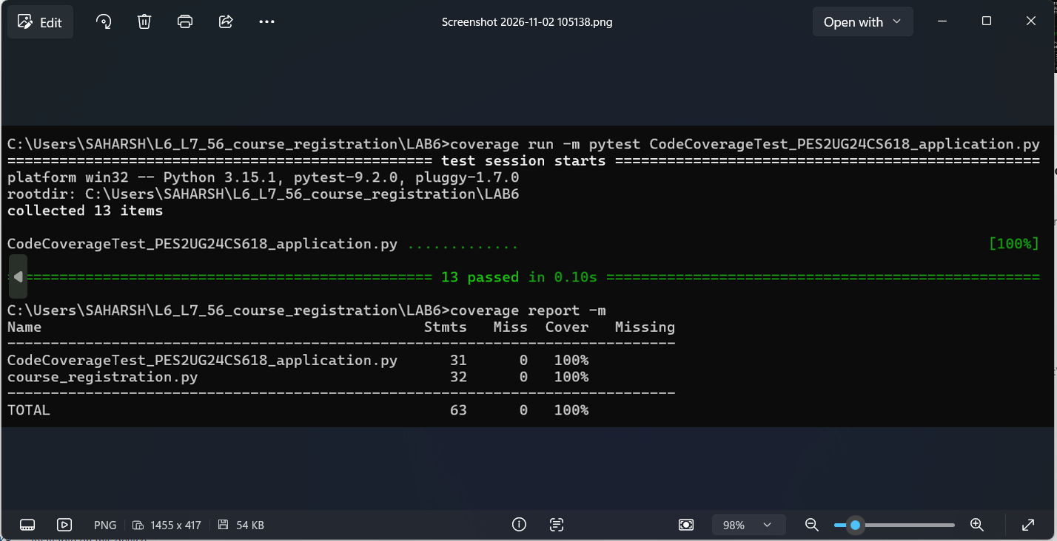
Figure 1: Code (line) coverage report

4. Branch Coverage
Test file: BranchCoverageTest_PES2UG24CS618_application.py (25 tests)
Tests were added so that every if condition is checked as both True and False, with extra attention to boundary values:
- Credits exactly at the limit (24 + 4 = 28 for honors) is still allowed
- Zero and negative course credits / capacity both raise errors
- A class that is exactly full goes to the waitlist; waitlist length 9 gets the last slot, 10 is full
- Exactly 7 days late is charged the flat 500
- Over 7 days, with and without the heavy-load surcharge
- A fee of exactly 2000 is not changed, while 2800 is capped to 2000
- Zero and negative days_late both give no fee

Result: 25 passed, 100% branch coverage (24/24 branches, 0 partial).
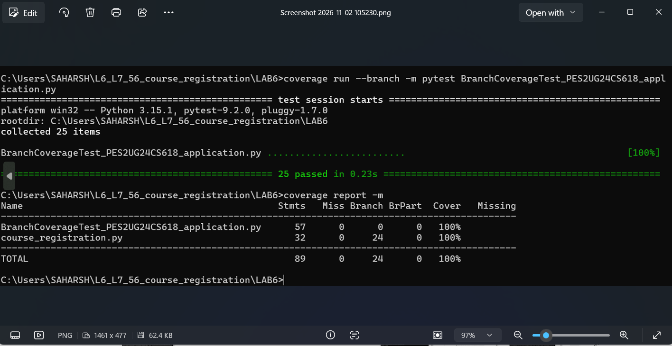
Figure 2: Branch coverage report

5. Summary
Test file | Tests | Line coverage | Branch coverage
Starter tests | 2 | 38% | 32%
Code coverage tests | 13 | 100% | 100%
Branch coverage tests | 25 | 100% | 100%

6. Observations
- In this module, covering every line also covered every branch, because each if either returns early or has an else. That is not always true: in the handout's calculate_discount example, one test reaches 100% line coverage but leaves branches untested.
- 100% branch coverage does not guarantee the code is correct. The branch tests add boundary cases (<= vs <, values exactly at limits), which is where off-by-one bugs usually hide.

