Digital Forensics and Incident Responses
Activity 2
B A Saharsh
PES1UG23CS130
6TH Sem C
Task 1:
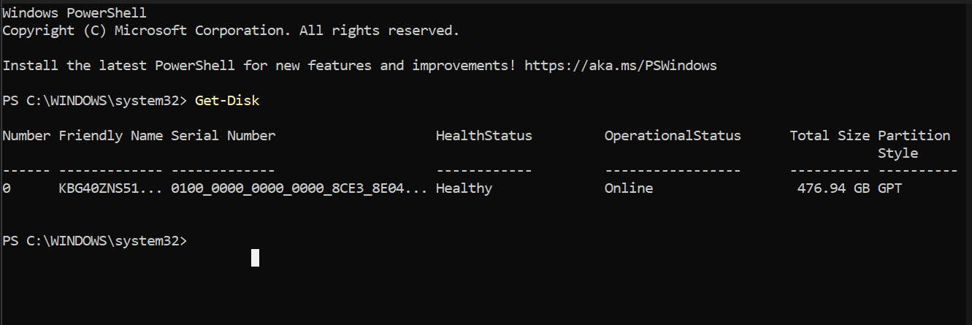
The disk size is 476.94 GB and Partition Style is GPT.
Task 2:
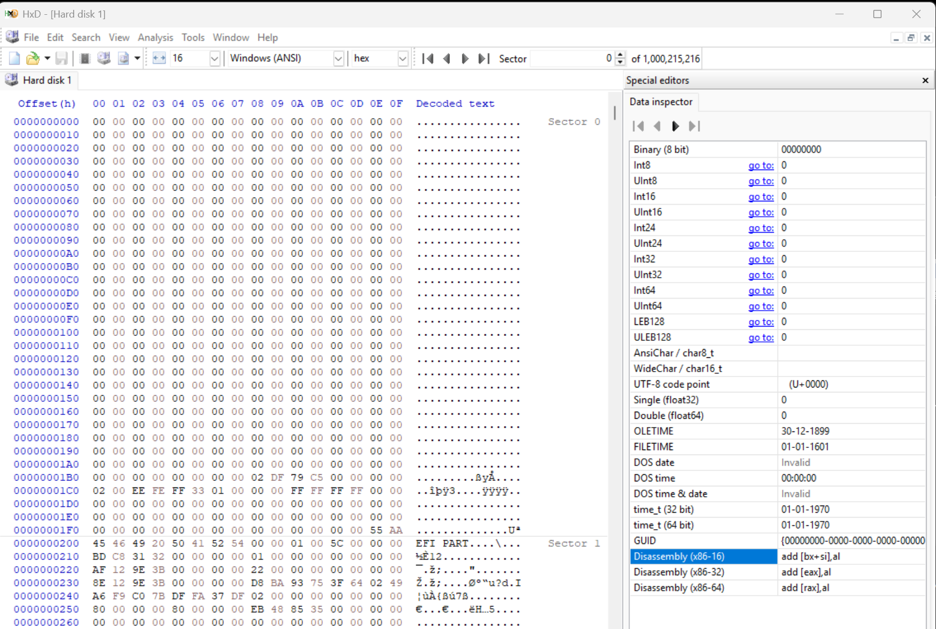
The Protective MBR (Sector 0), Partition type is EE. The GPT header signature in sector on is EFI PART. These two verify that the Disk is GPT.
Task 3:
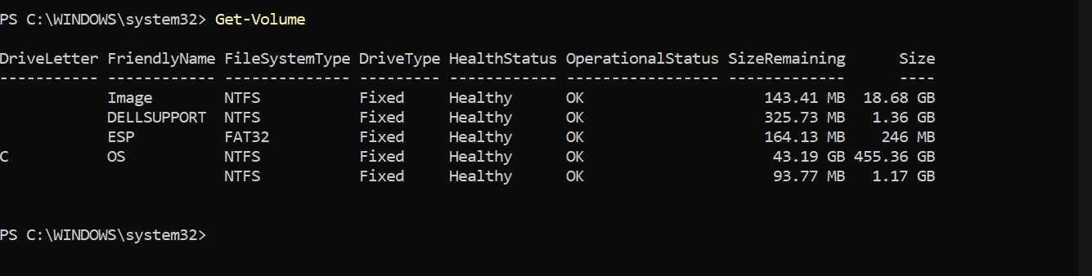
The C (Letter) Drive is of the file system NTFS. Its volume size is 455.36 GB.
Task 4:
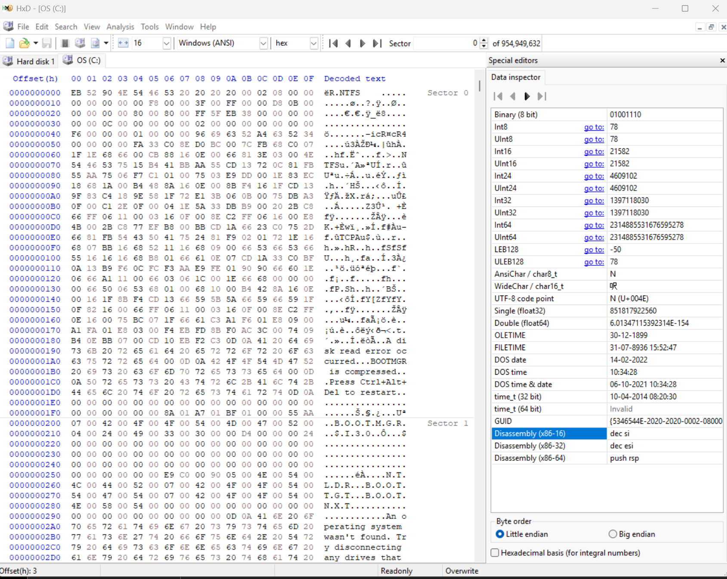
At the bottom of sector 0, at offset 000001FE, we can see the values 55 AA, which confirms valid NTFS boot sector.
The File System is NTFS since we can see the offer 0x00000003, which contains the hex value 4E 54 46 53, which is decoded into NTFS.
At offset 0x0B, row 00000000 and column 0B and 0C, we can see the hex values 00 02.
Since NTFS follows little endian, we reverse it to get 02 00 which when converted to decimal is 512 bytes. Hence Bytes per Sector is 512.
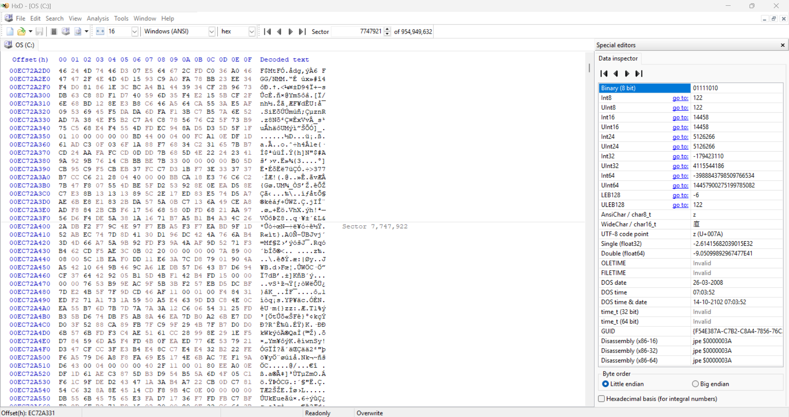
Located a MTF at offset, 0x00EC72A331.
Task 5:
There are no deleted files, hence could not locate any.
1. Explain the structure and forensic importance of the Master Boot Record (MBR).
Ans: The Master Boot Record (MBR) is in the first sector of a storage device and is 512 bytes in size. It consists of three main components: 446 bytes of bootloader code, a 64-byte partition table containing four 16-byte partition entries, and a 2-byte boot signature (55 AA) that validates the MBR. The MBR plays a critical role in the boot process by directing the system to the active partition. From a forensic perspective, the MBR is important because it reveals how a disk is partitioned and can expose hidden or manipulated partitions. It may also contain malicious bootloader code such as bootkits or rootkits. Since it defines the disk structure, examining the MBR helps investigators detect tampering, recover lost partitions, and understand how data is organized on the disk.
2. What is the purpose of the Protective MBR in GPT disks?
Ans: In GPT-partitioned disks, a Protective MBR is stored at LBA 0 to maintain compatibility with older systems that only understand MBR partitioning. Instead of containing standard partition entries, it includes a single partition entry with type 0xEE that spans the entire disk. This prevents legacy tools from misinterpreting the disk as unpartitioned and accidentally overwriting GPT structures. From a forensic standpoint, the Protective MBR helps investigators identify that the disk uses GPT and ensures that partition information is not mistakenly altered by outdated software. It acts as a safeguard while preserving backward compatibility.
3. Differentiate between MBR and GPT from a digital forensic perspective.
Ans: MBR and GPT differ significantly in structure and reliability, which affects forensic analysis. MBR supports only four primary partitions and disks up to 2 TB in size, whereas GPT supports up to 128 partitions by default and very large disk sizes. MBR stores its partition table only at the beginning of the disk, making it vulnerable to corruption, while GPT maintains both a primary and a backup partition table at the end of the disk for redundancy. GPT also uses CRC32 checksums to ensure data integrity. From a forensic perspective, GPT is more robust and recoverable due to its backup and integrity mechanisms, whereas MBR is easier to manipulate or damage. GPT also stores partition names, which can provide useful contextual evidence during investigations.
4. Explain how Logical Block Addressing (LBA) helps in partition analysis.
Ans: Logical Block Addressing (LBA) is a method of addressing disk sectors using sequential numbers rather than physical geometry such as cylinders and heads. Each sector on the disk is assigned a unique LBA number, allowing precise identification of data locations. In forensic investigations, LBA simplifies partition analysis by enabling examiners to calculate exact offsets and boundaries of partitions. It allows investigators to manually navigate disk images using hex editors, identify partition start and end points, and recover hidden or deleted partitions. LBA provides a standardized and systematic approach to analyzing disk structures, making forensic examinations more accurate and efficient.
5. How do SSD technologies such as TRIM and Garbage Collection affect forensic investigations?
Ans: SSD technologies such as TRIM and Garbage Collection significantly impact digital forensic investigations. When a file is deleted on an SSD, the operating system may issue a TRIM command that informs the drive that certain blocks are no longer in use. The SSD can then immediately erase or mark those blocks as available for reuse. Garbage Collection further reorganizes and cleans unused blocks in the background to optimize performance. Unlike traditional hard drives, where deleted data often remains recoverable until overwritten, SSDs may permanently erase deleted data quickly. This reduces the likelihood of recovering deleted files and makes forensic acquisition more time-sensitive. As a result, SSD forensics is more challenging compared to HDD investigations.
6. (From FAT) How does the FAT file system indicate a deleted file, and why is this important in digital forensics?
Ans: In the FAT file system (such as FAT12, FAT16, or FAT32), when a file is deleted, the first character of the filename in the directory entry is replaced with the hexadecimal value E5, and the corresponding FAT table entries are marked as free. However, the actual file data typically remains on the disk until it is overwritten by new data. This behavior is important in digital forensics because it allows investigators to recover deleted files and reconstruct filenames. Since deletion only removes the reference to the file rather than erasing its content immediately, forensic tools can analyze the remaining data to retrieve valuable evidence.
7. (From NTFS) What is the role of the Master File Table (MFT) in NTFS?
Ans: In NTFS, the Master File Table (MFT) is the central metadata structure that stores information about every file and directory on the volume. Each file is represented by a record in the MFT, typically 1024 bytes in size, containing details such as the file name, timestamps, file size, attributes, and the location of file data on disk. Even when a file is deleted, its MFT record may remain until overwritten, with flags indicating its deletion status. From a forensic perspective, the MFT is one of the most important sources of evidence because it helps investigators reconstruct file activity, recover deleted files, and build accurate timelines of user actions.

