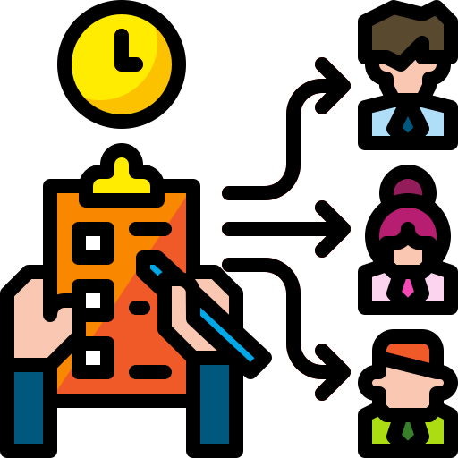
USER GUIDE
Cadre Management System
Workforce Management – Cadre Planning & Workforce Monitoring
Document details
System name | Cadre Management System (Workforce Management – Cadre Planning & Workforce Monitoring)
Company name | Guston Group
Document version | 1.0 (describes system version 1.4.2)
Prepared date | 13 October 2026
Prepared by | Concord IT Team
Confidential – for authorised users of the system only. The screenshots in this guide use sample data.
Contents
1. Introduction 3
1.1 What the system does 3
1.2 Purpose of this guide 3
1.3 Who should use the system 3
1.4 Main benefits 4
1.5 Key terms 4
2. Accessing the System 6
2.1 System address (URL) 6
2.2 Account requirements 6
2.3 Registering for an account 6
2.4 Logging in 7
2.5 First login after a password reset 9
2.6 Basic navigation 9
2.7 Logging out 11
3. Main Features and Step-by-Step Instructions 12
3.1 Dashboard 12
3.2 Week Master 15
3.2.1 Viewing the weeks of a month 15
3.2.2 Setting up the weeks for a new month 16
3.3 Daily Data Entry 19
3.3.1 The page at a glance 19
3.3.2 Understanding the Cadre / Recruitment Details form 19
3.3.3 Adding a daily record 21
3.3.4 Recording resigned or terminated employees 24
3.3.5 Recording transfers 25
3.3.6 Training Center and Transfer to Production Line 26
3.3.7 The Daily Data Records table 26
3.3.8 Viewing, deleting or rejoining resigned employees 28
3.3.9 Editing a record 29
3.3.10 Deleting a record 29
3.3.11 Downloading to Excel 29
3.3.12 Unlinked Employees (Administrators and SuperUsers) 29
3.4 Weekly Data View 30
3.5 Employees 31
3.6 Administration 34
3.6.1 Users (Administrators only) 34
3.6.2 Factory Master 36
3.6.3 Department Master 37
3.6.4 Section Master and 3.6.5 Designation Master 38
3.6.6 Service Range 39
3.6.7 Budget Master 40
3.6.8 Resignation Reasons 43
3.7 Messages and troubleshooting 43
4. User Responsibilities and Security 45
4.1 Data accuracy 45
4.2 Access permissions 45
4.3 Password security 45
4.4 Appropriate system usage 46
4.5 Reporting a problem or security concern 46
Appendices 47
Appendix A – Roles and permissions at a glance 47
Appendix B – Document history 47

1. Introduction

1.1 What the system does
The Cadre Management System (shown on screen as Workforce Management – Cadre Planning & Workforce Monitoring) is a web-based system used to plan, record and monitor the factory workforce – the “cadre” of Machine Operators (MO) and Trainee Machine Operators (TMO) – across the company’s factories.
In one place it lets authorised staff to:
- Plan the cadre – set the budgeted (planned) number of MO and TMO, and the Training Center budget, for each factory.
- Record daily movements – new recruits, resignations and terminations, transfers, absenteeism and Training Center activity for each factory, every day.
- Calculate automatically – shortage against budget, net increase or decrease, current allocation and present numbers are worked out by the system, not by hand.
- Roll up weekly – daily records are combined into a Weekly Data View, with Excel downloads for reporting.
- Monitor on a dashboard – current headcount, budget fulfilment, recruitment versus resignation, labour turnover (LTO) and absenteeism, by factory, month and year.
- Keep leaver records – each resigned or transferred employee is stored with their EPF number, designation, department, section, service period and reason, which feeds the turnover analysis.
- Administer – users, factories, departments, sections, designations, budgets and resignation reasons are maintained by administrators.

1.2 Purpose of this guide
This guide explains how to sign in and use each part of the system, with numbered steps and annotated screenshots for every common task. It also sets out what every user is responsible for when handling workforce data (Chapter 4). It is written for people who use the system, not for those who install or maintain it.
How to read this guide. Names of buttons, menus, tabs and fields appear in bold. Red numbered circles in a screenshot match the numbers in the steps or the list beside it. Boxes marked Note, Tip, Important and Caution highlight extra information. Yellow highlighted text marks details your organisation must fill in, such as the system address.

1.3 Who should use the system
What you can see and do depends on the role an administrator gives your account. There are three roles.
Role | Typical users | What the role can do
User | Factory HR and data-entry staff | Works on their assigned factory.  Records Daily Data Entry, sets up weeks in Week Master, views the Dashboard and Weekly Data View, and completes missing details on the Employees page.
SuperUser | Management and reviewers | View-only access across all factories.  Sees the Dashboard (including the Factory filter and Absenteeism), Daily Data Entry records, Weekly Data View and the master-data pages, but cannot add, edit or delete anything.
Administrator | System administrators | Full access, including Users, factory/department/section/designation masters, service ranges, budgets and resignation reasons.  Activates new accounts and assigns roles and factories.

A complete permission list is in Appendix A.

1.4 Main benefits
- One source of truth – every factory records its cadre the same way, in the same place.
- Fewer calculation errors – totals, shortage and present numbers are derived automatically, and the system checks entries (for example, that the employee details match the resignation count).
- Up-to-date visibility – the Weekly Data View and Dashboard update as soon as a daily record is saved.
- Ready for reporting – daily and weekly data can be downloaded to Excel.
- Insight into turnover – resignations are analysed by length of service, reason, civil status, section and age.
- Controlled access – roles and factory assignment limit what each person can see and change.

1.5 Key terms
These terms appear throughout the system and this guide.
Term | Meaning
Cadre | The group of production workers being planned and tracked: Machine Operators (MO) and Trainee Machine Operators (TMO).
MO / TMO | Machine Operator / Trainee Machine Operator. Most tiles show MO, TMO and a Total.
Planned (Budget) | The budgeted number of MO and TMO for a factory. It comes from the active budget in Budget Master and cannot be typed on the daily form.
Allocated_Actual | The opening headcount for the day. It is pre-filled from the previous record’s Allocated_Current.
Shortage | Planned minus Allocated_Actual.
New Recruitments | Employees who joined the cadre.
Rejoined | Previously resigned employees who came back. Set automatically when you use Rejoin (section 3.3.8).
Released from Tr. Cen. | Trainees moved from the Training Center to the production line. Set by the Transfer to Production Line pop-up.
Resigned / Terminated | Employees who left. Each one must be recorded with full details.
Transfer | An employee who leaves this cadre (for example, moves to another role or location) or a TMO who is promoted to MO.
Net Increase/Decrease | Everything added minus everything removed on the day.
Allocated_Current | The headcount at the end of the day (after recruits, rejoiners, releases, resignations and transfers).
Absenteeism / Present | Employees absent on the day / Allocated_Current minus absenteeism.
Training Center (TC) | The training area for TMO. It has its own budget (Planned), recruits, resignations, transfers to the production line, absentees and present numbers.
Week Master | The list of weeks (each starting on a date you set) that daily records are grouped into.
EPF number | The employee’s Employees’ Provident Fund number, used here as the unique employee identifier.
LTO | Labour turnover. On the Dashboard the LTO Ratio is resignations divided by allocated headcount for the month.

2. Accessing the System

2.1 System address (URL)
Open the system in a web browser at the address supplied by your IT team:
https://your-cadre-system-address
- Use a current version of Google Chrome, Microsoft Edge or Mozilla Firefox.
- A laptop or desktop screen is recommended. The Daily Data Entry form and its tables are wide.
- Dates are shown in your computer’s regional format (for example, 10/13/2026 or 13/10/2026).
Tip: Bookmark the address so that you always open the correct system.

2.2 Account requirements
- You need your own account. Never share an account.
- New accounts are created by registering (section 2.3) and must then be activated by an administrator before you can sign in.
- The administrator assigns your role and your factory. Without a factory, a User account sees empty factory-specific charts and cannot rely on factory defaults.
- Your password must be at least 8 characters long.
- You need network access to the server where the system is hosted.

2.3 Registering for an account
Skip this section if an administrator has already created an account for you.
- Open the system address. On the login page, click Register.
- Enter your Full Name, your Email address (this becomes your login name), and a Password. Type the password again in Confirm Password.
- Click Register.
- The message “Account created” appears. The account is inactive until an administrator activates it. Contact your administrator and ask for the correct role and factory.
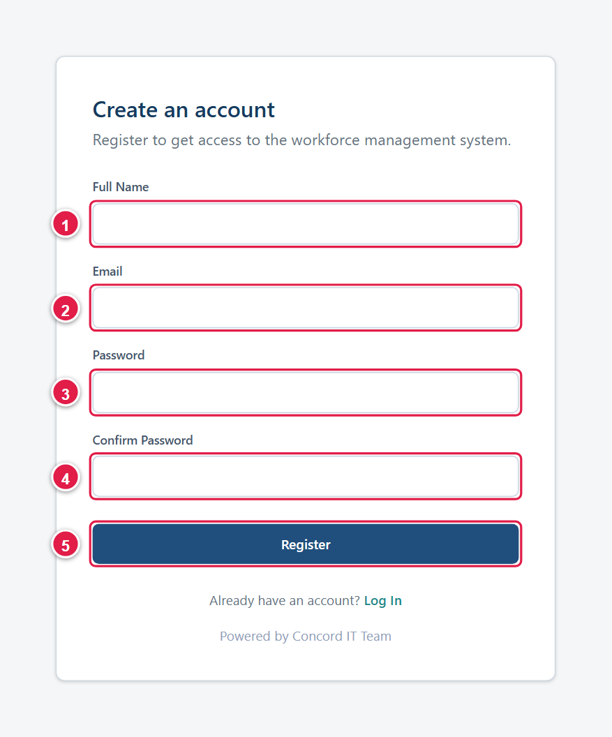  Figure 1. The Register page: (1) name, (2) email, (3) password, (4) confirm password, (5) Register. | 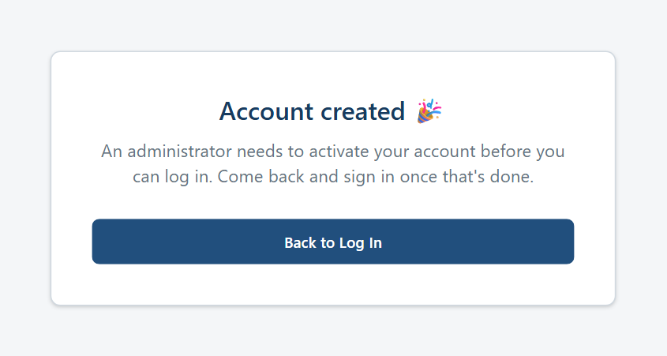  Figure 2. Registration complete – the account now waits for activation.

Note: The registration form checks that the two passwords match and that the password has at least 8 characters. An email address that is already registered is rejected with the message “An account with this email already exists.”

2.4 Logging in
- Open the system address. The Welcome back page appears.
- Type your Email (1) and Password (2).
- Click Log In (3).
- You arrive at the Dashboard. If you were trying to open another page first, you are taken to that page instead.
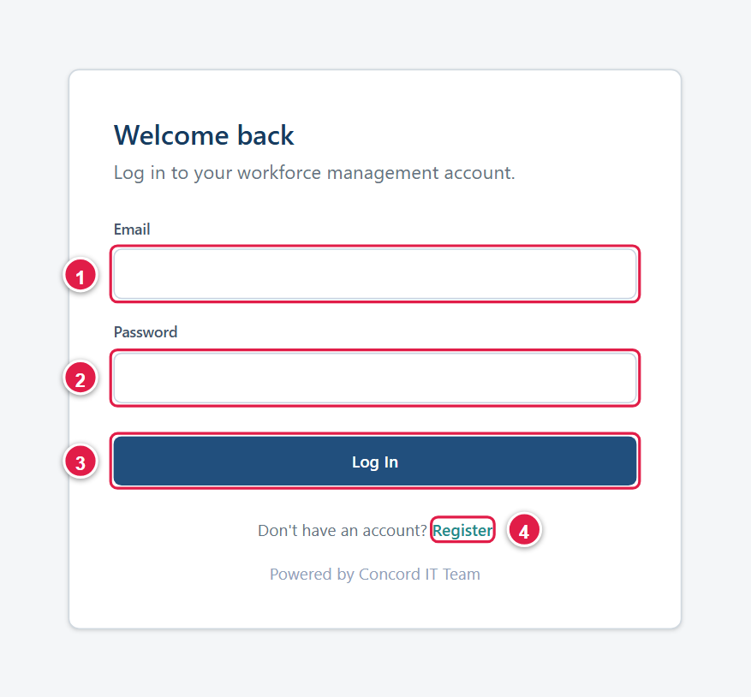
Figure 3. The login page: (1) email, (2) password, (3) Log In, (4) link to Register.
If sign-in fails, one of these messages appears:
Message | Meaning and what to do
Invalid email or password. | The email or password is wrong. Check Caps Lock and try again. If you have forgotten your password, ask an administrator to reset it (section 3.6.1).
Your account is pending admin activation. Please try again later. | The account exists but has not been activated, or was deactivated. Contact an administrator.

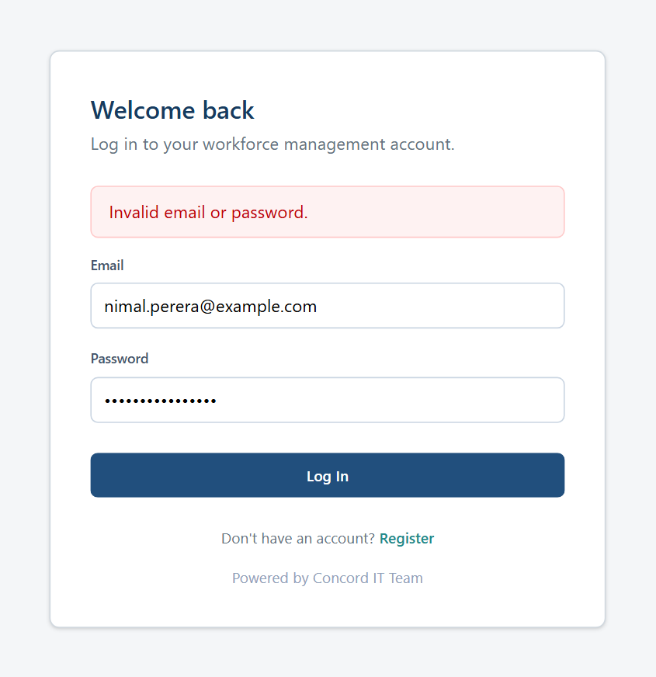  Figure 4. Wrong email or password. | 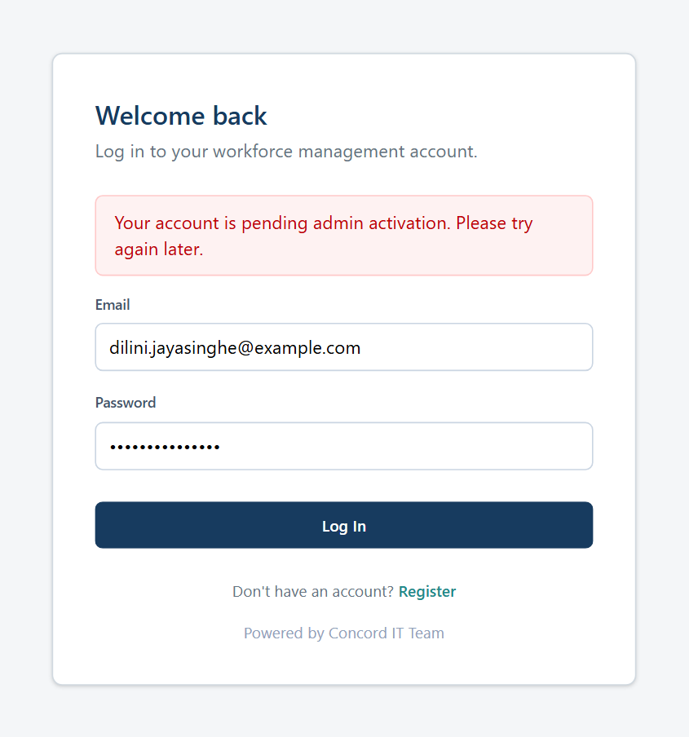  Figure 5. Account not yet activated.

Important: The system keeps you signed in on this browser for up to 24 hours, even if you close the browser. When the session ends you are returned to the login page automatically. On a shared computer, always use Log Out (section 2.7).

2.5 First login after a password reset
If an administrator resets your password, you receive a temporary password. The first time you sign in with it, the system will not let you open any other page until you choose your own password.
- Log in with your email and the temporary password.
- On the Set a new password page, type the temporary password in Current (temporary) password (1).
- Type your new password in New password (2) and again in Confirm new password (3). It must be at least 8 characters and different from the temporary password.
- Click Save new password (4). You are taken to the Dashboard.
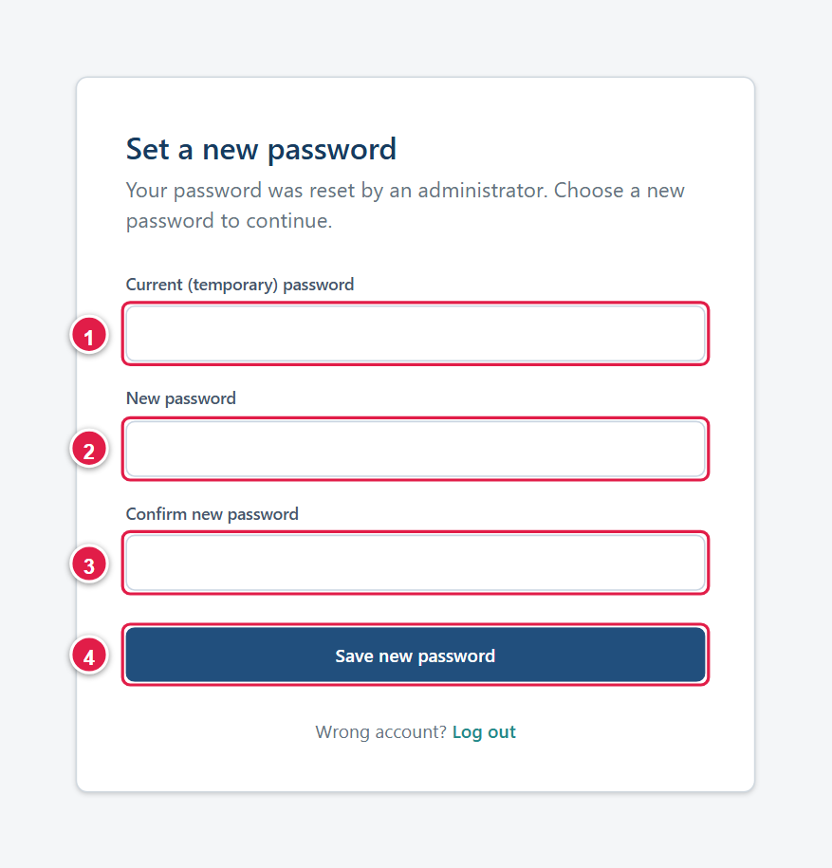
Figure 6. Choosing a new password after an administrator reset.
If you opened this page on the wrong account, click Log out at the bottom of the card.

2.6 Basic navigation
After login every page has the same layout:
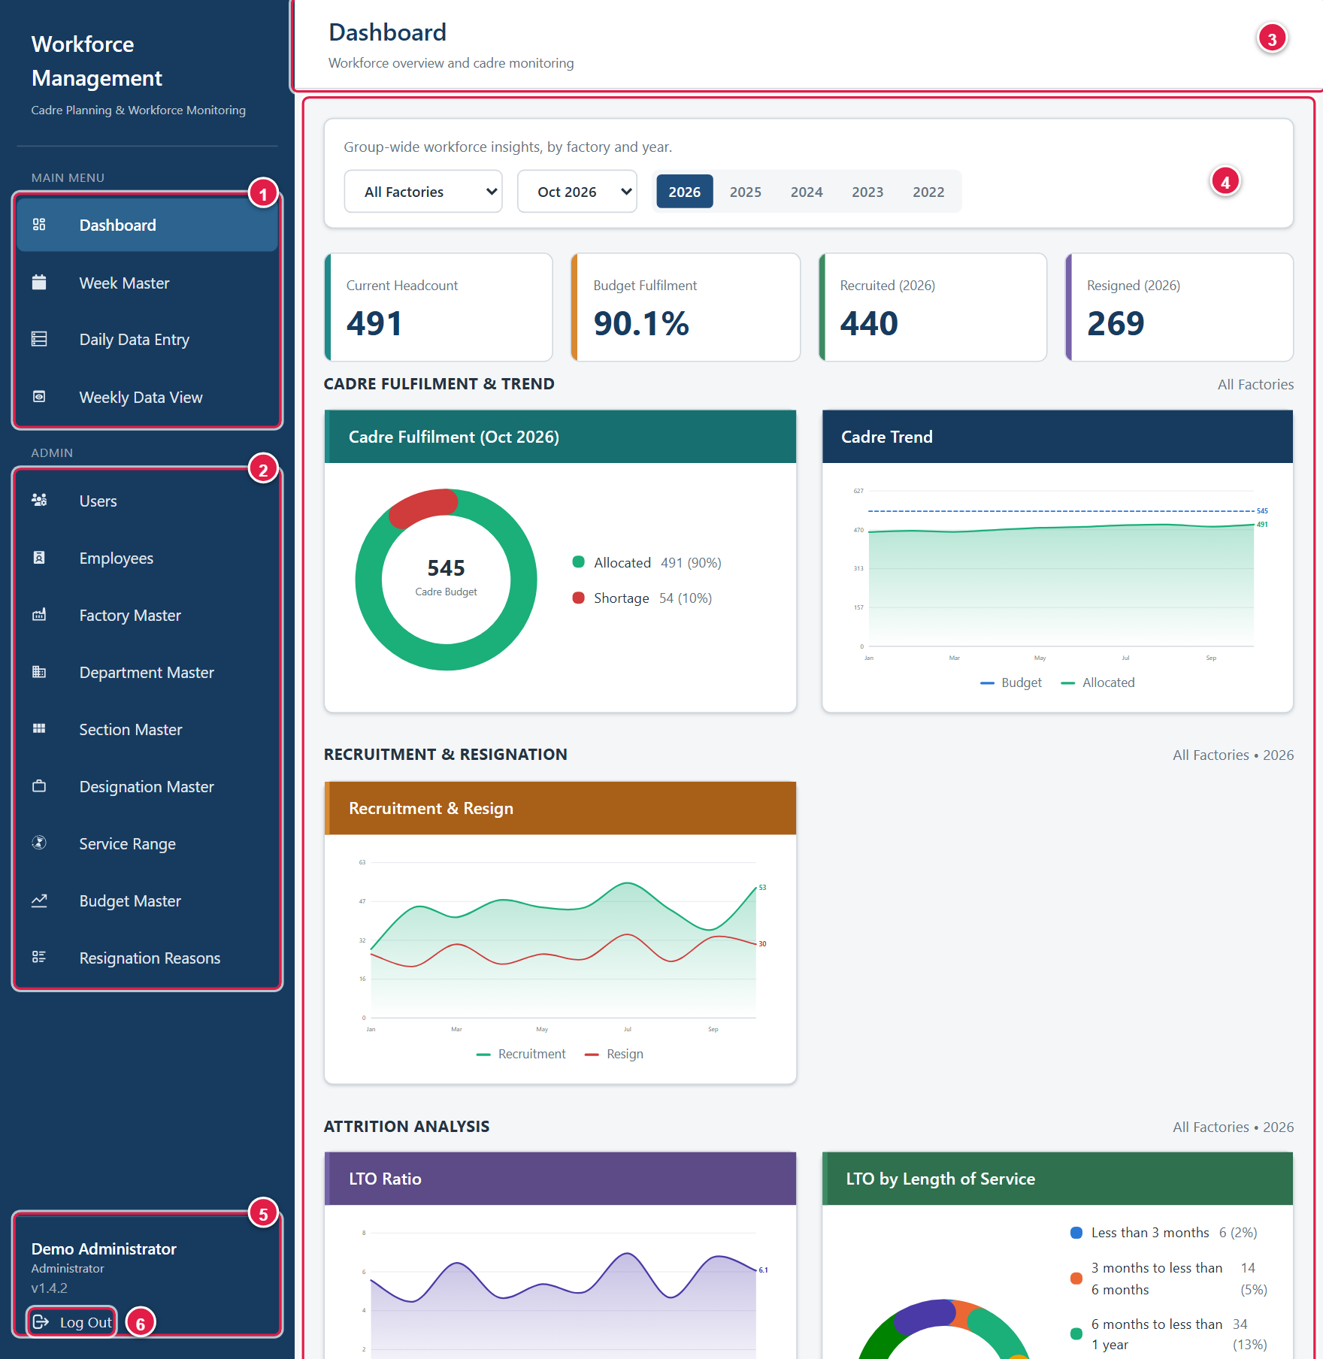
Figure 7. The screen layout (shown for an Administrator).
1 | Main Menu – Dashboard, Week Master, Daily Data Entry and Weekly Data View. Click an item to open it; the page you are on is highlighted.
2 | Admin menu – shown to Administrators and SuperUsers only (Users, Employees, and the master-data pages).
3 | Title bar – the page title and a short description.
4 | Content area – where the selected page is displayed. Wide tables scroll sideways inside their panel.
5 | Your details – your name, role and the system version number.
6 | Log Out.

Note: On some pages (for example Week Master, Employees and the master-data pages) the title bar may still read “Dashboard”. Use the highlighted item in the left menu to see which page you are on.

Which menu items you see depends on your role:
Menu item | User | SuperUser | Administrator
Dashboard | Own factory | All factories | All factories
Week Master | Edit | View only | Edit
Daily Data Entry | Add, edit, delete | View only | Add, edit, delete
Weekly Data View | View, download | View, download | View, download
Employees | Edit (own factory) | View only | Edit
Users | Not shown | Not shown | Full access
Factory, Department, Section, Designation, Service Range, Budget, Resignation Reasons | Not shown | View only | Full access

2.7 Logging out
- At the bottom of the left menu, click Log Out (item 6 in the layout screenshot in section 2.6).
- You are returned to the login page and your session on this browser is ended.
Tip: Log out whenever you leave your desk, and always on a shared computer.

3. Main Features and Step-by-Step Instructions
This chapter explains each part of the system in the order it is normally used. Numbers in the screenshots match the numbered lists beside them.
Feature | Used for | Roles
3.1 Dashboard | Headcount, budget fulfilment, recruitment, resignation, turnover and absenteeism charts. | All
3.2 Week Master | Defining the weeks that daily records belong to. | User, Administrator (SuperUser views)
3.3 Daily Data Entry | Recording each factory’s daily cadre movements and leavers. | User, Administrator (SuperUser views)
3.4 Weekly Data View | Reviewing weekly figures and downloading Excel reports. | All
3.5 Employees | Reviewing and completing leaver records. | User, Administrator (SuperUser views)
3.6 Administration | Users, factories, departments, sections, designations, service ranges, budgets and resignation reasons. | Administrator (SuperUser views)
3.7 Messages and troubleshooting | Common messages and what to do about them. | All

Typical routine
- Once, and when budgets change – an administrator sets up factories, departments, sections, designations, service ranges, resignation reasons and the active budgets.
- Each month – set up the weeks for the month in Week Master (section 3.2).
- Each working day – each factory records its Daily Data Entry (section 3.3).
- Weekly – review the Weekly Data View and download reports (section 3.4).
- Whenever needed – check the Dashboard (section 3.1) and complete missing employee details (section 3.5).

3.1 Dashboard
The Dashboard is the first page after login. It summarises the workforce for the factory, month and year you choose. It is read-only.
Using the Dashboard
- Click Dashboard in the Main Menu.
- Administrators and SuperUsers: pick a factory in the first selector (1), or leave All Factories for group-wide figures. A User always sees their own factory and has no factory selector.
- Pick a month in the second selector (2). It controls only the Cadre Fulfilment chart (this month and the 11 before it).
- Pick a year (3). The current year and the four before it are offered. The year drives the Recruited and Resigned tiles and every trend and analysis chart.
- Read the four headline tiles (4), then scroll down for the charts (5, 6 and below). Hover over a chart line or ring segment to see the exact value.
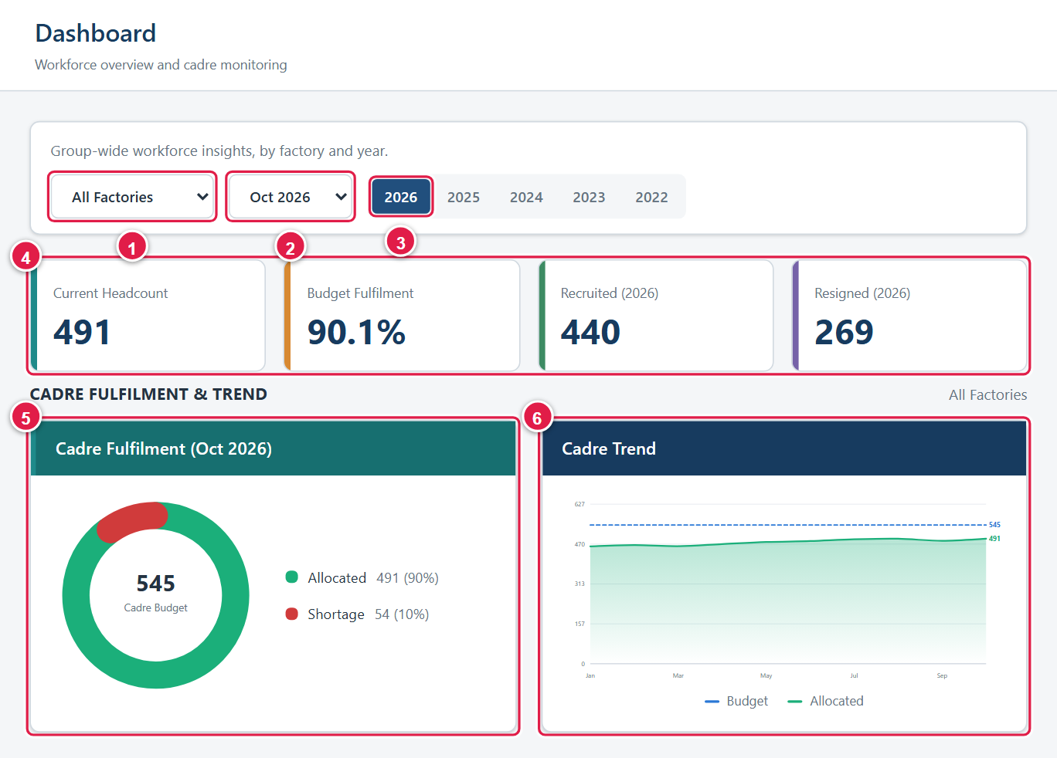
Figure 8. Dashboard: (1) factory, (2) month, (3) year, (4) headline tiles, (5) Cadre Fulfilment, (6) Cadre Trend.
What each part shows:
Item | What it shows
Current Headcount | Total Allocated_Current (MO + TMO) from each factory’s latest daily record. If a factory has no record yet this month, its most recent earlier record is used.
Budget Fulfilment | Allocated headcount as a percentage of the budget (planned) headcount.
Recruited / Resigned (year) | Total new recruitments and resignations for the selected year.
Cadre Fulfilment (month) | A ring showing Allocated versus Shortage against the budget, using each factory’s latest record in the selected month.
Cadre Trend | Budget compared with Allocated headcount, month by month.
Recruitment & Resign | New recruits compared with resignations, month by month.
LTO Ratio | Monthly labour turnover: resignations divided by allocated headcount, as a percentage.
LTO by Length of Service | Resigned employees grouped by service period, using the ranges in Service Range (section 3.6.6).
LTO by Reason / Civil Status / Section / Age | Resigned employees for the year grouped by resignation reason, civil status, section and age at resignation. A grey Not Recorded slice means the information is missing on the employee record (section 3.5).
Absenteeism Rate | Monthly absentees divided by allocated headcount. Shown to Administrators and SuperUsers only.

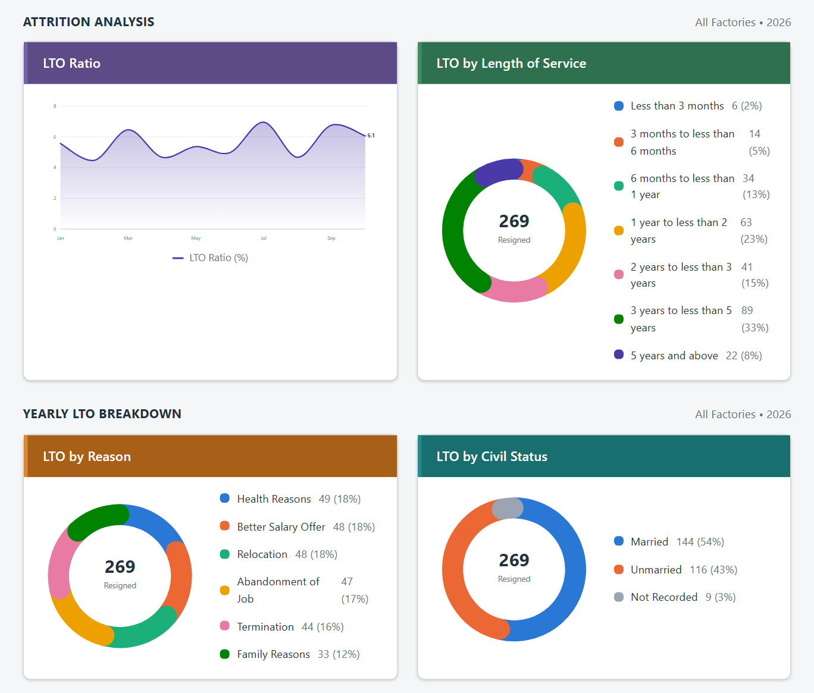
Figure 9. Lower part of the Dashboard: attrition analysis and the yearly LTO breakdown.
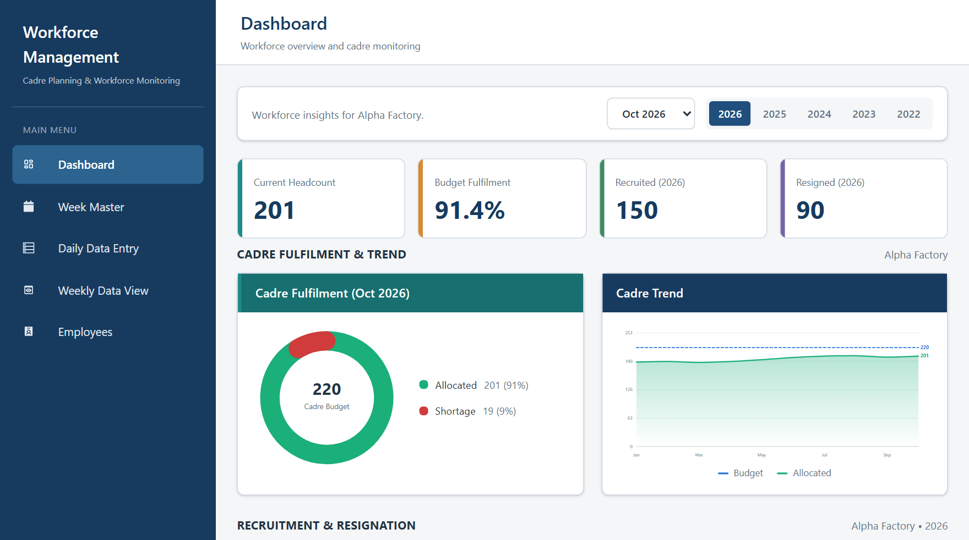
Figure 10. The same Dashboard for a User account: own factory only, no factory selector and no Admin menu.
Note: If you see “No factory is assigned to your account. Contact an administrator to assign one.”, your account has no factory yet. Ask an administrator to assign one in Users (section 3.6.1).

3.2 Week Master
Daily records are grouped by week. Week Master is where the weeks are defined. Each week starts on the date you set and covers the following seven days. When you enter a daily record, the system finds the week that contains the record’s date.
Important: A daily record cannot be saved for a date that is not covered by a configured week (“No week is configured to cover … Add it in Week Master first.”). Set up each month’s weeks before data entry begins.

Who can use it: Users and Administrators can add and change weeks. SuperUsers can view them.

3.2.1 Viewing the weeks of a month
- Click Week Master in the left menu (1).
- Use the arrows above the calendar (2) to move to the month you want. Weeks already saved for that month are loaded automatically; the highlighted calendar dates are the week start dates.
- Each Week card (3) shows the start date for that week. The badge at the top right of the panel shows how many weeks the month has.
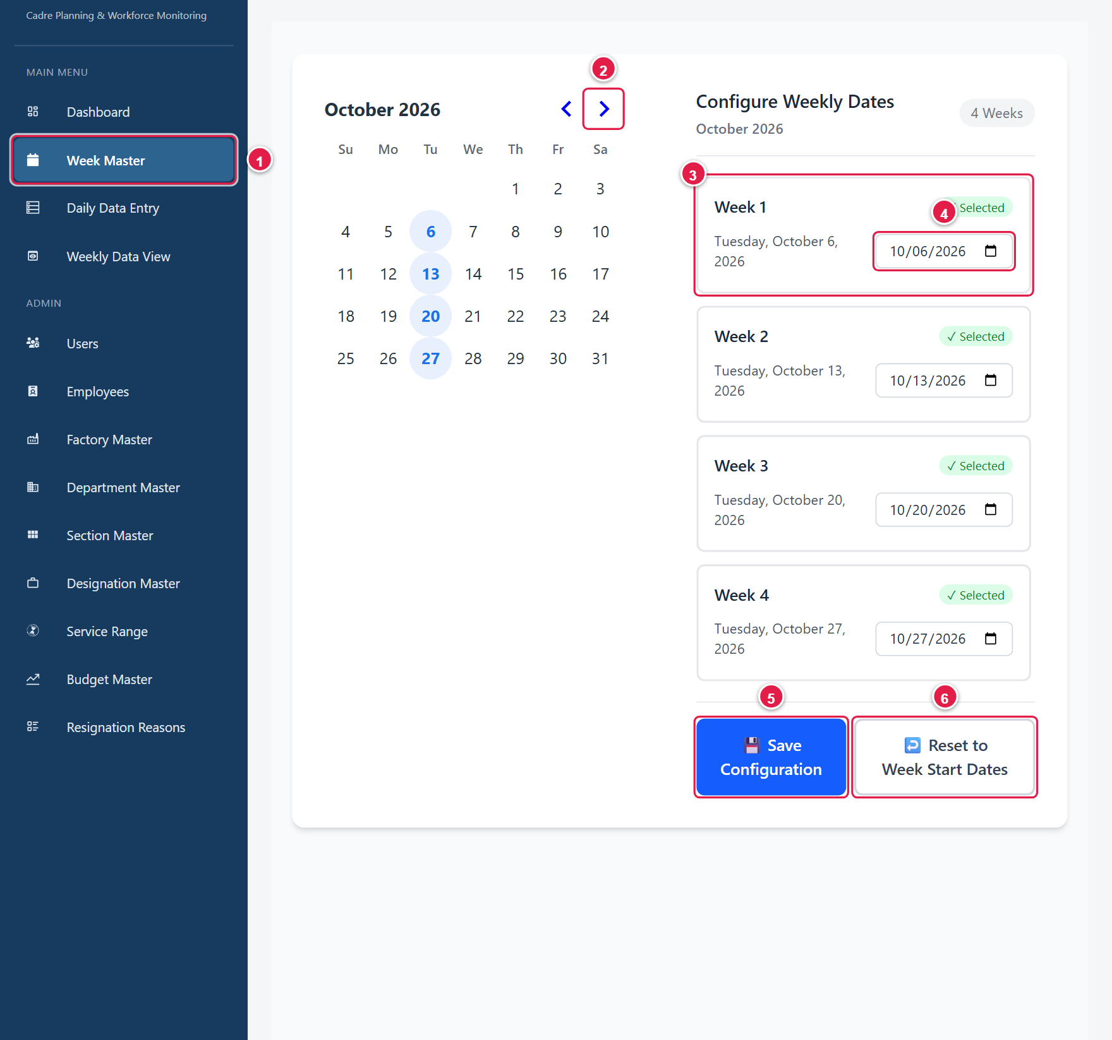
Figure 11. Week Master: (1) menu item, (2) month arrows, (3) a week card, (4) date field, (5) Save Configuration, (6) Reset to Week Start Dates.

3.2.2 Setting up the weeks for a new month
- Open Week Master and use the arrows to go to the month.
- The system suggests the Tuesdays of the month as week start dates (Week 1 is the first Tuesday). If that suits you, go to step 5.
- To change a date, click its Week card (it is outlined), then either click a date on the calendar (2) or type or choose a date in the date field (3).
- Each week needs a different date, and every date must fall inside the month shown.
- Click Save Configuration. A green message such as “Weeks saved: 4 added.” appears.
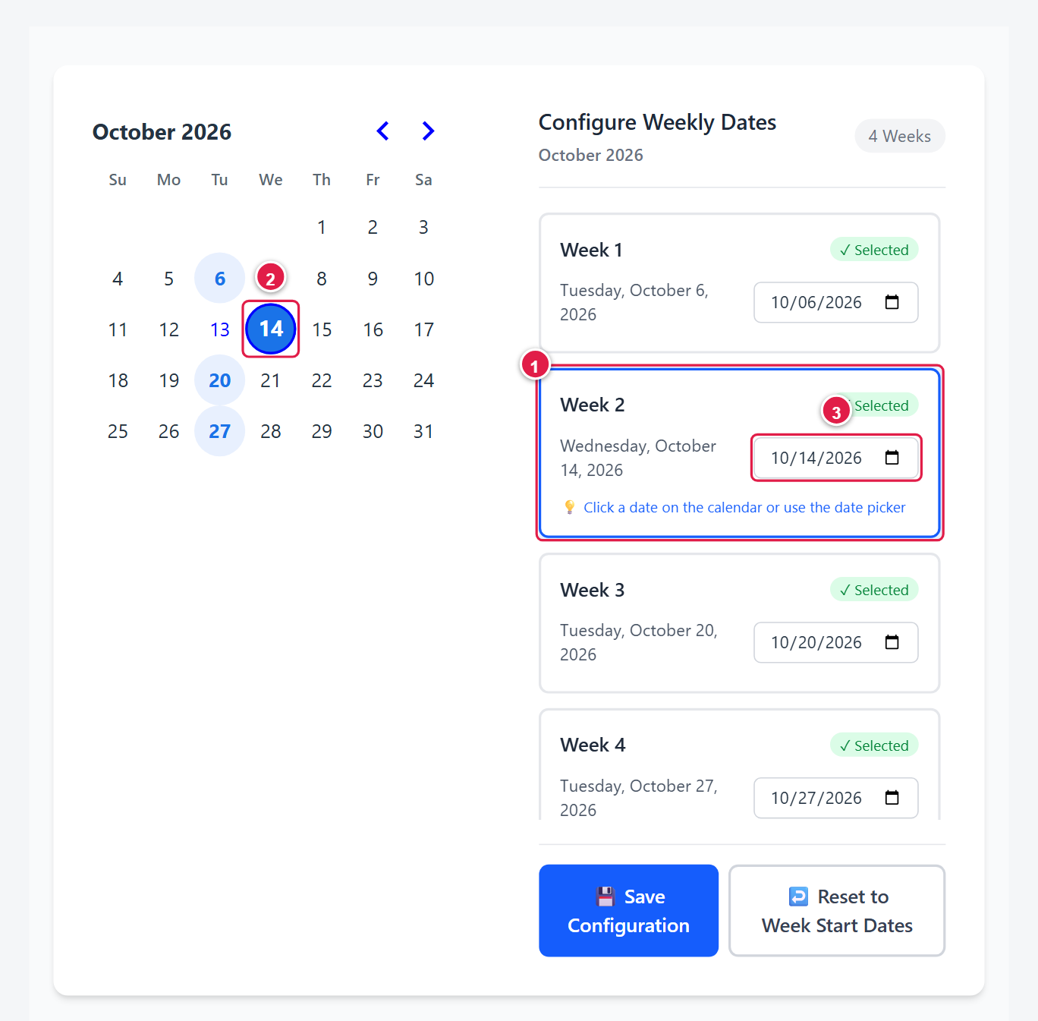
Figure 12. Changing Week 2: (1) the selected week, (2) the new date picked on the calendar, (3) the date field. Nothing is saved until you click Save Configuration.
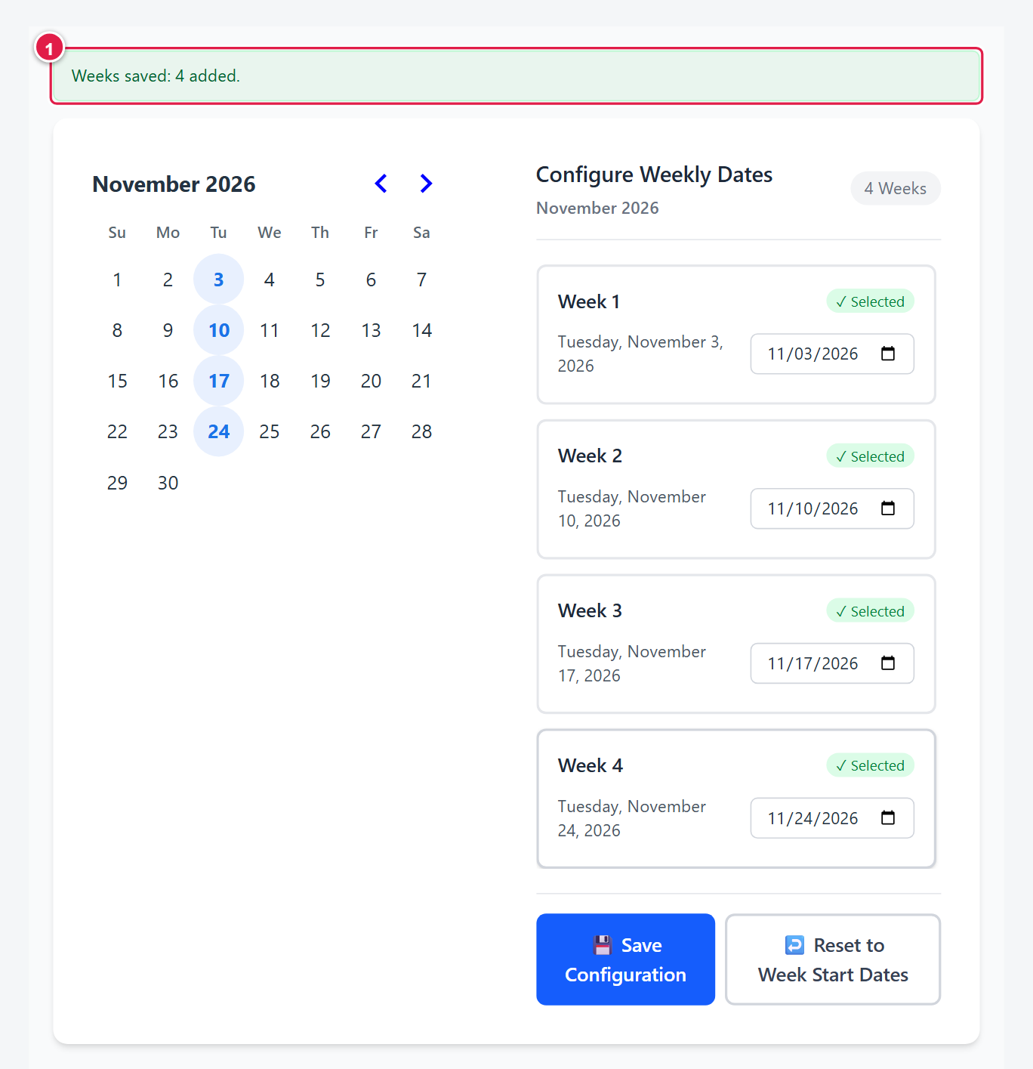
Figure 13. After saving the weeks for November 2026.
To discard changes you have not yet saved, click Reset to Week Start Dates, which puts the suggested Tuesdays back on screen.
Messages you may see while editing:
Message | Meaning
Date is required | A week has no date. Pick one.
Duplicate date selected / This date is already assigned to another week | Two weeks cannot share the same date.
Date must be in current month / Please enter a valid date in the current month | The date must lie in the month shown above the calendar.

Caution: Changing the date of a week that already has daily records changes how that week is labelled for every factory. Ask your administrator before editing a week that is in use.

3.3 Daily Data Entry
Daily Data Entry is the heart of the system. Each factory records, for each working day, what happened to its cadre. Everything else – the Weekly Data View and the Dashboard – is calculated from these records.
Who can use it: Users and Administrators can add, edit and delete records. SuperUsers can view every record but cannot change anything.

3.3.1 The page at a glance
The page has three parts, from top to bottom:
- Record Information – which factory, which date, and which week the record belongs to.
- Cadre / Recruitment Details – the figures for the day, shown as boxed MO / TMO / Total groups.
- Daily Data Records – a table of the records already saved for the chosen month, with buttons to edit or delete them.
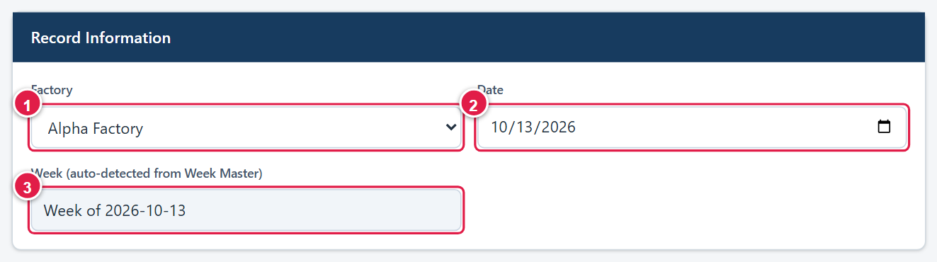
Figure 28. Record Information: (1) factory, (2) date, (3) week, detected automatically from Week Master.

3.3.2 Understanding the Cadre / Recruitment Details form
White boxes are for you to fill in. Grey boxes are calculated by the system and cannot be typed in.
Group | You enter? | Meaning
Planned MO/TMO | No | Taken from the active budget for the factory in Budget Master. If none is active you see “No active budget set for this factory in Budget Master.”
Allocated_Actual MO/TMO | Yes (pre-filled) | Opening headcount. Filled from the factory’s previous record’s Allocated_Current. Correct it only if the opening figure is wrong.
Shortage MO/TMO | No | Planned minus Allocated_Actual.
New Recruitments MO/TMO | Yes | Employees who joined.
Rejoined MO/TMO | No | Credited automatically when a resigned employee is marked Rejoin (section 3.3.8). The eye icon lists them.
Released from Tr. Cen. | No | Set by the Transfer to Production Line pop-up (section 3.3.6).
Resigned | Yes, then details | Counts of MO and TMO who left. A pop-up then asks for each employee’s details (section 3.3.4).
Transfer | Yes, then details | Counts of MO and TMO who were transferred or promoted (section 3.3.5).
Net Increase/Decrease | No | Additions minus reductions for the day.
Allocated_Current MO/TMO | No | Closing headcount for the day.
Absenteeism MO/TMO | Yes | Employees absent on the day.
Present MO/TMO | No | Allocated_Current minus Absenteeism.
TMO_Training Center | Mixed | Planned – from the Training Center budget (not typed).  Allocated – opening balance, carried from the previous record.  Recruit., Resigned, Transfer to Pro Line, Absent. – you enter.  Actual Allocated and Present – calculated.

How totals are calculated: The main figures are worked out as follows.
Shortage = Planned − Allocated_Actual.
Allocated_Current = Allocated_Actual + New Recruitments + Rejoined + Released from Tr. Cen. − Resigned − Transfers out. (A TMO promoted to MO moves from TMO to MO; the total does not change.)
Present = Allocated_Current − Absenteeism.
Training Center Actual Allocated = Allocated + Recruit. − (Resigned + Transfer to Pro Line); Present = Actual Allocated − Absent.

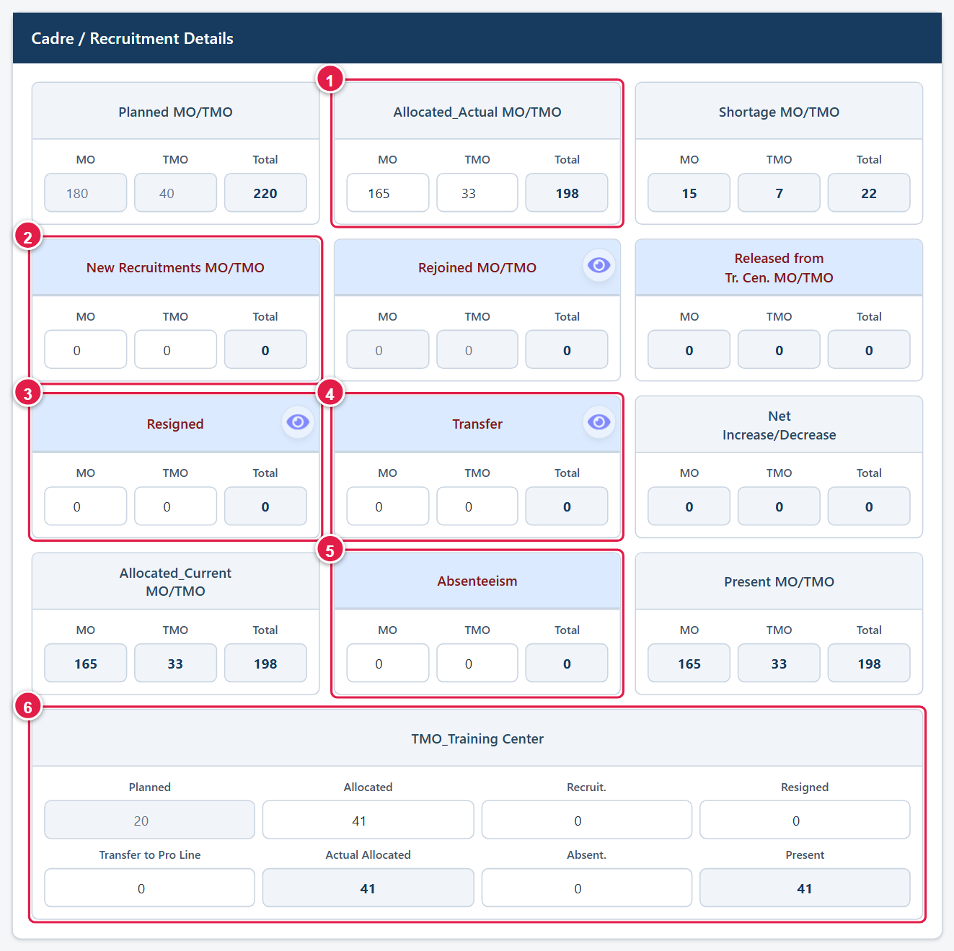
Figure 29. The form when it first opens: (1) Allocated_Actual, pre-filled, (2) New Recruitments, (3) Resigned, (4) Transfer, (5) Absenteeism, (6) TMO_Training Center.

3.3.3 Adding a daily record
- Click Daily Data Entry in the Main Menu.
- In Record Information, check the Factory (1). It is pre-filled with your assigned factory. Choose the Date (2); it starts as today, and you can pick an earlier date to enter a missed day.
- Look at Week (3). It must read Week of …. If it shows “No week configured for this date” in red, add the week in Week Master first (section 3.2).
- Check Allocated_Actual MO and TMO. They are pre-filled from the previous record; overwrite them only if the opening figure is wrong. Check the Training Center Allocated box in the same way.
- Type the New Recruitments MO and TMO.
- If anyone resigned or was terminated, type the counts in Resigned and complete the details pop-up (section 3.3.4).
- If anyone was transferred or promoted, type the counts in Transfer and complete the pop-up (section 3.3.5).
- Type Absenteeism MO and TMO.
- Fill the TMO_Training Center boxes: Recruit., Resigned, Transfer to Pro Line (section 3.3.6) and Absent.
- Review the grey boxes. Check that Allocated_Current, Net Increase/Decrease, Present and Shortage look sensible.
- Click Add to Table. The message “Record added successfully.” appears, the form clears, and the new record shows in Daily Data Records, highlighted.
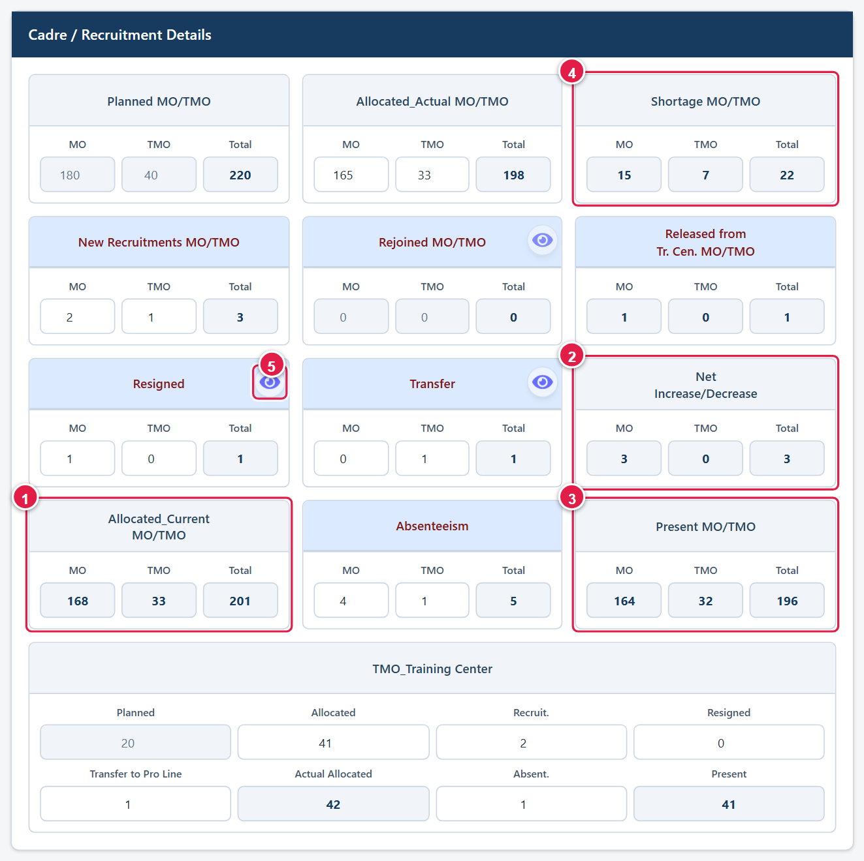
Figure 30. A completed form: (1) Allocated_Current, (2) Net Increase/Decrease, (3) Present, (4) Shortage and (5) the eye icon that lists the resigned employees – all calculated by the system.
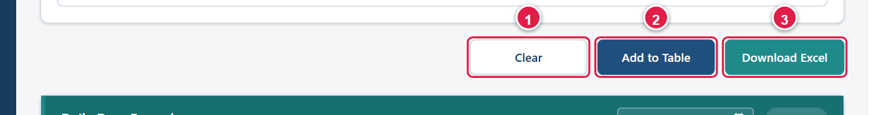
Figure 31. Action buttons: (1) Clear empties the form, (2) Add to Table saves the record, (3) Download Excel.
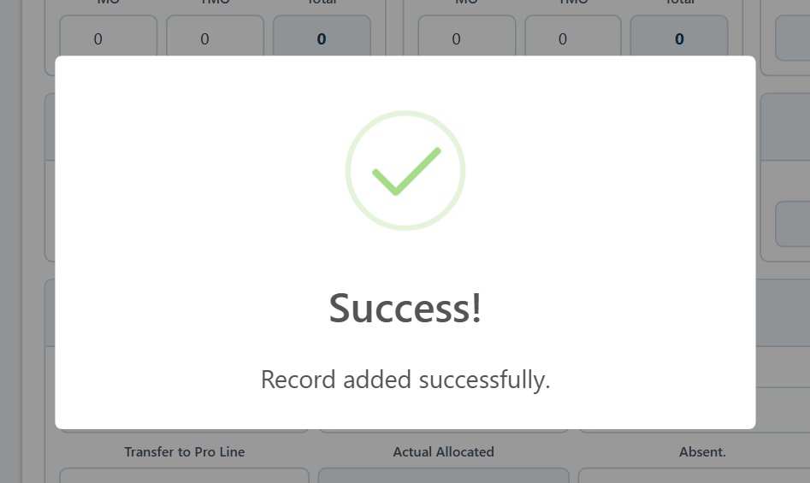
Figure 32. Confirmation after saving.
Important: Enter one record per factory per day. If you need to correct a record, edit it (section 3.3.9) rather than adding another.

If a check fails, a Validation Error message tells you what to fix:
Message | What to do
Please select a factory first. / Please enter a Date. | Choose the factory and date in Record Information.
Please enter details for all N resigned employee(s) … before submitting. | The number of employee detail rows must equal the MO + TMO count. Re-open the pop-up (click out of the Resigned box) and complete it. The same applies to transfers.
One or more resigned (or transfer) employee rows are missing details | Open the pop-up and fill every tab that shows a red dot.
EPF … is entered more than once across the Resigned/Transfer pop-ups | Each employee may appear only once in an entry. Correct the EPF number.
No week is configured to cover … Add it in Week Master first. | Add the week (section 3.2).

3.3.4 Recording resigned or terminated employees
Every resigned or terminated employee must be recorded individually, so that the Employees page and the turnover charts are accurate.
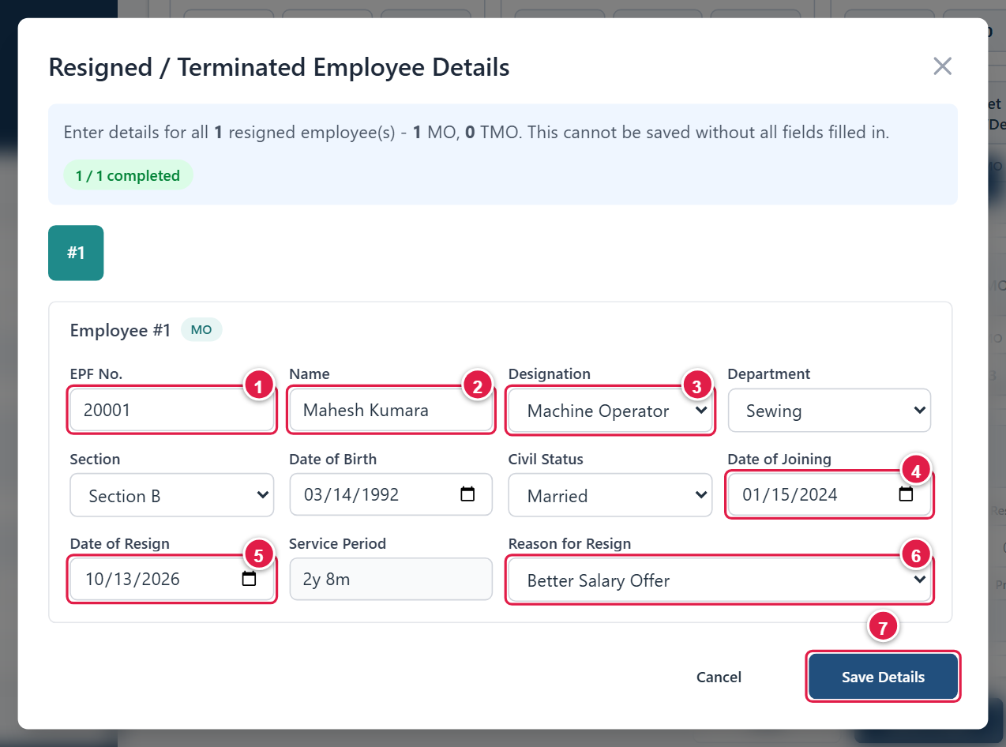
Figure 33. Resigned / Terminated Employee Details pop-up.
- In the Resigned group, type the number of MO and/or TMO who left (for example, 1 in MO).
- Click outside the box or press Tab. The Resigned / Terminated Employee Details pop-up opens.
- The pop-up has one numbered tab per employee (#1, #2 …) – first the MOs, then the TMOs. A red dot on a tab means it is incomplete; a green tab is complete. Work through each tab.
- Fill in EPF No. (1), Name (2), Designation (3), Department, Section, Date of Joining (4), Date of Resign (5) and Reason for Resign (6). Date of Birth and Civil Status are optional but strongly recommended, because the Dashboard analyses use them. Service Period is calculated for you.
- When every tab is complete, click Save Details (7). It is disabled until all tabs are complete. Cancel closes the pop-up without saving.
- Continue with the rest of the form, then click Add to Table.
- Date of Resign cannot be before Date of Joining, and Date of Birth must be before Date of Joining.
- The EPF number must be unique within the entry (resigned and transfer lists together).
- If you set the count back to 0 after entering details, the system asks “Remove employee details?”. Choose Keep if you are about to retype the count, or Remove to discard the details.
- Lowering the count by one does not remove anyone automatically. Use the eye icon (section 3.3.8) to remove a specific employee.

3.3.5 Recording transfers
Use Transfer when an employee leaves this cadre, or when a TMO is promoted to MO.
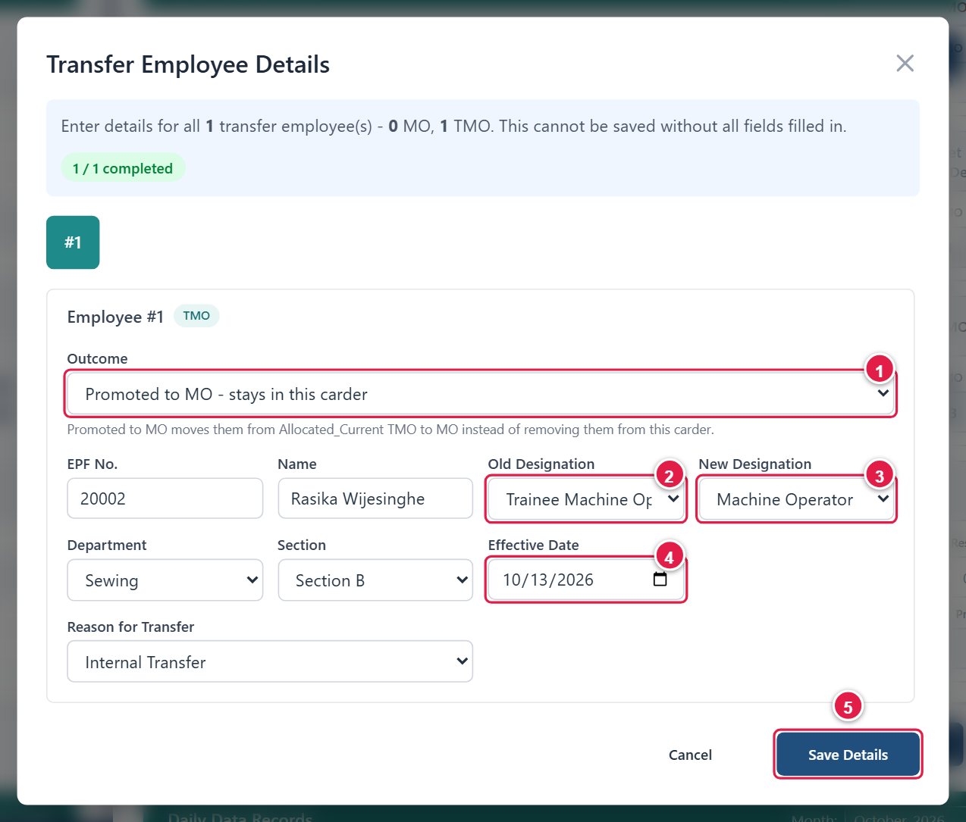
Figure 34. Transfer Employee Details pop-up for a promotion.
- In the Transfer group, type the number of MO and/or TMO transferred, then click outside the box. The Transfer Employee Details pop-up opens.
- For a TMO, choose the Outcome (1): Transferred out – leaves this carder, or Promoted to MO – stays in this carder. A promoted TMO moves from TMO to MO and the total headcount does not change.
- Fill in EPF No., Name, Old Designation (2), New Designation (3), Department, Section and Effective Date (4). Reason for Transfer is suggested for you (Internal or External Transfer) and can be changed.
- Click Save Details (5) when every tab is complete.

3.3.6 Training Center and Transfer to Production Line
The TMO_Training Center group tracks trainees. When trainees finish training and move to the production line, enter the number in Transfer to Pro Line.
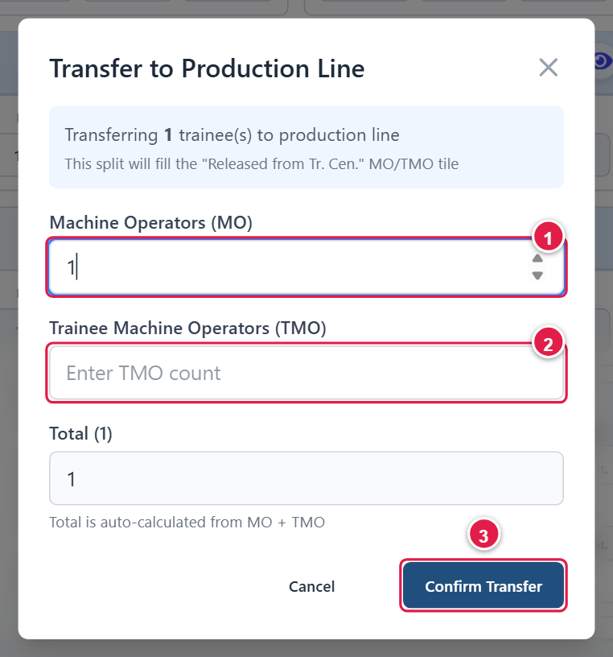
Figure 35. Splitting trainees released to the production line.
- Type the number in Transfer to Pro Line and click outside the box. The Transfer to Production Line pop-up opens.
- Split the trainees between Machine Operators (MO) (1) and Trainee Machine Operators (TMO) (2). The Total is calculated and must equal the number you typed.
- Click Confirm Transfer (3). The split fills the Released from Tr. Cen. group, and the headcount increases accordingly.

3.3.7 The Daily Data Records table
After saving, the record appears in Daily Data Records at the bottom of the page. The newest record is highlighted.
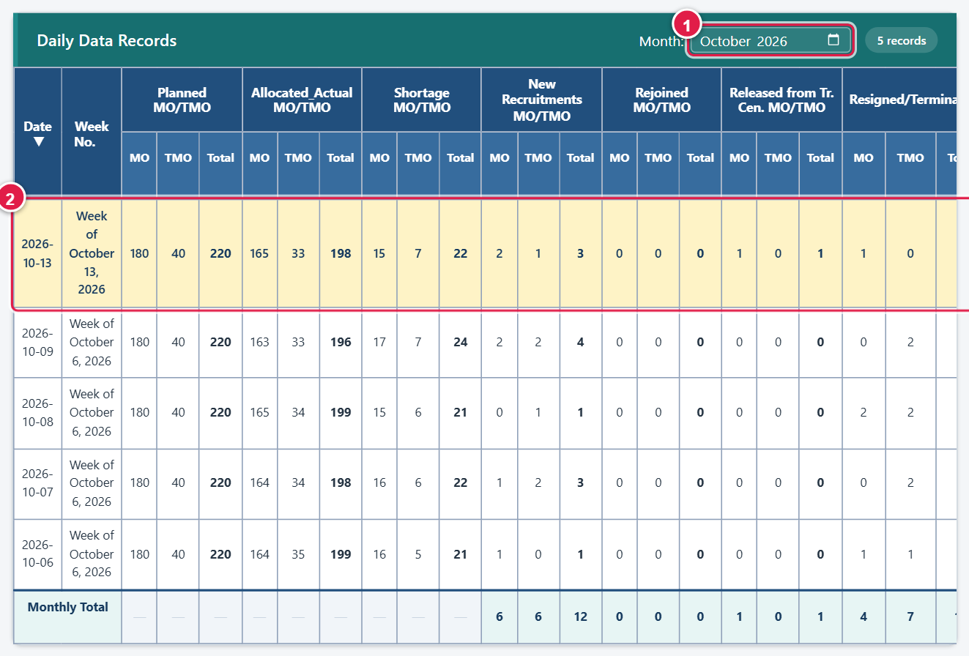
Figure 36. Daily Data Records: (1) month filter, (2) the record just saved.
- The table shows one calendar month at a time. Change the Month (1) to see or correct older data.
- Administrators and SuperUsers also get a Factory filter. Until you choose one, the table lists every factory’s records. Users see their own factory.
- The badge shows how many records are listed. Click a column heading to sort by it; click again to reverse the order.
- The Monthly Total row adds up the flow columns (recruits, resignations, absenteeism and so on). Snapshot columns such as planned and allocated show a dash because adding them up would not be meaningful.
- Scroll the table to the right to reach the Action column.
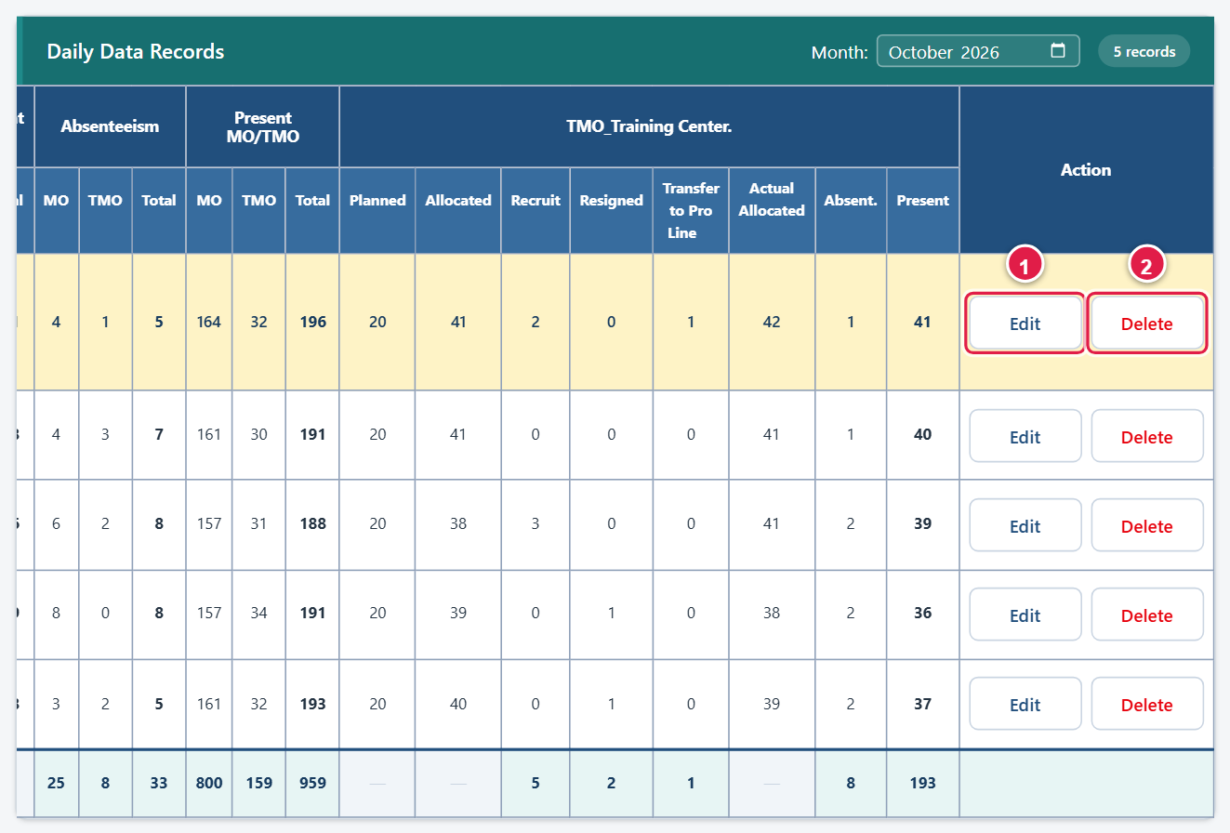
Figure 37. The right-hand end of the table: (1) Edit, (2) Delete. SuperUsers do not see this column.

3.3.8 Viewing, deleting or rejoining resigned employees
Next to Resigned and Transfer is an eye icon. It lists everyone recorded on that tile for the record you are working on. This is the only place where an individual employee is removed or re-activated.
- Open the record with Edit (section 3.3.9) so that its employees are loaded.
- Click the eye icon next to Resigned (or Transfer). The list of employees opens.
- To remove someone who was entered by mistake, click Delete (1) on their row and confirm. The employee record is permanently deleted and the counts are updated at once.
- If an employee has come back, click Rejoin (2). Enter the Rejoined Date; it cannot be before the Date of Resign or in the future. The employee is reactivated and counted as Rejoined MO or TMO.
- Click Close.
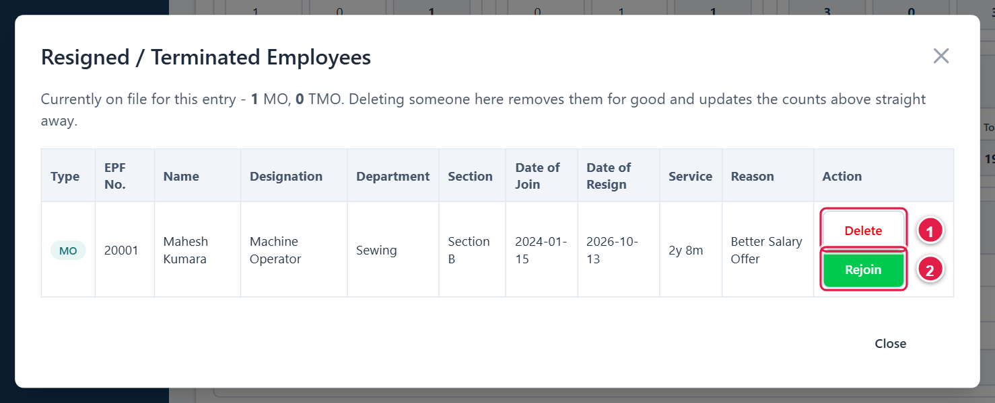
Figure 38. The list opened by the eye icon: (1) Delete, (2) Rejoin.
Caution: Delete removes the employee record for good and cannot be undone. Rejoin is the correct action for a person who returns to work.

3.3.9 Editing a record
- In Daily Data Records, use the Month (and, if you have it, Factory) filter to find the record.
- Scroll right and click Edit at the end of the row. The message “Record loaded. Make your changes and click Update Record.” appears and the form fills with the saved values.
- An orange banner (1) reminds you that you are editing an existing record. Make your changes. Resigned and Transfer details can be reviewed through the eye icons.
- Click Update Record (2). To abandon the changes, click Clear.
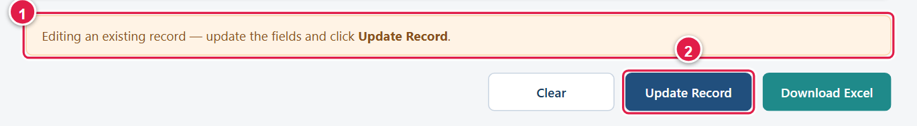
Figure 39. Editing mode: (1) the banner, (2) Update Record replaces Add to Table.

3.3.10 Deleting a record
- Find the record in Daily Data Records and click Delete at the end of its row.
- Your browser asks “Delete this record?” Click OK to confirm. The message “Record deleted.” appears.
Caution: Delete a record only with your supervisor’s approval. Employees recorded on a deleted record are not deleted, but they become unlinked (section 3.3.12) and no longer count on the Dashboard.

3.3.11 Downloading to Excel
Click Download Excel (the right-hand button under the form). The records currently listed in Daily Data Records – the month and factory you have selected – are saved as an Excel file, and “Daily Excel downloaded successfully.” appears. If nothing is listed you see “There are no records to download.”

3.3.12 Unlinked Employees (Administrators and SuperUsers)
Click Unlinked Employees to open a list of employees who have a Date of Resign but are no longer part of any daily record – for example because their record was deleted. They are not counted on the Dashboard. Use the list to find them, then re-add them to the correct entry or correct them on the Employees page. The list is view-only and can be searched by EPF number or name.
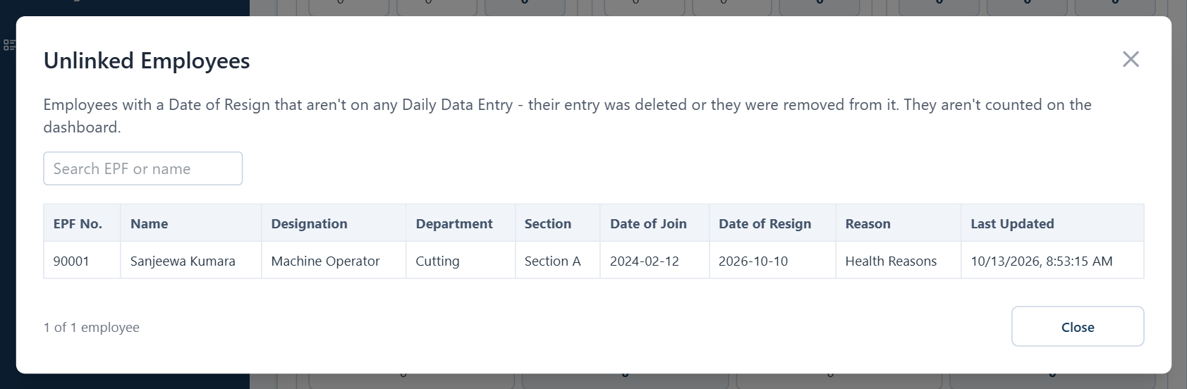
Figure 40. The Unlinked Employees list.

3.4 Weekly Data View
The Weekly Data View shows each factory’s figures week by week. It has no data of its own – it is built automatically from the daily records, so there is nothing to type. To correct a number, correct the daily record (section 3.3.9).
Using the Weekly Data View
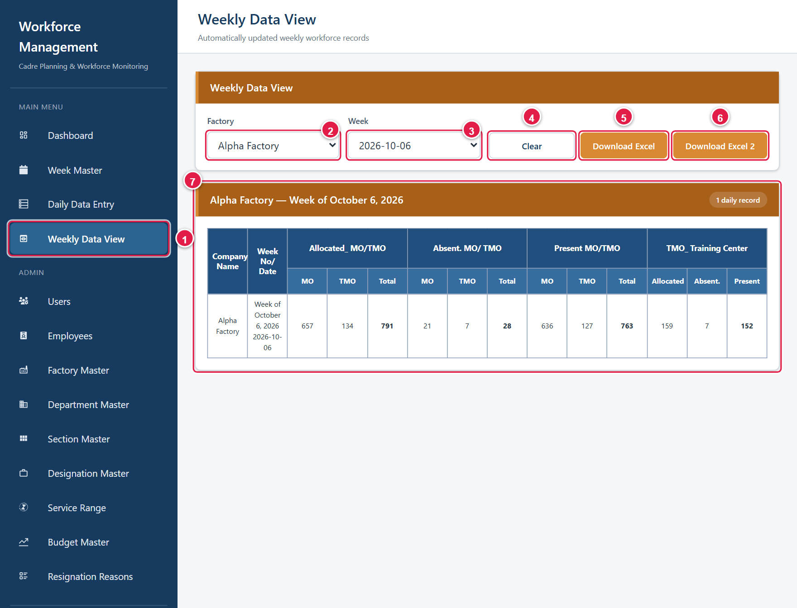
Figure 41. Weekly Data View: (1) menu, (2) factory, (3) week, (4) Clear, (5) Download Excel, (6) Download Excel 2, (7) a factory-week block.
- Click Weekly Data View (1).
- Optionally narrow the list with Factory (2) and Week (3). Click Clear (4) to remove both filters.
- Each block is one factory in one week, with the number of daily records it contains. The columns show Allocated MO / TMO / Total, Absent, Present, and the TMO_Training Center Allocated, Absent and Present figures.
- Click a row to highlight it as you read.
- Click Download Excel (5) to save the displayed weekly records to an Excel file.
- Click Download Excel 2 (6) for the Weekly Cadre Status Report (below).
Weekly Cadre Status Report (Download Excel 2)
- Click Download Excel 2. The Weekly Cadre Status Report window opens. It names the factory that is currently filtered, or All factories.
- Choose the From (1) and To (2) dates. The default range runs from the first day of the month two months ago to today.
- Click Download (3). A factory-wise report for that period is saved as an Excel file. Each week’s figures come from that factory’s first daily entry of the week.
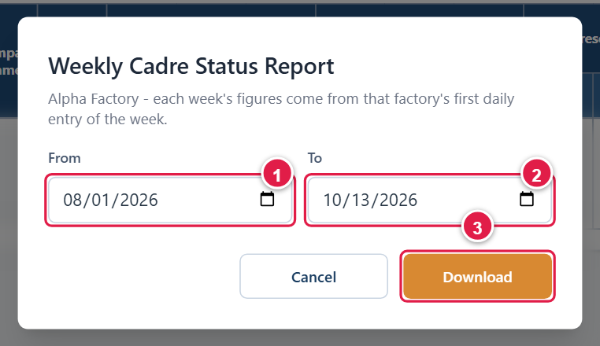
Figure 42. Choosing the report period.
Message | Meaning
No weekly records available for the selected factory/week. | No daily records exist for the filter. Use the Go to Daily Data Entry button, or change the filter.
No daily entries found in the selected date range. | Choose a wider date range.
The From date cannot be after the To date. | Swap or correct the dates.

3.5 Employees
The Employees page lists the employees recorded as resigned or transferred in Daily Data Entry. Records are created automatically from Daily Data Entry – you cannot add or delete employees on this page. Its purpose is to review and correct employee details, especially Date of Birth, Civil Status and Gender, which the Dashboard’s turnover analyses rely on.
Who can use it: Users (their own factory) and Administrators can edit; SuperUsers can view.
Note: Access to this page for the User role is a temporary arrangement so that missing Date of Birth, Civil Status and Gender can be filled in on older records. It may be withdrawn once that data is complete.

Finding employees
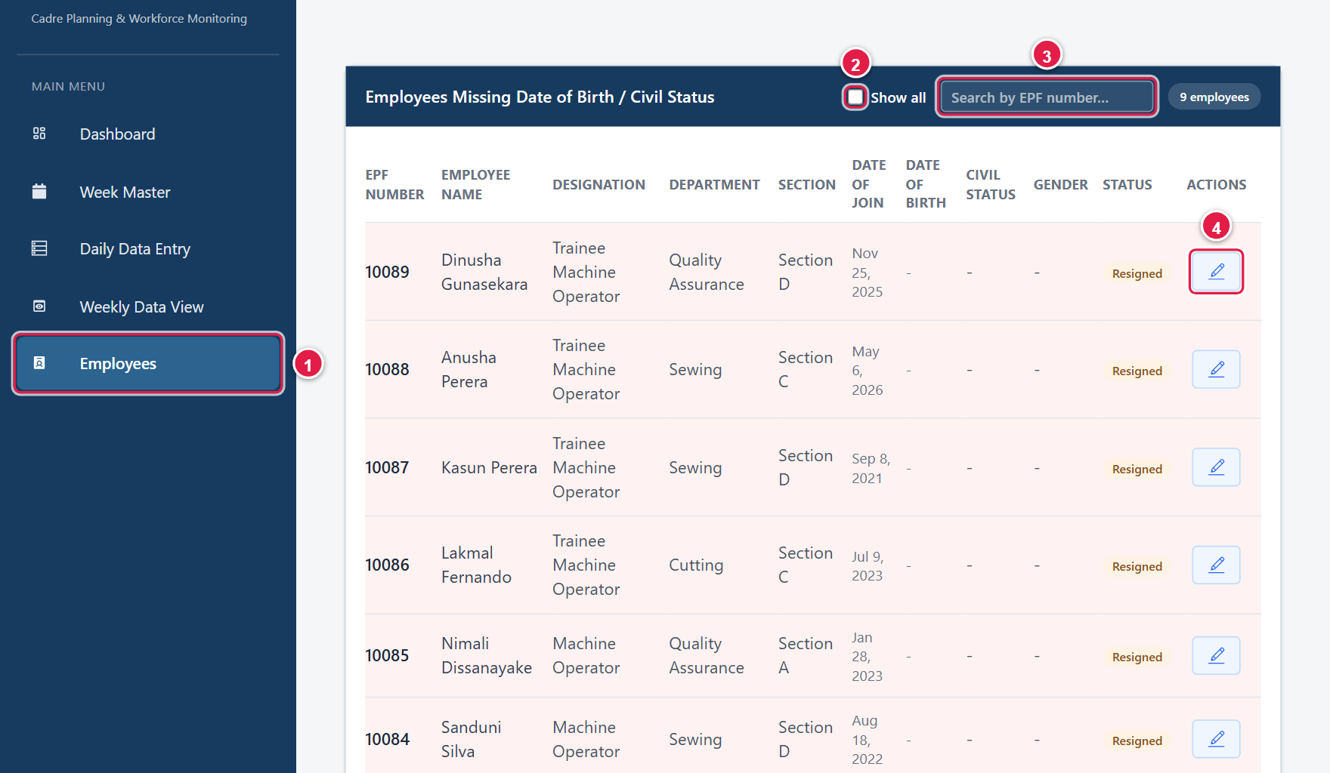
Figure 43. Employees: (1) menu, (2) Show all, (3) search, (4) Edit.
- Click Employees (1). By default the list is titled Employees Missing Date of Birth / Civil Status: it shows only employees who still need one of those details.
- Tick Show all (2) to list every employee (All Employees).
- Type an EPF number in Search by EPF number (3) to find a person. Click Clear to cancel the search.
- Administrators and SuperUsers can also pick a Factory in the selector. Users only see their own factory’s employees.
- The list shows 20 employees per page; use Previous and Next below the table.
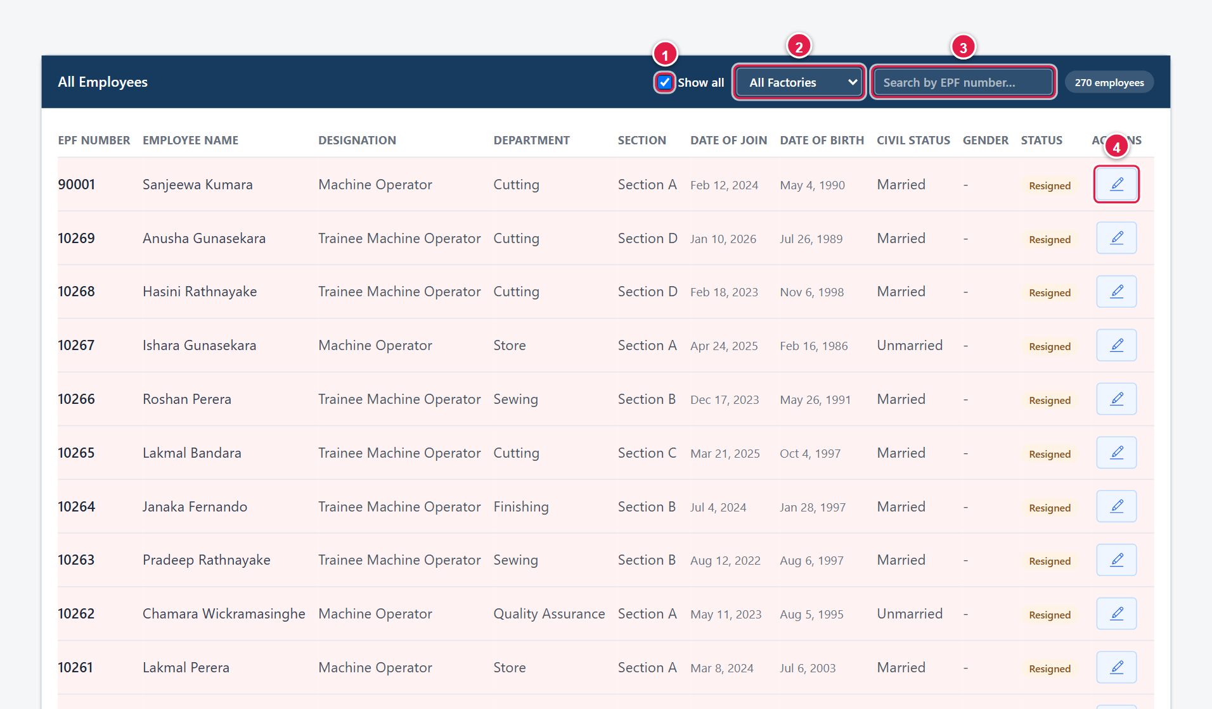
Figure 44. The Administrator view with **Show all** ticked: (1) Show all, (2) factory filter, (3) search, (4) Edit.
The Status column reads Resigned when the employee has a Date of Resign, and Active otherwise.
Completing or correcting an employee
- Click the pencil (Edit) icon on the employee’s row. The Edit Employee form opens above the list.
- Fill in Date of Birth (1), Civil Status (2) – Married or Unmarried – and Gender (3) – Male or Female. The other fields (EPF Number, Name, Designation, Department, Section, dates and reason) can also be corrected if they were entered wrongly.
- Click Update (4). “Employee updated successfully.” appears. Click Cancel to leave without saving (you are asked to confirm if you have made changes).
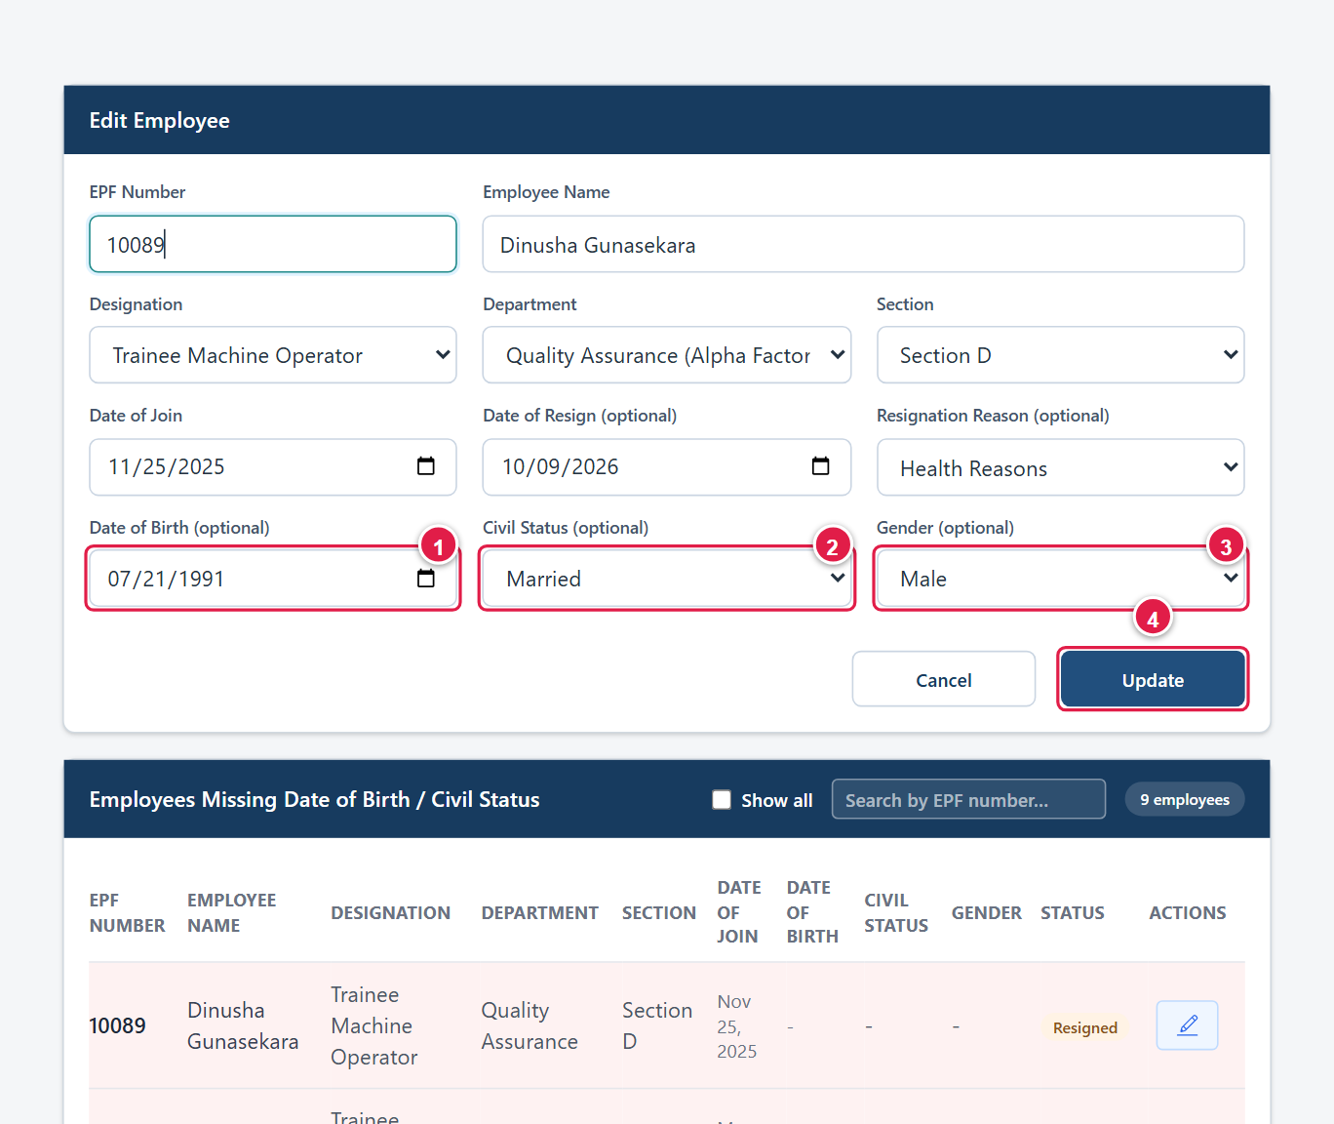
Figure 45. Edit Employee: (1) Date of Birth, (2) Civil Status, (3) Gender, (4) Update.
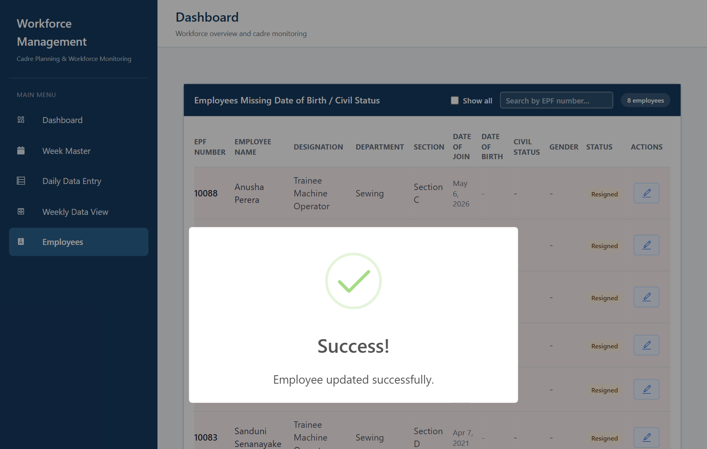
Figure 46. Confirmation after updating an employee. The list now has one fewer employee missing details.
Tip: Completing Date of Birth and Civil Status removes the grey “Not Recorded” slices from the Dashboard’s LTO by Age and LTO by Civil Status charts.

3.6 Administration
The Admin section of the menu holds the pages that maintain the system’s reference data. Administrators can add, change and delete; SuperUsers can open these pages but every add, edit and delete control is hidden. Users do not see the section (except Employees, section 3.5).

3.6.1 Users (Administrators only)
Use Users to activate new accounts, give each person a role and a factory, reset passwords and remove accounts.
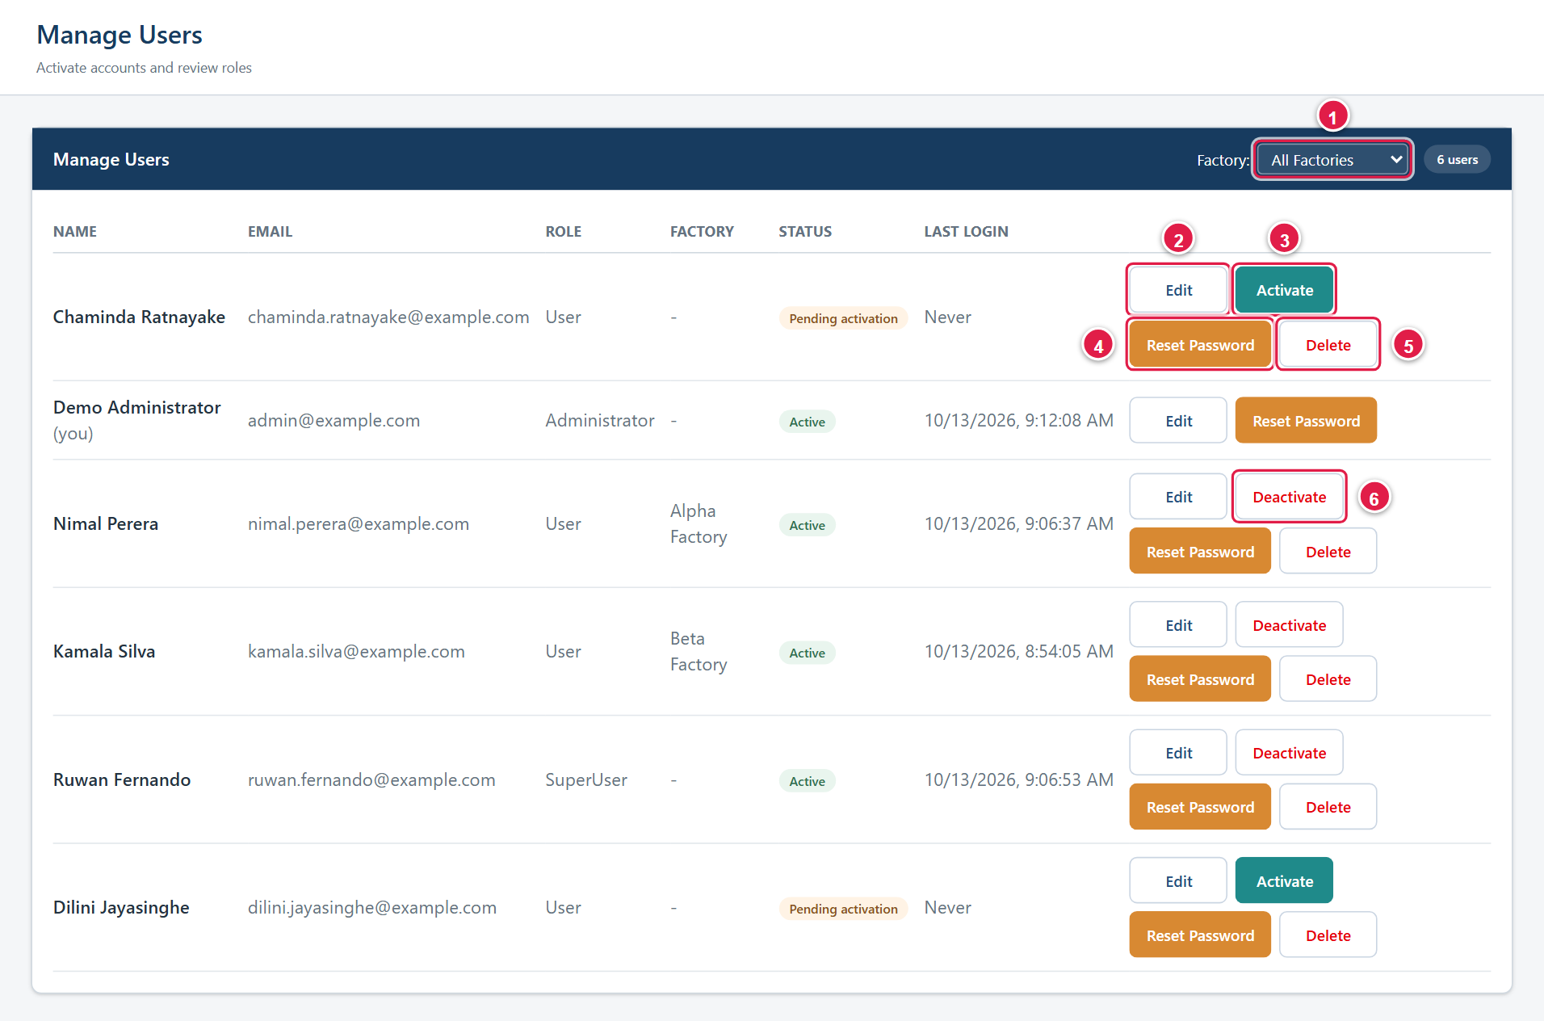
Figure 14. Users: (1) factory filter, (2) Edit, (3) Activate, (4) Reset Password, (5) Delete, (6) Deactivate.
The table shows each person’s name, email, role, factory, Status (Active or Pending activation) and last login.
Activating a new account
- Open Users. New registrations show Pending activation.
- Click Edit (2) first if you want to set the role and factory (see below).
- Click Activate (3). The message “… activated.” appears and the person can now log in.
Important: New accounts are created with the User role and no factory. A User with no factory sees empty charts on the Dashboard. Assign the correct factory before telling the person that the account is ready.

Changing a person’s role or factory
- Click Edit (2) on the person’s row. The Edit User panel opens above the table.
- Change Full Name (1), Email (2), Role (3) – User, SuperUser or Administrator – or Factory (4). Choose Unassigned to remove the factory.
- Click Save Changes (5). “User updated.” appears. Click Cancel to close without saving.
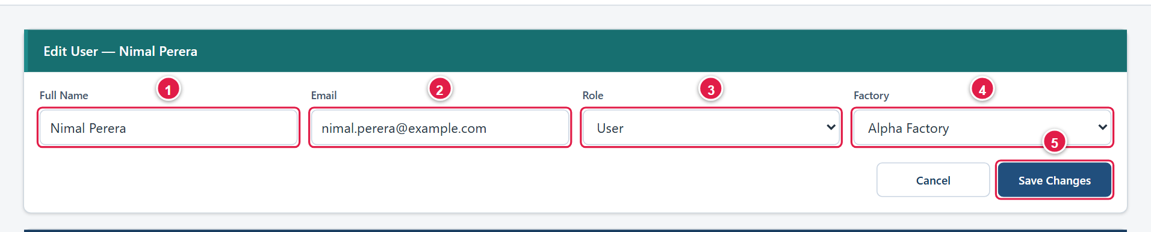
Figure 15. Edit User: (1) name, (2) email, (3) role, (4) factory, (5) Save Changes.
Deactivating or reactivating an account
Click Deactivate (6) to stop someone signing in without deleting their account; click Activate to restore access. You cannot deactivate or delete your own account. Deactivate the account of anyone who leaves the company or changes duties immediately.
Resetting a password
- Click Reset Password (4) on the person’s row and confirm the prompt. The person’s current password stops working at once.
- A Password Reset panel shows the new temporary password (1). It is shown only once. Click Copy (2) or write it down.
- Give the temporary password to the person through a private channel. Do not email it with their username in the same message or post it in a group chat.
- Click Dismiss (3) when done. At next login the person must choose their own password (section 2.5).
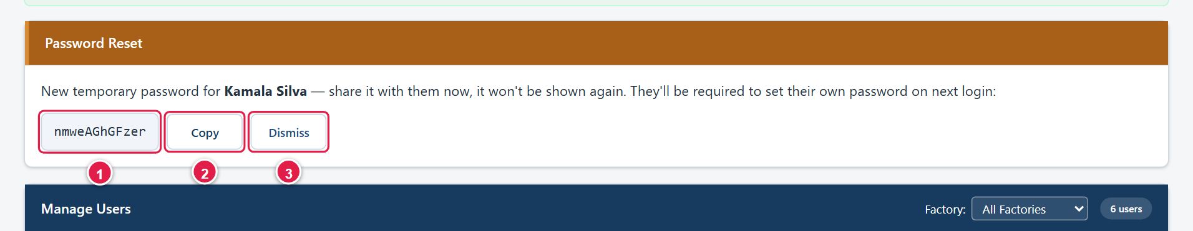
Figure 16. A reset password panel: (1) temporary password, (2) Copy, (3) Dismiss.
Deleting an account
Click Delete (5) and confirm the prompt “Permanently delete …? This cannot be undone.” Prefer Deactivate unless an account was created by mistake.

3.6.2 Factory Master
Factory Master lists the factories (code and name). Every other page that has a factory selector uses this list.
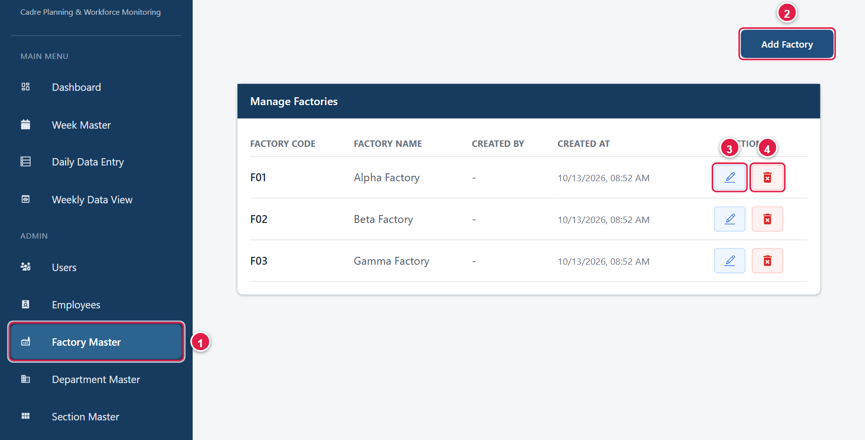
Figure 17. Factory Master: (1) menu item, (2) Add Factory, (3) Edit, (4) Delete.
- Click Factory Master, then Add Factory (2).
- Type the Factory Code (1) – a short unique code – and the Factory Name (2).
- Click Save (3). “Factory created successfully” appears. Click Cancel (4) to close the form.
- To change a factory, click the pencil icon, edit, and click Update.
- To remove a factory, click the bin icon and confirm “Are you sure you want to delete …?”
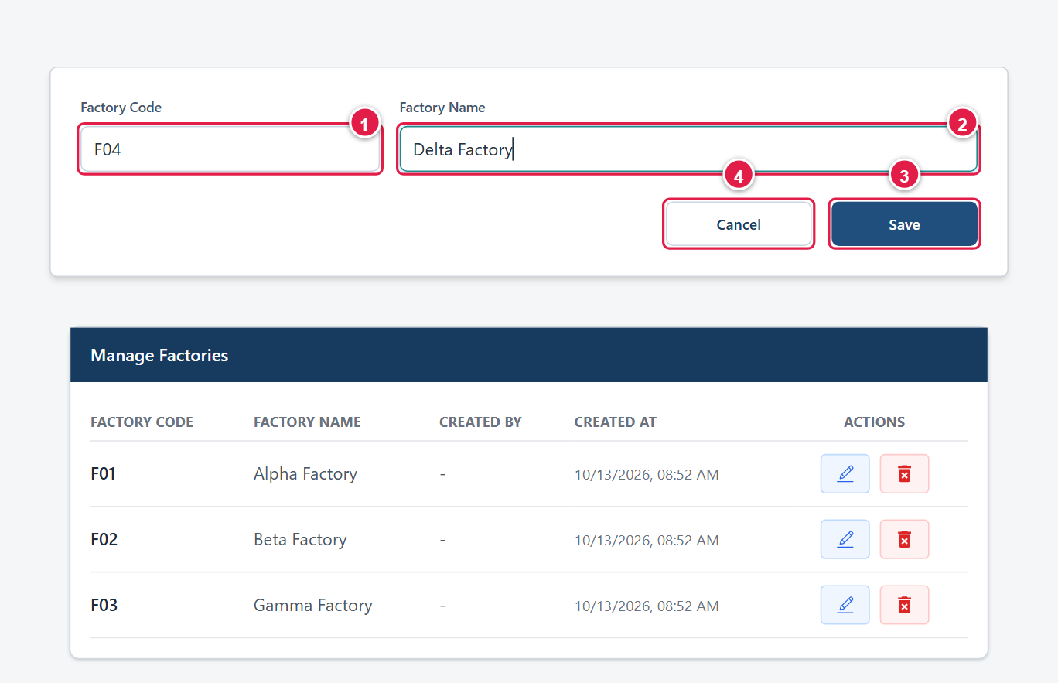
Figure 18. Adding a factory: (1) code, (2) name, (3) Save, (4) Cancel.
Caution: Delete a factory only if it was created by mistake. Factory codes must be unique.

3.6.3 Department Master
Departments belong to a factory (for example, Cutting or Sewing in Alpha Factory). They are chosen in the employee pop-ups and on the Employees page.
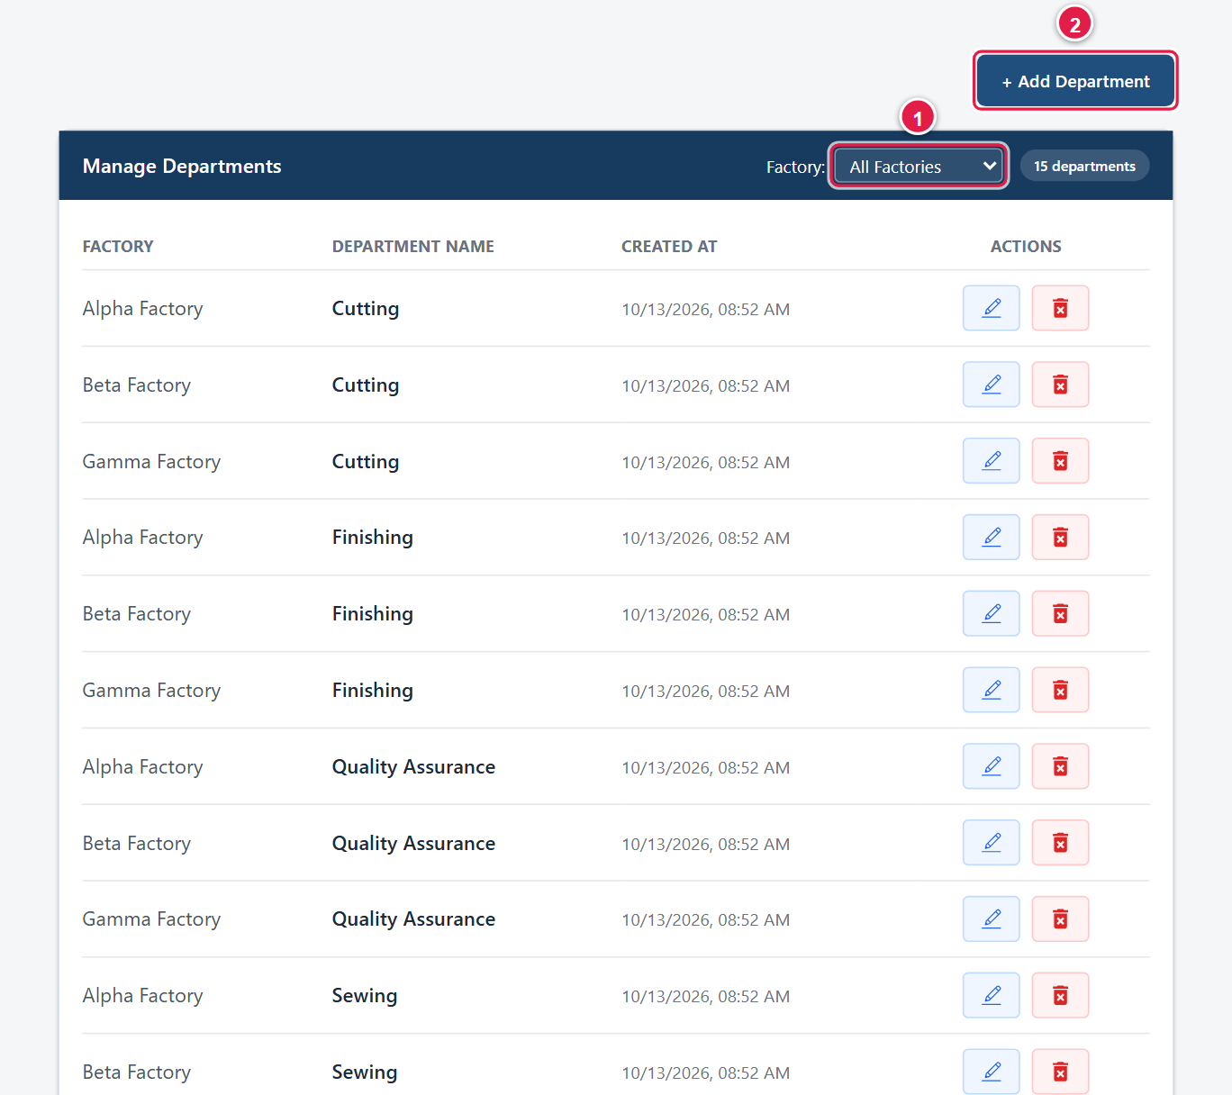
Figure 19. Department Master: (1) factory filter, (2) Add Department.
- Click Department Master. Use the Factory filter (1) to narrow the list.
- Click + Add Department (2), choose the Factory, type the Department Name, and click Save.
- Use the pencil to rename and the bin to delete. A department that is still used by employees cannot be deleted (“This department is still assigned to one or more employees…”).

3.6.4 Section Master and 3.6.5 Designation Master
Sections (for example, Section A) and designations (for example, Machine Operator) are lists shared by all factories. Both pages work the same way: click + Add Section or + Add Designation, type the name, click Save; use the pencil to rename and the bin to delete. An entry that is still used by employees cannot be deleted.
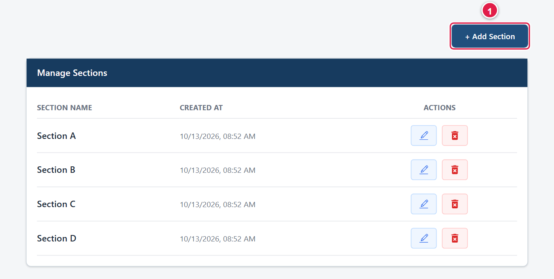
Figure 20. Section Master.
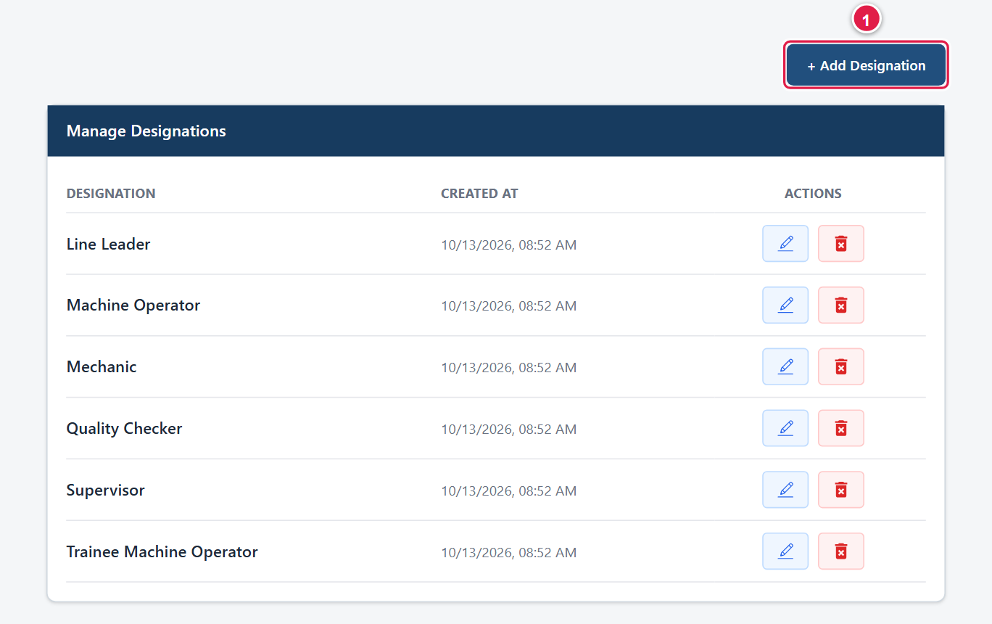
Figure 21. Designation Master.

3.6.6 Service Range
Service Ranges define the length-of-service groups in the Dashboard’s LTO by Length of Service chart. Each range is an upper limit in years and months. The chart groups resigned employees as “less than the first limit”, “between one limit and the next”, and “the last limit and above”.
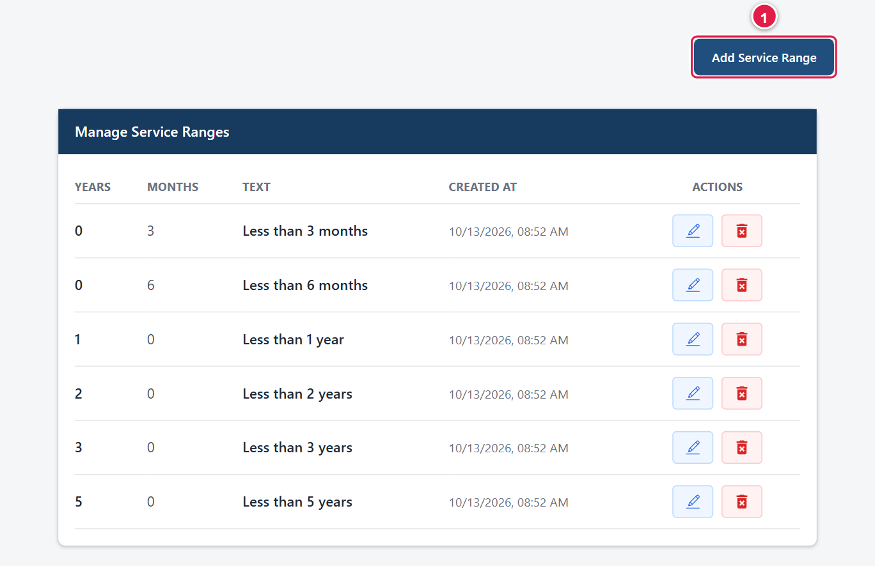
Figure 22. Service Range list. The **Text** column shows how each limit appears on the Dashboard.
- Click Service Range, then Add Service Range.
- Enter Years (1) and Months (2), for example 4 years and 0 months, and click Save (3).
- Use the pencil or bin to change or remove a range. A range that already exists (same years and months) is rejected.
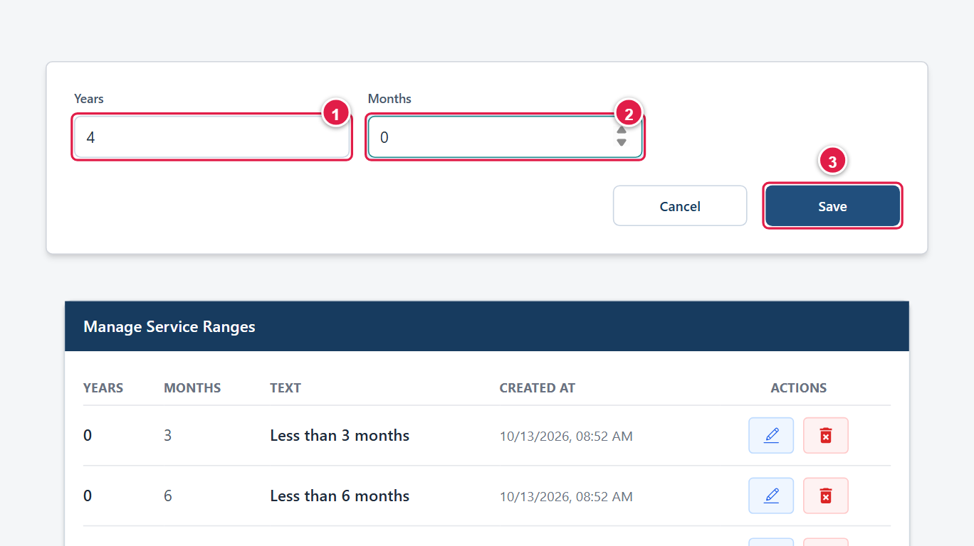
Figure 23. Adding a service range: (1) years, (2) months, (3) Save.

3.6.7 Budget Master
Budget Master holds the planned cadre for each factory. It has two tabs: Budget (planned MO and TMO) and Training Center Budget (planned trainees). The active budget for a factory supplies the Planned figures on Daily Data Entry.
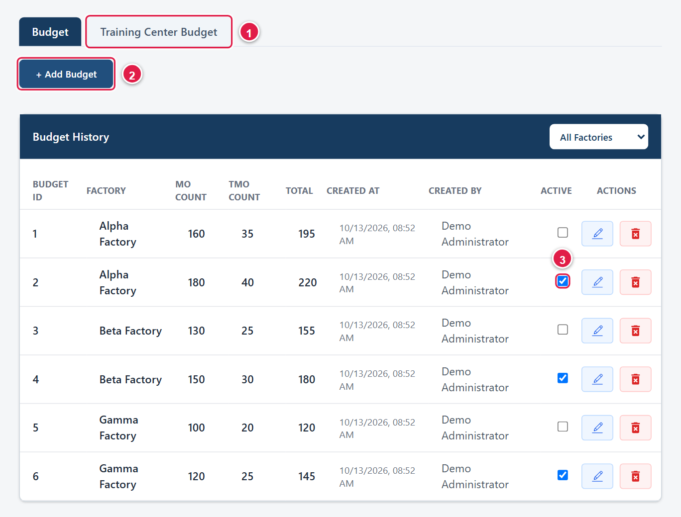
Figure 24. Budget Master: (1) Training Center Budget tab, (2) Add Budget, (3) Active checkbox.
- Click Budget Master. The Budget History table lists every budget, with the factory filter at its top right.
- Click + Add Budget (2). Choose the Factory (1), and type the MO (2) and TMO (3) counts. Total is calculated.
- Click Add (4). Click Close (5) to leave the form without saving.
- Tick the Active box (marked 3 in the Budget Master screenshot) on the budget that should apply from now on. A factory has only one active budget: ticking one automatically un-ticks that factory’s others.
- Click the Training Center Budget tab (1) to do the same for the trainee budget, which has a single Planned number.
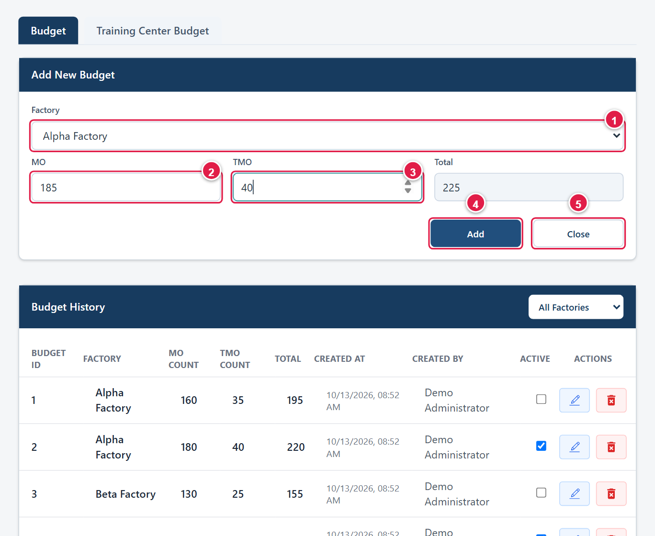
Figure 25. Adding a budget: (1) factory, (2) MO, (3) TMO, (4) Add, (5) Close.
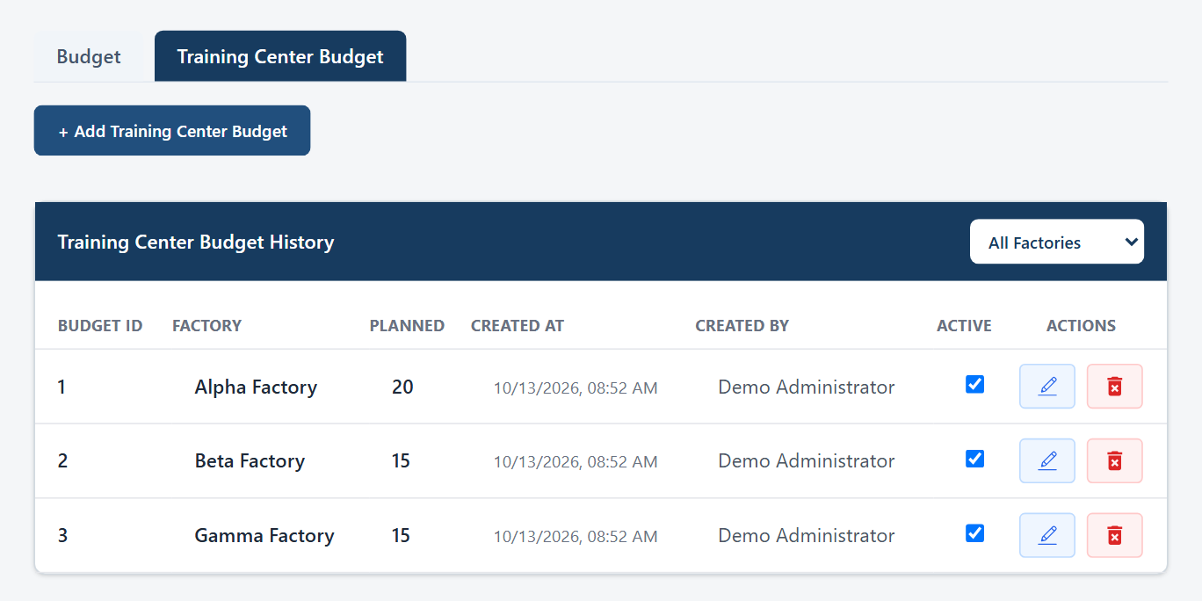
Figure 26. The Training Center Budget tab.
Tip: To change a budget going forward, add a new budget and make it active instead of editing the old one. Earlier daily records refer to the budget they were saved with.

3.6.8 Resignation Reasons
This list supplies the Reason for Resign choices in the employee pop-ups, and the reasons shown in the Dashboard’s LTO by Reason chart.
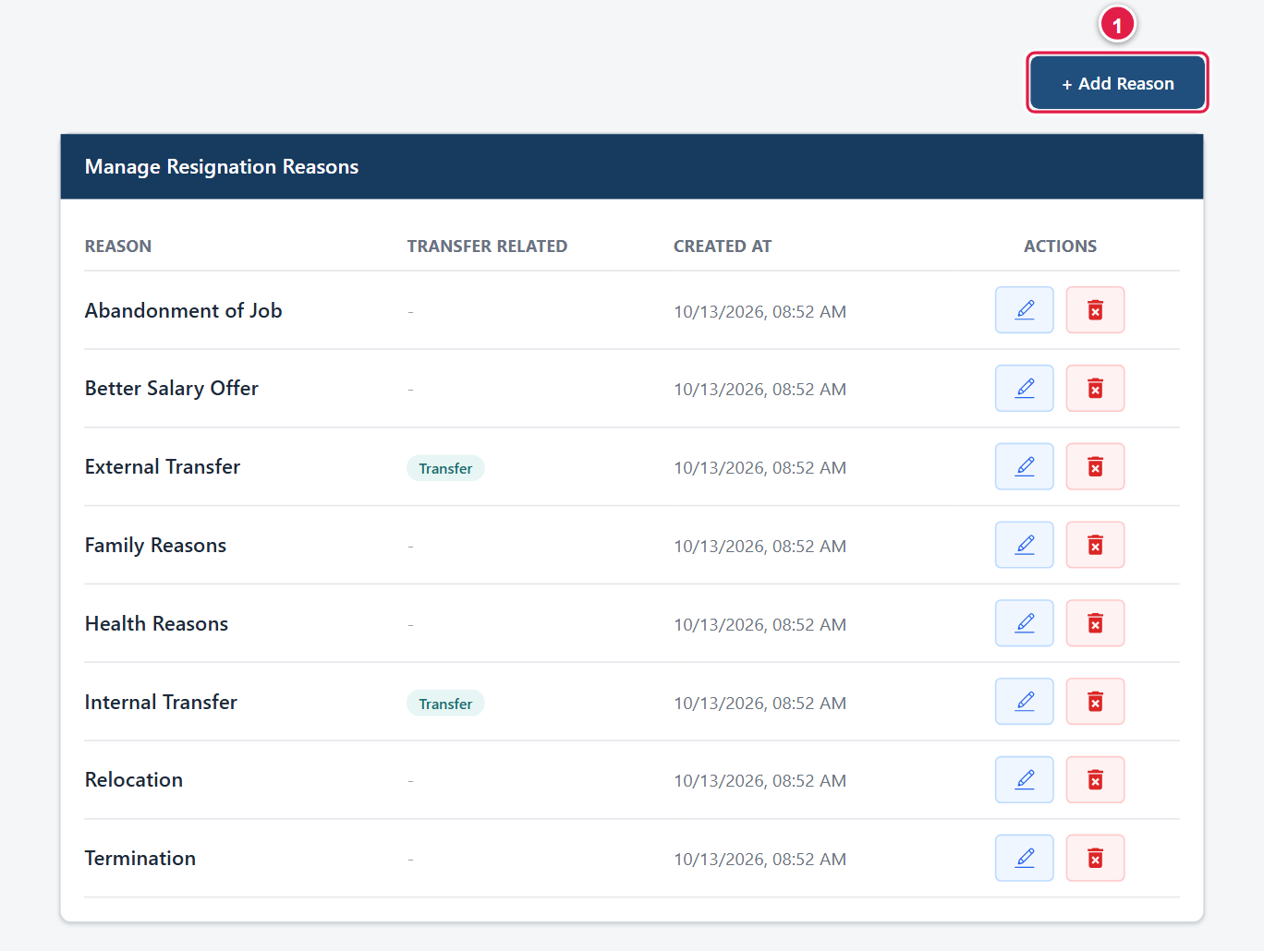
Figure 27. Resignation Reasons. The **Transfer** tag marks the reasons used by the Transfer pop-up.
- Click Resignation Reasons, then + Add Reason (1).
- Type the Resignation Reason and click Save.
- Use the pencil to rename and the bin to delete.
Note: Internal Transfer and External Transfer are marked as transfer-related and are suggested by the Transfer pop-up. Leave them in place.

3.7 Messages and troubleshooting
What you see | Likely cause and what to do
Your account is pending admin activation. | An administrator has not activated the account yet. Contact them.
You must change your password before continuing. | An administrator reset your password. Complete the Set a new password page (section 2.5).
Invalid or expired session. Please log in again. | Your sign-in has timed out (about 24 hours). Log in again.
You don’t have permission to do that. / Your account only has view access. | Your role does not allow that action. If you believe it should, ask an administrator to check your role.
Dashboard charts say “No data to show yet.” | No daily records exist for the chosen factory, month or year. Change the filters, or enter data.
“No factory is assigned to your account.” | Ask an administrator to assign your factory in Users.
Planned MO/TMO shows 0 with “No active budget set for this factory in Budget Master.” | An administrator must add and activate a budget for the factory (section 3.6.7).
Week shows “No week configured for this date”. | Add the week in Week Master (section 3.2), then enter the record.
“No Designations/Departments/Sections/Resignation Reasons found yet” in an employee pop-up. | The reference lists are empty. Ask an administrator to add them (section 3.6).
A saved record is not in Daily Data Records. | Check the Month (and Factory) filter above the table.
The title bar says “Dashboard” on another page. | This is only a display quirk. The highlighted menu item shows the real page.
An Excel file does not appear. | Check your browser’s downloads list. The browser may have blocked the download; allow it and try again.

If a problem continues, note the page, what you were doing and the exact message, and contact your administrator or IT support (IT support contact details).

4. User Responsibilities and Security
The system holds personal information about employees – names, EPF numbers, dates of birth, civil status, gender and reasons for leaving – and figures that management relies on. Everyone who uses it is responsible for keeping that information accurate and protected.

4.1 Data accuracy
- Enter data on the day. Record each day’s movements promptly, so the Weekly Data View and Dashboard are current.
- Check before you save. Confirm the factory and date, and review the calculated Shortage, Allocated_Current and Present figures. Errors carry forward, because the next day’s opening figure comes from today’s Allocated_Current.
- One record per factory per day. Correct mistakes by editing the record, not by adding a second one.
- Record every leaver in full. Enter the correct EPF number, name, designation, department, section, dates and reason. Give Date of Birth and Civil Status whenever you have them.
- Counts must match details. The number of employee rows must equal the MO and TMO counts you typed.
- Delete only with approval. Deleting a record or an employee cannot be undone and affects reports.
- Report problems. If you find wrong data you cannot correct yourself, tell your supervisor or administrator rather than working around it.

4.2 Access permissions
- Use only the access your role gives you. Do not try to open pages or data you are not meant to see.
- Work on your own factory’s records. Check that the correct factory is selected before saving.
- Tell an administrator if you can see or change something you should not, or cannot do something you need for your job.
- Administrators: give people the lowest role they need, assign every person the correct factory, deactivate accounts of leavers and role-changers at once, and review the Users list regularly. Activate an account only when you know the person who registered it.
- SuperUser access is view-only by design. Do not share SuperUser or Administrator credentials to “get a job done”.

4.3 Password security
- Choose a password of at least 8 characters. The system minimum is 8, but a longer passphrase of 12 or more characters mixing letters, numbers and symbols is much safer.
- Do not reuse a password from another system, and do not use obvious words such as your name or the company name.
- Never share your password, and never ask anyone else for theirs. IT staff and administrators will not ask for your password.
- Do not write your password where others can see it, and do not let a browser save it on a shared computer.
- Change a temporary password as soon as you receive it (section 2.5).
- Log out when you leave your desk and at the end of every session. The system remembers you in the browser for up to 24 hours.
- If you think someone else knows your password, ask an administrator to reset it immediately.

4.4 Appropriate system usage
- Use the system only for official workforce planning and reporting.
- Treat all employee information as confidential personal data. Do not discuss it, copy it or share screenshots or Excel downloads with anyone who is not authorised.
- Store downloaded Excel files in approved locations only, and delete them when they are no longer needed.
- Do not enter test, false or placeholder data in the live system.
- Do not try to bypass controls, probe the system for weaknesses, or interfere with other users’ data.
- Follow your company’s data protection, IT and acceptable-use policies at all times.

4.5 Reporting a problem or security concern
Report immediately to your administrator or IT support (IT support contact details) if you suspect an account has been misused, a password has been disclosed, a device with the system open has been lost, or you notice data that looks wrong or that you should not be able to see.
Checklist: Quick checklist before you click Add to Table
Right factory? Right date? Week detected? Opening figures correct? Resigned and Transfer details complete? Absenteeism entered? Totals look sensible?

Appendices

Appendix A – Roles and permissions at a glance
Capability | User | SuperUser | Administrator
Register an account | Anyone (needs activation) | – | –
Dashboard | Own factory | All factories | All factories
Dashboard: Factory filter and Absenteeism Rate | No | Yes | Yes
Week Master: view weeks | Yes | Yes | Yes
Week Master: add or change weeks | Yes | No | Yes
Daily Data Entry: view records | Own factory by default | All factories | All factories
Daily Data Entry: add, edit, delete records | Yes | No | Yes
Daily Data Entry: Unlinked Employees list | No | Yes | Yes
Weekly Data View and Excel downloads | Yes | Yes | Yes
Employees: view | Own factory | All factories | All factories
Employees: edit details | Yes | No | Yes
Users: activate, edit, reset password, deactivate, delete | No | No | Yes
Factory, Department, Section, Designation, Service Range, Resignation Reasons: view | No | View only | Yes
Same pages: add, edit, delete | No | No | Yes
Budget Master (MO/TMO and Training Center): view | No | View only | Yes
Budget Master: add, edit, delete, activate | No | No | Yes

Employee records cannot be added or deleted from the Employees page by any role; they are created from Daily Data Entry.

Appendix B – Document history
Version | Date | Description | Prepared by
1.0 | 13 October 2026 | First release, describing system version 1.4.2. | Concord IT Team

