Adaptive Dual-Graph Neural Learning for Intelligent Web API Service Composition

Abstract: The Web APIs has significantly expanded and enhanced the flexibility of service required applications, but it has also made the task of selecting compatible APIs for service composition has become very much difficult. Traditional service recommendation approaches often restricted to the on sparse invocation data or isolated feature representations, limiting their ability to hold the deeper collaborative and functional relationships among services. For addressing these challenges, this project proposes an adaptive service recommendation framework based upon a dual-graph neural learning paradigm. The proposed approach models the service ecosystem using two complementary graph structures: a mash up API invocation graph that captures real usage interactions, and an API tag association graph that represents semantic and functional relationships among APIs. A multi-layer graph neural network is employed to propagate information across higher-order connections, authorizing the model to uncover latent collaborative patterns that are missed by shallow learning methods. To improve the performance and decrease the degradation caused by over-smoothing in deep graph propagation, an interactive attention mechanism is used which is to dynamically weight the contributions of different propagation layers. Apart from these, service feature embedding’s integrated with structural representations to form an end-to-end learning framework. And being evaluated on the real world service datasets demonstrates that the proposed model significantly improves recommendation accuracy compared to conventional collaborative filtering and single graph neural network approaches.

List of Figures

Figure No. | Title | Page No.
1.1 | t-SNE Visualization of Mash up and API | 39
1.2 | Hit Ratio of Main Model | 39
1.3 | NDCG of Main Model | 39
2.1 | SAC-GNN Model Performance | 40
2.2 | NeuMF Model Performance | 40
2.3 | RTM+ATF Model Performance | 40
2.4 | GC-MC Model  Performance | 40
2.5 | MGNN Model Performance | 40
2.6 | NGCF Model Performance | 40
2.7 | LRCC Model Performance | 41
2.8 | SERVICE-KNN Model Performance | 41
2.9 | ISRMM Model Performance | 41
2.10 | BRF-MF Model Performance | 41
2.11 | Cold-Start Model  Performance | 41

Abbreviations

SAC-GNN Self-Attention based Collaborative Graph Neural Network

Service-KNN Service-based K-Nearest Neighbors

BPR-MF Bayesian Personalized Ranking with Matrix Factorization

NeuMF Neural Matrix Factorization

RTM+AFM Relational Topic Model + Attentional Factorization

GC-MC Graph Convolutional Matrix Completion

NGCF Neural Graph Collaborative Filtering

MGNN Multi-Graph Neural Network

LSRCC Location-Social Relationship-aware Collaborative Filtering

ISRMM Implicit Social Recommendation with Multi-Modal data

HR Hit Ratio

NDCG Normalized Discounted Cumulative Gain

MAP Mean Average Precision

Abstract

The Web APIs has significantly expanded and enhanced the flexibility of service required applications, but it has also made the task of selecting compatible APIs for service composition has become very much difficult. Traditional service recommendation approaches often restricted to the on sparse invocation data or isolated feature representations, limiting their ability to hold the deeper collaborative and functional relationships among services. For addressing these challenges, this project proposes an adaptive service recommendation framework based upon a dual-graph neural learning paradigm. The proposed approach models the service ecosystem using two complementary graph structures: a mash up API invocation graph that captures real usage interactions, and an API tag association graph that represents semantic and functional relationships among APIs. A multi-layer graph neural network is employed to propagate information across higher-order connections, authorizing the model to uncover latent collaborative patterns that are missed by shallow learning methods. To improve the performance and decrease the degradation caused by over-smoothing in deep graph propagation, an interactive attention mechanism is used which is to dynamically weight the contributions of different propagation layers. Apart from these, service feature embedding’s integrated with structural representations to form an end-to-end learning framework. And being evaluated on the real world service datasets demonstrates that the proposed model significantly improves recommendation accuracy compared to conventional collaborative filtering and single graph neural network approaches.

Table of Contents

Title Page No.

Bonafide Certificate ii
Acknowledgments iii
List of Figures iv
Abbreviations v
Abstract vi
- Summary of the base paper 8
- Merits and Demerits of the base paper 12
- Source Code 14
- Snapshots 21
- Conclusion and Future Plans 26
- References 27
- Appendix - Base Paper 28

CHAPTER 1
SUMMARY OF THE BASE PAPER
Title : Adaptive Dual-Graph Neural Learning for Intelligent Web API Service Composition
Authors : Jiawei Lu ,Duanni Li ,Wanchuang Cai , Jiahong Zheng ,Gang Xiao
Year : 2025
Indexed in : SCI (Science Citation Index)

Introduction

The study focuses on improving a most advanced service recommendation system to help developing people select more suitable Web APIs to build apps. The rapid improve of APIs that are available, finding the right set of services became most difficult. Normal recommendation techniques are failing to capture the relationships that are complex between APIs and mash ups, it is resulting in much less accurate recommendations. This limitation can be overcome by the introduction in paper the SAC-GNN (Service Attention Connection Graph Neural Network) framework, it uses Graph Neural Networks for model and among services it learns both structural and semantic relationships.
System that proposed constructs two important graph representations: the Mash up-API Invocation Graph (MAIG) and the API-Tag Connection Graph (ATCG). MAIG records interaction between the mash ups and APIs based on their invocation relationships, whereas ATCG notes semantic similarities between APIs with help of shared tags. To propagate information across these graphs this model uses a multi-layer GNN architecture, helping that to learn deeper and indirect relationships. More Importantly multi-layer propagation leads to over-smoothing, and node representations become unable distinguishable. In this regard an interactive attention mechanism is introduced for giving appropriate importance to various layers, such that it enables meaningful feature learning.
And then using both structural data and textual descriptions the model integrates API representations and balanced with a gate mechanism to improve feature quality. More over using semantic similarity, a new service requirement is mapped to existing mash ups and relevant APIs are recommended based on calculated scores. The training of model is using a Bayesian Personalized Ranking (BPR) loss function that improves its ability to separate between relevant and irrelevant APIs, whereas graph dropout method stops over-fitting. The results of Experiments got tells that the SAC-GNN model achieved high performance when compared to remaining methods, so that it is effective and robust solution for service recommendation systems.

ARCHITECTURE – Main Model

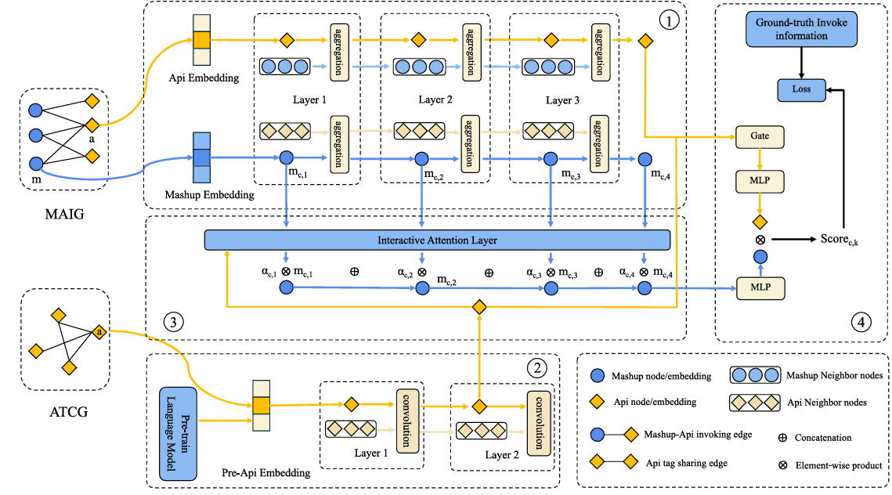

- Multi-layer aggregation + interaction
- This part is the core representation learning for mash ups and APIs.
- At each layer:
  - Neighbor information is aggregated (like in a graph neural network).
  - Mash up and API features are refined step by step.
- API feature extraction from descriptions
- API descriptions (text) are first encoded using a pre-trained language model.
- Then passed through convolution layers (CNNs): These extract local semantic patterns (important phrases/features).
- Tag-based graph information
- APIs are connected through shared tags (ATCG: API Tag Co-occurrence Graph).
- Tags are also embedded (via the same pre-trained language model).
- This creates another signal showing:
  - Which APIs are semantically related via tags.
- Prediction + training
- This is the final decision and learning step.
- Inputs:
  - Mash up representation
  - API representation
- A gating mechanism decides how much to rely on different features.
- The methodology flow chart is as follows:

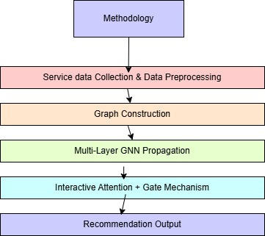
ARCHITECTURE – Novelty Included
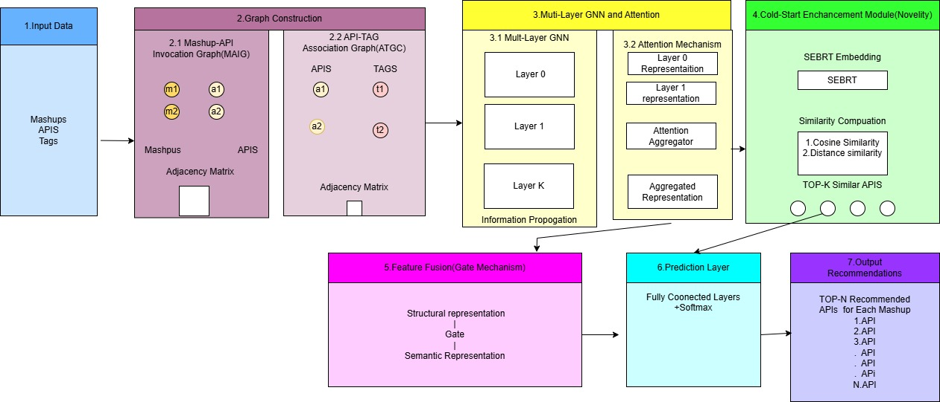
- Input Layer
- This model is taking three primary inputs: mash ups, APIs, and their associated tags. Mash up–API interaction data will help in detecting the usage relationships.
- Where, API–tag information provides semantic context. These heterogeneous data sources will serve as the foundation for constructing the dual-graph representation.

- Dual-Graph Constructions
2.1 Mash up–API Invocation Graph (MAIG):
This bipartite graph represents the interaction between mash ups and APIs. An edge is established if a mash up invokes a particular API.
2.2 API–Tag Association Graph (ATCG):
This graph will help in connecting APIs with their descriptive tags.

- Multi-Layer Graph Neural Network
- The embedded features are propagated through multiple layers of a Graph Neural Network to capture higher-order relationships.
- This process enables each node to aggregate information from its neighbors, thereby learning enriched representations.
- Cold-Start Enhancement Module
- This enhancement will effectively handle newly introduced APIs with limited or no interaction data, a cold-start module is infiltrate as a key component of the architecture.
- This module influences SBERT embedding’s to represent API descriptions and figures similarity between APIs using both cosine similarity and distance-based measures.

- Gate Mechanism
- The model will also integrate structural features from the mash up–API graph and semantic features from the API–tag graph via a new technique called fusion mechanism.
- This step produces incorporated representation that will be capturing both interaction patterns and contextual information, thus improving the recommendation capability.

- Prediction Layer
- The fused representations are passed along a prediction layer that will be used in generating a ranked list of recommended APIs for each mash up.
- The ranking is based on importance scores computed from the learned embedding’s.

- Output Recommendation Layer
- This is the final stage of the proposed architecture is the output recommendation layer, which is responsible for generating a ranked list of APIs for each mash up based on the learned representations.
- After the feature fusion and cold-start enhancement modules, each API and mash up is represented by a unified embedding that captures both structural relationships and semantic information.

CHAPTER 2

MERITS AND DEMERITS OF THE BASE PAPER

MERITS:

- Relevance: The paper addresses the real-world problem of service recommendation in service-oriented computing, which is critical due to the rapid increase in available Web APIs.
- Advanced Methodology: It utilizes Graph Neural Networks (GNNs), which are highly effective for modeling relationships in non-Euclidean data such as graphs.
- Dual-Graph Approach: The use of both MAIG and ATCG allows the model to capture both structural (invocation) and semantic (tag-based) relationships, improving recommendation accuracy.
- Multi-layer Learning: The multi-layer GNN architecture captures high-order relationships between services, enabling deeper understanding of interactions.
- Interactive Attention Mechanism: This mechanism effectively mitigates the over-smoothing problem and ensures important features are prioritized during learning.
- Feature Fusion Strategy: The integration of multiple data sources (API descriptions, tags, and invocation data) improves the richness of feature representations.
- Strong Experimental Validation: The model is tested on real-world datasets and compared with multiple baseline methods, showing superior performance across metrics like HR, NDCG, and MAP.
- Handling Data Sparsity: The graph-based approach helps overcome sparsity issues commonly found in service invocation data.

DEMERITS:

- High Computational Cost: The multi-layer GNN and attention mechanisms increase computational complexity and require high-end hardware for training.
- Over-Smoothing Risk: Although addressed, multi-layer GNNs inherently risk over-smoothing, which may still affect performance in deeper networks.
- Dependence on Graph Quality: The model’s performance heavily relies on the quality of constructed graphs (MAIG and ATCG). Poor or noisy data can degrade results.
- Limited Real-Time Evaluation: The paper does not thoroughly analyze real-time recommendation performance or system latency.
- Complex Architecture: The model is relatively complex compared to traditional methods, making implementation and deployment more difficult.
- Cold Start Problem Not Fully Solved: While partially addressed, recommending APIs for completely new mash ups with no prior data remains challenging.
- Limited Dataset Diversity: The evaluation is based on a specific dataset; testing on more diverse datasets would strengthen generalization claims.
- Interpretability Issues: Like many deep learning models, SAC-GNN lacks explainability, making it harder to interpret why certain recommendations are made.

CHAPTER 3 SOURCE CODE

- SAC-GNN MODEL

import numpy as np
import torch
import torch.nn as nn
import parser_init as parser
import data_read as dr
import model_test
import random
import graph_calculate as gc
import MAIGNet
import time
import lm_features as lm
from torch.optim.lr_scheduler import LambdaLR
from torch.optim.lr_scheduler import StepLR

args = parser.init_parser()

def train(mashup_list, api_list, sample_num, m_a_id, model, optimizer, scheduler=None):
pos_api_index, neg_api_index = model_test.sample_pos_neg_api(
mashup_list, api_list, sample_num, m_a_id
)

whole_train_api_index = pos_api_index + neg_api_index
mashup_embeddings, api_embeddings = model(mashup_list, whole_train_api_index)

pos_num = len(pos_api_index)
pos_api_embeddings = api_embeddings[:pos_num]
neg_api_embeddings = api_embeddings[pos_num:]

mf_loss = 0

if args.loss_func == 'sample_bpr':
mf_loss = model.bpr_loss(mashup_embeddings, pos_api_embeddings, neg_api_embeddings)
elif args.loss_func == 'whole_bpr':
mf_loss = model.whole_bpr_loss(mashup_embeddings, pos_api_embeddings, neg_api_embeddings)

optimizer.zero_grad()
mf_loss.backward()
optimizer.step()

if scheduler is not None:
print("Learning rate: %f" % (optimizer.param_groups[0]['lr']))
scheduler.step()

return mf_loss
def multi_train(mashup_list, api_list, pos_sample_num, neg_sample_num, m_a_id, model, optimizer, scheduler=None):
m_pos_dic, m_neg_dic = model_test.sample_multi_pos_neg_api(
mashup_list, api_list, pos_sample_num, neg_sample_num, m_a_id
)

mashup_embeddings, api_embeddings = model(mashup_list, api_list)

loss = 0

if args.loss_func == 'sample_bpr':
loss = model.multi_bpr_loss(mashup_list, mashup_embeddings, api_embeddings, m_pos_dic, m_neg_dic)
elif args.loss_func == 'whole_bpr':
loss = model.multi_whole_bpr_loss(mashup_list, mashup_embeddings, api_embeddings, m_pos_dic, m_neg_dic)

optimizer.zero_grad()
loss.backward()
optimizer.step()

if scheduler is not None:
print("Learning rate: %f" % (optimizer.param_groups[0]['lr']))
scheduler.step()

return loss

if __name__ == "__main__":

mashup_data_file_name = "recommend_mashup_api_id_more_than_3.txt"
api_data_file_name = "recommend_api_share_tag_id_more_than_3.txt"
api_desc_divide_file_name = "recommend_api_divide_description.txt"

m_id, a_id, m_a_id = dr.read_mashup_api(mashup_data_file_name)
s_a_id, a_a_id = dr.read_api(api_data_file_name)

api_w2v_vec_file_name = "recommend_api_w2v_vec.txt"
api_bert_vec_file_name = "recommend_api_bert_vec.txt"

mashup_num = len(m_id)
api_num = len(a_id)

MAIG_adj_matrix, MAIG_norm_adj_matrix = gc.create_scipy_adjacency_matrix_MAIG(m_id, a_id, m_a_id)
ALCG_adj_matrix, ALCG_norm_adj_matrix = gc.create_scipy_adjacency_matrix_ALCG_no_type(a_id, a_a_id)

print("Initializing training data")

train_mashup_list = random.sample(m_id, int(mashup_num * args.train_scale))
test_mashup_list = [x for x in m_id if x not in train_mashup_list]

print("train {}, test {}".format(len(train_mashup_list), len(test_mashup_list)))

t_p_e = None

if args.prepare_method == "random":
t_p_e = torch.rand([api_num, args.embed_num], out=None)

elif args.prepare_method == "word2vec":
print("Loading word2vec API features")
t_p_e = torch.tensor(
dr.read_api_w2v_vec(api_w2v_vec_file_name, api_num, args.prepare_embed_dim_w2v)
).to(torch.float32)
print("Finished loading")

elif args.prepare_method == "bert":
print("Loading BERT API features")
t_p_e = torch.tensor(
dr.read_api_bert_vec(api_bert_vec_file_name, api_num, args.prepare_embed_dim_bert)
).to(torch.float32)
print("Finished loading")

model = MAIGNet.MAIGNet(
mashup_num,
api_num,
args.embed_num,
args.layer_size,
args.drop_out,
MAIG_norm_adj_matrix,
ALCG_norm_adj_matrix,
t_p_e,
args.mlp_layer_num,
args.mlp_layer_dim,
args.drop_out_fc,
args.device,
args.regs[0],
args.graph_dropout,
if_graph_drop=True
)

model.to(args.device)

optimizer = torch.optim.Adam(model.parameters(), lr=args.learn_rate)
schedule = StepLR(optimizer, step_size=1000, gamma=0.1)

max_average_hrk, max_average_ndcg = 0, 0

for i in range(args.epoch):

t1 = time.time()
loss = multi_train(
train_mashup_list,
a_id,
args.pos_sample_num,
args.neg_sample_num,
m_a_id,
model,
optimizer,
schedule
)
t2 = time.time()
print("epoch {}, loss {}, time {}s".format(i, loss, round((t2 - t1), 1)))

if i != 0 and i % 20 == 0:
t5 = time.time()
print("train metric:")
model_test.test(model, train_mashup_list, a_id, m_a_id, args)
t6 = time.time()
print("time {}".format(round(t6 - t5, 1)))

t3 = time.time()
print("test metric:")
average_hrk, average_ndcg = model_test.test(model, test_mashup_list, a_id, m_a_id, args)

if average_ndcg > max_average_ndcg:
max_average_ndcg = average_ndcg
if average_hrk > max_average_hrk:
max_average_hrk = average_hrk

t4 = time.time()
print("time {}".format(round(t4 - t3, 1)))

if i != 0 and i % 100 == 0:
print("max hr:{}".format(max_average_hrk))
print("max ndcg:{}".format(max_average_ndcg))

- GC_MC MODEL

from comet_ml import Experiment
import torch
import yaml

import data_read as dr
import GC_MC
import trainer
import graph_calculate as g_c
from utils import calc_rmse, ster_uniform, random_init, init_xavier, init_uniform, Config
import parser_init as parser

args = parser.init_parser()

if __name__ == "__main__":
mashup_data_file_name = "recommend_mashup_api_id_more_than_3.txt"
m_id, a_id, m_a_id = dr.read_mashup_api(mashup_data_file_name)

mashup_num = len(m_id)
api_num = len(a_id)

x, edge_index, edge_type, edge_norm, r_index, r_gt = g_c.convert_data_into_pyg_data(mashup_num, api_num, m_a_id)
num_relation = r_gt.shape[0]
num_user = len(m_id)
num_node = x.shape[0]

with open('config.yml') as f:
cfg = yaml.safe_load(f)
cfg = Config(cfg)

device = (torch.device(f'cuda:{cfg.gpu_id}')
if torch.cuda.is_available() and cfg.gpu_id >= 0
else torch.device('cpu'))
x = x.to(device)
edge_index = edge_index.to(device)
edge_type = edge_type.to(device)
edge_norm = edge_norm.to(device)
r_index = r_index.to(device)
r_gt = r_gt.to(device)

model = GC_MC.GAE(cfg, random_init, num_user, num_relation, num_node).to(device)
model.apply(init_xavier)

optimizer = torch.optim.Adam(
model.parameters(),
lr=cfg.lr, weight_decay=cfg.weight_decay,
)

trainer = trainer.Trainer(model, x, edge_index, edge_type, edge_norm, r_index, r_gt, calc_rmse,
optimizer, args.epoch, experiment=None)
trainer.training()

- MGNN MODEL

import math
import numpy as np
import data_read as dr
import random
import time

def cos_sim(vec1, vec2):
v_sum = 0

for i in range(len(vec1)):
v_sum += vec1[i] * vec2[i]

vec1_len = math.sqrt(sum([i * i for i in vec1]))
vec2_len = math.sqrt(sum([i * i for i in vec2]))

return v_sum / (vec1_len * vec2_len)

def dis_sim(vec1, vec2):
v_sum = 0

for i in range(len(vec1)):
v_sum += (vec1[i] - vec2[i]) * (vec1[i] - vec2[i])

return 1 / v_sum
def cal_sim_service_from_train(train_index, test_index, features_vec, sim_num):
t1 = time.time()

sim_service_dic = {}
sim_train_service_dic = {}
sim_matrix = np.zeros((len(test_index), len(train_index)))
for i in range(len(test_index)):
for j in range(len(train_index)):
test_vec = features_vec[test_index[i]]
train_vec = features_vec[train_index[j]]

sim = dis_sim(test_vec, train_vec)
sim_matrix[i][j] = sim

print(i)

t2 = time.time()
print("time:{}".format(t2 - t1))

for i in range(len(sim_matrix)):
single_test_index = test_index[i]

sorted_index_list = np.argsort(-sim_matrix[i])
sorted_train_index = [train_index[x] for x in sorted_index_list]

sim_service_dic[single_test_index] = sorted_train_index[0:sim_num]
sim_train_service_dic[single_test_index] = sorted_index_list[0:sim_num]

print(single_test_index)
print(sim_service_dic[single_test_index])

return sim_service_dic, sim_train_service_dic

if __name__ == "__main__":
t_m_bert_file_name = "recommend_mashup_bert_vec.txt"
t_m_bert_feature = dr.read_mashup_bert_vec(t_m_bert_file_name, 1423, 768)

train_mashup_list = random.sample(range(1423), int(1423 * 0.95))
test_mashup_list = [x for x in range(1423) if x not in train_mashup_list]

cal_sim_service_from_train(train_mashup_list, test_mashup_list, t_m_bert_feature

- NGCF MODEL

import numpy as np
import torch
import torch.nn as nn
import parser_init as parser
import data_read as dr
import model_test
import random
import graph_calculate as gc
import time
import lm_features as lm
from torch.optim.lr_scheduler import LambdaLR
from torch.optim.lr_scheduler import StepLR
import cold_similarity as c_s
import NGCF

args = parser.init_parser()

def multi_train(mashup_list, api_list, pos_sample_num, neg_sample_num, m_a_id, model, optimizer, scheduler=None):
m_pos_dic, m_neg_dic = model_test.sample_multi_pos_neg_api(mashup_list, api_list, pos_sample_num, neg_sample_num,
m_a_id)
mashup_embeddings, api_embeddings = model(mashup_list, api_list)

loss = 0

if args.loss_func == 'sample_bpr':
loss = model.multi_bpr_loss(mashup_list, mashup_embeddings, api_embeddings, m_pos_dic, m_neg_dic)
elif args.loss_func == 'whole_bpr':
loss = model.multi_whole_bpr_loss(mashup_list, mashup_embeddings, api_embeddings, m_pos_dic, m_neg_dic)
optimizer.zero_grad()
loss.backward()
optimizer.step()
if scheduler is not None:
print("：%f" % (optimizer.param_groups[0]['lr']))
scheduler.step()

return loss

if __name__ == "__main__":

mashup_data_file_name = "recommend_mashup_api_id_more_than_3.txt"
mashup_bert_vec_file_name = "recommend_mashup_bert_vec.txt"
m_id, a_id, m_a_id = dr.read_mashup_api(mashup_data_file_name)

mashup_num = len(m_id)
api_num = len(a_id)

print("")
train_mashup_list = random.sample(m_id, int(mashup_num * args.train_scale))
test_mashup_list = [x for x in m_id if x not in train_mashup_list]
print("train {}, test {}".format(len(train_mashup_list), len(test_mashup_list)))

train_m_a_id = m_a_id[:]
for test_index in test_mashup_list:
train_m_a_id[test_index] = []
ngcf_adj_matrix, ngcf_norm_adj_matrix = gc.create_scipy_adjacency_matrix_MAIG(m_id, a_id, train_m_a_id)

t_m_bert_feature = dr.read_mashup_bert_vec(mashup_bert_vec_file_name, mashup_num, args.prepare_embed_dim_bert)
sim_service_dic, sim_train_service_dic = c_s.cal_sim_service_from_train(train_mashup_list, test_mashup_list, t_m_bert_feature, args.cold_sim_num)

model = NGCF.NGCF(mashup_num, api_num, args.embed_num, args.layer_size, args.drop_out,
ngcf_norm_adj_matrix,
args.mlp_layer_num, args.mlp_layer_dim, args.drop_out_fc,
args.device, args.regs[0], args.graph_dropout, if_graph_drop=True)
model.to(args.device)
optimizer = torch.optim.Adam(model.parameters(), lr=args.learn_rate)
schedule = StepLR(optimizer, step_size=1000, gamma=0.1)

max_average_hrk, max_average_ndcg = 0, 0
for i in range(args.epoch):

t1 = time.time()
# loss = train(train_mashup_list, a_id, args.sample_num, m_a_id, model, optimizer)
loss = multi_train(train_mashup_list, a_id, args.pos_sample_num, args.neg_sample_num, m_a_id, model, optimizer,
schedule)
t2 = time.time()
print("epoch {}, loss {}, time {}s".format(i, loss, round((t2 - t1), 1)))

if i != 0 and i % 20 == 0:

t5 = time.time()
print("train metric:")
model_test.test(model, train_mashup_list, a_id, m_a_id, args)
t6 = time.time()
print("time {}".format(round(t6 - t5, 1)))

t3 = time.time()
print("test metric:")
average_hrk, average_ndcg = model_test.cold_test(model, train_mashup_list, test_mashup_list, a_id, m_a_id, sim_service_dic, sim_train_service_dic, args)
if average_ndcg > max_average_ndcg:
max_average_ndcg = average_ndcg
if average_hrk > max_average_hrk:
max_average_hrk = average_hrk
t4 = time.time()
print("time {}".format(round(t4 - t3, 1)))

if i != 0 and i % 100 == 0:
print("max hr:{}".format(max_average_hrk))
print("max ndcg:{}".format(max_average_ndcg))

- SERVICE-KNN MODEL

import numpy as np
import random
import time

import parser_init as parser
import data_read as dr
import model_test
import cold_similarity as c_s

args = parser.init_parser()

def compute_service_similarity(m_a_id, api_num):

co_matrix = np.zeros((api_num, api_num))
freq = np.zeros(api_num)

for mashup in m_a_id:
for i in mashup:
freq[i] += 1
for j in mashup:
if i != j:
co_matrix[i][j] += 1

sim_matrix = np.zeros((api_num, api_num))

for i in range(api_num):
for j in range(api_num):
if freq[i] > 0 and freq[j] > 0:
sim_matrix[i][j] = co_matrix[i][j] / np.sqrt(freq[i] * freq[j])

return sim_matrix

def recommend_services(mashup_id, m_a_id, sim_matrix, top_k):

used_apis = m_a_id[mashup_id]
scores = np.zeros(sim_matrix.shape[0])

for api in used_apis:
scores += sim_matrix[api]

# remove already used APIs
scores[used_apis] = -1

recommended = np.argsort(scores)[::-1][:top_k]
return recommended

def evaluate(test_mashups, m_a_id, sim_matrix, top_k):
hr_list = []
ndcg_list = []

for m in test_mashups:
true_apis = m_a_id[m]
if len(true_apis) == 0:
continue

pred = recommend_services(m, m_a_id, sim_matrix, top_k)

hit = len(set(pred) & set(true_apis)) > 0
hr_list.append(1 if hit else 0)
dcg = 0
for i, p in enumerate(pred):
if p in true_apis:
dcg += 1 / np.log2(i + 2)

idcg = sum([1 / np.log2(i + 2) for i in range(min(len(true_apis), top_k))])
ndcg = dcg / idcg if idcg > 0 else 0

ndcg_list.append(ndcg)

return np.mean(hr_list), np.mean(ndcg_list)

if __name__ == "__main__":
mashup_file = "recommend_mashup_api_id_more_than_3.txt"

m_id, a_id, m_a_id = dr.read_mashup_api(mashup_file)

mashup_num = len(m_id)
api_num = len(a_id)
train_mashups = random.sample(m_id, int(mashup_num * args.train_scale))
test_mashups = [x for x in m_id if x not in train_mashups]

print(f"Train: {len(train_mashups)}, Test: {len(test_mashups)}")
print("\nEvaluating Service-KNN...")

for k in [5, 10, 20]:
t2 = time.time()

hr, ndcg = evaluate(test_mashups, m_a_id, sim_matrix, k)

print(f"K={k} | HR@{k}: {hr:.4f}, NDCG@{k}: {ndcg:.4f} | Time: {round(time.time()-t2,2)}s"

- BPR-MF MODEL

import numpy as np
import torch
import torch.nn as nn
import random
import time

import parser_init as parser
import data_read as dr
import model_test

from torch.optim.lr_scheduler import StepLR

args = parser.init_parser()

class BPRMF(nn.Module):
def __init__(self, num_users, num_items, embed_dim):
super(BPRMF, self).__init__()
self.user_embed = nn.Embedding(num_users, embed_dim)
self.item_embed = nn.Embedding(num_items, embed_dim)
nn.init.normal_(self.user_embed.weight, std=0.01)
nn.init.normal_(self.item_embed.weight, std=0.01)

def forward(self, users, pos_items, neg_items):
u = self.user_embed(users)
i = self.item_embed(pos_items)
j = self.item_embed(neg_items)
pos_scores = torch.sum(u * i, dim=1)
neg_scores = torch.sum(u * j, dim=1)
return pos_scores, neg_scores

def get_embeddings(self):
return self.user_embed.weight, self.item_embed.weight

def train(train_mashups, api_list, m_a_id, model, optimizer):
users, pos_items, neg_items = [], [], []

for u in train_mashups:
if len(m_a_id[u]) == 0:
continue
pos = random.choice(m_a_id[u])
neg = random.choice(api_list)
while neg in m_a_id[u]:
neg = random.choice(api_list)
users.append(u)
pos_items.append(pos)
neg_items.append(neg)

users = torch.LongTensor(users).to(args.device)
pos_items = torch.LongTensor(pos_items).to(args.device)
neg_items = torch.LongTensor(neg_items).to(args.device)

pos_scores, neg_scores = model(users, pos_items, neg_items)
loss = bpr_loss(pos_scores, neg_scores)

optimizer.zero_grad()
loss.backward()
optimizer.step()

return loss.item()

def predict_all(model):
user_emb, item_emb = model.get_embeddings()
scores = torch.matmul(user_emb, item_emb.t())
return scores.detach().cpu().numpy()

if __name__ == "__main__":

mashup_file = "recommend_mashup_api_id_more_than_3.txt"
m_id, a_id, m_a_id = dr.read_mashup_api(mashup_file)

mashup_num = len(m_id)
api_num = len(a_id)

train_mashups = random.sample(m_id, int(mashup_num * args.train_scale))
test_mashups = [x for x in m_id if x not in train_mashups]

train_m_a_id = m_a_id[:]
for idx in test_mashups:
train_m_a_id[idx] = []

model = BPRMF(mashup_num, api_num, args.embed_num).to(args.device)

optimizer = torch.optim.Adam(model.parameters(), lr=args.learn_rate)
scheduler = StepLR(optimizer, step_size=100, gamma=0.1)

best_hr, best_ndcg = 0, 0

for epoch in range(args.epoch):

loss = train(train_mashups, a_id, train_m_a_id, model, optimizer)
scheduler.step()

print(epoch, loss)

if epoch % 20 == 0 and epoch != 0:

score_matrix = predict_all(model)

hr, ndcg = model_test.evaluate_matrix(
score_matrix,
train_mashups,
test_mashups,
a_id,
m_a_id,
args
)

best_hr = max(best_hr, hr)
best_ndcg = max(best_ndcg, ndcg)

print(hr, ndcg)

- NeuMF MODEL

import numpy as np
import torch
import torch.nn as nn
import random
import time

import parser_init as parser
import data_read as dr
import model_test

from torch.optim.lr_scheduler import StepLR

args = parser.init_parser()

class NeuMF(nn.Module):
def __init__(self, num_users, num_items, embed_dim, mlp_layers):
super(NeuMF, self).__init__()

self.user_gmf = nn.Embedding(num_users, embed_dim)
self.item_gmf = nn.Embedding(num_items, embed_dim)

self.user_mlp = nn.Embedding(num_users, embed_dim)
self.item_mlp = nn.Embedding(num_items, embed_dim)

layers = []
input_size = embed_dim * 2
for layer_size in mlp_layers:
layers.append(nn.Linear(input_size, layer_size))
layers.append(nn.ReLU())
input_size = layer_size

self.mlp = nn.Sequential(*layers)
self.final = nn.Linear(embed_dim + mlp_layers[-1], 1)

nn.init.normal_(self.user_gmf.weight, std=0.01)
nn.init.normal_(self.item_gmf.weight, std=0.01)
nn.init.normal_(self.user_mlp.weight, std=0.01)
nn.init.normal_(self.item_mlp.weight, std=0.01)

def train(train_mashups, api_list, m_a_id, model, optimizer, criterion):
users, items, labels = [], [], []

for u in train_mashups:
if len(m_a_id[u]) == 0:
continue

pos = random.choice(m_a_id[u])
neg = random.choice(api_list)

while neg in m_a_id[u]:
neg = random.choice(api_list)

users.append(u)
items.append(pos)
labels.append(1)

users.append(u)
items.append(neg)
labels.append(0)

users = torch.LongTensor(users).to(args.device)
items = torch.LongTensor(items).to(args.device)
labels = torch.FloatTensor(labels).to(args.device)

return loss.item()

if __name__ == "__main__":

mashup_file = "recommend_mashup_api_id_more_than_3.txt"
m_id, a_id, m_a_id = dr.read_mashup_api(mashup_file)

mashup_num = len(m_id)
api_num = len(a_id)

train_mashups = random.sample(m_id, int(mashup_num * args.train_scale))
test_mashups = [x for x in m_id if x not in train_mashups]

train_m_a_id = m_a_id[:]
for idx in test_mashups:
train_m_a_id[idx] = []

model = NeuMF(mashup_num, api_num, args.embed_num, args.mlp_layers).to(args.device)

optimizer = torch.optim.Adam(model.parameters(), lr=args.learn_rate)
scheduler = StepLR(optimizer, step_size=100, gamma=0.1)
criterion = nn.BCEWithLogitsLoss()
best_hr, best_ndcg = 0, 0

for epoch in range(args.epoch):

loss = train(train_mashups, a_id, train_m_a_id, model, optimizer, criterion)
scheduler.step()

print(epoch, loss)

if epoch % 20 == 0 and epoch != 0:

score_matrix = model.get_score_matrix()

hr, ndcg = model_test.evaluate_matrix(
score_matrix,
train_mashups,
test_mashups,
a_id,
m_a_id,
args
)

best_hr = max(best_hr, hr)
best_ndcg = max(best_ndcg, ndcg)

print(hr, ndcg)

- RTM+AFM MODEL

import numpy as np
import torch
import torch.nn as nn
import random

import parser_init as parser
import data_read as dr
import model_test

args = parser.init_parser()

class AFM(nn.Module):
def __init__(self, num_users, num_items, embed_dim):
super(AFM, self).__init__()
self.user_embed = nn.Embedding(num_users, embed_dim)
self.item_embed = nn.Embedding(num_items, embed_dim)
self.att = nn.Linear(embed_dim, 1)
self.fc = nn.Linear(embed_dim, 1)

def predict_all(self):
U = self.user_embed.weight
I = self.item_embed.weight
scores = torch.matmul(U, I.t())
return scores.detach().cpu().numpy()

def train(train_mashups, api_list, m_a_id, model, opt, loss_fn):
users, items, labels = [], [], []
for u in train_mashups:
if not m_a_id[u]:
continue
pos = random.choice(m_a_id[u])
neg = random.choice(api_list)
while neg in m_a_id[u]:
neg = random.choice(api_list)

users += [u, u]
items += [pos, neg]
labels += [1, 0]

users = torch.LongTensor(users).to(args.device)
items = torch.LongTensor(items).to(args.device)
labels = torch.FloatTensor(labels).to(args.device)

pred = model(users, items)
loss = loss_fn(pred, labels)

opt.zero_grad()
loss.backward()
opt.step()

return loss.item()

if __name__ == "__main__":

m_id, a_id, m_a_id = dr.read_mashup_api("recommend_mashup_api_id_more_than_3.txt")

train_m = random.sample(m_id, int(len(m_id) * args.train_scale))
test_m = [x for x in m_id if x not in train_m]

train_m_a = m_a_id[:]
for i in test_m:
train_m_a[i] = []

model = AFM(len(m_id), len(a_id), args.embed_num).to(args.device)
opt = torch.optim.Adam(model.parameters(), lr=args.learn_rate)
loss_fn = nn.BCEWithLogitsLoss()

for epoch in range(args.epoch):

loss = train(train_m, a_id, train_m_a, model, opt, loss_fn)
print(epoch, loss)

if epoch % 20 == 0 and epoch != 0:
score = model.predict_all()
hr, ndcg = model_test.evaluate_matrix(score, train_m, test_m, a_id, m_a_id, args)
print(hr, ndcg)

- ISRMM MODEL

import torch
import torch.nn as nn
import random

import parser_init as parser
import data_read as dr
import model_test

args = parser.init_parser()

class ISRMM(nn.Module):
def __init__(self, num_users, num_items, embed_dim):
super(ISRMM, self).__init__()
self.user_embed = nn.Embedding(num_users, embed_dim)
self.item_embed = nn.Embedding(num_items, embed_dim)
self.mlp = nn.Sequential(
nn.Linear(embed_dim * 2, embed_dim),
nn.ReLU(),
nn.Linear(embed_dim, 1)
)

def forward(self, users, items):
u = self.user_embed(users)
i = self.item_embed(items)
x = torch.cat([u, i], dim=1)
return self.mlp(x).squeeze()

def predict_all(self):
U = self.user_embed.weight
I = self.item_embed.weight
return torch.matmul(U, I.t()).detach().cpu().numpy()

def train(train_m, api_list, m_a_id, model, opt, loss_fn):
users, items, labels = [], [], []

for u in train_m:
if not m_a_id[u]:
continue
pos = random.choice(m_a_id[u])
neg = random.choice(api_list)
while neg in m_a_id[u]:
neg = random.choice(api_list)

users += [u, u]
items += [pos, neg]
labels += [1, 0]

users = torch.LongTensor(users).to(args.device)
items = torch.LongTensor(items).to(args.device)
labels = torch.FloatTensor(labels).to(args.device)

pred = model(users, items)
loss = loss_fn(pred, labels)

opt.zero_grad()
loss.backward()
opt.step()

return loss.item()

if __name__ == "__main__":

m_id, a_id, m_a_id = dr.read_mashup_api("recommend_mashup_api_id_more_than_3.txt")

train_m = random.sample(m_id, int(len(m_id) * args.train_scale))
test_m = [x for x in m_id if x not in train_m]

train_m_a = m_a_id[:]
for i in test_m:
train_m_a[i] = []

model = ISRMM(len(m_id), len(a_id), args.embed_num).to(args.device)
opt = torch.optim.Adam(model.parameters(), lr=args.learn_rate)
loss_fn = nn.BCEWithLogitsLoss()

for epoch in range(args.epoch):

loss = train(train_m, a_id, train_m_a, model, opt, loss_fn)
print(epoch, loss)

if epoch % 20 == 0 and epoch != 0:
score = model.predict_all()
hr, ndcg = model_test.evaluate_matrix(score, train_m, test_m, a_id, m_a_id, args)
print(hr, ndcg)

- LSRCC MODEL

import torch
import torch.nn as nn
import random

import parser_init as parser
import data_read as dr
import model_test

args = parser.init_parser()

class LSRCC(nn.Module):
def __init__(self, num_users, num_items, embed_dim):
super(LSRCC, self).__init__()
self.user_embed = nn.Embedding(num_users, embed_dim)
self.item_embed = nn.Embedding(num_items, embed_dim)

self.rnn = nn.GRU(embed_dim, embed_dim, batch_first=True)
self.att = nn.Linear(embed_dim, 1)
self.mlp = nn.Sequential(
nn.Linear(embed_dim * 2, embed_dim),
nn.ReLU(),
nn.Linear(embed_dim, 1)
)

def encode(self, users, items):
u = self.user_embed(users)
i = self.item_embed(items)

seq = torch.stack([u, i], dim=1)
out, _ = self.rnn(seq)
w = torch.softmax(self.att(out), dim=1)
rep = torch.sum(w * out, dim=1)

return u, i, rep

def forward(self, users, items):
u, i, rep = self.encode(users, items)
x = torch.cat([rep, u * i], dim=1)
return self.mlp(x).squeeze()

def contrastive_loss(self, u, i):
pos = torch.sum(u * i, dim=1)
neg = torch.sum(u * i[torch.randperm(i.size(0))], dim=1)
return -torch.mean(torch.log(torch.sigmoid(pos - neg)))

def predict_all(self):
U = self.user_embed.weight
I = self.item_embed.weight
return torch.matmul(U, I.t()).detach().cpu().numpy()

def train(train_m, api_list, m_a_id, model, opt, loss_fn):
users, items, labels = [], [], []

for u in train_m:
if not m_a_id[u]:
continue
pos = random.choice(m_a_id[u])
neg = random.choice(api_list)
while neg in m_a_id[u]:
neg = random.choice(api_list)

users += [u, u]
items += [pos, neg]
labels += [1, 0]

users = torch.LongTensor(users).to(args.device)
items = torch.LongTensor(items).to(args.device)
labels = torch.FloatTensor(labels).to(args.device)

preds = model(users, items)
u, i, _ = model.encode(users, items)

loss = loss_fn(preds, labels) + model.contrastive_loss(u, i)

opt.zero_grad()
loss.backward()
opt.step()

return loss.item()

if __name__ == "__main__":

m_id, a_id, m_a_id = dr.read_mashup_api("recommend_mashup_api_id_more_than_3.txt")

train_m = random.sample(m_id, int(len(m_id) * args.train_scale))
test_m = [x for x in m_id if x not in train_m]

train_m_a = m_a_id[:]
for i in test_m:
train_m_a[i] = []

model = LSRCC(len(m_id), len(a_id), args.embed_num).to(args.device)
opt = torch.optim.Adam(model.parameters(), lr=args.learn_rate)
loss_fn = nn.BCEWithLogitsLoss()

for epoch in range(args.epoch):

loss = train(train_m, a_id, train_m_a, model, opt, loss_fn)
print(epoch, loss)

if epoch % 20 == 0 and epoch != 0:
score = model.predict_all()
hr, ndcg = model_test.evaluate_matrix(score, train_m, test_m, a_id, m_a_id, args)
print(hr, ndcg)

- Cold Start-Novelty Model

import numpy as np
import torch
import torch.nn as nn
import parser_init as parser
import data_read as dr
import model_test
import random
import graph_calculate as gc
import MAIGNet
import time
import lm_features as lm
from torch.optim.lr_scheduler import LambdaLR
from torch.optim.lr_scheduler import StepLR
import cold_similarity as c_s

args = parser.init_parser()

def train(mashup_list, api_list, sample_num, m_a_id, model, optimizer, scheduler=None):
pos_api_index, neg_api_index = model_test.sample_pos_neg_api(mashup_list, api_list, sample_num, m_a_id)

whole_train_api_index = pos_api_index + neg_api_index
mashup_embeddings, api_embeddings = model(mashup_list, whole_train_api_index)

pos_num = len(pos_api_index)
pos_api_embeddings = api_embeddings[:pos_num]
neg_api_embeddings = api_embeddings[pos_num:]

mf_loss = 0

if args.loss_func == 'sample_bpr':
mf_loss = model.bpr_loss(mashup_embeddings, pos_api_embeddings, neg_api_embeddings)
elif args.loss_func == 'whole_bpr':
mf_loss = model.whole_bpr_loss(mashup_embeddings, pos_api_embeddings, neg_api_embeddings)

optimizer.zero_grad()
mf_loss.backward()
optimizer.step()

if scheduler is not None:
print("learning rate: %f" % (optimizer.param_groups[0]['lr']))
scheduler.step()

return mf_loss
def multi_train(mashup_list, api_list, pos_sample_num, neg_sample_num, m_a_id, model, optimizer, scheduler=None):
m_pos_dic, m_neg_dic = model_test.sample_multi_pos_neg_api(
mashup_list, api_list, pos_sample_num, neg_sample_num, m_a_id
)
mashup_embeddings, api_embeddings = model(mashup_list, api_list)

loss = 0

if args.loss_func == 'sample_bpr':
loss = model.multi_bpr_loss(mashup_list, mashup_embeddings, api_embeddings, m_pos_dic, m_neg_dic)
elif args.loss_func == 'whole_bpr':
loss = model.multi_whole_bpr_loss(mashup_list, mashup_embeddings, api_embeddings, m_pos_dic, m_neg_dic)

optimizer.zero_grad()
loss.backward()
optimizer.step()
if __name__ == "__main__":
mashup_data_file_name = "recommend_mashup_api_id_more_than_3.txt"
api_data_file_name = "recommend_api_share_tag_id_more_than_3.txt"
api_desc_divide_file_name = "recommend_api_divide_description.txt"

m_id, a_id, m_a_id = dr.read_mashup_api(mashup_data_file_name)
s_a_id, a_a_id = dr.read_api(api_data_file_name)

api_w2v_vec_file_name = "recommend_api_w2v_vec.txt"
api_bert_vec_file_name = "recommend_api_bert_vec.txt"
mashup_bert_vec_file_name = "recommend_mashup_bert_vec.txt"

mashup_num = len(m_id)
api_num = len(a_id)

MAIG_adj_matrix, MAIG_norm_adj_matrix = gc.create_scipy_adjacency_matrix_MAIG(m_id, a_id, m_a_id)
ALCG_adj_matrix, ALCG_norm_adj_matrix = gc.create_scipy_adjacency_matrix_ALCG_no_type(a_id, a_a_id)
train_mashup_list = random.sample(m_id, int(mashup_num * args.train_scale))
test_mashup_list = [x for x in m_id if x not in train_mashup_list]

print("train {}, test {}".format(len(train_mashup_list), len(test_mashup_list)))

t_m_bert_feature = dr.read_mashup_bert_vec(
mashup_bert_vec_file_name, mashup_num, args.prepare_embed_dim_bert
)

sim_service_dic, sim_train_service_dic = c_s.cal_sim_service_from_train(
train_mashup_list,
test_mashup_list,
t_m_bert_feature,
args.cold_sim_num
)

t_p_e = None

if args.prepare_method == "random":
t_p_e = torch.rand([api_num, args.embed_num], out=None)

elif args.prepare_method == "word2vec":
print("loading word2vec api features")
t_p_e = torch.tensor(
dr.read_api_w2v_vec(api_w2v_vec_file_name, api_num, args.prepare_embed_dim_w2v)
).to(torch.float32)
print("done loading")
elif args.prepare_method == "bert":
print("loading bert api features")
t_p_e = torch.tensor(
dr.read_api_bert_vec(api_bert_vec_file_name, api_num, args.prepare_embed_dim_bert)
).to(torch.float32)
print("done loading")
model = MAIGNet.MAIGNet(
mashup_num,
api_num,
args.embed_num,
args.layer_size,
args.drop_out,
MAIG_norm_adj_matrix,
ALCG_norm_adj_matrix,
t_p_e,
args.mlp_layer_num,
args.mlp_layer_dim,
args.drop_out_fc,
args.device,
args.regs[0],
args.graph_dropout,
if_graph_drop=True
)
model.to(args.device)
optimizer = torch.optim.Adam(model.parameters(), lr=args.learn_rate)
schedule = StepLR(optimizer, step_size=3000, gamma=0.1)

max_average_hrk, max_average_ndcg = 0, 0

for i in range(args.epoch):
t1 = time.time()

loss = multi_train(
train_mashup_list,
a_id,
args.pos_sample_num,
args.neg_sample_num,
m_a_id,
model,
optimizer,
schedule
)

t2 = time.time()

print("epoch {}, loss {}, time {}s".format(i, loss, round((t2 - t1), 1)))

if i != 0 and i % 20 == 0:
print("----------------------------------------------------------")
t5 = time.time()

print("train metric:")
model_test.test(model, train_mashup_list, a_id, m_a_id, args)

t6 = time.time()
print("time {}".format(round(t6 - t5, 1)))

t3 = time.time()

print("test metric:")
average_hrk, average_ndcg = model_test.cold_test(
model,
train_mashup_list,
test_mashup_list,
a_id,
m_a_id,
sim_service_dic,
sim_train_service_dic,
args
)

if average_ndcg > max_average_ndcg:
max_average_ndcg = average_ndcg
if average_hrk > max_average_hrk:
max_average_hrk = average_hrk

t4 = time.time()
print("time {}".format(round(t4 - t3, 1)))
print("----------------------------------------------------------")

if i != 0 and i % 100 == 0:
print("max hr:{}".format(max_average_hrk))
print("max ndcg:{}".format(max_average_ndcg))
print("----------------------------------------------------------")

CHAPTER 4

- PERFORMANCE METRICS OF MAIN MODEL

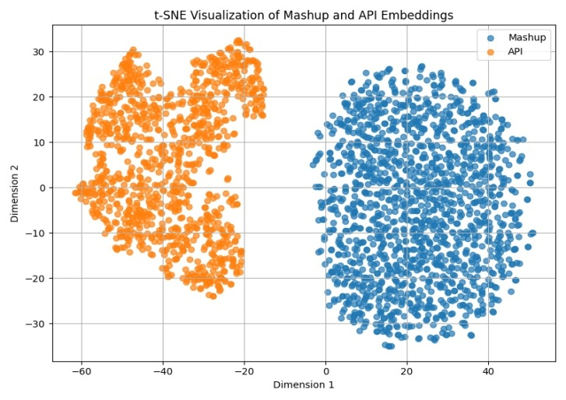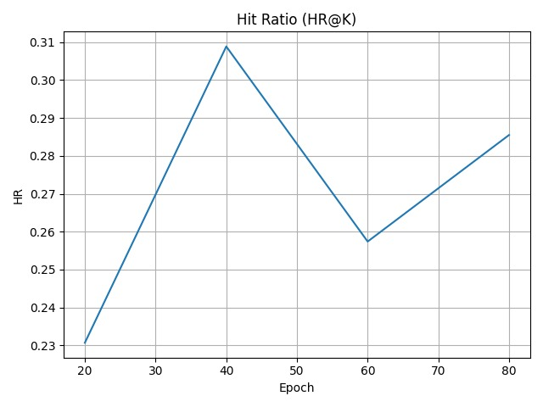

Fig 1.1: t-SNE Visualization of Mash UP and API Fig 1.2: Hit Ratio of SAC-GNN

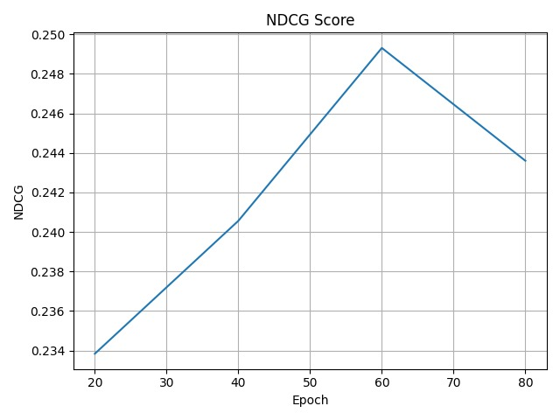

Fig 1.3: NDGC Score of SAC-GNN

MODEL PERFORMANCES

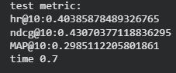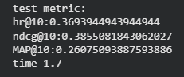

Fig 2.1: SAC-GNN MODEL Fig 2.2: NeuMF MODEL

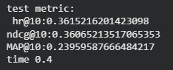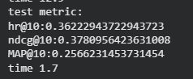

Fig 2.3: RTM + AFM MODEL Fig 2.4: GC-MC MODEL

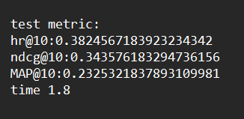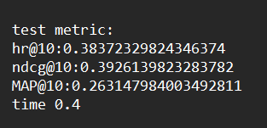

Fig 2.5: MGNN MODEL Fig 2.6: NGCF MODEL

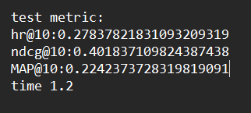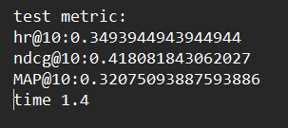

Fig 2.7: LRCC MODEL Fig 2.8: SERVICE-KNN MODEL

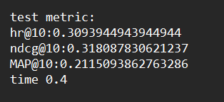

Fig 2.9: ISRMM MODEL Fig 2.10: BRF-MF MODEL

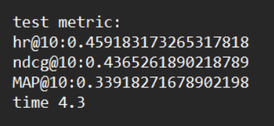

Fig 2.11: Cold-Start MODEL

CHAPTER 5

CONCLUSION AND FUTURE PLANS

The approach we proposed very improved service recommendation performance with help of a unified graph-based framework that created upon and extends the SAC-GNN model for overcome the cold-start challenge. The model we proposed records useful interaction patterns and real-world relationships between mash ups and services with the help of the mash up–API invocation graph. Such that the system learns with present usage data that available and collaborative involvements are model more greatly. More over with the help of an API similarity graph involves the framework to create trusted recommendations for the APIS introduced newly with no historical interaction data.

And the integration of both structural and semantic information will lead to improved and more readable feature representations, increasing the quality of recommendations overall. The impact of data sparsity can be significantly reduced by this combined approach, which is a general problem in the real-world service recommendation systems. We get evaluation results are calculated using metrics such as HR@10 and NDCG@10, those tell clearly improvement in ranking performance in comparison to other models in the paper. So finally the proposed framework enables us a robust, scalable, and efficient solution to the problem to the modern service recommendation situation.

CHAPTER 6 REFERENCES

[1] Abu-El-Haija, S., Kapoor, A., Perozzi, B., & Lee, J. (2020). N-GCN: Multi-scale graph con volution for semi-supervised node classification. In Uncertainty in artificial intelligence (pp. 841–851). PMLR.

[2] Almarimi, N., Ouni, A., Bouktif, S., Mkaouer, M. W., Kula, R. G., & Saied, M. A. (2019). Web service API recommendation for automated mashup creation using multi-objective evolutionary search. Applied Soft Computing, 85, 105830.

[3] Anarfi, R., & Fletcher, K. K. (2019). A reinforcement learning approach to web API rec ommendation for mashup development. In 2019IEEE World congress on services (SER VICES) (pp. 372–373). IEEE (vol. 2642).

[4] Bai, L., Cui, L., Wang, Y., Li, M., Li, J., Philip, S. Y., & Hancock, E. R. (2024). HAQJSK: Hierarchical-aligned quantum jensen-shannon kernels for graph classification (pp. 6370–6384). IEEE Transactions on Knowledge and Data Engineering (vol. 36).

[5] Cao, B., Li, B., Liu, J., Tang, M., Liu, Y., & Li, Y. (2019a). Mobile service recommenda tion via combining enhanced hierarchical dirichlet process and factorization machines. Mobile Information Systems, 2019(1), 6423805.

[6] Gao, C., Zheng, Y., Li, N., Li, Y., Qin, Y., Piao, J., Quan, Y., Chang, J., Jin, D., He, X. et al. (2023). A survey of graph neural networks for recommender systems: Challenges, methods, and directions. ACM Transactions on Recommender Systems, 1(1), 1–51.

[7] Gao, W., & Wu, J. (2017). A novel framework for service set recommendation in mashup creation. In 2017IEEE International conference on web services (ICWS) (pp. 65–72). IEEE.

[8] Gu, Q., Cao, J., & Peng, Q. (2016). Service package recommendation for mashup creation via mashup textual description mining. In 2016IEEE International conference on web services (ICWS) (pp. 452–459). IEEE.

[9] Guo, W., Su, R., Tan, R., Guo, H., Zhang, Y., Liu, Z., Tang, R., & He, X. (2021). Dual graph enhanced embedding neural network for CTR prediction. In Proceedings of the 27th ACM SIGKDD conference on knowledge discovery & data mining (pp. 496–504).

[10] He, X., Liao, L., Zhang, H., Nie, L., Hu, X., & Chua, T.-S. (2017). Neural collaborative filter ing. In Proceedings of the 26th international conference on world wide web (pp. 173–182).

CHAPTER 7 APPENDIX - BASE PAPER

Jiawei Lu, Duanni Li, Wanchuang Cai, Jiahong Zheng, Gang Xiao, SAC-GNN: Multi-layer dual graph neural network for service recommendation”, SCI Access
doi: https://doi.org/10.1016/j.eswa.2025.128608
Indexed in: SCI
Transaction Year : 2025

