AI ASSISTED CODING
LAB ASSIGNMENT –12.4
SAHASRA VEERAGONI
2403A53007
24BTCAICYB01-2-1

#TASK-1
Write a Python implementation of Bubble Sort.

Prompt:
OUTPUT:
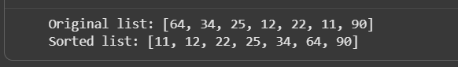

#TASK-2
Provide Bubble Sort code to AI and ask it to suggest a more efficient algorithm for partially sorted arrays.
PROMPT:
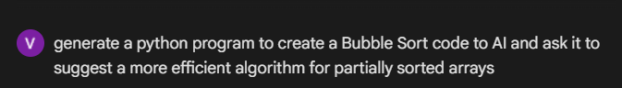

OUTPUT:
#TASK-3
Implement both Linear Search and Binary Search
PROMPT:
OUTPUT:

#TASK-4
Implement Quick Sort and Merge Sort using recursion
PROMPT:
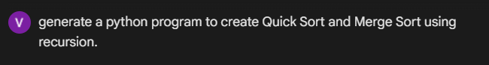

OUTPUT:
#TASK-5
Give AI a naive algorithm (e.g., O(n²) duplicate search).
PROMPT:
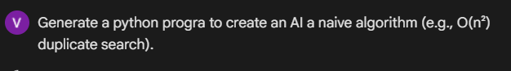
OUTPUT:

