**What are the top 10 algorithms every software engineer should know by heart?**

[Aastha Mehra](https://medium.com/@gyansetu?source=post_page-----c07a415271a6--------------------------------)

[Aastha Mehra](https://medium.com/@gyansetu?source=post_page-----c07a415271a6--------------------------------)

[Aug 2, 2019·3 min read](https://medium.com/@gyansetu/what-are-the-top-10-algorithms-every-software-engineer-should-know-by-heart-c07a415271a6?source=post_page-----c07a415271a6--------------------------------)

When you write a code, you basically provide a solution in the form of a program. Algorithms help in reaching a right decision or providing a right solution.

Knowledge and intuition regarding algorithms can greatly help you in coding.

Even though, every problem is unique but there’re certain algorithms that you can rely on in most cases.

Let me list them down for you –

- **HASHING**: Hashing helps in retrieving the items in a complex database easily by simple indexing rather than through original value which takes a lot of time.



- **STRING MATCHING ALGORITHM**: It can help you in finding a pattern or a string in a larger string or text.

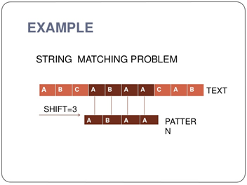

- **KNAPSACK PROBLEM**: It is basically a combination optimization problem. It helps in determining the number of items that can be included based on an item’s weight and value in a way that the total weight is less than or equal to a limit and as large as possible in value.

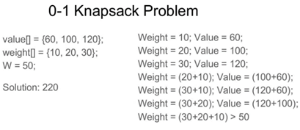

- **SEARCH TREE ALGORITHM**: With the help of tree algorithms, one can find an item in a reasonable balanced time.

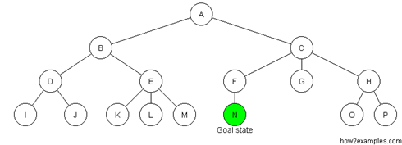

- **LINKED LIST OPERATIONS**: A linked list is extremely useful as it is able to shrink and grow in size when needed unlike array. Creation of new objects for the list can also be done easily.

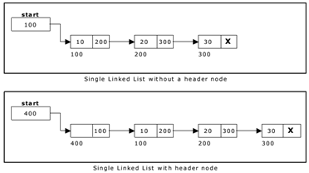

- **SHORTEST PATH**: One of the biggest advantage this offers is multiple solutions — distance of one particular point to other, one particular point to all other points and each point to other points.

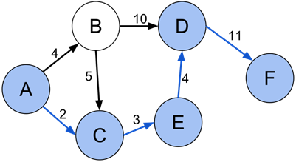

- **TRAVELLING SALESMAN** — Optimization is the key to success. This helps in solving a problem thought he quickest, most efficient and cheapest possible solution.

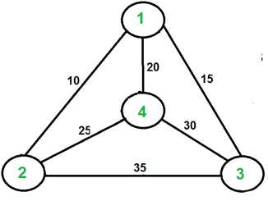

- **Sieve of Eratosthenes**: It is the simplest and ancient algorithm used to find the prime numbers up to any given limit.

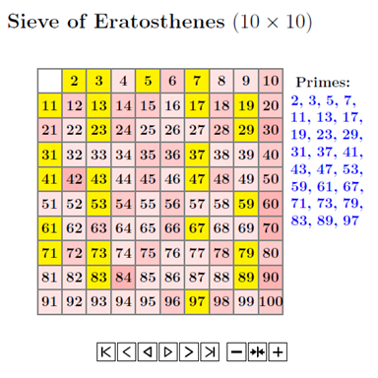

- **SORTING ALGORITHM:**You must brush up your basic concepts with bubble sort, selection sort and also quick sort.

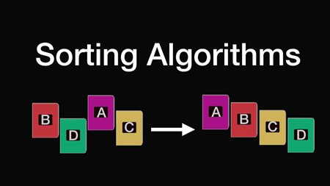

- **SEARCHING ALGORITHM:** Binary search comes in handy but liner search can also help in some cases.



WRITTEN BY

[Aastha Mehra](https://medium.com/@gyansetu?source=post_sidebar--------------------------post_sidebar-----------)

Tech aspirants. interest in Big Data Hadoop,Cloud Computing,Software Testing,Java,,Android,Excel,Salesforce. [https://www.gyansetu.in](https://www.gyansetu.in/)

Follow