**[Spiral Traversing of matrix:](https://www.geeksforgeeks.org/problems/spirally-traversing-a-matrix-1587115621/1)**

**Code:**

import java.util.*;

class Solution {

public ArrayList<Integer> spirallyTraverse(int mat[][]) {

ArrayList<Integer> res = new ArrayList<>();

int i_start = 0, i_end = mat.length - 1;

int j_start = 0, j_end = mat[0].length - 1;

while (i_start <= i_end && j_start <= j_end) {

// Traverse from left to right

for (int j = j_start; j <= j_end; j++) {

res.add(mat[i_start][j]);

}

i_start++;

// Traverse from top to bottom

for (int i = i_start; i <= i_end; i++) {

res.add(mat[i][j_end]);

}

j_end--;

// Traverse from right to left (if rows remain)

if (i_start <= i_end) {

for (int j = j_end; j >= j_start; j--) {

res.add(mat[i_end][j]);

}

i_end--;

}

// Traverse from bottom to top (if columns remain)

if (j_start <= j_end) {

for (int i = i_end; i >= i_start; i--) {

res.add(mat[i][j_start]);

}

j_start++;

}

}

return res;

}

}

**2) Counting Zeros after ones**

1)Using Nested Loop: O(n^2)

// Online Java Compiler

// Use this editor to write, compile and run your Java code online

import java.util.*;

class Main {

public static void main(String[] args) {

Scanner sc = new Scanner(System.in);

int n;

System.out.println("Enter the size of array:");

n = sc.nextInt();

int arr[] = new int[n];

System.out.println("Enter the array elements (0/1)");

for(int i=0;i<n;i++){

arr[i] = sc.nextInt();

}

System.out.println("Elements are:");

for(int i=0;i<n;i++){

System.out.println(arr[i]);

}

int count =0;

for(int i=0;i<n;i++){

if(arr[i] == 1){

for(int j=i+1;j<n;j++){

if(arr[j] ==0){

count++;

}

}

}

}

System.out.println("Zeros count is:"+count);

}

}

**Output:**

Enter the size of array:

6

Enter the array elements (0/1)

1

0

1

0

0

1

Elements are:

1

0

1

0

0

1

Zeros count is:5

2) Right to Left (O(n))

import java.util.*;

class Main {

public static void main(String[] args) {

Scanner sc = new Scanner(System.in);

int n;

System.out.println("Enter the size of array:");

n = sc.nextInt();

int arr[] = new int[n];

System.out.println("Enter the array elements (0/1)");

for(int i = 0; i < n; i++) {

arr[i] = sc.nextInt();

}

System.out.println("Elements are:");

for(int i = 0; i < n; i++) {

System.out.println(arr[i]);

}

int count = 0;

int zeroCount = 0;

for(int i = n - 1; i >= 0; i--) {

if(arr[i] == 0) {

zeroCount++;

} else {

count += zeroCount;

}

}

System.out.println("Zeros count is: " + count);

}

}

Output:

Enter the size of array:

6

Enter the array elements (0/1)

1

0

1

0

0

1

Elements are:

1

0

1

0

0

1

Zeros count is: 5

Output 2:

Enter the size of array:

6

Enter the array elements (0/1)

0

1

0

0

1

1

Elements are:

0

1

0

0

1

1

Zeros count is: 2

**Day-2**

GitHub

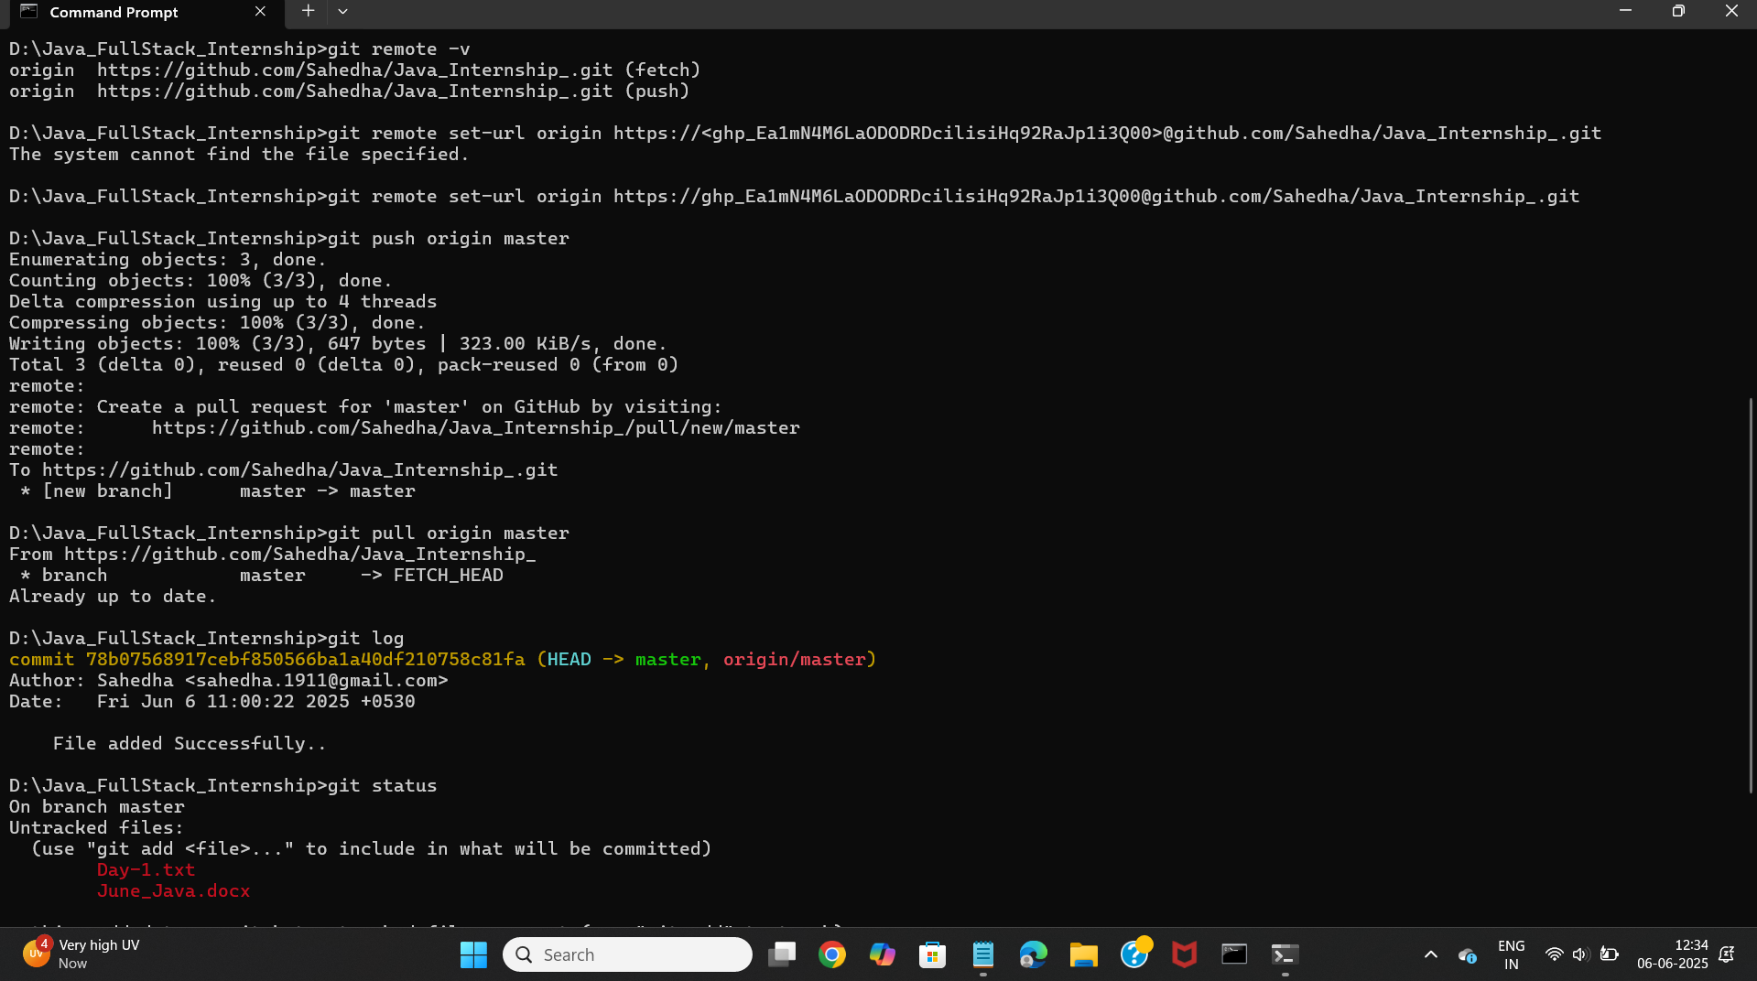

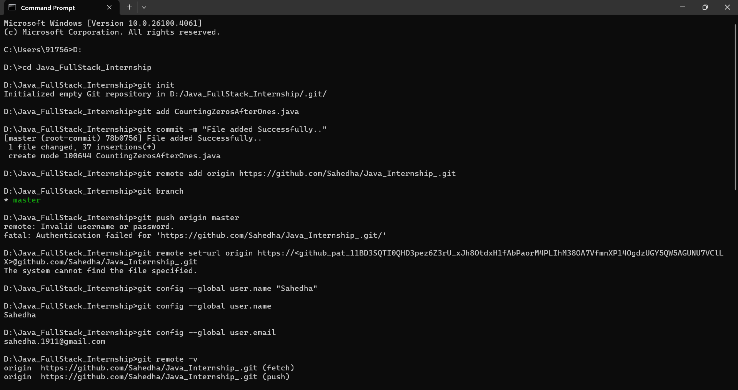

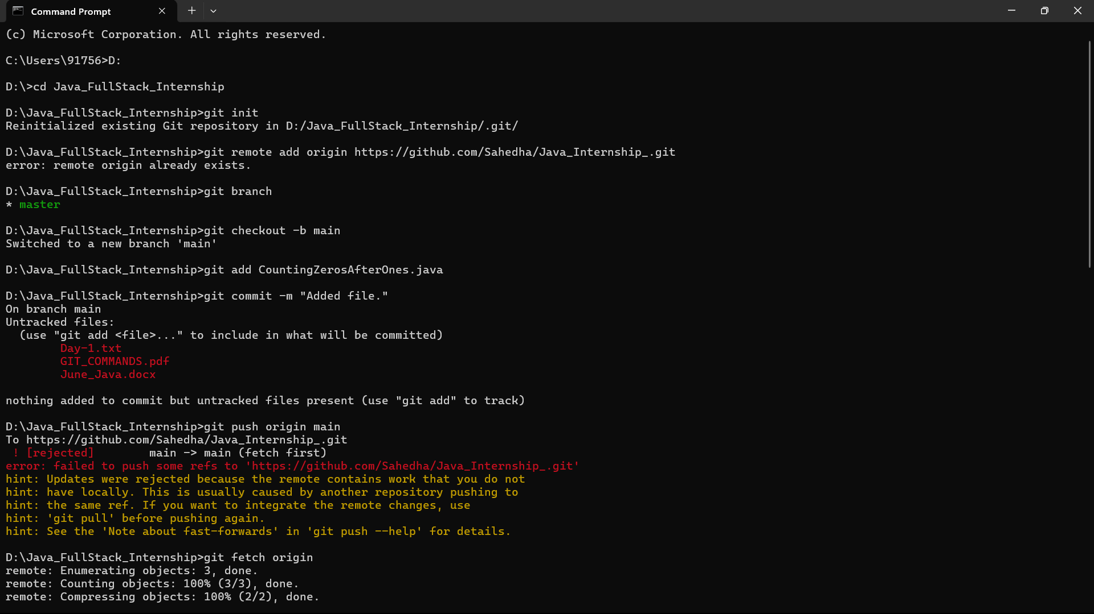

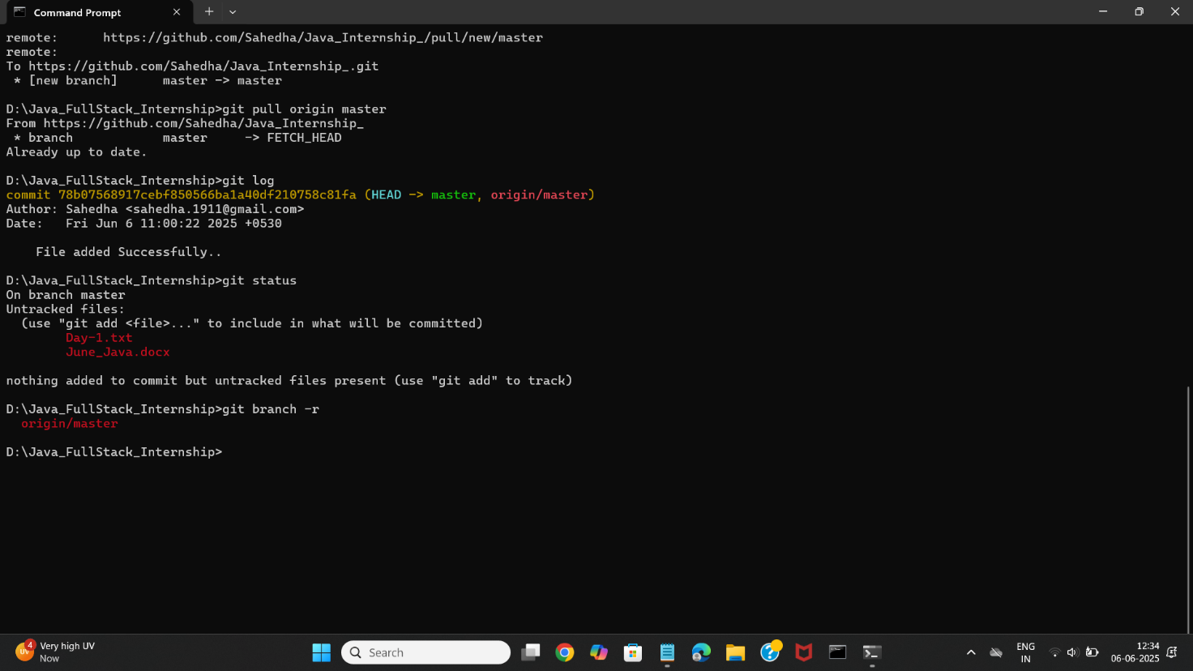

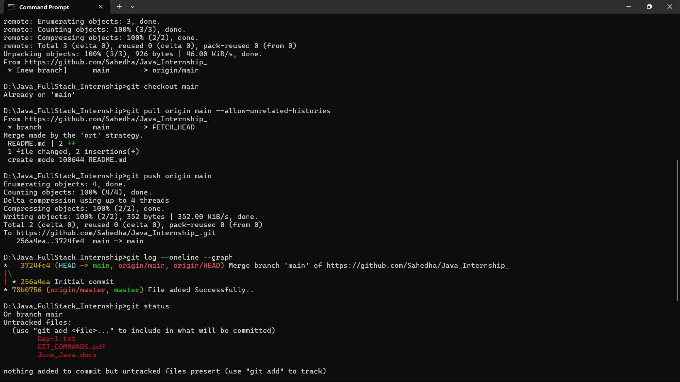

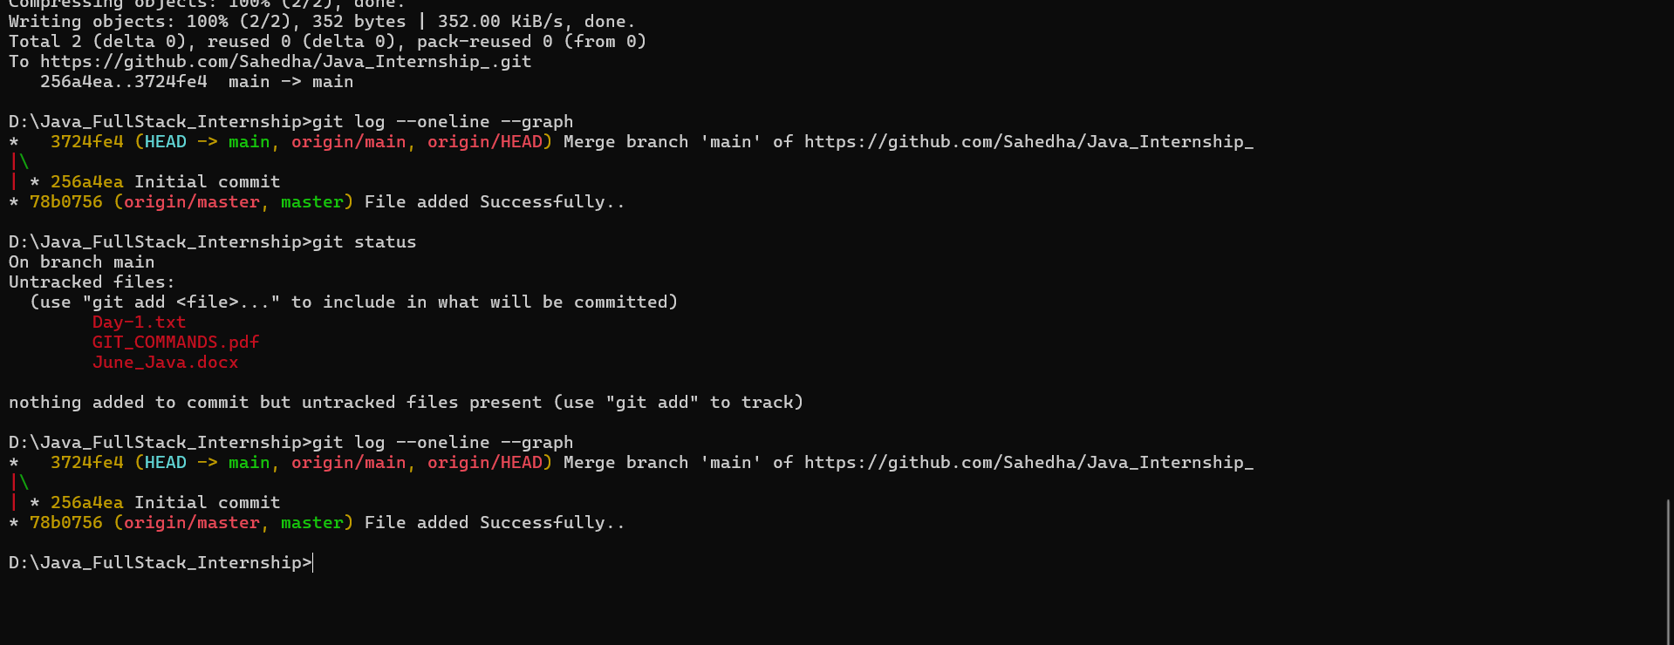

Swap 2 numbers using temporary variablr

Area and Perimeter of a triangle

Reverse a string

If a number is Prime or not

Fibonacci Series

Print pattern in triangle