<**body**>

<**h1**>Web Development</**h1**>

<**section**>

<**h2**>HTML</**h2**>

<**p**>

HTML defines a webpage's structure

and content.

</**p**>

</**section**>

<**section**>

<**h2**>CSS</**h2**>

<**p**>

CSS specifies a webpage's layout

and visible appearance.

</**p**>

</**section**>

<**section**>

<**h2**>JavaScript</**h2**>

<**p**>

JavaScript describes a webpage's

dynamic behaviors and actions.

</**p**>

</**section**>

</**body**>

<body>

<h1>Bill of Rights</h1>

<p>The following are the bill of rights of the USA</p>

<section>

<h2>Article 1</h2>

<p>Body of article 1</p>

</section>

<section>

<h2>Article 2</h2>

<p>Body of article 2</p>

</section>

</body>

**Text formatting**

A number of HTML tags cause the enclosed text to render in a different font in the browser:

* The ***<em>*** tag indicates ***emphasized*** text, such as text having an emphasized pronunciation when spoken, and is italicized by default.
* The ***<strong>*** tag indicates text that has ***strong importance***, and is bolded by default.
* The ***<cite>*** tag denotes a title, such as a book or song title, and is italicized by default. Ex: <cite>Spaceballs</cite> is a parody of the <cite>Star Wars</cite> trilogy. yields: *Spaceballs* is a parody of the *Star Wars* trilogy.
* The ***<mark>*** tag denotes important content that should be semantically highlighted and is rendered with a yellow background by default. Ex: <mark>Highlight</mark> what is important. yields: Highlight what is important.
* The ***<b>*** tag indicates text that needs attention, like key words in a document abstract or product names in a review, and renders the text in ***bold***. Ex: Mix the **flour** and **oil** together.
* The ***<i>*** tag indicates text in an alternative voice, such as a word or phrase in a foreign language, and is rendered using ***italics***. Ex: *Dashi* is a stock used in Japanese cooking.
* The ***<u>*** tag denotes text that should appear differently from normal text, such as misspelled words, and is underlined by default. Ex: Misspelled is often misspelled as mispelled.

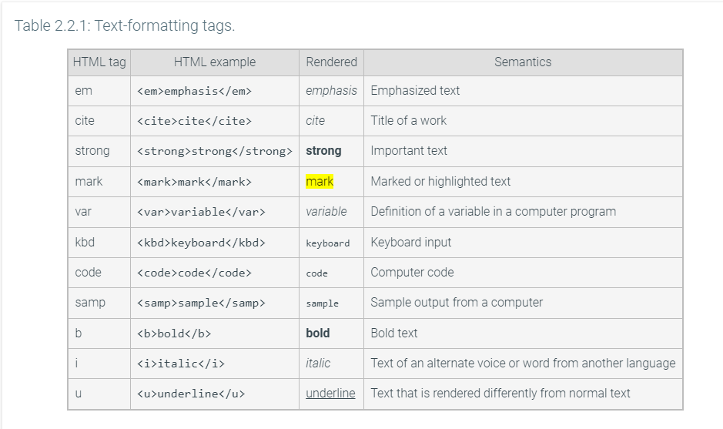

<**p**>Some high demand majors are:</**p**>

<**ul**>

<**li**>Mathematics</**li**>

<**li**>Statistics</**li**>

<**li**>Computer Science</**li**>

</**ul**>

<**p**>Source: College Consensus 2019</**p**>

<p>Top masters degrees in demand are: </p>

<ol>

<li>Physician Assistant</li>

<li>Statistics</li>

<li>Nursing</li>

<li>Counseling</li>

<li>Cybersecurity</li>

</ol>

<p>Source: College Consensus 2019</p>

<**ul**>

<**li**>Favorite movies

<ol>

<**li**>The Princess Bride</**li**>

<**li**>Remember the Titans</**li**>

<**li**>Moana</**li**>

</ol>

</li>

<li>Favorite books

<ol>

<li>To kill a Moss</li>

<li>To kill a Moss</li>

<li>To kill a Moss</li>

</ol>

</li>

</ul>

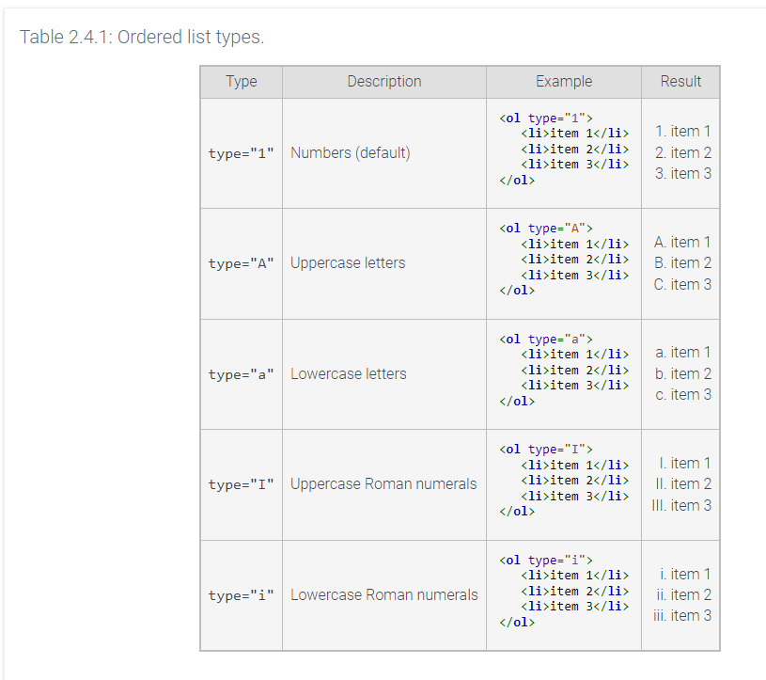

<img src="https://resources.zybooks.com/WebProgramming/mediumCatv1.jpg" alt="Cat picture" width = "250" height = "250">

temperatures = {

'Seattle': 56.5,

'New York': float(input()),

'Kansas City': 81.9,

'Los Angeles': 76.5

}

if 'New York' in temperatures:

if temperatures['New York'] > 90:

print('The city is melting!')

else:

print(f"The temperature in New York is {temperatures['New York']}.")

else:

print('The temperature in New York is unknown.')

your_number = my_number + 5 if my_number <= 9 else my_number - 5

print(your_number)

user_val = int(input())

cond_str = "negative" if (user_val < 0) else "nonnegative"

print(f'{user_val} is {cond_str}')