**BUNTS SANGHA’S**

**S.M. SHETTY COLLEGE OF SCIENCE, COMMERCE &**

**MANAGEMENT STUDIES, POWAI, MUMBAI-76**



**FastChat**

**CLASS: T.Y.B.Sc.I.T (2023-24)**

**SEMESTER: V**

**SUBMITTED BY (Name): Saheel Kanhaiyalal Singh**

**SEAT NUMBER: _______________**

SUBMITTED TO

**DEPARTMENT OF INFORMATION TECHNOLOGY**

***Dipti Parab* *Tushar Sambare***

**___________________________ ___________________________ _________________________________**

**Project Guide Coordinator External Examiner**

**For Partial Fulfilment for Degree of**

**Bachelor of Science in IT (*Information Technology*) in 2023-24**

# Acknowledgement

I would like to use this opportunity to convey my gratitude to Management of SM. Shetty College of science, Commerce and management studies for being generous for allowing me to pursue this project. I am very thankful to Dr. Sridhara Shetty, Principal of S.M.Shetty College for his co-operation in the successful accomplishment of our project.

A special thanks to our project guide Mrs. Dipti Parab and also our coordinator Dr.Tushar Sambare for his most sincere efforts, support and encouraging contribution throughout the project.

I would like to express thank all our teachers, friend & our family for their support, motivation and encouragement.

- SAHEEL KANHAIYALAL SIGNH

**INDEX**

|  |  |  |
| --- | --- | --- |
| **SR.NO** | **Content** | **Page No**. |
| **1.** | **INTRODUCTION** | 4 |
|  | 1.1Background | 5 |
|  | 1.2 Objectives | 5 |
|  | 1.3 Purpose, scope, Applicability | 5 |
|  | 1.3.1 Purpose | 5 |
|  | 1.3.2 Scope | 6 |
|  | 1.3.3Applicability | 6 |
|  | 1.4 Achievements | 6 |
|  | 1.5 Organization of report | 6 |
|  |  |  |
| 2 | **SURVEY OF TECHNOLOGIES** |  |
|  | 2.1 **Front-end** | 7 |
|  | 2.1.1 React JS. | 7 |
|  | 2.1.2 Tailwind CSS | 7 |
|  | 2.2 **Back-end** | 8 |
|  | 2.2.1 NodeJS | 8 |
|  | 2.2.2 Express JS | 8 |
|  | 2.3 **Database** | 9 |
|  | 2.3.1 MongoDB | 9 |
|  |  |  |
| 3 | **REQUIREMENT AND ANALYSIS** |  |
|  | 3.1 SOFTWARE REQUIREMENTS FOR DEVELOPMENT | 10 |
|  | 3.2 HARDWARE REQUIREMENTS FOR DEVELOPMENT | 10 |
|  | 3.3 EXISTING SYSTEM | 10 |
|  | 3.4 PROPOSED SYSTEM | 10 |
|  | 3.5 SUCCESS FACTORS | 11 |
|  | 3.6 LIMITATIONS | 11 |
|  | 3.7 GANTT CHAT | 12 |
|  | 3.7 APPLICATIONS OF FASTCHAT | 13 |
|  |  |  |
| 4 | **SYSTEM DESIGN** |  |
|  | 4.1 USE CASE DIAGRAM | 14 |
|  | 4.2 ACTIVITY DIAGRAM | 15 |
|  | 4.4 ENTITY RELATIONAL DIAGRAM | 16 |
|  | 4.5 DATA FLOW DIAGRAM | 17 |
|  | 4.6 USER INTERFACE DIAGRAM | 20 |
|  | 4.7 TEST CASE | 21 |
|  |  |  |

**Chapter 1**

**INTRODUCTION**

**1.1 Introduction**

In today's fast-paced, interconnected world, communication is at the heart of our daily lives. Whether it's keeping in touch with family and friends, collaborating with colleagues, or connecting with people around the globe, the way we communicate has undergone a remarkable transformation. Welcome to FastChat, a cutting-edge communication app designed to meet the demands of the modern era.

FastChat is more than just an ordinary messaging application; it's a powerful platform that empowers you to communicate seamlessly, efficiently, and securely. With its user-friendly interface and an array of innovative features, FastChat redefines the way we interact with one another. Whether you're a professional looking to streamline business communication or an individual seeking to stay connected with loved ones, FastChat has you covered.

FastChat is where convenience, speed, and security converge to provide you with an unmatched communication tool for the digital age. Say goodbye to the limitations of traditional messaging and embrace a new era of efficient and enjoyable conversations.

With FastChat, the world is at your fingertips, and communication has never been this easy. Experience the future of communication today.

**1.2 Background**

The story of FastChat begins at the intersection of innovation and the ever-evolving landscape of digital communication. In an era where connectivity is paramount and information travels at the speed of light, the creators of FastChat envisioned a revolutionary communication platform designed to address the needs and expectations of a modern, fast-paced world.

In the early 21st century, messaging apps had already become an integral part of our lives, connecting us with friends, family, and colleagues across the globe. However, there were persistent challenges that demanded innovative solutions. Slow message delivery, concerns about data security, and a fragmented user experience were just a few of the issues users faced daily. It was clear that there was room for improvement, and that's where the FastChat journey began.

The journey was marked by tireless research and development, with an unwavering commitment to providing a reliable and secure platform for users. FastChat's development team invested countless hours into crafting an intuitive interface, optimizing message delivery speed, and implementing robust end-to-end encryption to safeguard users' privacy.

**1.3 Objective:**

The primary objective of FastChat is to offer an advanced and streamlined communication experience in the digital age. It aims to provide users with efficient messaging capabilities, ensuring that messages are delivered swiftly, and to enhance the overall user experience with an intuitive and user-friendly interface. FastChat prioritizes privacy and security, offering end-to-end encryption and robust data protection measures to safeguard users' conversations. Additionally, it seeks to enable high-quality voice and video calls, supporting both personal and professional communication needs. The app is designed to be feature-rich, accommodating group messaging, multimedia sharing, file transfers, and customizable settings to cater to various user requirements. Cross-platform compatibility is a core objective, allowing users to communicate seamlessly across different devices and operating systems. FastChat strives to connect a global user base, breaking down geographical barriers, and remains committed to adaptability and innovation, regularly updating its features and functionalities to meet evolving user preferences. Moreover, it aims to create a strong user community, fostering engagement and providing a sense of belonging among its users. Financial sustainability is also an objective, achieved through user-focused monetization strategies. FastChat's objectives collectively demonstrate its dedication to delivering a secure, efficient, and feature-rich communication platform that redefines how individuals and businesses connect and interact in the digital age.

**1.4 Purpose:**

The purpose of the FastChat app is to provide users with a dynamic and efficient communication platform for the digital era. FastChat is designed to enable fast and seamless messaging, allowing users to connect and interact swiftly, whether for personal or professional communication. This app prioritizes user privacy and data security by offering end-to-end encryption, assuring that conversations remain confidential. Its purpose also extends to facilitating high-quality voice and video calls, enhancing real-time communication experiences. FastChat seeks to empower users with a feature-rich platform that includes group messaging, multimedia sharing, file transfers, and customizable settings to meet diverse communication needs. Its cross-platform compatibility ensures accessibility across various devices and operating systems, enabling users to communicate without constraints. FastChat's overarching purpose is to bridge geographical divides, connecting users from all corners of the world and continually evolving through innovation to stay at the forefront of communication technology. It aims to foster a vibrant user community, creating a sense of belonging, and pursuing financial sustainability through user-centric monetization strategies. In essence, FastChat's purpose is to redefine and elevate the way individuals and businesses connect, collaborate, and share in the modern digital landscape.

**1.5 Scope:**

The scope of the FastChat app is expansive, encompassing a broad range of applications and potential uses within the realm of digital communication. Its versatility and feature-rich design make it a versatile tool for various scenarios. FastChat serves as an efficient and secure messaging platform for individuals looking to connect with friends, family, or colleagues. With high-quality voice and video calls, it meets the needs of those seeking real-time communication, whether for personal or professional purposes. The app's capabilities extend to team collaboration, making it a valuable tool for businesses and organizations, supporting group discussions, file sharing, and project coordination. Cross-platform compatibility ensures accessibility on diverse devices, enabling seamless communication regardless of the preferred device or operating system. Furthermore, FastChat has a global scope, connecting users worldwide, transcending geographical boundaries, and fostering international connections.

**1.6 Applicability:**

The applicability of the FastChat app is far-reaching, offering a versatile and powerful tool for a wide range of scenarios in the digital communication landscape. FastChat is exceptionally applicable to individuals who seek efficient, secure, and feature-rich messaging solutions for staying connected with friends and family. it caters to the needs of those desiring real-time communication, whether for personal or professional use, and is particularly valuable for long-distance relationships and remote work scenarios.

FastChat's cross-platform compatibility ensures it can be used on diverse devices and operating systems, making it highly applicable to users regardless of their preferred tech ecosystem.

**1.7 Achievements:**

FastChat app has achieved significant milestones and made substantial contributions to the digital communication landscape since its inception. One of its notable achievements is the successful establishment of a user base that spans the globe, connecting individuals from diverse backgrounds and regions, thereby fostering cross-cultural interactions and relationships. The app's commitment to user privacy and security has been highly lauded, with its implementation of end-to-end encryption and robust data protection measures, ensuring that users' conversations remain confidential.

**1.8 Organization of Reports:**

Other chapters are as follows:

1. Ch2: Survey of Technology: This chapter will provide a thorough explanation of the technologies that are available for the project and those that are currently being used for it.

2. Chapter 3: Requirement and Analysis - In this chapter, we'll take user requirements and devise plans for putting them into practice in the project.

3. In the project's chapter four is on system design, here different conceptual designs such as class diagrams, E-R diagrams, and activity diagrams were constructed**.**

**CHAPTER 2**

**SURVEY OF TECHNOLOGIES**

**This chapter will answer what technology will be used (front end and back end) for the project**

**In this project I am using Mern Stack Technology which is stand for MongoDB Expressjs Reactjs Nodejs**

**2.1 Frontend: (Used for User Interface design)**

**1.React JS.**

The React.js framework is an open-source JavaScript framework and library developed by Facebook. It’s used for building interactive user interfaces and web applications quickly and efficiently with significantly less code than you would with vanilla JavaScript.

In React, you develop your applications by creating reusable components that you can think of as independent Lego blocks. These components are individual pieces of a final interface, which, when assembled, form the application’s entire user interface.

React’s primary role in an application is to handle the view layer of that application just like the V in a model-view-controller (MVC) pattern by providing the best and most efficient rendering execution. Rather than dealing with the whole user interface as a single unit, React.js encourages developers to separate these complex UIs into individual reusable components that form the building blocks of the whole UI. In doing so, the ReactJS framework combines the speed and efficiency of JavaScript with a more efficient method of manipulating the DOM to render web pages faster and create highly dynamic and responsive web applications.

**2. Tailwind CSS**

Tailwind CSS is a utility-first CSS framework which makes it very easy to apply great styling to your React web application by choosing from the framework’s ready-made CSS classes. This easy approach makes Tailwind CSS very popular among today’s CSS frameworks and speeds up the development & styling process significantly. Tailwind CSS is very easy and comprises only very few steps. In the following tutorial you can find the step-by-step approach of installing Tailwind CSS into your React project and get started using Tailwind’s CSS classes for styling.

**2.2 Back End (Node JS, Express JS):**

**Node JS:**

Node.js is designed to build scalable network applications. In the following "hello world" example, many connections can be handled concurrently. Upon each connection, the callback is fired, but if there is no work to be done, Node.js will sleep.

This is in contrast to today's more common concurrency model, in which OS threads are employed. Thread-based networking is relatively inefficient and very difficult to use. Furthermore, users of Node.js are free from worries of dead-locking the process, since there are no locks. Almost no function in Node.js directly performs I/O, so the process never blocks except when the I/O is performed using synchronous methods of Node.js standard library. Because nothing blocks, scalable systems are very reasonable to develop in Node.js.

**Express JS:**

Express.js, often simply referred to as Express, is a web application framework for Node.js, a runtime environment for executing JavaScript code on the server-side. It is one of the most popular and widely used frameworks for building web applications and APIs with Node.js.

Express.js is known for its simplicity and minimalism, providing a set of features and tools to make it easier to build robust and scalable web applications. Some of the key features and concepts associated with Express.js include:

Routing: Express allows you to define routes for handling different HTTP methods (GET, POST, PUT, DELETE, etc.) and URLs. This makes it easy to create the various endpoints of a web application.

Middleware: Middleware functions in Express are used to process requests and responses in between the server and the final route. This can be used for tasks like authentication, logging, parsing request bodies, and more.

Template Engines: While not included in Express itself, it's common to use template engines like EJS or Pug with Express for rendering dynamic HTML pages.

Static Files: Express can serve static files like CSS, JavaScript, and images, making it a useful tool for serving entire web applications, not just APIs.

Error Handling: Express provides a way to handle errors gracefully with error middleware.

Integration: It's easy to integrate with various databases and other Node.js modules, making it a flexible choice for building web applications.

**2.3 Database (MongoDB):**

**MongoDB:**

MongoDB is an open-source document-oriented database that is designed to store a large scale of data and also allows you to work with that data very efficiently. It is categorized under the NoSQL (Not only SQL) database because the storage and retrieval of data in the MongoDB are not in the form of tables. MongoDB is a NoSQL database, which means it stores data in a more flexible and JSON-like format.

Imagine you have a collection of documents, similar to how you might have a collection of files in a folder. Each document can have different types of information, and you can store data like names, addresses, and more in a way that's easy to access and modify. This flexibility makes MongoDB useful for applications where data can change in structure or where you need to store complex data types.

MongoDB is often used in web applications, mobile apps, and other software to store and retrieve data quickly and efficiently. It's especially well-suited for projects that involve a lot of data, data that changes often, or data with varying structures.

Nowadays there are so many companies that used MongoDB like Facebook, Nokia, eBay, Adobe, Google, etc. to store their large amount of data

**CHAPTER 3**

**REQUIREMENT AND ANALYSIS**

**3.1 Hardware Requirements**

* Processor – 1GHz
* RAM- 1GB
* Ethernet Connection or Wi-Fi

**3.2 Software Requirement**

* OPERATING SYSTEM
* WEB BROWSER
* IIS 8.0

**3.3 Existing System:**

The FastChat team was comprised of forward-thinking engineers, designers, and communication experts who shared a common goal: to create an app that would redefine the standards of digital communication. They drew upon their extensive knowledge of emerging technologies, data encryption, and user experience design to develop a solution that would truly stand out in a crowded market.

The journey was marked by tireless research and development, with an unwavering commitment to providing a reliable and secure platform for users. FastChat's development team invested countless hours into crafting an intuitive interface, optimizing message delivery speed, and implementing robust end-to-end encryption to safeguard users' privacy.

**3.4 Proposed System:**

Our website has only one part:

1) FastChat

In today's fast-paced, interconnected world, communication is at the heart of our daily lives. Whether it's keeping in touch with family and friends, collaborating with colleagues, or connecting with people around the globe, the way we communicate has undergone a remarkable transformation. Welcome to FastChat, a cutting-edge communication app designed to meet the demands of the modern era.

FastChat is more than just an ordinary messaging application; it's a powerful platform that empowers you to communicate seamlessly, efficiently, and securely. With its user-friendly interface and an array of innovative features, FastChat redefines the way we interact with one another. Whether you're a professional looking to streamline business communication or an individual seeking to stay connected with loved ones, FastChat has you covered.

**3.5 Success factors of the FastChat:**

The following are the success factors for The FastChat Project:

1. **User-Friendly Interface**;

2. **Speed and Efficiency**;

3. **Security and Privacy**;

4. **Reliability**;

5. **Cross-Platform Compatibility**;

6. **Innovative Features;**

**7. Scalability;**

8. **User Engagement and Community;**

9**. Global Reach;**

10. **Responsive Customer Support;**

**3.6 Limitation of FastChat:**

FastChat, like any software application, has certain limitations that users should be aware of. These limitations may affect the overall user experience and the range of scenarios in which the app can be effectively used. Some of the limitations of FastChat include potential challenges in achieving widespread user adoption, especially when competing with established messaging platforms. While it aims for cross-platform compatibility, there may be discrepancies in user experiences across different devices and operating systems. The app might also face scalability issues as it grows, impacting its ability to handle a large and rapidly expanding user base. FastChat's feature set may be more limited compared to larger, more established messaging apps, potentially restricting the functionalities available to users. Depending on its monetization strategy, users may encounter limitations related to advertisements or premium features. Ensuring robust security and encryption is essential, as any breaches in this area could compromise user privacy and trust. Additionally, building and maintaining an active user community may be a challenge, given the competition from well-established apps. Finally, FastChat's success may depend on the effectiveness of its marketing and promotional efforts in a crowded messaging app market. It's important to consider these limitations while using FastChat and be aware that they may evolve as the app continues to develop and improve.

**3.7 Gantt Chat:**

A Gantt graph is a flat bar outline created as a generation control apparatus in 1917 by Henry L. Gantt, an American architect and social researcher.

Frequently utilized in undertaking the board, a Gantt diagram gives a graphical representation of calendar that plans, organize, and track explicit errands in a venture

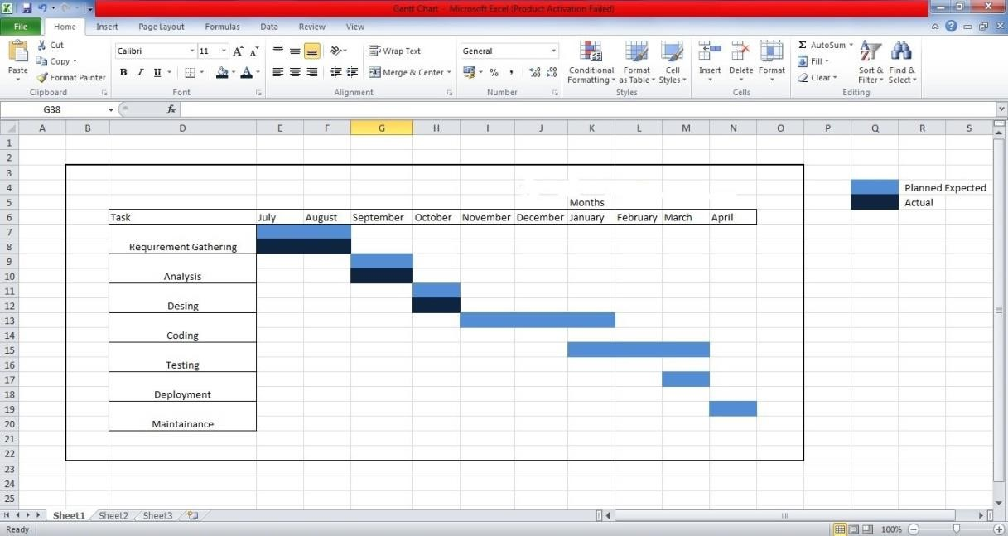

**3.8 Application OF FastChat:**

FastChat holds considerable potential in a wide range of applications, catering to diverse communication needs in both personal and professional settings. In personal communication, it provides an efficient and secure platform for individuals to connect with friends and family, facilitating real-time messaging and high-quality voice and video calls. It can be particularly valuable for those with long-distance relationships or for anyone seeking to stay in touch with loved ones, irrespective of geographical boundaries.

On the professional front, FastChat's applications are equally compelling. It serves as an effective tool for business communication, allowing teams to collaborate seamlessly through group messaging, file sharing, and video conferencing. Whether for remote work, project management, or inter-office discussions, FastChat streamlines communication, potentially increasing productivity and efficiency within organizations.

**CHAPTER 4**

**SYSTEM DESIGN**

**4.1 Use Case:**

The simplest case diagram is the presentation of user interactions with presentation of user interactions with system that shows the relationship between users and various use cases in which occupy the user. That’s in the UML diagram, defined and created by case analysis. Your goal is yes providing a graphical overview of the functions provided by the system participants, their goals (represented as use cases) and all the dependencies between them case.

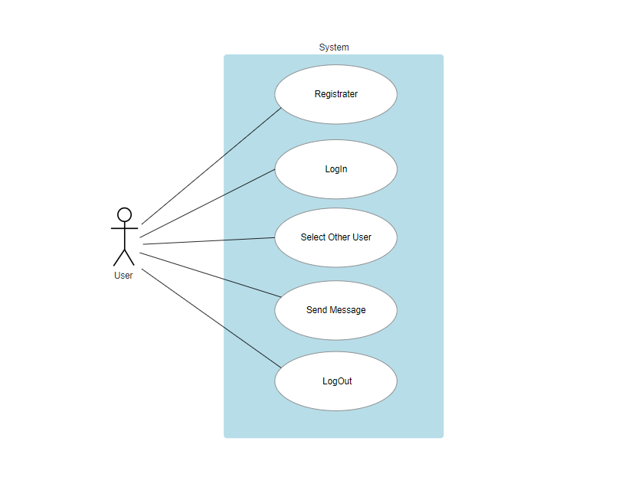

**4.2 Activity Diagram:**

Activity Diagram is also called as a UML Diagram. It focuses in the execution and flow of behavior of a system. It apply behavioral modelling technique. It is divided into one or more activities. In between the structure it has start, end node, Control flow, Decision node, fork, join, End State.

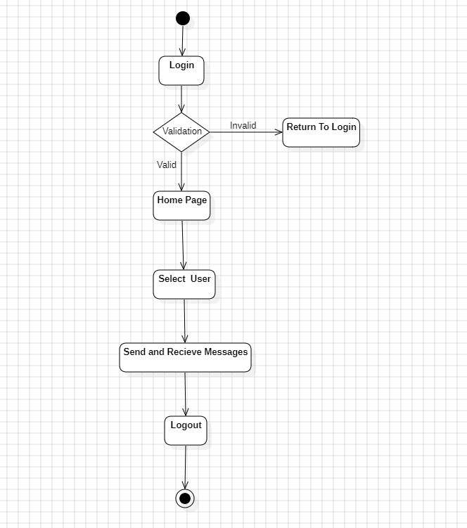

**4.2 Entity Relational Diagram:**

An Entity-Relationship (ER) diagram is a visual representation of the data model that depicts entities, attributes, relationships, and constraints in a structured and easy-to-understand manner. ER diagrams are commonly used to model the structure of a database and how different entities and data elements are related to each other.

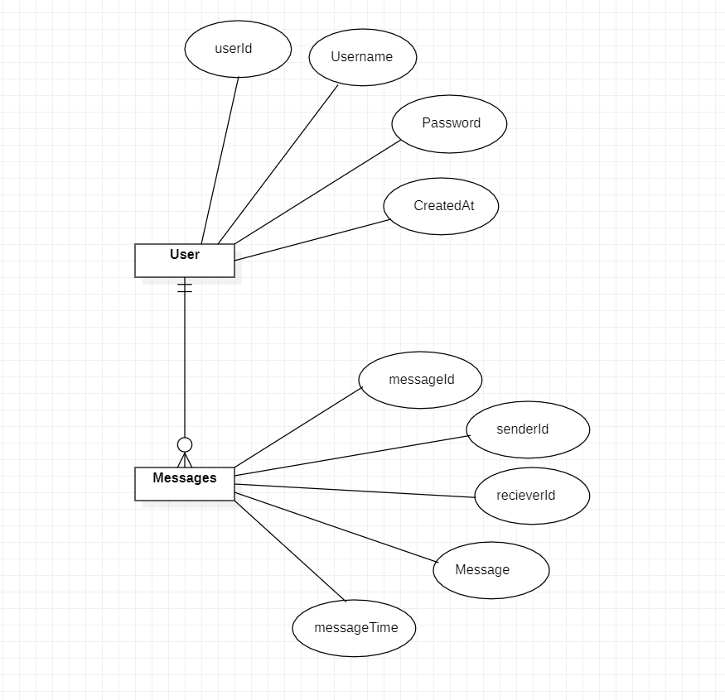

**4.5 Dataflow Diagram:**

Testing starts at the module level and work towards the incorporation of whole PC based framework. Nothing is complete without It is an approach to addressing a progression of an information of a cycle or a framework (generally a data framework).It additionally gives data about the results and contributions of every element and the actual cycle. Essential images are utilized to worldview information stream charts. They are images that address information source, information streams, and information changes and information stockpiling.

|  |  |  |  |
| --- | --- | --- | --- |
| **Sr.**  **No** | **Component**  **Name** | **Representation** | **Description** |
| 1. | Processes |  | A process is an activity or function that transforms input data into output data. It can represent a operation within a system. |
| 2. | Data Flows |  | Data flows represent the movement of data from one point to another, and they are labeled to describe the type of data being transferred. |
| 3. | Data Stores |  | Data Stores depict where data is stored within the system. Data stores can be physical locations such as databases, files, or folders, or they can represent temporary storage within a process. |
| 4. | External  Entity |  | External entities are external to the system being analyzed but interact with it by sending or receiving data. External entities can be users, other systems, or organizations. |

**Level 1:**

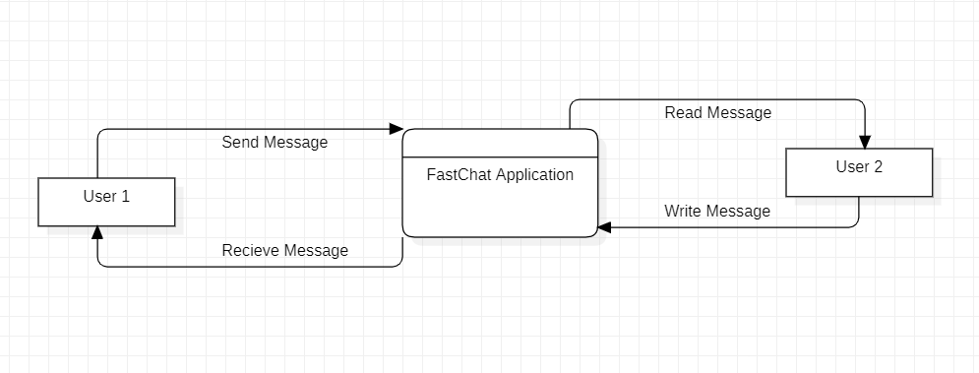

**Lavel 2:**

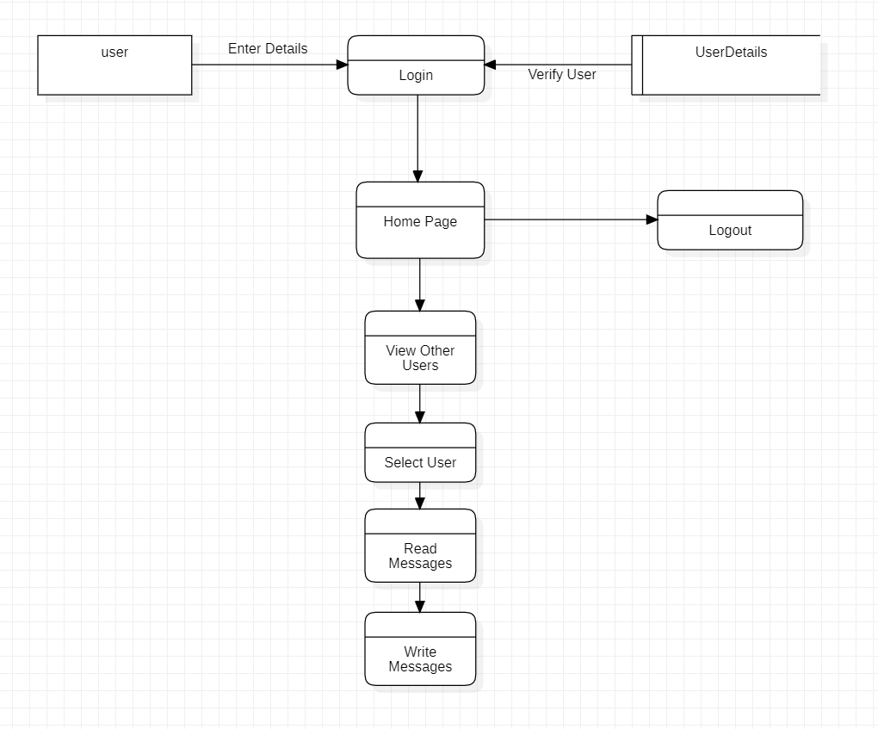

**4.5 User Interface Diagram:**

**4.5 Test Case:**

|  |  |  |  |  |  |  |
| --- | --- | --- | --- | --- | --- | --- |
| **Sr.no** | **Action** | **Input** | **Expected input** | **Actual output** | **Test browser** | **Test result** |
| 1 | Login  Page | Username:abc@gmail  .com  Password: xyz@123 | The password Entered is correct | The password Entered is correct | Google chrome | Pass |
| 2 | Login  Page | Username:abc@gmail  .com  Password: xyz@103 | The password Entered is correct | The password Entered is incorrect | Google chrome | Pass |
| 3 | Register  Page | Email:abc@gmail.  Com  User name: hello  Password: xyz@123 | Wrong Mail | Register  Successfully | Google  Chrome | Pass |
| 4 | Register  Page | Email:abc@gmail.  Com  User name: hello  Password: xyz@123 | Registration  Complete | Register  Successfully | Google  Chrome | Pass |