MUDALIAR MERCY ANNA GOMAGAN
962824104308
CSE B · III Year


Nikitha.M.R.
962824104065
CSE B · III Year


VISHAL V
962824104018
CSE A · III Year

S.MOHIDEEN IBRAAHEEM
962825104060
CSE A · II Year


Alfie Riya E
962825104017
CSE A · II Year


Anto Suthieksha S
962824205021
IT · III Year

Mabisha S
962824104107
CSE B · III Year


Nisha T
962825104058
CSE A · II Year


Shri Bharath Hariharan G
962824205046
IT · III Year


VS DEEPTHI SRI JOTHI
962824205015
IT · III Year

Varun ram R M
962825204113
CSE B · II Year


D Jebaselli Annabackiyam
962824205010
IT · III Year


RATHISHA. R
962824104072
CSE B · III Year

Jenisha Resmy R
962824104069
CSE B · III Year

JOHN VISHAL M
962824104056
CSE A · III Year


Sreekumar S
962824104088
CSE B · III Year


C G Anslin Jerfia
962824104063
CSE B · III Year


Anand
962824104004
CSE A · III Year

Jeya Shree R K
962824104037
CSE A · III Year


Ancy Rishika D
962824104038
CSE A · III Year


Akshaya R
962824104026
CSE A · III Year
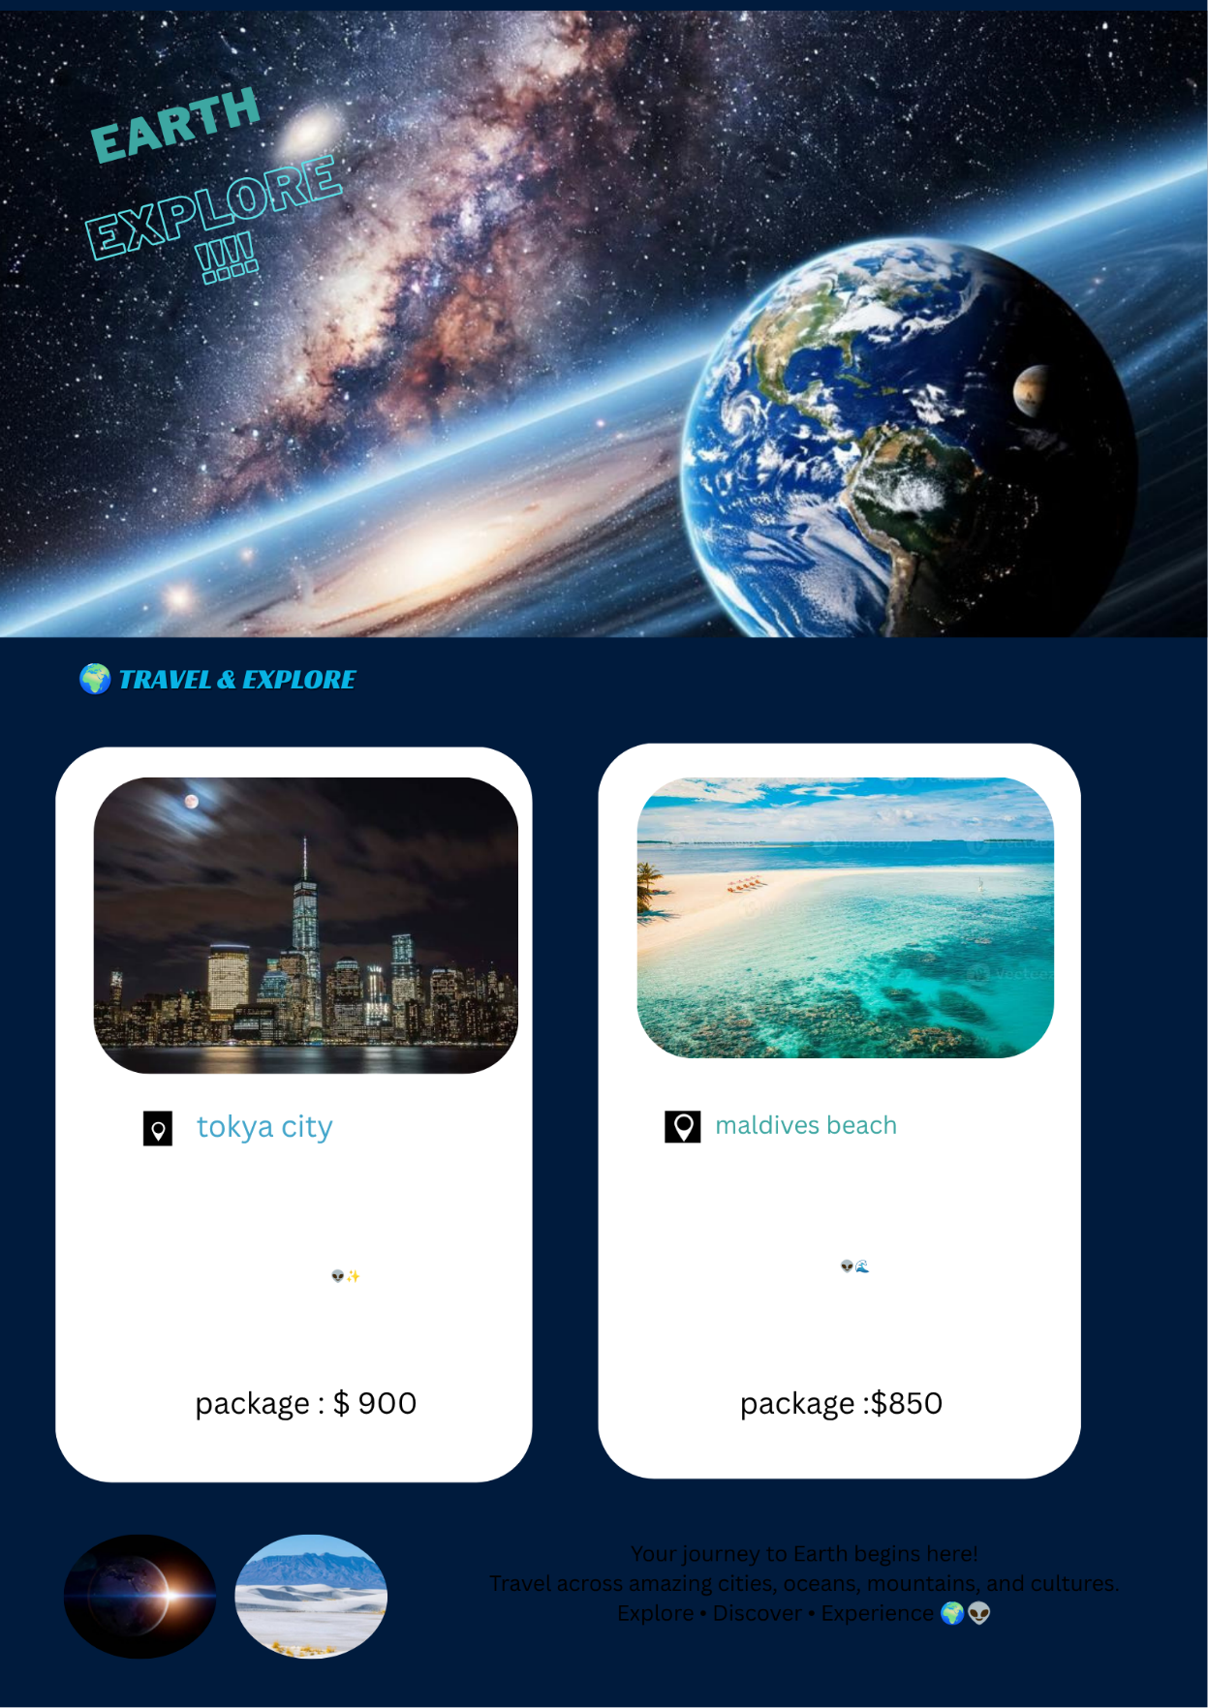
Aksaya V
962824104003
CSE A · III Year


Anu N
962824104035
CSE A · III Year


Nadar Vishakini Paulraj
962825104303
CSE B · II Year


Karthika R
962824205035
IT · III Year


A.Vinith Kumar
962825104104
CSE B · II Year


G.jeffrinson
962824103019
CIVIL · III Year


Atchaya M
962824104103
CSE B · III Year
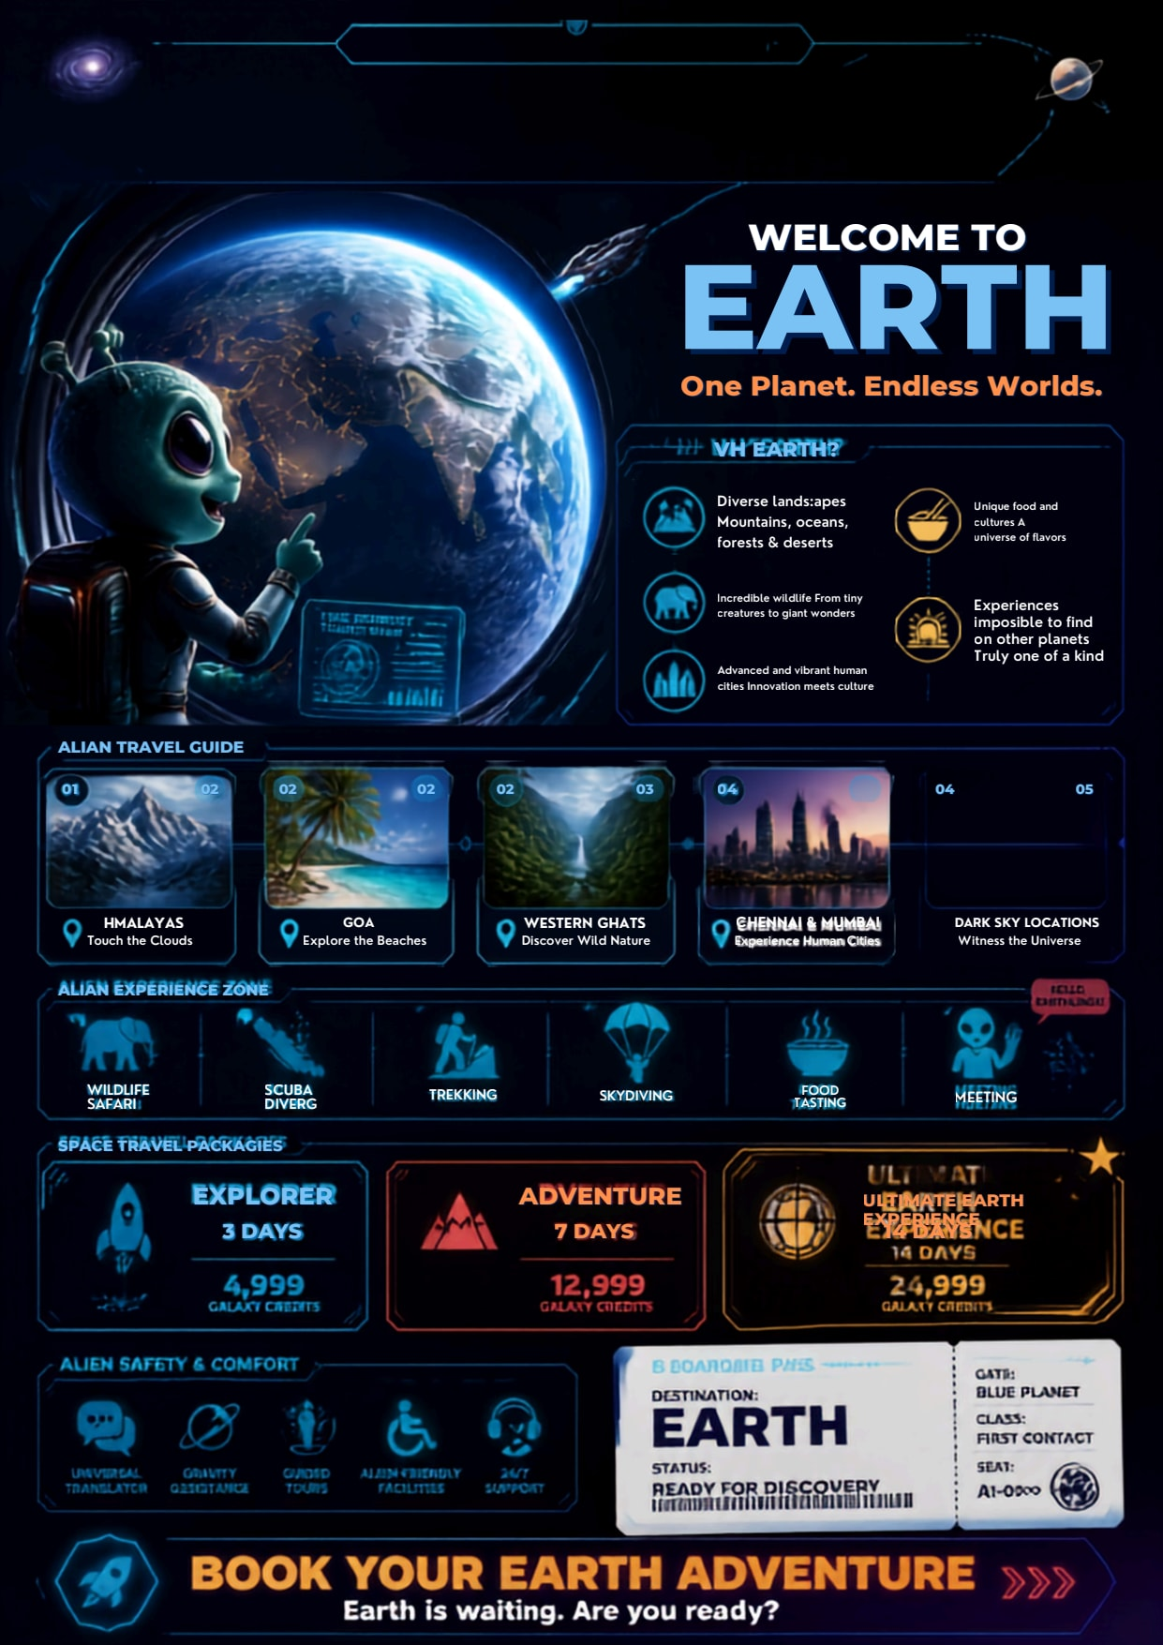
Leela Raja Lekshmi S S
962824104108
CSE B · III Year


Vinisha V
962824104093
CSE B · III Year


BenHanan
962825104308
CSE B · II Year

Abarna S L
962824104023
CSE A · III Year


Hamrutha S
962824104049
CSE A · III Year

ABINESH K
962825104002
CSE A · II Year


S.M.Sivathanush
962825104309
CSE B · II Year

JENISH J
962824114009
MECH · III Year

Saratha P
962825104023
CSE A · II Year


Shanmugamathi S
962825104042
CSE A · II Year


Barath Krishnan
962825104304
CSE B · II Year

FAWZANA H
962825104051
CSE A · II Year


S Mohammed Junaith
962824104024
CSE A · III Year


SUNDARAM R P
962824104002
CSE A · III Year


Ubakara Jayanth U
962824104013
CSE A · III Year


Srii Akshaya k
962825104013
CSE A · II Year

Lamia Mariath B
962824104001
CSE A · III Year


Ancy Reebha N
962825104019
CSE A · II Year


Yahael S
962824104028
CSE A · III Year

Sharmi M
962825104038
CSE A · II Year


