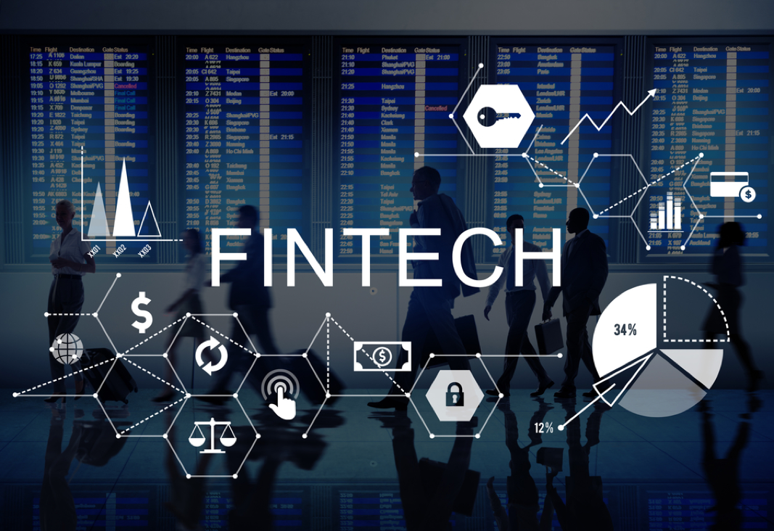

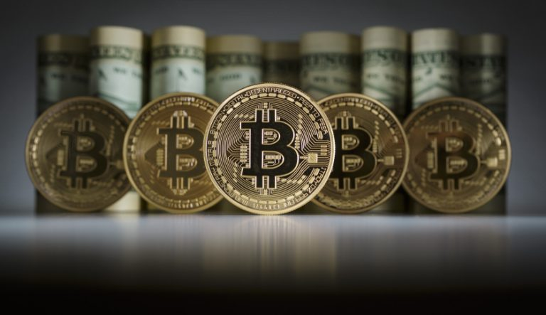

Cleaning and normalizing the Data using: -

* Stop word
* Unicode to String
* Stemmer
* Tokenizing

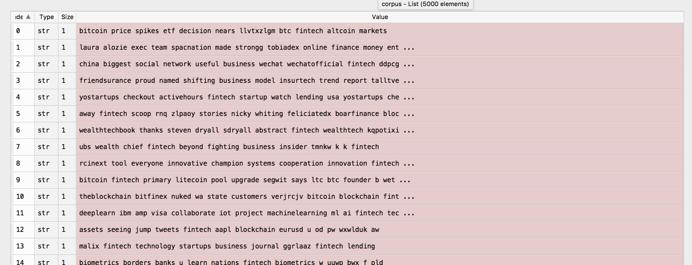



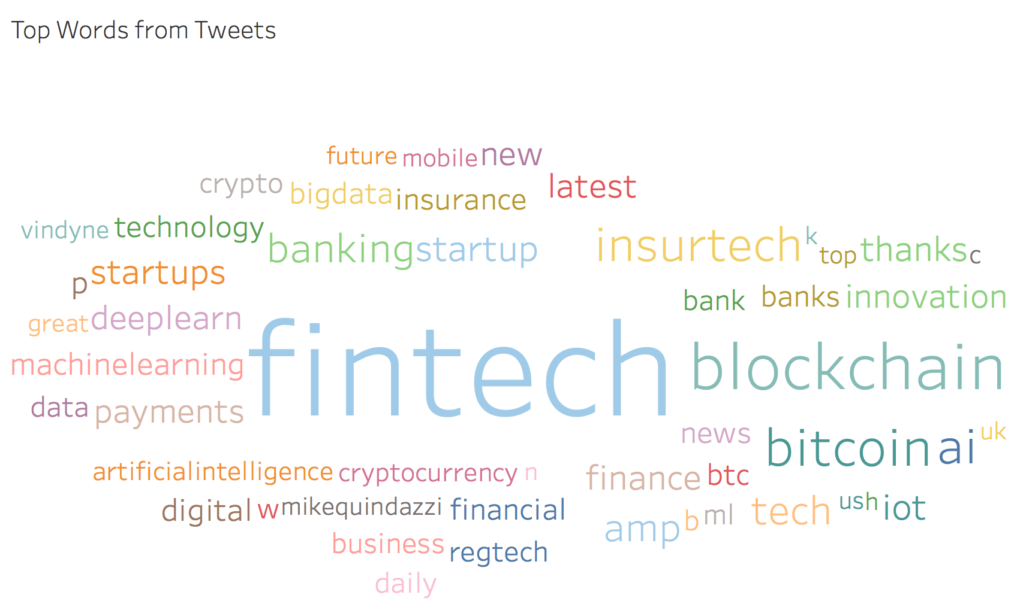

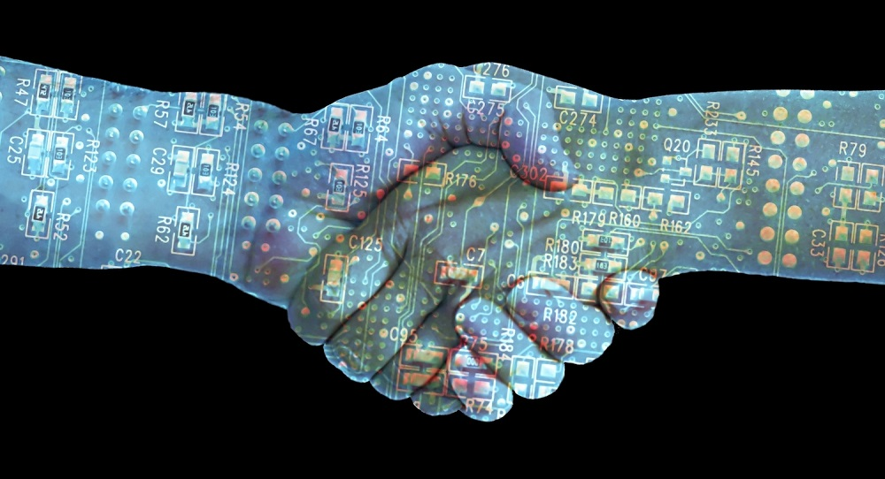

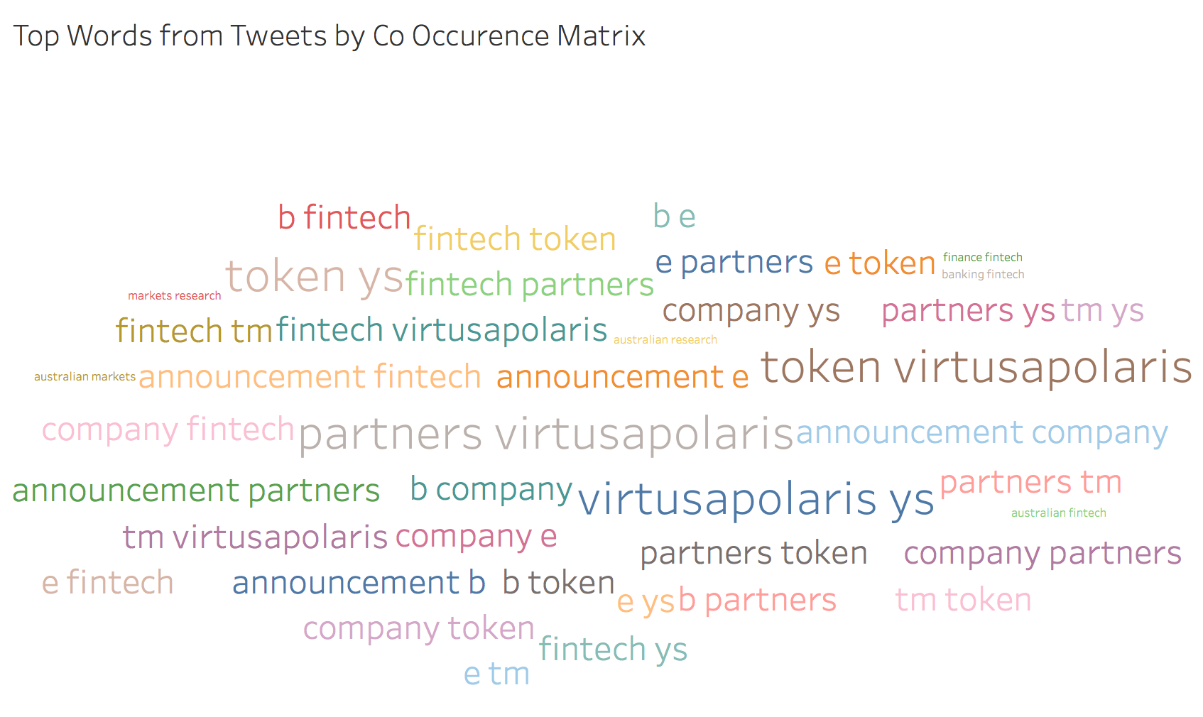

* People discussed about Virtusa Polaris, Fintech Lab. So, they also discussed about the improvement of Fintech.
* People discussed about Australian Fintech world and its clash, collaboration with Banks.
* People are concerned about the latest news about Fintech, how integrate new things in it. Such as token’s new payment ecosystem that uses end to end secure protocol with digital signature.
* We can see the word announcement has a high frequency, hence tweet users are mostly discussed about new partners, company updates and latest news of Fintech.

**Sentiment Analysis**

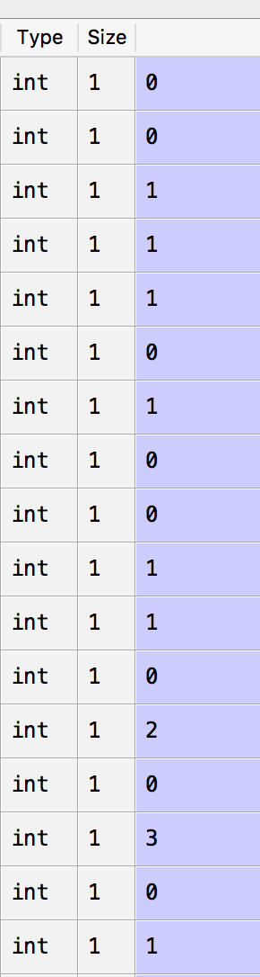 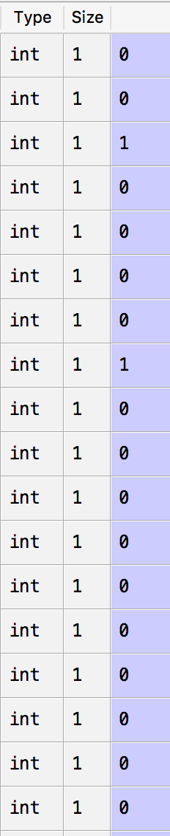

The chosen measure of “closeness” is [Pointwise Mutual Information](http://en.wikipedia.org/wiki/Pointwise_mutual_information) (PMI), calculated as follows (t1 and t2 are terms):

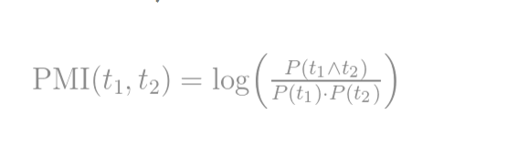

In Turney’s paper, the SO of a word was calculated against excellent and poor, but of course we can extend the vocabulary of positive and negative terms. Using V^{+} and a vocabulary of positive terms and V^{-} for the negative ones, the Semantic Orientation of a term t is hence defined as:

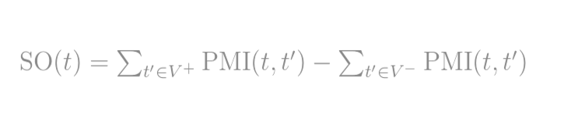

**Topic Analysis: -**

**Top 5 Topic using Non-Negative Matrix Factorization Algorithm: -**

* People discussed positive, negative and neutral aspects of Fintech. Where people are hopeful for Fintech future, with application of Big Data, IOT, Data Analytics.
* People discussed about the role of Regetch in diminishing the cyber security issues.
* Fintech is growing in Singapore with the help of PWC. Innovation under Hood engines are praised and disruption for Fintech using traditional method.
* Indian community’s contribution with latest technologies, where bank fails.
* On the contrary Russian Modulbank acquires three Fintech startups. Lastly people discussed about the famous SXSW conference and its impact on Fintech.

**Top 5 Topic using Latent Dirichlet Allocation Algorithm: -**

* People mostly discussed about the growth and development of Fintech. How fars it came using Machine Learning, Artificial Intelligence, Deep Learning and how far it will go using these technologies.
* Latest news and updates like PWC Singapore contribution, IOT updates, positive and negative effects of Brexit.
* Other top topics are SXSW conference, and its updates on startups competition, panel discussions and mentoring workshops and payment modes other than bitcoin for Asian Fintech World.
* Regulation Technology is growing in Fintech and Machine Learning applications are applying more rigorously in finance.
* Banks are still slow compare to Fintech but they are progressing to adopt digital sales capabilities.



