# Lab 9 – Week 12

## Submission

Your submission will be the script/code and the snapshot of the output to your, collections, documents. In a word file.

Name: Aditya Bhardwaj

Student id: 166959213

Answer Questions 13 to

1. Create a database by name competition
2. Create a collection called raffle
3. Add the following documents to the raffle collection

({"ticket_no":1,"ticket_name":"breeze","playername":"Tunde","age":25,"episode":"mimi"})

({"ticket_no":2,"ticket_name":"Wanne","playername":"Jin","age":12,"episode":"Gold"})

({"ticket_no":3,"ticket_name":"Fanny","playername":"Bill","age":28,"episode":"Silver"})

{"ticket_no":4,"ticket_name":"Loffy","playername":"Bankky","age":38,"episode":"Bronze"})

({"ticket_no":5,"ticket_name":"Bay","playername":"Julie","age":18,"episode":"Lite"})

({"ticket_no":6,"ticket_name":"Roller","playername":"Jean","age":43,"episode":"deep"})

({"ticket_no":7,"ticket_name":"Roller","playername":"Peter","age":33,"episode":"deep"})

1. Issue a query to display all the documents in your collection.
2. Issue a query to update the first document by setting the ticket_name from breeze to Fair
3. Issue a query using the $all operator to return all documents whose episode is deep
4. Create a query to retrieve documents whose tickect name is Loffy or Roller.
5. Create a query to retrieve documents whose ticket_name is Wanne and age is 12.
6. Create a query to return documents whose ticket number is 4, 5, 7.
7. Create a query to return documents whose ticket number is not 1,2.
8. Create a query to return documents where age is greater than or equal to 18.
9. Create a query where age is less than 18.
10. Using the $set operator add a new field as follows:

“Entrance”:”A”



Use the $push operator to add elements to the end of an Array, if the array does not exist it should create it.

“Main Entrance”:”Blue”,”Green”,”Yellow”,”Red”.

db.raffle.update({}, {$push: {"Main Entrance": {$each: ["Blue", "Green", "Yellow", "Red"]}}}, {upsert: true})

1. Use the addToSet to add an element as follows to the array:

“Main Entrance”: “Green”, was the element added. Yes or No. If no why.

db.raffle.update({}, {$addToSet: {"Main Entrance": "Green"}})

1. Use the addToSet to add a new elent into the array as follows:

“Main Entrance”:”Pink”

db.raffle.update({}, {$addToSet: {"Main Entrance": "Pink"}})

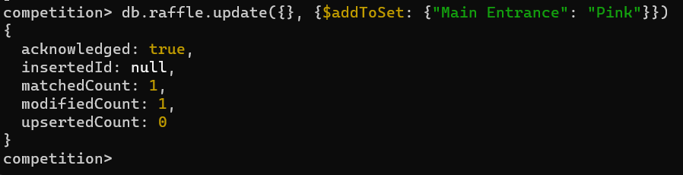

1. Use sort to sort the elements in the array.

db.raffle.update({}, {$push: {"Main Entrance": {$each: [], $sort: 1}}})

**(23 Marks)**