# Lab 7 – Week 10

# (Stored Procedures/Iterative Statements)

## Submission

Name: Sahibpreet Singh   
Id: 165338211

Email: sahibpreet-singh1@myseneca.ca

1. Create a database by name book_store

Use book_store



1. Create a collection called books

(Answer for question 3 solves this question as well. Please, refer to that answer below.)

1. Add the following documents to the books collection

db.books.insert ({“name”: “Daily Devotional”,”author”: “Lee Jin”, ”published”:”1965”, “description”:”pray always”,”price”:12})

db.books.insert ({“name”: “Achieve”,”author”: “Hiu Lee”, ”published”:”1970”, “description”:”Achiving greatness”,”price”:20})

db.books.insert ({“name”: “Gymnastic”,”author”: “Peter Blue”, ”published”:”1966”, “description”:”Steps to gym”,”price”:16})

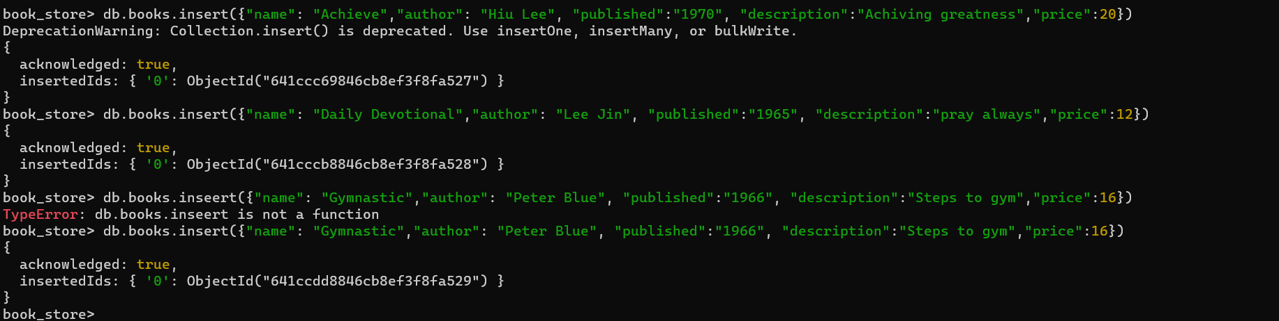

1. Add two more documents to the books collection.

db.books.insert({"name": "Dhaba","author": "Asli Jatt", "published":"1346", "description":"Dhaba mittran da","price":74})

db.books.inseert({"name": "Dukaan","author": "Peter Jatt", "published":"1956", "description":"Steps to store","price":14})

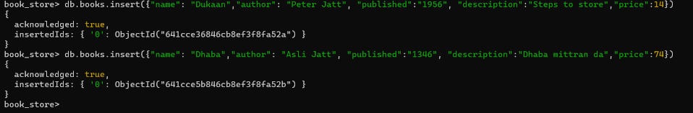

1. Issue a query to display all the documents in your collection.

db.books.find()

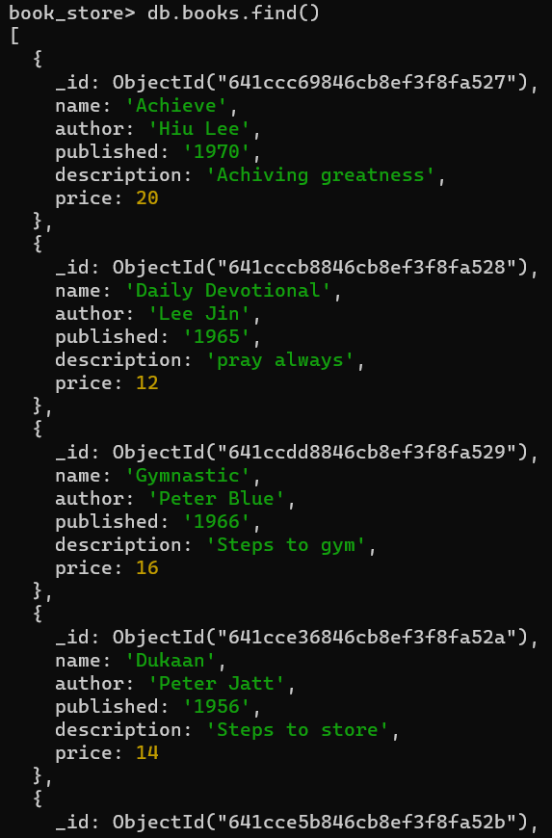

1. Issue a query to update the first document by setting the author from Lee Jin to Yin Hiu

db.books.updateOne({"name":"Achieve"},{$set:{"author":"Yin Hiu"}}) 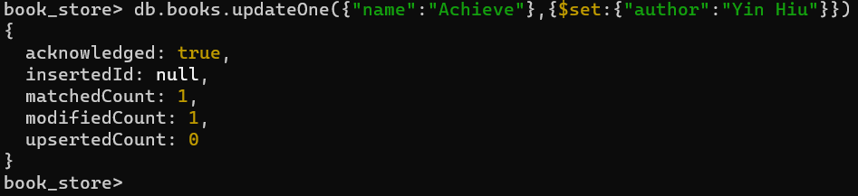

**(23 Marks)**