

**Image Classification**

Submitted by:

Sahib Hussain

**ACKNOWLEDGMENT**

This project would not have been possible without the support of many people. Many thanks to my SME Sapna Verma who gave suggestion how to proceed in building this model and helped make some sense of the confusion. Also thanks to my Internship Company FlipRobo Technologies Pvt. Ltd for giving me this opportunity to work on such a project.

**INTRODUCTION**

* **Business Problem Framing**

Images are one of the major sources of data in the field of data science and AI. This field is making appropriate use of information that can be gathered through images by examining its features and details. We are trying to give you an exposure of how an end to end project is developed in this field.

The idea behind this project is to build a deep learning-based Image Classification model on images that will be scraped from e-commerce portal. This is done to make the model more and more robust.

**Analytical Problem Framing**

* Mathematical/ Analytical Modeling of the Problem

The DataSet contains 200 images of Sarees, Trousers(Men), Jeans(Men ) each. These were then loaded to google drive and three separate folders were made each for Training, Validation and Testing purpose.

* Data Sources and their formats

The data was collected from Amazon ecommerce website using selenium to build this model.

We collected 700 images approx of Sarees, Trousers(Men) and Jeans(Men) each.

It was saved to local system in jpg format which was later loaded to google drive for further processing and building the model.

* **Data Preprocessing Done**

The images were loaded to google drive into a folder image.

Three separate folders were made inside it for Train, Test and Validation.

Three separate folders were made inside each one of them for Saree, Trousers and Jeans.

* Hardware and Software Requirements and Tools Used

**Software used** : In this we used Google Colab, Ms Word and Ms PowerPoint to build the model.

**Libraries used**: Pandas to read the dataset, OS, CV, TensorFlow, Keras, Adam, RMSProp, Reduce LRON Plateau, Image Data Generator, img to array, PIL Image, Load Model.

**Model/s Development and Evaluation**

* Identification of possible problem-solving approaches (methods)

# In order to build the model we have used VGG-16 | CNN model

* VGG models are a type of CNN Architecture proposed by Karen Simonyan & Andrew Zisserman of Visual Geometry Group (VGG), Oxford University, which brought remarkable results for the ImageNet Challenge.
* They experiment with 6 models, with different numbers of trainable layers. Based on the number of models the two most popular models are VGG16 and VGG19.

# What is this CNN Architecture?

Well, CNN is a specialized deep neural network model for handling image data.

* It does not need the traditional image processing filters like the edge, histogram, texture, etc., rather on CNN, the filters are learnable. So, these need not be determined through trial and error.
* CNN has two parts, the first part is a feature learning part and then there is a classification layer (Often referred to as the Fully Connected Layer)
* The main two building blocks of the feature learning part are the convolution layer and pooling layers
* **Convolution Layer:**The learnable filters or the feature extractors we talked about.
* **Pooling Layer:**This does some spatial compression also brings about invariance. A car will be a car, even if it is rotated a little bit.

Figure 2, gives an architectural overview of CNN. Convolutions create feature maps, Pooling is achieved through subsampling.

https://miro.medium.com/max/60/1*EsmiX29OAbYcvj4sibp3Jw.png?q=20

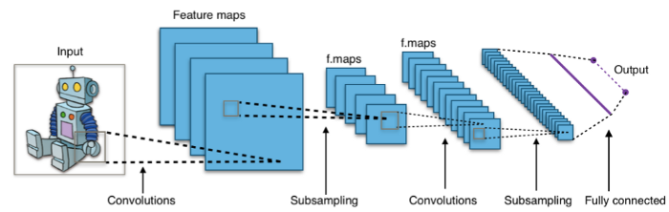

* Key Metrics for success in solving problem under consideration

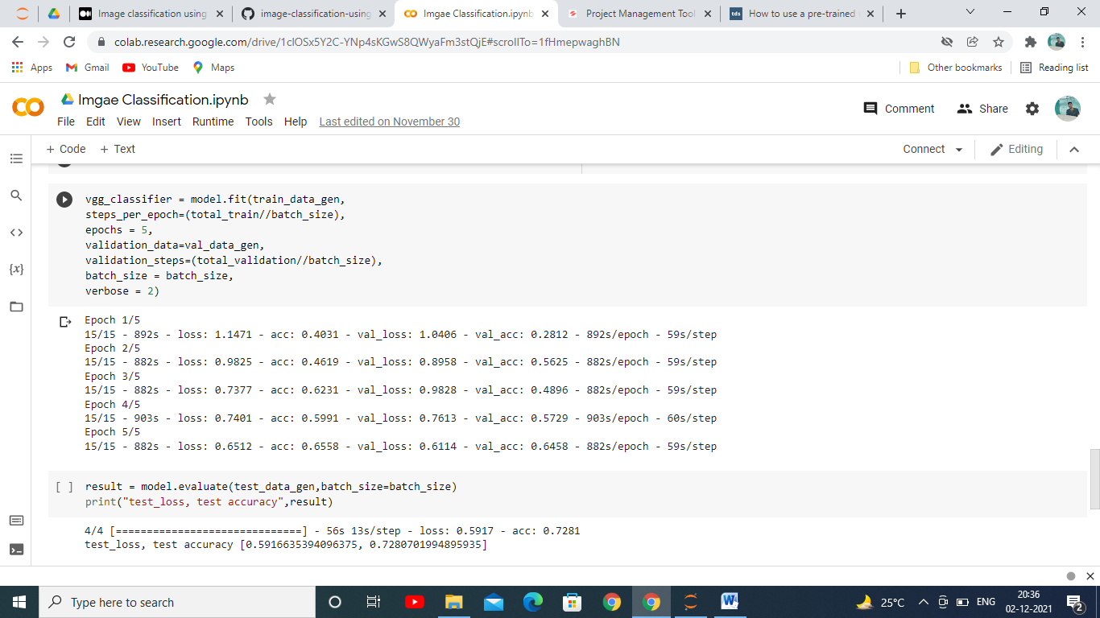

After Training Testing the model with 5 epochs we achieved accuracy score of 72.80%

**CONCLUSION**

* Key Findings and Conclusions of the Study

This model helped us to know whether a image is of a Saree, Trouser or a Jeans based on what input it is taking. We know these days Image Classification is becoming popular and its application are increasing rapidly in every sector.