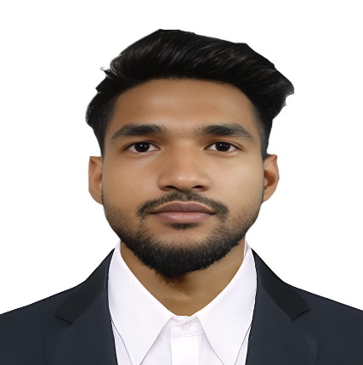

**CAREER OBJECTIVE**

* To secure a responsible career opportunity to fully utilize my training and skills, while making a

significant contribution to the success of the company.

* To seek an entry-level position to begin my career in a high-level professional environment.

**TECHNICAL SKILLS**

* **Languages**: C, Java, HTML, CSS, Node JS, React JS.
* Android App Development with Java.
* **Application Tools:** Microsoft Office LTSC professional plus 2021, VS code, Android Studio, IntelliJ IDEA Community.
* **Database**: Google Firebase, Mongo DB, MySQL

**PERSONAL INFORMATION**

**Date of Birth :** Fuck

**Nationality :** Indian

**Hobbies :** Computer programming, Make Money, Marketing, learning, playing football

**Language Known :** English, Hindi, Bengali

**Address :** Ardebok Road, Noapara, Barasat, North 24 parganas, Kolkata-700125

**EDUCATION**

|  |  |  |  |  |
| --- | --- | --- | --- | --- |
| **Degree / Certificate** | **School / Collage** | **Board / University** | **Year of Passing** | **Percentage** |
| **B.Tech(CSE)** | **Camellia School of Engineering & Technology** | **M.A.K.A.U. T** | **2020-24**  **(Till Running)** | **85%**  **(Till Running)** |
| **12th** | **Natni High School** | **W.B.C.H.S. E** | **2020** | **63%** |
| **10th** | **Suria Moulana Azad High School** | **W.B.B.S. E** | **2018** | **59%** |

**PROJECT**

* Build a Quiz App (Quiz Box)-

● Using Android Studio with Java

● Using Google Firebase as a Serve

● GitHub Link –https://github.com/SahiburRahaman

**DECLARATION**

I hereby declare that all the statements made in this resume are true to the best of my knowledge and belief.

Place:

Date: Signature

Signature:

Place :

Date:

I hereby declare that all the statements made in this resume are true to the best of my knowledge and belief.

Place:

Date: Signature

**🏠 Address:**

Ardebok Road, Noapara, Barasat, Kolkata-700125

**🖀 Phone:**

+91 9007519276 / 8101986647

**🖄 Email:**

Rahamansahibur93@gmail.com

**SAHIBUR**

**RAHAMAN**