**Create an OOP Based System for Storing School Data Using Design Patterns.**

**DESCRIPTION**

Write a program which will allow storing data about students, teachers and subjects using Classes. Populate the classes with test data and print them out on the console.

****Background of the problem statement:****

As part of the prototyping process of developing software for Rainbow Schools, they are trying out an OOP based system which will let them store data about teachers, subjects, and students.

**Program:**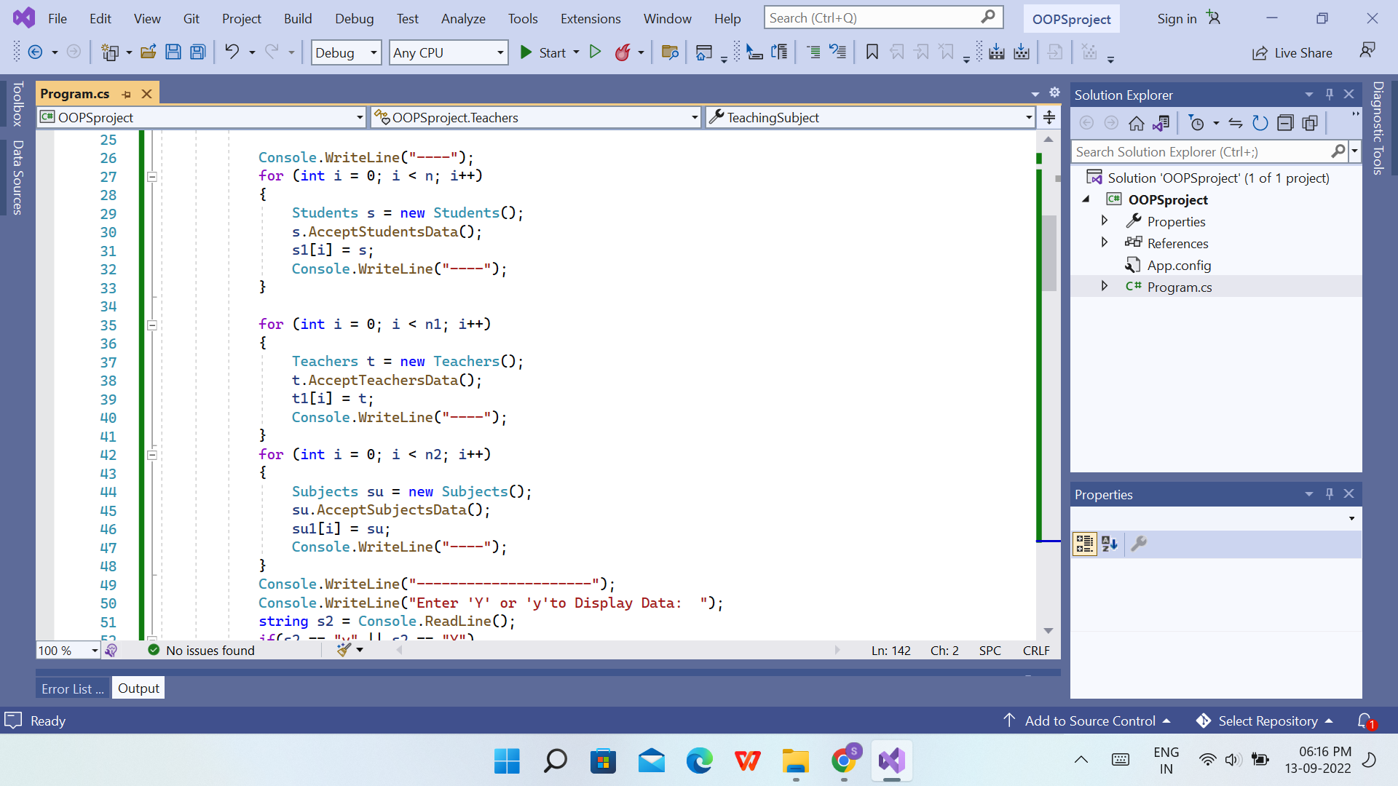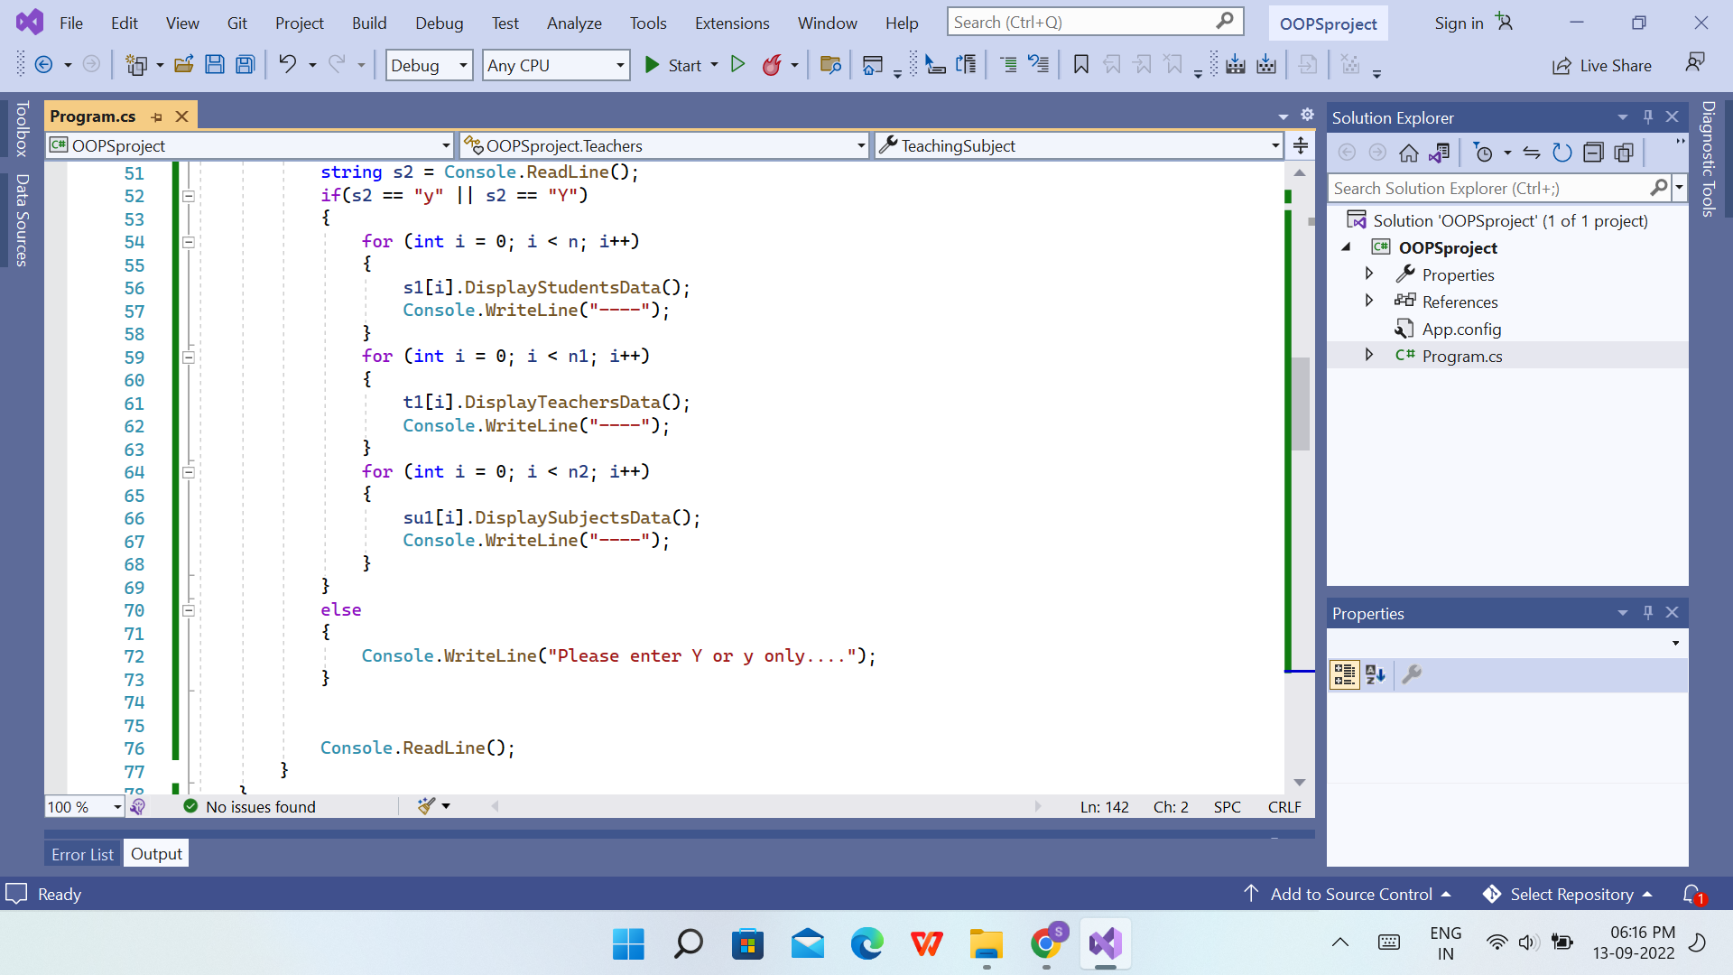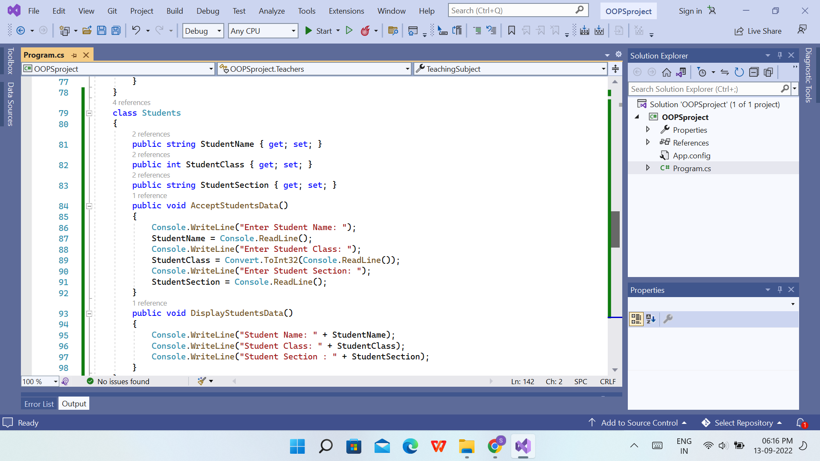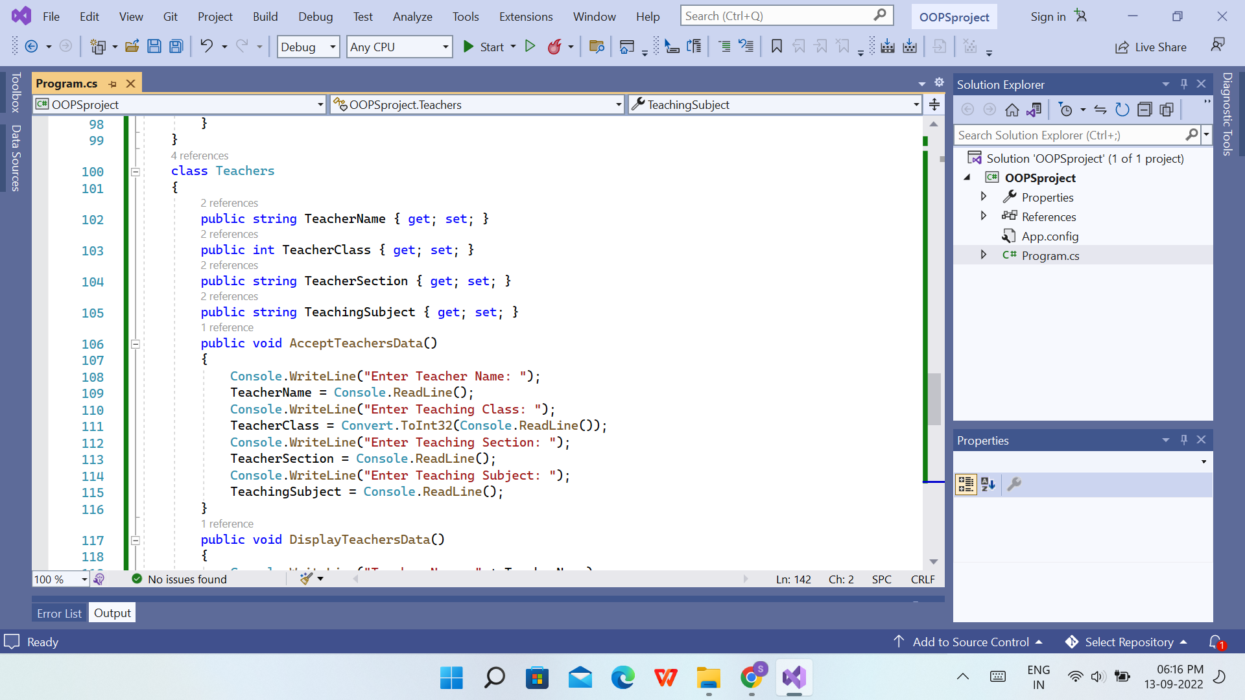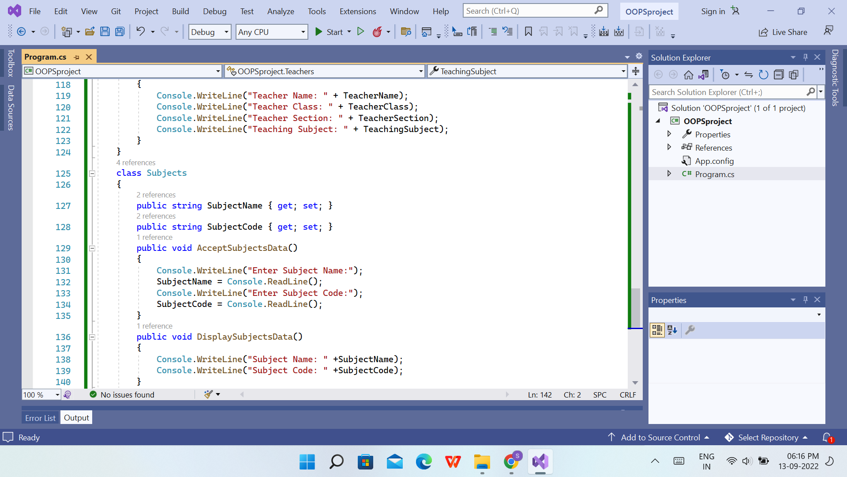

**Output of Program that will retrieve the data from studentsfile.txt with the Option of Sorting and Searching:**

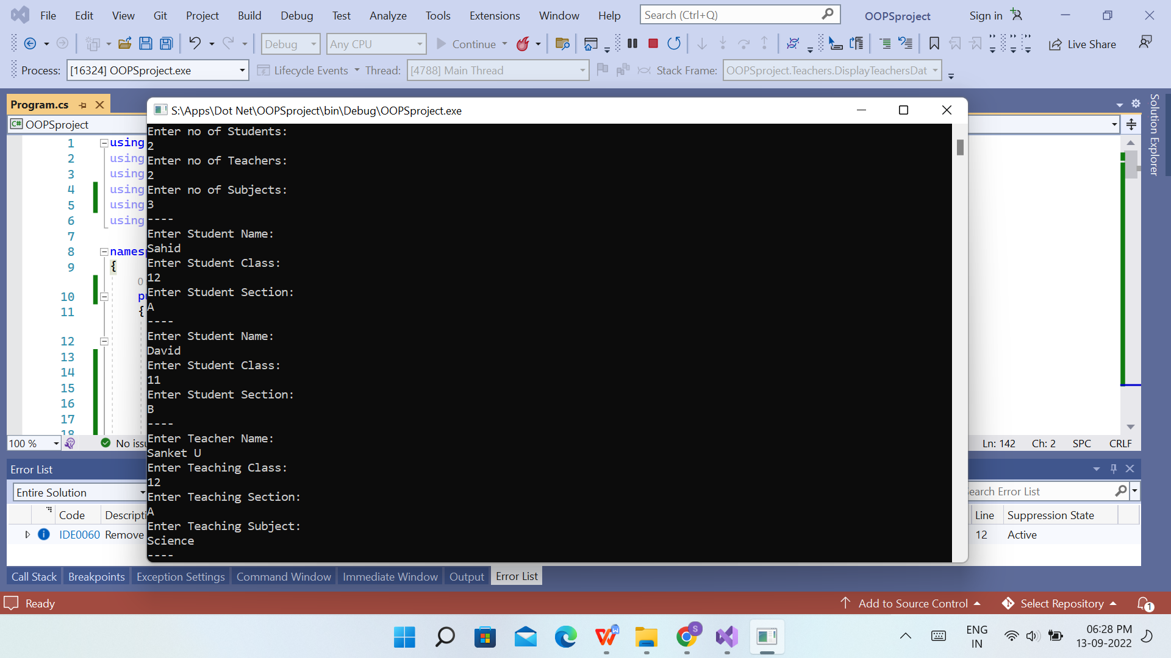

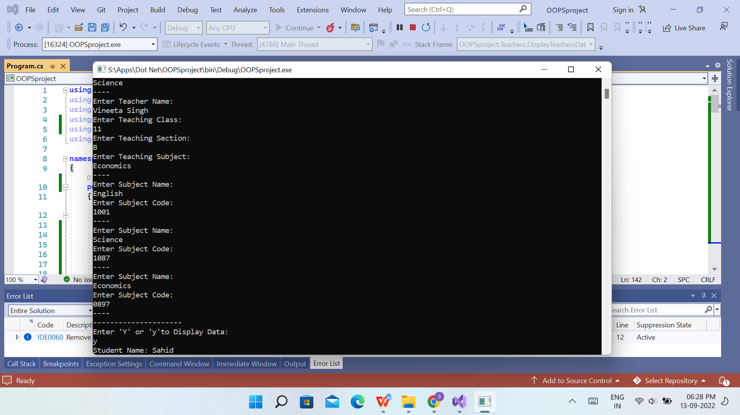

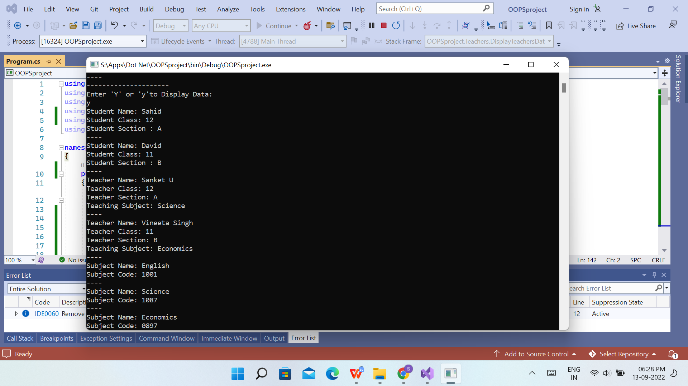

**Sahid Ali Khan**

**2529998**