**VIDYALANKAR INSTITUTE OF TECHNOLOGY**

Affiliated to University of Mumbai

Wadala(E), Mumbai - 37



A MINI-PROJECT REPORT

ON

**“GARBAGE MANAGEMENT APP”**

(Course – Android Apps Development Lab)

Submitted by

**STUDENT NAME ROLL NO**

**AMEYA PAWAR 17101A0021**

**SAHIL MIRGAL 17101A0024**

**SHUBHAM DESAI 17101A0025**

**Department of Information Technology VIT,**

**Wadala(E), Mumbai-37**

2020-2021

**VIDYALANKAR INSTITUTE OF TECHNOLOGY**

**Department of Information Technology**

**VIT, Wadala(E), Mumbai-37**



**CERTIFICATE**

Certified that the mini-project work entitled **“GARBAGE MANAGEMENT APP”** is a Bonafede work carried out by

**AMEYA PAWAR 17101A0021**

**SAHIL MIRGAL 17101A0024**

**SHUBHAM DESAI 17101A0025**

The report has been approved as it satisfies the academic requirements in respect of mini-project work prescribed for the **course- Android Apps Development Lab**.

…………………

Faculty In-Charge

………………… …………………

Internal Examiner External Examiner

**Table of Content**

Acknowledgement 1

Abstract 2

1. Introduction 3

1.1. Introduction 3

1.2. Problem Statement 4

1.3. Motivation 4

1.4. Scope 5

2. Literature Survey 6

3. Proposed System 7

3.1. Block Diagram 7

3.2. Hardware and Software Requirements 8

3.2.1. Hardware Requirement 8

3.2.2. Software Requirement 8

4. Implementation 9

4.1. Modules 9

4.1.1. Camera 9

4.1.2. Location 10

4.1.3. Recycler View with Database 11

4.2. Results 12

4.2.1. Activities 12

4.2.2. Databases 22

5. Conclusion and Future Scope 23

5.2. Conclusion 23

5.3. Future Scope 23

References 24

**Table of Figure**

Figure 3.1.1 Block Diagram 7

Figure 4.1.1.1. Camera module 9

Figure 4.1.1.2. Camera & Gallery module 10

Figure 4.1.2.1. Mapping Bin Location 10

Figure 4.1.2.2. Mapping User Live Location 11

Figure 4.2.1.1 App Icon 12

Figure 4.2.1.2 Splash Screen 13

Figure 4.2.1.3 Main/Home Screen 13

Figure 4.2.1.4 Navigation Drawer 14

Figure 4.2.1.5 Profile page 14

Figure 4.2.1.6 Edit Profile 15

Figure 4.2.1.7 Change Password 15

Figure 4.2.1.8 Message Page 16

Figure 4.2.1.9 Message Page 16

Figure 4.2.1.10 Individual Task Page 17

Figure 4.2.1.11 Filled individual Task page 17

Figure 4.2.1.12 Settings Page 18

Figure 4.2.1.13 About page 18

Figure 4.2.1.14 Bin Location Page 19

Figure 4.2.1.15 Current location with bin location 19

Figure 4.2.1.16 Login page 20

Figure 4.2.1.17 Login page 20

Figure 4.2.1.18 Archive Page 21

Figure 4.2.1.19 Bin Add Page 21

# Acknowledgement

We thank God for giving us the ability or this undertaking. This acknowledgement is not something which has been written in a day but we have been longing, right from the time we were allotted our guide, to express our gratitude. This is just a channel for our expression.

First and foremost, we express our profound gratitude and sincere thanks to **Prof. Indu Anoop** our respectable project guide, for her gigantic support and guidance. for providing us with all proper facilities and support as the project co-coordinator. We would like to thank her for support, patience and faith in our capabilities and for giving us flexibility in terms of working and reporting schedules. Without hercounselling our project would not have seen the light of the day.

Finally, we would like to thank everyone who has helped us directly or indirectly in our project. The days we have spent in the institute will always be remembered and also be reckoned as guiding in our career.

1. Ameya Pawar

2. Sahil Mirgal

3. Shubham Desai

# Abstract

This project deals with the problem of Waste management in cities, where the garbage collection system is not optimized. This project enables the organizations to meet their needs of garbage management system. As in our country tonnes of garbage is generated daily it is difficult to look after each and every place.

So here we have come with the solution by designing a monitoring system which will take into consideration the garbage bin of each and every locality. This system allows the user to know the location of each garbage bin and is the garbage is collected daily if yes, the where, when and by whom it is collected and by providing images of before and after collection of garbage we can authenticated the work done by the user or the worker of the Municipal Corporations.

In this project, we have successfully implemented a working app with Camera, Location and SQLite database connectivity with an attractive UI. This app registers user if he/she is not registered, the collected information includes the name, email and password at first then a bio, phone number and address of the user which can be edited in the settings also the password can be changes. It displays the daily schedule or task to be completed. The task includes cleaning of bins and upload images of before and cleaning of the bin to ensure authenticity of the work done by him/her. All the task done previously are displayed so we can analyse the efficiency of the worker. The user can write note or message to himself. The live location of the user and all the location of garbage bins can be shown on the map.

# Introduction

## Introduction

Waste management practices are not uniform among countries ,regions ,and [residential](https://en.wikipedia.org/wiki/Residential_area) and [industrial](https://en.wikipedia.org/wiki/Industrial_sector) sectors can all take different approaches. Proper management of waste is important for building sustainable and liveable cities, but it remains a challenge for many developing countries and cities. Effective waste management is quite expensive, usually comprising 20%–50% of municipal budgets. Operating this essential municipal service requires integrated systems that are efficient, sustainable, and socially supported. In view of this, the World Bank finances and advises on solid waste management projects using a diverse suite of products and services, including traditional loans, results-based financing, development policy financing, and technical advisory. World Bank-financed waste management projects usually address the entire lifecycle of waste right from the point of generation to collection and transportation, and finally treatment and disposal.

This application is specifically designed for the workers of Municipal Corporations. This Smart Garbage Monitoring app will help the users to carry out their work more effectively and will prove their authenticity of the work. This app accurately tracks each and every bin in a locality and populated the cleaning task according to it every day.

This idea is perfect for saving time and changes the regular way to dumping the trash, thus this app provides a cost-effective way or web-based system for the government to utilize available resources to efficiently manage the overall amounts of garbage collected regularly, while also providing a better solution for garbage disposal for many cities. Our Garbage Management APP integrates the best techniques to check and analyse data collected which can be used to analyse efficiency of the workers and will provide data to analyse and make prediction in future much easier which can implement as a smart city solution. This work proposes an efficient and waste management model for cities, focused on a worker’s perspective.

## Problem Statement

Compared with developed countries, citizens of underdeveloped countries suffer most severely from the impact of unsustainably managed waste. India generates 62 million tonnes of waste annually, and it has been predicted that this will reach 165 million tonnes in 2030. 43 million tonnes of municipal solid waste are collected annually, out of which 31 million is dumped in landfill sites and just 11.9 million is treated and rest waste is disposed inadequately every day. In these countries, garbage is often disposed of inappropriately in rivers, streets or even in open incineration; these practices have severe consequences for human health, safety and the environment. Improperly managed waste can serve as a rich source of disease and contribute to global climate change through the generation of greenhouse gases, and even promotes urban violence with the degradation of urban environments. Proper waste management is essential for the construction of sustainable and habitable cities but remains a challenge for many developing countries and cities. Effective waste management often becomes costly, compromising municipal budgets. Operating this essential municipal service requires an integrated system that is efficient and sustainable.

So ensure that the waste is collected proficiently and no health issues arise from [inadequate](https://www.thesaurus.com/browse/inadequate) cleaning and only sufficient amount of resources are only allocated for the management of the garbage we have developed an app which will ensure efficiency and integrity of the work.

## Motivation

In cities, the efficient management of waste is a crucial challenge for the environment that our current technology tends to address. Waste management covers all the activities necessary for monitoring the waste generated in a city, from its beginning, when citizens produce their waste, through collection, transportation, and arrival at its final accommodation, which can be the landfill, incineration, or recycling. It has been a significant challenge for cities around the world. Thus, in the absence of an effective and efficient solid waste management program, waste generated by urban activities, both industrial and domestic, can result in health risks and harm the environment. Understanding of the waste generated, the availability of resources and the environmental conditions of a given society is essential for the development of an appropriate waste management system so we decided to make an to contribute to such a society by implementing a small part of waste management toward government side to make the management system more reliable and to contribute toward the cleanliness drive to keep our city clean.

## Scope

* To efficiently carry out management service.
* To pin point each and every garbage bin in a locality.
* To schedule each task base on bin id.
* Don’t forget any task by adding note to yourself.
* Add garbage bins anytime.
* To design proper model which can be integrated with IOT.
* To perform analytics on the saved data to improve the system in the future by applying various prediction algorithm which will save enough resources.
* To determine is the user is carrying out its work efficiently and proficiently.
* To provide authenticity of the work.

# Literature Survey

|  |  |  |  |  |
| --- | --- | --- | --- | --- |
| **SRNO** | **YEAR** | **PAPER TITLE** | **AUTHOR** | **LEARNING** |
| 1. | **22 March 2017** | Blog  Challenges and opportunities associated with waste management in India | 1. [Sunil Kumar](https://royalsocietypublishing.org/doi/10.1098/rsos.160764) 2. [Stephen R. Smith](https://royalsocietypublishing.org/doi/10.1098/rsos.160764) 3. [Geoff Fowler](https://royalsocietypublishing.org/doi/10.1098/rsos.160764) | This blog gives us brief information about the waste management system in India. The amount of waste generated, collected and processed. The health risk due to inadequate cleaning to the workers as well as to the society. |
| 2. | February 2018 | Waste Management System Using IoT | 1. Mohammed Adam 2. Bakri Nasreldeen 3. Omer Mohammed Tawfeeq | This paper explains the IOT solution to waste management here we get the dustbin status with their location which we can used to register the dustbin and in future scope to integrated proper with our app. So from here we got idea to map location of dustbins on map and also best past can also be implemented. |

# Proposed System

## Block Diagram

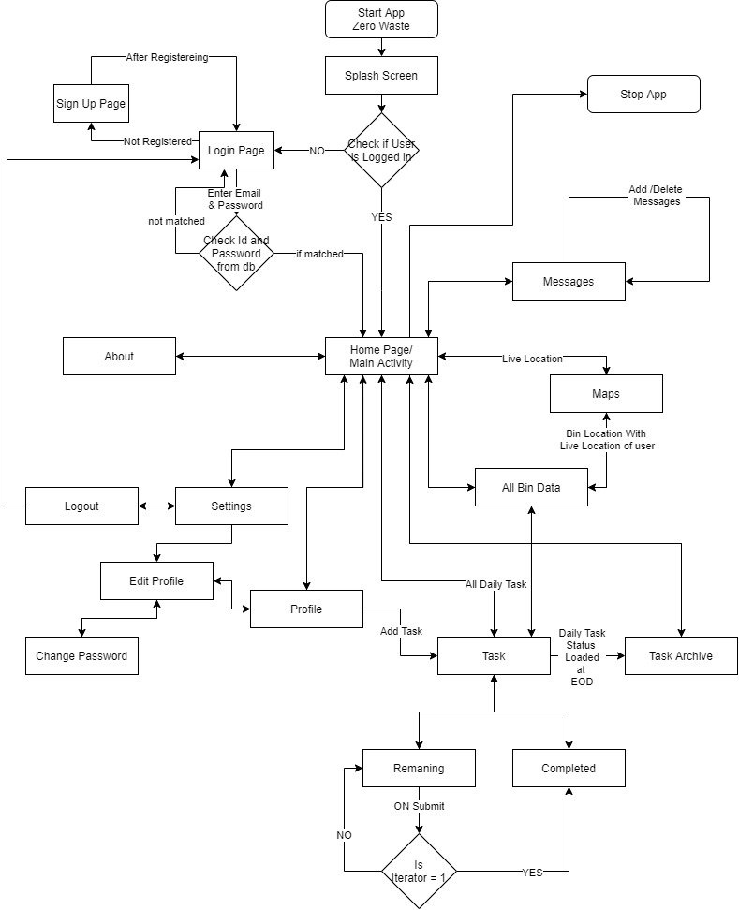

###### Figure 3.1.1 Block Diagram

## Hardware and Software Requirements

### Hardware Requirement

* PC i3 or above configuration.
* Minimum 4GB Ram (8GB+ Recommended)
* Phone

### Software Requirement

* Android Studio
* Java
* OS: Windows 10

# Implementation

## Modules

### Camera

Here we have implemented camera module for clicking user profile picture and taking picture of before and after cleaning.

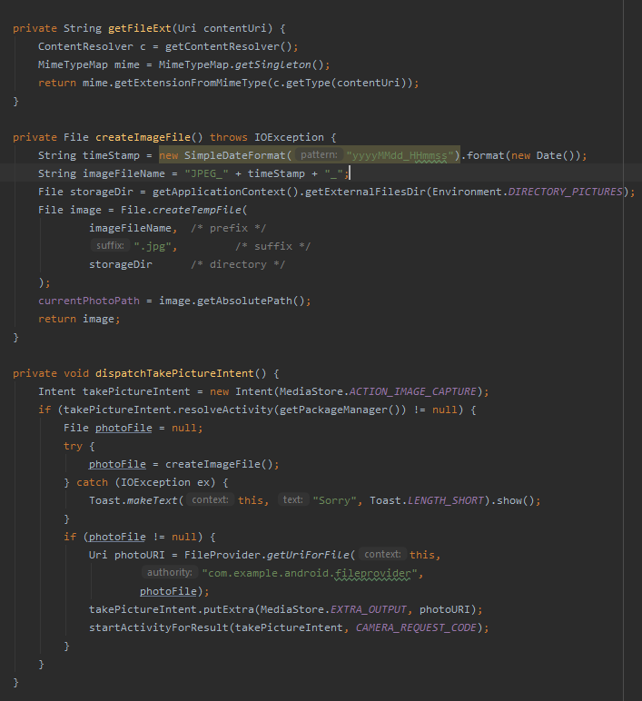

###### Figure 4.1.1.1. Camera module

Here for clicking image dispatchTakePictureIntent module is called which creates the image file with createImageFile function and store the url of image in currentPhotoPath variable which is called in activity result function.

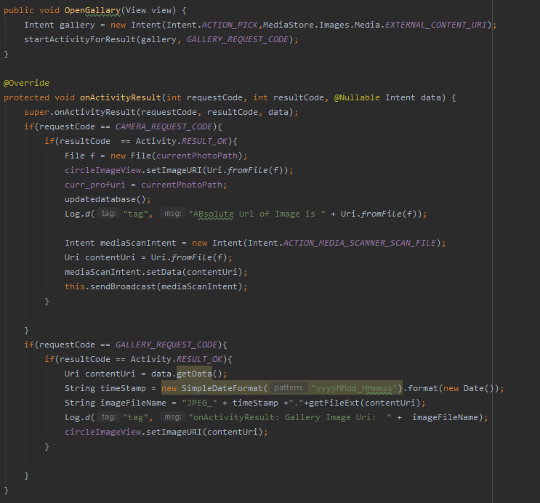

###### Figure 4.1.1.2. Camera & Gallery module

This is onActivity result function in which the image from camera or the gallery are set according to the request code set by the user or the function called.

### Location

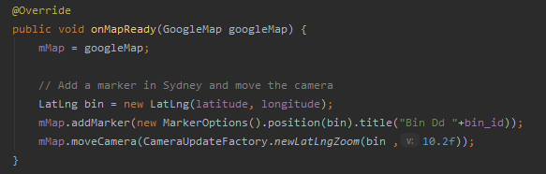

###### Figure 4.1.2.1. Mapping Bin Location

Here this code snippet tells us how the bin is mapped using stored latitude and longitude values and are displayed on the map.

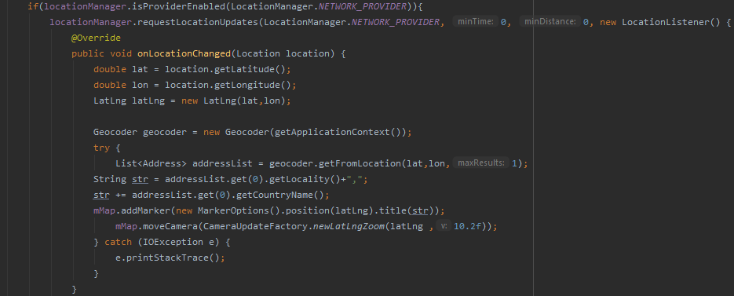

###### Figure 4.1.2.2. Mapping User Live Location

Here we have displayed the user live location with network provider the same code is done with the help of gps provider at the time of request the best possible alternative will be used to display the live location of the user.

### Recycler View with Database

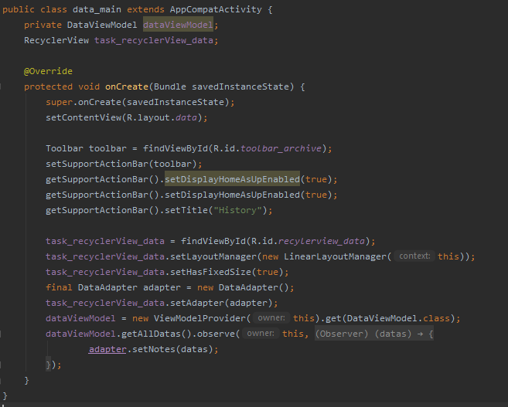

###### Figure 4.1.3.1. Recycler view with database.

This is the small cod snippet where we have attached a recycler view to a value which are fetched by executing a query. First, we initialize a recyclerview variable the we assign the recyclerview id at which we have to display the values. Then we define a adapter where all the binding of the items with the id and the holder takes place that which values will be displayed from where it has to fetch it and how to display it and if there are on any onclicklistners on the recycler view what to do. I have used Room + ViewModel + LiveData + RecyclerView type of architecture or practice to fetch, add, update or display any values from database to recyclerview.

## Results

### Activities

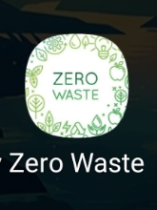

###### Figure 4.2.1.1 App Icon

This is just a simple app icon which we have set.

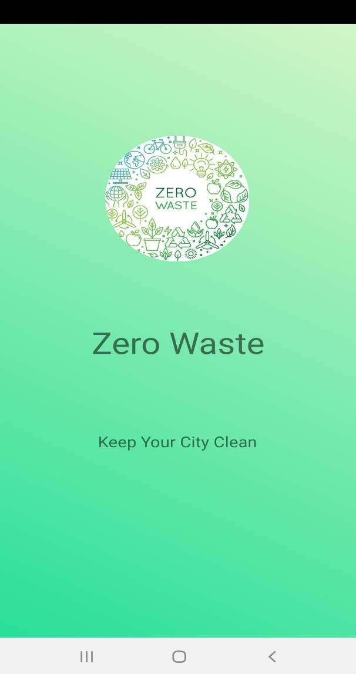

This is the splash screen which will be loaded at the start of the app and which will take overall 5 seconds to complete the animation and move to the next activity.

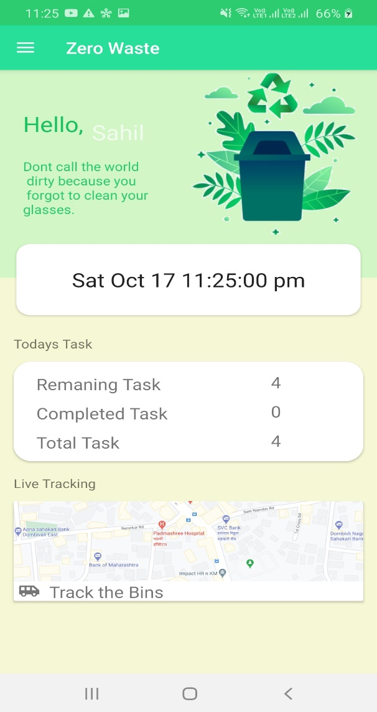

###### Figure 4.2.1.2 Splash Screen

This is the home screen of the app which will be loaded after the login screen. Here on home screen we get the name displayed of user with the current time with the overall view of today’s task i.e. remaining, completed and total task count. The next view is a image view which if we click on it will open display bin location page. On left to right swipe or by clicking on 3 bars on the toolbar we open the navigation drawer.

###### Figure 4.2.1.3 Main/Home Screen

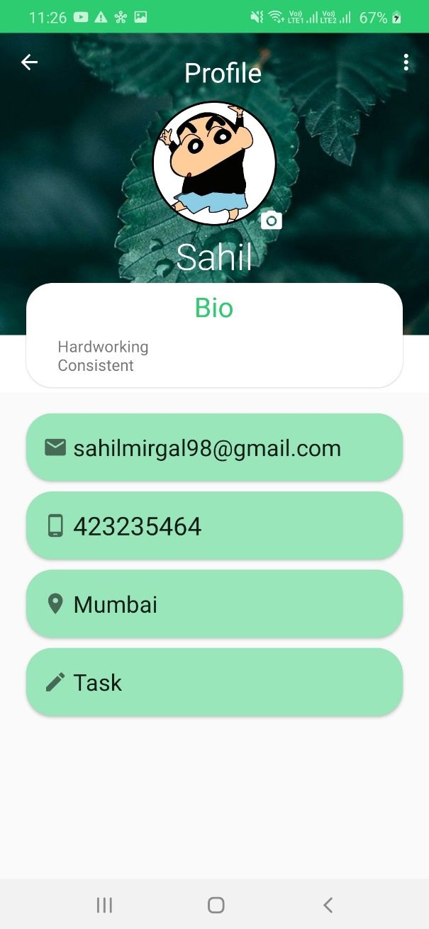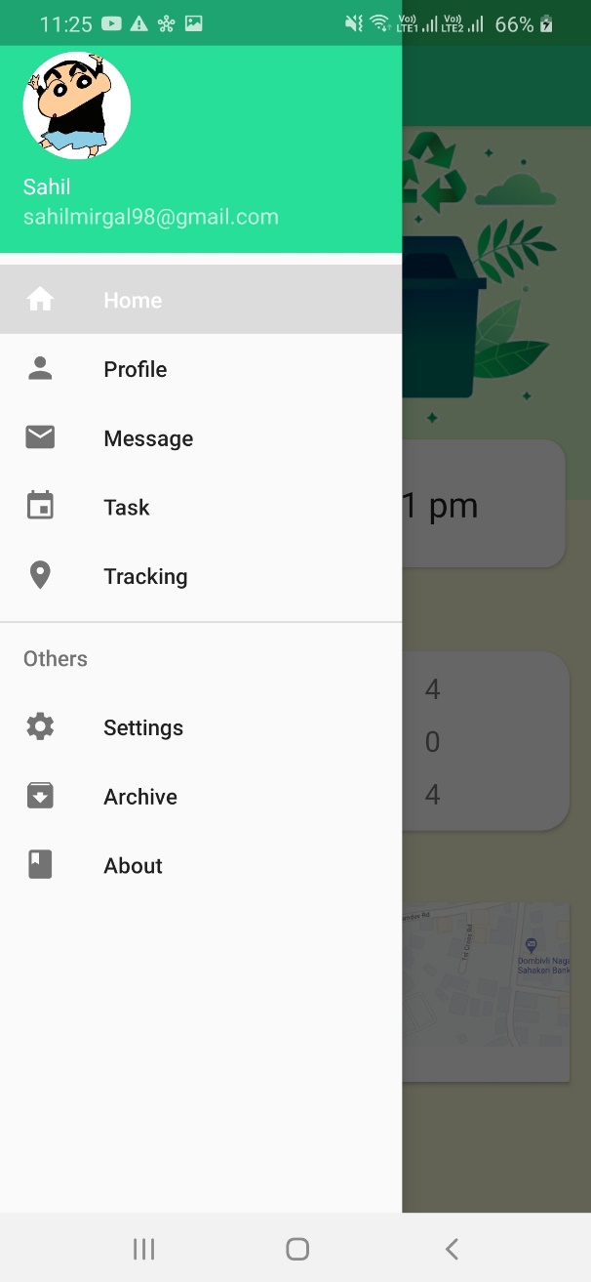

This is the navigation drawer which contains menu which has all the other activities link to it.

Figure 4.2.1.4 Navigation Drawer

This is the profile page which contains all the information of the user including a profile pic. The user can change his/her details by clicking on 3 vert dots and then to edit profile. And by clicking on task he can add bins.

Figure 4.2.1.5 Profile page

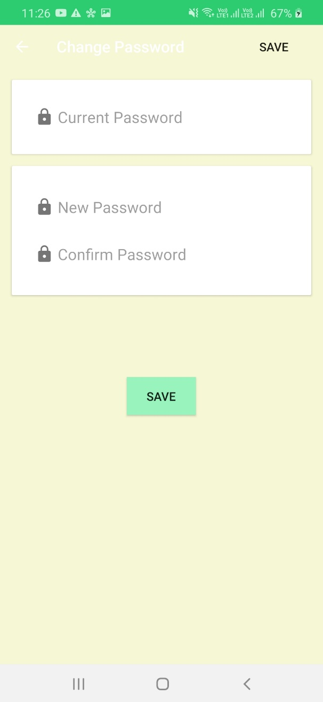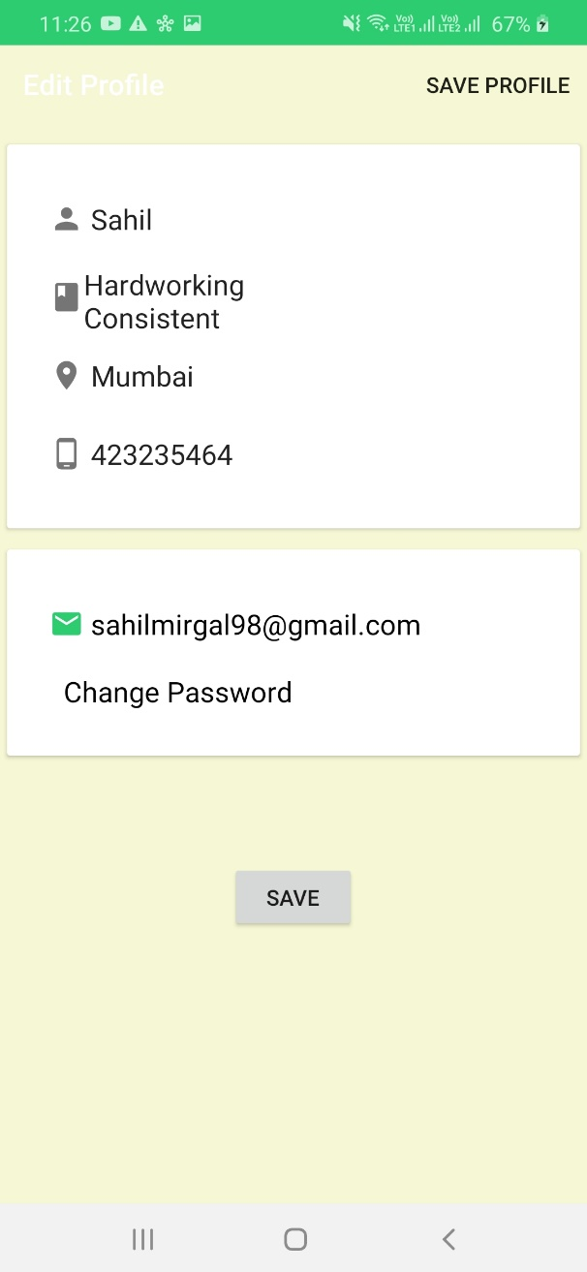

This is the profile edit page which contains all the current info of the user. The user can change his/her details by the text fields and change the password by clicking on Change Password.

Figure 4.2.1.6 Edit Profile

This is the changes password page where the user can change the password by entering current password and the by entering new password and then by clicking on the save button.

Figure 4.2.1.7 Change Password

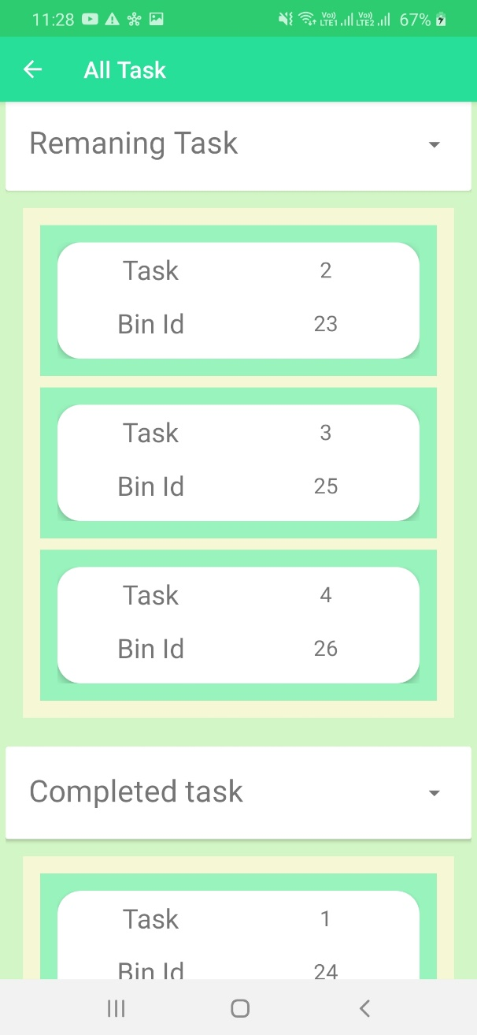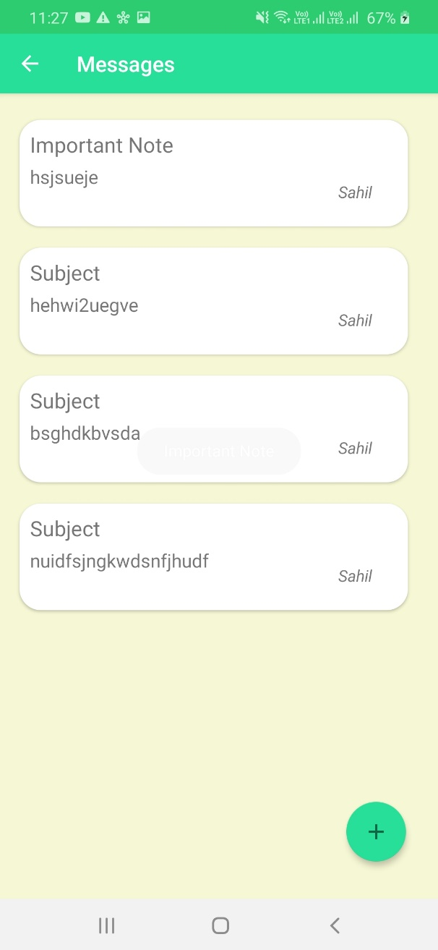

This is the message page where all the message will be displayed and can be added by clicking on floating action button.

Figure 4.2.1.8 Message Page

Figure 4.2.1.9 Message Page

This is the task page where all the task is bifurcated as remaining and completed and can be seen in respective recycler view. We can hide and show all the task by clicking on remaining and completed task tabs. And on by clicking on each task we will be directed to task individual page where we will get all the information about the task

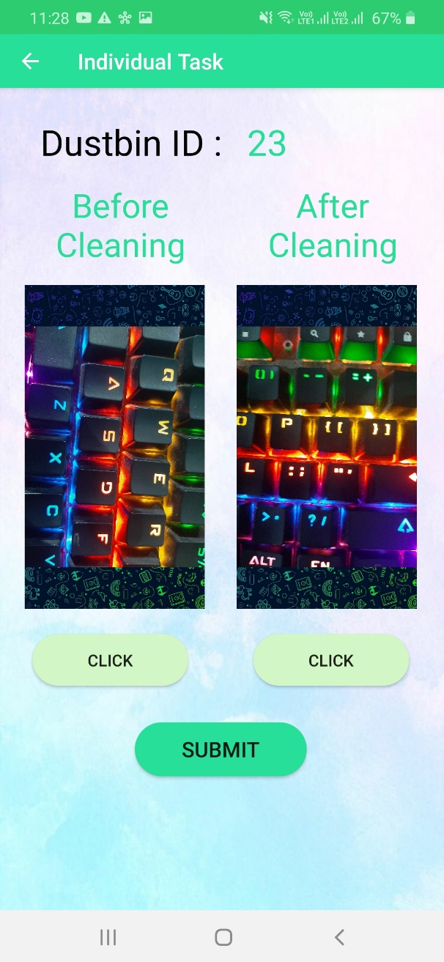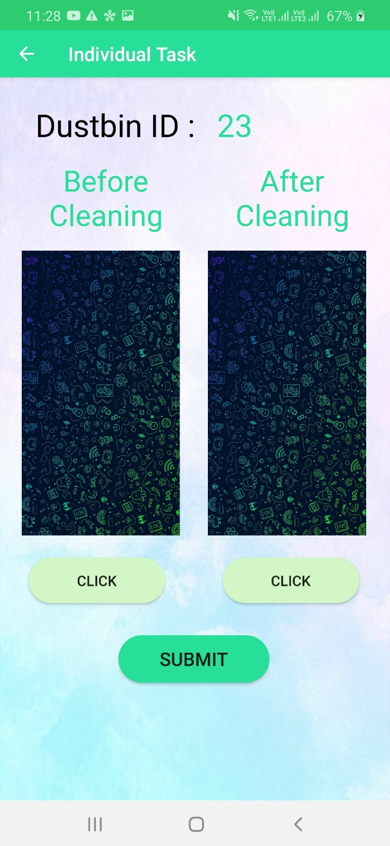

This is the individual task page which will be directed after clicking on the task in remaining or completed recycler view of the task page. Here the user can click one pic and then after once but after both the pictures are clicked and when submit is clicked the pictures cannot be edited.

Figure 4.2.1.10 Individual Task Page

This is a filled individual task page where the user cannot make changes.

Figure 4.2.1.11 Filled individual Task page

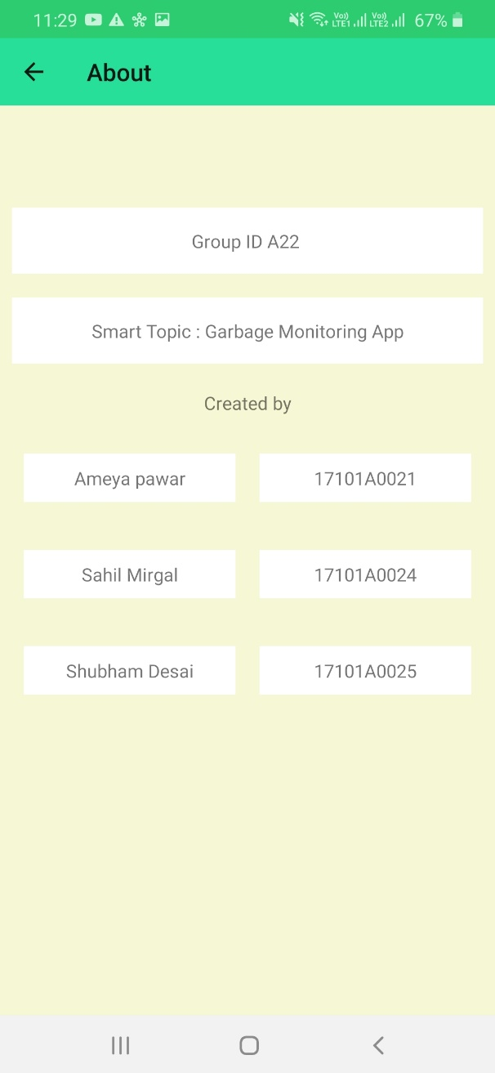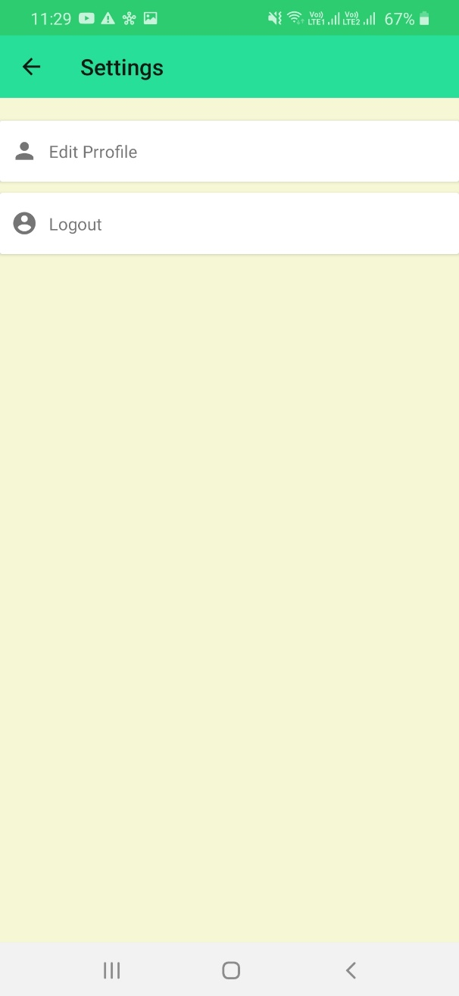

This is the settings page where can edit the profile and logout of the app.

Figure 4.2.1.12 Settings Page

This is just a about page where the information of the app will be displayed.

Figure 4.2.1.13 About page

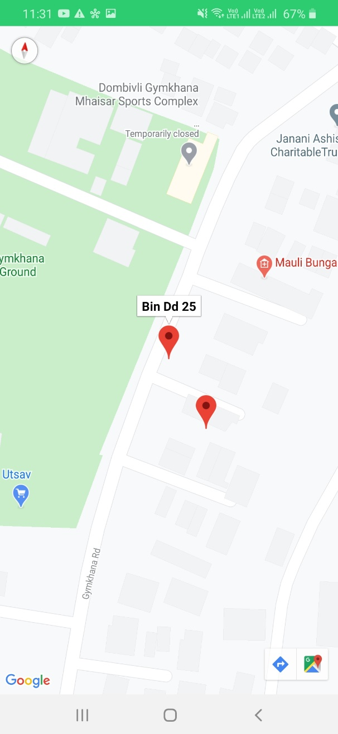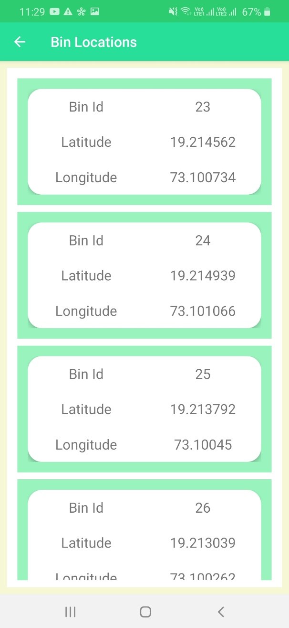

This is Bin location page where all the bins with their id, latitude and longitude will be displayed on this page.

Figure 4.2.1.14 Bin Location Page

This is Maps activity page where the live location of the user as well as selected dustbin will be displayed using a marker on google map.

Figure 4.2.1.15 Current location with bin location

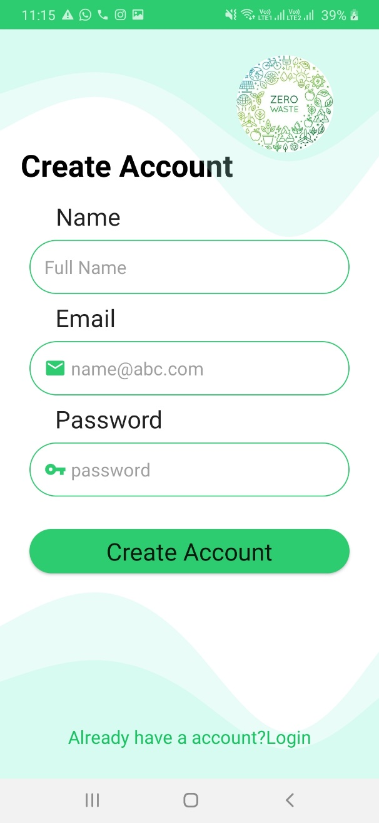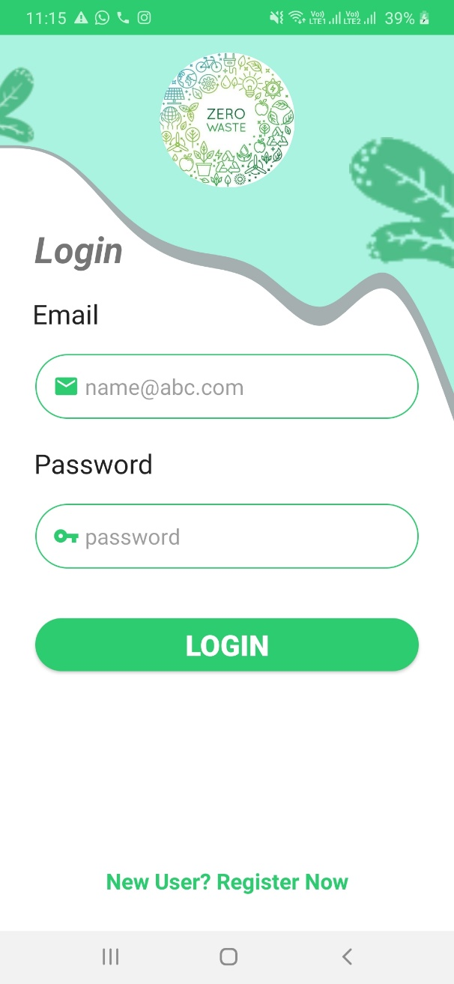

This is Login page where we have to enter our registered email and password to login.

Figure 4.2.1.16 Login page

This is Signup page where by just name, email and password we can create a user account. The validation on email and passwords is done. The password should be of min 6 characters.

Figure 4.2.1.17 Login page

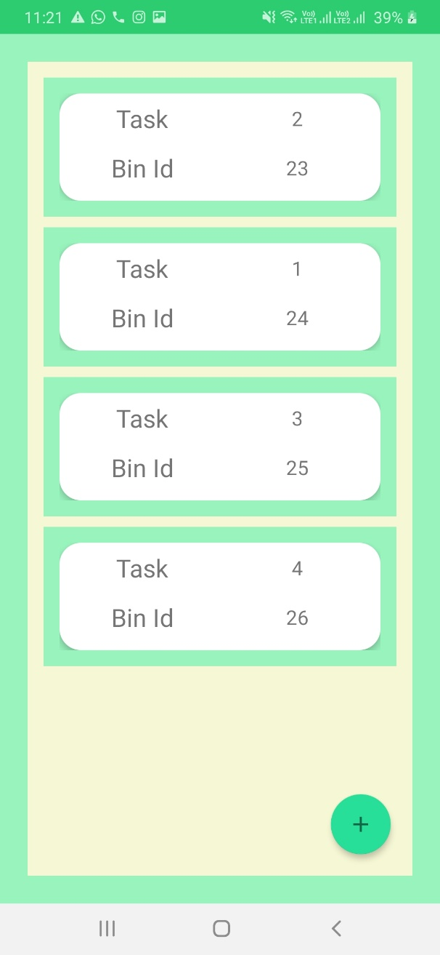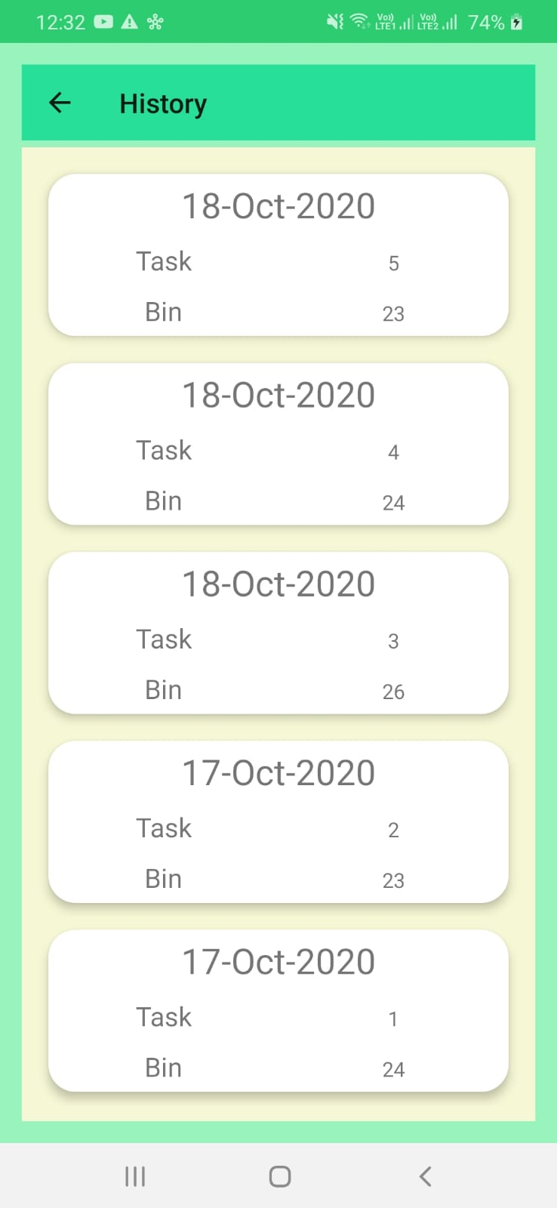

This is the archive/history page which contains all the completed task till date with all the information about that task.

Figure 4.2.1.18 Archive Page

This is the page where we can add the task/bin manually by proving the binid, latitude and longitude.

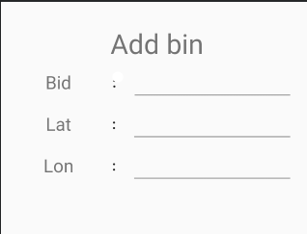

Figure 4.2.1.19 Bin Add Page

### Databases

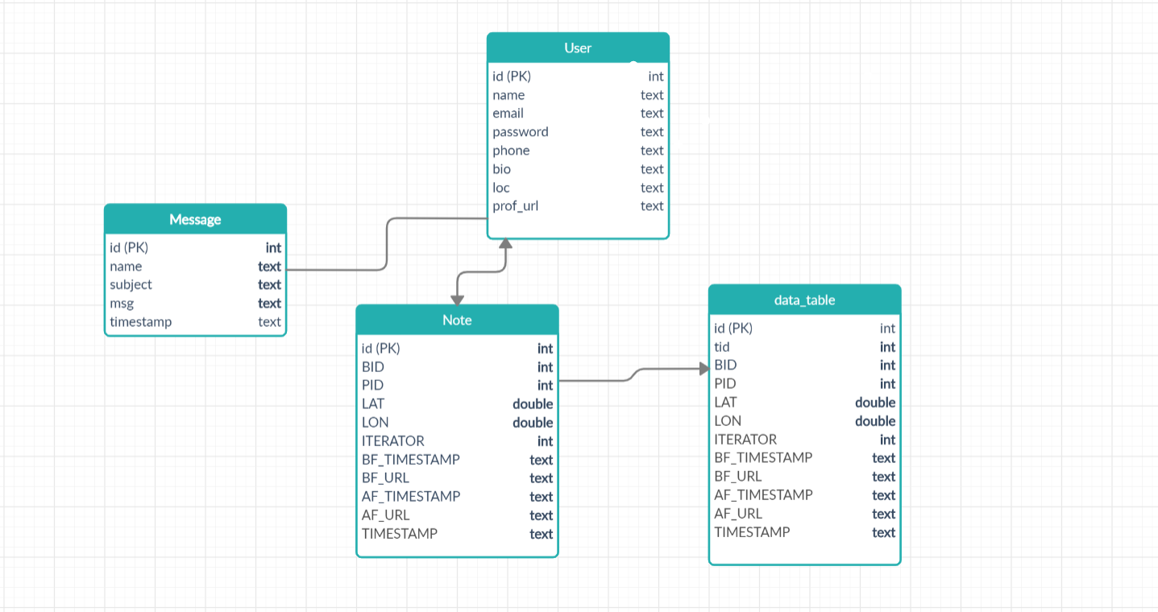

###### Figure 4.2.2.1. Database Schema

This is just the over all schema of all the tables present in our application. There are a total of 4 tables User, Message, Note(task), Data table.

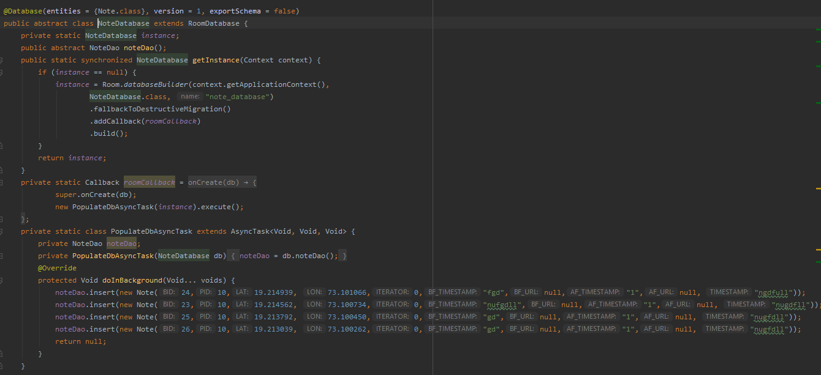

###### Figure 4.2.2.2. Database Creation Class

Here we create the database using name and the version of the database and populated the database with some default values if the user want if not user can all enter the values by using the task add module in the application.

# Conclusion and Future Scope

## Conclusion

Hence, we think we have made a successful attempt in creating a fully functional android app. During this course of work, we have gained the knowledge about framework or flow or the process of making an app let it be carefully planning, designing and implementing each and every page. The basic flow I that the user can create account if not already registered, then if registered he can login where he can see his todays task. The main functionality of this app is that we can authenticate the work of the user from the images we have stored. The additional functionality is that the user can add bin if its not there in the database. The task is reset every day and the data is stored so analytical functions can be carried out to make the process of collecting garbage more efficient. The user can also add note to himself as well as to others users. We have also been successful to integrate location service in which he can track the location of the bin if that bin is registered. So, we have successfully made an app which will help worker to locate the bins, carry out their daily task keep track of each and every task the time taken, the location the amount of work remaining and to be completed and so on so that no one could make any accusations that the workers does their job efficiently or not by just checking the archive of their work.

## Future Scope

Since we have successfully completed the project it can be integrated with various others modules so it can be a part of a much greater work. The future scope or work can be integrating it with IOT so we can in real time track the dustbin status. Also, we can use prediction and to find best path to efficiently find best possible path to clean dustbins which will save resources as well as time of the user.

# References

1. <https://codinginflow.com/>
2. <https://smallacademy.co/blog/android/capture-display-image-in-android-imageview/>
3. <https://www.youtube.com/watch?v=JLIFqqnSNmg>
4. <https://www.youtube.com/watch?v=eiexkzCI8m8>
5. <https://dribbble.com/tags/waste_management>