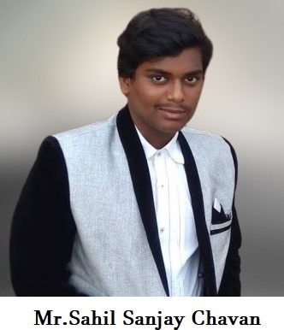

**LINKEDIN: https://www.linkedin.com/in/sahil-chavan**

**GITHUB:** [**https://github.com/Sahil-Chavan**](https://github.com/Sahil-Chavan)

Year : TE Class: A/A2 Roll. No.: 18CE2023

**Stack:**

WEB-DEVELOPMENT

Frontend : HTML 5,CSS 3, VanilaJS, Bootstrap, React(Ongoing)

Backend : PHP, NodeJS, Django, Flask, ExpressJS, Postman

DBMS : SQL(XAMPP), PostgreSQL, MongoDB

Pursuing ML

Python 3, Sklearn, Scipy, Pandas, Numpy, NLTK, Matplotlib, Seaborn

**Projects Completed:**

1) MY-RAIT Portal Refinement

2)Automated research proposal approval for DY Patil medical college

3)National Service Scheme Web Portal Automation

4)Weather App in Django

5)Weather API in Node JS

**Certifications:**

1)University of Michigan certified Getting started with Python (Coursera)

2)University of Michigan certified Python Data Structures (Coursera)

3)University of Michigan certified Exploratory Data Analysis (Coursera)

3)Python for Data Science (Ineuron)

4)Data Science Architectures (Ineuron)

5)Applied AI Course (60% completed)