**DTL Assignment 7**

1. Make a new file and Enter text into it
2. Change permission of the file created
3. List all the files in the directory
4. Execute the file

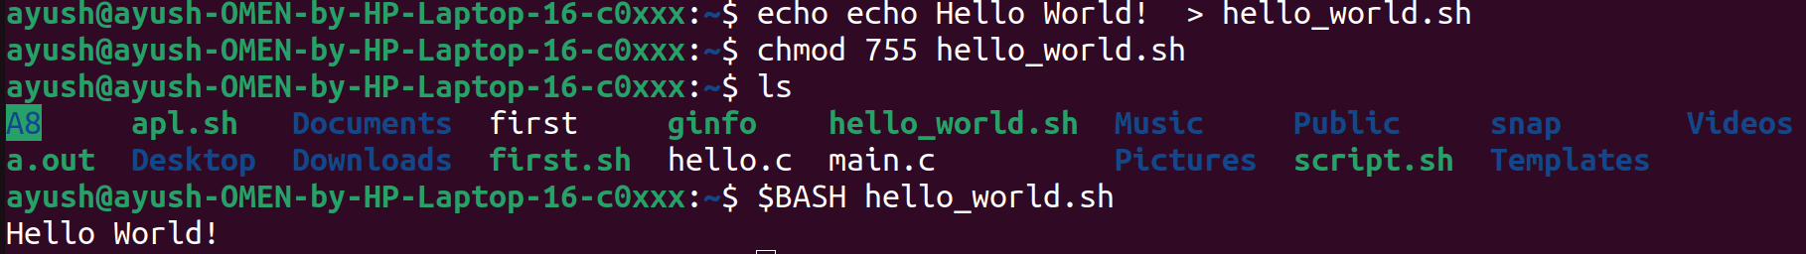

1. Add multiple lines to a file
2. Change permission of the file created
3. List all the files in the directory
4. Execute the file

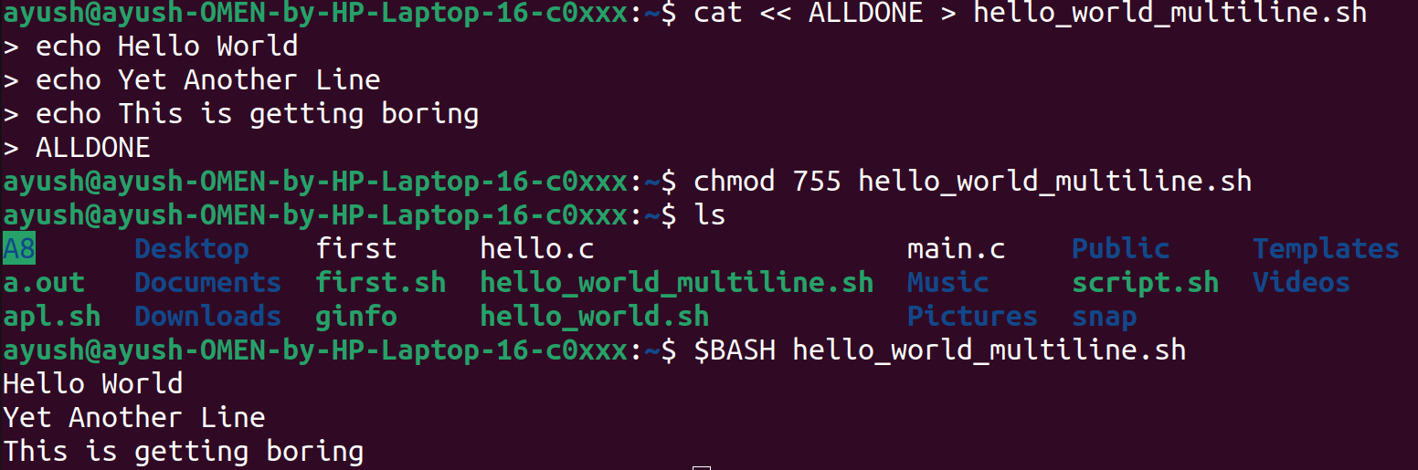

1. Open Downloads directory
2. Create a new file with current timestamp
3. Open the file
4. Change permissions
5. List the files in the directory
6. Execute the file

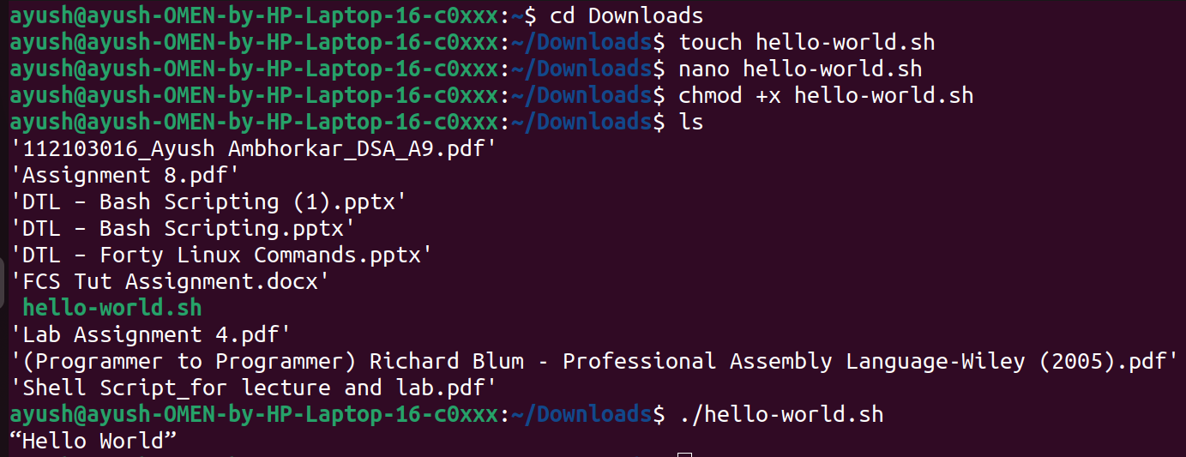

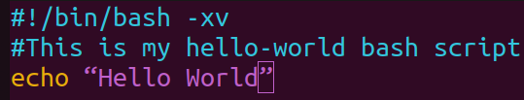

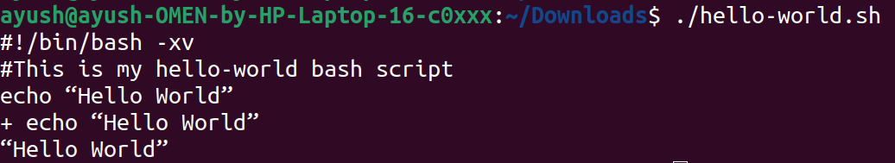

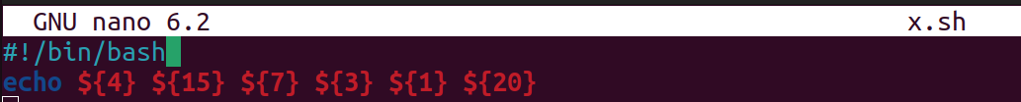

**Special Parameters:**

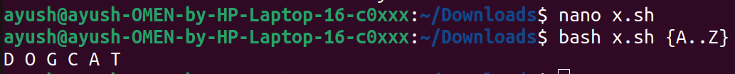

**Exploring all special parameters:**

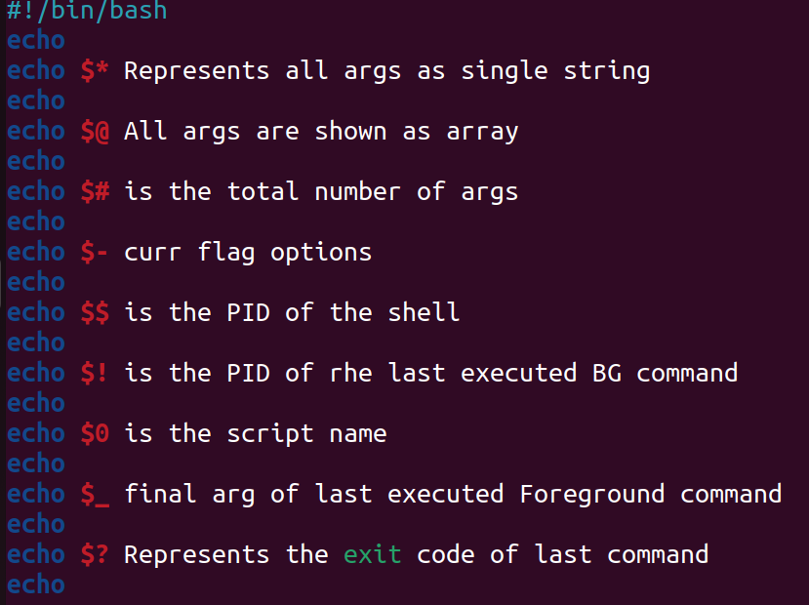

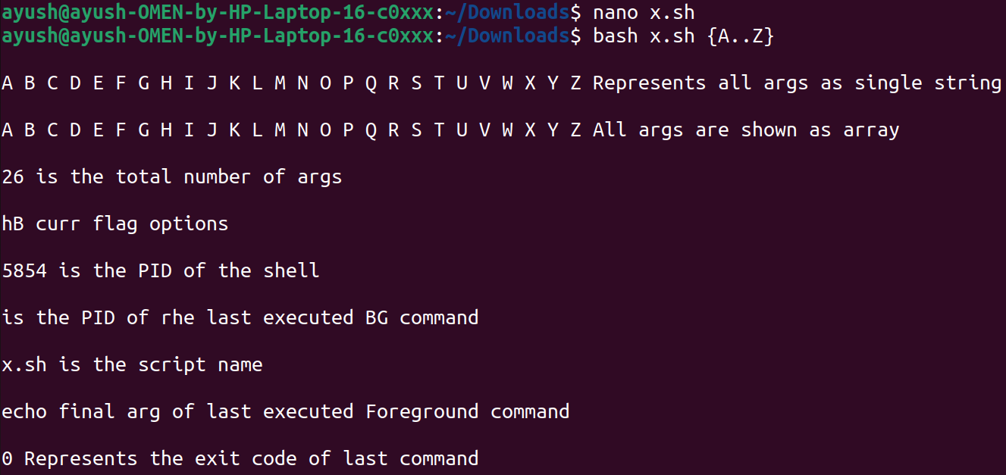

**Bracket expansion:**









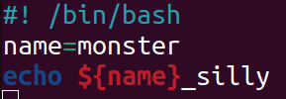



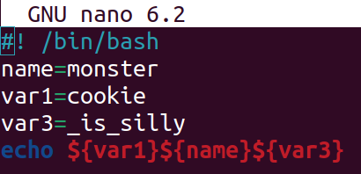



**Arithmetic Expansion:**

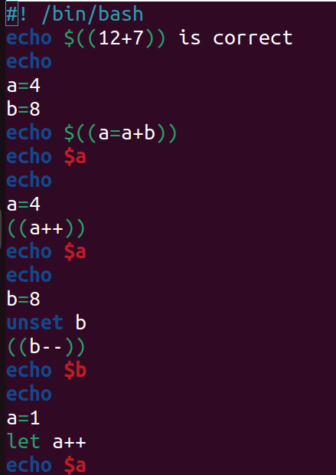

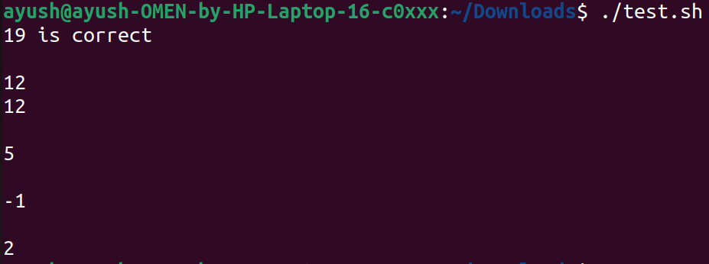

**Command Substitution:**



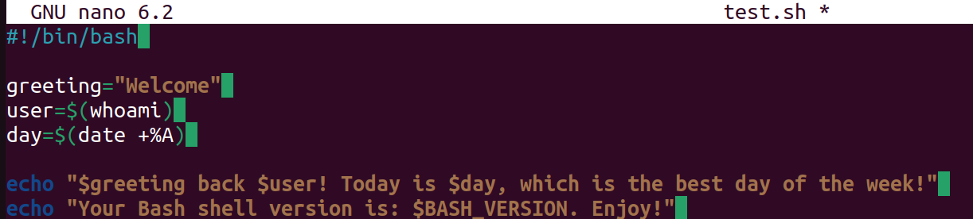

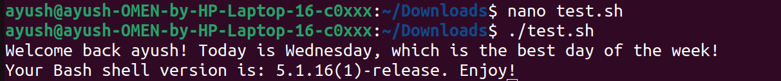

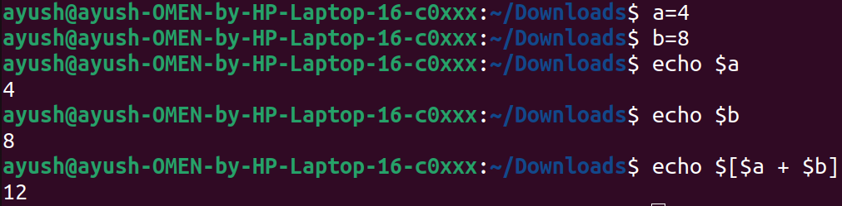

**Backup:**

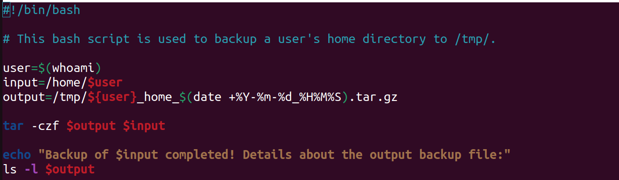



**Environment:**

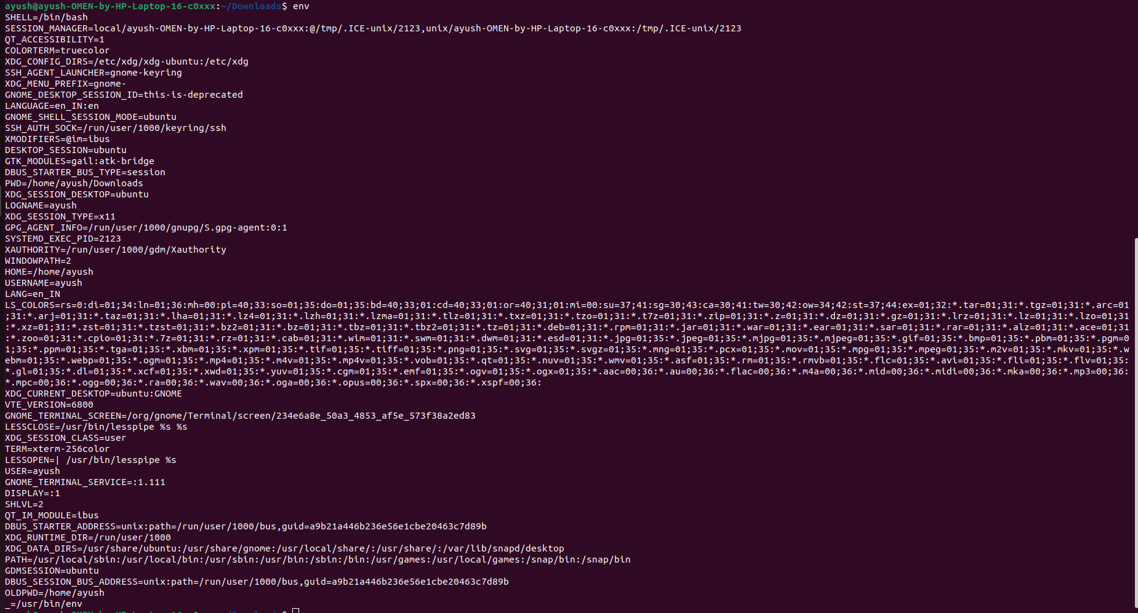



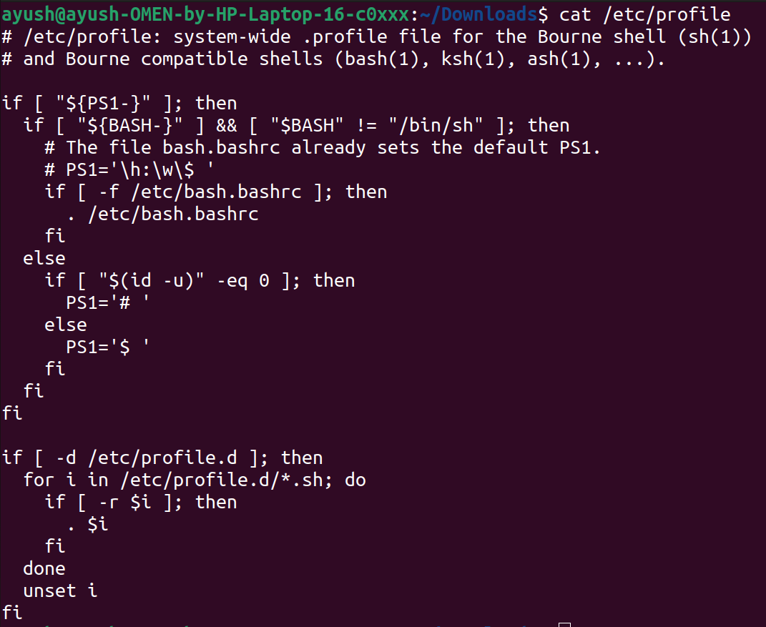

Input Output and Error Redirection



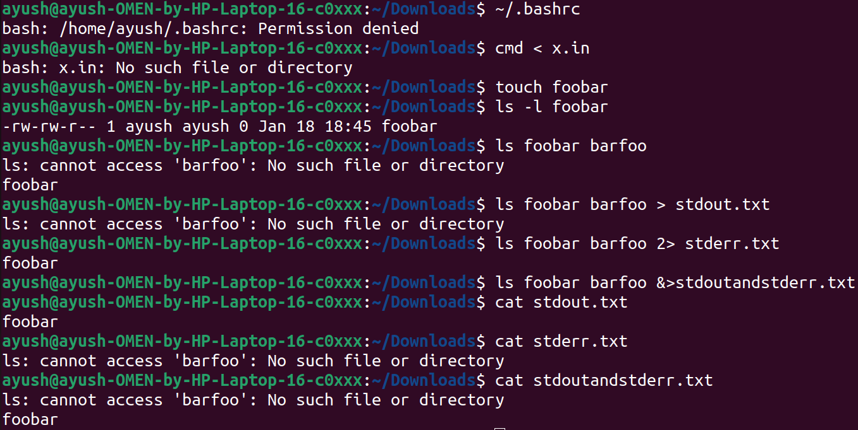

**Functions:**

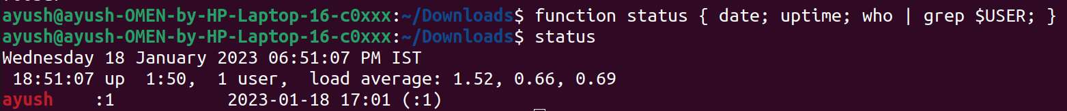

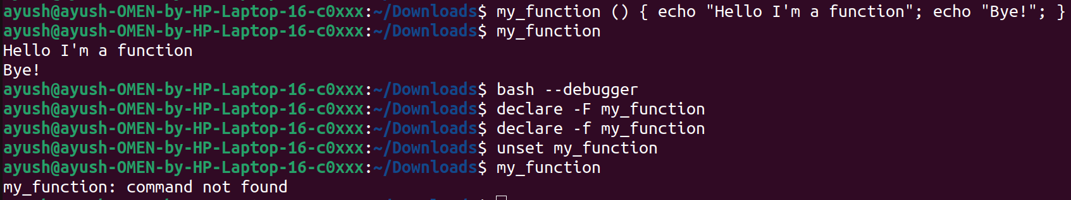

**Numeric and String Comparison:**

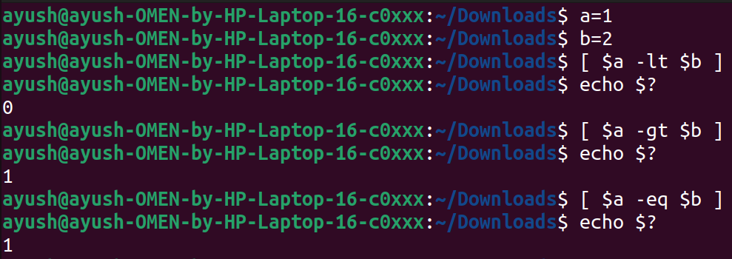



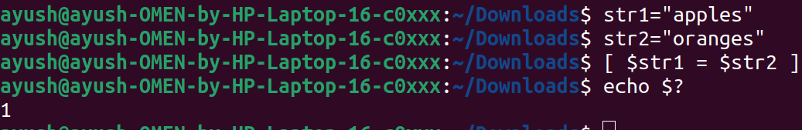

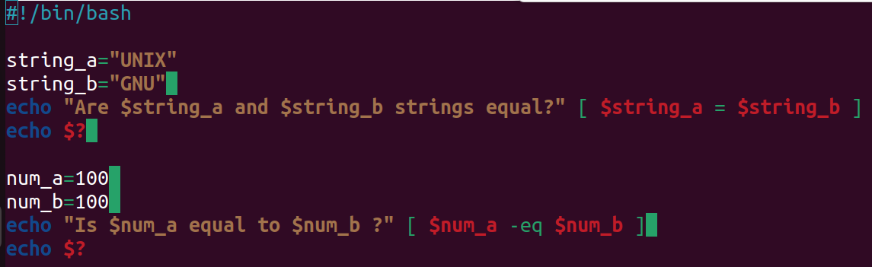

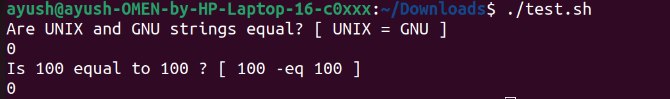

**Conditional Statements:**

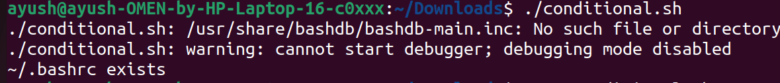





**Arithmetic Expansion:**

