1. **00_align_face_with_mtcnn.py**

Code:

import os

import json

import dlib

from facenet_pytorch import MTCNN

import numpy as np

import util_img as util

import cv2

import torch

os.environ["CUDA_VISIBLE_DEVICES"] = '0'

# CUDA (Compute Unified Device Architecture) is a **parallel computing platform and programming model** developed by **NVIDIA**. It enables developers to **leverage the power of GPUs** (Graphics Processing Units) for general-purpose computing tasks beyond graphics rendering, such as deep learning and image processing.

This line ensures that only **GPU 0** is used for processing, which is useful when multiple GPUs are available.

print("Preparing dlib ... ", end='', flush=True)

detector = dlib.get_frontal_face_detector()

Dlib is an open-source machine learning library for Python that can be used for tasks like face detection, facial landmark detection, and facial recognition

Initializes a face detector (get_frontal_face_detector) and loads a facial landmark predictor from a pre-trained model (shape_predictor_81_face_landmarks.dat).

predictor_path = '/EX_STORE/Beauty_app/DeepRhythm/shape_predictor_81_face_landmarks.dat'

Link : <https://github.com/codeniko/shape_predictor_81_face_landmarks>

Link : https://github.com/italojs/facial-landmarks-recognition/tree/master

predictor = dlib.shape_predictor(predictor_path)

print("Done")

print("Preparing MTCNN ... ", end='', flush=True)

mtcnn = MTCNN(thresholds=[0.3, 0.3, 0.3], margin=20, keep_all=True, post_process=False, select_largest=False, device=torch.device('cuda', 0))

Initializes a Multi-Task Cascaded Convolutional Neural Network (MTCNN) for face detection and alignment. Parameters like thresholds and margin control its behavior.

With Conventional neural networks, it’s hard to train the model on so many parameters, hence we use CNN, which uses a sliding window approach to detect the edges in the image, which are passed on to the next layer, so as to detect features

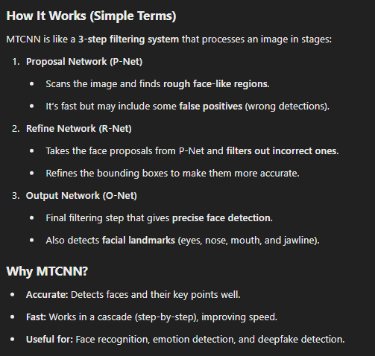

print("Done")

Provide the path to the i/p

dataset_root = '/DATASET/FaceForensics/FaceForensics_dataset/FaceForensics_dataset/'

video_dir_name = "original_sequences/youtube/c23/"

dataset_dir = dataset_root + video_dir_name + 'videos/'

Provide the path to o/p

# metadata path

meta_dir = '/EX_STORE/Beauty_app/00_Face_data/' + video_dir_name

if not os.path.exists(meta_dir):

os.makedirs(meta_dir)

'''

Generate aligned face and remove background

'''

def generate_align_face(data_path, save_path):

if not os.path.exists(save_path):

os.makedirs(save_path)

vidlist = os.listdir(data_path)

vidlist.sort()

sorting is done **lexicographically** (like dictionary order),

Eg "video_10.mp4" comes before "video_2.mp4" because "1" (in "video_10.mp4") appears before "2" in string comparison.

for vidname in vidlist:

vidpath = data_path + vidname

save_vid_path = meta_dir + vidname[:-4] + '/'

if os.path.exists(save_vid_path):

continue

else:

os.mkdir(save_vid_path)

try:

align_face = util.preprocess_video(vidname[:-4], detector, predictor, mtcnn, vidpath, save_vid_path)

except:

print("Error caused !!")

if __name__=="__main__":

If this script is executed, this part is executed (not if this is imported as module)

generate_align_face(dataset_dir, meta_dir)

1. **Util_img.py**

generate_align_face function calls preprocess_video present in util_img.py

Function call :

util.preprocess_video(vidname[:-4], detector, predictor, mtcnn, vidpath, save_vid_path)

Here, predictor = dlib.shape_predictor(predictor_path)

detector = dlib.get_frontal_face_detector()

preprocess_video:

def preprocess_video(video_file_name, detector, predictor, mtcnn, vidpath, facepath):

print("Processing "+video_file_name+":")

video_file_path = vidpath

Stores the path of the video file.

face_align_dir = facepath

Directory where processed face images will be saved.

margin = (20, 20, 20, 20) # (start_point_x & y, end_point_x & y)

Adds a margin around detected faces to ensure the full face is captured.

batch_size = 30

Number of frames processed at once to optimize performance

first_frame_distance = None

Tracks the distance between eyes in the first frame to maintain consistency across frames.

video = cv2.VideoCapture(video_file_path)

Opens the video file for reading

face_imgs = []

List to store processed face images.

idx = 0

Frame counter

stime = time.time()

Records the start time for performance tracking

frames = []

Stores frames in batches

while True:

# ttime = time.time()

success, frame = video.read()

Reads frames from the video one by one.

if not success:

break

height, width = frame.shape[:2]

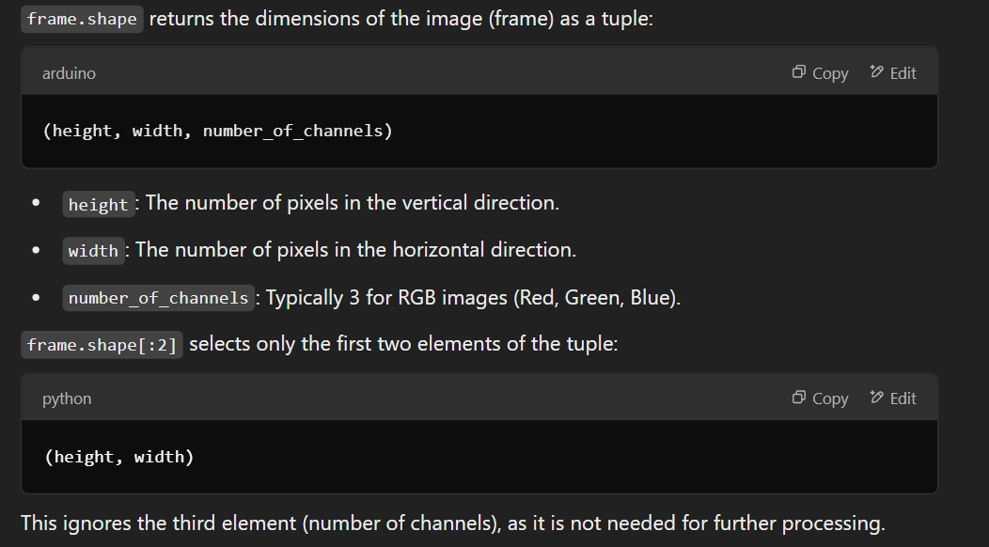

frames.append(frame)

idx += 1

if idx > 300:

break

if idx % batch_size == 0:

first_frame_center = None

first_frame_center is reset for each batch

batch_boxes, _ = mtcnn.detect(frames)

Every batch_size (30) frames, face detection is performed for all the frames using **MTCNN**.

pos = 0

pos is used to track the position of frames in the batch.

for boxes in batch_boxes:

Iterates over detected face bounding boxes for each frame

print(" %04d ... " % (idx - batch_size + pos), end='', flush=True)

# print(box.shape)

if boxes is None:

If no face is detected (boxes is None), it skips the frame.

print("Done, there is no face")

continue

st = [int(boxes[0,0]-margin[0]), int(boxes[0,1]-margin[1])]

Starting **(x, y)** of the expanded bounding box.

ed = [int(boxes[0,2]+margin[2]), int(boxes[0,3]+margin[3])]

Ending **(x, y)** of the expanded bounding box.

Expands the detected face bounding box by adding margins

Ensures the bounding box does not go outside the image boundaries.

if st[0]<0:

If st[0] (x-start) goes negative → Set it to 0

st[0] = 0

if st[1]<0:

If st[1] (y-start) goes negative → Set it to 0

st[1] = 0

if ed[0]>width:

If ed[0] (x-end) exceeds image width → Set it to width

ed[0] = width

if ed[1]>height:

If ed[1] (y-end) exceeds image height → Set it to height.

ed[1] = height

box = [st[0], st[1], ed[0], ed[1]]

face_img = frames[pos][st[1]:ed[1], st[0]:ed[0], :]

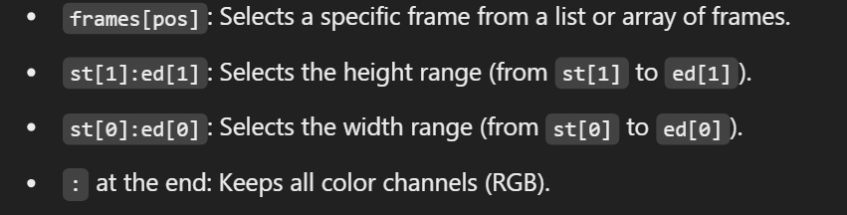

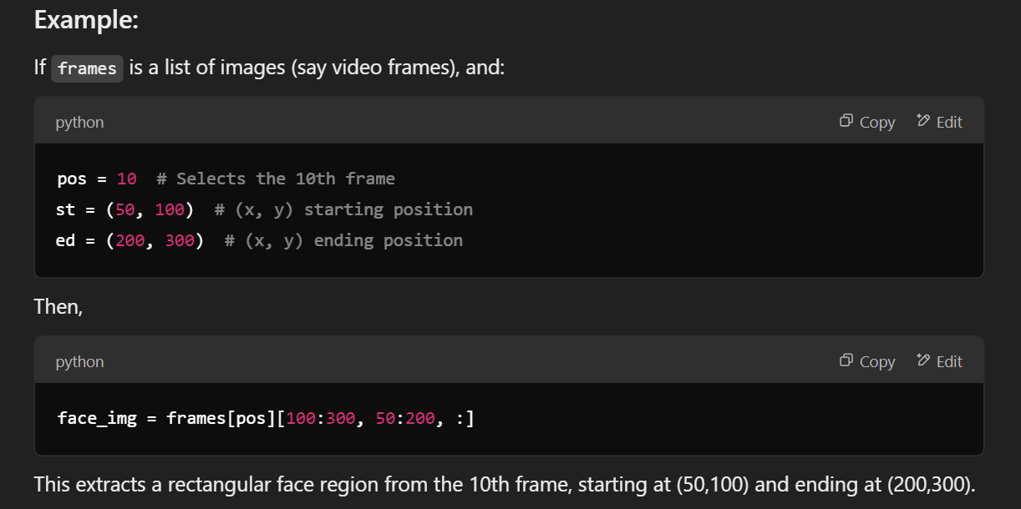



cv2.imwrite(face_align_dir + ("%04d_face.jpg" % (idx - batch_size + pos)), face_img)

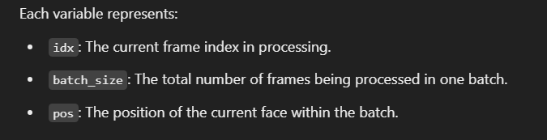

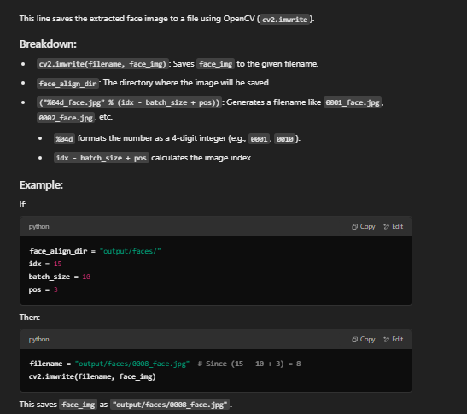

pre_img, distance, center, landmark = preprocess_img(face_img, detector, predictor, first_frame_distance, first_frame_center, (idx - batch_size + pos))

if first_frame_distance is None:

first_frame_distance = distance

**First frame distance** refers to the distance between the eyes in the first frame of the video. It is used as a reference to maintain consistent scaling of the face across frames.

if first_frame_center is None:

first_frame_center = center

**First frame center** refers to the center point of the eyes in the first frame of the video. It is used to align the face consistently across frames.

if pre_img is not None:

print("Done, saving ... ", end='', flush=True)

cv2.imwrite(face_align_dir + ("%04d.jpg" % (idx - batch_size + pos)), pre_img)

Save the pre_img as .jpg file and landmark as .npy file

np.save(face_align_dir + ("%04d_landmark.npy" % (idx - batch_size + pos)), landmark)

print("Done")

else :

print("Done, no face")

pos += 1

frames = []

print("-- Using time:", time.time() - stime)

preprocess_img function:

def preprocess_img(img, detector, predictor, first_frame_distance, first_frame_center, idx):

landmark = get_landmark(img, detector, predictor)

if landmark is None:

return None, None, None, None

rotate_img, distance, center, rotate_land = get_rotate_img(img, landmark, first_frame_distance, first_frame_center, idx)

bound_img, bounding_land = get_bounding_image(rotate_img, rotate_land) # TOUGH!!!!!

no_bg_img = remove_background(bound_img, bounding_land)

return no_bg_img, distance, center, landmark

get_landmark function:

def get_landmark(img, detector, predictor):

height, width = np.shape(img)[:2]

dets = detector(img, 0)

Uses the detector (which is a dlib face detector) to detect faces in the image.

dets stores the detected face regions.

0 **means no upscaling**

landmarks = None

for k, det in enumerate(dets):

shape = predictor(img, det)

For each detected face, the **shape predictor** finds **81 facial landmarks** (x, y coordinates of key points on the face like eyes, nose, mouth, etc.).

landmarks = np.matrix([[p.x, p.y] for p in shape.parts()])

Converts the detected landmarks into a **NumPy matrix**, where:

* Each row represents a landmark point (x, y).
* There are 81 points in total.

for i in range(81):

for j in range(2):

if landmarks[i, j]<0:

landmarks[i, j] = 0

if landmarks[i, 1]>height:

landmarks[i, 1] = height

if landmarks[i, 0]>width:

landmarks[i, 0] = width

return landmarks

remove_background function:  
  
def remove_background(img, landmark):

height, width, channels = np.shape(img)

This gets the **height**, **width**, and **number of color channels (RGB = 3)** of the input image.

mask = np.zeros((height, width))

This creates a **black mask** (same size as the image) filled with zeros.

It creates a **grayscale** image (because it has only one channel) where every pixel has a value of 0.

A **grayscale image** is a type of image that only has **shades of gray**, instead of colors like red, green, or blue.

**Simple Explanation:**

* Each pixel in a grayscale image has a **single value** that represents brightness.
* The value ranges from **0 to 255**:
  + 0 → **Black**
  + 255 → **White**
  + Values in between (like 128) are different shades of gray.

A **grayscale image** has only **one channel** because each pixel stores just **one value**—the brightness (how light or dark it is).

In grayscale images, pixel values range from **0 to 255**:

* 0 → **Black**
* 255 → **White**

Since np.zeros((height, width)) initializes all values to 0, the entire mask is black.

This mask will later be used to define which areas should be kept or removed.

OUT_POINT = [0,1,2,3,4,5,6,7,8,9,10,11,12,13,14,15,16,78,74,79,73,72,80,71,70,69,68,76,75,77]

The list **OUT_POINT** contains the landmark indices for the **face outline (jawline, cheeks, forehead, etc.).**

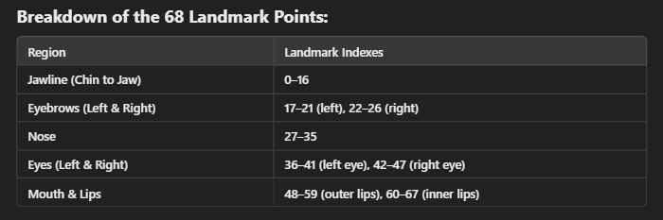

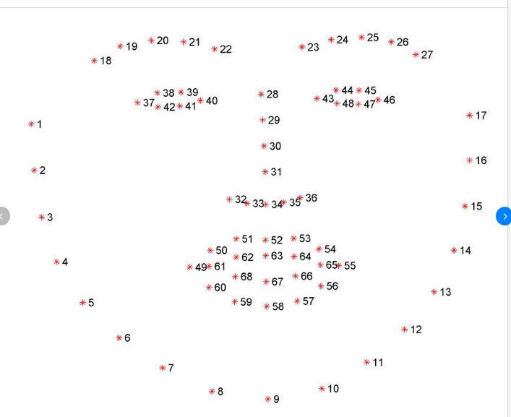

additional 13 landmarks to cover the forehead area

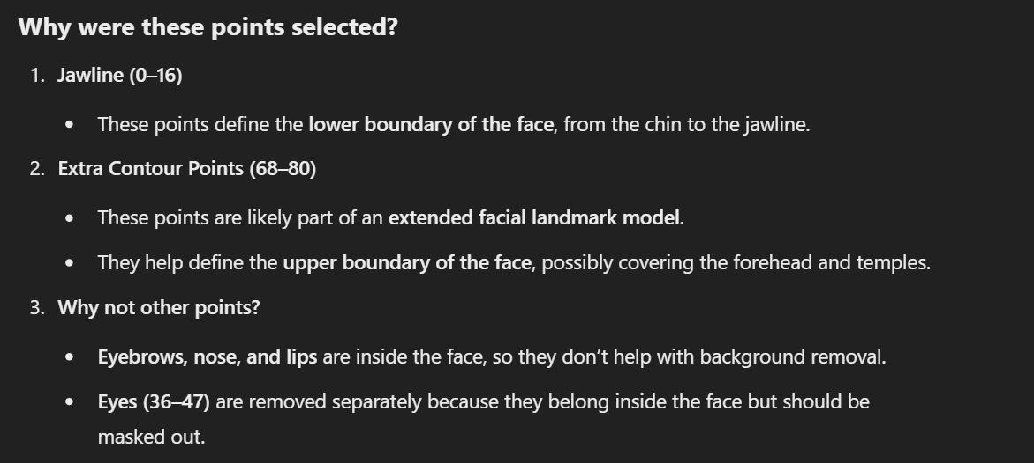

outline = np.array(landmark[OUT_POINT])

cv2.fillPoly(mask, [outline], (255, 255, 255))

The function cv2.fillPoly(mask, [outline], (255, 255, 255)) **fills** the mask with **white (255)** in this region, indicating the area that should be kept.

# remove eye area

eyeline = np.array(landmark[36:42])

cv2.fillPoly(mask, [eyeline], (0, 0, 0))

eyeline = np.array(landmark[42:48])

cv2.fillPoly(mask, [eyeline], (0, 0, 0))

The eye landmark indices **36 to 41 (left eye)** and **42 to 47 (right eye)** define the eye regions.

cv2.fillPoly(mask, [eyeline], (0, 0, 0)) fills the **eye areas with black (0)**, removing them.

So basically, initially, the whole image is black.

cv2.fillPoly(mask, [outline], (255, 255, 255)) this line fills the jaw and forehead region with white, thus keeping them.

After that, eyes are filled with black, hence only the face shape remains as white, everything else is black, thus removing background

nbg_img = np.zeros((height, width, channels))

for h in range(height):

for w in range(width):

if mask[h][w]==0:

continue

nbg_img[h][w] = img[h][w]

return nbg_img

Creates an empty image (nbg_img) with the same shape as the original image.

**Loops through every pixel**:

* If the mask value is **0 (black)**, that pixel is **ignored (background removed).**
* If the mask value is **255 (white)**, that pixel is **copied from the original image (kept).**

**So, black mask is initialized, then face part is kept white, then eyes part is kept black, hence only face remains, eyes and the other background is removed**

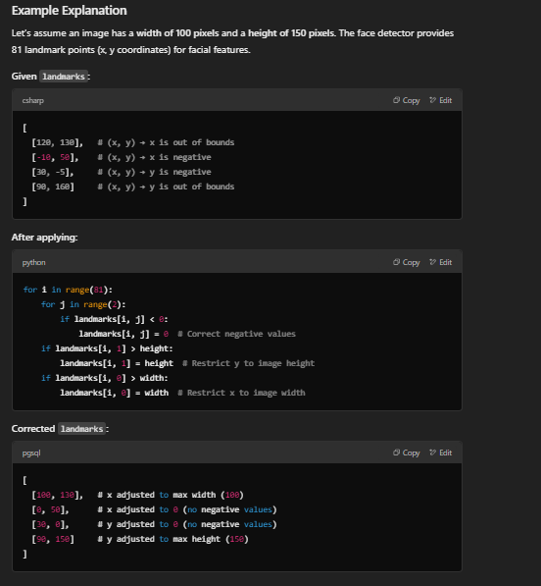

1. **01_1_resize_frame.py**

**Code :**

import os

import cv2

import numpy as np

'''

Resize the aligned face so they can be formed into a video, which will

be used into motion magnification.

'''

def resize_frame(align_path, resize_path):

if not os.path.exists(resize_path):

os.makedirs(align_path)

vidlist = os.listdir(align_path)

vidlist.sort()

for vidname in vidlist:

print("{} - {} ... ".format(align_path, vidname), end='', flush=True)

vidpath = align_path + vidname + '/'

save_vid_path = resize_path + vidname + '/'

os.mkdir(save_vid_path)

imglist = os.listdir(vidpath)

imglist.sort()

f_h, f_w = None, None

for imgname in imglist:

if imgname.endswith('.npy'):

continue

if imgname.endswith('_face.jpg'):

continue

imgpath = vidpath + imgname

img = cv2.imread(imgpath)

if f_h is None:

f_h, f_w = img.shape[:2]

f_h = ((int(f_h/10)+1)*10)

f_w = ((int(f_w/10)+1)*10)

If it's the first image (f_h is None), it determines its height (f_h) and width (f_w).

Rounds f_h and f_w **up to the nearest multiple of 10** (to standardize dimensions).

img = cv2.resize(img, (f_w, f_h))

Resizes the image to f_w × f_h.

save_img_path = save_vid_path + imgname

cv2.imwrite(save_img_path, img)

Saves the resized image in the corresponding directory

idx = None

imglist = os.listdir(save_vid_path)

imglist.sort()

imglist.append("0300.jpg")

for imgname in imglist:

if int(imgname[:4]) >= 300:

break

if idx is None and int(imgname[:4])!=0:

for i in range(0, int(imgname[:4])):

ori_img = save_vid_path + imgname

new_img = save_vid_path + ("%04d.jpg"%i)

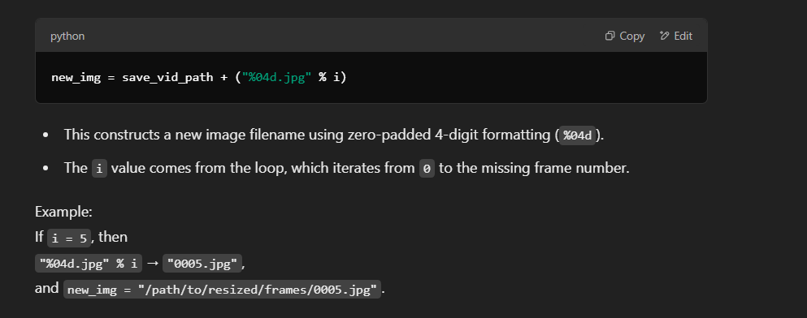

os.system("cp " + ori_img + " " + new_img)

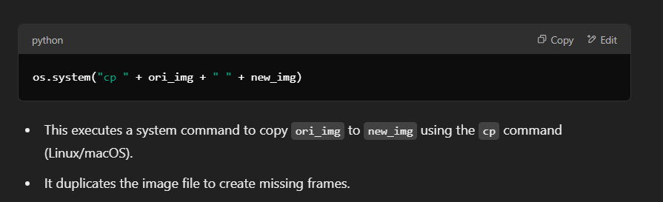

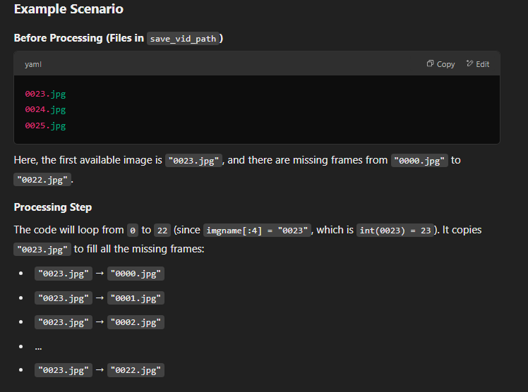

if idx is not None and idx < int(imgname[:4]):

for i in range(idx, int(imgname[:4])):

ori_img = save_vid_path + ("%04d.jpg"%(idx-1))

new_img = save_vid_path + ("%04d.jpg"%i)

os.system("cp " + ori_img + " " + new_img)

This checks if:

idx has been assigned a value (idx is not None).

idx is smaller than the current image number (idx < int(imgname[:4])).

It ensures that there is a gap between the last processed frame (idx-1) and the current image (imgname).

Loops from idx (the next expected frame) to the current frame number (imgname[:4]).

This fills all missing frames between the last known frame and the new frame.

Selects the last available frame (idx-1) to use as a filler.

If idx = 5, then "0004.jpg" is used as ori_img

Creates the new filename for the missing frame.

If i = 6, it will generate "0006.jpg".

Executes a system command to copy the last available frame (ori_img) to the missing frame (new_img).

idx = int(imgname[:4]) + 1

print("Done")

if __name__=="__main__":

video_dir_name = "original_sequences/youtube/c23/"

data_root_dir = "/EX_STORE/Beauty_app/00_Face_data/"

datadir = data_root_dir + video_dir_name

resize_root_dir = "/EX_STORE/Beauty_app/01_1_resize_original_frame/"

resizedir = resize_root_dir + video_dir_name

if not os.path.exists(resizedir):

os.makedirs(resizedir)

resize_frame(datadir, resizedir)

1. **01_2_align_video.py**

import os

import cv2

import numpy as np

'''

Generate video with aligned face. These videos will be used in motion magnificaiton.

'''

def generate_align_video(video_frame_path, video_store_path):

if not os.path.exists(video_store_path):

os.makedirs(video_store_path)

vidlist = os.listdir(video_frame_path)

vidlist.sort()

for vidname in vidlist:

print("{} - {} ... ".format(video_frame_path, vidname), end='', flush=True)

vidpath = video_frame_path + vidname +'/'

save_vid_path = video_store_path + vidname + '.avi'

os.system("ffmpeg -i {}%04d_face.jpg {}".format(vidpath, save_vid_path))

Command : ffmpeg -i Frames/Video1/%04d_face.jpg Output/Video1.avi

**%04d** means the images are named sequentially like 0001_face.jpg, 0002_face.jpg, etc.

FFmpeg reads all the **_face images** in order and treats them as frames of a video. It stitches them together into a .avi file

Output/Video1.avi: This is the final video file that FFmpeg creates from those images.

Why .avi?

**Less Compression** – AVI files use less compression than MP4, preserving more quality.

**Lossless Editing** – Easier to edit without quality loss.

**FFmpeg Default Support** – AVI works well with FFmpeg without needing extra codecs.

**Research & Processing** – Often used in AI/ML projects where raw video data is needed for analysis.

print("Done")

if __name__=="__main__":

video_dir_name = "original_sequences/youtube/c23/"

data_root_dir = "/EX_STORE/Beauty_app/01_0_resize_original_frame/"

datadir = data_root_dir + video_dir_name

new_vid_root_dir = "/EX_STORE/Beauty_app/01_0_align_original_video/"

newviddir = new_vid_root_dir + video_dir_name

if not os.path.exists(newviddir):

os.makedirs(newviddir)

generate_align_video(datadir, newviddir)

1. **02_gen_motion_mag_video.py**

Code :

import os

from python_eulerian_video_magnification.magnifycolor import MagnifyColor

from python_eulerian_video_magnification.metadata import MetaData

from python_eulerian_video_magnification.mode import Mode

import cv2

import numpy as np

'''

Magnification video

'''

def generate_mag_video(vid_path, mag_path):

if not os.path.exists(mag_path):

os.makedirs(mag_path)

vidlist = os.listdir(vid_path)

vidlist.sort()

for vidname in vidlist:

print("{} - {} ... ".format(video_dir_name, vidname), end='', flush=True)

vidpath = vid_path + vidname

save_vid_path = mag_path + vidname

MagnifyColor(MetaData(file_name=vidpath, low=0.833, high=2, levels=1,

amplification=10, target_path=save_vid_path, output_folder='', mode=Mode.COLOR, suffix='color')).do_magnify()

The main goal is to highlight tiny changes in color or motion that are otherwise hard to notice.

This executes the do_magnify() function, which applies **Eulerian Video Magnification** to the input video.

**Parameters explained:**

* file_name=vidpath: Path to the input video file.
* low=0.833, high=2: Defines the frequency band (in Hz) for filtering.
* levels=1: Number of pyramid levels used for processing.
* amplification=10: Magnification factor for color variations.
* target_path=save_vid_path: Path where the magnified video will be saved.
* output_folder='': No specific output folder is defined.
* mode=Mode.COLOR: Specifies that this is a color magnification mode.
* suffix='color': Suffix added to the output filename.

print("Done")

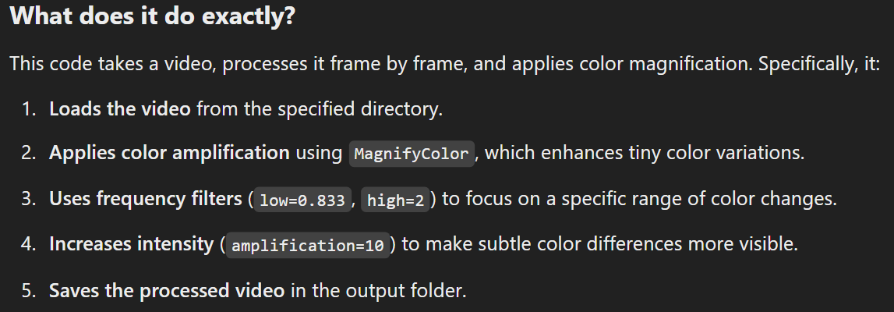

if __name__=="__main__":

video_dir_name = "manipulated_sequences/Deepfakes/c23/"

data_root_dir = "/EX_STORE/Beauty_app/01_2_align_video/"

datadir = data_root_dir + video_dir_name

new_vid_root_dir = "/EX_STORE/Beauty_app/02_mag_video/"

newviddir = new_vid_root_dir + video_dir_name

if not os.path.exists(newviddir):

os.makedirs(newviddir)

generate_mag_video(datadir, newviddir)

1. **03_gen_map.py**

Code :

import os

import cv2

import util_mit as util

import numpy as np

datadir = "/DATASET/__saika_data/dfdc/03_mag_video/"

newviddir = "/DATASET/__saika_data/dfdc/stmap/"

'''

Use magnified video to produce mmst-map

'''

def generate_mmst_map(mag_path, map_path):

if not os.path.exists(map_path):

os.makedirs(map_path)

ROI_h, ROI_w = 5, 5

These define the height and width of the region of interest

vidlist = os.listdir(mag_path)

vidlist.sort()

for vidname in vidlist:

print("{} - {} ... ".format(typename, vidname), end='', flush=True)

vidpath = mag_path + vidname

vid = cv2.VideoCapture(vidpath)

Opens the video file so frames can be read

full_st_map = np.zeros((300, 25, 3))

np.zeros((300, 25, 3)): Creates an empty NumPy array (size 300x25x3) to store processed frame data.

* 300: Number of frames (time dimension).
* 25: Width of the processed data.
* 3: Likely represents color channels (RGB).

idx = 0

frame index 0

while idx < 300:

success, frame = vid.read()

Reads the next frame from the video

if not success:

If no more frames are available, exit the loop.

break

frame_seg = util.get_frame_seg(frame, ROI_h, ROI_w)

extracts a small segment of the frame

full_st_map[idx] = frame_seg

Stores the processed frame data in full_st_map

idx += 1

# print("Done")

save_vid_path = map_path + vidname

np.save(save_vid_path + ".npy", full_st_map)

Saves the processed MMST map as a .npy file

print("Done")

if __name__=="__main__":

generate_mmst_map(datadir, newviddir)

get_frame_seg function :

def get_frame_seg(img, ROI_h, ROI_w):

ROI_seg = calculate_ROI(img, ROI_h, ROI_w)

# frame_seg = reshape_ROI_SEG(ROI_seg)

return ROI_seg

calculate_ROI function :

def calculate_ROI(img, block_h, block_w):

height, width, channels = np.shape(img)

blk_h, blk_w = int(height/block_h), int(width/block_w)

roi_seg = np.zeros((block_h*block_w, channels))

for bh in range(block_h):

for bw in range(block_w):

roi_seg[bh*block_w+bw] = [np.average(img[blk_h*bh:blk_h*(bh+1),blk_w*bw:blk_w*(bw+1),i]) for i in range(3)]

# roi_seg[bh][bw] = [np.average(img[blk_h*bh:blk_h*(bh+1),blk_w*bw:blk_w*(bw+1),i]) for i in range(3)]

return roi_seg

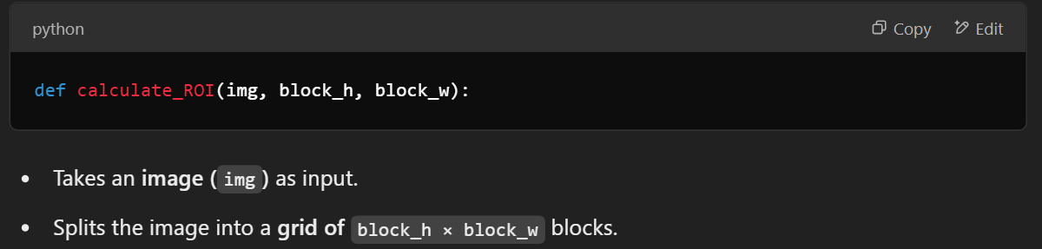

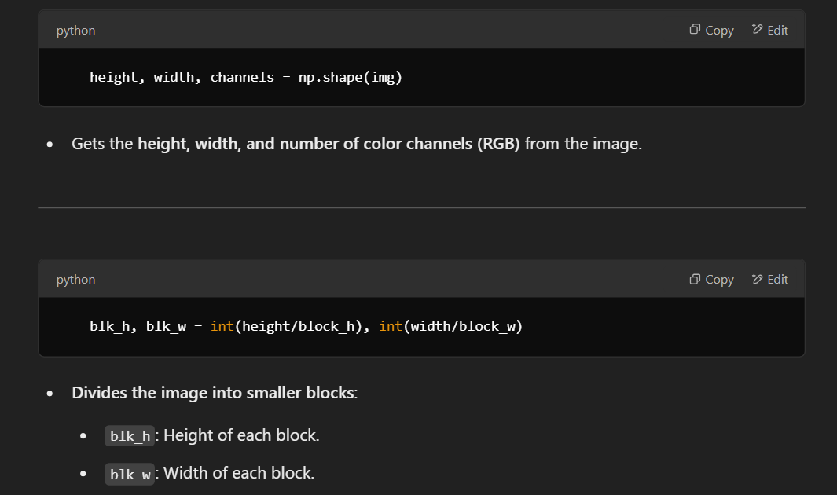

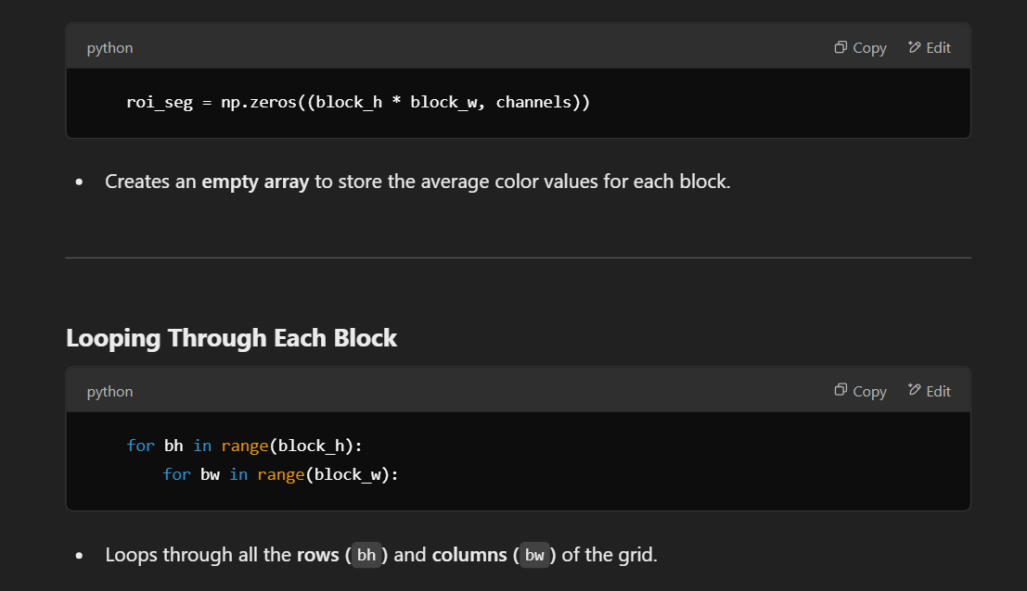

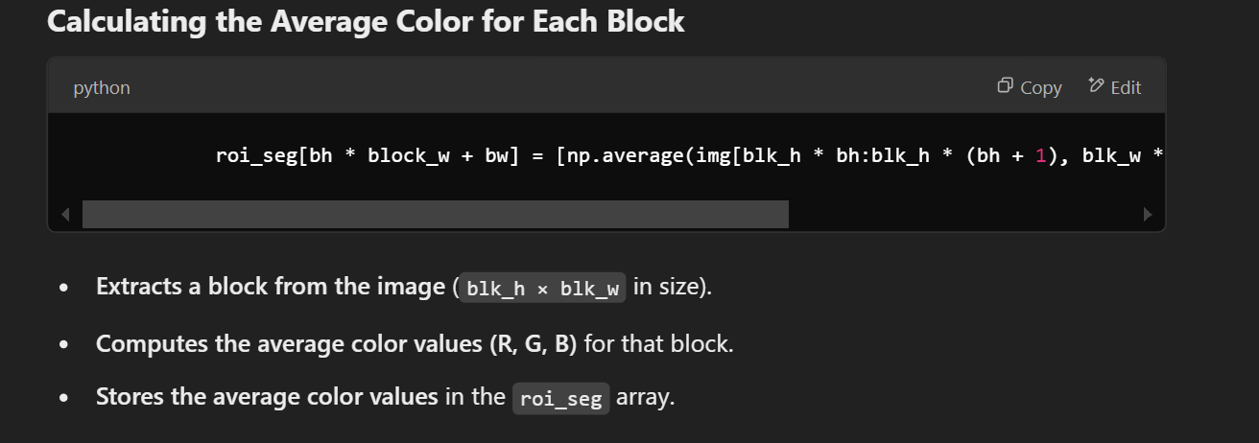

Returns roi_seg, which contains the **average color values of all blocks**.

1. **04_gen_training_data.py**

Code:

import numpy as np

from classifiers import *

from pipeline import *

from keras.preprocessing.image import ImageDataGenerator

from keras.models import load_model

import os

import cv2

os.environ["CUDA_VISIBLE_DEVICES"] = '1'

Specifies **which GPU** (device 1) should be used for deep learning model execution

# ---------------------------- data_Meso ------------------------------

'''

collect meso data

'''

# Load the model and its pretrained weights

classifier = MesoInception4()

MesoInception4 (a deep learning model for detecting DeepFakes).

classifier.load('/WORKSPACE/ff++/final_data/model/FaceForensics/faceforensics++_models_subset/face_detection/Meso/c23/Deepfakes/weights.h5')

Loads pre-trained weights from the given path

real_video_dir = "/WORKSPACE/ff++/original/youtube/c23/align_original/"

real_vid_list = os.listdir(real_video_dir)

real_vid_list.sort()

real_vid_dict = {x:real_video_dir + x for x in real_vid_list}

Creates a dictionary {filename: filepath}

fake_video_dir = "/WORKSPACE/ff++/manipulate/DeepFakes/c23/align_original/"

fake_vid_list = os.listdir(fake_video_dir)

fake_vid_list.sort()

fake_vid_dict = {x:fake_video_dir + x for x in fake_vid_list}

video_dict = real_vid_dict

video_dict.update(fake_vid_dict)

data_name_list = real_vid_list + fake_vid_list

# ---------------------------- data_mit ------------------------------

'''

collect mmst map data

'''

Reads pre-processed .npy files (NumPy format) from the fake MIT dataset directory.

fake_mit_dir = "/WORKSPACE/ff++/manipulate/DeepFakes/c23/data_mit_rgb/"

fake_mit_list = os.listdir(fake_mit_dir)

fake_mit_list.sort()

fake_mit_dict = {x:fake_mit_dir + x + '/' + x + '.npy' for x in fake_mit_list}

real_mit_dir = "/WORKSPACE/ff++/original/youtube/c23/data_mit_rgb/"

real_mit_list = os.listdir(real_mit_dir)

real_mit_list.sort()

real_mit_dict = {x:real_mit_dir + x + '/' + x + '.npy' for x in real_mit_list}

mit_dict = fake_mit_dict

mit_dict.update(real_mit_dict)

# ---------------------------- save ------------------------------

'''

save meso data and mmst map data into a form that can be used in training

'''

save_path = "/WORKSPACE/ff++/final_data/data_new/df_ytb_c23/"

if not os.path.exists(save_path):

os.mkdir(save_path)

data_Meso_set = []

Model predictions for frames.

data_mit_set = []

MIT data

data_y_set = []

Labels (1 = fake, 0 = real).

data_name_set = []

Video filenames.

for vid_name in data_name_list:

print("video {}:".format(vid_name), end='', flush=True)

if vid_name+".avi" in mit_dict:

vid_path = video_dict[vid_name] + '/'

img_list = os.listdir(vid_path)

if img_list==[]:

continue

* Gets the **path of the video’s frame folder** and lists images inside it.
* **Skips empty folders**.

img_list.sort()

data_Meso = np.ones(300) * 0.5

Creates an array of **300 values initialized to 0.5** (default confidence).

try:

for img_name in img_list:

if int(img_name[:-4]) >= 300:

continue

img_path = vid_path + img_name

img = cv2.resize(cv2.imread(img_path), (256, 256))

pred = classifier.predict(np.array([img]))

data_Meso[int(img_name[:-4])] = pred

**Reads each image** from the video folder.

**Resizes it to 256x256 pixels**.

**Runs it through the classifier** (MesoInception4 model).

**Stores prediction in data_Meso array**.

except Exception:

continue

data_Meso_set.append(data_Meso)

data_mit = np.load(mit_dict[vid_name+".avi"])

Loads the **MIT .npy file** for the video.

data_mit_set.append(data_mit)

if vid_name.find('_')!=-1:

data_y_set.append(1)

print(1)

else:

data_y_set.append(0)

print(0)

If **video name contains _**, it is **fake (1)**.

Otherwise, it is **real (0)**. (Based on the naming convention of videos in the dataset)

data_name_set.append(vid_name)

print(" ", np.shape(data_Meso_set))

print(" ", np.shape(data_mit_set))

print(" ", np.shape(data_y_set))

print(" ", np.shape(data_name_set))

Prints the **size of each dataset** being collected.

print("SAVING .... ")

np.save(save_path+"Meso.npy", data_Meso_set)

np.save(save_path+"mit.npy", data_mit_set)

np.save(save_path+"y.npy", data_y_set)

np.save(save_path+"name.npy", data_y_set)

**Saves everything as .npy files** for later use

Layers used in training:

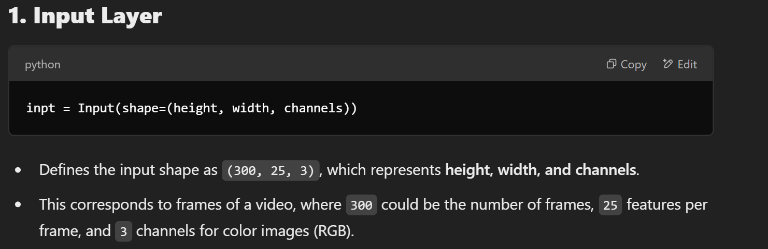

In simple terms, **channels** refers to the number of color components or feature maps in the input image.

For example:

* A **grayscale** image has **1 channel** (only intensity values).
* A **color (RGB)** image has **3 channels** (Red, Green, and Blue).
* If you're working with **feature maps** from a neural network, channels represent the depth of the feature representation at that layer.

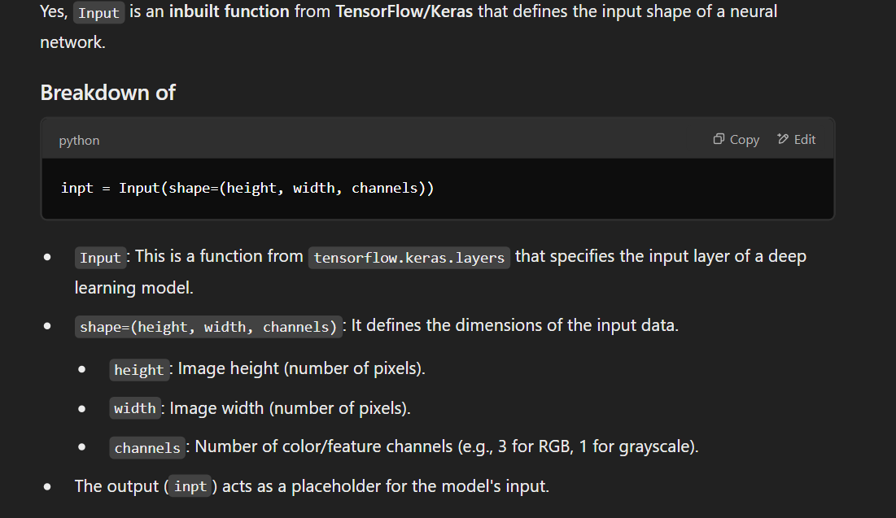

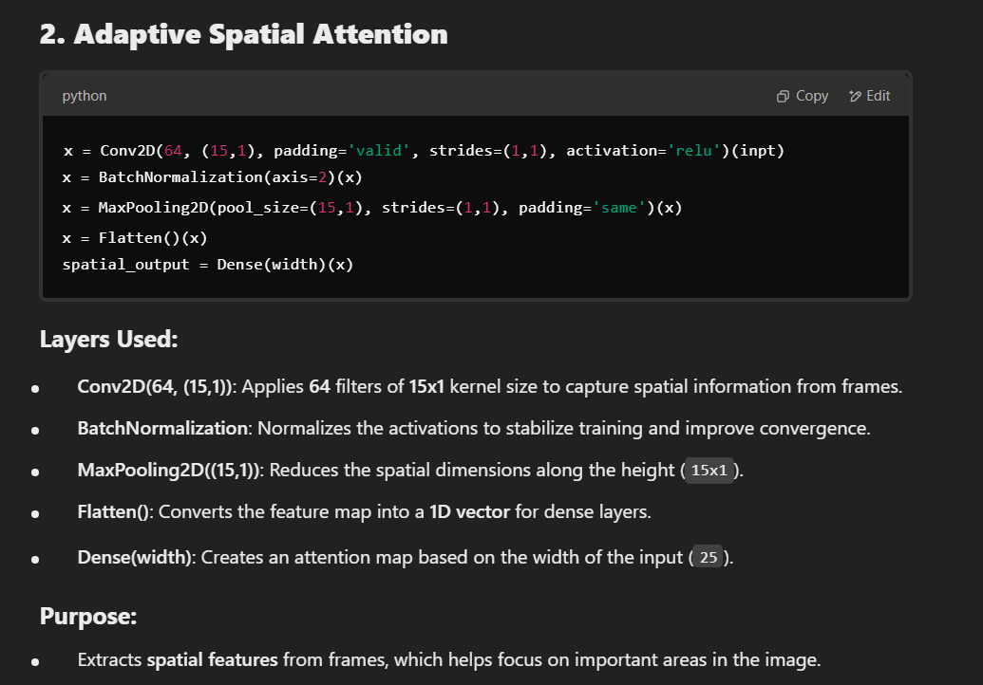

(inpt) at the end means the convolution operation is applied to the input tensor inpt.