

## Vision

**Provide skilled professionals in Computer Engineering to contribute towards the advancement of technology useful for society and industrial environment.**

## Mission

**M1**. Impart need based and value based education by providing exposure of latest tools and technologies in the area of computer engineering to satisfy the stakeholders.

**M2**. Upgrade and maintain facilities for quality technical education with continuous effort for excellence in Computer Engineering.

**M3.** Train students with Computer Engineering knowledge to apply it in the general disciplines of design, deployment of software and integration of existing technologies for E-governance and for benefit of society.

**M4**. Provide a learning ambience to enhance innovations, problem solving skills, leadership qualities, team spirit and ethical responsibilities.

**M5.** Provide an academic environment and consultancy services to the industry and society in the area of Computer Engineering.

### DEPARTMENT OF COMPUTER ENGG. :

### VISION :

### Provide skilled professionals in Computer Engineering to contribute towards the advancement of technology useful for society and the industrial environment..

**MISSION:**

* M1. Impart need-based and value-based education by providing exposure to the latest tools and technologies in the area of computer engineering to satisfy the stakeholders.
* M2: Upgrade and maintain facilities for quality technical education with continuous effort for excellence in Computer Engineering.
* M3: Train students with Computer Engineering knowledge to apply it in the general disciplines of design, deployment of software and integration of existing technologies for E-governance and benefit of society.
* M4: Provide a learning ambiance to enhance innovations, problem-solving skills, leadership qualities, team spirit and ethical responsibilities.
* M5: Provide an academic environment and consultancy services to the industry and society in the area of Computer Engineering.

### MICRO-PROJECT REPORT

ON

### *“ Stimulate a Dictionary using Linked list”*

**In Partial fulfilment of Diploma in Computer Engineering In the subject of**

### Data Structures using C (FC4503)

**By :**

* + - Mr. Khushal Lawankar (23CM041)
    - Mr. Roshan Thokal (23CM067)
    - Mr. Sahil Dhurde (24CM401)
    - Mr. Anuraj Kharabadkar (24CM402)

**Submitted To**



# Government Polytechnic, Amravati

**(An Autonomous Institute of Govt. of Maharashtra)**

Under the guidance of

### Mr. Ashish Tedhe

**Lecturer in Data Structures using C**

Department of Computer Science & Engg.

Government Polytechnic, Amravati

**(2024 -25)**

# Government Polytechnic, Amravati.

**(An Autonomous Institute of Govt. of Maharashtra)**

## Department of Computer Science & Engg.

*Certificate*

**This is a certificate that micro-project entitled:**

**“****Develop a ‘C’ program for to stimulate a dictionary using linked list.”**

Is bonafide work and submitted to Government Polytechnic Amravati

*BY:*

* + - Mr. Khushal Lawankar (23CM041)
    - Mr. Roshan Thokal (23CM067)
    - Mr. Sahil Dhurde (24CM401)
    - Mr. Anuraj Kharabadkar (24CM402)

In the partial fulfilment of the course FC4503 Data structure using ‘C’ for the requirement of the Diploma in Computer Engineering, during the academic year 2024-25.

(Under the Guidance of)

**Mr. Ashish Tedhe**

**(Lecturer in Computer Engg)**

INDEX:

|  |  |  |
| --- | --- | --- |
| **Sr.No.** | **Topic** | **Page No.** |
| 1 | * Vision And Mission | 1-2 |
| 2 | * Certificate Page | 3-4 |
| 3 | * Abstract | 6 |
| 4 | * Annexure * Program in C * About Project | 7-8    10-13    9 |
| 5 | * Output | 14-15 |
| 6 | * Conclusion | 16 |

**ABSTARCT :**

This project aims to develop a simple dictionary application using a linked list data structure in C. The dictionary will allow users to add, search, and display word. By utilizing a linked list, the program provides a dynamic and flexible way to manage dictionary entries, as it can easily handle varying numbers of words without the need for predefined limits on size.

The dictionary will support the following functionalities:

1. Add Word: Users can input a new word and its corresponding value which will be stored in a new node of the linked list.
2. Search Word: If the word exists, the program will display its key and value. otherwise, it will inform the user that the word is not found.
3. Display Dictionary: Users can view all the words and their value currently stored in the dictionary.

This project will highlight the advantages of linked lists in managing dynamic datasets, demonstrating concepts of memory management, pointer manipulation, and basic data structures in C. The implementation will serve as a foundational exercise for understanding linked lists and their applications in real-world scenarios, such as text processing and database management.

**Features:**

* Dynamic memory allocation for efficient memory usage.
* User-friendly interface for interaction.
* Basic error handling for invalid operations.

**ANNEXURE:**

## Title of Micro-Project:

## Develop a ‘C’ program for to stimulate a dictionary using linked list

**1.0 Brief Introduction**

The project entitled “**Develop a ‘C’ program for to stimulate a dictionary using linked list.**” is a program build in C programming to implement the linked list for real world project.

#### Aim of the Micro-Project:

#### *Develop a ‘C’ program for to stimulate a dictionary using linked list.*

**This Micro-Project aims at:**

1. Learn concepts of Data Structure.
2. Implement Data Structures Concepts in Real World project.

**3.0 Resources Required** (major resources such as raw material, some machining facility, software etc.)

|  |  |  |  |
| --- | --- | --- | --- |
| S.N. | Name of Resource/material | Specifications | Remarks |
| 1 | Computer System (System with  basic configuration) |  |  |
| 2 | Visual Studio Code |  |  |
| 3 | Dev cpp |  |  |
| 4 | M S Word |  |  |
| 5 | Windows 10 or above |  |  |

#### Names of Team Members with Identity Codes :

* + - Khushal Lawankar (23CM041)
    - Roshan Thokal (23CM067)
    - Sahil Dhurde (24CM401)
    - Anuraj Kharabadkar (24CM402)

#### 5.0 Output of the Micro-Project

Output of this Micro-Project is attached to this file.

#### Skill Developed / Learning outcomes of this Micro-Project

* + 1. To Implement Basic Data Structures.
    2. Use Various concepts of Data Structure and Develop Algorithms on it.
    3. Implement these concepts to solve real problems.
    4. Make use of Linked-List for real project.
    5. Implement a Basic operation on Linked list.

#### 7.0 Assessment by Faculty as per Rubrics

|  |  |  |  |
| --- | --- | --- | --- |
| **Process Assessment (06)** | **Product Assessment (04)** | **Total Marks (10)** | **Signature of Faculty** |
|  |  |  |  |

**8.0 Action Plan** (Sequence and time required for major activities for 8 weeks)

|  |  |  |  |  |
| --- | --- | --- | --- | --- |
| S.N. | Details of activity | Planned start  date | Planned Finish  date | I. Code &Name of Team Members |
| 1 | Gathering Information |  |  |  |
| 2 | Making report and file |  |  |  |
| 3 | Preparing the Code of  project in C |  |  |  |
| 4 | Planning proposal  submission |  |  |  |
| 5 | Gathering content |  |  |  |

***************************

**TITLE :**

“**Develop a ‘C’ program for to stimulate a dictionary using linked list.**”

**ABOUT PROJECT :**

*Creating a dictionary using a linked list in C is an elegant way to map keys to values, offering  flexibility and dynamic memory usage. The project involves:*

1. **Dictionary Structure**:
   * Each node stores a key (string) and a value (integer).
   * Nodes are connected in a linked list, forming a chain.
2. **Core Operations**:
   * **Insertion**: Adds new key-value pairs or updates existing ones.
   * **Search**: Retrieves the value associated with a given key.
   * **Display**: Shows all key-value pairs in the dictionary.
3. **Key Benefits**:
   * Dynamic Memory Allocation: Efficient use of memory, adapting to data size.
   * Simple Yet Effective: Straightforward approach to mapping keys to values.

This project serves as a practical introduction to data structures, memory management, and basic  algorithm and  implementation in C.

**DATA STRUCTURE USED :**

* **Link list :**

A linked list is a linear data structure where elements, known as nodes, are stored in non-contiguous memory location. Each node contains two main components: data and a pointer to the next node in the sequence. Linked lists can grow or shrink dynamicall y.

**PROGRAM IN C :**

#include <stdio.h>

#include <stdlib.h>

#include <string.h>

// Node definition

struct Dictionary {

char key[100];

int value;

struct Dictionary* next;

};

struct Dictionary* head = NULL;

// Insert or update key-value pair

void insert() {

char key[100];

int value;

struct Dictionary* temp = head;

struct Dictionary* newNode;

printf("Enter key: ");

scanf("%s", key);

printf("Enter value: ");

scanf("%d", &value);

while (temp != NULL) {

if (strcmp(temp->key, key) == 0) {

temp->value = value; // Update value if key exists

return;

}

temp = temp->next;

}

newNode = (struct Dictionary *)malloc(sizeof(struct Dictionary));

strcpy(newNode->key, key);

newNode->value = value;

newNode->next = head;

head = newNode;

}

// Search for a key

void search() {

char key[100];

struct Dictionary* temp = head;

printf("Enter key to search: ");

scanf("%s", key);

while (temp != NULL) {

if (strcmp(temp->key, key) == 0) {

printf("Value for key '%s': %d\n", key, temp->value);

return;

}

temp = temp->next;

}

printf("Key '%s' not found.\n", key);

}

// Display the dictionary

void display() {

struct Dictionary* temp = head;

while (temp != NULL) {

printf("%s: %d\n", temp->key, temp->value);

temp = temp->next;

}

}

int main() {

int choice;

do

{

printf("\nMenu:\n");

printf("1. Insert/Update\n");

printf("2. Search\n");

printf("3. Display\n");

printf("4. Exit\n");

printf("Enter your choice: ");

scanf("%d", &choice);

switch (choice) {

case 1:

insert();

break;

case 2:

search();

break;

case 3:

display();

break;

case 4:

printf("Exiting...Press Any key to EXIT\n");

return 0;

default:

printf("Invalid choice. Please try again.\n");

break;

}

}

while(choice != 4);

return 0;

}

****OUTPUT ****:

**Insertion in Dictionary:**

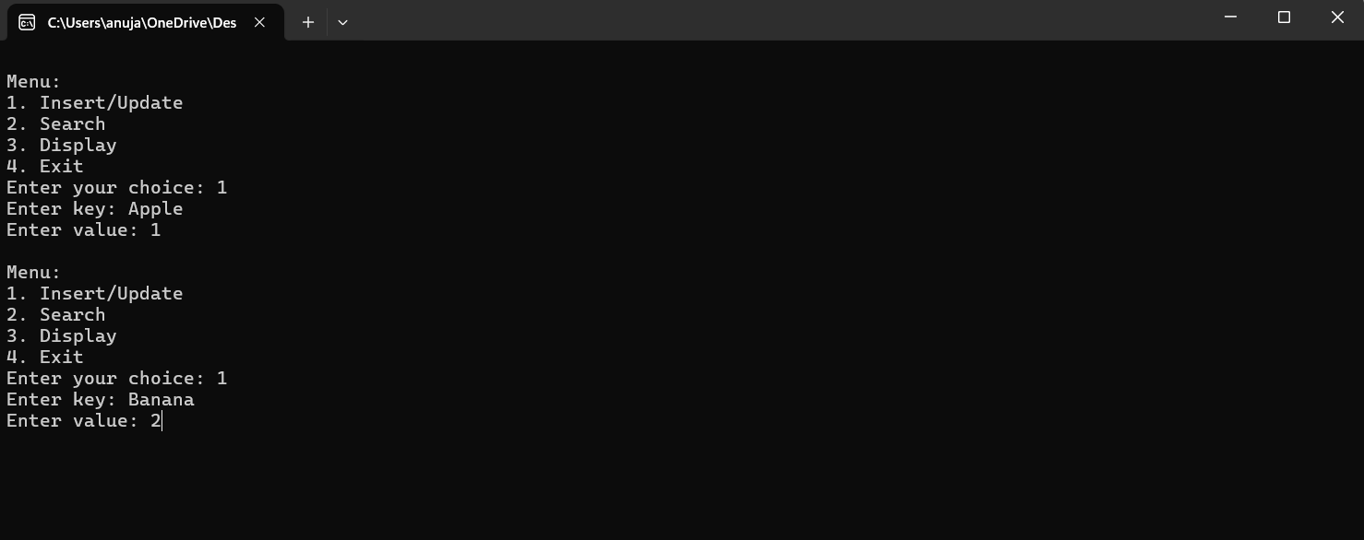

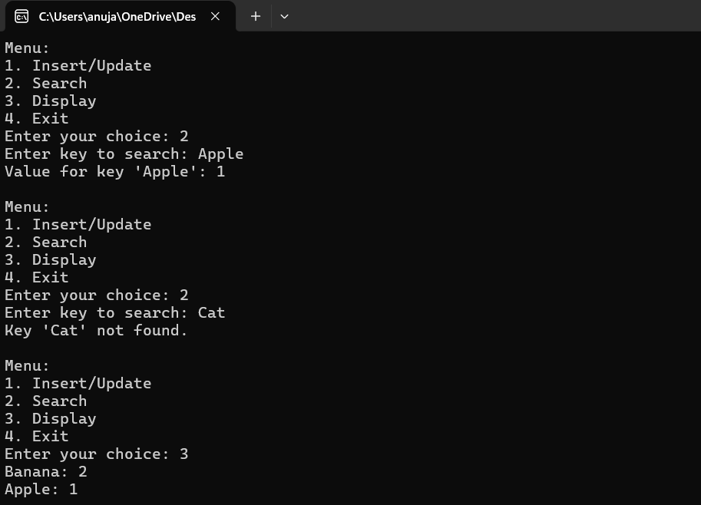c



The implementation of a dictionary using a linked list in C provides a fundamental way to store, manage, and retrieve key-value pairs efficiently. Through this project, we have demonstrated how linked lists can be leveraged to create a flexible data structure that supports dynamic insertion, and searching of elements**.**

In the process, we implemented various functions such as inserton, searching, and display and ensuring the integrity of the data structure. Using a linked list allows for efficient memory utilization, as it avoids the need for pre-allocation of large blocks of memory, unlike arrays or hash tables**.**

overall, the project has provided valuable insights into the workings of linked lists and their practical applications in data storage and retrieval, offering a strong foundation for further exploration into more advanced data structures and algorithms.

