User Story Document

|  |  |  |  |
| --- | --- | --- | --- |
| User Story Id | As a <as a user> | I want to  <Perform some task> | So that I can  <Achieve some Goal> |
| 1 | patient of Amblyopia | know the exercises of Eyes | I can treat Amblyopia |
| 2 | patient | login | access the facilities provided by medicare.com. |
| 3 | patient | use chronic illness detector | predict there are chronic disorders in me or not. |
| 4 | patient | a feature My Mental Health | detect there is any mental disorder in me or not. |
| 5 | patient | Share my health documents securely with doctor | he can treat me if i am not able to go to his clinic |
| 6 | Doctor | Login | See the reports of patients and treat them. |

Open Source License Statement

MIT License

Copyright (c) 2023 Sahil-Karanje04

Permission is hereby granted, free of charge, to any person obtaining a copy

of this software and associated documentation files (the "Software"), to deal

in the Software without restriction, including without limitation the rights

to use, copy, modify, merge, publish, distribute, sublicense, and/or sell

copies of the Software, and to permit persons to whom the Software is

furnished to do so, subject to the following conditions:

The above copyright notice and this permission notice shall be included in all

copies or substantial portions of the Software.

THE SOFTWARE IS PROVIDED "AS IS", WITHOUT WARRANTY OF ANY KIND, EXPRESS OR

IMPLIED, INCLUDING BUT NOT LIMITED TO THE WARRANTIES OF MERCHANTABILITY,

FITNESS FOR A PARTICULAR PURPOSE AND NONINFRINGEMENT. IN NO EVENT SHALL THE

AUTHORS OR COPYRIGHT HOLDERS BE LIABLE FOR ANY CLAIM, DAMAGES OR OTHER

LIABILITY, WHETHER IN AN ACTION OF CONTRACT, TORT OR OTHERWISE, ARISING FROM,

OUT OF OR IN CONNECTION WITH THE SOFTWARE OR THE USE OR OTHER DEALINGS IN THE

SOFTWARE.

Activity Uml Diagram

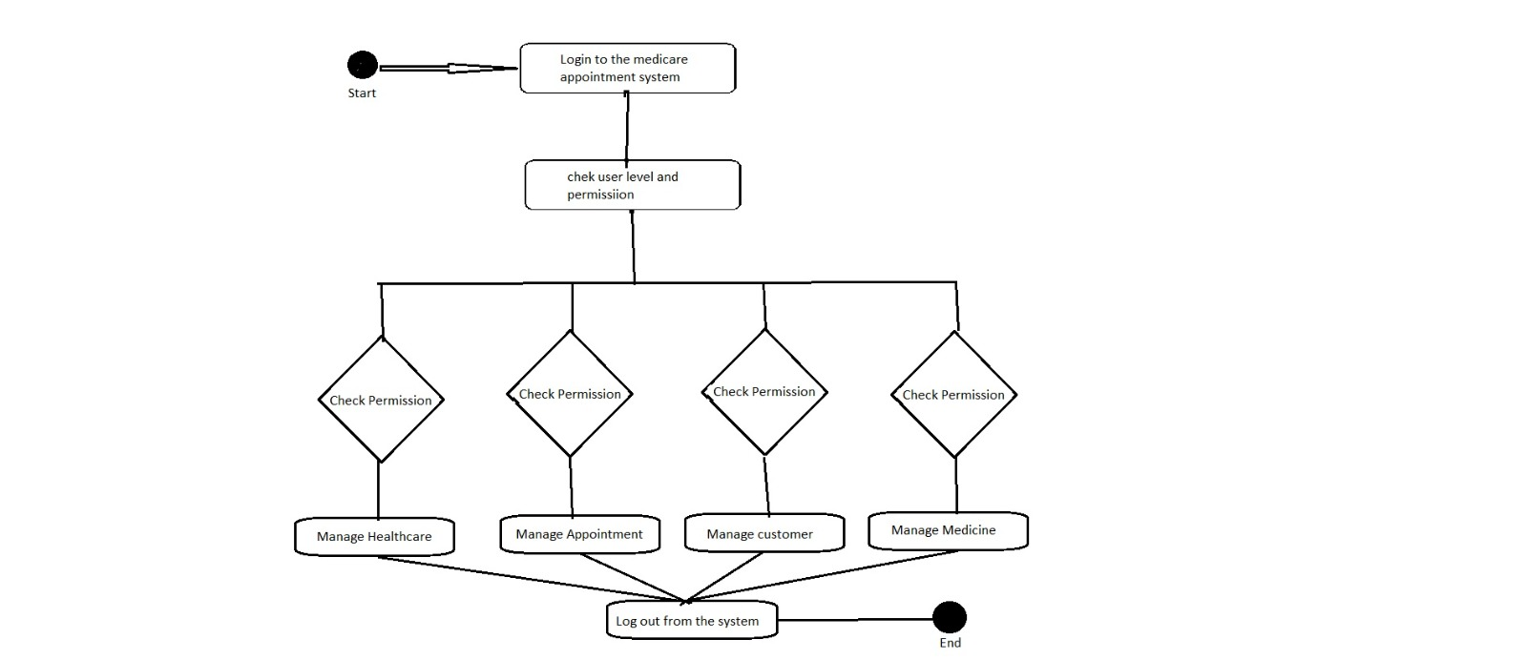

Use case Diagram

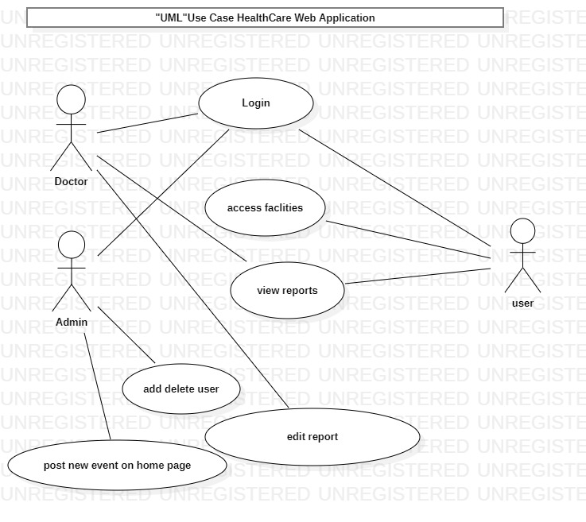

Deployment UML diagram

